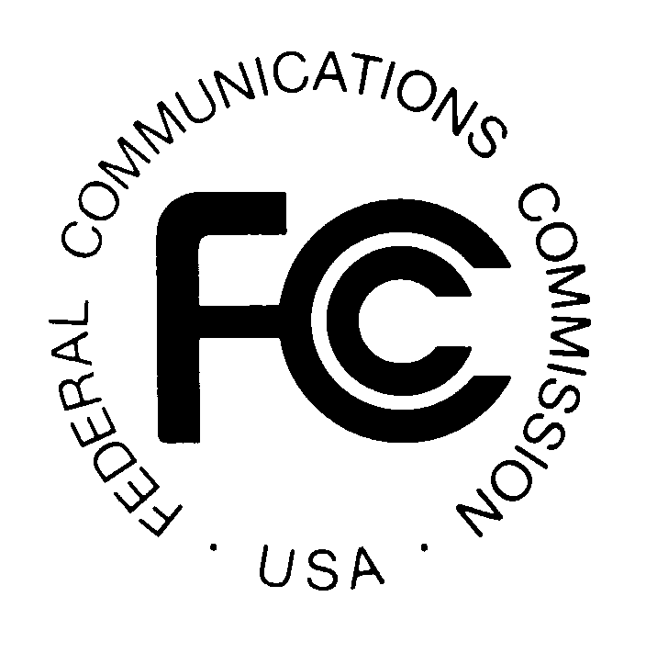
News media information 202 / 418-0500
TTY 202 / 418-2555
Internet: http://www.fcc.gov
PUBLIC NOTICE

Federal Communications Commission
445 12th St., S.W.
Washington, D.C. 20554

DA 12-2048

December 19, 2012

PUBLIC SAFETY AND HOMELAND SECURITY BUREAU ANNOUNCES

REGION 19 (NEW ENGLAND) 700 MHZ/4.9 GHZ PUBLIC SAFETY REGIONAL PLANNING COMMITTEE MEETING CALENDAR FOR YEAR 2013

The Region 19 (New England) 700 MHz Public Safety Regional Planning Committee will hold its next meetings at the following locations:

- Tuesday, March 12, 2013, 10:00 a.m. - 2:00 p.m., at the Massachusetts State Police General Headquarters, 470 Worcester Road, Framingham, Massachusetts

- Tuesday, June 11, 2013, 10:00 a.m. - 2:00 p.m., at the Putney Volunteer Fire Department,
14 Main Street, Putney, Vermont

- Tuesday, September 10, 2013, 10:00 a.m. - 2:00 p.m., at the Kennebunkport Fire Department, 32 North Main Street, Kennebunkport, Maine

- Tuesday, December 10, 2013, 10:00 a.m. - 2:00 p.m., at the Rhode Island Emergency Operations Center, 645 New London Avenue, Cranston, Rhode Island

The purpose of the meetings will be to discuss the needs of the 700 MHz and 4.9 GHz spectrum users, including Public Safety, Public Health, Emergency Management and Public Utility services.

The Region 19 700 MHz/4.9 GHz Public Safety Regional Planning Committee meetings are open to the public. All eligible public safety providers in Region 19 may utilize these frequencies. To ensure that each agency’s future spectrum needs are considered in the allocation process, it is essential that public safety agencies in all areas of government, including state, municipality, county, and Native American Tribal be represented. Administrators who are not oriented in the communications field should delegate someone with this knowledge to attend, participate, and represent their agency’s needs.

All interested parties wishing to participate in planning for the use of public safety spectrum in the 700 MHz and 4.9 GHz bands within Region 19 should plan to attend. For further information, please the Region 19 Chairman or Vice-Chairman or visit the committee website at www.ner700mhz.org.

Jerry Zarwanski, Chairman
Region 19 700 MHz Public Safety Regional Planning Committee
Department of Public Safety
Division of Fire, Emergency and Building Services
1111 Country Club Road
P.O. Box 2794
Middletown, Connecticut 06457
(860) 685-8157
Jerry.Zarwanski@po.state.ct.us

Stephen Verbil, Vice-Chairman
Region 19 700 MHz Public Safety Regional Planning Committee
Department of Public Safety
Division of Fire, Emergency and Building Services
1111 Country Club Road
P.O. Box 2794
Middletown, Connecticut 06457
(860) 685-8127
Stephen.Verbil@po.state.ct.us

-FCC-

The Region 19 area includes the following states: Connecticut (except Fairfield, Litchfield, New Haven and Middlesex counties), Maine, New Hampshire, Rhode Island, and Vermont.

