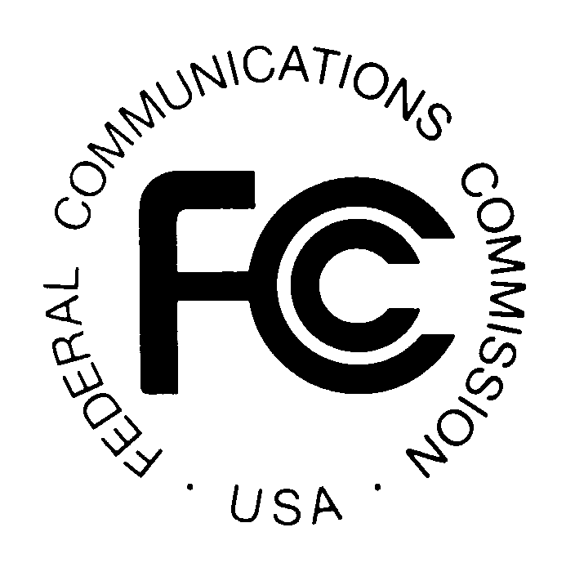
News media information 202 / 418-0500
TTY 202 / 418-2555
Internet: http://www.fcc.gov
PUBLIC NOTICE

Federal Communications Commission
445 12th St., S.W.
Washington, D.C. 20554

DA 12-2050

December 19, 2012

PUBLIC SAFETY AND HOMELAND SECURITY BUREAU ANNOUNCES

REGION 28 (EASTERN PENNSYLVANIA, SOUTHERN NEW JERSEY AND DELAWARE AREA) PUBLIC SAFETY REGIONAL PLANNING COMMITTEES TO HOLD 700 MHZ AND 800 MHZ NPSPAC MEETINGS

PR Docket No. 92-287

The Region 28 (Eastern Pennsylvania, Southern New Jersey and Delaware Area) Public Safety Regional Planning Committees (RPCs) will hold two consecutive planning meetings on Tuesday, January 15, 2013. Beginning at 10:00 a.m., the 800 MHz Public Safety RPC will convene at the Delaware River and Bay Authority Police Department, Delaware Memorial Bridge Toll Plaza, Julia Building, 2nd Floor Training Room, located at 2162 New Castle Avenue, New Castle, Delaware.

The agenda for the 800 MHz meeting includes:
- Call to Order
- Chair Report (Mark Grubb)
- Vice Chair Report (Jay Groce)
- Secretary Report (Judith Brackin)
- Technical Report (Jay Groce)
- Update – Rebanding progress
- Old Business (Open)
- New Business (Open)
- Next Meeting – Tuesday, April 9, 2013

Immediately following the 800 MHz Public Safety RPC meeting, the 700 MHz Public Safety RPC will convene at the same location.

The agenda for the 700 MHz meeting includes:
- Call to Order
- Chair Report (Mark Grubb)
- Vice Chair Report (Sean Petty)
- Secretary Report (Jody Nestor)
- Technical Committee Report (Sean Petty)
- Interoperability and State Interoperability Executive Committee (SIEC) updates
- Old Business (Open)
- New Business (Open)
- Next Meeting – Tuesday, April 9, 2013

Both Region 28 Public Safety RPCs’ meetings are open to the public. All eligible public safety providers in Region 28 may utilize these frequencies. It is essential that eligible public safety agencies in all areas of government, including state, municipality, county, and Native American Tribal be represented in order to ensure that each agency’s future spectrum needs are considered in the allocation process. Administrators who are not oriented in the communications field should delegate someone with this knowledge to attend, participate, and represent their agency’s needs.

All interested parties wishing to participate in planning for the use of public safety spectrum in the 700 MHz and 800 MHz bands within Region 28 should plan to attend. For further information, please contact:

Mark A. Grubb, Chairman
700 MHz and 800 MHz Public Safety RPCs
State of Delaware
Division of Communications
3050 Upper King Road
Dover, Delaware 19904
(302) 739-4207
mark.grubb@state.de.us

Jay Groce, Region 28 Vice Chairman
800 MHz Public Safety RPC
Chester County
Department of Emergency Services
601 Westtown Road
West Chester, Pennsylvania 19382
(610) 344-5084
mgroce@chesco.org

Sean Petty, Region 28 Vice Chairman
700 MHz Public Safety RPC
Senior Technology Specialist
Mission Critical Partners, Inc.
200 Innovation Blvd.
State College, PA 16803
(888) 862-7911
seanpetty@mcp911.com
- FCC -

The Region 28 (Delaware, Eastern Pennsylvania, Southern New Jersey) regional planning area includes the entire state of Delaware, the Pennsylvania counties of Berks, Bradford, Bucks, Carbon, Chester, Columbia, Dauphin, Delaware, Lackawanna, Lancaster, Lebanon, Lehigh, Luzerne, Lycoming, Monroe, Montgomery, Montour, Northampton, Northumberland, Philadelphia, Pike, Schuylkill, Sullivan, Susquehanna, Tioga, Wayne, Wyoming, and York, and the Southern New Jersey counties of Atlantic, Burlington, Camden, Cape May, Cumberland, Gloucester, Ocean, and Salem.
The Delaware River and Bay Authority Toll Plaza resides on the Delaware side of the Delaware Memorial Bridge and the Delaware 9 (New Castle Avenue) cloverleaf interchange.

