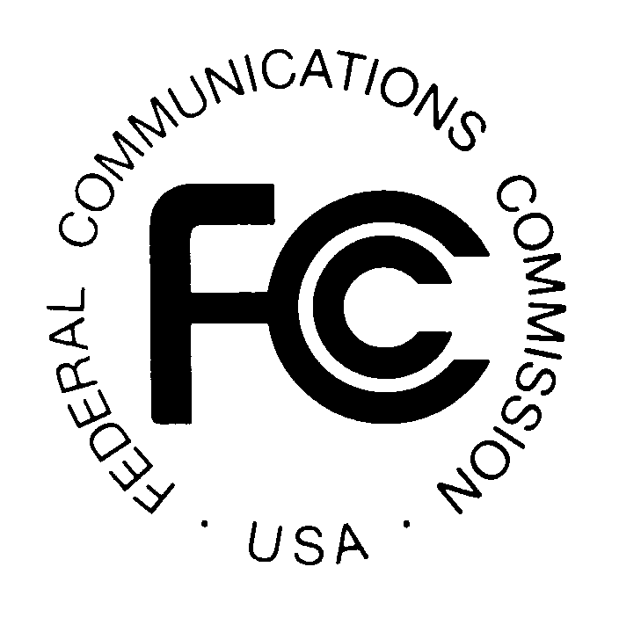
News media information 202 / 418-0500
TTY 202 / 418-2555
Internet: http://www.fcc.gov
PUBLIC NOTICE

Federal Communications Commission
445 12th St., S.W.
Washington, D.C. 20554

DA 12-2092

December 27, 2012

PUBLIC SAFETY AND HOMELAND SECURITY BUREAU ANNOUNCES

REGION 55 (NEW YORK - BUFFALO) PUBLIC SAFETY REGIONAL PLANNING COMMITTEES TO HOLD 700 MHZ AND 800 MHZ NPSPAC PLANNING MEETINGS

PR Docket No. 92-190

The Region 55 (New York - Buffalo) Public Safety Regional Planning Committees (RPCs) will hold two consecutive planning meetings on Thursday, February 7, 2013. Beginning at 10:00 a.m., the 700 MHz RPC will convene at the Monroe County Public Safety Training Facility (Room 107), 1190 Scottsville Road, Rochester, New York.

The agenda for the 700 MHz meeting includes:
  - Review and approve agenda February 7, 2013 Meeting Agenda
  - Review and approve August 16, 2012 Meeting Report
  - Interoperability (SIEC Reports) NYS-DHSES-OIEC Representatives
  - Old Business
- Window 8 Application for City of Buffalo status
- Window 7 Application/Concurrence Status
- Monroe County Special Temporary Authority (STA) application
- Ontario County STA application WQPL347 modified FCC Form 601
  - New Business
- Window 9 Applications (January 1-31, 2013)
  - Schedule next meeting (to be determined at the end of the 800 MHz RPC Meeting)
  - Adjourn

Immediately following the 700 MHz Public Safety RPC meeting, the 800 MHz Public Safety RPC will convene at the same location.

The agenda for the 800 MHz meeting includes:
  - Review and approve agenda February 7, 2013 Meeting Agenda
  - Review and approve August 16, 2012 Meeting Report
  - Old business
- Update – Wave 4 Rebanding (Genesee County)
  - New business
  - Schedule next meeting
  - Adjourn

Both Region 55 Public Safety RPCs’ meetings are open to the public. All eligible public safety providers in Region 55 may utilize these frequencies. It is essential that eligible public safety agencies in all areas of government, including state, municipality, county, and Native American Tribal be represented in order to ensure that each agency’s future spectrum needs are considered in the allocation process. Administrators who are not oriented in the communications field should delegate someone with this knowledge to attend, participate, and represent their agency’s needs.

All interested parties wishing to participate in planning for the use of public safety spectrum in the 700 MHz and 800 MHz bands within Region 55 should plan to attend. For further information, please contact:

Steven Sharpe, Chairman
Region 55 700 MHz and 800 MHz Public Safety RPCs
Genesee County
Director of Emergency Communications
165 Park Road
Batavia, NY 14020
(585) 345-3000
ssharpe@co.genesee.ny.us

Paul Stritzinger, Vice Chairman
Region 55 700 MHz and 800 MHz Public Safety RPCs
Carlton Fire Company
Iberdrola USA Management Corporation, Lead Engineer
89 East Avenue
Rochester, NY 14649
(585) 724-8956
Peter.stritzinger@berdrolaus.com or
Pjs8779@yahoo.com

- FCC -

