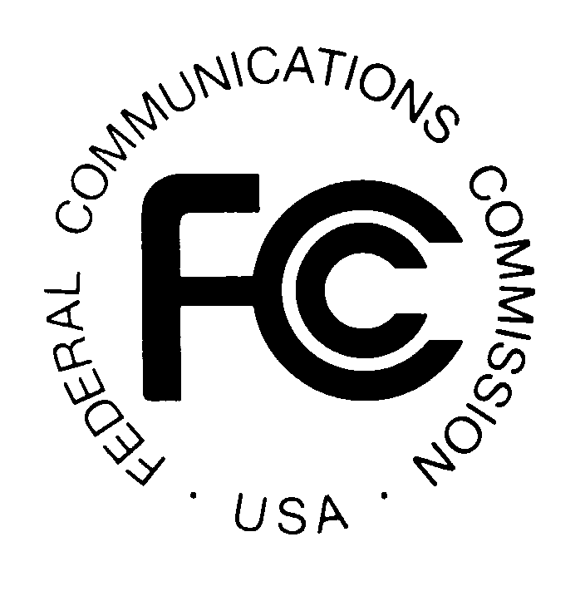
News media information 202 / 418-0500
TTY 202 / 418-2555
Internet: http://www.fcc.gov
PUBLIC NOTICE

Federal Communications Commission
445 12th St., S.W.
Washington, D.C. 20554

DA 13-1133

May 17, 2013

PUBLIC SAFETY AND HOMELAND SECURITY BUREAU ANNOUNCES

REGION 12 (IDAHO) PUBLIC SAFETY REGIONAL PLANNING COMMITTEE

TO HOLD ANNUAL 700 MHZ REGIONAL PUBLIC SAFETY PLANNING MEETING

The Region 12 (Idaho) 700 MHz Public Safety Regional Planning Committee (RPC) will hold its 2013 statewide meeting on Wednesday, May 22, 2013, from 2 p.m. to 4 p.m. at the Idaho State Police Headquarters, 700 S. Stratford Drive, Meridian, Idaho 83642.

The agenda for the meeting includes:
- Welcome and introduction of members
- Review and approval of meeting minutes
- Financial Report
- Old Business -- updates on:
  - Update on 700 MHz narrowbanding -- FCC Seventh Report and Order and NPRM, PS Docket No. 13-87, WT Docket No. 96-86, RM-11433, PS Docket No. 06-229,
(rel. Apr. 1, 2013). Comments due by June 18, and Reply Comments by July 18, 2013.
  - CAPRAD
  - Lifecycle management
- New Business -- updates on:
  - Past year’s license requests
  - Eastern Idaho’s request for additional channels
  - SCIP
  - State of Idaho waiver approval, PSHSB Policy Division Order, DA 13-550, (rel. Mar. 26, 2013) – to permit the licensing of a mobile 700 MHz trunked system to operate on six 12.5 kHz channel pairs – presented by Robert E. Hugi
  - Statewide Interoperability Executive Committee (SIEC)
  - Regional-statewide fleet map coordination and planning
  - Region 12 700 MHz radio: Region 1-North, Region 2-West, Region 3-East
  - State of Idaho 700 MHz
- Open Comments
  - Next meeting regularly scheduled meeting, May, 2014 – location TBD
- Adjourn

The Region 12 700 MHz Public Safety RPC meeting is open to the public. It is essential that public safety agencies in all areas of government, including state, municipality, county, and Native American Tribal, and non-governmental organizations eligible under Section 90.523 of the Commission’s rules, 47 C.F.R. § 90.523, be represented in order to ensure that each agency’s future spectrum needs are considered in the allocation process. Administrators who are not oriented in the communications field should delegate someone with this knowledge to attend, participate, and represent their agency’s needs.

All interested parties wishing to participate in the planning for the use of public safety spectrum in the 700 MHz band within Region 12 should plan to attend. For further information, please contact:

Lieutenant Todd Herrera, Chairman
Region 12 (Idaho) 700 MHz RPC
Canyon County Sheriff’s Office
1115 Albany Street
Caldwell, Idaho 83605
(208) 454-7271
therrera@canyonco.org
www.700region12.org

-FCC-

