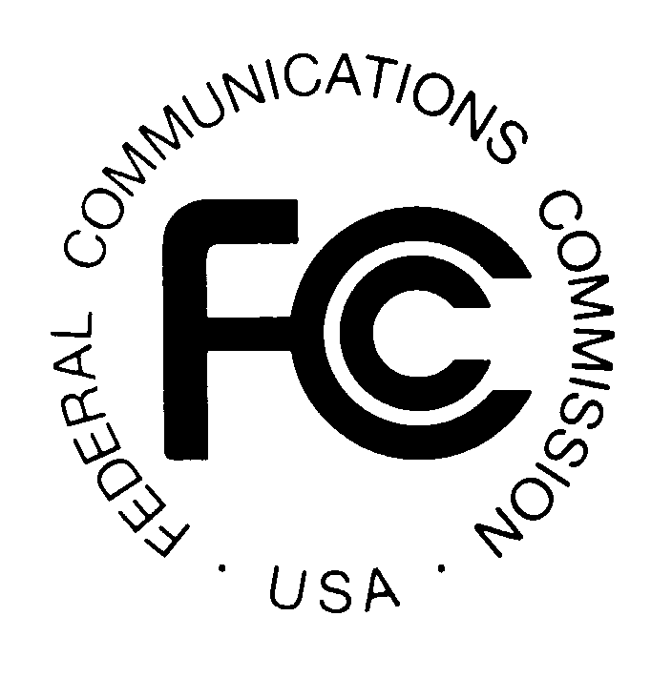
PUBLIC NOTICE

News media information 202 / 418-0500
Fax-On-Demand 202 / 418-2830
TTY 202 / 418-2555
Internet: http://www.fcc.gov
ftp.fcc.gov
Federal Communications Commission
445 12th St., S.W.
Washington, D.C. 20554

DA 13-137

Released: February 1, 2013

COMMISSION OPENS FILING WINDOW FOR
COMMERCIAL OPERATOR LICENSE EXAMINATION MANAGERS

WT Docket No. 98-228

On January 14, 1993, the Commission privatized the administration of license examinations for Commercial Radio Operators, and delegated authority to the Chief, Wireless Telecommunications Bureau to certify private entities to be Commercial Operator License Examination (COLE) managers. In its initial solicitation for COLE managers, the Commission stated that “other” filing window(s) may be opened in the future if the Commission determined that additional COLE managers would be beneficial. The last filing window was announced on September 3, 2004. Since that time, numerous entities have expressed interest in being certified as COLE managers. The purpose of this Public Notice is to announce a filing window for requests from additional entities interested in being certified as a COLE manager.

In the COLE R&O, the Commission established that certification of an entity as a COLE manager would be through the use of a Memorandum of Agreement (MOA). Entities interested in becoming a COLE manager should familiarize themselves with the Commission's rules pertaining to COLE administration before applying.

Each request for certification must be signed and include the name and telephone number of a person familiar with the request and must include:

1. a description of the entity requesting to be certified and its qualifications,
2. how it will prevent any conflicts of interest,
3. its proposed fee structure.
The Commission will consider the following factors in deciding whether to certify an applicant as a COLE manager:

- Experience and ability to administer qualification examinations both by means of computer and by written examinations.
- Area in which applicant is willing to administer examinations. NOTE: Preference will be given to applicants that can provide nationwide testing and have existing administration infrastructure to do so.
- Frequency of examinations that applicant is prepared to offer at each examination point. NOTE: Preference will be given to applicants that offer examinations on a more frequent basis.
- Length of time before an applicant can begin administering examinations.

All requests should address each of the four (4) factors identified in this Public Notice. Interested parties should bear in mind that only applicants that propose to administer all written examination elements will be considered.

All requests for certification as a COLE manager must be received by May 2, 2013. Requests received after this date, or which do not comply with the filing procedures, will not be considered. The names and addresses of certified COLE managers will be announced in a future Public Notice.

Requests may be filed using the Commission's Electronic Comment Filing System (ECFS) or by filing paper copies. See Electronic Filing of Documents in Rulemaking Proceedings, 63 Fed. Reg. 24121 (1998). Comments filed through the ECFS can be sent as an electronic file via the Internet to http:// apps.fcc.gov/ecfs//. Generally, only one copy of an electronic submission must be filed. If multiple docket or rulemaking numbers appear in the caption of this proceeding, however, commenters must transmit one electronic copy of the comments to each docket or rulemaking number referenced in the caption. In completing the transmittal screen, commenters should include their full name, U.S. Postal Service mailing address, and the applicable docket or rulemaking number. Parties may also submit an electronic comment by Internet e-mail. To get filing instructions for e-mail comments, commenters should send an e-mail to ecfs@fcc.gov, and should include the following words in the body of the message, “get form.” A sample form and directions will be sent in reply.

Parties who choose to file by paper must file an original and one copy of each filing. If more than one docket or rulemaking number appears in the caption of this proceeding, commenters must submit two additional copies for each additional docket or rulemaking number.

Filings can be sent by hand or messenger delivery, by commercial overnight courier, or by first-class or overnight U.S. Postal Service mail. All filings must be addressed to the Commission's Secretary, Office of the Secretary, Federal Communications Commission.

-All hand-delivered paper filings for the Commission’s Secretary must be delivered to FCC Headquarters at 445 12th St., S.W., Room TW-A325, Washington, DC 20554. All hand deliveries must be held together with rubber bands or fasteners. Envelopes must be disposed of before entering the building. The filing hours at this location are 8:00 a.m. to 7:00 p.m.

-Commercial overnight mail (other than U.S. Postal Service Express Mail and Priority Mail) must be sent to 9300 East Hampton Drive, Capitol Heights, MD 20743.
-U.S. Postal Service first-class mail, Express Mail, and Priority Mail should be addressed to 445 12th Street, S.W., Washington, DC 20554.

Parties are requested to send one copy of their request to Best Copy and Printing, Inc., Portals II, 445 12th Street, S.W., Room CY-B402, Washington, D.C. 20554, (800) 378-3160, e-mail FCC@BCPIWEB.com.

The requests filed in response to this Public Notice will be available for viewing via the Commission's Electronic Comment Filing System (ECFS) by entering the docket number, WT 98-228. The documents also will be available for public inspection and copying during business hours in the FCC Reference Information Center, Portals II, 445 12th Street S.W., Room CY-Level, Washington, D.C. 20554. They may also be purchased from Best Copy and Printing, Inc., telephone (800) 378-3160, facsimile (202) 488-5563, TTY (202) 488-5562, e-mail FCC@BCPIWEB.com.

Alternate formats of this Public Notice (computer diskette, large print, audio recording, and Braille) are available to persons with disabilities by contacting the Consumer & Governmental Affairs Bureau at (202) 418-0530 (voice), (202) 418-0432 (TTY), or send an e-mail to fcc504@fcc.gov.

Questions regarding this Public Notice may be directed to Ms. Stana Kimball, Mobility Division, Wireless Telecommunications Bureau (202) 418-1306, TTY (202) 418-7233, stanislava.kimball@fcc.gov.

Action by Deputy Chief, Mobility Division, Wireless Telecommunications Bureau.

-FCC-

Amendment of Part 13 of the Commission’s Rules to Privatize the Administration of Examinations for Commercial Operator Licenses and to Clarify Certain Rules, Report and Order, FO Docket No. 92-206, 8 FCC Rcd 1046 (1993) (COLE R&O).
Commission Opens Filing Window for Commercial Operator License Examination Managers, Public Notice, 8 FCC Rcd 2570 (WTB PSCID 1993).
Commission Opens Filing Window for Commercial Operator License Examination Managers, Public Notice, 19 FCC Rcd 17490 (WTB PSCID 2004).
In addition to the COLE R&O and Part 13 of the Commission’s Rules, 47 C.F.R. Part 13, interested parties should review the recent Report and Order amending the Commission's rules pertaining to COLE administration, Amendment of the Commission’s Rules Concerning Commercial Radio Operators, Report and Order, WT Docket No. 10-177, FCC 13-4 (rel. Jan. 8, 2013).

