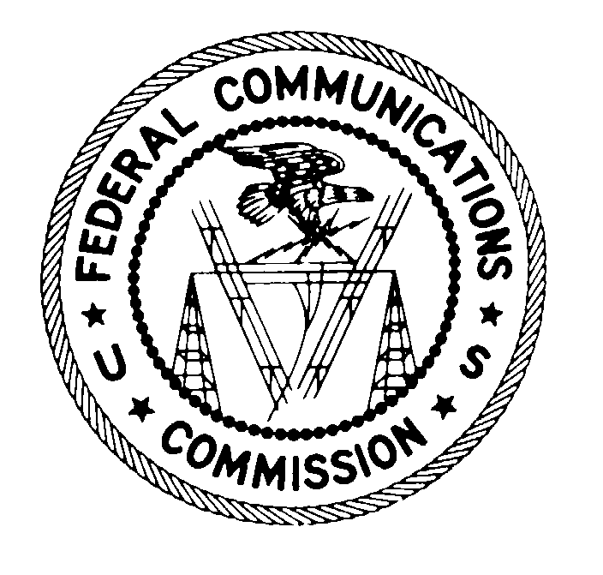
FEDERAL COMMUNICATIONS COMMISSION
Washington DC 20554

DA 13-1437
June 25, 2013

Via E-mail

William E. Cook
Arnold & Porter LLP
555 Twelfth Street, NW
Washington, DC 20004

Re: Applications of AT&T Inc., Cellco Partnership d/b/a/ Verizon Wireless, Grain Spectrum, LLC, and Grain Spectrum II, LLC for Consent To Assign Licenses and Grant Long-Term De Facto Transfer Spectrum Leasing Arrangements (WT Docket No. 13-56) – Request for Supplement to Second Protective Order

Dear Counsel:

By your letter, dated June 19, 2013, you have requested that the Commission supplement the Second Protective Order in the above-captioned proceeding. Based upon the matters set forth in your letter and the representations contained therein, we hereby revise Appendix A to the Second Protective Order by replacing it in its entirety with the new Appendix A attached to this letter.

If you have any questions regarding this matter, please contact Scott Patrick, Mobility Division, Wireless Telecommunications Bureau, at (202) 418-2853, or Kate Matraves, Spectrum and Competition Policy Division, Wireless Telecommunication Bureau, at (202) 391-6272.

Sincerely,

Ruth Milkman
Chief, Wireless Telecommunications Bureau

Attachment

cc: Joan Marsh, AT&T

APPENDIX A
(Revised)
Highly Confidential Information and Documents

As specified in paragraphs 2 and 3 of the Second Protective Order, only information and documents set forth in this Appendix and that otherwise meet the definition of Highly Confidential Information or Highly Confidential Documents may be designated as Highly Confidential. This Appendix will be updated as necessary.
- Information that details the terms and conditions of or strategy related to a Submitting Party’s most sensitive contracts (e.g., marketing, service or product agreements, nondisclosure agreements relating to potential mergers and acquisitions, and comparably sensitive contracts).
- Information that discusses specific steps that will be taken to integrate companies or discussions of specific detail or disaggregated quantification of merger integration benefits or efficiencies (including costs, benefits, timeline, and risks of the integration).
- Information that discusses in detail current or future plans to compete for a customer or specific groups or types of customers (e.g., business or wholesale customers), including future procurement strategies, pricing strategies, product strategies, advertising or marketing strategies, future business plans, technology implementation or deployment plans and strategies (e.g., engineering capacity planning documents), plans for handling acquired customers, and human resources and staffing strategies.
- Information that provides granular information about a Submitting Party’s current or future costs, revenues, marginal revenues, or market share.
- Detailed information describing or illustrating how a Submitting Party analyzes its competitors, including sources and methods used in these analyses, any limits on use of these analyses or data, and how such analyses or data are used.
- Information that provides numbers of customers and revenues broken down by customer type (e.g., business) and market area (e.g., CMA/MSA/RSA, DMA, state, regional cluster) or zip code.
- Information that discloses the identity or characteristics (including identifying information about specific customer facilities) of specific customers (including their levels of demand) or of those a company is targeting or with whom a company is negotiating.
- Information that discusses in detail the number or anticipated changes in the number of customers or amount of traffic, including churn rate data, broken down by zip code or market and detailed information about why customers discontinue service.
- Information that provides detailed or granular engineering capacity information or information about specific facilities, including collocation sites, cell sites, or maps of network facilities.
- Information that provides detailed technical performance data and test results.

Applications of AT&T Inc., Cellco Partnership d/b/a/ Verizon Wireless, Grain Spectrum, LLC, and Grain Spectrum II, LLC for Consent to Assign Licenses and Grant Long-Term De Facto Transfer Spectrum Leasing Arrangements, WT Docket No. 13-56, Second Protective Order, DA 13-1367 (WTB rel. June 13, 2013).

