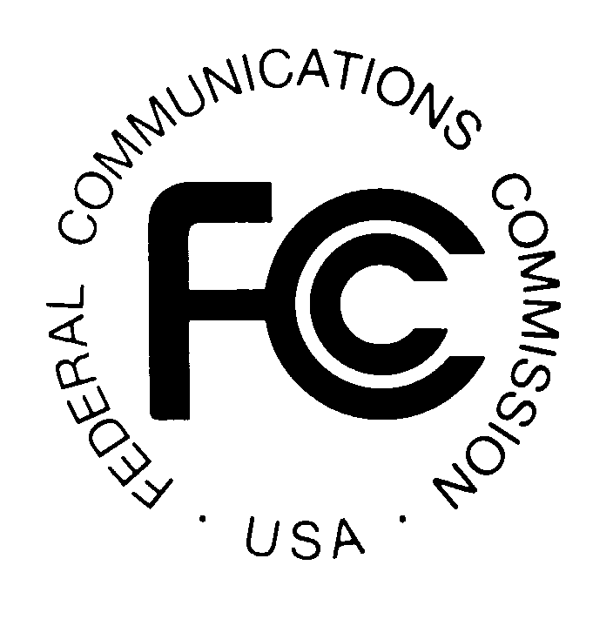PUBLIC NOTICE
FEDERAL COMMUNICATIONS COMMISSION
445 12th Street, S.W.
WASHINGTON, DC 20554 DA 13-1457

Released: July 1, 2013

WIRELESS TELECOMMUNICATIONS BUREAU SEEKS FURTHER COMMENT ON
THE STATE OF MOBILE WIRELESS COMPETITION AND THE ROLE OF MINORITY AND WOMEN-OWNED BUSINESS ENTERPRISES AND EXTENDS PERIOD FOR REPLY COMMENTS

WT Docket No. 13-135

Reply Comments Due: July 15, 2013

On May 17, 2013, the Bureau released a Public Notice (PN) seeking comment on the state of competition in the mobile wireless marketplace. About the time of release of the PN, the Minority Media and Telecommunications Council (MMTC) submitted letters requesting that the Commission collect information on the role minority and women-owned enterprises (MWBEs) play in mobile wireless competition.
- We invite parties to address in this docket the important issues raised in the MMTC letters.
- We seek comment on levels of, and opportunities for, participation in the wireless marketplace for MWBEs. How many MWBEs are actively associated with the industry and in what capacities? How many such entities operate as carriers and/or spectrum licensees? Commenters should address efforts within the industry to increase diversity and access for MWBEs. Do MWBEs provide services to consumers who might otherwise be overlooked by others in the marketplace?
In order to accommodate comments on the issues raised herein, we are extending the original date for reply comments by an additional two weeks. Therefore, pursuant to sections 1.415 and 1.419 of the Commission’s rules, 47 CFR §§ 1.415, 1.419, interested parties may file reply comments on or before July 15, 2013. All filings should refer to WT Docket No. 13-135. Comments may be filed: (1) using the Commission’s Electronic Comment Filing System (ECFS), or (2) by filing paper copies. See Electronic Filing of Documents in Rulemaking Proceedings, 63 FR 24121 (1998).
Comments and reply comments filed in response to this Public Notice will be available for public inspection and copying in the Commission’s Reference Center, Room CY-A257, 445 12th Street, S.W., Washington, D.C. 20554, and via the Commission’s Electronic Comment Filing System (ECFS) by entering the docket number, WT 11-186. Copies of the request are also available from Best Copy and Printing, Inc., telephone (800) 378-3160, facsimile (301) 816-0169, e-mail FCC@BCPIWEB.com.
Comments may be filed using the ECFS or by filing paper copies. See Electronic Filing of Documents in Rulemaking Proceedings, 63 Fed. Reg. 24121 (1998). Comments filed through the ECFS can be sent as an electronic file via the Internet to http://www.fcc.gov/cgb/ecfs/. Generally, only one copy of an electronic submission must be filed. If multiple docket or rulemaking numbers appear in the caption of this proceeding, however, commenters must transmit one electronic copy of the comments to each docket or rulemaking number referenced in the caption. In completing the transmittal screen, commenters should include their full name, U.S. Postal Service mailing address, and the applicable docket or rulemaking number. Parties may also submit an electronic comment by Internet e-mail. To get filing instructions for e-mail comments, commenters should send an e-mail to ecfs@fcc.gov , and should include the following words in the body of the message, “get form.” A sample form and directions will be sent in reply.
Parties who choose to file by paper must file an original and one copy of each filing. If more than one docket or rulemaking number appears in the caption of this proceeding, commenters must submit two additional copies for each additional docket or rulemaking number.
Filings can be sent by hand or messenger delivery, by commercial overnight courier, or by first-class or overnight U.S. Postal Service mail (although we continue to experience delays in receiving U.S. Postal Service mail). All filings must be addressed to the Commission’s Secretary, Office of the Secretary, Federal Communications Commission, as follows:
-All hand-delivered paper filings for the Commission’s Secretary must be delivered to FCC Headquarters at 445 12th St., S.W., Room TW-A325, Washington, DC 20554. All hand deliveries must be held together with rubber bands or fasteners. Envelopes must be disposed of before entering the building. The filing hours at this location are 8:00 a.m. to 7:00 p.m. PLEASE NOTE: This is the ONLY location where hand-delivered or messenger-delivered paper filings for the Commission’s Secretary will be accepted. The Commission’s former filing location at 236 Massachusetts Ave., N.E., is permanently closed.
-Commercial overnight mail (other than U.S. Postal Service Express Mail and Priority Mail) must be sent to 9300 East Hampton Drive, Capitol Heights, MD 20743.
-U.S. Postal Service first-class mail, Express Mail, and Priority Mail should be addressed to 445 12th Street, S.W., Washington, DC 20554.
-All filings must be addressed to the Commission's Secretary, Office of the Secretary, Federal Communications Commission.
Parties are requested to send one copy of their comments and reply comments to Best Copy and Printing, Inc., Portals II, 445 12th Street, S.W., Room CY-B402, Washington, D.C. 20554, (800) 378-3160, e-mail FCC@BCPIWEB.com.
Alternate formats of this Public Notice (computer diskette, large print, audio recording, and Braille) are available to persons with disabilities by contacting the Consumer & Governmental Affairs Bureau at (202) 418-0530 (voice), (202) 418-0432 (TTY), or send an e-mail to fcc504@fcc.gov.
For further information, contact Paroma Sanyal, Spectrum & Competition Policy Division, Wireless Telecommunications Bureau, (202) 418-2425, or Heidi Kroll, Spectrum & Competition Policy Division, Wireless Telecommunications Bureau, (202) 418-2361.

See Wireless Telecommunication Seeks Comment on the State of Mobile Wireless Competition, Public Notice, WT Docket No. 13-135 (rel. May 17, 2013)
See Minority Media and Telecommunications Council (MMTC) Letter to Mignon Clyburn, Acting Chairwoman, (May 20, 2013), available at http://apps.fcc.gov/ecfs/document/view?id=7022415051. See also, MMTC Letter to Ruth Milkman, Wireless Telecommunications Bureau, WT Docket No.11-186 and Subsequent Dockets (May 10, 2013), available at http://apps.fcc.gov/ecfs/document/view?id=7022311914

