PUBLIC NOTICE
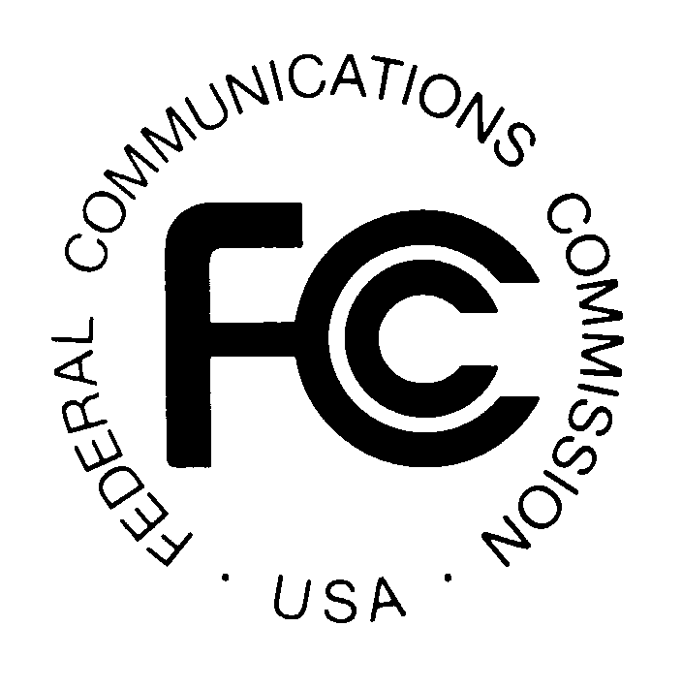

News media information 202 / 418-0500
TTY 202 / 418-2555
Internet: http://www.fcc.gov
Federal Communications Commission
445 12th St., S.W.
Washington, D.C. 20554

DA 13-1690

August 2, 2013

PUBLIC SAFETY AND HOMELAND SECURITY BUREAU ANNOUNCES

REGION 10 (GEORGIA) PUBLIC SAFETY REGIONAL PLANNING COMMITTEES TO HOLD 700 MHZ AND 800 MHZ NPSPAC REGIONAL PUBLIC SAFETY PLANNING MEETINGS

PR Docket No. 92-189

The Region 10 (Georgia) Public Safety Regional Planning Committees (RPCs) will hold two consecutive planning meetings on Tuesday, October 29, 2013. Beginning at 10:00 a.m., the 700 MHz Public Safety RPC will convene at the Georgia Public Safety Training Center, 1000 Indian Springs Drive, Bay A, Forsyth, Georgia. A continental breakfast and lunch will be provided. Breakfast will be served from 9:00 – 10:00 a.m.

The agenda for the 700 MHz meeting includes:
- Election of new officers
- Review and approval of the meeting minutes
- FCC Application process
- Old business
- New business
- Standing Committee Reports
- Regional Radio Groups
- FCC Regulatory update
- Schedule 2014 RPC meeting

Immediately following the 700 MHz Public Safety RPC meeting, the 800 MHz Public Safety RPC will convene at the same location.

The agenda for the 800 MHz meeting includes:
- Election of new officers
- Update on Region 10, 800 MHz Public Safety Communications Plan
- Old business
- New business
- Region 10 8CALL and 8TAC
- FCC Regulatory update
- Standing Committee Reports
- Repacking 800 MHz Plan

Both Region 10 Public Safety RPCs’ meetings are open to the public. All eligible public safety providers in Region 10 may utilize these frequencies. It is essential that eligible public safety agencies in all areas of government, including state, municipality, county, and Native American Tribal be represented in order to ensure that each agency’s future spectrum needs are considered in the allocation process. Administrators who are not oriented in the communications field should delegate someone with this knowledge to attend, participate, and represent their agency’s needs.

All interested parties wishing to participate in planning for the use of public safety spectrum in the 700 MHz and 800 MHz bands within Region 10 should plan to attend. For further information, please contact:

Jim Mollohan, Chairman
Region 10, 700 MHz and 800 MHz Public Safety RPCs
Georgia Technology Authority
47 Trinity Avenue SW, Suite 330-22
Atlanta, Georgia 30334-9007
(404) 656-5619
Jim.Mollohan@gta.ga.gov

- FCC -

The Region 10 700 MHz and 800 MHz Regional Planning Committees’ area includes all 159 counties in the State of Georgia.
The Region 10 700 MHz Public Safety Communications Plan is available on the Computer Assisted Pre-coordination Resource and Database (CAPRAD) website at http://caprad.nlectc.du.edu/cp/index.jsp, or a copy may be requested from the Chairman by email.

