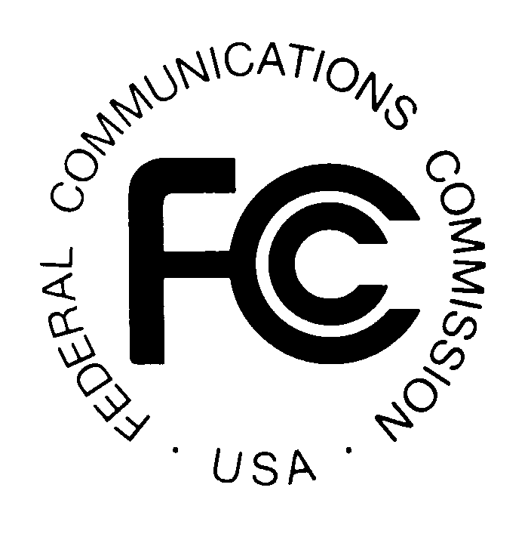
PUBLIC NOTICE
Federal Communications Commission
News Media Information 202 / 418-0500
Internet: http://www.fcc.gov
TTY: 1-888-835-5322

445 12th St., S.W.
Washington, D.C. 20554

DA 13-1932

September 19, 2013

PUBLIC SAFETY AND HOMELAND SECURITY BUREAU ANNOUNCES

REGION 9 (FLORIDA) PUBLIC SAFETY REGIONAL PLANNING COMMITTEES

TO HOLD 700 MHZ AND 800 MHZ NPSPAC MEETINGS

Gen. Docket No. 90-119

The Region 9 (Florida) Public Safety Regional Planning Committees (RPCs) will hold two consecutive planning meetings on Tuesday, October 29, 2013. Beginning at 9:00 a.m., the 700 MHz Public Safety RPC will convene at the Tampa Hilton, 211 N. Tampa Street, Tampa, Florida.

The agenda for the 700 MHz meeting includes:
- Introduction of officers
- Replacement officers for vacant positions
- Review of 700 MHz By-laws and Plan amendments
- State of Florida general status report
- New business
- Adjourn

Beginning at 1:00 p.m., the 800 MHz Public Safety RPC will convene at the same location.

The agenda for the 800 MHz meeting includes:
- Introduction of Officers
- Replacement officers for vacant positions
- Rebanding review and update
- Status of current Plan
- New business
- Adjourn

Both Region 9 Public Safety RPCs’ meetings are open to the public. All eligible public safety providers in Region 9 may utilize these frequencies. To ensure that RPC meetings consider each agency’s future spectrum needs in the allocation process, it is essential that eligible public safety agencies in all areas of government, including state, municipality, county, and Native American Tribal be represented. Administrators who are not oriented in the communications field should delegate someone with this knowledge to attend, participate, and represent their agency’s needs.

All interested parties wishing to participate in planning for the use of public safety spectrum in the 700 MHz and 800 MHz bands within Region 9 should plan to attend. For further information, please contact:

Ray Carlson, Chairman
Region 9 700 MHz and 800 MHz Public Safety RPCs
3228 Gun Club Road
West Palm Beach, Florida 33406
(561) 688-3514
carlsonr@pbso.org

- FCC -

