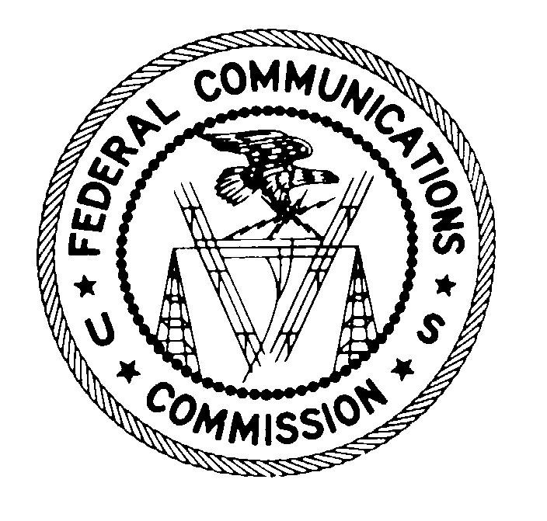
Federal Communications Commission
Washington, D.C. 20554

February 20, 2013

DA 13-235

Engineers for the Integrity of
Broadcast Auxiliary Services Spectrum (EIBASS)
18755 Park Tree Lane
Sonoma, CA 95476

Attention: Dane E. Ericksen P.E., CSRTE, 8-VSB, CBNT
Richard A. Rudman, CPBE

Dear Mr. Ericksen and Mr. Rudman:

On March 11, 2012, Engineers for the Integrity of Broadcast Auxiliary Services Spectrum (EIBASS) filed a request for declaratory ruling pursuant to Section 1.2 of the Commission’s rules, regarding the use of certain equipment by television Broadcast Auxiliary Service (BAS) operators. In its Request, EIBASS asks Commission staff to confirm that it is permissible for a TV BAS station licensed with an analog emission designator to install an encoder-decoder (codec) that allows a microwave radio to pass an asynchronous serial interface (ASI) digital signal without having to modify the license to change the emission designator. By this letter, we clarify that installation and use of a codec in this manner is permissible without a license modification.

Section 2.201 of the Commission’s Rules specifies the elements that define an emission designator. The first symbol of the emission designator indicates the type of modulation of the main carrier, the second symbol indicates the nature of the signal modulating the main carrier, and the third symbol indicates the type of information to be transmitted. The second symbol can consist of a variety of different configurations (e.g., single channel containing analog information, a single channel containing quantized or digital information, etc.). Analog emissions are characterized by either a 3 or 8 in the second character of the emission. Digital emissions are characterized by a 1, 2, 7, or 9 in the second character of the emission. Section 1.915 and 1.929 describe when an application to modify a station must be filed, and what constitutes a major or minor modification.

EIBASS states that there are many TV stations that have existing TV studio-to-transmitter (STL) or Inter City Relay (ICR) microwave links licensed for 25M0F8W FM analog video emission. For these analog stations, a cost effective way to carry a digital signal across an existing analog link is to use a codec pair. However, EIBASS indicates that there is regulatory uncertainty within the broadcast industry as to whether the use of codecs would require a BAS licensee to file a modification application to change emission designators to reflect the transmission of ASI data.

EIBASS states that using codecs with analog radios simply applies the digital bit stream to the baseband input of the FM (analog) microwave transmitter, so that the transmitted signal still employs frequency modulation of the microwave carrier. In support of its position, EIBASS submitted figures comparing the spectra of a conventional FM video signal with the signal from an FM video transmitter using codecs to demonstrate that they both have the signature “triangular” spectral shape associated with an analog transmission as opposed to the “rectangular” spectral shape seen when using QAM or COFDM.

After careful review of the issues and the information submitted, we find that when a transmitted emission continues to be frequency modulated and is contained within the bandwidth limits specified for frequency modulation, and when there are no modifications to transmitter circuitry, a change in the emission designator is not necessary. Therefore, we agree with EIBASS that it is not necessary for a licensee to modify its license to reflect a change in the emission designator in the circumstances described above.

Accordingly, EIBASS’s request for declaratory ruling IS GRANTED to the extent indicated herein.
This action is taken under delegated authority pursuant to Sections 0.131 and 0.331 of the Commission’s rules, 47 C.F.R. §§ 0.131, 0.331, and 1.2.

FEDERAL COMMUNICATIONS COMMISSION

Stephen Buenzow
Deputy Chief
Broadband Division
Wireless Telecommunications Bureau

See Request for Declaratory Ruling, EIBASS (filed March 11, 2012) (EIBASS Request).
See 47 CFR§ 2.201.
See 47 CFR § 2.201(b).
See 47 CFR § 2.201(d).
See Id.
See 47 CFR § 1.915 and 1.929.
See EIBASS Request at 1
See EIBASS Request at 2
See Id.

