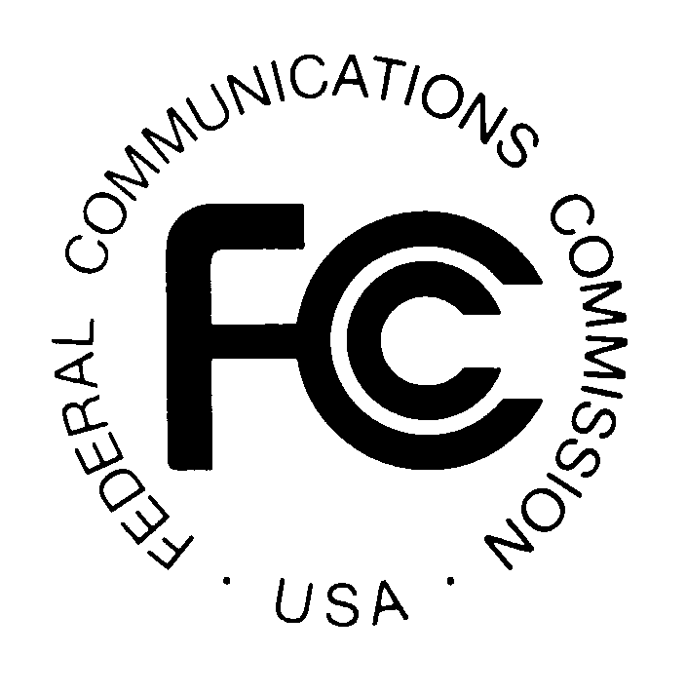
PUBLIC NOTICE
Federal Communications Commission
445 12th St., S.W.
Washington, D.C. 20554

News Media Information: 202.418.0500
TTY: 202.418.2555
Internet: http://www.fcc.gov

DA 13-2435

December 19, 2013

PUBLIC SAFETY AND HOMELAND SECURITY BUREAU ANNOUNCES

REGION 19 (NEW ENGLAND) 700 MHZ AND 4.9 GHZ PUBLIC SAFETY REGIONAL PLANNING COMMITTEE 2014 MEETING SCHEDULE

The Region 19 (New England) 700 MHz Public Safety Regional Planning Committee (RPC) will hold the following meetings during 2014:

- Tuesday, March 11, 2014, 10:00 a.m. - 2:00 p.m., at the Connecticut Fire Academy,
34 Perimeter Road, Windsor Locks, Connecticut

- Tuesday, June 10, 2014, 10:00 a.m. - 2:00 p.m., at the New Hampshire Department of Public Safety, 33 Hazen Drive, Concord, New Hampshire

- Tuesday, September 9, 2014, 10:00 a.m. - 2:00 p.m., at the Massachusetts State Police General Headquarters, 470 Worcester Road, Framingham, Massachusetts

- Tuesday, December 9, 2014, 10:00 a.m. - 2:00 p.m., at the Putney Volunteer Fire Department, 14 Main Street, Putney, Vermont

The purpose of the meetings is to discuss user needs, and plan for the continued use of the 700 MHz and 4.9 GHz spectrum -- which includes public safety, public health, emergency management, and public utility services.

The Region 19 700 MHz and 4.9 GHz Public Safety RPC meetings are open to the public. The meetings are held at locations throughout the Region 19 area to encourage wide participation. It is essential that public safety agencies in all areas of government, including state, municipality, county, and Native American Tribal, and non-governmental organizations eligible under Section 90.523 of the Commission’s rules, 47 C.F. R. § 90.523, be represented in order to ensure that each agency’s future spectrum needs are considered in the allocation process. Administrators who are not oriented in the communications field should delegate someone with this knowledge to attend, participate, and represent their agency’s needs.

All interested parties wishing to participate in planning for the use of public safety spectrum in the 700 MHz and 4.9 GHz bands within Region 19 should plan to attend. For further information, please contact the Chair or Vice-Chairman listed below or visit the RPC website at www.ner700mhz.org.

Jerry Zarwanski, Chairman
Region 19 700 MHz Public Safety RPC
Department of Public Safety
Division of Fire, Emergency and Building Services
1111 Country Club Road
P.O. Box 2794
Middletown, Connecticut 06457
(860) 685-8157
Jerry.Zarwanski@ct.gov

Stephen Verbil, Vice-Chairman
Region 19 700 MHz Public Safety RPC
Department of Public Safety
Division of Fire, Emergency and Building Services
1111 Country Club Road
P.O. Box 2794
Middletown, Connecticut 06457
(860) 685-8127
Stephen.Verbil@ct.gov

-FCC-

The Region 19 regional planning area includes the following states: Connecticut (except Fairfield, Litchfield, New Haven and Middlesex counties), Maine, New Hampshire, Rhode Island and Vermont.

