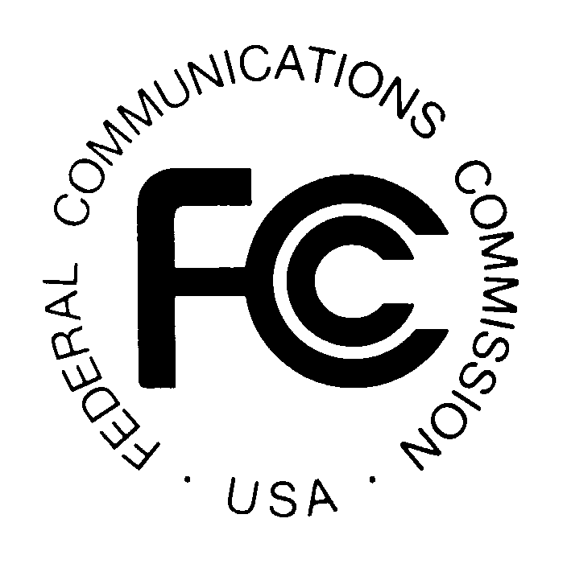
News media information 202 / 418-0500
TTY 202 / 418-2555
Internet: http://www.fcc.gov
PUBLIC NOTICE

Federal Communications Commission
445 12th St., S.W.
Washington, D.C. 20554

DA 13-907

April 26, 2013

PUBLIC SAFETY AND HOMELAND SECURITY BUREAU ANNOUNCES

REGION 45 (WISCONSIN) PUBLIC SAFETY REGIONAL PLANNING COMMITTEES TO HOLD 700 MHZ AND 800 MHZ NPSPAC REGIONAL PLANNING MEETINGS

PR Docket No. 92-190

The Region 45 (Wisconsin) Public Safety Regional Planning Committees (RPCs) will hold two consecutive planning meetings on Tuesday, May 14, 2013. Beginning at 1:00 p.m. to 2:00 p.m. the 700 MHz RPC will convene at the City of Sheboygan Police Department, 1315 North 23rd Street, Sheboygan, Wisconsin.

The agenda for the 700 MHz RPC meeting includes:
- Call Meeting to Order
- Status of Region 45 Plan
- Discuss application activity
- Discuss “D” block issues and status of “First Net” activity
- Discuss FCC 700 MHz 7th Report and Order and Further Notice of Proposed Rulemaking,
PS Docket No. 13-87 (rel. April 1, 2013) Comments due June 18, 2013 and reply comments due July 18, 2013
- Discuss 4.9 GHz issues and impact to region RPC’s
- Nominations & Election of Executive Committee Members for Year 2013
- Questions or Comments
- Adjourn Meeting

Beginning at 2:00 p.m., the 800 MHz NPSPAC RPC meeting will convene at the same location.

The agenda for the 800 MHz meeting includes:
- Call Meeting to Order
- Status of Region 45 Plan and discuss possible joint adjacent region planning meeting
- Discuss approval of applications submitted by Winnebago County for use of 8CALL/8TACxx frequencies
- Discuss approval of applications submitted by Outagamie County for use of 8CALL/8TACxx frequencies
- Discuss approval of applications submitted by the State of Wisconsin
- Status of Rebanding
- Nominations and election of Executive Committee members for Year 2013
- Questions or Comments
- Adjourn Meeting

Both Region 45 Public Safety RPCs’ meetings are open to the public. All eligible public safety providers in Region 45 may utilize these frequencies. It is essential that eligible public safety agencies in all areas of government, including state, municipality, county, and Native American Tribal be represented in order to ensure that each agency’s future spectrum needs are considered in the allocation process. Administrators who are not oriented in the communications field should delegate someone with this knowledge to attend, participate, and represent their agency’s needs.

All interested parties wishing to participate in planning for the use of public safety spectrum in the 700 MHz and 800 MHz bands within Region 45 should plan to attend. For further information, please contact:

Russ Schreiner, Chairman
Region 45 700 MHz and 800 MHz Public Safety RPCs
Sheboygan Police Department
828 Center Avenue, Sheboygan, Wisconsin 53081
rschreiner@ci.sheboygan.wi.us
(920) 459-3351
-FCC-

The Region 45 700 MHz and 800 MHz Regional Planning Committee encompasses the State of Wisconsin except for the counties of Dane, Dodge, Jefferson, Kenosha, Milwaukee, Ozaukee, Racine, Rock, Walworth, Washington, and Waukesha, which are part of the Region 54 (Great Lakes Area) regional planning area.

