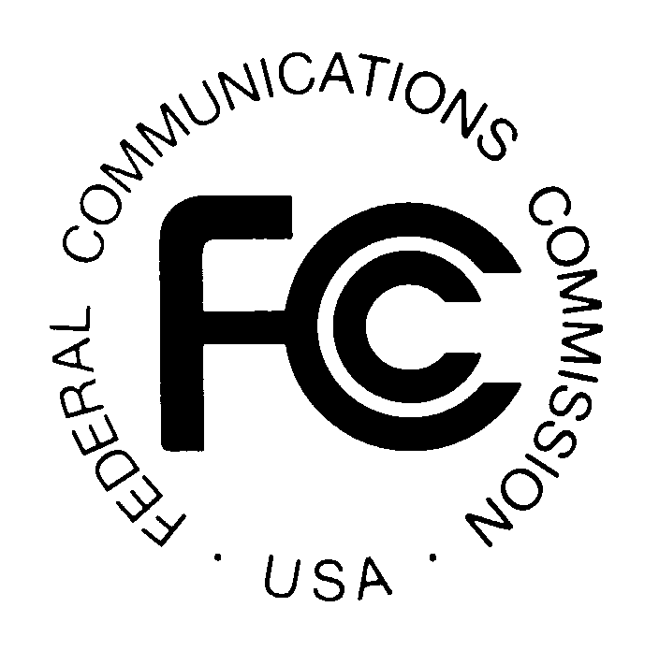
News media information 202 / 418-0500
TTY 202 / 418-2555
Internet: http://www.fcc.gov
PUBLIC NOTICE

Federal Communications Commission
445 12th St., S.W.
Washington, D.C. 20554

DA 13-951

April 26, 2013

PUBLIC SAFETY AND HOMELAND SECURITY BUREAU ANNOUNCES

REGION 30 (NEW YORK – ALBANY) PUBLIC SAFETY REGIONAL PLANNING COMMITTEES TO HOLD 700 MHZ AND 800 MHZ NPSPAC MEETINGS

Gen. Docket No. 90-394

The Region 30 (New York-Albany) Public Safety Regional Planning Committees (RPCs) will hold two consecutive planning meetings on Tuesday, May 14, 2013. Beginning at 10:00 a.m., the 700 MHz Public Safety RPC will convene at the Tompkins County Emergency Response Center, Village of Lansing, Airport Complex, 92 Brown Road, Ithaca, New York.

The agenda for the 700 MHz meeting includes:
- Review and approval of the May 14, 2013 Meeting Agenda
- Review and approval of the February 25, 2013 Meeting Report
- Interoperability
- New York State Interoperability Executive Committee and Statewide Planning
Reports (Robert Barbato)
- Technical Subcommittee
  - 4.9 GHz guidelines development
  - Region 30 700 MHz
- New business and opportunity for comments
- Schedule next meeting
- Adjourn

Immediately following the 700 MHz Public Safety RPC meeting, the 800 MHz Public Safety RPC will convene at the same location.

The agenda for the 800 MHz meeting includes:
- Review and approval of the May 14, 2013 Meeting Agenda
- Review and approval of the February 25, 2013 Meeting Report
- Technical Subcommittee update
- Approval letter request
- Concurrence requests
- Old business
- New business and opportunity for comments
- Schedule next meeting
- Adjourn

Both Region 30 Public Safety RPC meetings are open to the public. All eligible public safety providers in Region 30 may utilize these frequencies. It is essential that eligible public safety agencies in all areas of government, including state, municipality, county, and Native American Tribal be represented in order to ensure that each agency’s future spectrum needs are considered in the allocation process. Administrators who are not oriented in the communications field should delegate someone with this knowledge to attend, participate, and represent their agency’s needs.

All interested parties wishing to participate in planning for the use of public safety spectrum in the 700 MHz and 800 MHz bands within Region 30 should plan to attend. For further information, please contact:

Lee Shurtleff
Region 30 Chair, 700 MHz and 800 MHz Public Safety RPCs
92 Brown Road
Ithaca, NY 14850
lshurtleff@tompkins-co.org
(607) 257-3888

Larissa Guedko
Region 30 Vice-Chair, 700 MHz and 800 MHz Public Safety RPCs
Office of Interoperable and Emergency Communications
New York State Division of Homeland Security and Emergency Services
State Campus Building 7A Suite 710
1220 Washington Ave
Albany, NY 12242
LGuedko@dshes.ny.gov
(518) 322-4911

Matthew Delaney
Technical Subcommittee Chair
Office of Interoperable and Emergency Communications
New York State Division of Homeland Security and Emergency Services
State Campus Building 7A, Suite 710
1220 Washington Avenue
Albany, NY 12242
(518) 322-4911
MDelaney@DHSES.ny.gov

-FCC –

The Region 30 regional planning area includes thirty-one counties in upstate New York: Albany, Broome, Cayuga, Chenango, Clinton, Columbia, Cortland, Delaware, Essex, Franklin, Fulton, Green, Hamilton, Herkimer, Jefferson, Lewis, Madison, Montgomery, Oneida, Onondaga, Oswego, Otsego, Rensselaer, St. Lawrence, Saratoga, Schenectady, Schoharie, Tioga, Tompkins, Warren, and Washington.

