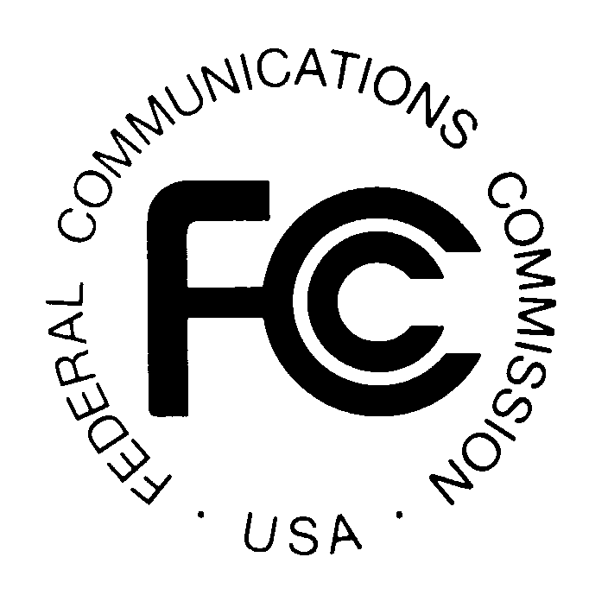
PUBLIC NOTICE
Federal Communications Commission
445 12th St., S.W.
Washington, D.C. 20554
News Media Information: 202.418.0500
TTY: 202.418.2555
Internet: http://www.fcc.gov

DA 14-101

January 30, 2014

PUBLIC SAFETY AND HOMELAND SECURITY BUREAU ANNOUNCES

REGION 8 (NEW YORK METROPOLITAN AREA) 700 MHZ AND 800 MHZ PUBLIC SAFETY REGIONAL PLANNING COMMITTEES 2014 MEETING SCHEDULE

General Docket No. 88-476

The Region 8 (New York Metropolitan Area) 700 MHz and 800 MHz NPSPAC Public Safety Regional Planning Committees (RPCs) will hold their 2014 quarterly meetings at the following dates, times and locations. All 800 MHz NPSPAC meetings will commence immediately following the adjournment of the 700 MHz meeting sessions:

700 MHz and 800 MHz NPSPAC RPC meeting schedule:

February 27, 2014 at 10:00 am.
Paramus Life Safety Complex
1 Jockish Square
Paramus, New Jersey 07652

May 15, 2014 at 10:00 am.
Rockland County Fire Training Center
35 Firemens Memorial Drive,
Pomona, New York 10970

August 21, 2014 at 10:00 am.
Paramus Life Safety Complex
1 Jockish Square
Paramus, New Jersey 07652

November 20, 2014 at 10:00 am.
Orange County Department of Emergency Services
22 Wells Farm Road
Goshen, New York 10924

The Region 8 700 MHz and 800 MHz NPSPAC Public Safety RPC meetings are open to the public. It is essential that public safety agencies in all areas of government, including state, municipality, county, Native American Tribal, and non-governmental organizations eligible under Section 90.523 of the Commission’s rules, 47 C.F. R. § 90.523, be represented in order to ensure that each agency’s future spectrum needs are considered in the allocation process. Administrators who are not oriented in the communications field should delegate someone with this knowledge to attend, participate, and represent their agency’s needs.

All interested parties wishing to participate in planning for the use of public safety spectrum in the 700 MHz and 800 MHz NPSPAC bands within Region 8 should plan to attend. For further information, please contact:

Anthony Melia, Chairperson
Communications Manager
City Of Newark Police Department
480 Clinton Avenue
Newark, NJ 07108
973-877-9375
meliaa@apco911.org

Allen J. Demcoe, Vice-Chairperson
Middlesex County Radio Systems and Interoperability Coordinator
1001 Fire Academy Drive
Sayreville, NJ 08872
732-316-7183
allen.demcoe@co.middlesex.nj.us

-FCC-

The Region 8 (New York Metropolitan Area) includes Region 8 (New York – Metropolitan area) consists of Bronx, Kings, Nassau, New York, Orange, Putnam, Queens, Richmond, Rockland, Suffolk, Sullivan, Ulster, Dutchess, and Westchester Counties, New York; and Bergen, Essex, Hudson, Morris, Passaic, Sussex, Union, Warren, Middlesex, Somerset, Hunterdon, Mercer, and Monmouth Counties, New Jersey.

