DA 14-1023
July 18, 2014

THE FEDERAL COMMUNICATIONS COMMISSION AND THE NATIONAL TELECOMMUNICATIONS AND INFORMATION ADMINISTRATION:
COORDINATION PROCEDURES IN THE 1695-1710 MHz AND 1755-1780 MHz BANDS
GN Docket No. 13-185

INTRODUCTION
In March 2014, the Federal Communications Commission (Commission or FCC) adopted new rules that will make available significantly more spectrum for Advanced Wireless Services (AWS). The rules are a milestone in providing commercial access to new spectrum bands through a spectrum-sharing arrangement with incumbent federal users. As part of that arrangement, the Commission’s AWS-3 rules require successful coordination with Federal incumbents prior to operation in Protection Zones (also referred to here as coordination zones). By this Public Notice the Commission, through its Wireless Telecommunications Bureau, and the National Telecommunications and Information Administration (NTIA) provide (i) information for potential bidders in the AWS-3 auction and (ii) guidance to the ultimate AWS-3 licensees and the affected Federal incumbents regarding coordination between Federal and non-Federal for shared use of the 1695-1710 MHz and 1755-1780 MHz bands. The joint nature of this Public Notice reflects intersecting jurisdictions of the Commission (commercial users) and NTIA (Federal users) in these bands.

The Public Notice proceeds as follows. In section II, we provide general background information about Federal/non-Federal coordination in the AWS-3 bands in which Federal incumbents have spectrum assignments. In section III, we jointly refine certain AWS-3 Protection Zones, reducing them from nationwide scope to more specific geographic areas. Section IV provides information and guidance on the overall coordination process, as contemplated by the AWS-3 R&O, including informal pre-coordination discussions and the formal process of submitting coordination requests and receiving results from relevant agencies. Section V provides refined Protection Zones for AWS-3 licenses for which proximity to certain Federal satellite uplink stations could potentially cause harmful interference into AWS-3 licensee base stations along with a streamlined option for satisfying this coordination requirement.

Background
AWS-3 R&O. On March 31, 2014, the Commission adopted rules governing commercial use of spectrum in the 1695-1710 MHz, 1755-1780 MHz, and 2155-2180 MHz bands making 65 megahertz of spectrum available for flexible use wireless services, including mobile broadband. The Commission’s action was another step in implementing the Congressional directive in Title VI of the Middle Class Tax Relief and Job Creation Act of 2012 (Spectrum Act) to make more spectrum available for flexible uses. It was also the culmination of years of effort to facilitate commercial access to some of these bands through spectrum-sharing arrangements with incumbent Federal users. In particular, 40 megahertz in the band is being made available for commercial use pursuant to collaboration among the wireless industry and Federal agencies facilitated in part by NTIA, which chartered the Commerce Spectrum Management Advisory Committee (CSMAC) to advise it on these matters.

Information on Incumbent Federal operations. Information about incumbent Federal operations is generally available through the affected agencies’ Transition Plans. The publicly available Transition Plans are published at www.ntia.doc.gov/category/aws-3-transition. NTIA and CSMAC reports are also available through this website. By way of background, Federal incumbents in the 1695-1710 MHz and 1755-1780 MHz bands were required to develop and submit Transition Plans to implement relocation or sharing arrangements and affected Federal agencies have recently done so. Transition Plans contain information on these Federal systems including the frequencies used, emission bandwidth, system use, geographic service area, authorized radius of operation, and estimated timelines and costs for relocation or sharing. Affected agencies are permitted to redact from the publicly-released transition plans classified national security information and “other information for which there is a legal basis for nondisclosure and the public disclosure of which would be detrimental to national security, homeland security, or public safety or would jeopardize a law enforcement investigation.”

Generally, incumbent Federal operations in 1695-1710 MHz and 1755-1780 MHz include the following categories of systems:

- 1695-1710 MHz. This band is used by the meteorological satellite (MetSat) service (restricted to space-to-Earth operation). Details on the protected 47 Federal MetSat operations that will continue to be protected on a primary basis in the 1675-1695 MHz band and a co-primary basis in the 1695-1710 MHz band are publicly available in the relevant Transition Plans.

- 1755-1780 MHz. Federal assignments in this band (and for purposes of describing the AWS-3 coordination requirements that the Commission adopted in the AWS-3 R&O) can be grouped into two categories: (1) United States and Possessions (USP) assignments; and (2) non-USP assignments.

  - Federal USP assignments. Some Federal incumbents have assignments in the band that specify an area of transmission, reception, or operation as “USP.” Such assignments authorize agencies to operate particular radio systems anywhere they are needed throughout the United States and Possessions. Put differently, incumbent use may not be simultaneous nationwide and incumbents may be able to share frequencies in some areas prior to relocating all operations from the band. All USP assignments will be transitioned out of the 1755-1780 MHz band.
    - The specific areas where incumbents operate under their USP assignments are redacted from publicly released Transition Plans.
    - The Commission’s rules require each AWS-3 licensee, prior to its first operations in its AWS-3 licensed area, to reach a coordination arrangement with each Federal agency that has a USP assignment in the band on an operator-to-operator basis.
    - This Public Notice does not change this requirement—the refined Protection Zones discussed in sections III and V are inapplicable to this requirement.
    - There are 21 USP assignments including one telemetry assignment, two robotics assignments, and 18 video assignments. The incumbent agencies are: Department of Homeland Security, Department of Justice, National Aeronautics and Space Administration, Department of the Treasury, Department of Housing and Urban Development (HUD), United States Agency for International Development (USAID), and Department of Veterans Affairs. Updated contact information for each of these agencies is available at www.ntia.doc.gov/category/aws-3-transition.
  - Federal non-USP assignments. Most Federal assignments specify particular areas of operation within the United States (rather than USP).
    - Details on incumbent Federal agencies’ operations are generally available in the relevant, publicly-released Transition Plans.
    - Most non-USP assignments will be transitioned out of 1755-1780 MHz, with the exception of the six sites in which Joint Tactical Radio Systems may operate, the two polygons within which the Air Combat Training System may operate, and the 25 sites where Federal earth stations may transmit.
    - Most details of Department of Defense (DoD) operations are redacted from the publicly released Transition Plans, but will be made available in a modified format with slightly more generalized details through a separate release.
    - The Commission’s rules require that, prior to operating in a Protection Zone a base station that enables mobiles and portables to transmit in the 1755-1780 MHz band, AWS-3 licensees successfully coordinate with each Federal incumbent.
    - In the AWS-3 R&O, the Commission stated that, for the 1755-1780 MHz band, the default Protection Zones are nationwide.
    - This Public Notice refines the nationwide default Protection Zones. The refined Protection Zones (discussed in sections III and V below and Appendices B and C, respectively) are intended in part to provide information to potential AWS-3 licensees on Federal operations in the 1755-1780 MHz band without disclosing non-public information about these systems.

The Transition Plans generally provide detailed information about these systems, including the transition timelines. After reaching an arrangement with each USP agency, AWS-3 licensees are permitted to operate anywhere in these bands outside of Protection Zones that protect Federal incumbents during transition and on a permanent basis for systems that remain in the bands indefinitely. AWS-3 licensees may expect that the magnitude of the requirement to coordinate will decrease over time as agencies execute their Transition Plans. We describe the specific coordination requirements below.

REFINED PROTECTION ZONES ESTABLISHING AREAS WHERE AWS-3 Licensees must Successfully Coordinate with Federal IncumbentS Operating under Non-USP Assignments
In this section and in section V, we discuss refined Protection Zones for coordination with Federal agencies operating under non-USP assignments in the 1695-1710 MHz and 1755-1780 MHz bands. As described in section II above, for USP assignments, AWS-3 licensees are required to reach a coordination arrangement with each Federal agency that has a USP assignment in 1755-1780 MHz on an operator-to-operator basis prior to first operation in its licensed area.

In the AWS-3 R&O, the Commission adopted rules that require AWS-3 licensees to successfully coordinate with incumbent Federal users before operating within coordination zones (as noted above, also referred to here as Protection Zones). Several statutory provisions encourage negotiation, coordination, and spectrum sharing between non-Federal users and Federal entities. Under the AWS-3 R&O, AWS-3 licensees are permitted to operate anywhere outside of the Protection Zones without prior coordination with non-USP incumbents. There are two Federal/non-Federal coordination scenarios:

(1) temporary sharing prior to Federal relocation from the band under an approved Transition Plan; and

(2) permanent sharing where incumbent Federal operations will remain in the band indefinitely.

Under the first scenario, AWS-3 licenses will be conditioned, by rule, on not causing harmful interference to relocating Federal operations. Under both scenarios the Commission’s rules require successful coordination with Federal incumbents prior to operation in Protection Zones. For coordination with Federal incumbents operating under non-USP assignments, AWS-3 licensee requests to operate base stations inside Protection Zones (that enable mobiles and portables to transmit in the 1695-1710 MHz or 1755-1780 MHz bands) trigger the coordination requirement.

Federal use of the radio spectrum is generally governed by NTIA while non-Federal use is governed by the Commission. As such, consistent with the approach used for AWS-1, the Commission determined in the AWS-3 R&O that that any guidance or details concerning Federal/non-Federal coordination including, if possible, revisions to the nationwide coordination zones, should be issued jointly by NTIA and the Commission. In this regard, the Commission authorized and directed its Wireless Telecommunications Bureau to work with NTIA staff, in collaboration with affected Federal agencies or CSMAC members, to develop a joint FCC and NTIA public notice with information on coordination procedures in the 1695-1710 MHz and 1755-1780 MHz bands. This Public Notice was developed under that direction.

We note that in the AWS-3 R&O, the Commission declined to specify that licensees deploy systems using a particular technology – such as LTE – and instead sought to adopt technical and operational requirements as necessary to protect against harmful interference or effectuate other compelling public interest objectives. The Commission recognized that CSMAC assumed baseline LTE uplink characteristics to determine Protection Zones – in particular a 20 dBm maximum EIRP – and concluded that this did not require adoption of LTE for all purposes. This determination was made consistent with the Commission’s policy of supporting flexible use. The Commission noted if a licensee decides to use a technology other than LTE, the licensee will still be subject to the Commission’s technical rules. The Commission also noted that the required coordination process could address any issues that may arise if the use of a different technology complies with the Commission’s rules but nonetheless poses a greater risk of interference to incumbent Federal operations. As such, AWS-3 licensees deploying technology that differs from CSMAC’s baseline LTE uplink assumptions may need to address as part of coordination whether such operations pose a greater risk of interference to incumbent Federal operations than the baseline LTE uplink characteristics that CSMAC assumed. If relevant to the technical analysis, the licensee may need to provide technical data regarding its base stations outside of but nearby a relevant Protection Zone, but the licensee is not required to successfully coordinate such stations.

Refinements to the 1695-1710 MHz Protection Zones
Forty-seven Federal earth stations will continue to receive satellite signals in the 1675-1695 MHz band on a primary basis and on a co-primary basis in the 1695-1710 MHz band and will continue to do so indefinitely. In the AWS-3 R&O, the Commission adopted rules establishing 27 Protection Zones that encompass the 47 earth stations. AWS-3 licensees must successfully coordinate prior to operating a base station in a Protection Zone that enables mobile and portable AWS-3 stations to operate up to 20 dBm EIRP.

Appendix A of this Public Notice sets forth the 27 Protection Zones for operations up to 20 dBm as specified in the Commission’s rules, which the Commission adopted in accordance with NTIA’s recommendation endorsing these zones in the CSMAC WG-1 Final Report (WG-1). Appendix A also includes refined Protection Zones (larger than the zones established for operations up to 20 dBm but substantially smaller than nationwide zones) for operations above 20 dBm up to the maximum of 30 dBm EIRP permitted under the Commission’s rules. These refined Protection Zones for operations above 20 dBm use the same 27 center points that define the 27 zones for operations up to 20 dBm. To account for the higher operating power, however, the radius of the Protection Zone around each center point is larger.

Aside from the 47 Federal earth stations that will operate on a primary (1675-1695 MHz) or co-equal primary (1695-1710 MHz) basis with AWS-3 licensees, all other Federal Earth stations operate on a secondary basis. Non-Federal earth stations may continue to receive MetSat data from primary Federal MetSat space stations on an unprotected basis.

Refinements to the 1755-1780 MHz Protection Zones for Coordination with Federal Incumbents with non-USP Assignments
Some incumbent Federal systems in 1755-1780 MHz will be relocating from the band over a period of time while others will remain in the band indefinitely. AWS-3 licensees must successfully coordinate with both types of Federal incumbents prior to operating a base station in a Protection Zone that enables mobiles and portables to transmit in the 1755-1780 MHz band. Coordination with agencies that hold USP assignments is discussed in section II above. For agencies that hold non-USP assignments, the AWS-3 R&O established default nationwide coordination requirements for any proposed base station that enables mobiles and portables to operate in the band unless otherwise agreed in writing among all relevant parties, or if the FCC and NTIA jointly announce refined protection zones for base stations that enable mobiles and portables to operate in the band up to 20 dBm EIRP. This Public Notice announces such refined Protection Zones.

We note that some incumbent Federal operations have a potential to interfere with AWS-3 base stations located outside of the refined Protection Zones. Under the rules that the Commission adopted in the AWS-3 R&O, AWS-3 licensees must accept harmful interference from these incumbent Federal operations. With one exception, these zones are intended to protect incumbent Federal operations from AWS-3 operations. In the Auction 97 Comment Public Notice, the Wireless Telecommunications Bureau proposed to require an applicant to participate in the auction to acknowledge that its operations in the 1755-1780 MHz band may be subject to interference from Federal systems, that the applicant must accept interference from incumbent Federal operations, and that the applicant has considered these risks before submitting any bids for applicable licenses in the auction.

Below we describe the refined Protection Zones in 1755-1780 MHz for non-USP DoD operations and non-USP operations by all other affected agencies.

DoD Assignments. Appendix B-1 provides the reference for refined Protection Zones for coordination of AWS-3 base stations (that enable mobiles and portables to transmit in the band up to 20 dBm EIRP) with incumbent DoD operations depicted by system type (DoD Workbook, Tab 1). This reference will link to a data table that DoD is finalizing that will map the coordination requirements in each five-megahertz block over census tracts. The use of census tracts and five-megahertz blocks should allow licensees to analyze the data for all AWS-3 licenses. The distances used in this analysis were equal to or, in some cases, substantially shorter than the CSMAC recommendation. The electronic version will include Transition Plan timelines for those impacted systems along with documentation describing assumptions (e.g., operational area and coordination zone) used to determine the Protection Zone. The information will be as specific as possible, accounting for the need to protect classified and other sensitive information and in a format that can be manipulated and imported into mapping and other data analysis tools.
As noted above, even in areas where coordination with Federal non-USP incumbents is not required, AWS-3 licensees may still be susceptible to harmful interference from these incumbent Federal operations. AWS-3 licensees must accept this interference and design their systems to overcome or avoid it in the event that they receive it. The workbook will include a second data table mapping areas within which there is a higher possibility that AWS-3 licensees will receive harmful interference from non-ground based DoD operations (DoD Workbook, Tab 2). This data table will be purely informational and will not define the Protection Zones where successful coordination is required. AWS-3 licensees are required by rule to accept harmful interference from these Federal operations. The DoD Workbook, Tab 2, will identify the areas within which AWS-3 licensees may have a higher expectation of interference from incumbent Federal operations. These will include areas outside of Protection Zones and areas surrounding 25 uplink Earth stations for which coordination is required for AWS-3 base stations located in the refined Protection Zones discussed in section V and Appendix C.

Non-DoD Assignments. Appendix B-2 provides refined Protection Zones for coordination of AWS-3 base stations (that enable mobiles and portables to transmit in the band up to 20 dBm EIRP) with certain non-DoD incumbent Federal operations. The locations and other pertinent information for these systems are available in the publicly released Transition Plans. These refined Protection Zones are based on distances that are consistent with the Commission’s AWS rules to protect non-Federal microwave systems to minimize potential coordination/transaction costs while protecting against harmful interference into protected Federal operations.

The refined Protection Zones in Appendix B apply only to AWS-3 base stations that enable mobiles and portables to operate in the 1755-1780 MHz band up to 20 dBm EIRP. The Protection Zone remains nationwide for base stations that enable mobiles and portables to operate in 1755-1780 MHz at powers above 20 dBm EIRP.

COORDINATION process GUIDANCE
The purpose of coordination is to avoid harmful interference to protected Federal operations and missions in the 1695-1710 MHz and 1755-1780 MHz bands while expediting access to and maximizing commercial use of the spectrum. The coordination guidance described below applies to all AWS-3 licensees seeking to operate in the 1695-1710 MHz band or the 1755-1780 MHz band, unless the AWS-3 licensee and the relevant Federal incumbents have agreed otherwise. Below is a general description of the process and is not intended to encompass all coordination requirements and scenarios. AWS-3 licensees and Federal incumbents must use good faith throughout the coordination process, regardless of whether they use the steps below or whether all relevant parties have agreed to their own negotiated coordination arrangement. This extends to AWS licensees sharing information with Federal incumbents and cooperating once Federal incumbents develop and implement real-time spectrum monitoring systems around existing Federal operations protected in the 1695-1710 MHz and adjacent bands.

Contact
Federal incumbents’ Transition Plans identify a point of contact within each agency that an AWS-3 licensee may contact to initiate coordination. In addition, the Institute for Telecommunication Sciences (ITS) within NTIA and DoD are creating online portals through which an AWS-3 licensee may initiate coordination for relevant systems (collectively referred to here as the Portals). The ITS Portal will support coordination for all Federal incumbents in the 1695-1710 MHz band. The DoD Portal will support coordination for all DoD incumbents in the 1755-1780 MHz band and may over time accommodate other Federal incumbent systems in the band.

Informal Discussions
Before an AWS-3 licensee submits a formal coordination request, it may share draft proposals and/or request that Federal agency coordination staff discuss draft coordination proposals. These discussions are voluntary, informal, and non-binding and can begin at any time. AWS-3 licensees may discuss their proposed deployment and seek guidance on appropriate measures to ensure that electromagnetic compatibility (EMC) analyses produce positive results. Further, AWS-3 licensees and Federal incumbents may discuss the scope and extent of temporary sharing for those Federal assignments that may share with AWS-3 licensees on a temporary basis. AWS-3 licensees and agency representatives may also, on an operator-to-operator basis, develop an analysis methodology that reflects the characteristics of the licensee’s proposed deployment and the Federal agency’s operation. These discussions can also involve developing a process for identification and resolution of interference.

These discussions are intended to allow the Federal incumbent and AWS-3 licensee to share information about their respective system designs, and identify any potential coordination issues prior to the filing of a formal coordination request. We make clear that these discussions are non-binding, and the Federal agencies involved are not, unless they specify, making any determination regarding the outcome of the formal coordination. We strongly encourage parties to use informal, non-binding discussions to minimize or resolve basic methodological issues upfront before the AWS-3 licensee submits a formal coordination request.

Formal Coordination
We provide guidance for the formal coordination process below. This description is general, and the process may differ between agencies and is subject to additional modification by the agencies and licensees as agreed to on an operator-to-operator basis. We expect and encourage the Federal agencies and AWS-3 licensees to engage in good faith coordination.

Initiation
Coordination shall be initiated by the AWS-3 licensee formally requesting access within a temporary or permanent Protection Zone and by contacting each USP incumbent (see section II above) prior to first operations in each AWS-3 license area. This request can be made directly through the agency point of contact specified in the Transition Plan, through the DoD Portal (which may accommodate other agencies), or through the ITS Portal, depending on system type (see section IV.A above.) The AWS-3 licensee must set up its Portal account(s) and, once established, the AWS-3 licensee will receive a user guide(s) and training on the use of the Portal(s).

Timing
No formal coordination for nine (9) months. Unless otherwise agreed among an AWS-3 licensee and the relevant Federal incumbent(s), Federal incumbents are not obligated to entertain formal coordination requests until nine (9) months after the date of the auction closing Public Notice. AWS-3 licensees may, as described above, request informal discussions during this time.

Timing generally. After the first nine (9) months following the close of the auction, Federal incumbents are expected to timely review and respond to formal coordination requests. We encourage licensees and incumbents, through informal discussions, to serialize formal coordination requests as appropriate to avoid an overwhelming influx of coordination requests at the conclusion of the nine (9) month quiet period. We also encourage licensees and incumbents to discuss, as appropriate, extended review timelines to the extent that the incumbents’ coordination resources are exhausted due to a large number of requests within a short time period after the quiet period. This will help maximize the quick and efficient review of coordination requests.

When a licensee submits a formal request, the Federal point of contact will affirmatively acknowledge receipt of the request within five (5) calendar days after the date of submission. Within ten (10) calendar days after the submission date, Federal staff will notify the AWS-3 licensee whether the request is complete or incomplete. Unless the Federal agency finds the request incomplete or the agency and AWS-3 licensee agree to a different timeline, the Federal response (the results letter discussed below) is due within sixty (60) calendar days after the deadline for the notice of completeness.

Unless otherwise agreed in writing, the requirement to reach a coordination arrangement with each agency that has a USP assignment (discussed above) and the requirement to successfully coordinate each base station proposed within a Protection Zone with each agency that has a non-USP assignment is satisfied only by obtaining the affirmative concurrence of the relevant incumbents. These requirements are not satisfied by omission: if a Federal agency does not timely respond, AWS-3 licensees should contact NTIA for assistance.

Special temporary authority. Section 1.931 of the Commission’s rules governs applications for special temporary authority (STA). In the Wireless Telecommunications Services, carriers may request STAs to operate new or modified equipment in circumstances requiring immediate or temporary use of a station. STA requests must contain complete details about the proposed operation and the circumstances that fully justify and necessitate the grant of STA. The Commission coordinates non-Federal STA requests for operations in Federal or shared Federal/non-Federal bands with NTIA, which in turn typically provides the incumbent Federal agencies a short timeframe to object or be deemed to have concurred.

Applications for STAs in the 1695-1710 MHz and 1755-1780 MHz bands (for operations that require successful coordination with Federal incumbents under the rules adopted in the AWS-3 R&O), should, among other things, contain complete details about the proposed operation and circumstances that fully justify and necessitate the grant of STA under expedited Federal coordination. Such STA requests that do not fully justify the necessity for bypassing the timeframe and other coordination procedures in this Public Notice for coordination of AWS operations in the 1695-1710 MHz and 1755-1780 MHz bands with incumbent Federal agencies will be dismissed as defective without referral to NTIA.

Submission Information
To submit a formal coordination request, the AWS-3 licensee must include information about the technical characteristics for the AWS-3 base stations and associated mobile units relevant to operation within the Protection Zone. This information may be provided in a form agreed to by the agency and licensee, or if coordination takes place through the Portals, in accordance with the instructions provided in the AWS-3 Portal user’s guide. The types of specific information, including the likely data fields in the Portals, include basic technical operating parameters, (e.g., system technology, mobile EIRP, frequency block, channel bandwidth, site name, latitude, and longitude). The AWS-3 Portals will accept uploaded attachments that include narratives that explain area-wide deployments.

AWS-3 licensees must prioritize their deployments in Protection Zones for each Federal incumbent when submitting a formal coordination request. If a licensee is seeking to coordinate with multiple systems and/or multiple locations of operation controlled by one Federal incumbent, it must specify the order in which it prefers the Federal incumbent process the request (i.e. the order of systems or geographic locations).

Notice of Complete or Incomplete Request
Once a licensee submits a formal coordination request, the relevant Federal coordination staff will review the data to ensure that it is in the proper format (if submitted through one of the Portals) and contains the proper content. Federal agency coordination staff will notify the AWS-3 licensee within ten (10) calendar days through direct communication or through the applicable Portal that its formal coordination request is complete or that it is incomplete. If the Federal agency coordination staff finds a request to be incomplete, it must identify the information the licensee must provide in as much specificity as possible. We expect that parties will work collaboratively to ensure completeness in a timely manner.

Coordination Analysis
As noted above, unless a timely notice of incomplete application is sent to the AWS-3 licensee (or the parties agree to different a timeline), the clock for the Federal response begins to run on the deadline for the notice of completeness. The Federal response is due within sixty (60) calendar days thereafter unless the AWS-3 licensee agrees otherwise. During these sixty (60) days, the Federal agency will coordinate with appropriate internal units, complete EMC analysis, and post the AWS-3 concurrence, partial concurrence with operating conditions, or denial. Each Federal incumbent is responsible for ensuring that it completes its internal, multi-level review in a timely manner. Federal incumbents are encouraged, through their designated internal coordination point of contact or through other means, to engage the AWS-3 licensee to ask any questions and discuss any issues in the event that any arise.

Once the designated Federal agency coordinator completes its analysis pursuant to the formal coordination request, the AWS-3 licensee and the relevant Federal agency field offices are automatically notified when a results letter is posted by the Federal user in the relevant AWS-3 Portal or, for agencies that do not use a Portal, transmitted to the AWS-3 licensee. The result of a coordination request will be concurrence, partial concurrence with operating conditions that specify the terms in which the licensee may begin operations, or denial of the request. Because of the sensitive nature of the data involved in much of the EMC analysis, the results letter may not present details of the analysis, the Federal frequency assignments affected, or timelines. In the case of partial concurrence or denial, the results letter will contain technical information objectively justifying the partial concurrence or denial. If a Federal agency does not provide the necessary information within the sixty (60) day deadline, AWS licensees may contact NTIA for assistance.

Upon receipt of results letter, the AWS-3 licensee may accept, conditionally accept, or object to the partial concurrence, operating conditions, or denial. If an AWS-3 licensee objects to the result, it may contact the Federal agency coordinator to propose network design modifications to help address EMC issues raised in the results letter. The Federal agency coordinator may, where feasible, review technical proposals from the AWS-3 licensee to relieve a denial, partial concurrence and/or any operating condition contained in the results letter. Once the AWS-3 licensee has revised its network design, it resubmits a formal coordination request, and the AWS-3 formal coordination process begins again.

We stress again, at this juncture, the benefits of informal discussions among AWS-3 licensees and Federal agencies, including during the formal coordination process. Although in many cases, Federal agency staff may be unable to provide specific information about the protected Federal operations in the results letter, and are not responsible for designing the AWS-3 system, they may offer some suggestions on how to address or mitigate the issue, given the limited information that can be made available on some Federal systems. If the parties agree that informal discussions would be helpful, the sixty (60)-day clock will be paused so the Federal incumbents are not forced to formally decline or condition the pending, formal coordination request within the sixty (60)-day deadline.

Dispute Resolution
Disputes generally—during coordination or regarding a sharing agreement. If disputes arise during the coordination process, we strongly encourage parties to negotiate in good faith to resolve them. If an AWS licensee believes a Federal incumbent is not negotiating in good faith, NTIA is available to assist and AWS-3 licensees have the option to inform the Commission. If a Federal incumbent believes that an AWS-3 licensee is not negotiating in good faith, it must nonetheless timely respond to a formal request and can seek NTIA’s assistance. We also encourage parties to enter into operator-to-operator agreements that have dispute resolution provisions for any or all possible disputes. If a dispute arises between an incumbent Federal entity and an AWS-3 licensee over an operator-to-operator coordination/sharing agreement, provisions calling for informal negotiation, mediation, or non-binding arbitration efforts between the parties will help clearly define and narrow the issues for formal agency resolution by NTIA, the Commission, or jointly, as applicable. The coordination agreement in Appendix C-3 (relevant only to that system) also contains provisions that will be applicable to parties to such agreements.

Certain disputes for which the law and NTIA rules allow parties to request a dispute resolution board. If a dispute arises between a Federal entity and a non-Federal user regarding the execution, timing, or cost of the transition plan submitted by the Federal entity, the law provides that either the Federal entity or the non-Federal user may request that NTIA establish a dispute resolution board to resolve the dispute. NTIA has adopted regulations that govern the working of any dispute resolution boards established by NTIA. Those regulations cover matters related to the workings of a board, including the content of any request to establish a board, the associated procedures for convening it, and the dispute resolution process itself.

The Spectrum Act requires a board to rule on the dispute within thirty (30) days after a party has requested NTIA to convene the board. As stated in Annex O, “[t]he statute’s 30-day deadline for responding to formal dispute resolution requests could possibly impact a board’s ability to convene, meet with the parties, and adequately address complex cases.” At the same time, however, the statute and Annex O encourage cooperation to assure timely transitions between Federal and non-Federal use of the spectrum. If and when differences surface among Federal and non-Federal parties, NTIA’s rules require the parties to make good faith efforts to solve these problems on an informal basis before submitting a formal request to establish a dispute resolution board. Informal negotiation, mediation, or non-binding arbitration efforts between the parties will help clearly define and narrow the issues that are necessary to bring into the formal dispute resolution process.

The scope of a dispute resolution request and, consequently, a board’s decision, are limited by law and NTIA’s regulations to matters “regarding the execution, timing, or cost of the transition plan submitted by the Federal entity.” The statute authorizes a dispute resolution board to make binding decisions with respect to such matters that can be appealed to the United States Court of Appeals for the District of Columbia Circuit. Under NTIA’s rules, that dispute resolution board must also ensure that its decision does not have a detrimental impact on any national security, law enforcement, or public safety function made known to the board by an agency. To fulfill that obligation, the board may request additional written submissions from an agency regarding the impact of such a decision on the agency’s operations, services, or functions.

Refined Protection Zones FOR 25 satellite earth stations and Streamlined Coordination Option
In the sub-band 1761-1780 MHz, Federal earth stations in the space operation service (Earth-to-space) may continue to transmit at 25 sites and, under the Commission’s rules, non-Federal (AWS-3) base stations must accept harmful interference caused by the operation of these Federal earth stations at these sites. Under the Commission’s rules, AWS-3 licensees must successfully coordinate with these Federal incumbents and the default Protection Zone is nationwide unless jointly refined by the FCC and NTIA. If reasonable modifications or new locations are required, these Federal incumbents must successfully coordinate with all affected AWS licensees.

The use of 1761-1780 MHz varies by earth station. CSMAC reports include analysis regarding representative use of the band at the sites and analysis showing the likelihood and geographical distribution of potential interference.

Protection zones near 25 Federal satellite uplinks
AWS-3 licensees must successfully coordinate with Federal incumbents prior to operating a base station in a Protection Zone that enables mobiles and portables to transmit in the 1755-1780 MHz band. As described above, the default Protection Zone is nationwide unless jointly revised by the Commission and NTIA.

Appendix C is divided into three subparts that refine the nationwide Protection Zone applicable to AWS-3 coordination with these Federal Earth stations, and provides details of the coordination process including a streamlined option for AWS-3 licensees to consider.

Appendix C-1 provides geographic coordinates defining refined Protection Zones for AWS-3 coordination with these incumbents. Appendix C-2 depicts maps showing these refined Protection Zones. By way of further refinement, the Protection Zones in Appendix C-1 will apply to base stations that enable mobiles and portables to transmit up to 30 dBm EIRP only in the AWS-3 Blocks H, I, and J (1760-1780 MHz). AWS-3 licensees may operate in the Block G (1755-1760 MHz) up to 30 dBm EIRP without prior coordination with these Federal Earth stations.

A streamlined framework is available to meet the coordination requirement associated with these 25 Protection Zones. AWS-3 licensees requesting coordination for a Protection Zone in Appendix C-1 have a streamlined option set forth in Appendix C-3 in the form of a template coordination agreement. Once an AWS-3 licensee completes and delivers (via the DoD Portal) a signed copy of the template agreement set forth in Appendix C-3, and the Federal agency countersigns, the Commission and NTIA will deem the coordination requirement satisfied for the AWS-3 licenses and Protection Zones listed in Table 1 of the agreement. Federal agencies will complete and countersign a template agreement within thirty (30) calendar days of receiving one signed by the AWS-3 licensee. Note that satisfaction of the coordination requirement through this template agreement does not eliminate the need for coordination with other types of systems, under the procedures established herein, to avoid harmful interference into Federal systems in the Protection Zones described in Appendix B. Exchange of information during execution of these coordination agreements may be facilitated by use of the DoD Portal described in section IV above.

Federal coordination with all affected AWS-3 licensees
Federal incumbents must successfully coordinate required, reasonable modifications of these Federal satellite earth stations in 1755-1780 MHz beyond their current authorizations or the addition of new earth station locations with all affected AWS-3 licensees. Prior NTIA authorization is required for any such modifications or new stations and NTIA will coordinate any such requests with the Commission so that the AWS-3 licensees affected by a proposed modification or new station can be determined on a case-by-case basis. For any affected AWS-3 licenses in the Commission’s inventory at the time of the request, the Federal incumbent must successfully coordinate the request with the Commission.

further information
For further information, contact: Janet Young at (202) 418-0837 or janet.young@fcc.gov, Broadband Division, Wireless Telecommunications Bureau, FCC, or Gary Patrick, Office of Spectrum Management, NTIA, at (202) 482-3650 or gpatrick@ntia.doc.gov.

By the Chief, Wireless Telecommunications Bureau, Federal Communications Commission, and the Assistant Secretary for Communications and Information, National Telecommunications and Information Administration, U.S. Department of Commerce

-FCC-

APPENDIX A
1695-1710 MHz Band
Protection Zones for AWS-3 Operations
up to 20 dBm EIRP and above 20 dBm up to 30 dBm EIRP

Forty-seven Federal earth stations located within the 27 protection zones listed below operate on a co-equal, primary basis with AWS operations. All other Federal earth stations operate on a secondary basis.
(1) Protection zones for Federal earth stations receiving in the band 1695-1710 MHz:
State | Location | Latitude | Longitude | Radius (km)  (up to 20 dBm) | Radius (km)  (above 20 dBm)
AK | Barrow ……………... | 71° 19' 22" | 156° 36' 41" | 35 | 60
AK | Elmendorf AFB ……. | 61° 14' 08" | 149° 55' 31" | 98 | 129
AK | Fairbanks …………... | 64° 58' 22" | 147° 30' 02" | 20 | 45
AZ | Yuma ………………. | 32° 39' 24" | 114° 36' 22" | 95 | 120
CA | Monterey …………... | 36° 35' 34" | 121° 51' 20" | 76 | 101
CA | Twenty-Nine Palms... | 34° 17' 46" | 116° 09' 44" | 80 | 105
FL | Miami ……………… | 25° 44' 05" | 080° 09' 45" | 51 | 76
HI | Hickam AFB ………. | 21° 19' 18" | 157° 57' 30" | 28 | 53
MD | Suitland ……………. | 38° 51' 07" | 076° 56' 12" | 98 | 123
MS | Stennis Space Center | 30° 21' 23" | 089° 36' 41" | 57 | 82
SD | Sioux Falls ………… | 43° 44' 09" | 096° 37' 33" | 42 | 67
VA | Wallops Island …….. | 37° 56' 45" | 075° 27' 45" | 30 | 55
GU | Andersen AFB …….. | 13° 34' 52" | 144° 55' 28" | 42 | 67
(2) Protection zones for Federal earth stations receiving in the band 1675-1695 MHz:
State | Location | Latitude | Longitude | Radius (km)  (up to 20 dBm) | Radius (km)  (above 20 dBm)m)
CA | Sacramento ………… | 38° 35' 50" | 121° 32' 34" | 55 | 80
CO | Boulder …………….. | 39° 59' 26" | 105° 15' 51" | 02 | 27
ID | Boise ………………. | 43° 35' 42" | 116° 13' 49" | 39 | 64
IL | Rock Island …….…... | 41° 31' 04" | 090° 33' 46" | 19 | 44
MO | Kansas City ………... | 39° 16' 40" | 094° 39' 44" | 40 | 65
MO | St. Louis …………… | 38° 35' 26" | 090° 12' 25" | 34 | 59
MS | Columbus Lake ……. | 33° 32' 04" | 088° 30' 06" | 03 | 28
MS | Vicksburg ……....….. | 32° 20' 47" | 090° 50' 10" | 16 | 41
NE | Omaha …….…..….... | 41° 20' 56" | 095° 57' 34" | 30 | 55
OH | Cincinnati …...……... | 39° 06' 10" | 084° 30' 35" | 32 | 57
OK | Norman ……….……. | 35° 10' 52" | 097° 26' 21" | 03 | 28
TN | Knoxville …………... | 35° 57' 58" | 083° 55' 13" | 50 | 75
WV | Fairmont …………… | 39° 26' 02" | 080° 11' 33" | 04 | 29
PR | Guaynabo ………….. | 18° 25' 26" | 066° 06' 50" | 48 | 73
Note: The coordinates are specified in the conventional manner (North latitude, West longitude), except that the Guam (GU) entry is specified in terms of East longitude.

APPENDIX B-1

1755-1780 MHz—Federal non-USP Assignments
Protection Zones to Avoid Harmful Interference to Department of Defense Incumbents

Refined Protection Zones for coordination of AWS-3 base stations (that enable mobiles and portables to transmit in the 1755-1780 MHz band up to 20 dBm EIRP) with incumbent DoD operations depicted by system type, e.g., Aeronautical Mobile Telemetry (AMT), Air Combat Training Systems (ACTS) will be available online at:

www.ntia.doc.gov/category/aws-3-transition

APPENDIX B-2
1755-1780 MHz—Federal non-USP Assignments
Protection Zones to Avoid Harmful Interference to non-DoD Federal Incumbents

Agency | System Type | Coordination Distance (km) | NOTES
DOC | UAS | 140 km | Specified distance in this table beyond the authorized area of operation stated in the approved Transition Plan.
DOJ | UAS | 140 km | Specified distance in this table beyond the authorized area of operation stated in the approved Transition Plan.
DHS | Video |  | Coordinate same as USP
DOI | Video | 90 km from designated center of  District of Columbia | Coordinates: 38º 53’ 40” N, 77º 02’ 33.5” W
USCP | Video | 90 km from designated center of  District of Columbia | Coordinates: 38º 53’ 40” N, 77º 02’ 33.5” W
DHS | Microwave | 90 km
DOC | Microwave | 90 km²
DOE | Microwave | 90 km²
DOJ | Microwave | 90 km²
DOI | Microwave | 90 km²
FAA | Microwave | 90 km²

APPENDIX C

Appendix C is divided into three subparts, as described below. This Appendix specifically applies only to coordination requirements with the Federal Earth stations listed in 47 C.F.R. § 2.106 footnote US91(b)(3). These Protection Zones will apply to base stations that enable mobiles and portables to transmit up to 30 dBm EIRP only in the AWS-3 Blocks H, I, and J (1760-1780 MHz), i.e. AWS-3 licensees may operate in the Block G (1755-1760 MHz) without prior coordination with these Federal Earth stations.

Appendix C-1: Refined Protection Zones for 25 Uplink Sites
Table 1: Geographic coordinates defining refined protection zones for AWS-3 Blocks H, I, and J (1760-1780 MHz) coordination with Federal Earth stations at 25 locations.
Table 2: Federal agency responsible for coordination at each SGLS site and the Economic Areas (EAs) partially or wholly contained within the associated coordination zone
Table 3: Economic Area (EA) and SGLS Sites

Appendix C-2: Maps Depicting Refined Protection Zones for 25 Uplink Sites
Appendix C-3: Streamlined Coordination Option—Template Agreement

APPENDIX C-1

Refined Protection Zones for 25 Uplink Sites

Table 1: Geographic coordinates defining refined protection zones for AWS-3 Blocks H, I, and J (1760-1780 MHz) coordination with Federal Earth stations at 25 locations.

State | Site | Latitude | Longitude | Coordination Zones  Latitude Longitude
AK | Fairbanks | 64° 58' 20" | 147° 30' 59" | Polygon 65° 14' 47" 147° 57' 0"  65° 0' 45" 148° 14' 40"  65° 2' 22" 148° 32' 12"  64° 49' 30" 148° 34' 22"  64° 46' 50" 148° 8' 13"  64° 52' 14" 147° 40' 28"  64° 50' 17" 147° 32' 4"  64° 50' 42" 147° 20' 35"  64° 54' 40" 147° 18' 2"  65° 4' 50" 147° 22' 41"  65° 13' 14" 147° 41' 16"
CA | Camp Parks | 37° 43' 51" | 121° 52' 50" | Polygon 38° 17' 40" 122° 44' 55"  37° 53' 17" 122° 36' 3"  37° 29' 36" 122° 26' 41"  37° 9' 44" 121° 56' 40"  37° 46' 50" 121° 12' 22"  37° 52' 41" 121° 50' 3"  38° 28' 44" 122° 29' 14"  38° 17' 40" 122° 44' 55"
CA | Huntington Beach | 33° 44' 50" | 118° 02' 04" | Polygon 32° 42' 32" 118° 30' 18"  32° 50' 12" 117° 11' 56"  34° 17' 51" 116° 52' 58"  34° 49' 0" 118° 55' 16"  34° 38' 26" 119° 15' 30"  34° 2' 47" 118° 58' 13"
CA | Laguna Peak | 34° 06' 31" | 119° 03' 53" | Polygon 33° 8' 13" 119° 29' 3"  34° 44' 34" 118° 15' 55"  34° 27' 3" 120° 53' 13"
CA | Monterey | 36° 35' 42" | 121° 52' 28" | Polygon 37° 12' 23" 122° 25' 12"  36° 27' 29" 121° 54' 20"  36° 25' 25" 121° 48' 17"  36° 26' 52" 121° 33' 55"  36° 44' 8" 121° 29' 42"  36° 57' 17" 121° 10' 42"  37° 15' 59" 121° 34' 51"  37° 15' 6" 122° 9' 32"
CA | Sacramento | 38° 39' 59" | 121° 23' 33" | Polygon 37° 52' 50" 122° 38' 58"  37° 28' 33" 121° 53' 12"  37° 24' 46" 121° 24' 8"  37° 34' 10" 119° 34' 23"  38° 50' 6" 119° 53' 28"  39° 40' 42" 120° 38' 38"  40° 17' 3" 121° 36' 15"  40° 2' 45" 122° 46' 60"  39° 52' 15" 122° 59' 17"
CA | Vandenberg AFB | 34° 49' 23" | 120° 30' 07" | Polygon 33° 54' 41" 119° 51' 4"  34° 31' 52" 119° 25' 55"  35° 56' 44" 120° 21' 36"  35° 57' 48" 120° 26' 7"  36° 5' 31" 120° 38' 10"  35° 47' 56" 121° 17' 15"  33° 52' 21" 120° 24' 45"
CO | Buckley | 39° 42' 55" | 104° 46' 29" | Polygon 40° 0' 23" 105° 45' 36"  39° 25' 3" 105° 41' 50"  38° 41' 51" 104° 58' 29"  39° 27' 11" 103° 36' 42"  40° 50' 10" 103° 55' 40"  41° 17' 36" 105° 29' 33"
CO | Schriever AFB | 38° 48' 22" | 104° 31' 41" | Polygon 37° 13' 6" 105° 9' 42"  36° 59' 8" 104° 17' 30"  37° 9' 38" 103° 32' 34"  37° 52' 13" 103° 21' 22"  39° 6' 42" 103° 9' 29"  39° 25' 17" 104° 2' 41"  39° 11' 58" 105° 6' 26"  38° 27' 40" 105° 7' 9"  38° 15' 9" 105° 48' 37"
FL | Cape Canaveral AFS | 28° 29' 09" | 080° 34' 33" | Circle of radius 126 km
FL | Cape GA, CCAFB | 28° 29' 03" | 080° 34' 21" | Circle of radius 92 km
FL | JIATF-S Key West | 24° 32' 36" | 081° 48' 17" | Circle of radius 126 km
HI | Kaena Point, Oahu | 21° 33' 43" | 158° 14' 31" | Polygon 21° 27' 24" 158° 12' 51"  21° 31' 4" 157° 58' 13"  21° 42' 1" 157° 55' 35"  22° 13' 53" 159° 21' 17"  22° 2' 25" 159° 33' 55"  21° 53' 51" 159° 40' 6"
MD | Annapolis | 38° 59' 27" | 076° 29' 25" | Polygon 38° 55' 23" 77° 22' 29"  38° 38' 41" 77° 14' 25"  38° 13' 37" 76° 36' 7"  38° 15' 57" 76° 11' 25"  38° 25' 29" 75° 52' 18"  38° 55' 41" 75° 26' 28"  39° 27' 28" 75° 40' 16"  39° 41' 14" 75° 57' 56"  39° 45' 26" 76° 44' 13"  39° 31' 34" 77° 5' 16"
MD | Blossom Point | 38° 25' 53" | 077° 05' 06" | Polygon 38° 19' 56" 78° 34' 21"  37° 57' 52" 77° 53' 21"  37° 43' 51" 77° 24' 44"  37° 40' 32" 76° 36' 33"  37° 54' 31" 76° 16' 54"  38° 17' 37" 76° 8' 26"  38° 53' 22" 76° 28' 38"  39° 12' 51" 77° 5' 41"  39° 14' 16" 77° 46' 32"  38° 49' 59" 78° 15' 28"
MD | Patuxent River NAS | 38° 16' 28" | 076° 24' 45" | Circle of radius 126 km
ME | Prospect Harbor | 44° 24' 16" | 068° 00' 46" | Polygon 44° 47' 9" 66° 51' 41"  45° 5' 38" 67° 6' 60"  45° 35' 17" 67° 30' 25"  45° 5' 44" 69° 42' 4"  43° 50' 20" 68° 52' 8"
NC | Ft Bragg | 35° 09' 04" | 078° 59' 13" | Polygon 35° 15' 50" 80° 13' 49"  34° 30' 49" 80° 3' 52"  34° 1' 12" 79° 20' 59"  33° 55' 49" 78° 52' 7"  34° 10' 50" 78° 3' 19"  34° 48' 42" 77° 34' 3"  35° 23' 5" 77° 35' 44"  35° 51' 6" 77° 51' 15"  36° 15' 9" 78° 40' 19"  36° 8' 4" 79° 24' 1"  35° 57' 17" 79° 47' 24"
NH | New Boston AFS | 42° 56' 46" | 071° 37' 44" | Polygon 43° 28' 43" 71° 2' 47"  44° 18' 7" 71° 5' 7"  44° 9' 36" 71° 47' 7"  44° 4' 36" 72° 24' 48"  42° 23' 10" 72° 52' 4"  41° 17' 22" 72° 9' 35"  41° 37' 4" 69° 54' 57"  43° 57' 39" 69° 40' 53"
NM | Kirtland AFB | 34° 59' 06" | 106° 30' 28" | Polygon 34° 10' 57" 106° 31' 49"  34° 40' 38" 106° 15' 41"  36° 1' 31" 106° 29' 26"  36° 7' 59" 106° 51' 53"  35° 37' 23" 107° 9' 8"  35° 5' 43" 108° 11' 53"  34° 14' 38" 107° 47' 41"  33° 51' 23" 107° 30' 25"  33° 51' 28" 106° 54' 30"
TX | Ft Hood | 31° 08' 57" | 097° 46' 12" | Polygon 30° 59' 46" 98° 52' 25"  30° 29' 56" 98° 33' 50"  30° 6' 42" 98° 17' 36"  30° 12' 42" 97° 5' 58"  30° 23' 39" 96° 47' 30"  30° 58' 59" 96° 29' 36"  31° 33' 57" 96° 31' 38"  32° 11' 31" 97° 3' 53"  31° 56' 24" 97° 58' 47"  32° 9' 14" 98° 23' 52"
VA | Fort Belvoir | 38° 44' 04" | 077° 09' 12" | Polygon 37° 46' 39" 77° 28' 52"  37° 46' 9" 77° 15' 30"  37° 53' 23" 76° 26' 53"  38° 21' 35" 76° 2' 13"  38° 52' 12" 75° 56' 4"  39° 15' 59" 76° 11' 41"  39° 32' 37" 76° 12' 22"  39° 28' 6" 77° 6' 21"  39° 23' 53" 77° 38' 36"  38° 43' 37" 78° 19' 5"  38° 24' 17" 78° 27' 58"
WA | Joint Base Lewis-McChord | 47° 06' 11" | 122° 33' 11" | Polygon 47° 14' 31" 124° 3' 46"  46° 13' 41" 123° 7' 39"  46° 38' 41" 121° 45' 48"  47° 11' 5" 121° 39' 7"  47° 37' 5" 121° 18' 38"  48° 50' 43" 121° 47' 44"
GU | Andersen AFB | 13° 36' 54" | 144° 51' 22" | Circle of radius 179 km
GU | NAVSOC Det. Charlie | 13° 34' 58" | 144° 50' 32" | Circle of radius 38 km

The coordinates are specified in the conventional manner (North latitude, West longitude), except that the Guam (GU) entries are specified in terms of East longitude.

The figures in Appendix C-2 show the coordination zones for each site.

Table 2 specifies the Federal agency responsible for coordination at each SGLS site and the Economic Areas (EAs) partially or wholly contained within the associated coordination zone.

Table 2 : Federal Agencies for each site
State | Site | Federal agency | EA(s)
AK | Fairbanks | NOAA | 171
CA | Camp Parks | DoD | 163
CA | Huntington Beach | DoD | 160, 161
CA | Laguna Peak | DoD | 160
CA | Monterey | DoD | 163
CA | Sacramento | DoD | 151, 163
CA | Vandenberg AFB | DoD | 160, 163
CO | Buckley | DoD | 141, 143
CO | Schriever AFB | DoD | 140, 141
FL | Cape Canaveral AFS | DoD | 30, 31
FL | Cape GA, CCAFB | DoD | 30, 31
FL | JIATF-S Key West | DoD | 31
HI | Kaena Point, Oahu | DoD | 172
MD | Annapolis | DoD | 11, 12, 13, 14
MD | Blossom Point | DoD | 13, 15
MD | Patuxent River NAS | DoD | 12, 13, 14, 15, 20
ME | Prospect Harbor | DoD | 1, 2
NC | Ft Bragg | DoD | 18, 19, 21, 22, 25
NH | New Boston AFS | DoD | 2, 3, 10
NM | Kirtland AFB | DoD | 139, 156
TX | Ft Hood | DoD | 127, 130, 131
VA | Fort Belvoir | DoD | 13, 15
WA | Joint Base Lewis-McChord | DoD | 170
GU | Andersen AFB | DoD | 173
GU | NAVSOC Det. Charlie | DoD | 173

NOAA: National Oceanic and Atmospheric Administration
POC: Carmelo Rivera
crivera@doc.gov
301-628-5646

DoD: Department of Defense
POC: Ken Turner
kenneth.r.turner46.civ@mail.mil
703-699-3437

Table 3 lists the SGLS coordination zone sites that are partially or wholly within the indicated economic area.

Table 3: Economic Area (EA) and SGLS Sites
EA | SGLS Site(s)
1 | Prospect Harbor
2 | Prospect Harbor | New Boston AFS
3 | New Boston AFS
10 | New Boston AFS
11 | Annapolis
12 | Annapolis | Patuxent River NAS
13 | Annapolis | Blossom Point | Patuxent River NAS | Fort Belvoir
14 | Annapolis | Patuxent River NAS
15 | Blossom Point | Fort Belvoir | Patuxent River NAS
18 | Ft Bragg
19 | Ft Bragg
20 | Patuxent River NAS
21 | Ft Bragg
22 | Ft Bragg
25 | Ft Bragg
30 | Cape Canaveral AFS | Cape GA, CCAFB
31 | Cape Canaveral AFS | Cape GA, CCAFB | JIATF-S Key West
127 | Ft Hood
130 | Ft Hood
131 | Ft Hood
139 | Kirtland AFB
140 | Schriever AFB
141 | Buckley | Schriever AFB
143 | Buckley
151 | Sacramento
156 | Kirtland AFB
160 | Huntington Beach | Laguna Peak | Vandenberg AFB
161 | Huntington Beach
163 | Camp Parks | Monterey | Sacramento | Vandenberg AFB
170 | Joint Base Lewis-McChord
171 | Fairbanks
172 | Kaena Point, Oahu
173 | Andersen AFB | NAVSOC Det. Charlie

Appendix C-2

Maps Depicting Refined Protection Zones for 25 Uplink Sites

The blue contour is the 3 dB desense contour around the site from the CSMAC WG 3 report (baseline scenario), yellow contour is the Opt 1 scenario and red contour is the Opt 2 scenario (see Table 4.2.3-10 in CSMAC WG 3 report).

Opt 1 scenario provides 11.5 dB of isolation from baseline scenario using an antenna pointing 60 degrees away from the Satellite terminal location and assuming the Reference ITU- R F.1336-3 antenna pattern.

Opt 2 scenario provides 30.4 dB of isolation from the baseline scenario using an antenna pointed 60 degrees away from the Satellite terminal location and assuming the antenna pattern from a manufacturer’s specification (Andrew HBX-9016DS-T0M).

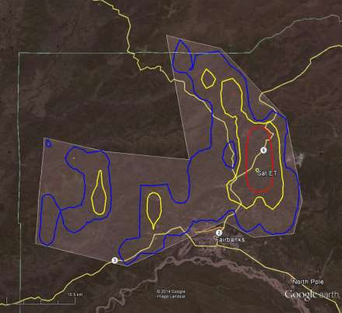
Figure 1: Coordination zone for Fairbanks Alaska.

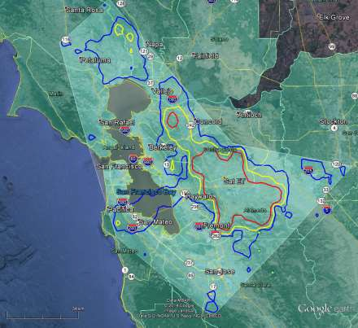
Figure 2: Coordination zone for Camp Park, CA.

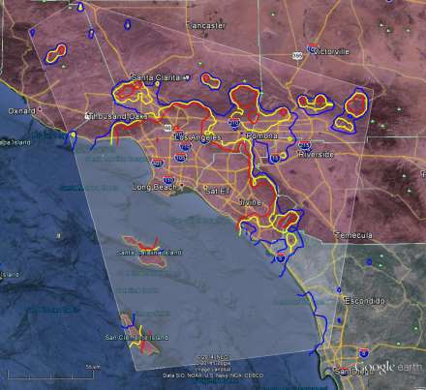
Figure 3: Coordination zone for Huntington Beach, CA.
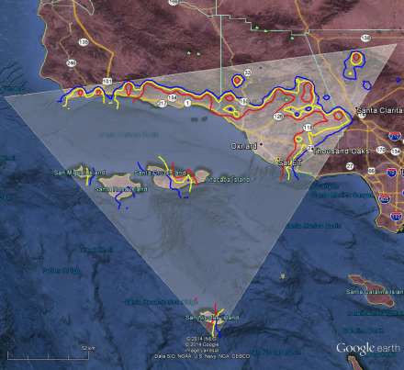
Figure 4: Coordination zone for Laguna Peak, CA.

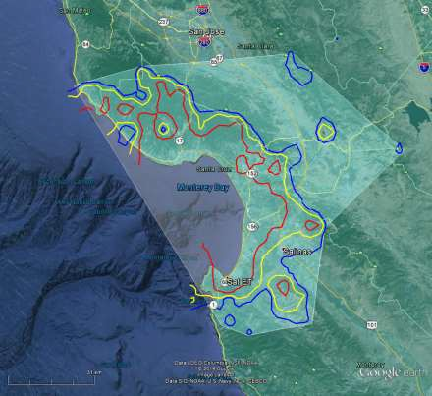
Figure 5: Coordination zone for Monterey, CA.
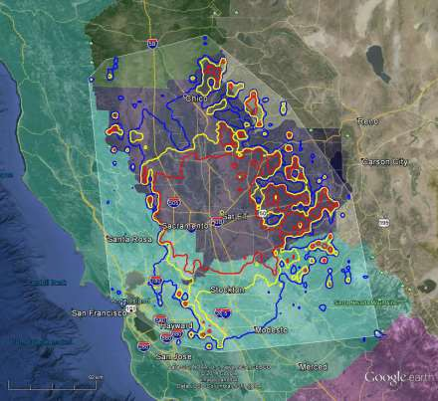
Figure 6: Coordination zone for Sacramento, CA.

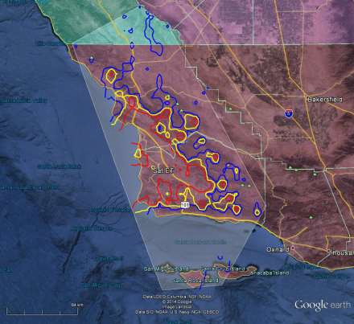
Figure 7: Coordination zone for Vandenberg AFB, CA.
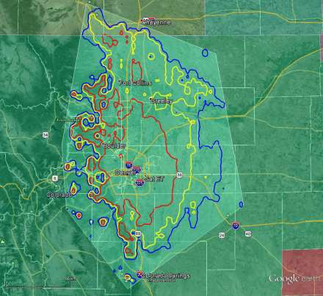
Figure 8: Coordination zone for Buckley, CO.

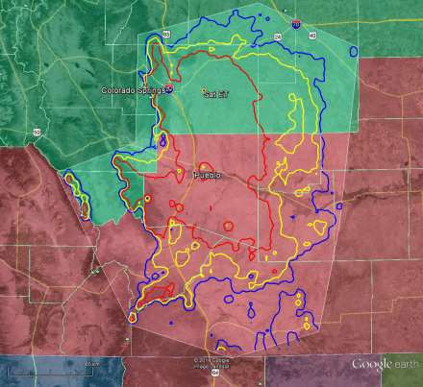
Figure 9: Coordination zone for Schriever AFB, CO.
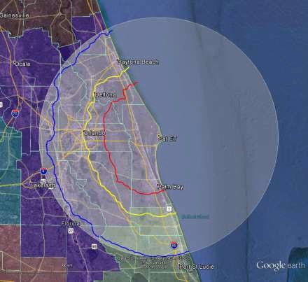
Figure 10: Coordination zone for Cape Canaveral AFS, FL.

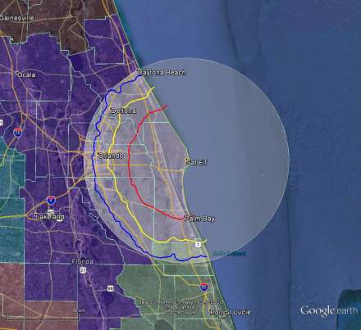
Figure 11: Coordination zone for Cape GA, CCAFB, FL.
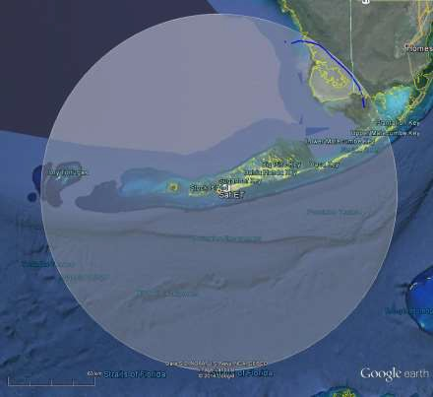
Figure 12: Coordination zone for JIATF-S Key West, FL.

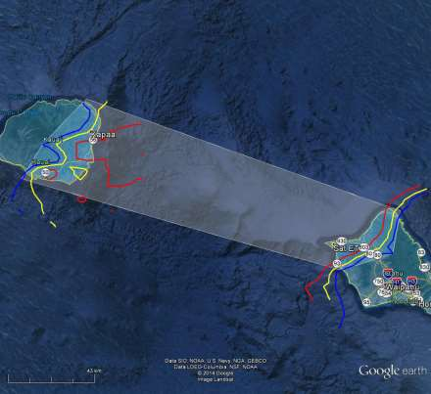
Figure 13: Coordination zone for Kaena Point, Oahu, HI.
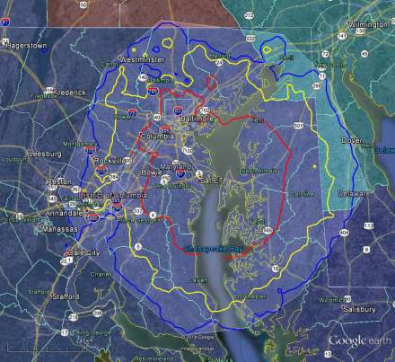
Figure 14: Coordination zone for Annapolis, MD.

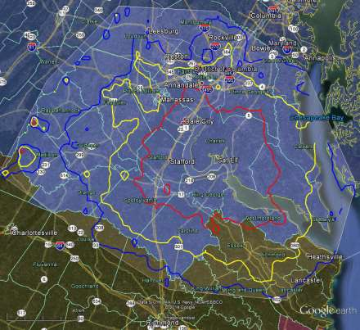
Figure 15: Coordination zone for Blossom Point, MD.
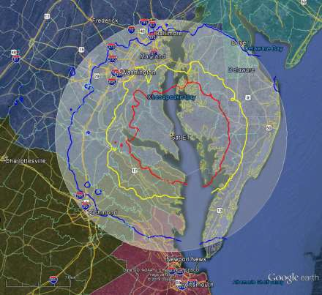
Figure 16: Coordination zone for Patuxent River NAS, MD.

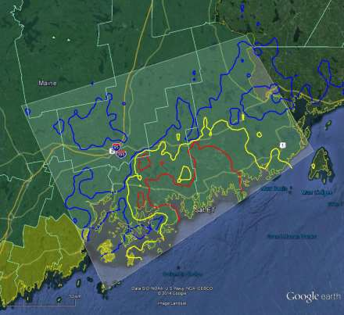
Figure 17: Coordination zone for Prospect Harbor, ME.
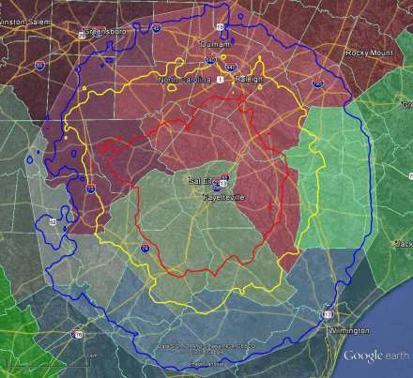
Figure 18: Coordination zone for Ft Bragg, NC.

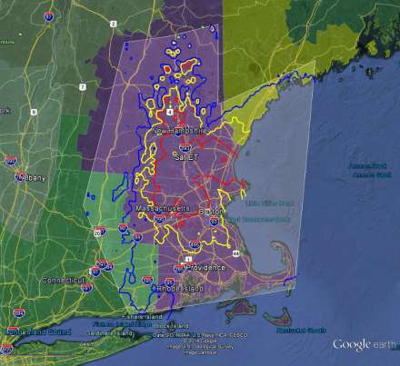
Figure 19: Coordination zone for New Boston AFS, NH.
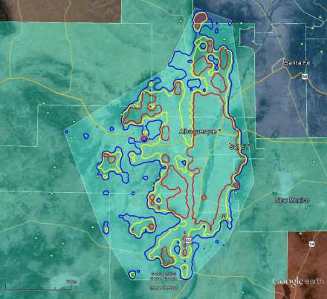
Figure 20: Coordination zone for Kirtland AFB, NM.

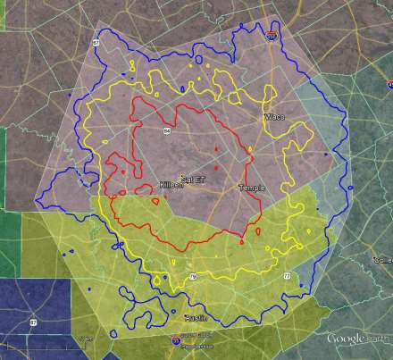
Figure 21: Coordination zone for Ft Hood, TX.
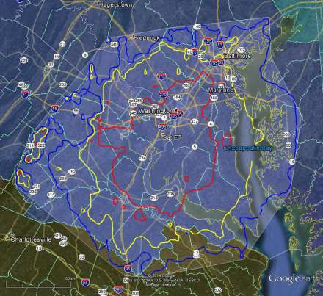
Figure 22: Coordination zone for Fort Belvoir, VA.

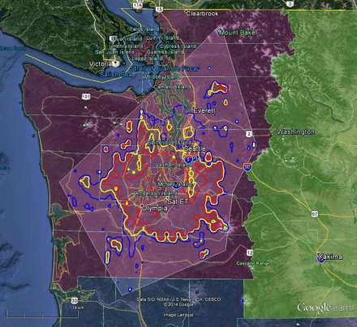
Figure 23: Coordination zone for Joint Base Lewis-McChord, WA.
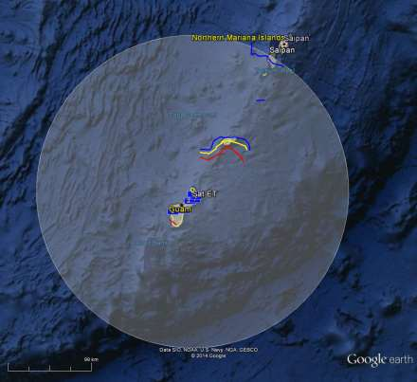
Figure 24: Coordination zone for Andersen AFB, GU.

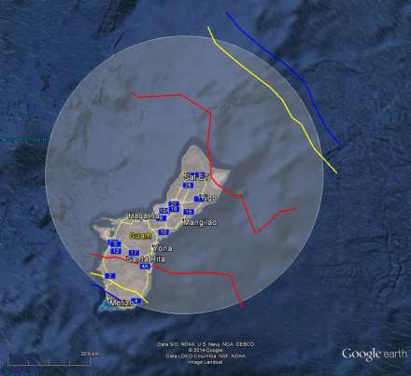
Figure 25: Coordination zone for NAVSOC Det. Charlie, GU.

Appendix C-3

Streamlined Coordination Option—Template Agreement

Coordination Agreement

Between

[Advanced Wireless Service-3 Licensee] (“AWS-3 Licensee”)

And

[Federal Agency] (“Federal Agency”)

- Introduction

This Coordination Agreement is between [Insert name of AWS-3 Licensee](hereinafter referred to as the "AWS-3 Licensee"), and [Insert name of Federal Agency] (hereinafter referred to as the "Federal Agency"), and sets forth the terms and conditions for their operations in the 1761-1780 MHz band.

- Acknowledgement of regulations

All AWS-3 licensees must accept any interference caused by the operation of Federal Agency’s Space- Ground Link System (SGLS) earth station site(s) and shall protect Federal Agency’s SGLS operations, as required by 47 CFR §27.1134 and 47 CFR § 2.106. The parties agree that within the coordination zones listed in Table A below, the AWS-3 Licensee will coordinate with the Federal Agency by notifying the Federal Agency of the AWS-3 Licensee’s intent to commence advanced wireless service within the coordination zone and submitting the additional information as listed in Section 4 below, prior to use of the spectrum. In cases where interference from SGLS earth stations results in AWS-3 Licensee customer complaints against the Federal Government, the AWS-3 Licensee will take actions to address those complaints and employ mitigation methods to reduce the likelihood of them reoccurring.

Table A: Description of license(s) subject to this agreement

State Site AWS-3 License Call Sign(s) Coordination Zone

- Point-of-contact

The Federal Agency and the AWS-3 Licensee hereby authorize the individuals listed in Table B below to serve as their Points of Contact (POC) for purposes of compliance with the notification and communication requirements of this Coordination Agreement.

Table B: Points of Contact

[Federal Agency] | [AWS-3 Licensee]
Name:  Address:  Phone:  E-mail: | Name:  Address:  Phone:  E-mail:

- AWS-3 Licensee Notification to Federal Agency

As required by Section 2 above, the AWS-3 Licensee will provide to the Federal Agency the following information:

  - AWS-3 Licensee’s deployment plans in the coordination zone;
  - Methods the AWS-3 Licensee plans to use to mitigate interference into base station receivers, and an explanation of how the methods will mitigate interference from SGLS earth stations and prevent any impaired consumer experience;
  - Contact information for the AWS-3 Licensee’s network operation center and local engineering staff; and
  - Assurance that the AWS-3 Licensee will satisfy its obligations to provide safety of life services (i.e., 911) such as routing traffic on bands other than the AWS-3 band in the coordination zone as needed.

- Continuing communications between AWS-3 Licensee and Federal Agency

The parties shall:

  - Address with each other, when the need first arises, any consumer complaints associated with the AWS-3 Licensee’s operations near Federal earth stations. This may include the AWS-3 Licensee’s development of external communication regarding reports of interference or interruption of service using AWS-3 bands. This external communication should reflect the acknowledgement of regulations in Section 2 above; and
  - Meet annually to discuss network deployments, current and future technologies, interference mitigation techniques, consumer experiences, and other relevant topics necessary to help the Federal Agency understand the evolving use of the band, and its impact upon SGLS operations;
  - The above additional interactions can be initiated by either POC listed above.

- Substantial changes to SGLS earth station operations or AWS-3 deployments

If either party plans operations that are substantially different from the Commerce Spectrum Management Advisory Committee (CSMAC) Working Group 3 studied concept of operations, the differences must be discussed during the annual meeting required by Section 5 above unless an immediate meeting is required to mitigate new and/or unexpected interference.

- Sensitive/Proprietary Information

All information exchanged under this Coordination Agreement is considered sensitive/proprietary. Any exchange of information associated with this coordination agreement should be marked as sensitive/proprietary.

- Successful Coordination

Execution of and compliance with all terms of this Coordination Agreement meets the regulatory requirement for successful coordination in 47 CFR §27.1134.

Signatories:

[Federal Agency] [AWS-3 Licensee]

Date:

See Amendment of the Commission’s Rules with Regard to Commercial Operations in the 1695-1710 MHz, 1755- 1780 MHz, and 2155-2180 MHz Bands, GN Docket No. 13-185, Report and Order, 29 FCC Rcd 4610 (2014) (recon. pending) (AWS-3 R&O).
In the AWS-3 R&O, the Commission authorized and directed its Wireless Telecommunications Bureau to work with NTIA staff, in collaboration with affected Federal agencies or Commerce Spectrum Management Advisory Committee (CSMAC) members, to develop this joint FCC and NTIA public notice with information on coordination procedures in the 1695-1710 MHz and 1755-1780 MHz bands. AWS-3 R&O, 29 FCC Rcd at 4693 ¶ 221.
See infra note 23.
See AWS-3 R&O, 29 FCC Rcd at 4611-12 ¶ 1.
See Middle Class Tax Relief and Job Creation Act of 2012, Pub. L. No. 112-96, 126 Stat. 156 (2012) (Spectrum Act).http://go.usa.gov/XxHV.
In 2010, the President directed NTIA to collaborate with the Commission to “make available a total of 500 MHz of Federal and non-Federal spectrum over the next 10 years, suitable for both mobile and fixed wireless broadband use.” Memorandum for Heads of Executive Departments and Agencies, Unleashing the Wireless Broadband Revolution (rel. Jun. 28, 2010), 75 Fed. Reg. 38387 (Jul. 1, 2010). Then, in 2013, the President released another memorandum stating that where technically and economically feasible, spectrum sharing can and should be used to enhance efficiency among all users and to expedite commercial access to additional spectrum bands, subject to adequate interference protection for Federal users, especially users with national security, law enforcement, and safety-of-life responsibilities. Memorandum for the Heads of Executive Departments and Agencies, Expanding America’s Leadership in Wireless Innovation (rel. Jun. 14, 2013), published at 78 Fed. Reg. 37431 (Jun. 20, 2013).
See 47 U.S.C. § 923(h)(5) (requiring NTIA to publish approved plans on its website no later than 120 days before the start of the auction).
See 47 U.S.C. § 923(h).
See 47 U.S.C. § 923(h)(2). See also AWS-3 R&O, 29 FCC Rcd at 4693 ¶ 223.
See AWS-3 R&O, 29 FCC Rcd at 4694 ¶ 224 & n.673 (citing 47 U.S.C. §§ 923(h)(7), 929). Each Federal entity that requested pre-auction funds attested in its Transition Plan that it will, during the transition period, make available to a non-Federal user with appropriate security clearances any classified information regarding the relocation process, on a need-to-know basis, to assist the non-Federal user in the relocation process with the eligible Federal entity or other eligible Federal entities. Accord 47 U.S.C. § 928(d)(3(B)(ii)(4). See also NTIA Manual of Regulations and Procedures for Federal Radio Frequency Management (NTIA Manual), Annex O at §§ O.4.1 ¶ 3, O.6.1, and at Appendix: Common Format for Transition Plans, Tab B.
In Federal spectrum management, the term “non-USP” can refer to operations outside of the United States and Possessions, but in this Public Notice the term “non-USP” refers to assignments that are not Federal USP assignments as described above.
Section G.2 of Annex G of the NTIA Manual contains abbreviations used in the Transmitter and Receiver State/County fields of the Government Master File (GMF). The abbreviation “USP” is for use only when transmitting and/or receiving throughout the United States and Possessions, id. § G.2.3, which “includes the 50 States, the District of Columbia, the Commonwealth of Puerto Rico, and the territories and possessions (but less the Canal Zone).” NTIA Manual, § 6.1 Definitions.
See 47 C.F.R. § 27.1134(f)(1). See also NTIA Manual § 9.8.2 (Application Data Requirements), Field 39 (Circuit Remarks) (e) (Authorized States) (allowing the transmitter and receiver antenna location fields to describe an area of operation as USP if within four or more States and the area includes a Possession).
HUD and USAID each specify USP assignments in their Transition Plans under relocation timelines of 0-1 month, making coordination arrangements unnecessary.
See 47 C.F.R. § 2.106 footnote US91.
As noted above, affected agencies are permitted to redact from the publicly-released transition plans classified national security information and “other information for which there is a legal basis for nondisclosure and the public disclosure of which would be detrimental to national security, homeland security, or public safety or would jeopardize a law enforcement investigation.” See 47 U.S.C. § 929.
The refined Protection Zones in this Public Notice are organized into two sections depending on their purpose. The Protection Zones discussed in this section III (with details in Appendices A & B) are intended to protect incumbent Federal operations from AWS-3 operations in the 1695-1710 MHz band up to 30 dBm EIRP and in the 1755-1780 MHz band up to 20 dBm EIRP. The Protection Zones discussed in section V (with details in Appendix C) are intended to address potential interference into AWS-3 base stations in proximity to certain Federal satellite uplink stations.
The refined Protection Zones in sections III and V are inapplicable to coordination with USP agencies.
See NTIA Manual, Annex O (Relocation or Sharing by Federal Government Stations in Support of Reallocation) § O.5.1 (Negotiation and Coordination with Non-Federal Users), citing, e.g., 47 U.S.C. §§ 923(g)(3)(A)(iv)(II) and (g)(3)(B)(i), 923(h)(2)(F); see also id. at § 928(d)(3)(B)(i)(II).
See AWS-3 R&O, 29 FCC Rcd at 4704, App A., 47 C.F.R. § 27.5(h). See also 47 U.S.C. § 309(j)(16)(C) (Authority to issue prior to deauthorization) (“In any auction conducted under the regulations required by [the 110 percent rule], the Commission may grant a license assigned for the use of eligible frequencies prior to the termination of an eligible Federal entity’s authorization. However, the Commission shall condition such license by requiring that the licensee cannot cause harmful interference to such Federal entity until such entity’s authorization has been terminated by the [NTIA].”).
Under the terms of the AWS-3 R&O, AWS-3 licensees will be permitted to operate in any area: outside of a Protection Zone for any Federal operation in 1695-1710 MHz or 1755-1780 MHz during the transition of any system; outside the Protection Zones for systems remaining in the bands permanently; and within the Protection Zone of a transitioning or permanent system subject to successful coordination. AWS-3 R&O, 29 FCC Rcd at 4690-93 ¶¶ 216-220.
See 47 U.S.C. §§ 305(a), 902(b)(2)(A).
See The Federal Communications Commission and the National Telecommunications and Information Administration Coordination Procedures in the 1710-1755 MHz Band, Public Notice, 21 FCC Rcd 4730 (2006).
AWS-3 R&O, 29 FCC Rcd at 4693 ¶ 221. In adopting final rules in the AWS-3 R&O, the Commission discussed relevant statutes and related considerations that led to its determination to establish certain default, nationwide Protection Zones that would be refined or shrunk to the extent that NTIA, representing the recipients of this protection (i.e., the Federal users), determined that the full extent of this protection was not required. AWS-3 R&O, 29 FCC Rcd at 4645 ¶ 91; 47 C.F.R. §§ 2.106 footnotes US88, US91, 27.1134(c), (f). In particular, the Commission noted that NTIA has authority to assign frequencies to Federal users and to amend, modify, or revoke such assignments; AWS-3 R&O, 29 FCC Rcd at 4693¶ 221 citing 47 U.S.C. §§ 305(a) (stating that Federal stations are not subject to provisions of Sections 301 (FCC licensing authority) or 303 (FCC general powers) of the Act), 902(b)(2)(A); and that the Commission must condition AWS-3 licenses on not causing harmful interference to a relocating Federal entity prior to NTIA’s termination of such entity’s authorization, see supra note 20. See also AWS-3 R&O, 29 FCC Rcd at 4690¶ 214. NTIA’s determination must also account for the requirement of current law that “the Secretary of Commerce, the Secretary of Defense, and the Chairman of the Joint Chiefs of Staff jointly certify . . . that such alternative band or bands provides comparable technical characteristics to restore essential military capability that will be lost as a result of the band of frequencies to be so surrendered.” Id. See also 47 U.S.C. § 923(j) and NTIA, Notification to Congress Pursuant to 47 U.S.C. § 923(j)(2) Regarding the 1695-1710 MHz and 1755-1780 MHz (AWS-3) Spectrum Bands (Jun. 4, 2014), available at http://go.usa.gov/XxHV. Specification of the refined Protection Zones outlined below, which reflects the determination that NTIA has now made, thus implements provisions already incorporated in the Commission’s AWS-3 rules pursuant to notice and comment rulemaking. Additionally, NTIA’s directives to Federal agencies regarding Protection Zones (and coordination requirements) is a matter for NTIA and not the Commission. See, e.g., 47 U.S.C. § 923(g)(6) (establishing that NTIA shall take such actions as necessary to ensure the timely relocation and timely implementation of arrangements for the sharing of frequencies). For this reason, further notice to and comment by non-Federal users to the Commission would be impracticable and unnecessary as well as contrary to the public interest in negotiating agreement among the Commission, NTIA, and multiple Federal users on an expedited basis, pursuant to the timetable for licensing of the AWS-3 spectrum required by the Spectrum Act. See 47 U.S.C. § 1451(b). Nor does this reduction of Protection Zones involve any “major policy proposals that are not classified and that involve spectrum management,” requiring NTIA to provide for further public comment and review. See 47 U.S.C. § 903(b)(2). See also 78 Fed. Reg. 52097 (2013) (revisions to NTIA Manual are subject to good cause exception of Administrative Procedure Act because they apply only to Federal agencies); see also 5 U.S.C. § 553(a)(2).
AWS-3 R&O, 29 FCC Rcd at 4649-50 ¶ 105.
See, e.g., AWS-3 R&O, 29 FCC Rcd at 4642 ¶ 79, n. 251 citing Appendix 3 of the WG1 Final Report (Baseline LTE Uplink Characteristics).
AWS-3 R&O, 29 FCC Rcd at 4649-50 ¶ 105 (“Where the rules that we adopt today differ from proposed rules that reflected CSMAC’s assumptions, we also adopt corresponding changes to the coordination zones.”).
AWS-3 R&O, 29 FCC Rcd at 4649-50 ¶ 105.
AWS-3 R&O, 29 FCC Rcd at 4649-50 ¶ 105.
47 C.F.R. § 2.106 footnote US88. There are 13 Protection Zones listed in footnote US88(b)(1) for Federal earth stations receiving in the band 1695-1710 MHz and 14 Protection Zones listed in footnote US88(b)(2) for Federal earth stations receiving in the band 1675-1695 MHz.
See 47 C.F.R. §§ 2.106 footnote US88, 27.1134(c).
47 C.F.R. § 2.106 footnote US88(b).
See AWS-3 R&O, 29 FCC Rcd at 4684-85 ¶ 199.
AWS-3 R&O, 29 FCC Rcd at 4645, 4692-93 ¶¶ 91, 220. See also 47 C.F.R. §§ 2.106 footnote US91, 27.11334(f).
See, e.g., 47 C.F.R. § 27.1134(f) (“[t]he Federal Government operates communications systems in the 1755-1780 MHz band. Certain systems are expected to continue to operate in the band indefinitely. All other operations will be relocating to other frequencies or otherwise cease operations in the 1755-1780 MHz band in accordance with 47 CFR part 301. Until such a time as Federal operations in the 1755-1780 MHz bands vacate this spectrum, AWS licensees shall protect such systems and must accept any interference received from these Federal operations. See 47 C.F.R. § 2.106, US note 91 of this chapter for details.”).
We discuss the exception in section V below and Appendix C to this Public Notice (refined protection zones for 25 Federal earth stations).
Auction of Advanced Wireless Services Licenses Scheduled for November 13, 2014; Comment Sought on Competitive Bidding Procedures for Auction 97, AU Docket No. 14-78, Public Notice, 29 FCC Rcd 5217, 5225 ¶ 24 (WTB 2014).
A census tract is “[a] small, relatively permanent statistical subdivision of a county delineated by a local committee of census data users for the purpose of presenting data. Census tracts nest within counties, and their boundaries normally follow visible features, but may follow legal geography boundaries and other non-visible features in some instances, Census tracts ideally contain about 4,000 people and 1,600 housing units. http://www.census.gov/glossary/#term_Censustract There are 73,057 census tracts for the 50 states and the District of Columbia (2010 tally does not include Puerto Rico and the Island Areas). http://www.census.gov/geo/maps-data/data/tallies/national_geo_tallies.html. The U.S. Census Bureau provides references, including links to mapping files. See, e.g., http://www.census.gov/geo/education/pdfs/CensusTracts.pdf
See supra note 35. We also note that AWS-3 licensees are required to comply with all other applicable rules governing their operations.
See generally 47 C.F.R. §§ 24.237, 27.1131.
AWS-3 R&O, 29 FCC Rcd at 4645 ¶ 91. Special requirements near satellite earth stations in the 1761-1780 MHz band are discussed in section V below and Appendix C.
The Commission’s AWS-3 rules contemplate “a good faith effort from both the AWS-3 licensees and the Federal incumbents to share information about their systems, agree to appropriate interference methodologies, and communicate results so as to facilitate commercial use of the band.” AWS-3 R&O, 29 FCC Rcd at 4693¶ 222.
See AWS-3 R&O, 29 FCC Rcd at 4693 ¶ 222.
47 C.F.R. § 1.931.
As noted in section III, licensees deploying technology that differs from CSMAC’s baseline LTE uplink assumptions (apart from a maximum EIRP above 20 dBm which is already accounted for in Appendices A and B) may need to address as part of coordination whether such operations pose a greater risk of interference to Federal operations than the baseline LTE uplink characteristics that CSMAC assumed. In so doing, if relevant to the technical analysis, the licensee may need to provide technical data about (but not successfully coordinate) its base stations located outside of but nearby a relevant Protection Zone. We encourage AWS-3 licensees and Federal agencies to discuss these issues informally prior to submission of formal requests.
For AWS-1 coordination, this was called “site/spectrum activation requirements.”
For AWS-1 coordination, this was called the “composite output letter.”
The Freedom of Information Act exempts disclosure to the public of detailed characteristics of military systems, where specifically authorized by Executive Order to be kept secret in the interest of national defense or foreign policy. 5 U.S.C. § 552(b(1). The characterization of the interference interactions of systems that conflict with an AWS-3 desired deployment plan may disclose information, either directly or by inference, that has been classified and subject to substantial restrictions on access under Executive Orders and applicable regulations. See, e.g., Executive Order 13526 at part 4, 75 Fed. Reg. 707 (2009). Hence, notification letters sent out by the designated Federal agency coordinator will identify only site and spectrum/channel activation requirements to ensure EMC with Federal systems.
See generally 47 C.F.R. § 1.17.
See Section 113(i) of the NTIA Organization Act, as amended (47 U.S.C. § 923(i)).
See 47 C.F.R. Part 301.
Membership of a dispute resolution board shall be composed of a representative of OMB, NTIA, and the FCC, each appointed by the head of his or her respective agency. The OMB representative serves as the Chair of any board. With respect to the resolution of any disputes that may arise, the law and NTIA’s rules require a board to meet simultaneously with representatives of the Federal entity and the non-Federal user to discuss the dispute.
47 U.S.C. § 923(i)(4).
NTIA Manual, Annex O at § O.5.2 ¶ 3. See 47 C.F.R. § 301.200(a)(2).
Id., Annex O.
47 U.S.C. § 923(i)(1).
47 U.S.C. § 923(i)(7).
See 47 C.F.R. § 301.220(b). See also NTIA Manual, Annex O at § O.5.2 ¶ 4.
See 47 C.F.R. § 301.220(b). See also NTIA Manual, Annex O at § O.5.2 ¶ 4.
See 47 C.F.R. §§ 2.106 footnote US91(b)(3), 27.11334(f).
See 47 C.F.R. §§ 2.106 footnote US91(b)(3), 27.11334(f). See also AWS-3 R&O, 29 FCC Rcd at 4645, 4692-93 ¶¶ 91, 220.
See 47 C.F.R. §§ 2.106 footnote US91(b)(3), 27.11334(f). The Commission noted in the AWS-3 R&O that “federal incumbents remaining in the band must be able to have the flexibility to coordinate with commercial licensees if reasonable modification of existing, grandfathered operations are required in the future.” See AWS-3 R&O, 29 FCC Rcd at 4693 ¶ 222.
47 C.F.R. § 27.1134(f). See also 47 C.F.R. § 2.106 footnote US91(a), (b)(3).
If an AWS-3 licensee elects not to use this streamlined framework, it must successfully coordinate with the relevant Federal incumbent prior to operating a base station in a Protection Zone in Appendix C-1 that enables mobile and portables to transmit in the 1760-1780 MHz band.
Section 2, Table A of the template agreement calls for a description of license(s) to be subject to the agreement by State, Site, Call Sign, and Coordination Zone. Section 3 of the template agreement calls for the AWS-3 licensee (and the Federal agency) to provide Point-of-Contact information. Sections 2 and 4 of the template agreement contemplate AWS-3 licensee notifications to the Federal agency.
47 C.F.R. § 2.106 footnote US91(b)(3). The modification or new station must be required, reasonable, and authorized by NTIA. The details of the coordination must be filed with NTIA and the Commission. Id.
DoJ redacted the centerpoint coordinates of the authorized areas of operation from its publicly available Transition Plan. See generally supra, Public Notice at note 16. DoJ’s publicly available Transition Plan identifies five UAS operations and that each has an operating area with a radius of 80 km in the following states: Colorado (1), Texas (2), Virginia (2). Licensees proposing operations within 220 km of a border of these three states should contact DoJ to arrange access to the redacted data to determine where coordination is required.
See generally 47 C.F.R. §§ 24.237, 27.1131. The minimum distance separation is measured from the location of the proposed commercial base station (that would enable mobiles and portables to transmit in the 1755-1780 MHz band) to each Federal fixed microwave station that receives Federal fixed microwave transmissions in the 1755-1780 MHz band. With the exception of DoJ, the locations of these stations are identified in each agency’s publicly available Transition Plan. DoJ redacted the locations but its publicly available Transition Plan identifies the relevant city and state for each link. Licensees should contact DoJ to arrange access to redacted data.

