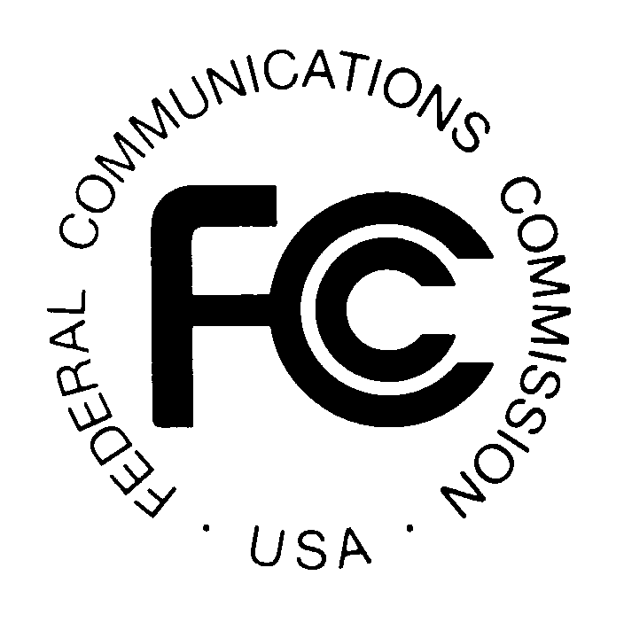
PUBLIC NOTICE
Federal Communications Commission
445 12th St., S.W.
Washington, D.C. 20554

News Media Information: 202.418.0500
TTY: 202.418.2555
Internet: http://www.fcc.gov

DA 14-1603

November 4, 2014

PUBLIC SAFETY AND HOMELAND SECURITY BUREAU ANNOUNCES

REGION 46 (WYOMING) 700 MHZ AND 800 MHZ PUBLIC SAFETY REGIONAL PLANNING COMMITTEE MEETINGS

General Docket No. 91-59

The Region 46 (Wyoming) 700 MHz and 800 MHz Public Safety Regional Planning Committees (RPC) will hold a meeting on November 14, 2014, at 10:00 am, at the Best Western Ramkota, 800 N. Poplar, Casper, Wyoming 82601.

The purpose of the meetings are to discuss user needs, and plan for the continued use of the 700 MHz and 800 MHz spectrum -- which includes public safety, public health, emergency management, and public utility services. A phone conference call will be available to interested parties by contacting Bob Symons.

The Region 46 700 MHz and 800 MHz Public Safety RPC meetings are open to the public. It is essential that public safety agencies in all areas of government, including state, municipality, county, and Native American Tribal, and non-governmental organizations eligible under Section 90.523 of the Commission’s rules, 47 C.F. R. § 90.523, be represented in order to ensure that each agency’s future spectrum needs are considered in the allocation process. Administrators who are not oriented in the communications field should delegate someone with this knowledge to attend, participate, and represent their agency’s needs.

All interested parties wishing to participate in planning for the use of public safety spectrum in the 700 MHz and 800 MHz bands within Region 46 should plan to attend. For further information, please contact the Bob Symons, WYPSCC Administrative Support, 5500 Bishop Blvd, Cheyenne, WY, 82002 or 307-777-5065 or bob.symons@wyo.gov

William Walter, Chair
Region 46 (Wyoming) 700 and 800 MHz RPCs
Federal Bureau of Investigation, Interoperable Communications
1109 Airport Parkway
Cheyenne, WY 82001
(307) 632-6224 or William.walter@ic.fbi.gov

-FCC-

