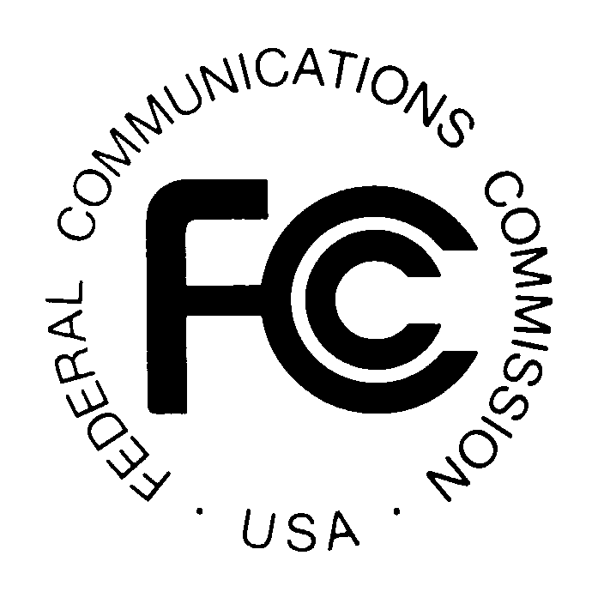
PUBLIC NOTICE
Federal Communications Commission
445 12th St., S.W.
Washington, D.C. 20554

News Media Information: 202.418.0500
TTY: 202.418.2555
Internet: http://www.fcc.gov

DA 14-182

February 11, 2014

PUBLIC SAFETY AND HOMELAND SECURITY BUREAU ANNOUNCES

REGION 13 (ILLINOIS) 700 MHZ AND 800 MHZ NPSPAC PUBLIC SAFETY REGIONAL PLANNING COMMITTEES 2014 MEETING SCHEDULE

PR Docket No. 91-228

The Region 13 (Illinois) Regional Conference Review and Implementation Committee, also known as the 700 MHz and 800 MHz Public Safety Regional Planning Committees (RPCs), will hold the four joint meetings during 2014. Each meeting session will begin at 10:00 a.m. beginning with the 700 MHz RPC meeting session. The 800 MHz NPSPAC RPC meetings will convene immediately following the conclusion of the 700 MHz sessions.

Tuesday, February 18, 2014
Illinois Emergency Management Agency Public Outreach
2200 South Dirksen Parkway
Springfield, IL 62764

Wednesday, May 14, 2014
Effingham City Hall
201 East Jefferson
Effingham, IL 62401

Tuesday, August 19, 2014
Illinois Law Enforcement Alarm System Building
1701 E Main Street
Urbana, IL 61802

Tuesday, November 18, 2014
Grundy County 911 PSAP
78 West Lowery Road
Morris, IL 60450

The purpose of the meetings is to discuss user needs, and plan for the continued use of the frequencies in 700 MHz and 800 MHz NPSPAC bands which includes public safety, public health, emergency management, and public utility services.

Both Region 13 700 MHz and 800 MHz Public Safety RPC meetings are open to the public. The meetings are held at locations throughout the Region 13 area to encourage wide participation. It is essential that public safety agencies in all areas of government, including state, municipality, county, and Native American Tribal, and non-governmental organizations eligible under Section 90.523 of the Commission’s rules, 47 C.F.R. § 90.523, be represented in order to ensure that each agency’s future spectrum needs are considered in the allocation process. Administrators who are not oriented in the communications field should delegate someone with this knowledge to attend, participate, and represent their agency’s needs.

All interested parties wishing to participate in planning for the use of public safety spectrum in the 700 MHz and 800 MHz NPSPAC bands within Region 13 should plan to attend. For further information, please contact:

William Carter, Chairperson
700 MHz and 800 MHz Regional Planning Committees
Illinois Department of Public Health
Radio Communications Coordinator
122 South Michigan
Chicago, Illinois 60603
(312) 814-5208
(312) 497-6802 Mobile
Billy.carter@illinois.gov

-FCC-

The Region 13 (Illinois) 800 MHz NPSPAC regional planning area includes the entire state of Illinois, except for the “Southern Lake Michigan” counties of Winnebago, McHenry, Cook, Kane, Kendall, Grundy, Boone, Lake DuPage, DeKalb, Will and Kankakee.

