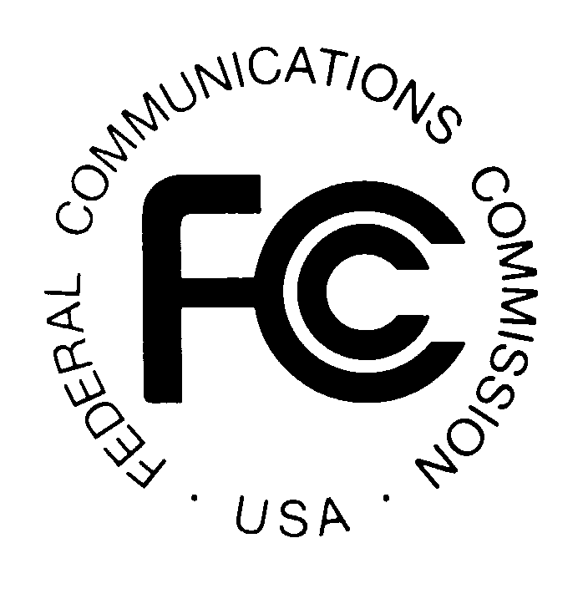
PUBLIC NOTICE
Federal Communications Commission
445 12th St., S.W.
Washington, D.C. 20554

News Media Information: 202.418.0500
TTY: 202.418.2555
Internet: http://www.fcc.gov

DA 14-237

February 21, 2014

PUBLIC SAFETY AND HOMELAND SECURITY BUREAU ANNOUNCES

REGION 46 (WYOMING) 700 MHZ AND 800 MHZ PUBLIC SAFETY REGIONAL PLANNING COMMITTEE MEETINGS

General Docket No. 91-59

The Region 46 (Wyoming) 700 MHz and 800 MHz Public Safety Regional Planning Committees (RPCs) will hold two meetings on March 18, 2014, beginning with the 800 MHz RPC session at 1:00 pm in Casper, Wyoming at the Natrona County Emergency Operations Center, Hall of Justice, 201 N. David, Second Floor. The 700 MHz meeting session will commence immediately following the conclusion of the 800 MHz RPC meeting.

The purpose of the meetings is to discuss user needs, and plan for the continued use of the 700 MHz and 800 MHz spectrum -- which includes public safety, public health, emergency management, and public utility services. A conference call will be established for this meeting and a detailed agenda will be distributed at the meeting.

Both Region 46 700 MHz and 800 MHz Public Safety RPC meetings are open to the public. It is essential that public safety agencies in all areas of government, including state, municipality, county, and Native American Tribal, and non-governmental organizations eligible under Section 90.523 of the Commission’s rules, 47 C.F.R. § 90.523, be represented in order to ensure that each agency’s future spectrum needs are considered in the allocation process. Administrators who are not oriented in the communications field should delegate someone with this knowledge to attend, participate, and represent their agency’s needs.

All interested parties wishing to participate in planning for the use of public safety spectrum in the 700 MHz and 800 MHz bands within Region 46 should plan to attend. For further information and conference call set-up details, contact Bob Symons, RPC Administrative Support.

Bob Symons, Region 46 (Wyoming) RPC Administrative Support
Statewide Interoperable Coordinator, Wyoming Office of Homeland Security
Wyoming Public Safety Communications Commission
5500 Bishop Boulevard, Cheyenne, WY 82002
(307) 777-5065 or bob.symons@wyo.gov

William Walter, Chair
Region 46 (Wyoming) 700 and 800 MHz RPCs
Federal Bureau of Investigation, Interoperable Communications
1109 Airport Parkway
Cheyenne, WY 82001
(307) 632-6224 or William.walter@ic.fbi.gov

-FCC-

