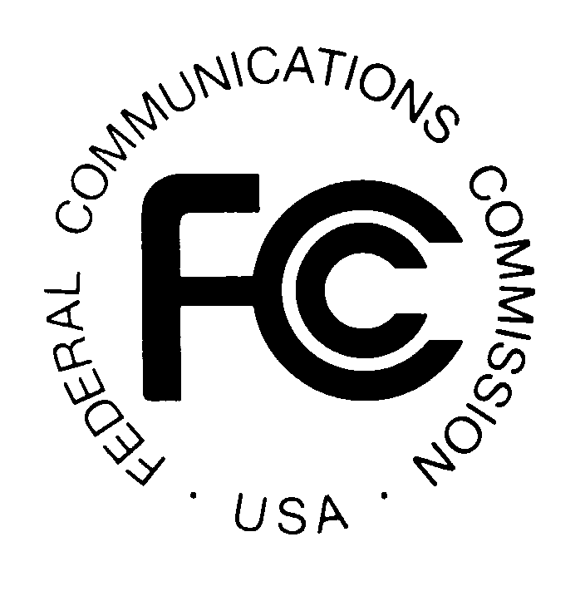
PUBLIC NOTICE

News media information 202 / 418-0500
TTY 202 / 418-2555
Internet: http://www.fcc.gov
Federal Communications Commission
445 12th St., S.W.
Washington, D.C. 20554

DA 14-388

March 20, 2014

PUBLIC SAFETY AND HOMELAND SECURITY BUREAU ANNOUNCES

REGION 12 (IDAHO) PUBLIC SAFETY REGIONAL PLANNING COMMITTEE

TO HOLD ANNUAL 700 MHZ REGIONAL PUBLIC SAFETY PLANNING MEETING

The Region 12 (Idaho) 700 MHz Public Safety Regional Planning Committee (RPC) will hold its statewide meeting on Wednesday, April 2, 2014, from 8:30 a.m. to 9:15 a.m. at the Ada County Sheriff’s Office, Training Annex A, 7200 Barrister Drive, Boise, Idaho 83704.

The agenda for the meeting includes:
- Welcome and introduction of members
- Review and approval of meeting minutes
- Financial Report
- Old Business
  - Update on 700 MHz narrowbanding - FCC Seventh Report and Order and Further Notice of Rulemaking
- New Business - Update on past year’s license requests
- Open Comments
- Next regularly scheduled meeting, May, 2015 – location TBD
- Adjourn

The Region 12 700 MHz Public Safety RPC meeting is open to the public. It is essential that public safety agencies in all areas of government, including state, municipality, county, Native American Tribal, and non-governmental organizations eligible under Section 90.523 of the Commission’s rules, 47 C.F.R. § 90.523, be represented in order to ensure that each agency’s future spectrum needs are considered in the allocation process. Administrators who are not oriented in the communications field should delegate someone with this knowledge to attend, participate, and represent their agency’s needs.

All interested parties wishing to participate in the planning for the use of public safety spectrum in the 700 MHz band within Region 12 should plan to attend. For further information, please contact:

Lieutenant Todd Herrera, Chairman
Region 12 (Idaho) 700 MHz RPC
Canyon County Sheriff’s Office
1115 Albany Street
Caldwell, Idaho 83605
(208) 454-7271
therrera@canyonco.org
www.700region12.org

-FCC-

See Seventh Report and Order Notice of Proposed Rulemaking, PS Docket No. 13-87, WT Docket No. 96-86, 28 FCC Rcd 4783 (2013).

