Before the
Federal Communications Commission
Washington, D.C. 20554

In the Matter of  SES Americom, Inc.  Application for Authority to Operate the SES-3 Satellite at 103º W.L. | )  )  )  )  )  ) | IBFS File Nos. SAT-RPL-20121228-00227  SAT-AMD-20131113-00132  Call Sign: S2892
ORDER

Adopted: April 4, 2014 Released: April 4, 2014

By the Chief, International Bureau:

introduction
- By this Order, we authorize SES Americom, Inc. (SES Americom) to operate the SES-3 (Call Sign S2892) satellite at the 103º W.L. orbital location for telemetry, tracking and command (TT&C) and for two Ku-band beacons. The specific center frequencies authorized are: 3700.5 MHz, 4199.5 MHz, 11701.0 MHz, 12199.0 MHz (space-to-Earth); 6423.5 MHz and 14499.0 MHz (Earth-to-space). In addition to C- and Ku-band frequencies, the SES-3 satellite is also capable of operating in the 17/24 GHz (17.3-17.8 GHz downlink and 24.75-25.25 GHz uplink) frequency bands. These frequencies are currently authorized by Industry Canada. The Commission has completed an exchange of letters with Industry Canada concerning the operations of the satellite and the related licensing arrangements. In response to a Petition to Deny or Defer filed by DIRECTV, LLC, we defer action on SES Americom’s application to operate other C- and Ku-band frequencies on the SES-3 satellite as a replacement for the AMC-1 satellite (Call Sign S2445) at the 103º W.L. orbital location. This action will allow SES Americom to begin preparations, at its own risk, for a planned hand-over of C- and Ku- band traffic from the AMC-1 satellite to the SES-3 satellite, and will provide a period in which DIRECTV, LLC and SES Americom can pursue resolution of coordination matters concerning the satellite.

background
- SES-3 Application. SES Americom filed its application on December 28, 2012. The AMC-1 satellite SES Americom seeks to replace has been operating in the conventional C- and Ku-bands at 103º W.L. since its launch in 1996. SES intends to use the SES-3 space station to continue to provide video, broadband and data services, including direct-to-home (“DTH”) services, to users primarily in North America and the Caribbean. SES Americom amended its application on November 13, 2013 to correct errors contained in the original application’s Technical Appendix. SES Americom indicates that it needs extra time to transition customer traffic from AMC-1 to SES-3 because the two satellites have different Ku-band polarization characteristics. The application and amendment were placed on Public Notice on November 15, 2013. In response to the Public Notice, DIRECTV, LLC filed its Petition, SES Americom opposed the DIRECTV Petition, and DIRECTV, LLC filed a reply to that opposition. DIRECTV is the licensee of a 17/24 GHz satellite, to be located at the 102.825° W.L. orbital location, scheduled for launch in 2015. Eighteen ex parte filings have also been filed during the course of this proceeding.
- Background Concerning the SES-3 satellite. In September 2012, SES Americom moved SES-3 to the 103.1º W.L. orbital location. In connection with the operation of the satellite at the 103.1° W.L. orbital location, Industry Canada issued an authorization to Ciel Satellite Limited Partnership, a Canadian affiliate of SES Americom, on September 21, 2012. In the C- and Ku-bands at the 103.1º W.L. orbital location, SES is currently operating only for telemetry, tracking and command (TT&C) purposes. SES Americom states that these TT&C operations are based upon a Luxembourg ITU filing.
- The 17/24 GHz transponder on SES-3 is designated as Ciel 6i by Industry Canada and is considered an interim satellite. Ciel also has an Industry Canada authorization for a satellite designated as Ciel-6 to provide service in the 17/24 GHz frequencies at 103º W.L. The current deadline for placement at the authorized orbital location and start of service of the new satellite is December 1, 2018.

discussion

Dual Licensing
- The Commission has exchanged letters with Industry Canada to ensure a mutual understanding regarding the operations of SES-3. The understandings, and the factual background for these understandings, are provided in Appendix A and are material considerations for the authorization contained in this order.

Waiver of 25.113(g)
- SES Americom requests a waiver, to the extent necessary, of Section 25.113(g) of the Commission’s rules which requires that a “launch authorization and station license (i.e., operating authority) must be applied for and granted before a space station may be launched and operated in orbit.” SES-3 was launched in 2011, but SES did not seek FCC approval in connection with the launch and initial operation of the satellite. As stated earlier, we will address SES Americom’s replacement application at a later date. Because we are deferring action on the C- and Ku- band replacement operations, we will also defer a final ruling concerning this issue until that time. In light of the extended preparatory period requested for the proposed hand-over of traffic from AMC-1 to SES-3, we provide a limited waiver, to the extent necessary, now to permit preparatory activities, solely at SES Americom’s risk. We conclude, therefore, that the prior approval requirement of Section 25.113(g) would not be subverted by and is therefore not an impediment to granting operating authority for SES-3’s TT&C and Ku-band beacons.

License Term
- Section 25.121 of the Commission’s rules specifies that licenses for satellites shall be issued for a period of 15 years or less. On July 13, 2013, SES Americom filed a supplement to the record stating that based on events that occurred after the launch of SES-3, the nominal end-of-life estimate for the satellite had been reduced to 13.9 years, or June 2025. We therefore specify a license term ending June 30, 2025.

International Coordination and SES-3 17/24 GHz Payload
- In its Petition to Deny or Defer SES Americom’s application, DIRECTV raises an issue related to international coordination between its planned 17/24 GHz BSS operations of the DIRECTV 15 satellite and the 17/24 GHz BSS operations of SES Americom at the 103º W.L. orbital location. In 2009, the Commission granted DIRECTV authority to launch and operate a “state-of-the-art 17/24 GHz satellite” at 102.825º W.L. The Canadian ITU filing for the 17/24 GHz BSS operations at the 103° W.L. orbital location predates the U.S. filing. DIRECTV states that it is engaging in coordination discussions with Ciel, SES Americom’s affiliate, which holds the Canadian authorization for the SES-3 17/24 GHz BSS payload. DIRECTV requested that the Commission either deny SES Americom’s application or defer decision on the application to replace AMC-1 with SES-3 until coordination between the parties has been completed.
- We are providing a limited grant of SES Americom’s application to permit SES Americom to perform TT&C functions for SES-3, and to prepare earth stations currently served by the AMC-1 satellite. The Commission will rule on the regular operations of SES-3 at a later date. SES Americom describes this process of preparing for regular operations as involving transmission of a beacon signal from SES-3. This signal is briefly acquired and information regarding the signal characteristics is stored in the earth station equipment for use upon the future switchover to operations with SES-3. Given the unusual technical challenges and substantial time required to prepare for this particular replacement, we consider it reasonable to allow SES Americom to proceed with such preparations, at its own risk.

17/24 GHz Information Requirements
- SES Americom seeks limited waivers, to the extent necessary, in connection with certain information requirements applicable to 17/24 GHz operations. Specifically, section 25.114(d)(3) requires predicted space station antenna gain contour(s) for each transmit and each receive antenna beam and nominal orbital location requested. SES Americom provided 17/24 GHz payload coverage maps which portray the -2, -4, -6, -8, -10, and -12 dB contours but states that it could not include a -15 or -20 dB contour because those contours fall beyond the visible Earth and cannot be depicted. We find that SES Americom has provided sufficient justification of a partial waiver of Section 25.114(d)(3). Sections 25.264(c)-(d) require each applicant to provide the measured data on 17/24 GHz off-axis gain and associated power flux density levels. SES Americom provided the available measured data responsive to Sections 25.264(c)-(d), but states that it does not have the measured data for the full range of parameters specified in these rules provision because the Commission had not yet released the space path interference rules when SES-3 was being constructed. We find that the information provided in SES Americom’s Technical Appendix, together with the descriptive characterization provided in the waiver request contained in the Narrative, are sufficient under the circumstances.

conclusion
- We authorize SES Americom to operate the SES-3 TT&C frequencies and the two Ku-band beacons at the 103º W.L. orbital location. We defer action on SES Americom’s application to operate SES-3 as a replacement satellite for AMC-1 in the conventional C- and Ku-band frequencies.

ORDERING CLAUSES
- It is ordered that SES Americom, Inc. is granted authority to operate the TT&C functions and beacon frequencies of SES-3 at the 103º W.L. orbital location, subject to the following terms and conditions:

SES-3 may operate TT&C using the following center frequencies: 3700.5 MHz, 4199.5 MHz, 11701.0 MHz, 12199.0 MHz (space-to-Earth); 6423.5 MHz and 14499.0 MHz (Earth-to-space). SES Americom may also use its beacon transmissions to prepare for a planned hand-over of C-and Ku-band traffic from the AMC-1 satellite to the SES-3 satellite, solely at SES Americom’s risk.

The license term for SES-3 will be until June 30, 2025.

SES Americom shall maintain its SES-3 satellite with an east-west longitudinal station-keeping tolerance of ± 0.05 degrees of the 103º W.L. orbital location.
- It is further ordered that DIRECTV LLC’s Petition to Deny or Defer is granted to the extent indicated herein.
- It is further ordered that SES Americom, Inc. is afforded 30 days from the date of the release of this order and authorization to decline this authorization as conditioned. Failure to respond within that period will constitute formal acceptance of the authorization as conditioned.

- This order is issued pursuant to Section 0.261 of the Commission’s rules on delegations of authority, 47 C.F.R. § 0.261, and is effective upon release. Petitions for reconsideration under Section 1.106 or applications for review under Section 1.115 of the Commission’s rules, 47 C.F.R. §§ 1.106, 1.115, may be filed within 30 days of the date of the public notice indicating that this action was taken.

FEDERAL COMMUNICATIONS COMMISSION

Mindel De La Torre
Chief, International Bureau

APPENDIX A
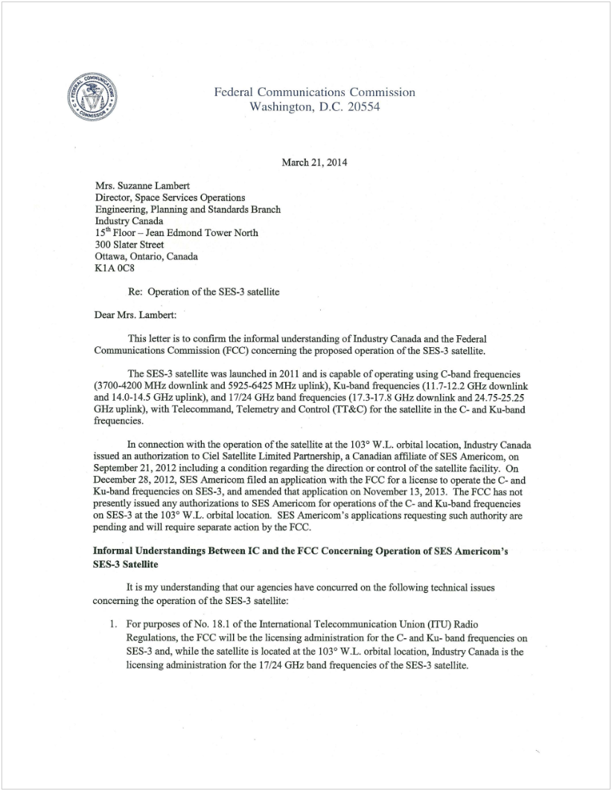
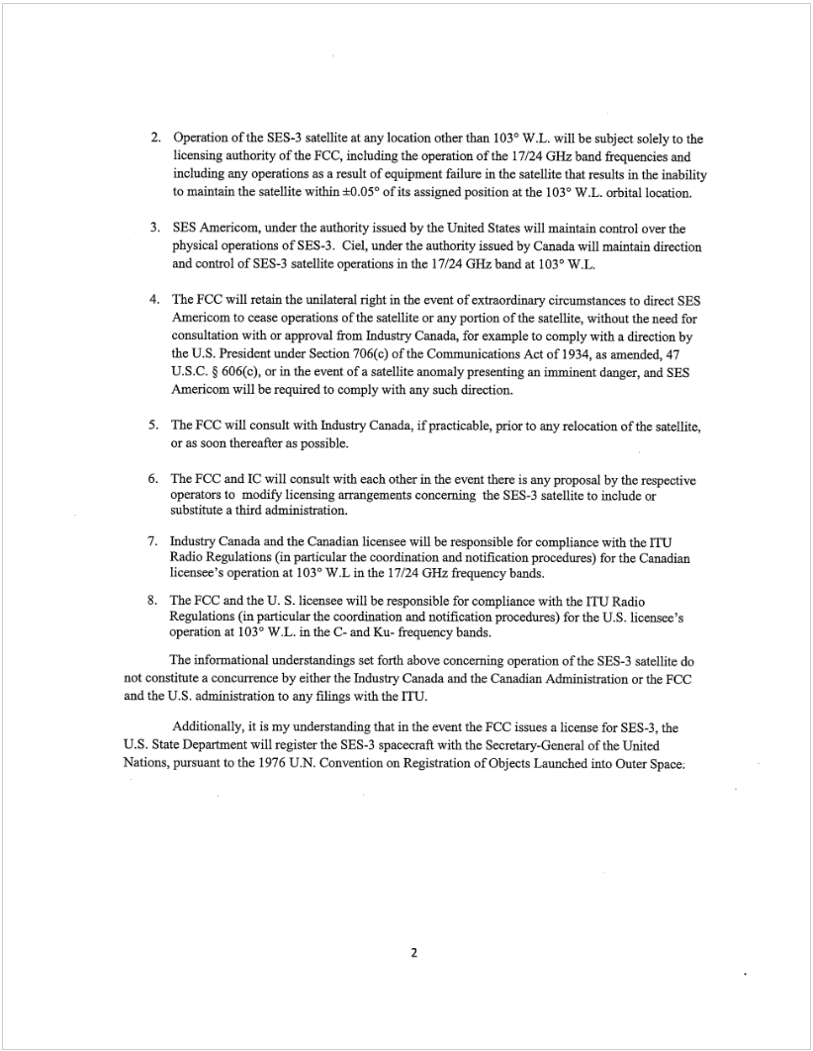
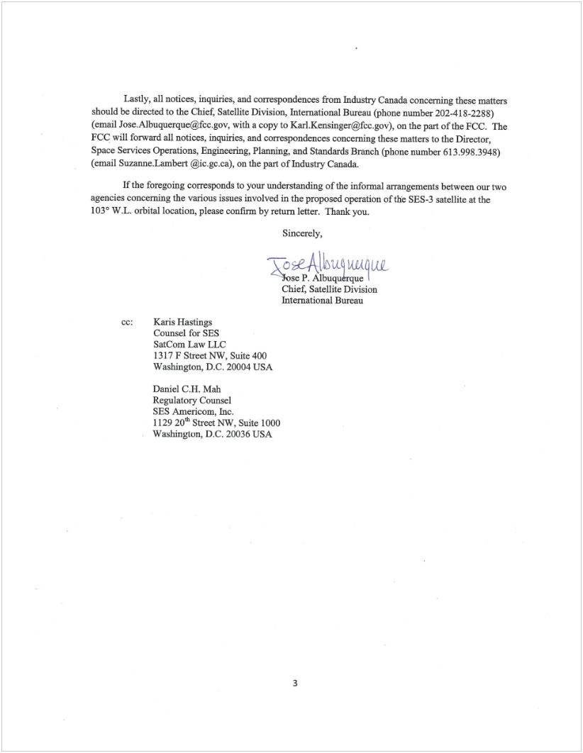
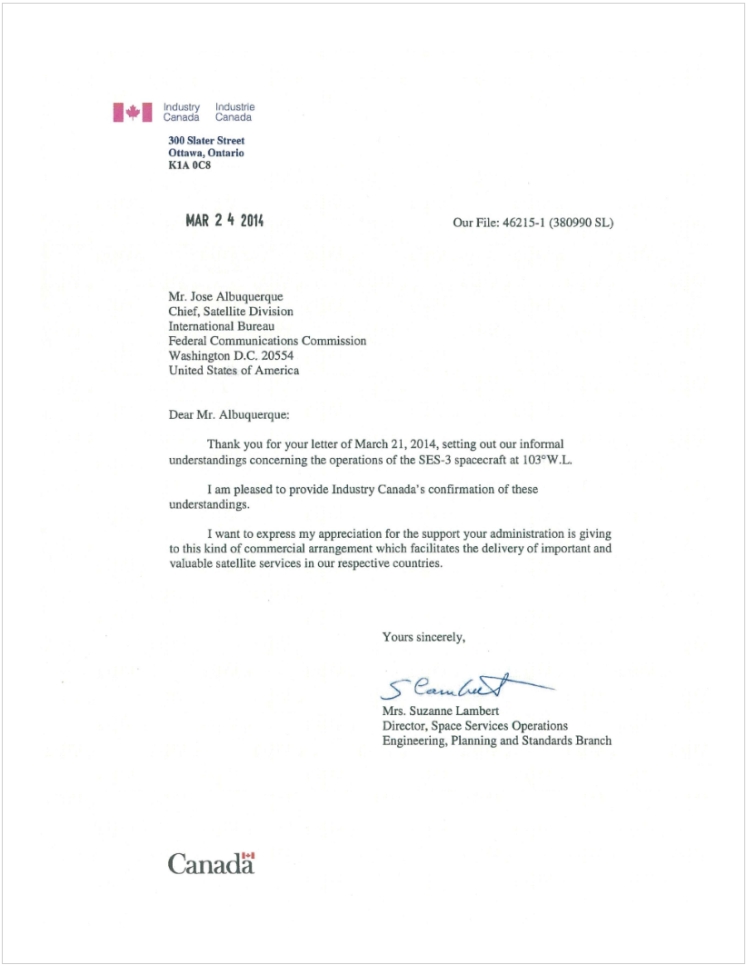

DIRECTV, LLC, Petition to Deny or Defer, IBFS File Nos. SAT-RPL-20121228-00227, SAT-AMD-20131113-00132 (filed Dec. 16, 2013) (DIRECTV Petition).
Both SES-3 and AMC-1 are capable of operating in the conventional C-band (3700-4200 MHz downlink and 5925-6425 MHz uplink) and conventional Ku-band (11.7-12.2 GHz downlink and 14.0-14.5 GHz uplink) frequencies.
SES Americom, Inc., Application to Operate the SES-3 Replacement Satellite at 103º W.L., IBFS File No. SAT-RPL-20121228-00227 (filed Dec. 28, 2012).
SES states that it expects to seek Commission authority to relocate AMC-1 to another orbital location once SES-3 is in place. Application Narrative, at n.5. AMC-1’s license term extends until October 16, 2016. GE American Communications, Inc., 3 FCC Rcd 6984 (Comm. Car. Bur. 1988); GTE Spacenet Corp. and GE American Communications, Inc., 9 FCC Rcd 1271 (Comm. Car. Bur. 1994); SES Americom, Inc., Call Sign S2445, IBFS File No. SAT-MOD-20110718-00130 (IB Sat. Div. grant Oct. 13, 2010) (granting extension of license term until Oct. 16, 2016 and deorbit authority).
Narrative at 4.
SES Americom, Inc., Amendment to Correct SFD Table, IBFS File No. SAT-AMD-2013-1113-00132 (filed Nov. 13, 2013). The AMC-1 satellite’s estimated end-of-life is April 2016. Letter from Karis A. Hastings, Counsel for SES Americom, to Marlene H. Dortch, Secretary, Federal Communications Commission (filed Feb. 11, 2014).
Narrative at 5. The AMC-1 Ku-band transponders have a polarization cant of 26 degrees while the SES-3 Ku-band transponders have horizontal and vertical polarization with no cant. Narrative at 5, n.9; Technical Appendix, Section 2.1 and Table 1.
Policy Branch Information, Satellite Space Applications Accepted for Filing, Public Notice, Report No. SAT-00980 (rel. Nov. 15, 2013).
SES Americom, Inc., Opposition, IBFS File Nos. SAT-RPL-20121228-00227, SAT-AMD-20131113-00132 (filed Dec. 24, 2013) (SES Americom Opposition).
DIRECTV, LLC, Reply, IBFS File Nos. SAT-RPL-20121228-00227, SAT-AMD-20131113-00132 (filed Jan. 3, 2014) (DIRECTV Reply).
DIRECTV Enterprises, LLC, Application for Authorization to Launch and Operate DIRECTV RB-2, a Satellite in the 17/24 GHz Broadcasting Satellite Service at the 102.825º W.L. Orbital Location, Order and Authorization, DA 09-1624 (granted July 28, 2009); DIRECTV Enterprises, LLC, Application for 17/24 GHz Satellite at 102.825º W.L., Order, IBFS File No. SAT-LOA-20060908-00100 (granted July 28, 2009). The authorization for DIRECTV’s 17/24 GHz satellite, known as DIRECTV 15, covers the 17.3-17.7 GHz of downlink spectrum but does not include the 17.7-17.8 GHz downlink spectrum which is limited to international service. DIRECTV Petition at 3, n.8.
DIRECTV Petition at 3-4.
Letter from Karis A. Hastings, Counsel for SES Americom, to Marlene H. Dortch, Secretary, Federal Communications Commission (filed Nov. 13, 2013); Letter from Margaret L. Tobey, Vice President, Regulatory Affairs, NBCUniversal Media, LLC, to Marlene H. Dortch, Secretary, Federal Communications Commission (filed Jan. 16, 2014) (NBCU Jan. 16 ex parte); Letter from Karis A. Hastings, Counsel for SES Americom, to Marlene H. Dortch, Secretary, Federal Communications Commission (filed Jan. 21, 2014); Letter from Karis A. Hastings, Counsel for SES Americom, to Marlene H. Dortch, Secretary, Federal Communications Commission (filed Jan. 28, 2014); Letter from Karis A. Hastings, Counsel for SES Americom, to Marlene H. Dortch, Secretary, Federal Communications Commission (filed Feb. 11, 2014) (SES Americom Feb. 11 ex parte); Letter from Margaret L. Tobey, Vice President, Regulatory Affairs, NBCUniversal Media, LLC, to Marlene H. Dortch, Secretary, Federal Communications Commission (filed Feb. 11, 2014); Letter from Karis A. Hastings, Counsel for SES Americom, to Marlene H. Dortch, Secretary, Federal Communications Commission (filed Feb. 18, 2014) (SES Americom Feb. 18 ex parte); Letter from Karis A. Hastings, Counsel for SES Americom, to Marlene H. Dortch, Secretary, Federal Communications Commission (filed Feb. 19, 2014); Letter from William M. Wiltshire, Counsel for DIRECTV Enterprises, LLC, to Marlene H. Dortch, Secretary, Federal Communications Commission (filed Feb. 19, 2014); Letter from Karis A. Hastings, Counsel for SES Americom, to Marlene H. Dortch, Secretary, Federal Communications Commission (filed Feb. 24, 2014); Letter from Karis A. Hastings, Counsel for SES Americom, to Marlene H. Dortch, Secretary, Federal Communications Commission (filed Feb. 24, 2014); Letter from William M. Wiltshire, Counsel for DIRECTV Enterprises, LLC, to Marlene H. Dortch, Secretary, Federal Communications Commission (filed Feb. 25, 2014); Letter from Karis A. Hastings, Counsel for SES Americom, to Marlene H. Dortch, Secretary, Federal Communications Commission (filed Mar. 4, 2014); Letter from Karis A. Hastings, Counsel for SES Americom, to Marlene H. Dortch, Secretary, Federal Communications Commission (filed Mar. 6, 2014); Letter from Karis A. Hastings, Counsel for SES Americom, to Marlene H. Dortch, Secretary, Federal Communications Commission (filed Mar. 7, 2014); Letter from Karis A. Hastings, Counsel for SES Americom, to Marlene H. Dortch, Secretary, Federal Communications Commission (filed Mar. 11, 2014); Letter from Karis A. Hastings, Counsel for SES Americom, to Marlene H. Dortch, Secretary, Federal Communications Commission (filed Mar. 11, 2014); Letter from William M. Wiltshire, Counsel for DIRECTV Enterprises, LLC, to Marlene H. Dortch, Secretary, Federal Communications Commission (filed Mar. 11, 2014).
Narrative at 5.
Industry Canada Radio License, Account No. 07-140006068, effective Sept. 21, 2012.
Narrative at 5.
See Industry Canada, “Authorized and Approved Canadian Satellites,” available at http://www.ic.gc.ca/eic/site/smt-gst.nsf/eng/sf05343.html.
Letter to Bernie Haughian, Managing Director, Ciel Satellite Limited Partnership, from Suzanne Lambert, Director, Space Services Operations, Industry Canada (Sept. 21, 2012), available at https://www.ic.gc.ca/eic/site/smt-gst.nsf/eng/sf09772.html.
47 C.F.R. § 25.113(g).
See infra ¶ 9.
Letter from Karis Hastings, Counsel for SES Americom, to Marlene H. Dortch, Secretary, Federal Communications Commission, IBFS File Nos. SAT-RPL-20121228-00227, SAT-AMD-20131113-00132 (July 19, 2013).
DIRECTV Petition at 9; DIRECTV Reply at 9-10.
DIRECTV Enterprises, LLC, Application for Authorization to Launch and Operate DIRECTV RB-2, a Satellite in the 17/24 GHz Broadcasting Satellite Service at the 102.825º W.L. Orbital Location, Order and Authorization, DA 09-1624 (granted July 28, 2009).
The Canadian CANBSS-19 filing was filed on January 30, 2006 and published in Special Section CRC 1907 with IFIC No. 2590 on March 3, 2007 prior to the date of filing of the U.S filings. USABSN-12 was filed on February 10, 2006 and published in Special Section CRC 2009 with IFIC No. 2600 on July 23, 2007, USABSN-12A, was filed on September 24, 2008 and published in Special Section CRC 2389 with IFIC No. 2648 on June 29, 2009; and, USABSN-12B filing was filed on August 19, 2011 and published in Special Section CRC 3410 with IFIC No. 2756 on October 14, 2013.
DIRECTV Petition at 9; DIRECTV Reply at 9-10.
DIRECTV Petition at 14; DIRECTV Reply at 9-10.
SES Americom Feb. 11 ex parte at 1-2; SES Americom Feb. 18 ex parte at 1-2. See also NBCU Jan. 16 ex parte at 2.

