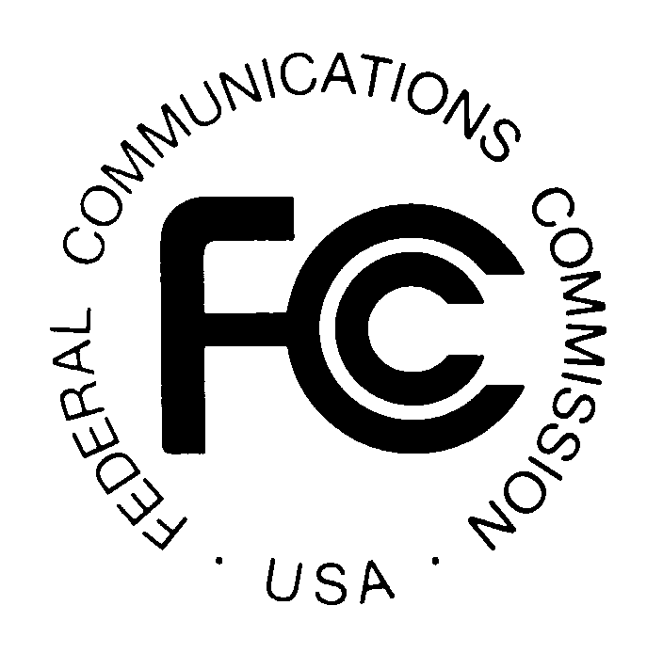
PUBLIC NOTICE

News media information 202 / 418-0500
TTY 202 / 418-2555
Internet: http://www.fcc.gov
Federal Communications Commission
445 12th St., S.W.
Washington, D.C. 20554

DA 14-475

April 8, 2014

PUBLIC SAFETY AND HOMELAND SECURITY BUREAU ANNOUNCES

REGION 21 (MICHIGAN) PUBLIC SAFETY REGIONAL PLANNING COMMITTEES TO HOLD 700 MHZ AND 800 MHZ NPSPAC MEETINGS

PR Docket No. 90-221

The Region 21(Michigan) Public Safety Regional Planning Committees (RPCs) will hold two consecutive planning meetings on Thursday, May 15, 2014. Beginning at 10:00 a.m., the 800 MHz Michigan Public Safety Frequency Advisory Committee, also known as the Region 21 800 MHz Public Safety RPC, will convene at the State of Michigan Communications Administration Building, 4000 Collins Road, Lansing, Michigan.

The agenda for the 800 MHz meeting includes:
- Call to order
- Introductions
- Approval of Agenda
- Approval of March 20, 2014 Meeting Minutes
- Applications:
- Old applications
- New applications
- 800 MHz Subcommittee Reports
- Interoperable Communications
- Engineering/Technical
- Ongoing Plan Revision Standing Committee
- Other
- Old business
- Website
- Collection of meeting minutes
- By-Laws revision
- New Member Welcome Packet
- Other
  - New business
  - Next meeting date – to be announced
  - Adjournment

Immediately following the 800 MHz Public Safety RPC meeting, the 700 MHz Public Safety RPC will convene at the same location.

The agenda for the 700 MHz meeting includes:
  - Call to order
  - Introductions
  - Approval of Agenda
  - Approval of March 20, 2014 Meeting Minutes
  - Applications:
- Old applications
- New applications
  - Subcommittee Reports
- Standing 700 MHz Plan Update
- Other
  - Old Business
  - New Business
  - Next meeting date – to be announced
  - Adjournment

Both Region 21 Public Safety RPC meetings are open to the public. All eligible public safety providers in Region 21 may utilize these frequencies. It is essential that eligible public safety agencies in all areas of government, including state, municipality, county, and Native American Tribal be represented in order to ensure that each agency’s future spectrum needs are considered in the allocation process. Administrators who are not oriented in the communications field should delegate someone with this knowledge to attend, participate, and represent their agency’s needs.

All interested parties wishing to participate in planning for the use of public safety spectrum in the 700 MHz and 800 MHz bands within Region 21 should plan to attend. For further information, please contact:

Keith M. Bradshaw, CET
Chair, Region 21 700 MHz and 800 MHz RPCs
Macomb County Technical Services
21930 Dunham
Mount Clemens, Michigan 48043
(586) 469-6433
Keith.bradshaw@macombgov.org

- FCC -

The Region 21 (Michigan) 700 MHz regional planning area includes all eighty-three counties in the Upper and Lower Peninsulas in the state of Michigan. The Region 21 800 MHz regional planning area consists of all the Upper Peninsula and all counties in the Lower Peninsula except the counties of Allegan, Barrien, Barry, Cass, Kalamazoo, Ottawa, St. Joseph, and Van Buren, which are part of the Region 54 (Great Lakes Area).

