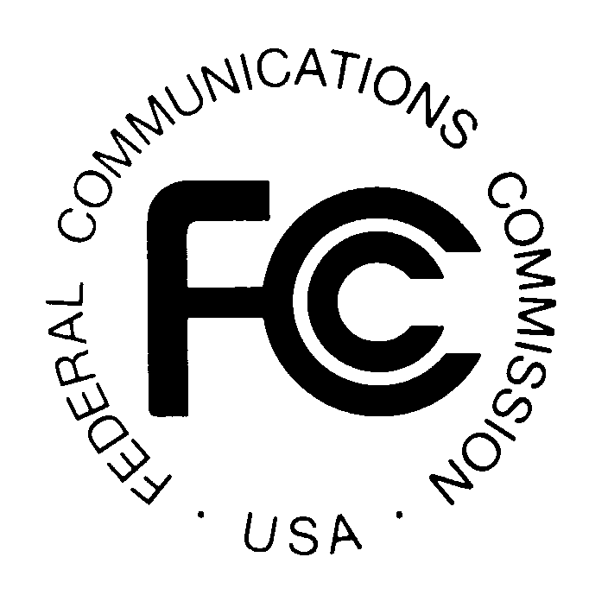
PUBLIC NOTICE

News media information 202 / 418-0500
TTY 202 / 418-2555
Internet: http://www.fcc.gov
Federal Communications Commission
445 12th St., S.W.
Washington, D.C. 20554

DA 14-476

April 8, 2014

PUBLIC SAFETY AND HOMELAND SECURITY BUREAU ANNOUNCES

REGION 9 (FLORIDA) PUBLIC SAFETY REGIONAL PLANNING COMMITTEES

TO HOLD 700 MHZ AND 800 MHZ NPSPAC MEETINGS

Gen. Docket No. 90-119

The Region 9 (Florida) Public Safety Regional Planning Committees (RPCs) will hold two consecutive planning meetings on Wednesday, May 21, 2014. Beginning at 9:00 a.m., the 700 MHz Public Safety RPC will convene at the Wyndham Lake Buena Vista Resort, 1850 Hotel Plaza Boulevard, Lake Buena Vista, Florida 32830.

The agenda for the 700 MHz meeting includes:
- Review of Officers and any open positions
- By-Laws and amendments to the Regional Plan
- General status report from the State of Florida
- Adjourn

Beginning at 1:00 p.m., the 800 MHz Public Safety RPC will convene at the same location.

The agenda for the 800 MHz meeting includes:
- Review of Officers and any open positions
- By-Laws and amendments to the Regional Plans
- General status report from the State of Florida
- Adjourn

Both Region 9 Public Safety RPCs’ meetings are open to the public. All eligible public safety providers in Region 9 may utilize these frequencies. To ensure that RPC meetings consider each agency’s future spectrum needs in the allocation process, it is essential that eligible public safety agencies in all areas of government, including state, municipality, county, and Native American Tribal be represented. Administrators who are not oriented in the communications field should delegate someone with this knowledge to attend, participate, and represent their agency’s needs.

All interested parties wishing to participate in planning for the use of public safety spectrum in the 700 MHz and 800 MHz bands within Region 9 should plan to attend. For further information, please contact:

Ray Carlson, Chairman
Region 9 700 MHz and 800 MHz Public Safety RPCs
3228 Gun Club Road
West Palm Beach, Florida 33406
(561) 688-3514
carlsonr@pbso.org

- FCC -

