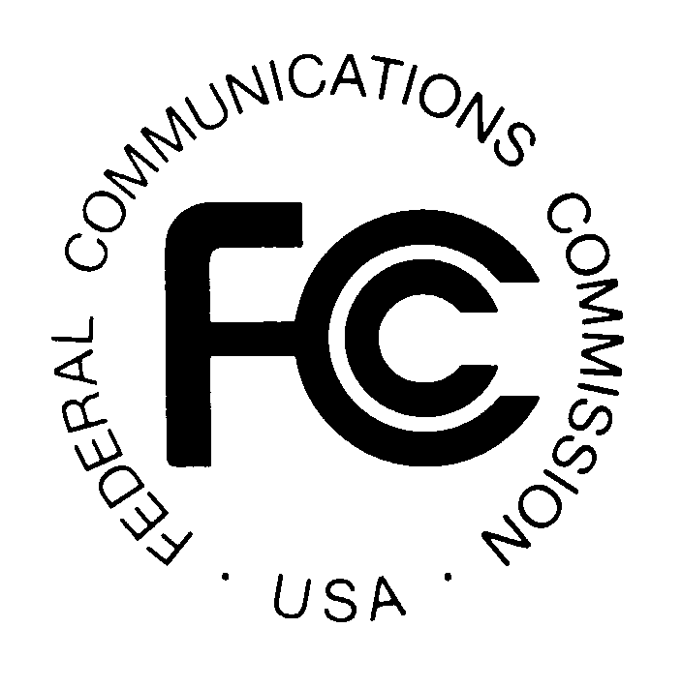
News media information 202 / 418-0500
TTY 202 / 418-2555
Internet: http://www.fcc.gov
PUBLIC NOTICE

Federal Communications Commission
445 12th St., S.W.
Washington, D.C. 20554

DA 14-511

April 16 , 2014

PUBLIC SAFETY AND HOMELAND SECURITY BUREAU ANNOUNCES

REGION 38 (SOUTH DAKOTA) 700 MHZ PUBLIC SAFETY REGIONAL PLANNING COMMITTEE TO HOLD MEETING

The Region 38 (South Dakota) 700 MHz Public Safety Regional Planning Committee (RPC) will hold its next meeting on Thursday, May 15, 2014, from 9:00 a.m. to 12:00, MDT at the South Dakota Division of Wildland Fire, Airport Old Terminal Building, 4250 Fire State Road, 24 Conference Room A, Rapid City, South Dakota 57703. The purpose of the meeting is to initiate the public safety Region 38 planning process for the General Use (769-775/799-805) frequencies located in the 700 MHz frequency band.

The agenda for the meeting includes:
- Introductions and record of attendance
- Region 38 700 MHz planning -- presentation by the Region’s consultant, ACD Telecom, LLC
- Open discussion on what is needed to develop the Region 38 700 MHz Plan
- Description of Planning Committee roles and duties
- Elect third member to the Planning Committee, and identify and assign members to other subcommittees
- Review action items and schedule next meeting

The Region 38 700 MHz RPC meeting is open to the public. It is essential that public safety agencies in all areas of government, including state, municipality, county, and Native American Tribal, and non-governmental organizations eligible under Section 90.523 of the Commission’s rules, 47 C.F.R. § 90.523, be represented in order to ensure that each agency’s future spectrum needs are considered in the allocation process. Administrators who are not oriented in the communications field should delegate someone with this knowledge to attend, participate, and represent their agency’s needs.

All interested parties wishing to participate in the planning for the use of public safety spectrum in the 700 MHz band within Region 38 should plan to attend. For further information, please contact:

Todd Dravland, Chairman
Region 38 (South Dakota) 700 MHz Public Safety RPC
State Radio Engineering, 1302 E. Highway 14, Suite 8, Pierre, South Dakota 57501
(605) 773-4635 or Todd.Dravland@state.sd.us

The General Use spectrum is administered by regional planning committees and is licensed for public safety services on a site-by-site basis in accordance with the relevant Commission-approved regional plan and frequency coordination. -FCC-

