DA 14-637

Ms. Joslyn Read
Vice President, Regulatory Affairs
O3b Limited
900 17th Street NW, Suite 300
Washington, DC 20006

Re: O3b Limited
Earth Stations on Non-U.S. Registered Maritime Vessels using the 28.6 - 29.1 GHz and the 18.8-19.3 GHz frequency bands

Dear Ms. Read:

On October 23, 2013, O3b Limited (O3b) filed a request for waiver of the United States Table of Frequency Allocations and the Commission’s Ka-band Plan in connection with its plan to operate a network of earth stations aboard non-U.S. registered maritime vessels in and near U.S. territorial waters. O3b filed its waiver request in conjunction with its blanket license application to operate earth stations aboard U.S.-registered maritime vessels that will communicate with O3b’s Ka-band NGSO FSS system in U.S. territorial waters, international waters, and foreign waters. In its application, O3b explains that it will operate its earth stations aboard both U.S. registered maritime vessels and non-U.S. registered maritime vessels under the same technical characteristics and operating parameters. In both circumstances, O3b will use 2.2 meter and 1.2 meter antennas to communicate with its non-geostationary orbit (NGSO) Fixed-Satellite Service (FSS) system licensed by the United Kingdom. The antennas will transmit in the 28.6-29.1 GHz frequency band and receive in the 18.8-19.3 GHz frequency band and the same models of antennas will be installed on the U.S.-registered vessels and the non-U.S. registered vessels. O3b indicates that its operations aboard non-U.S.-registered vessels will be pursuant to an authorization from the country of registry of the respective maritime vessel.

Although the Commission does not license transmissions on non-U.S. registered maritime vessels, O3b is nevertheless required to comply with the Commission’s interference regulations to the extent its signals are received within the United States. The use of the radiocommunication frequencies in the United States must be in accordance with the Table of Frequency Allocations contained in Section 2.106 of the Commission’s rules. O3b plans to operate the earth stations on non-U.S. registered vessels in frequency bands allocated to NGSO FSS on a primary basis, and seeks a waiver to the extent necessary to allow use of these bands aboard non-U.S. registered vessels when operating in U.S. territorial waters. Because the Commission has not adopted technical rules governing satellite operations in the Ka-band NGSO FSS bands aboard maritime vessels, we view O3b’s planned operations as requiring a waiver of the Commission’s Table of Frequency Allocations and the Ka-band Plan.

In considering requests for non-conforming spectrum uses, the Commission has indicated it would generally grant such waivers when there is little potential for interference into any service authorized under the Table of Frequency Allocations and when the non-conforming operator accepts any interference from authorized services. O3b represents that its operations will not cause harmful interference to present or future users. In particular, O3b provides an analysis that it will not cause interference to any GSO satellite network operating in these bands and will accept interference from any terrestrial users. At present, there are no other NGSO FSS satellite systems operating in these bands. No parties commented on its proposed operations. Based on the information on file with the Commission, the proposed operations do not pose a risk of interference to other users of the band. Consequently, we grant O3b’s waiver request conditioned on operations on an unprotected, non-interference basis in the 28.6-29.1 GHz (Earth-to-space) and 18.8-19.3 GHz (space-to-Earth) bands. Accordingly, O3b’s operations on non-U.S. registered maritime vessels must accept interference from any authorized users in these bands and may not cause harmful interference to any authorized user in these bands.

Sincerely,

Jose P. Albuquerque
Chief, Satellite Division
International Bureau

Mark Settle
Chief, Policy and Rules Division
Office of Engineering and Technology

ATTACHMENT

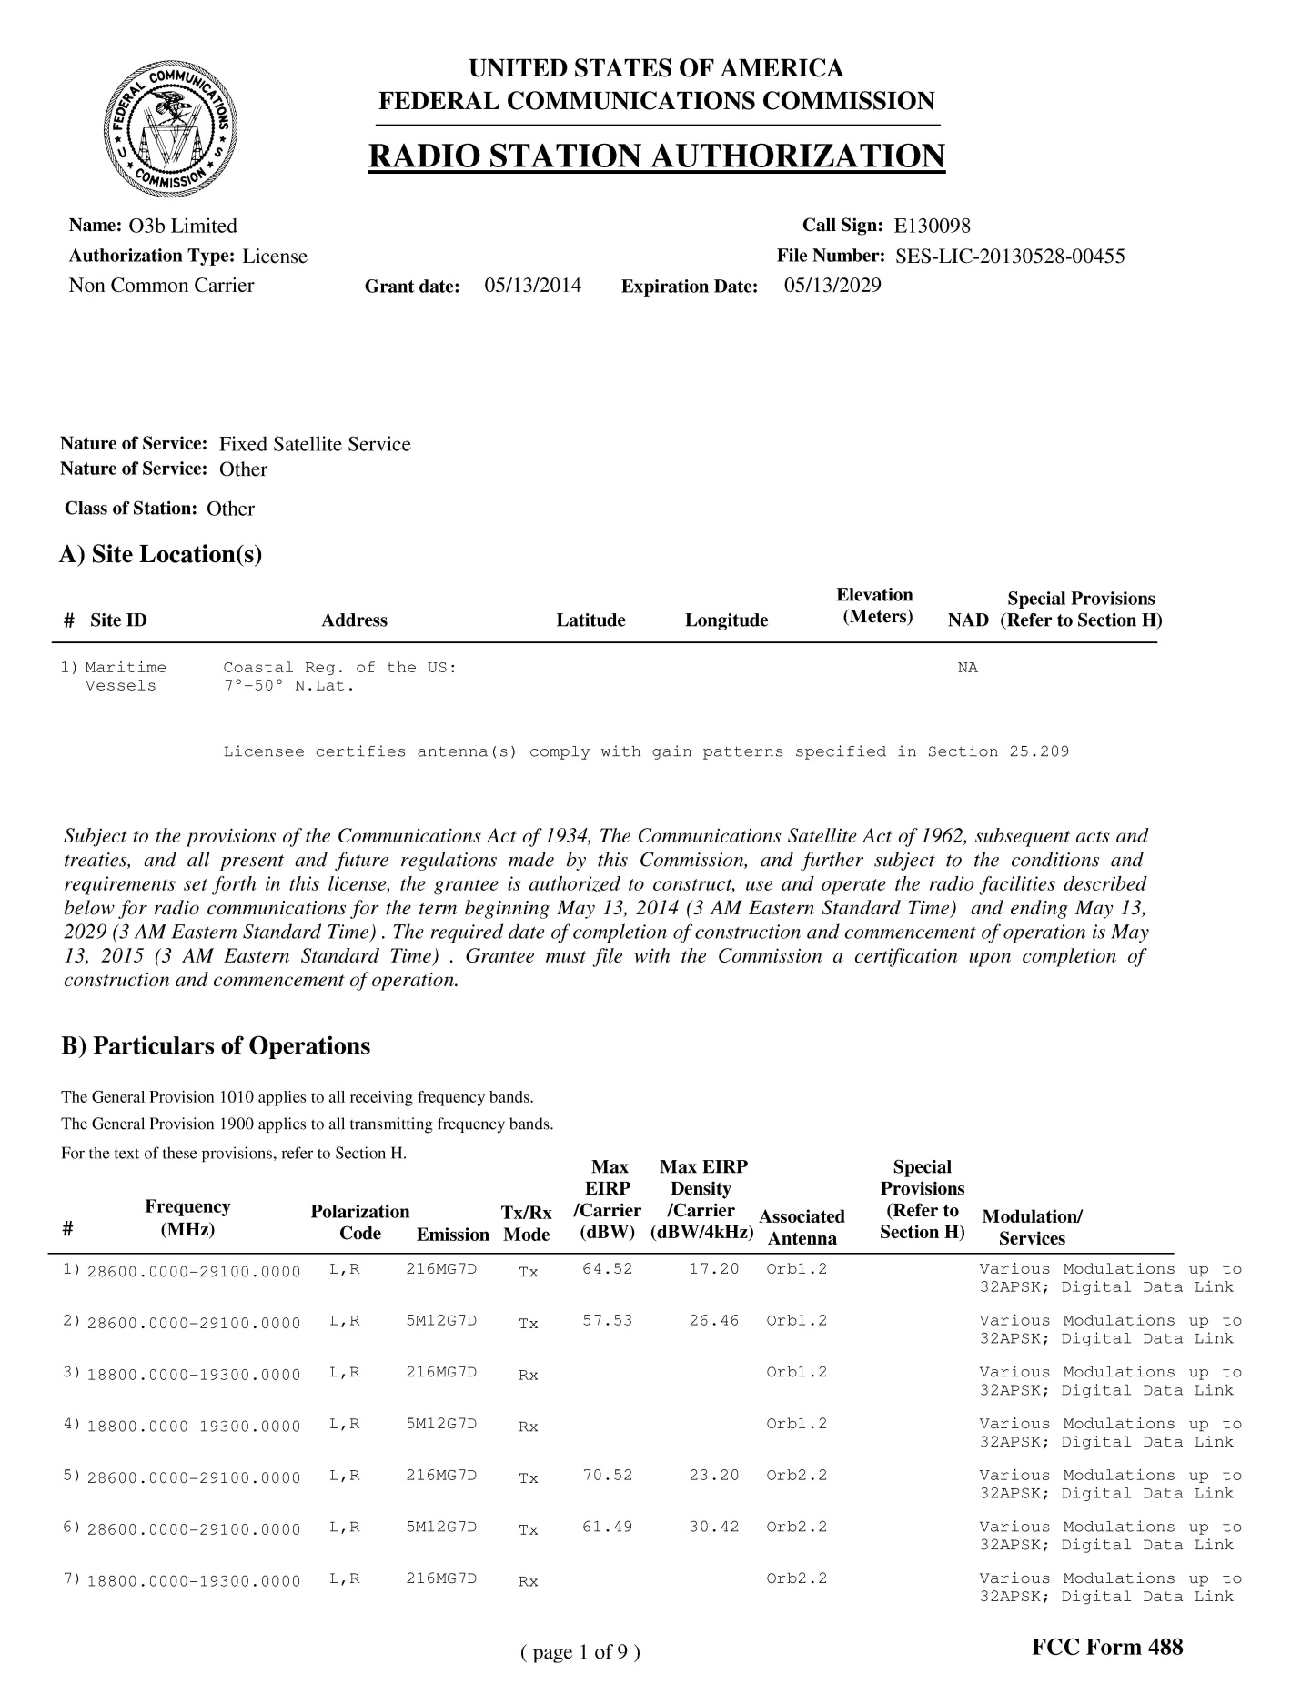

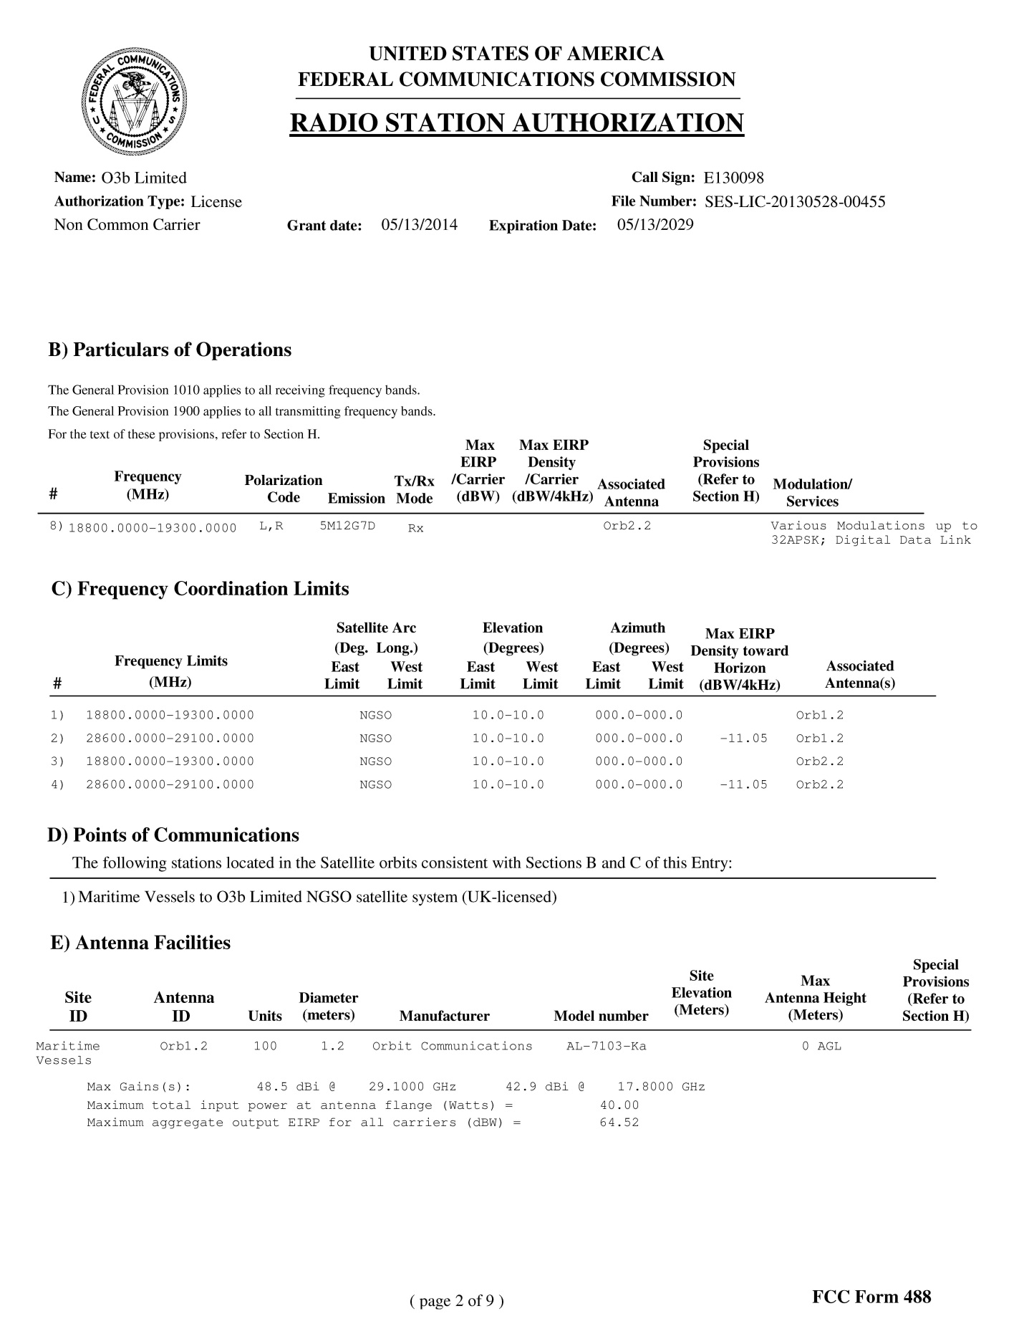

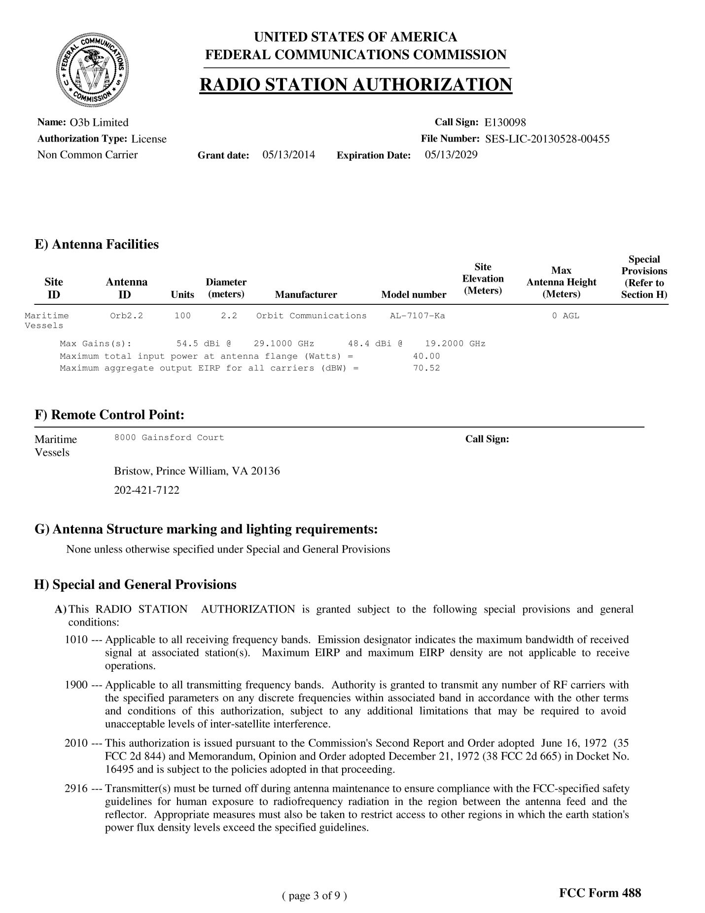

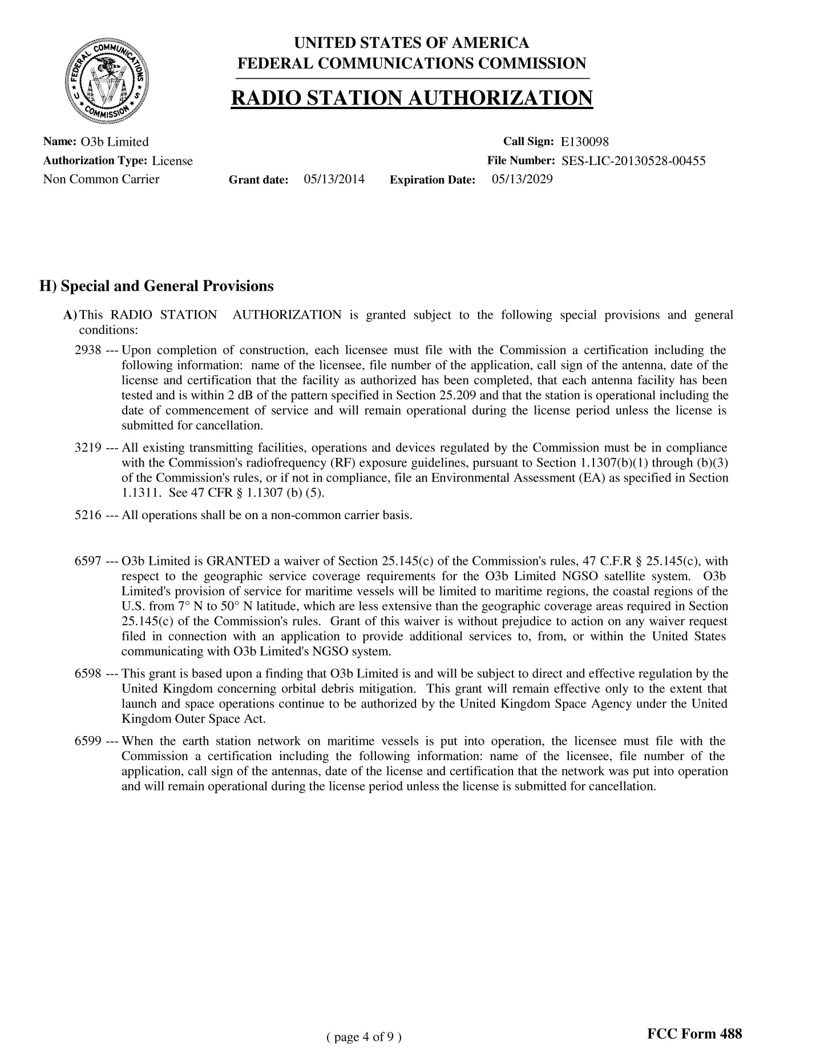

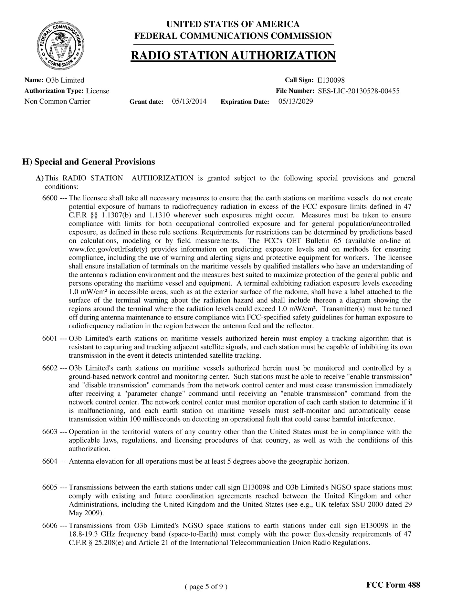

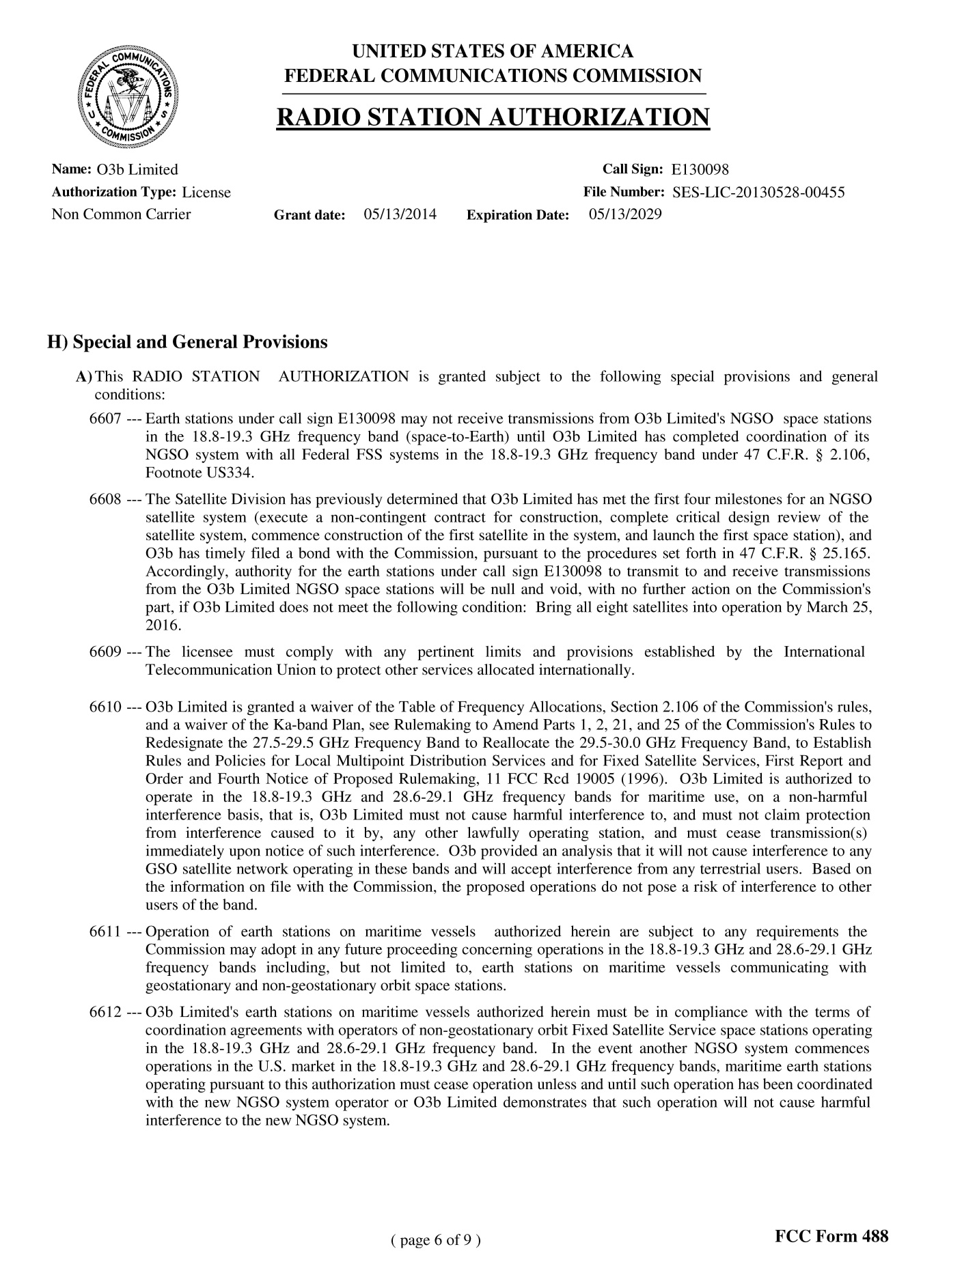

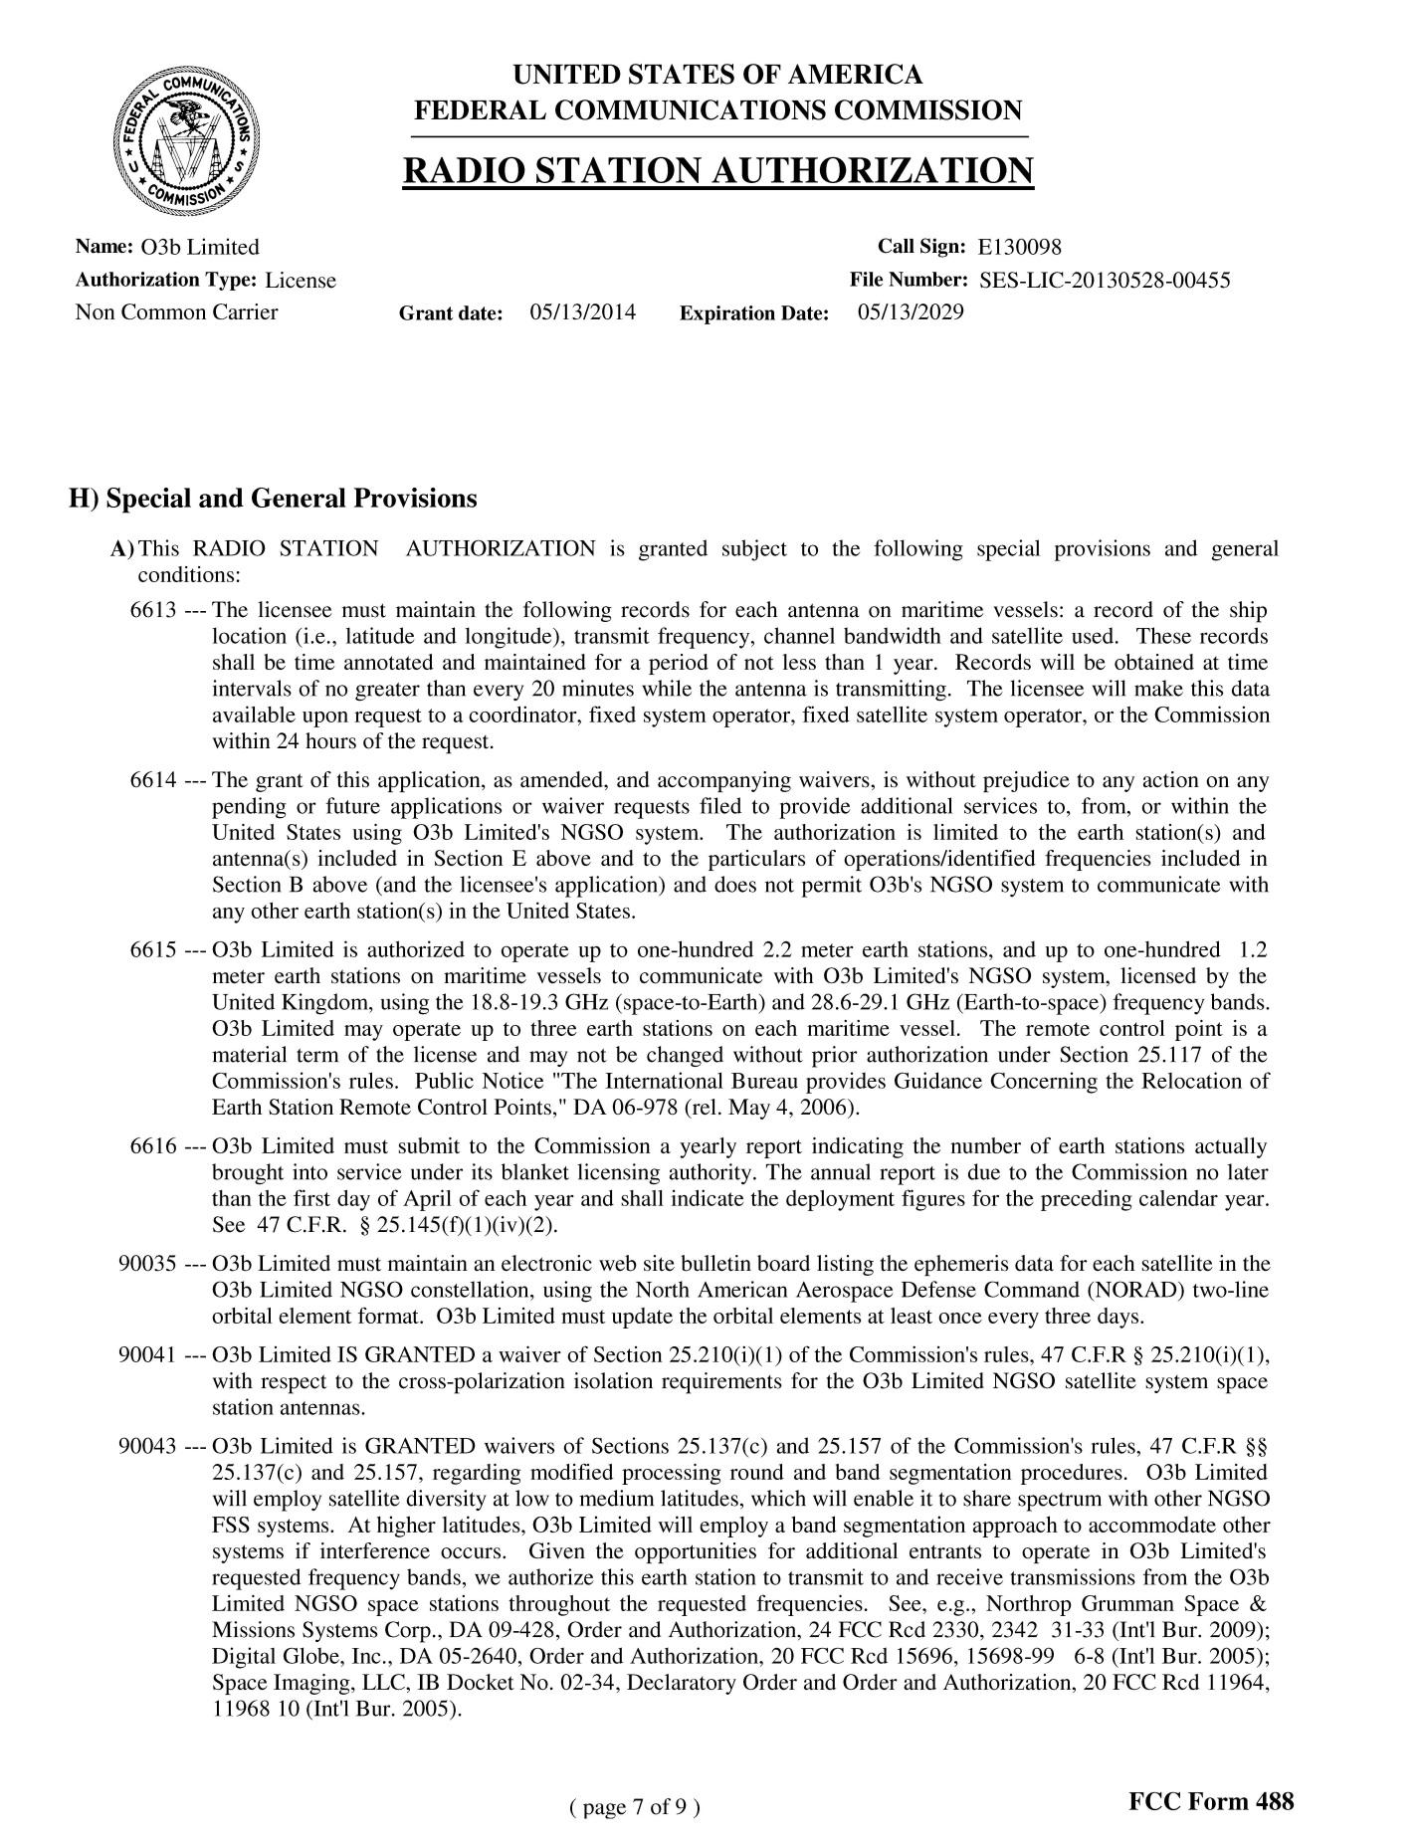

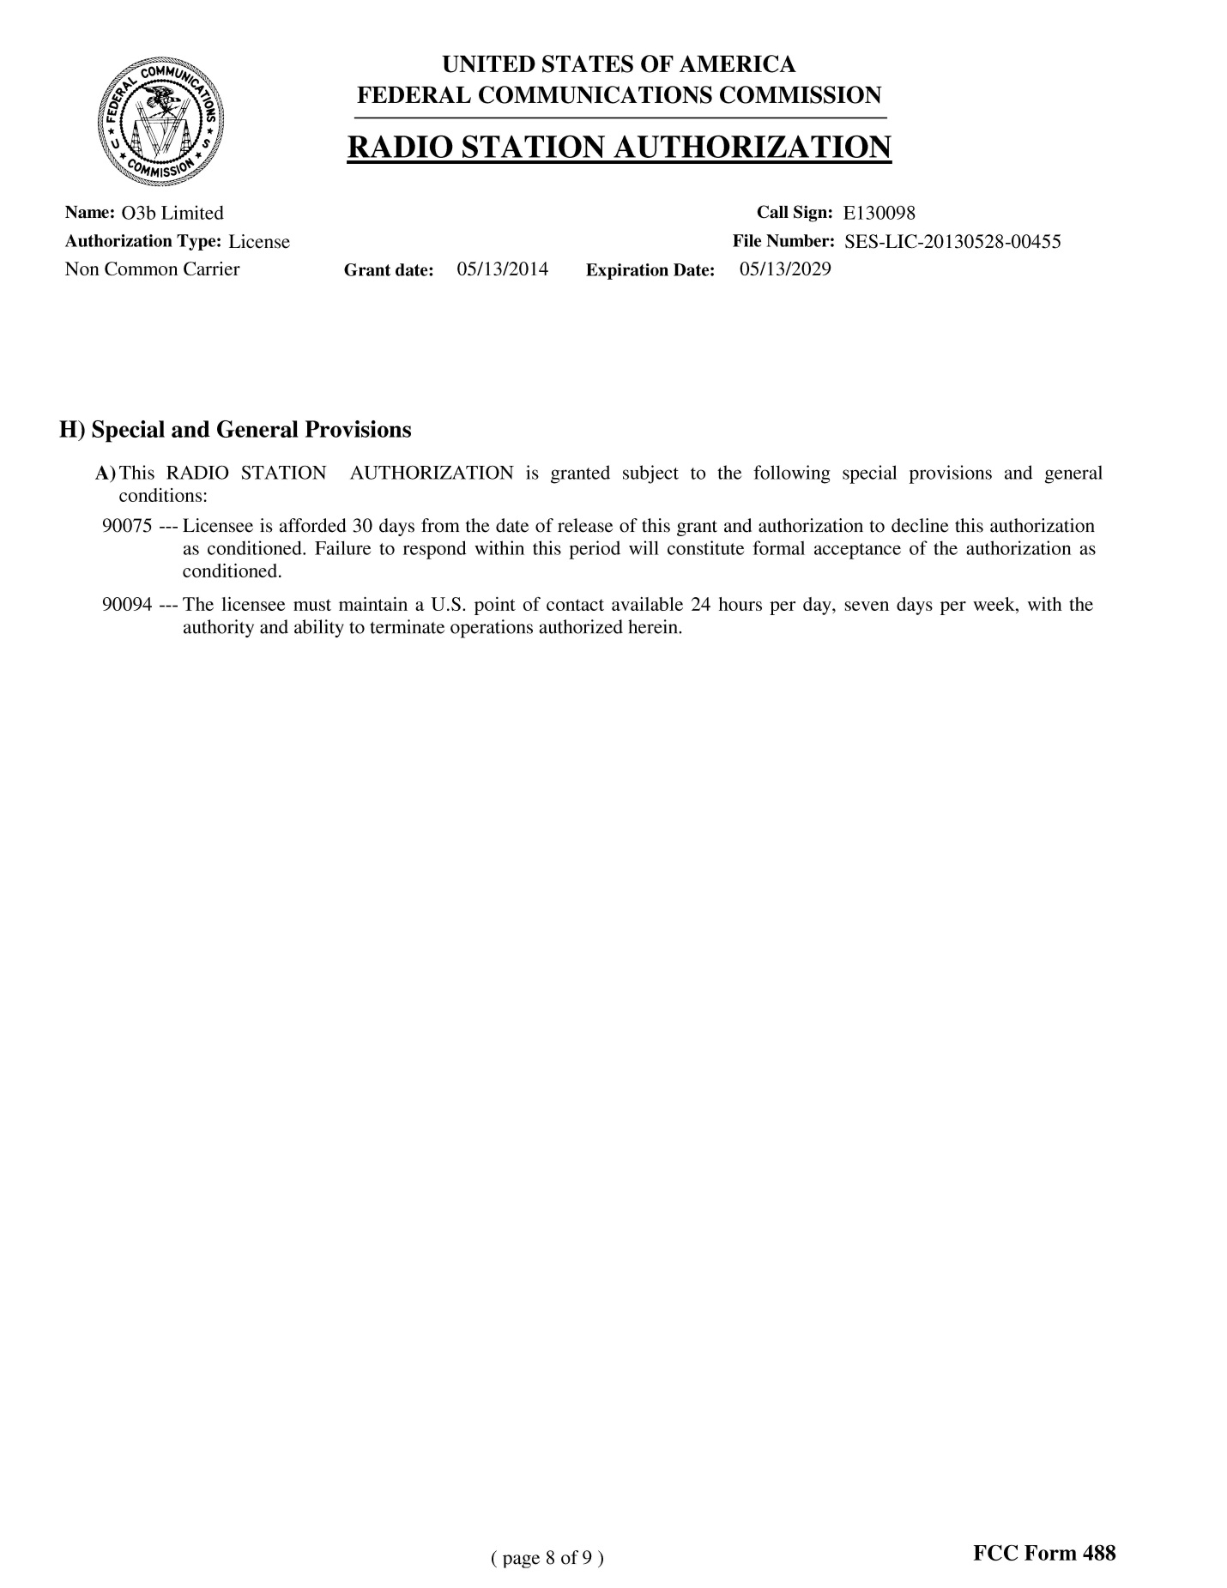

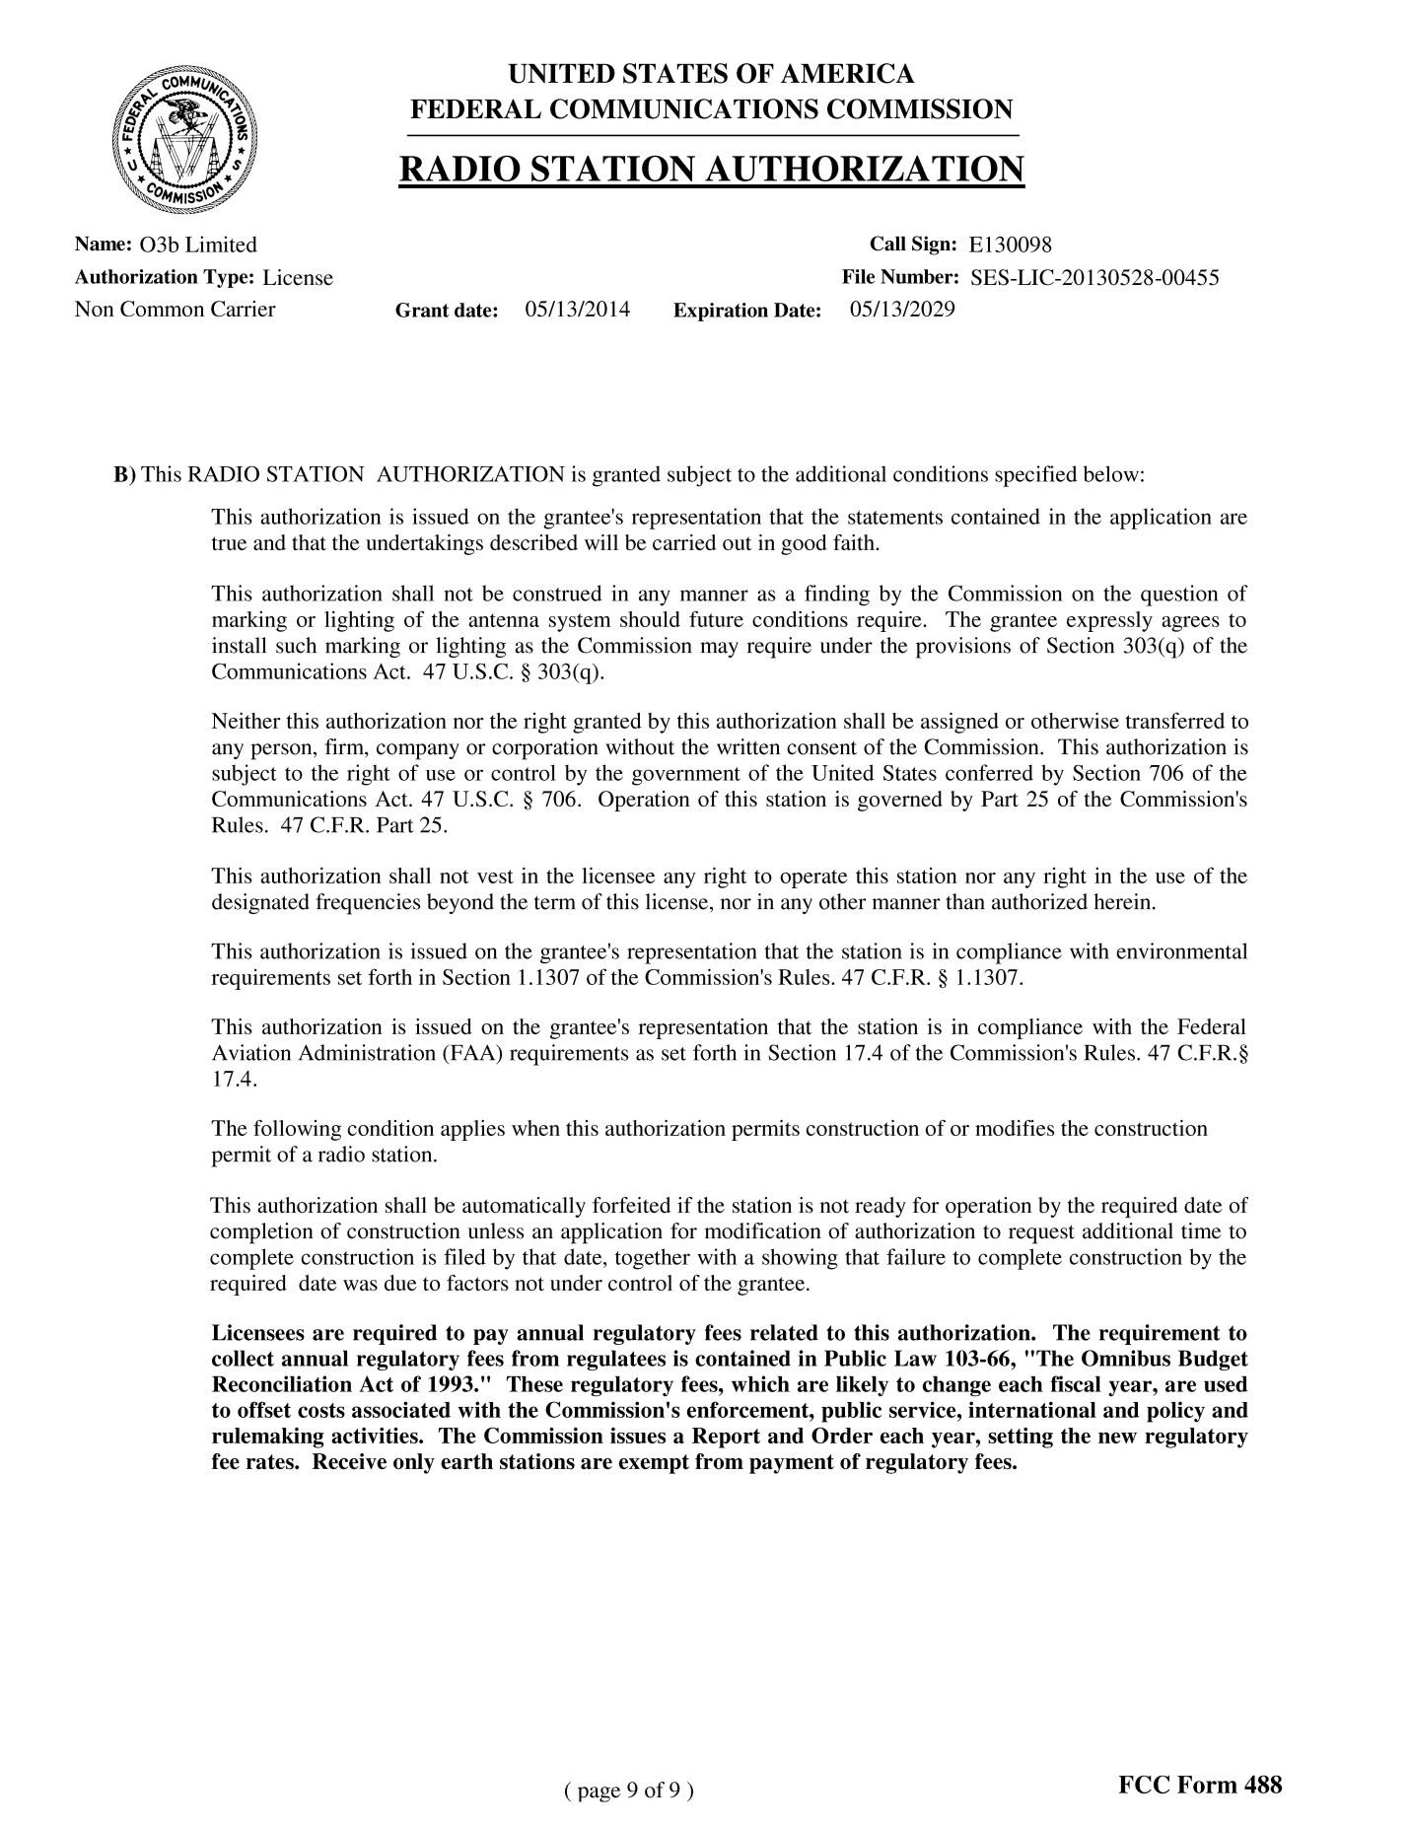

The Commission issued a series of related Orders in CC Docket No. 92-297. The First Report and Order in the proceeding established an allocation plan for use of the Ka-band by non-Federal users. Rulemaking to Amend Parts 1, 2, 21, and 25 of the Commission's Rules to Redesignate the 27.5-29.5 GHz Frequency Band, to Reallocate the 29.5-30.0 GHz Frequency Band, to Establish Rules and Policies for Local Multipoint Distribution Service and for Fixed Satellite Services, First Report and Order and Fourth Notice of Proposed Rulemaking, 11 FCC Rcd 19005 (1996) (Ka-band Report and Order), modified by Third Report and Order, 12 FCC Rcd 22310 (1997).
O3b Limited, IBFS File Nos. SES-LIC-20130528-00455 and SES-AMD-20131025-01138, Call Sign: E130098 (O3b Blanket Application). The Blanket Application was placed on Public Notice as acceptable for filing. Satellite Applications Accepted for Filing, Public Notice, Report No. SES-01600 (Nov. 27, 2013). No comments were filed. Earlier today, the Commission granted O3b’s Blanket License Application, a copy of which is attached to this letter.
O3b Limited, IBFS File No. SES-LIC-20130528-00455 (Blanket Application) at 2, 6, and Response to FCC Questions at 3 (Supplement) (Filed Oct. 25, 2013).
O3b launched its first set of four satellites in 2013. The second set of four satellites is planned to launch in 2014. The Commission previously authorized O3b to operate two FSS earth stations to communicate with O3b’s NGSO FSS Ka-band system. The first authorization was for a fixed earth station in Haleiwa, Hawaii, and the second authorization was for a fixed earth station in Vernon, Texas. O3b Limited, IBFS File No. SES-LIC-20130124- 00089 (Vernon, Texas, Call Sign E130021), granted June 20, 2013 and IBFS File No. SES-LIC-20100723-00952 (Haleiwa, Hawaii, Call Sign E100088), granted Sept. 25, 2012. The Haleiwa, Hawaii, earth station provides gateway and telemetry, tracking and command (TT&C) services and the Vernon, Texas, earth station provides gateway and back-up TT&C services.
It is our understanding that O3b’s operations will comply with coordination agreements reached between the United Kingdom and other Administrations, including all coordination agreements reached between the United Kingdom and the United States (see e.g., UK Telefax SSU 2000 dated 29 May 2009). Further, O3b will not receive transmissions from O3b’s NGSO space stations in the 18.8-19.3 GHz frequency band (space-to-Earth) until O3b has completed coordination of its NGSO FSS system with all Federal FSS systems in the 18.8-19.3 GHz frequency band under 47 C.F.R. § 2.106, Footnote US334.
Supplement at 3-4.
Letter to Marlene H. Dortch, Secretary FCC, from Joslyn Read, Vice President, Regulatory Affairs, O3b Limited (March 10, 2014).
See 47 U.S.C. § 306. This section provides that Section 301 of this title shall not apply to any person sending radio communications or signals on a foreign ship while the same is within the jurisdiction of the United States, but such communications or signals shall be transmitted only in accordance with such regulations designed to prevent interference as may be promulgated under the authority of this chapter. See also United States v. McIntire, 365 F. Supp. 618, 622 n.11 (D.N.J., 1973)(The Commission has authority to take action against a party broadcasting in violation of its rules, without a license, and whose broadcasts causes interference to Commission-licensed broadcasters, even though the broadcaster was operating from a boat outside U.S. territorial waters).
47 C.F.R. § 2.106; Ka-band Report and Order, 11 FCC Rcd 19005 (1996) and Third Report and Order, 12 FCC Rcd 22310 (1997).
Contactmeo Communications, LLC, Order and Authorization, 21 FCC Rcd 4035, 4044 (IB 2006); see also 47 C.F.R. § 1.3.
GSO FSS satellites operate in the 28.6-29.1 GHz frequency band (Earth-to-space) on a secondary basis and in the 18.8-19.3 GHz frequency band on a non-interference basis (space-to-Earth). Among other things, in its blanket license application, O3b explained that there will always be an off-axis discrimination of more than 2.6 degrees between GSO orbits and O3b’s NGSO orbit as viewed from the terminals aboard the ships and O3b’s system will operate within acceptable power flux density limits applicable to GSO FSS operations. O3b Blanket Application at 17-20).
There are no Fixed Service allocations in the 28.6-29.1 GHz frequency band. Terrestrial fixed licenses in the 18.8-19.3 GHz are no longer grandfathered. See 47 C.F.R. § 101.85(b)(2). O3b Limited’s earth stations receive in the 18.8-19.3 GHz frequency band and it agrees to accept any interference from any terrestrial users. Blanket Application at 7.

