



**Appendix:**

**Analysis of Potential Aggregate Interference**

# Introduction to the Appendix

The Incentive Auction Task Force, which is comprised of staff from the Commission’s Office of Engineering and Technology, Office of Strategic Planning and Policy Analysis, and the International, Media, and Wireless Telecommunications Bureaus, is releasing, in conjunction with today’s Public Notice,a staff analysis of potential impacts of aggregate interference on television stations as a result of the repacking process. This Appendix describes the approach followed in conducting this analysis, including various preliminary staff assumptions necessary to complete this study.

FCC staff created a large set of representative repacking scenarios by simulating the reverse auction using a diverse set of station selection methodologies which facilitated the generation of a broad range of possible post-auction channel plans. Each plan of tentative channel assignments was then run through *TVStudy* to determine how much new aggregate interference individual stations were predicted to experience. The approach used to generate these post-auction channel plans is described in detail in **Section 4**, and the results are shared in **Section 5**.

Guiding the repacking process in these simulations were pairwise constraints consistent with Option 2 in the NPRM,[1] adopted by the Commission in the *Report and Order*.[2] The approach outlined in Option 2 is also consistent with the approach described in the *Repacking Data PN* released in July of 2013, as well as the pairwise constraints which were released in conjunction with the July Notice.[3]

The study of aggregate interference, however, also required FCC staff to make several new preliminary assumptions because they were not addressed in the *Repacking Data PN*. For example, the specific approach to calculate aggregate interference was not addressed in the *Repacking Data PN*. Moreover, FCC staff used this opportunity to take advantage of recent improvements to the FCC’s constraint generation approach for use in repacking, as well as to update preliminary assumptions about which facilities the Commission will protect in the repacking process. These changes are detailed in **Section 2** and **Section 3** of this Appendix.

The primary change resulting from recent improvements to the FCC’s constraint generation was the ability to calculate interference using actual (or specific) channels rather than proxy channels, which were intended to be representative of each television broadcast band. This differs from the approach taken in the *Repacking Data PN*, where proxy channels were used to reduce complexity.[4] Recent improvements to *TVStudy* and constraint generation approaches now make the consideration of actual-channel constraints feasible. Staff believes that these actual-channel constraints will be more accurate than constraints based on proxy channels.[5] Building upon this, the Commission adopted the use of actual channels in the *Report and Order*.[6]

Staff is now releasing these new actual-channel constraint files (both an updated *Interference_Paired* file and a *Domain* file). These updated constraint files can be used by interested parties as an input into third party repacking software packages so that new post-auction channel plans can be generated which are consistent with these new constraints. Together with the approach for calculating aggregate interference detailed in **Section 3**, interested parties can then assess the impact of aggregate interference under various scenarios or validate the FCC’s own results.

The updated constraint files consist of two files for each station:

1. A ***Domain file*** (called Domain_2014May20.csv) defining the domain of available channels of any station given certain fixed constraints.
2. An ***Interference_Paired file*** (called Interference_Paired_2014May20.csv) defining which pairs of stations cannot operate co-channel, upper-adjacent channel, or lower-adjacent channel to each other given the amount of potential interference between them, calculated using actual channels.

The constraint files will be accessible via a link on the FCC’s LEARN website under the Repacking Section, which can be found at <http://wireless.fcc.gov/incentiveauctions/learn-program/repacking.html>. Alternatively, these files will be posted at [http://data.fcc.gov/download/incentive-auctions/  
Constraint_Files/](http://data.fcc.gov/download/incentive-auctions/Constraint_FilesXXXX/).

# Key Changes to Constraint Files

As described in **Section 1**, FCC staff needed to revisit certain assumptions made to create the initial pairwise constraint files released in conjunction with the July 2013 *Repacking Data PN* to reflect recent improvements to the constraint generation capabilities and to update preliminary staff assumptions regarding protected facilities. The primary change was the FCC staff’s ability to transition from constraint files based on interference calculations using “proxy channels”[7] to constraint files based on interference calculations using actual (or specific) channels. These new constraints should be more accurate than constraints based on proxy channels because the interference and coverage determinations (using *TVStudy* software) are made for every channel within each band rather than on one representative proxy channel. These actual-channel constraints also address concerns with the use of proxy channels raised by the NAB.[8]

## Reading Actual Channel *Interference_Paired* File Format

Moving to actual-channel constraints did not cause any format changes to the existing *Domain* file, though, as described in the following section, the attached files reflect an update to the underlying data from the *Domain* file that was released in July 2013.[9] However, the *Interference_Paired* file’s format does change slightly with respect to the way that the considered channels are expressed due to the move to actual-channel constraints:

**Interference Type**

**Interfering Stations**

**Study**

**Station**

**Channels**

**Considered**

CO, 2, 2, 5243, 5237, 17680, 35694, 35724, 47670, 169030

ADJ+1, 2, 3, 5243, 47670

ADJ-1, 3, 2, 5243, 47670

***In words, the first line reads:***

After re-packing, if Station #5243 is placed on channel 2, then Stations #5237, #17680, #35694, #35724, #47670, and #169030 cannot be placed on channel 2 (co-channel).

***In words, the second line reads:***

After re-packing, if Station #5243 is placed on channel 2, then Station #47670 cannot be placed on channel 3 (*meaning cannot be upper-adjacent to Station #5243)*.

***In words, the third (last) line reads:***

After re-packing, if Station #5243 is placed on channel 3, then Station #47670 cannot be placed on channel 2 (*meaning cannot be lower-adjacent to Station #5243*).

## Changes to the Station/Allotment Lists Underlying the Constraint Files

In addition to moving to actual-channel constraints, FCC staff also updated the underlying data which are used in creating the constraint files. The changes update preliminary staff assumptions regarding the universe of stations that will be protected during the auction. However, we emphasize that the facilities or allotments (including foreign allotments along the U.S. border) that will ultimately be protected will be decided by the Commission in the *Report and Order* or at a later date, and that these lists are for illustrative purposes only.

The key updates to the data released with the *Repacking Data PN* include the following:

1. **An update to the illustrative list of protected U.S. facilities**:

In the *Repacking Data PN*, staff used criteria consistent with the *NPRM* to establish an illustrative U.S. Station Baseline List.[10] For purposes of this aggregate interference analysis, and consistent with protections adopted by the Commission in the *Report and Order*, FCC staff included all stations that were already in operation as of February 22, 2012 in its new U.S. Station Baseline List.[11] We also protected certain categories of facilities that were not licensed or the subject of a pending license to cover application as of February 22, 2012.[12] More specifically, consistent with the *Report and Order*, staff included: (1) the small number of new full power television stations that were authorized, but not constructed or licensed, as of February 22, 2012; (2) full power facilities authorized in outstanding construction permits issued to effectuate a channel substitution for a licensed station; (3) modified facilities of full power and Class A stations that were authorized by construction permits granted on or before April 5, 2013, the date the Media Bureau issued a freeze on the processing of certain applications; and (4) Class A facilities authorized by construction permits to implement Class A stations’ mandated transition to digital operations.[13]

1. **An update to the illustrative list of Canadian allotments:**

The *Repacking Data PN* also included an illustrative list of Canadian allotments that would be protected during the repacking process.[14] Based on subsequent discussions internally and with Canada, FCC staff has made a few minor changes to this list of allotments.

1. **An update to the illustrative list of Mexican allotments:**

The *Repacking Data PN* also included an illustrative list of Mexican allotments that would be protected during the repacking process.[15] In subsequent discussions internally and with Mexico, FCC staff has made a few minor changes to this list of allotments.

1. **An update to the illustrative list of Land Mobile Stations protected:**

The *Repacking Data PN* also included an illustrative list of Land Mobile City Centers and Land Mobile Waiver Stations that would be protected during the repacking process.[16] These lists have also been updated to reflect recent updates to these operating facilities.[17]

These illustrative protected facilities lists used in the creation of the actual-channel constraints will be accessible via a link on the FCC’s LEARN website under the Repacking Section, which can be found at <http://wireless.fcc.gov/incentiveauctions/learn-program/repacking.html>. Alternatively, these files will be posted at [http://data.fcc.gov/download/incentive-auctions/Constraint_Files/](http://data.fcc.gov/download/incentive-auctions/Constraint_FilesXXXX/).

Additional details regarding how this data was used in the constraint generation process can be found in the *Repacking Data PN*.

## Parameters Selected in *TVStudy* to Generate Data Underlying the Constraint Files

As was the case in producing the constraint files that accompanied the July 2013 *Repacking Data PN,* FCC staff had to select study parameters in *TVStudy* to generate the underlying cell-level interference data.[18] The updated set of parameters chosen to create the actual-channel constraints are listed below. The use of these parameters does not reflect any final determination by the Commission.

**Study parameter settings:**

|  |
| --- |
| **General** |
| Grid type = Global |
| Cell size = 2 |
| Average terrain database = 1-second |
| Average terrain profile resolution = 10 |
| Path-loss terrain database = 1-second |
| Path-loss profile resolution = 1 |
| U.S. population = 2010 |
| Canadian population = 2011 |
| Mexican population = 2010 |
| Round population coordinates = No |
| Spherical earth distance = 111.15 |
| Check individual DTS transmitter distances = No |
| Rule limit extra distance = 162 |
| Co-channel MX distance = 30 |
| Minimum Channel = 2 |
| Maximum Channel = 51 |

|  |
| --- |
| **CDBS** |
| Respect CDBS DA flag = No |
| Use generic patterns for Canadian records = Yes |
| Mexican digital ERP, VHF low = 45 |
| Mexican digital HAAT, VHF low = 305 |
| Mexican digital ERP, VHF high = 160 |
| Mexican digital HAAT, VHF high = 305 |
| Mexican digital ERP, UHF = 1000 |
| Mexican digital HAAT, UHF = 365 |
| Mexican analog ERP, VHF low = 100 |
| Mexican analog HAAT, VHF low = 305 |
| Mexican analog ERP, VHF high = 316 |
| Mexican analog HAAT, VHF high = 305 |
| Mexican analog ERP, UHF = 5000 |
| Mexican analog HAAT, UHF = 610 |

|  |
| --- |
| **Patterns** |
| Depression angle method = True geometry |
| Use mechanical beam tilt = Never |
| Mirror generic patterns = No |
| Beam tilt on generic patterns = Offset |
| Invert negative tilts = Yes |
| Digital receive antenna f/b, VHF low = 10 |
| Digital receive antenna f/b, VHF high = 12 |
| Digital receive antenna f/b, UHF = 14 |
| Analog receive antenna f/b, VHF low = 6 |
| Analog receive antenna f/b, VHF high = 6 |
| Analog receive antenna f/b, UHF = 6 |

|  |
| --- |
| **Contours** |
| Use real elevation patterns for contours = No |
| Digital full-service contour, VHF low = 28 |
| Digital full-service contour, VHF high = 36 |
| Digital full-service contour, UHF = 41 |
| Digital Class A/LPTV contour, VHF low = 43 |
| Digital Class A/LPTV contour, VHF high = 48 |
| Digital Class A/LPTV contour, UHF = 51 |
| Analog full-service contour, VHF low = 47 |
| Analog full-service contour, VHF high = 56 |
| Analog full-service contour, UHF = 64 |
| Analog Class A/LPTV contour, VHF low = 62 |
| Analog Class A/LPTV contour, VHF high = 68 |
| Analog Class A/LPTV contour, UHF = 74 |
| Use UHF dipole adjustment = Yes |
| Dipole center frequency = 615 |
| Propagation curve set, digital = F(50,90) |
| Propagation curve set, analog = F(50,50) |
| Truncate DTS service area = No |
| DTS distance limit, VHF low Zone I = 108 |
| DTS distance limit, VHF low Zone II/III = 128 |
| DTS distance limit, VHF high Zone I = 101 |
| DTS distance limit, VHF high Zone II/III = 123 |
| DTS distance limit, UHF = 103 |
| HAAT radial count = 8 |
| Minimum HAAT = 30.5 |
| Contour radial count = 360 |
| Service distance limit, VHF low = 0 |
| Service distance limit, VHF high = 0 |
| Service distance limit, UHF = 0 |

|  |
| --- |
| **Replication** |
| Replication method = Equal area |
| Digital full-service minimum ERP, VHF low = 1 |
| Digital full-service minimum ERP, VHF high = 3.2 |
| Digital full-service minimum ERP, UHF = 50 |
| Digital full-service maximum ERP, VHF low Zone I = 10 |
| Digital full-service maximum ERP, VHF low Zone II/III = 45 |
| Digital full-service maximum ERP, VHF high Zone I = 30 |
| Digital full-service maximum ERP, VHF high Zone II/III = 160 |
| Digital full-service maximum ERP, UHF = 1000 |
| Digital Class A/LPTV minimum ERP, VHF = 0.07 |
| Digital Class A/LPTV minimum ERP, UHF = 0.75 |
| Digital Class A/LPTV maximum ERP, VHF = 3 |
| Digital Class A/LPTV maximum ERP, UHF = 15 |

|  |
| --- |
| **Pathloss** |
| Longley-Rice error handling = Assume service |
| Receiver height AGL = 10 |
| Minimum transmitter height AGL = 10 |
| Digital desired % location = 50 |
| Digital desired % time = 90 |
| Digital desired % confidence = 50 |
| Digital undesired % location = 50 |
| Digital undesired % confidence = 50 |
| Analog desired % location = 50 |
| Analog desired % time = 50 |
| Analog desired % confidence = 50 |
| Analog undesired % location = 50 |
| Analog undesired % confidence = 50 |
| Signal polarization = Horizontal |
| Atmospheric refractivity = 301 |
| Ground permittivity = 15 |
| Ground conductivity = 0.005 |
| Longley-Rice service mode = Broadcast |
| Longley-Rice climate type = Continental temperate |

|  |
| --- |
| **Service** |
| Set service thresholds = No |

|  |
| --- |
| **Clutter** |
| Apply clutter adjustments = No |

# Calculating Aggregate Interference

As highlighted in **Section 1**, Commission staff had to choose an approach for calculating aggregate interference. The selected approach used for purposes of this study was designed to be consistent with the approach used for creating pairwise constraints in the *Repacking Data PN*, which followed Option 2.[19] This approach requires protecting the specific viewers currently predicted to receive a broadcast signal. Thus, the proposed approach for calculating aggregate interference considers only *new* interference to the existing population served and *does not* take credit for new viewers that were gained as a result of replication to a new channel.

Thus, for every set of stations assigned new channels in a simulated repacking scenario, the staff calculated each station’s *additional or new* aggregate interference percentage using the following steps:

1. Given the station’s original interference-free points[20] (on its original or present-day channel), determine which of those points now have interference caused by stations operating co- or adjacent-channel to its replicated, new channel assignment.
2. Sum the population of the new interference points (from any station) to determine the total aggregate interference population.
3. Divide the total aggregate interference population by the original interference free population.

Stated differently, the following formula is used to calculate *additional (or new)* aggregate interference:



where **IXagg,new** is the percentage of new interference aggregated of all interfering stations, PopIX,new js the population where new interference is predicted using “repacked” channel assignments (considering only the same interference-free points used in the denominator, and PopIX-free,orig is the total population of all interference-free points based on the original channel assignments.

This approach can be visualized in the **Figure III.A and Figure III.B**:

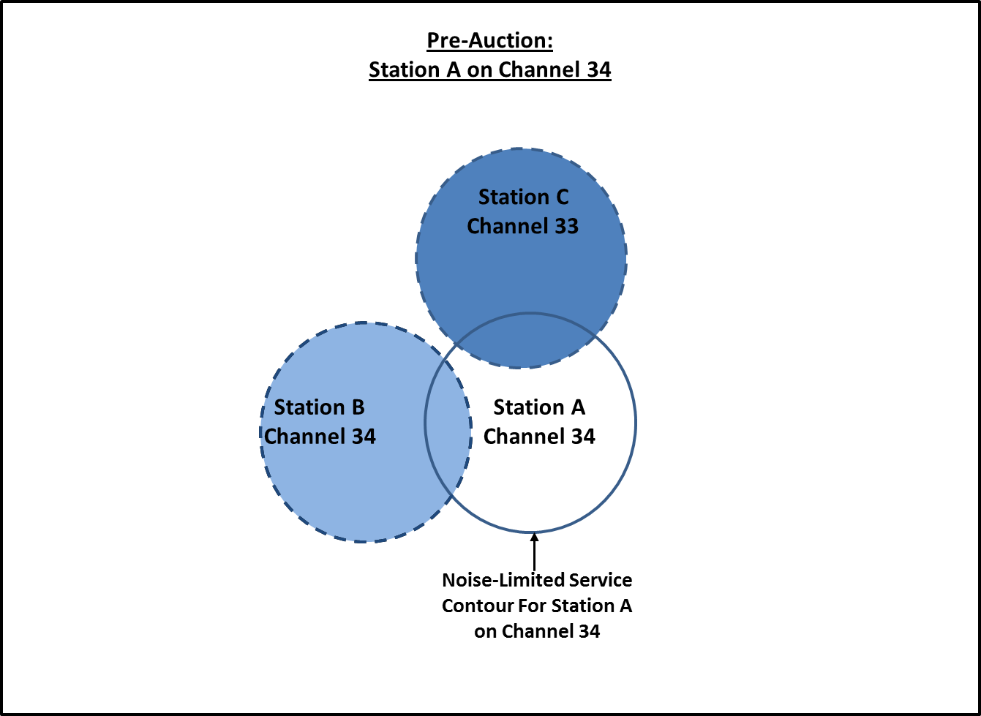

**Figure III.A**

In **Figure III.A** above, we assume that there is no terrain affecting coverage or interference, as might be the case in the Great Plains or Florida. Station A’s noise-limited service contour on channel 34 is mapped and we assume that the entire population within that contour has predicted service. Station B (co-channel with Station A on channel 34) and Station C (lower-adjacent to Station A on channel 33) are predicted to cause interference to Station A where their circles overlap. The populations in the two areas of overlap are summed to provide the total current aggregate interference facing Station A. The aggregate interference is subtracted from the total population that would otherwise receive service (in the absence of interference) to obtain Station A’s interference-free coverage population on its original channel of 34 – *i.e*., its “baseline” interference-free population served.

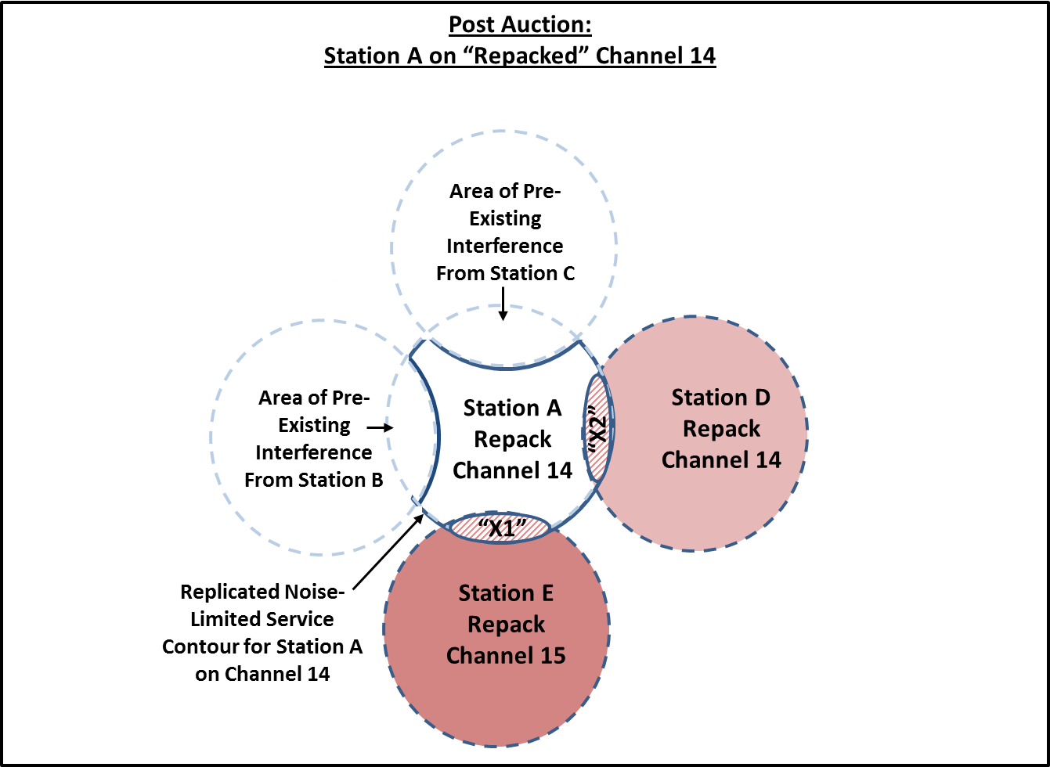

**Figure III.B**

In **Figure III.B** above, Station A is now repacked post auction to channel 14 and its “baseline” interference-free service area (as described in **Figure III.A**) is mapped above. Now both Station D (co-channel with Station A on channel 14) and Station E (upper adjacent to Station A on channel 15) cause interference to Station A’s original “baseline” interference-free population. The areas of new interference are represented as “X1” and “X2” above. To calculate the percentage of *additional* aggregate interference that Station A now faces, sum the total population within “X1” and “X2,” divide that sum by Station A’s “baseline” interference-free population, and multiply by 100.

Note that under this approach, any population gained as a result of the change in channel from 34 to 14 or due to the elimination of pre-existing interference from Stations B and C is not used to offset population lost from within the Station A’s “baseline” interference-free population. FCC staff believes that this proposed approach is most consistent with Option 2 used in the pairwise constraints because it prioritizes the protection of existing viewers.

# Overview of the Aggregate Interference Studies

To conduct the aggregate interference analysis, Incentive Auction Task Force staff developed an approach for creating sets of stations to be assigned channels during the repacking process. This approach seeks to create representative repacking scenarios by simulating the output of the reverse auction, selecting certain stations to relinquish their licenses, and assigning channels to the remaining stations consistent with the pairwise interference constraint data. A more detailed description of this approach follows below.

## Simulation Approach Overview

Because repacking is likely to most heavily impact the UHF band, the approach described was applied only to stations in the UHF band. To create a variety of repacking scenarios to study, the approach randomly varied which stations participate given certain thresholds of nationwide participation.

The specific details of each approach are discussed below,

## Selecting Clearing Target

The studies required a spectrum clearing target to be chosen. For purposes of this study, the clearing target was a user-defined parameter setting and the “Down from 51” band plan adopted in the *Report and Order* was used.[21] Two clearing targets – 120 MHz and 84 MHz – were selected and the simulation approach divided the runs evenly across these two targets.

## Selecting Participation Levels

Given that predicting levels of station participation is difficult, the approach employs a user-defined auction participation parameter of 80%, 90% or 100% of UHF television stations for each simulation. If less than 100% participation was selected, the approach randomly selected the stations that were flagged as participating in the simulated auction. An integer optimization solver was then used to assign as many non-participating stations as possible a channel in the UHF band, below the defined clearing target and consistent with the pairwise interference constraints. This set of packed, non-participating stations became the base to which other stations were assigned using the repacking algorithm.

## Process for Selecting Stations to Repack

Because FCC staff did not want to make any assumptions about potential station bidding activity, staff used different data sets to base the determination of which stations would be repacking in the studies.

In an effort to create variation in the data sets, the approach uses one of three metrics to rank stations for repacking:

* The first metric is the interference-free population served by the station as determined by the *TVStudy* software.
* The second metric is calculated as a station’s interference-free population served divided by the station’s “blocked channels” indicator (pop/channels-blocked). This ratio effectively reduces a station’s population metric proportionally by an indication of how much it may block other stations from being assigned to the same or an adjacent channel as it is assigned. A detailed description of how a station’s “blocked channels” indicator is determined is provided below.
* The third metric is equal to the station’s 2013 Nielsen DMA ranking.

A user-defined parameter determines which of the three metrics will be used for a given simulation.

## Blocked-Channels Indicator

A blocked-channels indicator was used to show the relative potential a station has to block other stations from being assigned a channel near that station. Given a channel assignment to a station, the number of stations that could not simultaneously be assigned to that same channel or adjacent channels was derived from the actual-channel *Interference_Paired* file released with this Public Notice. For example, consider the case where Station A (presently residing on channel 42) is assigned to channel 25. From the interference constraint data, we found that Station B could then not reside on channel 25 and Station C could not reside on channels 24, 25, or 26. In this example, placing Station A on channel 25 would cause four channel assignments to be “blocked.” We then performed this same calculation supposing Station A is assigned to channel 26, channel 27, etc.

To generate an indicator for a station’s potential to block channel assignments, we took the average number of channel assignments the station blocks in a given range of channels. For the subset of simulations using this approach, the staff calculated a station’s blocked-channels indicator as the average number of channel assignments the station blocks across all the channels in the UHF band for a given clearing target. The relative value of this metric is used for comparison between stations.

## Repacking Process

Once each participating station is assigned a metric in one of the ways described above, the approach ranks stations from highest to lowest according to that value. The participating stations were then divided into “buckets” according to their rank. If the metric was based on population coverage or population/channel-blocking, the stations were divided into ten equal buckets; the first bucket contained the highest 10% of ranked stations, the second bucket the next 10%, and so forth. If ranked by Neilson DMA, a bucket was created for each DMA containing all of the stations in that DMA; the buckets were ordered from highest to lowest DMA rank.

Next, the approach employed a repacking process on all stations in a bucket, beginning with the highest ranked bucket, before proceeding to the next ranked bucket. Each bucket was “repacked” by randomly choosing a station to consider for assignment in the television band and determining if that station could be feasibly assigned a channel below the clearing target using feasibility checking software.[22] If the station assignment was feasible, then the station was added to the set of stations that remain “on-air.” If not, the station was considered “off-air.” The algorithm continued randomly choosing stations within this set until all stations were tested for feasibility with the set of stations that had already been designated to be assigned channels.

## Study Scenarios

For purposes of this study, 100 unique repacking scenarios were created using the approach described above. The table below displays the parameter settings for the 100 data sets.

|  |  |  |  |
| --- | --- | --- | --- |
| **Clearing Target** | **Participation** | **Bid Value** | **Count** |
| 120 MHz | 100% | Population | 13 |
| 120 MHz | 90% | Population | 6 |
| 120 MHz | 80% | Population | 6 |
| 84 MHz | 100% | Population | 13 |
| 84 MHz | 90% | Population | 6 |
| 84 MHz | 80% | Population | 6 |
| 120 MHz | 100% | Pop/Blocked-Channels | 7 |
| 120 MHz | 90% | Pop/Blocked-Channels | 3 |
| 120 MHz | 80% | Pop/Blocked-Channels | 3 |
| 84 MHz | 100% | Pop/Blocked-Channels | 6 |
| 84 MHz | 90% | Pop/Blocked-Channels | 3 |
| 84 MHz | 80% | Pop/Blocked-Channels | 3 |
| 120 MHz | 100% | DMA | 7 |
| 120 MHz | 90% | DMA | 3 |
| 120 MHz | 80% | DMA | 3 |
| 84 MHz | 100% | DMA | 6 |
| 84 MHz | 90% | DMA | 3 |
| 84 MHz | 80% | DMA | 3 |
| **TOTAL SIMULATIONS** | | | **100** |

## Calculating Interference

After running simulations using the approach described above, the resulting channel plans were then run through *TVStudy* to determine the additional aggregate level of interference experienced by each station after the auction using the approach described in **Section 3**.

# Results of the Aggregate Interference Study

This section presents the study results on aggregate interference. The results are grouped by the bid value parameter used in the study set and provide summary statistics as well as a graph displaying the distribution of aggregate interference percentages for each group.

As was stated in the Public Notice, these studies show that on average ***roughly 1 percent*** of all stations are predicted to receive *additional (new)* aggregate interference after channel reassignment above NAB’s proposed 1 percent cap,[23] while the average additional aggregate interference level any station faced was well below the *de minimis* interference threshold,[24] varying between a narrow range of ***0.19 percent*** and ***0.20 percent*** depending on the bid values used. In none of the results did any station receive additional aggregate interference above 2 percent.

We note that even for those few stations that may experience more than 1% additional aggregate interference post auction, there may be additional measures that the FCC can take to reduce interference. For example, as part of its final channel assignment optimization, which will be completed following the close of the auction to create a final table of channel assignments, the FCC may include the minimization of aggregate interference as one of the objective functions of the optimization. The results discussed below do not factor in any reduction of aggregate interference that could be achieved through such an optimization process.

## Population (50 simulated data sets)

For these simulations, stations were rank ordered by their interference-free population coverage (calculated using *TVStudy*) from highest to lowest and then grouped into 10 buckets of equal size.

Across the 50 simulations at different clearing targets and levels of participation, no station experienced more than 1.95% additional aggregate interference, while the typical station (median value) experienced 0.08%. Moreover, only 1.1% of stations experienced more than 1% additional aggregate interference. See results below:

|  |  |
| --- | --- |
| **Statistic** | **Aggregate Interference %** |
| Minimum | 0.00% |
| Maximum | 1.95% |
| Average | 0.20% |
| Median | 0.08% |
| Lower (25%) Quartile | 0.00% |
| Upper (75%) Quartile | 0.33% |

**Summary of Results**

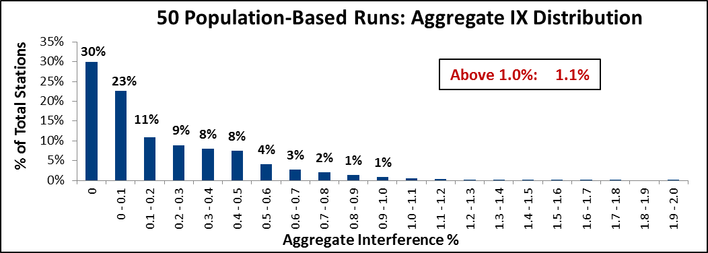

## Distribution of Aggregated Interference Results

## Population/Blocked-Channels (25 simulated data sets)

For these simulations, stations were rank ordered by the results of dividing interference-free population coverage (calculated using *TVStudy*) by the number of blocked channel assignments (calculated as defined in **Section 4.5**) from highest to lowest, and then grouped into 10 buckets of equal size.

Across the 25 simulations at different clearing targets and levels of participation, no station experienced more than 1.82% additional aggregate interference, and the median was just 0.08%. Moreover, only 1.1% of stations experienced more than 1% additional aggregate interference. See results below:

|  |  |
| --- | --- |
| **Statistic** | **Value** |
| Minimum | 0.00% |
| Maximum | 1.82% |
| Average | 0.20% |
| Median | 0.08% |
| Lower (25%) Quartile | 0.00% |
| Upper (75%) Quartile | 0.33% |

**Summary of Results**

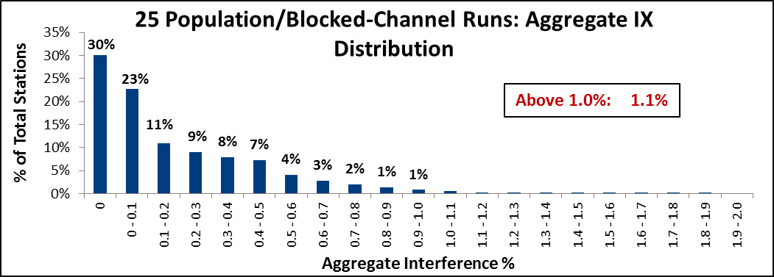

## Distribution of Aggregated Interference Results

## DMA (25 simulated data sets)

For these simulations, stations were ordered by Nielsen DMA number and then grouped into DMA buckets (210 DMAs in total).

Across the 25 simulations at different clearing targets and levels of participation, no station experienced more than 1.68% additional aggregate interference, and the median was just 0.07%. Moreover, only 1.1% of stations experienced more than 1% additional aggregate interference. See results below:

|  |  |
| --- | --- |
| **Statistic** | **Value** |
| Minimum | 0.000% |
| Maximum | 1.67% |
| Average | 0.19% |
| Median | 0.07% |
| Lower 25% Quartile | 0.00% |
| Upper 75% Quartile | 0.32% |

**Summary of Results**

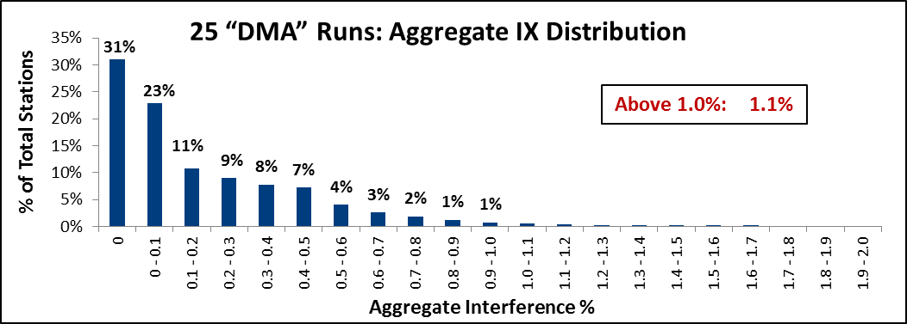

## Distribution of Aggregated Interference Results

1. *Expanding the Economic and Innovation Opportunities of Spectrum Through Incentive Auctions*, GN Docket No. 12-268, Notice of Proposed Rulemaking, 27 FCC Rcd 12357, 12394, para. 106 (2012) (*NPRM*) (“Under this approach, no individual channel reassignment, considered alone, could reduce another station's specific population served on February 22, 2012 by more than 0.5 percent.”).
2. *Expanding the Economic and Innovation Opportunities of Spectrum Through Incentive Auctions*, GN Docket No. 12-268, Report and Order, FCC 14-50, para. 179 (2014) (*Report and Order*).
3. *See* *Incentive Auction Task Force Releases Information Related to Incentive Auction Repacking*, GN Docket No. 12-268, ET Docket No. 13-26, Public Notice, 28 FCC Rcd 10370, 10385, 10387 (WTB 2013) (*Repacking Data PN*).
4. *Repacking* *Data PN,* 28 FCC Rcd at 10385 (“Given the computational burden of considering each station pair on every possible channel during a multi-round auction, Commission staff selected a single channel in each of the three television spectrum bands as a proxy for that band to conduct the pairwise study.”).
5. In the *Repacking Data PN*, we noted that “[s]taff recognizes that both coverage and interference may vary from channel to channel within each band.” *Id.*
6. *Report and Order* at para. 115.
7. In the *Repacking* *Data PN*, the calculations for coverage and interference were made on a single channel in each of the three television bands (low VHF, high VHF, and UHF) as a proxy for that band. *See* *Repacking* *Data PN,* 28 FCC Rcdat 10385.
8. NAB objected to the use of the proxy channel approach, expressing concern that it might underestimate actual interference after the repacking process. *See* Letter from Rick Kaplan, NAB, to Marlene H. Dortch, Secretary, FCC, GN Docket No. 12-268 at 21 (filed Sept. 5, 2013) (NAB Sept. 5, 2013 *Ex Parte* Letter); *see also* Letter from Rick Kaplan, NAB, to Marlene H. Dortch, Secretary, FCC, GN Docket No. 12-268, at 2-3(filed Nov. 27, 2013) (NAB Nov.27, 2013 *Ex Parte* Letter).
9. *See* *Repacking* *Data PN,* 28 FCC Rcdat 10396 (describing the *Domain* file format in detail).
10. *See* *id.* at 10399.
11. *Report and Order*, para. 186 (“The full power and Class A facilities that were in operation as of February 22, 2012 are facilities that were licensed on that date or for which an application for a license to cover an authorized construction permit was on file.”).
12. *See id.*, para.194*.*
13. *Id.*
14. *See* *Repacking* *Data PN,* 28 FCC Rcdat 10401-03.
15. *See* *id.* at 10403-04.
16. *Id.* at 10407-10.
17. FCC staff made one additional change to the illustrative list of Land Mobile Waiver Base Stations to provide additional protection to T-Band operations in Suffolk County, NY on Channel 16. Because eligibility in the Public Safety Radio Pool can operate without a waiver in this county, which extends a significant distance from the New York urbanized area geographic center, FCC staff created a hypothetical land mobile base station which operated close to the middle of Suffolk County (40º 56' 25.7”N and 72º 41' 6.9”W) to ensure adequate protection. This hypothetical base station can be found in the newly released list of Land Mobile Waiver Base Stations. *See* 47 C.F.R. § 90.303(c) (outlining use of Channel 16 in Suffolk County).
18. *Repacking* *Data PN,* 28 FCC Rcdat 10380-82 (listing the *TVStudy* parameters selected).
19. In the *Repacking* *Data PN*, staff developed pairwise constraints using Option 2 where a single interfering station, when examined alone, is not permitted to reduce the current interference-free population of a station by more than 0.5%. *Id.* at 10387. This approach is conservative because it does not consider any population coverage that may be gained to the station as a result of being moved to a different channel.
20. These points are the geographic coordinates of the centroids of each cell studied that are predicted to have a field strength above the applicable threshold value and are not predicted to be affected by interference.
21. Report and Order at para. 51; see also *Wireless Telecommunications Bureau Seeks to Supplement the Record on the 600 MHz Band Plan*, GN Docket No. 12-268, Public Notice, 28 FCC Rcd 7414, 7418-19 (2013) (*Band Plan PN*).
22. *See Incentive Auction Task Force Releases Information Related to Repacking; Announces Workshop/Webinar to Provide Additional Detail*, GN Docket No. 12-268, ET Docket No. 13-26, Public Notice, 29 FCC Rcd 47 (WTB 2014) (*Feasibility Checking PN*).
23. Comments of the National Association of Broadcasters at 20-21 (NAB Comments).
24. The *Report and Order* considers not allowing greater than 0.5% additional interference to be *de minimis*, or “no interference at integer precision.” *See* *Report and Order* at para. 179.