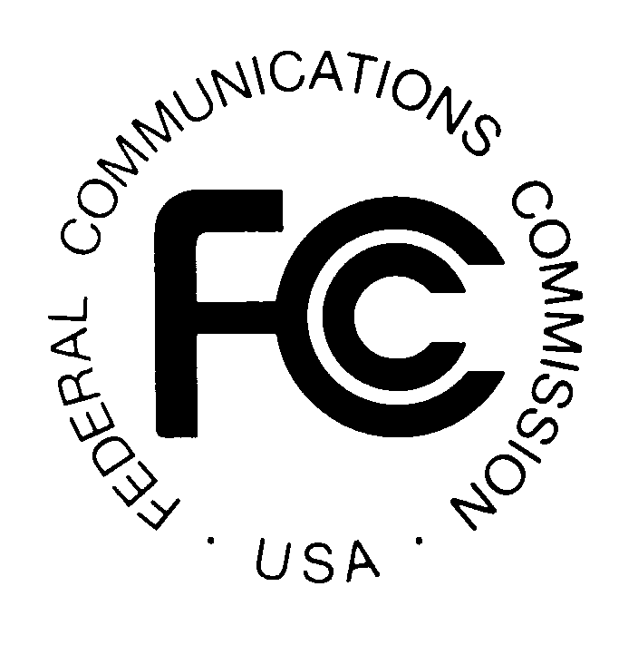
News media information 202 / 418-0500
TTY 202 / 418-2555
Internet: http://www.fcc.gov
PUBLIC NOTICE

Federal Communications Commission
445 12th St., S.W.
Washington, D.C. 20554

DA 14-681

May 19 , 2014

PUBLIC SAFETY AND HOMELAND SECURITY BUREAU ANNOUNCES

REGION 30 (NEW YORK – ALBANY) PUBLIC SAFETY REGIONAL PLANNING COMMITTEES TO HOLD 700 MHZ AND 800 MHZ NPSPAC MEETINGS

Gen. Docket No. 90-394

The Region 30 (New York-Albany) Public Safety Regional Planning Committees (RPCs) will hold two consecutive planning meetings on Wednesday, June 4, 2014. Beginning at 10:00 a.m., the 700 MHz Public Safety RPC will convene at the New York State – Harriman State Office Campus, Building 7A, 1st Floor Training Room, 1200 Washington Avenue, Albany, New York 12242.

The agenda for the 700 MHz meeting includes:
- Introductions
- Review and approval of the June 4th, 2014 Meeting Agenda
- Review and approval of the March 12th, 2014 Meeting Report
- Interoperability (SIEC Report)
- New York State (Robert Barbarato)
- Technical Subcommittee
  - Interregional concurrence requests
  - 4.9 GHz
  - 700 MHz
- New business and comments
- Schedule next meeting
- Adjourn

Immediately following the 700 MHz Public Safety RPC meeting, the 800 MHz Public Safety RPC will convene at the same location.

The agenda for the 800 MHz meeting includes:
- Review and approval of the June 4, 2014 Meeting Agenda
- Review and approval of the March 12, 2014 Meeting Minutes
- Technical Subcommittee
- Interregional concurrence requests
- Application discussions: Application Windows 800-14-1 and 800-14-2
- Other frequency band discussion
- Update Committee Report
- New business and comments
- Schedule next meeting
- Adjourn

Both Region 30 Public Safety RPC meetings are open to the public. All eligible public safety providers in Region 30 may utilize these frequencies. It is essential that eligible public safety agencies in all areas of government, including state, municipality, county, and Native American Tribal be represented in order to ensure that each agency’s future spectrum needs are considered in the allocation process. Administrators who are not oriented in the communications field should delegate someone with this knowledge to attend, participate, and represent their agency’s needs.

All interested parties wishing to participate in planning for the use of public safety spectrum in the 700 MHz and 800 MHz bands within Region 30 should plan to attend. For further information, please contact:

Lee Shurtleff, Chairman
Region 30 700 MHz and 800 MHz Public Safety RPCs
Tompkins County
92 Brown Road
Ithaca, New York 14850
(607) 257-3888
shurtleff@tompkins-co.org

-FCC -

The Region 30 regional planning area includes thirty-one counties in upstate New York: Albany, Broome, Cayuga, Chenango, Clinton, Columbia, Cortland, Delaware, Essex, Franklin, Fulton, Green, Hamilton, Herkimer, Jefferson, Lewis, Madison, Montgomery, Oneida, Onondaga, Oswego, Otsego, Rensselaer, St. Lawrence, Saratoga, Schenectady, Schoharie, Tioga, Tompkins, Warren, and Washington.

