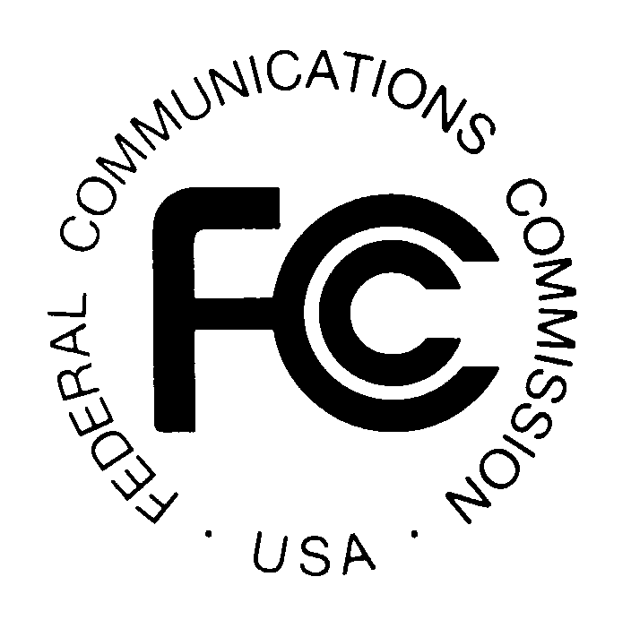
PUBLIC NOTICE
News media information 202 / 418-0500
TTY 202 / 418-2555
Internet: http://www.fcc.gov
Federal Communications Commission
445 12th St., S.W.
Washington, D.C. 20554

DA 14-780

June 5, 2014

PUBLIC SAFETY AND HOMELAND SECURITY BUREAU ANNOUNCES

REGION 47 (PUERTO RICO) PUBLIC SAFETY REGIONAL PLANNING COMMITTEES TO HOLD 700 MHZ AND 800 MHZ NPSPAC MEETINGS

PR Docket No. 93-82

The Region 47 (Puerto Rico) Public Safety Regional Planning Committees (RPCs) will hold two consecutive planning meetings on Friday, June 27, 2014. Beginning at 9:00 a.m., the 700 MHz Public Safety RPC will convene at the Bayamón Emergency Management Agency (AMME) Office, Puerto Rico Road-2 (PR-2) with PR-5 at the Rubén Rodriguez Coliseum.

The agenda for the 700 MHz meeting includes:
- Welcome and introductions
- 700 MHz broadband update
- Open discussion for any Plan changes
- 700 MHz Interoperability
- State License
- Computer Assisted Pre-coordination Resource and Database (CAPRAD)
- Vote on proposed Plan modifications, and election of officers
- Adjourn

Immediately following the 700 MHz Public Safety RPC meeting, the 800 MHz NPSPAC Public Safety RPC will convene at the same location.

The agenda for the 800 MHz meeting includes:
- Welcome and introductions
- 800 MHz P25 system deployment updates
- Rebanding discussion
- Open discussion for any Plan changes
  - Channel loading
  - CAPRAD
  - Frequency give back
  - Discussion of other possible changes to the 800 MHz NPSPAC Plan
  - Plan modification voting
- Adjourn

Both Region 47 Public Safety RPC meetings are open to the public. All eligible public safety providers in Region 47 may utilize these frequencies. It is essential that eligible public safety agencies in all areas of government, including state, municipality, county, and Native American Tribal be represented in order to ensure that each agency’s future spectrum needs are considered in the allocation process. Administrators who are not oriented in the communications field should delegate someone with this knowledge to attend, participate, and represent their agency’s needs.

All interested parties wishing to participate in planning for the use of public safety spectrum in the 700 MHz and 800 MHz bands within Region 47 should plan to attend. For further information, please contact:

Ferdinand Ceden͂o, P.E.
Chair, Region 47 700 MHz and 800 MHz Public Safety RPCs
P.O. Box 3858
Bayamón Gardens Station
Bayamón, PR 00958
Ferdinand.cedeno@gmail.com
(787) 504-7110

-FCC -

The Region 47 (Puerto Rico) public safety regional planning area includes the entire Commonwealth of Puerto Rico.
CAPRAD is a public safety spectrum management tool available at http://caprad.org/cp/index.jsp.

