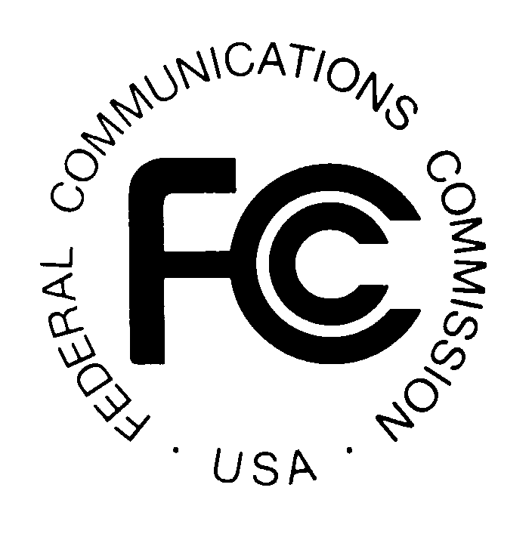
PUBLIC NOTICE
Federal Communications Commission
445 12th St., S.W.
Washington, D.C. 20554
News Media Information: 202.418.0500
TTY: 202.418.2555
Internet: http://www.fcc.gov

DA 14-78

January 23, 2014

PUBLIC SAFETY AND HOMELAND SECURITY BUREAU ANNOUNCES

REGION 7 (COLORADO) 700 MHZ AND 800 MHZ PUBLIC SAFETY REGIONAL PLANNING COMMITTEES 2014 – 2015 MEETING SCHEDULE

General Docket No. 89-452

The Region 7 (Colorado) 700 and 800 MHz NPSPAC Public Safety Regional Planning Committees (RPCs) will hold the next six meetings at the State of Colorado’s Emergency Operations Center and Office of Emergency Management, 9195 East Mineral Avenue, Suite 200, Centennial, Colorado 80112 on the following dates and times:

700 MHz RPC schedule:
- Friday, March 7, 2014 at 1:00 p.m.
- Friday, May 2, 2014 at 1:00 p.m.
- Friday, July 11, 2014 at 1:00 p.m.
- Friday, September 5, 2014 at 1:00 p.m.
- Friday, November 7, 2014 at 1:00 p.m.
- Friday, January 9, 2015 at 1:00 p.m.

The basic agenda for all meetings includes the following:
- Introductions and roll call
- Review of Meeting Minutes
- New business - Presentation and discussion of frequency requests and applications
- Sub-committee Reports
- Old business
- Adjournment

Immediately following the adjournment of the 700 MHz meetings, the 800 MHz NPSPAC meetings are scheduled to begin at 1:45 p.m.

800 MHz NPSPAC schedule:
- Friday, March 7, 2014 at 1:45 p.m.
- Friday, May 2, 2014 at 1:45 p.m.
- Friday, July 11, 2014 at 1:45 p.m.
- Friday, September 5, 2014 at 1:45 p.m.
- Friday, November 7, 2014 at 1:45 p.m.
- Friday, January 9, 2015 at 1:45 p.m.

The Region 7 700 MHz and 800 MHz NPSPAC Public Safety RPC meetings are open to the public. It is essential that public safety agencies in all areas of government, including state, municipality, county, and Native American Tribal, and non-governmental organizations eligible under Section 90.523 of the Commission’s rules, 47 C.F. R. § 90.523, be represented in order to ensure that each agency’s future spectrum needs are considered in the allocation process. Administrators who are not oriented in the communications field should delegate someone with this knowledge to attend, participate, and represent their agency’s needs.

All interested parties wishing to participate in planning for the use of public safety spectrum in the 700 MHz and 800 MHz NPSPAC bands within Region 7 should plan to attend. For further information, please contact:

Ed Boyer, Chairman
Region 7 700 MHz and 800 MHz NPSPAC Public Safety RPCs
Electronics Engineer, Office of Information Technology
Communications Services
601 E. 18th Avenue, Suite 250
Denver, Colorado 80203
(303) 866-2244
Edward.boyer@state.co.us

Emery Reynolds, Secretary
Region 7 700 MHz and 800 MHz NPSPAC Public Safety RPCs
Littleton, Colorado 80123-1712
(303) 719-8146
emreynolds@aol.com

-FCC-

The Region 7 (Colorado) 700 MHz and 800 MHz Public Safety Regional Planning area includes the entire State of Colorado.

