**DA 14-98**

**Release Date: January 29, 2014**

**OFFICE OF ENGINEERING AND TECHNOLOGY**

**SEEKS TO SUPPLEMENT THE INCENTIVE AUCTION PROCEEDING RECORD**

**REGARDING POTENTIAL INTERFERENCE BETWEEN**

**BROADCAST TELEVISION AND WIRELESS SERVICES**

**ET Docket No. 14-14**

**GN Docket No. 12-268**

**Comments Date: February 28, 2014**

The FCC’s Office of Engineering and Technology (OET) seeks to supplement the record in the incentive auction proceeding by inviting comment on a methodology for predicting potential interference between broadcast television and licensed wireless services. In the *Broadcast Television Incentive Auction NPRM*, the Commission sought public comment on creating a 600 MHz wireless band plan from the spectrum made available for flexible use through the broadcast television incentive auction.[1] The Commission expressed a strong interest in establishing a band plan framework that is flexible enough to accommodate market variation (*i.e.*, offering varying amounts of spectrum in different geographic locations, depending on the spectrum recovered[2]) to maximize the amount of spectrum repurposed.

In response to the *NPRM* and the *600 MHz Band Plan Supplemental Public Notice*, a number of commenters raised concerns about co-channel and adjacent-channel interference between television and wireless services in nearby markets as a result of accommodating market variation.[3] Some commenters proposed separation distances between the two services. The most common approach commenters propose is to use a pre-defined separation distance between TV and mobile service areas.[4] Commenters proposed distances that varied significantly—ranging from 100 kilometers to 500 kilometers—and generally provided limited technical analysis in support of these proposals.

The Commission has rules in place to control co-channel and adjacent-channel interference from mobile operations to digital television (DTV) reception for the 470–512 MHz (“T-Band”) and 700 MHz bands.[5] However, these rules do not have direct applicability in the incentive auction. The rules were addressing situations where wireless licensees could design their systems to avoid causing interference to television reception by techniques such as reducing power and antenna height or for a transitional period during which relatively few wireless facilities would be constructed. In the “T-band,” the pertinent wireless systems are conventional land mobile facilities that do not utilize cellular architectures used for commercial wireless service. In the case of 700 MHz, the rules were intended as an interim measure for spectrum that was eventually going to be cleared of TV broadcasting. Further, the present rules do not address interference from DTV into wireless systems.

**Potential Interference Scenarios**

Four scenarios exist that could result in interference between broadcast television and licensed wireless services, depending upon the geographic locations and spectrum where DTV operation is permitted relative to wireless operation under the 600 MHz band plan that the Commission ultimately adopts. These scenarios are illustrated in Figure 1 and are discussed below:

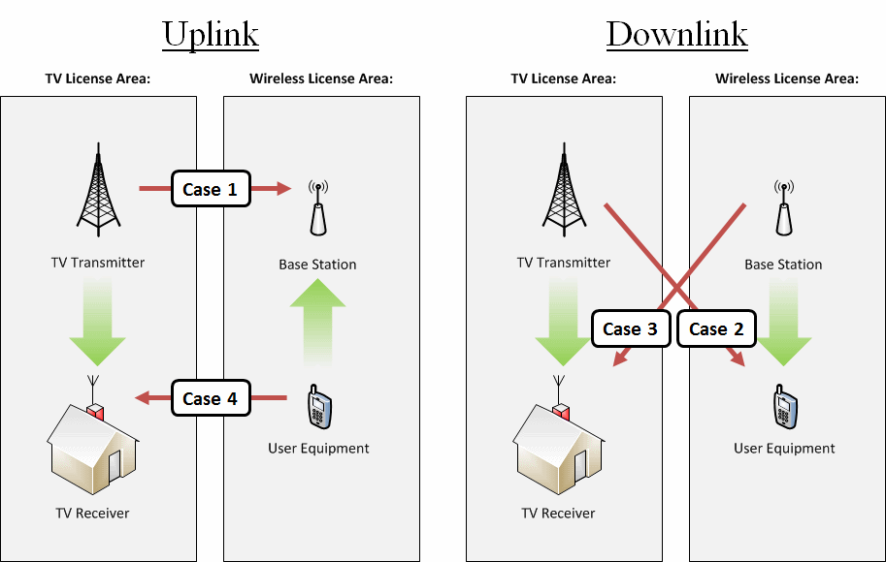Figure 1. Interference scenarios

(1) DTV transmitter-into-wireless base station (uplink) interference. Based on our calculations and the comments submitted into the record, this case tends to lead to the largest required separation distances because both the base station receive antenna and the DTV transmitting antenna are often located well above the surrounding terrain, potentially creating a line-of-sight path between them.

(2) DTV transmitter-into-wireless user equipment (downlink) interference. This case is not likely to require separation distances as large as Case 1 because the wireless user equipment (UE) typically operates near ground level or in buildings where propagation conditions including clutter or other losses are likely to greatly reduce the strength of distant co-channel DTV signals. We note that there is a potential for interference to UE receivers from nearby adjacent-channel DTV transmissions because the off-channel rejection of UE receivers is often limited compared with base station receivers.

(3) Wireless base station (downlink)-into-DTV receiver interference. Although the separation distance may be relatively large between a wireless base station and a co-channel DTV transmitter operating in the base station’s uplink spectrum (Case 1), the distance from a wireless base station to DTV receivers at the edge of a DTV station’s service contour would be much less. In addition, DTV reception, especially at the edge of a DTV station’s service contour, would likely use outdoor antennas at rooftop levels. This would tend to increase the likelihood that a DTV receiver could experience interference from a wireless base station. A separate analysis that factors in these conditions needs to be performed relative to the potential for co-channel and adjacent-channel harmful interference that could be caused to DTV reception by the base station downlink transmitter.

(4) Wireless user equipment (uplink)-into-DTV receiver interference. To avoid interference with the associated uplink spectrum, base station receivers require a relatively large separation distance from co-channel DTV transmitters (Case 1). Therefore, we believe that there is no significant risk of co-channel interference to DTV reception from UE transmitters. However, adjacent-channel interference to DTV receivers may result when wireless user equipment operates in close proximity to DTV receivers.

**Potential Solutions**

We are concerned that prescribing a pre-defined separation distance as proposed by some commenters may be spectrally inefficient and overly conservative. Specifically, this approach lumps together all of the above cases and applies separation distances based on a worst case scenario without considering factors such as the actual technical characteristics of the DTV transmitter (*e.g*., power level, antenna height, and radiation patterns), terrain variability and the density of population in areas predicted to receive interference. Such an approach also fails to account for technologies and techniques that wireless licensees might employ to mitigate potential interference, such as antenna characteristics and resource block provisioning.

Accordingly, we invite comment on an alternative methodology that could enable the Commission to accommodate market variation in a more spectrally efficient manner than that proposed by various commenters. This alternative methodology uses established planning factors and industry standards to define thresholds of coverage and interference, suggests typical engineering specifications in the absence of industry standards, and applies commonly used protocols, databases, and propagation models to create a predictive model that can be run on a computer. This methodology is described in detail in the appendix to this Public Notice.

**Specific Topics for Comment**

OET seeks comment on the methodology for predicting potential interference between television and wireless services, described in the attached appendix (OET Methodology). Specifically, OET seeks comment on whether this methodology can provide greater accuracy than a generic separation distance (pre-defined radius) in predicting potential harmful interference between services, thereby enabling the Commission to repurpose more spectrum by accommodating market variation.

OET seeks comment on whether interference to and from analog television stations should be considered and what assumptions and parameters would be appropriate for studies involving such stations. OET also invites comment on a number of specific topics as discussed below.

*General Methodology*

While the OET Methodology may potentially improve the efficiency of spectrum use compared to the use of fixed separation distances, OET recognizes that it also increases the complexity of the analysis required. Would this methodology strike a more appropriate balance between efficiency of spectrum use and the technical analysis required in the incentive auction than fixed co-channel and adjacent channel separation distances? Are there variations of the OET methodology or other approaches that would better address these concerns for interference protection and spectrum efficiency?

*Methodology to Determine DTV Interference to Wireless*

We seek comment on the approach described to determine wireless license impairments. Are there other methods to determine wireless market impairments in the 600 MHz band?

*Methodology to Determine Wireless Interference to DTV*

We seek comment on the approach described to determine interference to DTV stations. Should we instead set one or more simple separation distance requirements? Will calculation of the D/U ratio values on a 2-kilometer grid with base stations spaced uniformly at 10-kilometer intervals provide sufficient resolution when determining possible interference?

We request comment on the extent of predicted interference to DTV reception based on our grid-based approach. Should we define areas within a wireless market, such as county boundaries, where if the operations of any given hypothetical wireless base station cause predicted interference to a DTV station, regardless of population impacted, we would infer that all wireless operation in that area would cause interference to that station?

*Technical Assumptions*

The OET methodology makes certain assumptions about the characteristics of DTV transmission facilities and DTV receivers as well as wireless transmission facilities and receivers based mostly on existing industry standards and available technical data. For digital television, the DTV planning factors[6] underlie the definition of service. Receiver performance expectations were used to develop the interference criteria in the Commission’s rules.[7] Because 600 MHz wireless services are expected to be noise-like and studies have shown that noise-like signals have interference potential nearly identical to ATSC digital television,[8] we believe that the existing DTV protection criteria can be applied with some adjustments for frequency offsets as discussed below. Similarly, for wireless systems operating at 600 MHz, industry standards[9] define reception thresholds and provide receiver performance criteria. The methodology assumes a uniform distribution of wireless base stations. We seek comment on whether these assumptions are appropriate. We also seek comment on whether the criteria for service and interference are appropriate for use in a predictive model to establish locations of likely interference between TV broadcast and wireless services operating co-channel or adjacent-channel.

One significant issue that will impact the potential for co-channel and adjacent-channel interference between TV broadcast and wireless services is the varying degree of spectral overlap that will exist between the two services. Because the Commission has proposed to repurpose six megahertz TV broadcast channels as five megahertz wireless blocks,[10] a single television channel may overlap two wireless channels in a nearby wireless license area. The difference in channel bandwidth (six *vs*. five megahertz) means that the channels will not perfectly align, and the different amounts of spectral overlap suggest that protection requirements should reflect the variation.

Figure 2 provides an example where the spectral overlap between potential wireless Block E and TV Channel 47 is one megahertz, meaning that one megahertz of TV Channel 47 is co-channel with Block E. On the other hand, the spectral overlap between potential wireless Block D and TV Channel 47 is -4 megahertz, because there are four megahertz of frequency separation between the respective channel edges. We invite comment on whether the total power in the spectral overlap should be used in assessing interference. Will these assumptions be applicable if licensees aggregate multiple spectrum blocks to provide wider bandwidth channels? How should interference power be accounted for in cases where there is a potential for interference from two adjacent wireless blocks?



Figure 2. 6 MHz DTV and 5 MHz Wireless channel alignment

For predicting television coverage and interference over large distances, the FCC has often applied the “Longley-Rice” radio propagation model.[11] Although the FCC has not previously applied this model in a wireless or inter-service context, its use may be appropriate for predicting propagation losses over the range of distances and antenna heights involved in three of the four scenarios described above.[12] We seek comment on whether applying Longley-Rice is an appropriate propagation model for some or all of the four interference scenarios described above, and we seek suggestions for specific alternative propagation models. We also seek comment on the appropriate configuration parameters to use in each case, as well as whether the consideration of morphology (clutter) is appropriate and appropriate clutter losses for interference cases involving the user equipment. We also seek comment on the appropriate statistical parameters for the Longley-Rice model, in particular the use of F(50, 50) when examining DTV field strength at the wireless receiver. We also request suggestions of alternative methods for modeling the propagation of signals from mobile devices to DTV receivers.

**Additional Topics**

Further, we invite comment on how to use the information derived from the OET Methodology in the context of the repacking of broadcasters.

The OET Methodology addresses adjacent channel interference. Most commenters have focused their concerns on co-channel interference more than adjacent-channel interference, perhaps due to assumptions that guard bands would be used to prevent adjacent-channel interference. In the case of market variation, however, guard bands could be slightly different in each market, creating the potential for interference between DTV and wireless services that otherwise would not exist. We invite comment on the impact of adjacent-channel interference constraints in the context of market variation.

The OET Methodology provides a technique for calculating the predicted interference to DTV service, but does not address what limits should be applied to such interference, whether wireless license areas should be auctioned if predicted interference to wireless service exceeds some threshold, or whether interference from wireless facilities should be accounted for in calculating a DTV station’s service area and/or population served. Should predicted interference from wireless facilities to a DTV station be ignored if it does not affect the population within the station’s service area? Would it be appropriate to set a low threshold for acceptable interference from wireless to DTV service, such as allowing a wireless licensee to reduce the coverage of a DTV station by no more than 0.1% of its population served? Would it be sufficient to consider only interference from base station facilities, or should interference from wireless user equipment also be considered?

The OET Methodology provides a technique for calculating the predicted interference to wireless. We also seek comment on how this information should be made available to bidders in the forward auction. Should the Commission set predefined impairment thresholds, *e.g*., where less than 5% of the market population may potentially experience interference, should we consider this wireless market to be effectively unimpaired? What should the thresholds for specifying impairments be?

This Public Notice and the attached appendix relate to the technical aspects of the repacking process and auction design. We emphasize that nothing in this Public Notice is intended to signal any final staff recommendation to the Commission relative to the prospective band plan or other issues raised in the incentive auctions proceeding, such as whether to make spectrum available only on a paired basis, provide supplemental downlink spectrum or permit time-division duplex operation. Further, although we seek input on the four interference cases discussed above, we note that we may not encounter each of those scenarios in practice, depending on the band plan and repacking methodology the Commission ultimately adopts. Rather, this Public Notice seeks only to expand the record by seeking comment on a potential method for minimizing the potential for interference between TV broadcast and wireless services operating in different markets on the same or adjacent spectrum.

The Incentive Auction Task Force intends to host a Workshop/Webinar on February 21 to discuss this methodology for predicting potential interference between television and wireless mobile broadband services.  At that time, Task Force staff will also respond to questions and comments about the details of this Public Notice and the attached Technical Appendix.  More information, including how to participate, will be released prior to the Workshop/Webinar.   Details about the Workshop/Webinar will be released by Public Notice and on the LEARN website at: <http://www.fcc.gov/learn>.

This Public Notice is being issued pursuant to section 0.31 of the Commission’s rules by the Office of Engineering and Technology, a member of the Incentive Auction Task Force.[13] Comments may be filed using the Commission’s Electronic Comment Filing System (ECFS). See Electronic Filing of Documents in Rulemaking Proceedings, 63 FR 24121 (1998).

* Electronic Filers: Comments may be filed electronically using the Internet by accessing the ECFS: <http://fjallfoss.fcc.gov/ecfs2/>.
* Paper Filers: Parties who choose to file by paper must file an original and one copy of each filing. If more than one docket or rulemaking number appears in the caption of this proceeding, filers must submit two additional copies for each additional docket or rulemaking number.
* Filings can be sent by hand or messenger delivery, by commercial overnight courier, or by first-class or overnight U.S. Postal Service mail. All filings must be addressed to the Commission’s Secretary, Office of the Secretary, Federal Communications Commission.
* All hand-delivered or messenger-delivered paper filings for the Commission’s Secretary must be delivered to FCC Headquarters at 445 12th St., SW, Room TW-A325, Washington, DC 20554. The filing hours are 8:00 a.m. to 7:00 p.m. All hand deliveries must be held together with rubber bands or fasteners. Any envelopes and boxes must be disposed of before entering the building.
* Commercial overnight mail (other than U.S. Postal Service Express Mail and Priority Mail) must be sent to 9300 East Hampton Drive, Capitol Heights, MD 20743.
* U.S. Postal Service first-class, Express, and Priority mail must be addressed to 445 12th Street, SW, Washington DC 20554.

People with Disabilities: To request materials in accessible formats for people with disabilities (braille, large print, electronic files, audio format), send an e-mail to fcc504@fcc.gov or call the Consumer & Governmental Affairs Bureau at 202-418-0530 (voice), 202-418-0432 (tty).

The proceeding this Notice initiates shall be treated as a “permit-but-disclose” proceeding in accordance with the Commission’s *ex parte* rules.[14] Persons making *ex parte* presentations must file a copy of any written presentation or a memorandum summarizing any oral presentation within two business days after the presentation (unless a different deadline applicable to the Sunshine period applies). Persons making oral *ex parte* presentations are reminded that memoranda summarizing the presentation must (1) list all persons attending or otherwise participating in the meeting at which the *ex parte* presentation was made, and (2) summarize all data presented and arguments made during the presentation. If the presentation consisted in whole or in part of the presentation of data or arguments already reflected in the presenter’s written comments, memoranda or other filings in the proceeding, the presenter may provide citations to such data or arguments in his or her prior comments, memoranda, or other filings (specifying the relevant page and/or paragraph numbers where such data or arguments can be found) in lieu of summarizing them in the memorandum. Documents shown or given to Commission staff during *ex parte* meetings are deemed to be written *ex parte* presentations and must be filed consistent with rule 1.1206(b). In proceedings governed by rule 1.49(f) or for which the Commission has made available a method of electronic filing, written *ex parte* presentations and memoranda summarizing oral *ex parte* presentations, and all attachments thereto, must be filed through the electronic comment filing system available for that proceeding, and must be filed in their native format (*e.g.*, .doc, .xml, .ppt, searchable .pdf). Participants in this proceeding should familiarize themselves with the Commission’s *ex parte* rules.

For further information, contact Cecilia Sulhoff at [cecilia.sulhoff@fcc.gov](mailto:cecilia.sulhoff@fcc.gov).

**– FCC –**

# Appendix

# Methodology for

# Predicting Potential Interference between

# Television and Wireless MOBILE BROADBAND Services

**Introduction**

This appendix sets forth a methodology for predicting interference between broadcast television and wireless services when co-channel or on adjacent channels. Generally, co-channel interference between wireless services (base stations or mobile user equipment (UE)) and broadcast television becomes unlikely if these services are geographically separated by a predetermined distance. Likewise, adjacent-channel interference becomes unlikely at a lesser distance than for the co-channel case, depending on the frequency separation between the television channel and the wireless block. The methodology described in this appendix may be used to predict whether interference is expected to occur at a location and thereby establish the necessary separation distances in a deterministic way.

The methodology described herein uses the Institute of Telecommunications Science’s Irregular Terrain Model (Longley-Rice model) for predicting radio signal propagation losses, established planning factors and industry standards to define thresholds of coverage and interference, suggests typical technical specifications in the absence of industry standards, and generally applies commonly used protocols, databases, and propagation models to describe a predictive methodology that can be run on a computer. For broadcast television, we assume use of the Advanced Television Systems Committee’s (ATSC) Digital Television (DTV) Standard,[15] although it is possible, especially across international borders, that the National Television Systems Committee (NTSC) analog Television (TV) standard may also be used.[16] For wireless, we assume use of the 3rd Generation Partnership Project (3GPP) Long-Term Evolution (LTE) standard.[17] We use the Longley-Rice radio model, which predicts field strength at receive points based on the elevation profile of terrain between the transmitter and each specific reception point.[18] Predictions are made either over a large area (described as a 2-kilometer grid of calculation cells) or at specific locations, depending upon whether the model is configured to use its broadcast or individual location mode. The methodology described in this appendix deals primarily with predictions over large areas using the broadcast mode.

# Overview of Methodology

There are four interference scenarios if digital broadcast television (DTV) and wireless services are permitted in the 600 MHz band. These scenarios are listed below and are illustrated in Figure A-1.

* Case 1: DTV Transmitter into Wireless Uplink (base station receiver)
* Case 2: DTV Transmitter into Wireless Downlink (UE receiver)
* Case 3: Base Station Transmitter (downlink) into DTV Receiver
* Case 4: User Equipment Transmitter (uplink) into DTV Receiver



Figure A-1. Market variation interference scenarios

*Spectral Overlap.* A significant issue that will impact the potential for co-channel and adjacent-channel interference between TV broadcast and wireless services is the varying degree of spectral overlap that may exist between the two services in the new 600 MHz band. Because the broadcast television channels to be reclaimed are six megahertz wide and the Commission has proposed to repurpose them as five megahertz wireless blocks,[19] a single television channel may overlap two wireless blocks in a nearby wireless license area. The difference in channel bandwidth (six *vs*. five megahertz) means that the channels and blocks do not perfectly align, and the different amounts of spectral overlap suggest that protection requirements should reflect the variation.

Figure A-2 provides an example of market variation between two wireless markets where the amount of wireless spectrum in Wireless Market 2 is reduced in order to assign TV channels 47 and 48 to television broadcast in that market. Figure A-2 also shows an example guard band between the DTV service and wireless service in Wireless Market 2.[20] The spectral overlap between wireless Block E in Market 1 and TV Channel 47 in Wireless Market 2 is one megahertz, meaning that one megahertz of TV Channel 47 is co-channel with Block E. On the other hand, the spectral overlap between potential wireless Block D in Market 1 and TV Channel 47 in Wireless Market 2 is -4 megahertz, because there are four megahertz of frequency separation between the respective channel edges. In this example, the guard band is eight megahertz in Market 2 between TV channel 48 and wireless block B, but across markets there is sufficient distance separation between Market 1 and Market 2 such that co- and adjacent-channel interference is minimized.

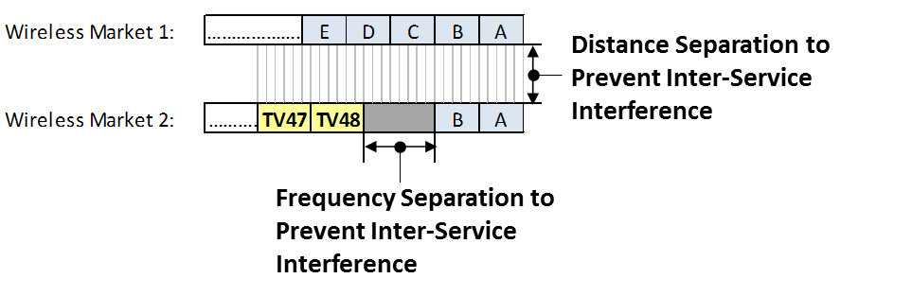

Figure A-2. 6 MHz TV channel and 5 MHz wireless block alignment

We define as co-channel those TV channel/wireless block pairs having frequency overlaps of +5 MHz to +1 MHz,[21] and to define adjacent-channel relationships as those TV channel/wireless block pairs with frequency overlaps of 0 MHz to -5 MHz.[22] Further, we examine all TV channel/wireless block overlaps from +5 MHz to -5 MHz for all cases, in one megahertz increments, considering both DTV interference into wireless as well as wireless interference into DTV.

*Field Strength and D/U Interference Limits as a Function of Spectral Overlap.* To determine potential wireless license impairments, our methodology sets field strength limits at the wireless receive antenna as a function of the amount of spectral overlap between the DTV transmit channel and the wireless receive channel. For example, a DTV station with an overlap of -5 MHz (*i.e*., adjacent-channel operation) is assumed to be able to produce a higher maximum field strength at the victim receive antenna without causing harmful interference than would a DTV station with an overlap of +5 MHz (*i.e*., co-channel operation).

Similarly, to assess potential interference to a DTV receiver, our methodology uses the co-channel D/U ratio specified in OET Bulletin No. 69[23] for a +5 MHz overlap and adjusts the D/U requirement based on the extent of overlap between the wireless transmitter channel and the DTV receiver channel. We account for the possibility that a wireless licensee may aggregate several 5 MHz channel blocks in Table 5, Table 6, and Table 10 below, as described in footnote 7.

*Methodology to Determine DTV Interference to Wireless.* Cases 1 and 2 involve interference caused by a co- or adjacent-channel DTV transmitter to a wireless base station or user equipment located within the wireless license area. To determine areas of possible wireless interference (wireless service impairments) we divide the wireless license area into a 2-kilometer grid and calculate field strength levels at each grid point for each DTV facility that is assigned a co- or adjacent-channel frequency within approximately 500 km.[24] The predicted field strength at each grid point is then compared with the appropriate interference threshold field strength.

Figure A-3 illustrates how the spectral overlaps and field strength interference limits can be used to determine potential market impairments. In the illustration, two DTV facilities are assigned co- or adjacent-channel to wireless Block D. From Figure A-2 we see that the edge of TV Channel 47 is 4 MHz from the D block (overlap = -4 MHz) and TV channel 48 overlaps the D block by 2 MHz (overlap = +2 MHz).

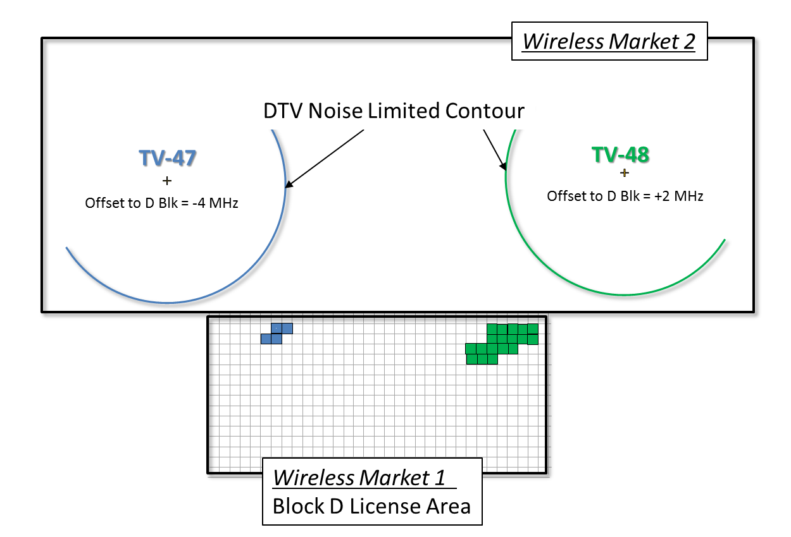

Figure A-3. Illustration of interference prediction from DTV to wireless license area

We note each grid point where the calculated field strength from a co- or adjacent-channel facility exceeds the appropriate field strength limit. In Figure A-3, predicted interference is shown as blue grid cells for “TV-47” and green grid cells for “TV-48.” The total market impairment would be based on the sum of the populations in those unique grid cells where the calculated field strength exceeds the applicable interference threshold value. If more than one DTV facility causes predicted interference in a single grid cell, the population associated with that grid cell is only counted once. We apply this methodology for each co- and adjacent-channel DTV/wireless spectral overlap condition in the range -5 to +5 MHz in every wireless market.

*Methodology to Determine Wireless Interference to DTV.* Cases 3 and 4 involve interference to a co- or adjacent-channel DTV receiver from a wireless transmitter operating within the wireless license area. We divide the area within a DTV station’s noise limited contour into 2-kilometer cells as specified in OET Bulletin No. 69, Table 2[25] and calculate the desired DTV field strength at each grid point. To calculate the undesired wireless base station transmitter field strength at each cell, we assume a deployment of hypothetical wireless base stations spaced uniformly every 10 kilometers with transmitting antennas at 30 meters above ground in every wireless license area within 500 km of the DTV facility.[26] The undesired field strength from each hypothetical base station is then predicted at each grid point within the DTV noise limited contour and a D/U ratio is determined. The predicted D/U ratio for each grid point/base station pair is then compared with the appropriate D/U ratio limit to determine whether interference is predicted to the DTV station.

Figure A-4 illustrates how the spectral overlaps and D/U interference limits would be used to predict whether a wireless base station transmitter would cause interference to a DTV receiver. In the example, two DTV stations are assigned channels within the spectrum allocated for wireless use nationally. Each grid point where the predicted D/U ratio exceeds the appropriate limit is noted along with the corresponding hypothetical base station location causing the predicted interference. In Figure A-4, this is illustrated with green grid cells inside the “TV-48” contour and the corresponding hypothetical interfering base station locations are highlighted inside the wireless license boundary. In this example, hypothetical base stations transmitting on the D Block (having an overlap of -4 MHz) do not cause predicted interference within the TV-47 contour, while some base stations (having an overlap of +2 MHz) do cause interference within the TV-48 contour.

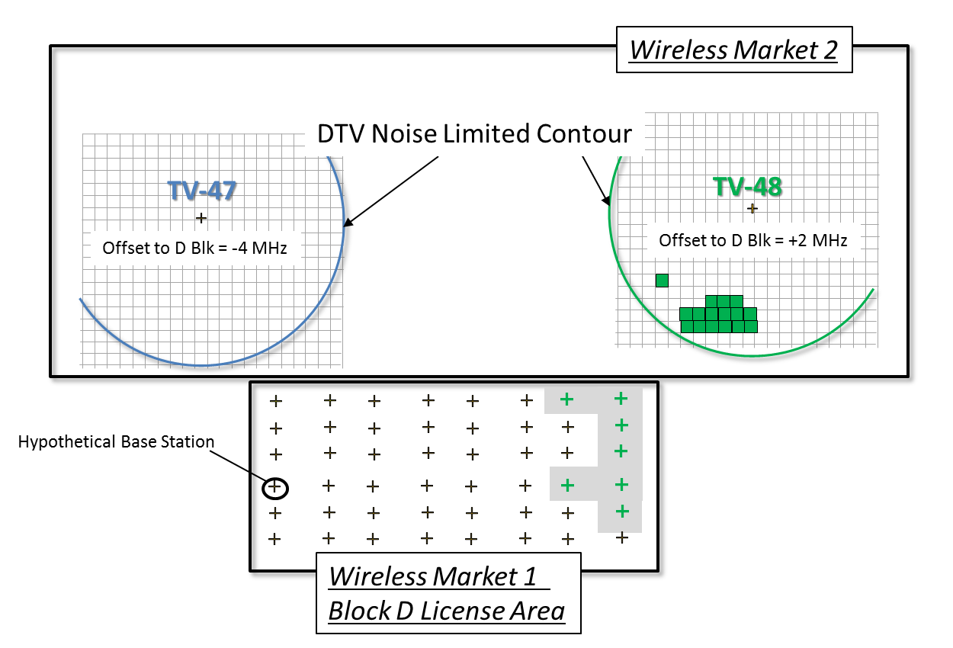

Figure A-4. Illustration of interference prediction from wireless to DTV

This approach would define areas within wireless markets where base station operation may cause interference to a co- or adjacent-channel DTV facility. To further generalize the areas where wireless operations could cause interference to a DTV station, we define “restricted” areas based on a market sub-area (e.g. county boundaries) which lies within the wireless license boundary. In Figure A-5, counties within the wireless market are identified because at least one hypothetical base station(s) within a county is predicted to cause co- or adjacent-channel interference to at least one cell on a 2-kilometer grid in the service area of a DTV station.

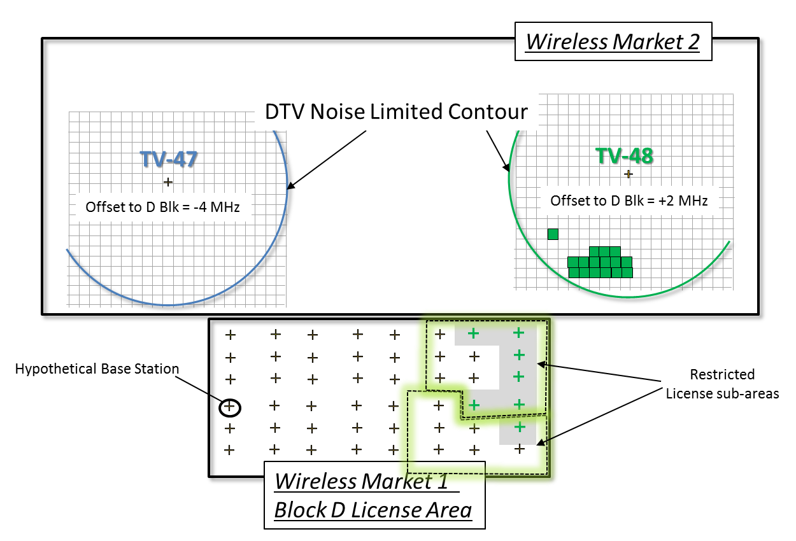

Figure A-5. Interference from wireless to DTV illustrating restricted operating areas

In the case of wireless uplink to DTV interference (Case 4), the necessary separation distances are likely to be much smaller than for Cases 1–3. A uniform separation distance of 5 kilometers[27] has been suggested between a co-channel user equipment and a DTV receiver (*i.e*., no UE transmissions would be permitted within 5 km of the co-channel DTV station’s contour).

# Propagation Model

*Prediction of Interfering Field Strength.* For Cases 1–3, we use a version of the Longley-Rice propagation model to make deterministic predictions of desired field strength at receive points. The presence or absence of interference in each grid cell of the area subject to calculation is determined by further application of Longley-Rice methodology, taking into account clutter losses, as described below. Radio paths between undesired transmitters and each 2-kilometer grid point inside the service area are examined using the Longley-Rice model. At each point, we use the result obtained for median situations (that is, confidence set to 50%), for 50% of locations, 10% of the time for the prediction of potential interference to TV receivers from wireless base stations (*i.e*., F(50, 10)). For prediction of potential interference from DTV to wireless receivers, we use the result obtained for median situations, for 50% of locations, 50% of the time (*i.e*., F(50, 50)).

*Methodology to Define DTV Service Area.* For digital television, the service area of a station us defined in the FCC rules; the rules also specify standards for determining interference to DTV service.[28] Because wireless services are expected to be noise-like and studies have shown that noise-like signals have interference potential nearly identical to DTV,[29] the existing DTV protection criteria can generally be applied with some adjustments as discussed below.

Under the FCC’s rules, a TV station’s service area is limited to the areas within specific field strength contours where the station’s field strength exceeds a threshold value. As of the date of this Public Notice, Class A TV stations can be either analog or digital, but all analog Class A facilities are required to cease operation by September 1, 2015.[30] Full-power TV stations can transmit only in digital (ATSC).[31] There may be analog television facilities operating outside the U.S. to consider in regions along common borders, however, subject to international negotiations and agreements.[32] Prediction of interference to or from analog television facilities is beyond the scope of this document.

For digital Class A TV stations, service evaluations are made inside the protected contours defined in 47 CFR § 73.6010, with the exception that the defining field strength for UHF channels is modified by subtracting a frequency-dependent factor. Thus, the area subject to calculation for digital Class A TV stations includes the geographic locations at which the field strength is predicted by the FCC F-curves to exceed the values given in Table 1 at 50% of locations 90% of the time.

|  |  |
| --- | --- |
| Channels | Defining Field Strength, dBµV/m, calculated using  F(50, 90) curves |
| 2 - 6 | 43 |
| 7 - 13 | 48 |
| 14 - 51 | 51 - 20log10[615/(channel mid-frequency in MHz)] |

Table 1. Field Strengths defining the area subject to calculation for digital Class A TV stations

For full-power DTV stations, service is evaluated inside contours determined by the DTV planning factors in combination with the FCC field strength curves derived for 50% of locations and 90% of the time. The F(50, 90) curves are calculated for both digital Class A TV stations and for full-power DTV stations by the formula F(50, 90) = F(50, 50) - [F(50, 10) - F(50, 50)], using the F(50, 50) and F(50, 10) curves in 47 CFR § 73.699.

The defining field strengths for DTV noise-limited service are shown in Table 2. These values, which are set forth in the rules, are used to determine the area subject to calculation using FCC curves, and subsequently to determine whether service is present at particular points within this area using Longley-Rice terrain-dependent propagation model.[33]

|  |  |
| --- | --- |
| Channels | Defining Field Strength, dBµV/m, calculated using  F(50, 90) curves |
| 2 - 6 | 28 |
| 7 - 13 | 36 |
| 14 - 51 | 41 - 20log10[615/(channel mid-frequency in MHz)] |

Table 2. Field Strengths defining the area subject to calculation for Digital Full-Power TV stations

Parameter values in Longley-Rice as implemented by the FCC are given in Table 3. In addition to these parameters, determination of the field strength requires a specification of the percent of time and locations at which the predicted fields will be realized or exceeded, and generally also a third percentage identifying the degree of confidence (situational variability) desired in the results. For the purposes of this methodology, in those cases where error code 3 occurs (KWX = 3), the predicted field strength is to be accepted as the field strength available at that location.

|  |  |  |
| --- | --- | --- |
| Parameter | Value | Meaning/Comment |
| EPS | 15.0 | Relative permittivity of ground. |
| SGM (S/m) | 0.005 | Ground conductivity. |
| ZSYS | 0.0 | Coordinated with setting of EN0. See page 72 of NTIA Report. |
| EN0 (ppm) | 301.0 | Surface refractivity in N-units. |
| IPOL | 0 | Denotes horizontal polarization. |
| MDVAR | 3 | Calculation Mode (Broadcast). |
| KLIM | 5 | Climate Code (Continental Temperate). |
| XI (km) | 0.1 | Terrain sampling interval. |
| HG(1) (m) | See note | Height of the radiation center above ground. |
| HG(2) (m) | 10 | Height of TV receiving antenna above ground. |
| Note 1. HG(1) in Table 3 is the height of the transmitting antenna radiation center above ground. For TV, it is determined by subtracting the ground elevation above mean sea level (AMSL) at the transmitter location from the height of the radiation center AMSL. The latter value is contained in the FCC's CDBS, and may be found by query at <http://www.fcc.gov/mb/video/tvq.html>. The former is retrieved from the terrain elevation database as a function of the transmitter site coordinates also found in CDBS. Bilinear interpolation between the surrounding data points in the terrain database is used to determine the ground elevation. Care should be used to ensure that consistent horizontal and vertical datums are employed among all data sets. | | |

Table 3. Longley-Rice parameter values

**Technical Specifications**

*Field Strength Limits for DTV Interference to Wireless.* We define the field strength interference limit for interference from DTV sources as shown in Table 4.

|  |  |  |  |  |  |  |  |  |  |  |  |
| --- | --- | --- | --- | --- | --- | --- | --- | --- | --- | --- | --- |
| Spectral Overlap (MHz) | 5 | 4 | 3 | 2 | 1 | 0 | -1 | -2 | -3 | -4 | -5 |
| DTV Field Strength  into Wireless Uplink (dBµV/m) | 17.3 | 18.2 | 19.5 | 21.2 | 24.0 | 34.4 | 61.4 | 62.5 | 63.7 | 65.5 | 68.6 |
| DTV Field Strength  into Wireless Downlink (dBµV/m) | 33.8 | 34.7 | 36.0 | 37.6 | 40.4 | 50.7 | 65.8 | 66.6 | 67.6 | 68.9 | 70.8 |

Table 4. Interference field strength values for DTV into wireless

The values shown in Table 4 are derived from the technical specifications and assumptions given in Table 5, Table 6, and Table 7 using the formula below.

Field Strength Limit (dBµV/m) = Pr - Kd - G + L + OTR + OFR(Δf)

Where:

Pr (dBm) = victim receiver sensitivity level

Kd (dBm-dBµV/m) = dipole factor at 615 MHz[34]

G (dBd) = antenna gain

L (dB) = line loss

OTR (dB) = receiver on-tune rejection (dB)

OFR(Δf) (dB) = off-frequency rejection (dB) as a function of frequency separation

|  |  |  |
| --- | --- | --- |
| Parameter | Value | Comment |
| Pr (dBm) | -101.5 | Reference sensitivity level, per 3GPP Technical Specification 36.104 § 7.2. |
| Kd (dBm-dBµV/m) | -130.8 | Dipole Factor, OET Bulletin No. 69, Table 3. |
| G (dBd) | 13.8 | G (dBd) = 12.8 dBd + Gdiv - Ghoriz. Gdiv is receive antenna diversity gain, assumed to be 3 dB, and Ghoriz is additional antenna discrimination due to downtilt below the radio horizon, assumed to be 2 dB. |
| L (dB) | 1 | Assumed line loss. |
| Receiver BW (MHz) | 5 | For bandwidths (BWs) ≥ 5 MHz, the reference sensitivity level is measured in accord with the 3GPP Technical Specification 36.104 using 25 consecutive resource blocks, corresponding to a channel bandwidth of 4.5 MHz. |
| Thermal noise, Nt (dBm) | -107.5 | = -174 (dBm/Hz) + 10log10(4.5 MHz). |
| Effective noise figure, Ne (dB) | 6 |  |
| OTR (dB) | 0.8 | For TV into wireless, OTR = 10log10(6/5) = 0.8 dB. Using typical 3 dB transmit signal bandwidths, 10log10(5.38/4.5) is also approximately 0.8 dB. |
| OFR(Δf) (dB) | See note |  |
| HG(2) (m) | 30 | Assumed receive antenna height for wireless base stations. |
| Note: The values for OFR(Δf) were derived using NTIA’s MSAM FDR computer program using FCC’s emission limits, and DTV and LTE receiver performance standards published by ATSC and 3GPP, respectively. The results are provided in Table 7. | | |

Table 5. Wireless base station receiver technical parameters

|  |  |  |
| --- | --- | --- |
| Parameter | Value | Comment |
| Pr (dBm) | -100 | Receiver sensitivity level, per 3GPP Technical Specification 36.101 § 7.3. |
| Kd (dBm-dBµV/m) | -130.8 | Dipole Factor, OET Bulletin No. 69, Table 3. |
| G (dBd) | -2.2 | Assumes 0 dBi - 2.2 (approximate dipole gain). |
| L (dB) | 0 | Assumed line loss. |
| Receiver BW (MHz) | 5 | For bandwidths (BWs) ≥ 5 MHz, the reference sensitivity level is measured in accord with the 3GPP Technical Specification 36.104 using 25 consecutive resource blocks, corresponding to a channel bandwidth of 4.5 MHz. |
| Thermal noise, Nt (dBm) | -107.5 | = -174 (dBm/Hz) + 10log10(4.5 MHz). |
| Effective noise figure, Ne (dB) | 7.5 |  |
| OTR (dB) | 0.8 | For TV into wireless, OTR = 10log10(6/5) = 0.8 dB. Using typical 3 dB transmit signal bandwidths, 10log10(5.38/4.5) is also approximately 0.8 dB. |
| OFR(Δf) (dB) | varies | See Note from Table 5. |
| HG(2) (m) | 1.5 | Assume 1.5 m height for user equipment receiver. |

Table 6. Wireless user equipment receiver technical parameters

|  |  |  |  |  |  |  |  |  |  |  |  |
| --- | --- | --- | --- | --- | --- | --- | --- | --- | --- | --- | --- |
| Overlap in MHz  OFR (dB) | 5 | 4 | 3 | 2 | 1 | 0 | -1 | -2 | -3 | -4 | -5 |
| DTV into Uplink | 0 | 0.9 | 2.2 | 3.9 | 6.7 | 17.1 | 44.1 | 45.2 | 46.4 | 48.2 | 51.3 |
| DTV into Downlink | 0 | 0.9 | 2.2 | 3.8 | 6.6 | 16.9 | 32 | 32.8 | 33.8 | 35.1 | 37 |

Table 7. Calculated off-frequency rejection (OFR) values for DTV into wireless

*D/U Ratio Limits for Interference to DTV.* Criteria for thresholds of interference using the ratio of desired to undesired (D/U) field strengths for TV are specified in 47 C.F.R. § 73.623. The specified 15.2 dB D/U ratio for co-channel interference to DTV service is valid only at locations where the signal-to-noise ratio is 28 dB or greater. Near the edge of the noise-limited service area, where the predicted signal-to-noise (S/N) ratio is 16 dB or less, the co-channel D/U ratio is 23 dB. At locations where the S/N ratio is greater than 16 dB but less than 28 dB, D/U values for co-channel interference to DTV are as follows:

To protect DTV reception from wireless co-channel interference, the minimum D/U ratios are computed from the following formula:

D/U = 15 + 10log10[1.0/(1.0-10-x/10)], where x = S/N - 15.19 dB.

The quantity x is the amount by which the actual desired S/N exceeds the minimum required for DTV reception.

To protect DTV reception from wireless downlink interference for various amounts of spectral overlap, the minimum D/U ratios are shown in Table 8. These were derived by letting the receive filter selectivity factor α = 10log10[1.0/(1.0 - 10-x/10)] and applying the OFR(Δf) values for the “Downlink into DTV” and “Uplink to DTV” cases from Table 9. OTR is set to zero in this case because the DTV receiver bandwidth is assumed to be larger than the wireless emission.

|  |  |  |  |  |  |  |  |
| --- | --- | --- | --- | --- | --- | --- | --- |
| Spectral Overlap (MHz) | 5 | 4 | 3 | 2 | 1 | 0 | -1 to -5[35] |
| Downlink to DTV  D/U Required (dB) | 15.0 + α | 14.1 + α | 12.8 + α | 11.1 + α | 8.3 + α | -2.0 + α | -18 + α |
| Uplink to DTV D/U Required (dB) | 15.0 + α | 14.1 + α | 12.8 + α | 11.2 + α | 8.4 + α | -1.9 + α | -16 + α |

Table 8. Threshold Interfering D/U Ratio for Wireless Base Station into DTV

|  |  |  |  |  |  |  |  |  |  |  |  |
| --- | --- | --- | --- | --- | --- | --- | --- | --- | --- | --- | --- |
| Overlap in MHz  OFR  (dB) | 5 | 4 | 3 | 2 | 1 | 0 | -1 | -2 | -3 | -4 | -5 |
| Downlink into DTV | 0 | 0.9 | 2.2 | 3.9 | 6.7 | 17.0 | 33 | 33 | 33 | 33 | 33 |
| Uplink  into DTV | 0 | 0.9 | 2.2 | 3.8 | 6.6 | 16.9 | 31 | 31 | 31 | 31 | 31 |

Table 9. Calculated off-frequency rejection (OFR) values for Wireless into DTV

In the case of wireless downlink interference to DTV, we recognize that transmitters in multiple adjacent wireless spectrum blocks have the potential to cause interference to a DTV facility. To offset this we assume base station ERP based on the power in a 6 MHz channel (see Table 10 and footnote 22).

In the absence of specific information about a wireless base station deployment, hypothetical wireless base stations are placed uniformly across the wireless license area, spaced approximately 10 kilometers apart. Predicted interference to DTV receivers from those hypothetical base stations is evaluated to determine whether an area, which could be an entire wireless license area, a county, or a smaller area such as a 100 square kilometer rectangle corresponding to the spacing of these hypothetical base stations, may cause interference to any DTV station. That area would then be assumed to be restricted from wireless base station (downlink) operation, resulting in a market impairment for purposes of the incentive auction. In the absence of specific information, the ERP and antenna height values given in Table 10 are used. For wireless user equipment, the ERP and antenna height values given in Table 11 are used. The wireless base station antennas are assumed to be non-directional in the azimuth direction.

|  |  |  |
| --- | --- | --- |
| Parameter | Value | Comment |
| Emission BW (MHz) | 5 |  |
| ERP (W) | 720[36] | Assumes 1.2 kW in 10 MHz channel with two 40 W power amplifiers. |
| ERP (dBm) | 58.6 | = 10log10(ERP) + 30. |
| G (dBd) | 12.8 | Assumes 15 dBi - 2.2 (approximate dipole gain). |
| L (dB) | 1 | Line loss |
| HG(1) (m) | 30 | Antenna height above ground |

Table 10. Assumed wireless base station transmitting specifications

|  |  |  |
| --- | --- | --- |
| Parameter | Value | Comment |
| Emission BW (MHz) | 5 |  |
| ERP (W) | 0.12 | EIRP = 200 mW – 0 dB Line Loss + 0 dBi Antenna Gain 3GPP TS 36.101, § 6.3.2. |
| ERP (dBm) | 20.8 | = 10log10(EIRP) - 2.2 dB. |
| Gr (dBd) | -2.2 | Assumes 0 dBi - 2.2 (approximate dipole gain). |
| Lr (dB) | 0 | Line loss |
| HG(1) (m) | 1.5 | Antenna height above ground |

Table 11. Assumed wireless user equipment transmitting specifications

The interference analysis for TV receivers examines only those cells across the global 2-kilometer grid that have already been determined to have a desired field above the field strength threshold for reception given in Table 1 or Table 2, as appropriate. A cell on the global 2-kilometer grid is counted as receiving interference to TV if the ratio of the desired field to that of any one of the possible undesired wireless interference sources is less than a certain critical minimum value. The comparison is made after applying the discrimination effect of the receiving TV antenna and clutter losses, as appropriate.

*TV Receiving Antenna Pattern.* The TV receiving antenna is assumed to have a directional gain pattern which tends to discriminate against off-axis undesired stations. This pattern is a planning factor affecting interference. The specific form of this pattern was chosen by a working group of the FCC Advisory Committee for Advanced Television Service. The discrimination, in relative field, provided by the assumed TV receiving pattern is a function of the angle between the lines joining the desired and undesired stations to the reception point. One of these lines goes directly to the desired station, the other goes to the undesired station. The discrimination is calculated as the fourth power of the cosine of the angle between these lines but never exceeds the front-to-back ratio of 14 dB for UHF. When both desired and undesired stations are on the receive antenna’s boresight, the angle is 0.0 giving a cosine of unity so that there is no discrimination. When the undesired station is somewhat off-axis, the cosine will be less than unity and the resulting interference field strength is reduced accordingly; when the undesired station is far off axis,[37] the maximum discrimination given by the front-to-back ratio is attained.

**Engineering Databases**

*DTV Engineering Data.* Engineering data for TV stations in the U.S. (including full-power DTV and Class A) is available from the FCC. Data for individual stations can be found at <http://www.fcc.gov/mb/video/tvq.html>, and consolidated data for all authorized stations can be found at <ftp://ftp.fcc.gov/pub/Bureaus/MB/Databases/cdbs/>. Where more than one authorization exists for a particular station, the record associated with the facility actually operating is used. Where specific elevation pattern data are not provided, a generic elevation pattern may be used as described generally in OET Bulletin No. 69. The generic elevation pattern should, however, be offset by the amount of electrical beam tilt specified in the CDBS.

*Clutter Database and Losses.* Land use and land cover (*e.g.,* vegetation and buildings) in the vicinity of the receiving location can be incorporated through use of a lookup table of clutter losses additional to those inherent in the basic Longley-Rice v1.2.2 model. The 2006 National Land Clutter Database (NLCD) is available from the Multi-Resolution Land Characteristics Consortium (MRLC).[38] The clutter loss, if any, at an individual reception location is determined by reference to the NLCD database. The geographic coordinates of the reception point are compared with the NLCD data to find the point’s NLCD classification and, subsequently, to determine a clutter loss value from either Table 14 or Table 15, if applicable, depending on the interference cases listed in Table 12. The clutter loss is subtracted from the predicted interfering signal strength.

|  |  |  |  |
| --- | --- | --- | --- |
| *Interference Case* | *Transmitter Antenna Height (m)* | *Receive Antenna Height (m, AGL)* | *Apply Clutter?* |
| Case 1: TV into Uplink: | Value from CDBS (AMSL) | 30 | No |
| Case 2: TV into Downlink: | Value from CDBS (AMSL) | 1.5 | Yes  (Table **15**) |
| Case 3: Downlink into TV: | 30 (AGL) | 10 | Yes, only for undesired path  (Table **14**) |
| Case 4: Uplink into TV: | 1.5 (AGL) | 10 | Yes, only for undesired path  (Table **15**) |

Table 12. Applicability of Clutter Losses to Interference Case

*NLCD Categories.* Since the NLCD classifications have a broader purpose and are not targeted for application to radio propagation analyses, we have regrouped these classifications into more appropriate categories for use in this methodology. Table 13 defines this regrouping. For each computer run of the program, the appropriate clutter category number should be selected from Table 13 according to environmental conditions in the vicinity of the individual reception point. The clutter loss value, if any, is then determined as a function of the clutter category number and the TV channel number, by referring to either Table 14 or Table 15, if applicable depending on the interference cases listed in Table 12.

|  |  |  |  |
| --- | --- | --- | --- |
| NLCD  Classification  Number | NLCD Classification Description[39] | TVStudy Clutter Category Mapping | TVStudy Clutter  Category Description |
| 11 | Water | 4 | Water |
| 12 | Perennial Ice Snow | 10 | Snow and Ice |
| 21 | Developed, Open Space | 7 | Residential |
| 22 | Developed, low intensity | 7 | Residential |
| 23 | Developed, Medium Intensity | 9 | Commercial / Industrial |
| 24 | Developed High Intensity | 8 | Mixed urban / buildings |
| 31 | Bare Rock / Sand / Clay | 1 | Open Land |
| 41 | Deciduous Forest | 5 | Forest Land |
| 42 | Evergreen Forest | 5 | Forest Land |
| 43 | Mixed Forest | 5 | Forest Land |
| 52 | Shrub/Scrub | 3 | Rangeland |
| 71 | Grasslands/Herbaceous | 3 | Rangeland |
| 81 | Pasture/Hay | 2 | Agricultural |
| 82 | Row Crops | 2 | Agricultural |
| 90 | Woody Wetlands | 5 | Forest land |
| 95 | Emergent Herbaceous Wetlands | 6 | Wetland |

Table 13. Regrouping of NLCD Categories for Longley Rice Applications

|  |  |  |  |  |  |
| --- | --- | --- | --- | --- | --- |
|  | | Clutter Loss (dB)[40]  (to be subtracted from calculated field strength) | | | |
| Clutter  Category | Clutter  Category Description | Channels  2-6 | Channels  7-13 | Channels  14-36 | Channels  38-51 |
| 1 | Open land | 0 | 0 | 4 | 5 |
| 2 | Agricultural | 0 | 0 | 5 | 6 |
| 3 | Rangeland | 0 | 0 | 3 | 6 |
| 4 | Water | 0 | 0 | 0 | 0 |
| 5 | Forest land | 0 | 0 | 5 | 8 |
| 6 | Wetland | 0 | 0 | 0 | 0 |
| 7 | Residential | 0 | 0 | 5 | 7 |
| 8 | Mixed Urban / Buildings | 0 | 0 | 6 | 6 |
| 9 | Commercial / Industrial | 0 | 0 | 5 | 6 |
| 10 | Snow and Ice | 0 | 0 | 0 | 0 |

Table 14. Clutter Loss as a Function of NLCD Clutter Category and TV Channel for Interference Cases Involving the Wireless Base Station to DTV

|  |  |  |  |  |  |
| --- | --- | --- | --- | --- | --- |
|  | | Clutter Loss (dB)[41]  (to be subtracted from calculated field strength) | | | |
| Clutter  Category | Clutter  Category Description | Channels  2-6 | Channels  7-13 | Channels  14-36 | Channels  38-51 |
| 1 | Open land | 0 | 0 | 6 | 7 |
| 2 | Agricultural | 0 | 0 | 5 | 6 |
| 3 | Rangeland | 0 | 0 | 3 | 6 |
| 4 | Water | 0 | 0 | 0 | 0 |
| 5 | Forest land | 0 | 0 | 10 | 13 |
| 6 | Wetland | 0 | 0 | 0 | 0 |
| 7 | Residential | 0 | 0 | 11 | 13 |
| 8 | Mixed Urban / Buildings | 0 | 0 | 13 | 13 |
| 9 | Commercial / Industrial | 0 | 0 | 12 | 13 |
| 10 | Snow and Ice | 0 | 0 | 0 | 0 |

Table 15. Clutter Loss as a Function of NLCD Clutter Category and TV Channel for Interference Cases Involving the Wireless User equipment

1. *Expanding the Economic and Innovation Opportunities of Spectrum Through Incentive Auctions*, Notice of Proposed Rulemaking, 27 FCC Rcd 12357, 12401-27, paras. 123-98 (2012) (*NPRM*).
2. *NPRM*, 27 FCC Rcd at 12401, para. 123-24. *See Wireless Telecommunications Bureau Seeks to Supplement the Record on the 600 MHz Band Plan,* Public Notice, 28 FCC Rcd 7414 (May 17, 2013) (*600 MHz Band Supplemental Public Notice*) (seeking further comment on how certain band plan approaches can best address the potential for market variation).
3. Alcatel-Lucent Supplemental Comments at 6-7; Block Stations Supplemental Comments 3-4; Sinclair Supplemental Comments 2; AT&T Comments 4-7 27-28, Exh A 15, 32-33; T-Mobile Supplemental Comments 17 n.32, Supplemental Reply Comments 13-14; Qualcomm Supplemental Comments 14, 17; US Cellular Supplemental Comments 3; Cohen, Dippell and Everist Supplemental Comments 1-2; CTIA Supplemental Reply Comments 8-9; Ericsson Supplemental Comments 9; Free Press Supplemental Reply Comments 9; HBC Supplemental Reply Comments 3-5; NAB Reply Comments 12-18, Supplemental Comments 2-6, Supplemental Reply Comments 3-8; WISPA Supplemental Reply Comments 8.
4. Qualcomm Supplemental Comments at 14 (“the distances at which a full power TV broadcast signal will interfere with mobile broadband uplink operations is . . . approximately 500 km (or 310 miles).”); Letter from Rick Kaplan, NAB, to Marlene H. Dortch, Secretary, FCC, (filed Jul. 10, 2013) (interference from TV transmission to base station receiver is 225 to 375 km); AT&T Supplemental Comments at 4 (“separation distances between TV transmitters and wireless base station receivers would generally need to be in the range of more than 200 kilometers in order to avoid harmful co-channel interference to mobile base station receivers”); Verizon Supplemental Comments at 8 (geographic separation zones of 200-400 kilometers would likely be required to mitigate [co-channel] interference from broadcaster transmitters into wireless base stations). *See also* AT&T Comments 4-6; AT&T *Ex Parte* 4-14; T-Mobile *Ex Parte* (Supplement by Roberson and Associates, LLC) 1-17; NAB *Ex Parte* 1-41; CEA *Ex Parte* 1-58.
5. *See* 47 C.F.R. §§ 90.307 and 27.60
6. *See* OET Bulletin No. 69 (OET-69), *Longley-Rice Methodology for Evaluating TV Coverage and Interference*, Feb. 6, 2004, Table 3.
7. *See* OET-69, Table 5A.
8. *See* Stephen R. Martin, “Interference Rejection Thresholds of Consumer Digital Television Receivers Available in 2005 and 2006,” FCC/OET Report 07-TR-1003, March 30, 2007. *See also,* “Tests of ATSC 8-VSB Reception Performance of Consumer Digital Television Receivers Available in 2005,” FCC/OET Report TR-05-1017 November 2, 2005.
9. *See* 3GPP Technical Specification 36.101, *Evolved Universal Terrestrial Radio Access (E-UTRA); User Equipment (UE) radio transmission and reception*, available at <http://www.3gpp.org/DynaReport/36101.htm>. *See also* 3GPP Technical Specification 36.104, *Evolved Universal Terrestrial Radio Access (E-UTRA); Base Station (BS) radio transmission and reception*, available at <http://www.3gpp.org/DynaReport/36104.htm>.
10. *See* NPRM 27 FCC Rcd at 12403-04, paras. 127-130.
11. OET Bulletin No. 69 (Feb. 6, 2004), available at <http://transition.fcc.gov/Bureaus/Engineering_Technology/Documents/bulletins/oet69/oet69.pdf>.

    OET Bulletin No. 72 (July 2, 2002), available at <http://transition.fcc.gov/Bureaus/Engineering_Technology/Documents/bulletins/oet72/oet72.pdf>.

    OET Bulletin No. 73 (Nov. 23, 2010), available at <http://transition.fcc.gov/Bureaus/Engineering_Technology/Documents/bulletins/oet73/oet73.pdf>.

    *See also* Hufford, G.A., Longley, A.G., and Kissick, W.A., “A Guide to the Use of the ITS Irregular Terrain Model in the Area Prediction Mode,” NTIA Report 82-100, U.S. Department of Commerce, April 1982.
12. Case 4 (UE-into-DTV interference) is expected involve distances of less than one kilometer up to a few kilometers and the Longley-Rice model may not be suitable for such short distances. *See* Daniel, W. and Wong, H., “Propagation in Suburban Areas at Distances less than Ten Miles,” FCC/OET TM 91-1, Federal Communications Commission, Office of Engineering and Technology, January 25, 1991.
13. 47 C.F.R. § 0.31.
14. 47 C.F.R. §§ 1.1200 *et seq*.
15. *See* 47 C.F.R. § 73.682(d).
16. For analog NTSC television transmission standards, *see*, *e.g.*, 28 FR 13676. Domestically, low-power television stations, including Class A and television translators, are the only remaining over-the-air broadcast television service permitted to transmit analog signals. However, they are required to cease analog operation and convert to digital by September 1, 2015. *See* Amendment of Parts 73 and 74 of the Commission’s Rules to Establish Rules for Digital Low Power Television, Television Translator, and Television Booster Stations and to Amend Rules for Digital Class A Television Stations, *Second Report and Order*, 26 FCC Rcd 10732 (2011).
17. Specifically, we reference the radio access layer of the 3GPP LTE technical specification, Release 10. *See* Evolved Universal Terrestrial Radio Access (E-UTRA); Base Station (BS) radio transmission and reception, 3GPP specification detail, <http://www.3gpp.org/DynaReport/36104.htm>, Version 10.11.0. *See also* Evolved Universal Terrestrial Radio Access (E-UTRA); User Equipment (UE) radio transmission and reception, 3GPP specification detail, <http://www.3gpp.org/DynaReport/36101.htm>, Version 10.12.0. For a synopsis of LTE deployments to date *see*, *e.g.*, <http://www.4gamericas.org/index.cfm?fuseaction=pressreleasedisplay&pressreleaseid=4746>.
18. The Commission has used the Longley Rice propagation model in several contexts including OET Bulletin Nos. 69, 72 and 73.
19. *See* NPRM 27 FCC Rcd at 12403-04, paras. 127-130.
20. *See* NPRM 27 FCC Rcd at 12420, para. 176.
21. Assuming a 5 MHz wireless block bandwidth, the entire 5 MHz wireless signal may overlap co-channel with the 6 MHz passband of a TV receiver. However, we recognize that multiple contiguous wireless spectrum blocks might be licensed to a single network operator. For co-channel wireless interference into DTV, where the overlap is +5 MHz, we assume in Table 10 that the interference power in the wireless block is spread across contiguous adjacent 5 MHz wireless blocks affecting one 6 MHz TV channel. For co-channel DTV into wireless, we assume that the susceptibility to interference of wireless systems having greater bandwidths are similar to 5 MHz systems, because the applicable 3GPP Technical Specifications shown in Table 5 and used to derive the uplink row of Table 7 are similar among 5, 10, 15 and 20 MHz base station (uplink) receiver bandwidths, and also shown in Table 6 and used to derive the downlink row of Table 7 are similar among 5 and 10 MHz UE (downlink) receiver bandwidths.
22. In the NPRM, the Commission recognized that six megahertz of spectrum separation was sufficient to protect DTV from mobile transmitters. *See* NPRM, 27 FCC Rcd at 12413-14, paras 156, 158.
23. OET Bulletin No. 69 (Feb. 6, 2004), available at <http://transition.fcc.gov/Bureaus/Engineering_Technology/Documents/bulletins/oet69/oet69.pdf>.
24. Calculation distances from the DTV facility to the grid point are set for a 0 dBµV/m F(50,10) contour. This generally equates to a distance of about 500 km but varies based on terrain and DTV facility parameters.
25. “Longley Rice Methodology for Evaluating TV Coverage and Interference,” OET Bulletin No. 69, February 6, 2004 <http://transition.fcc.gov/Bureaus/Engineering_Technology/Documents/bulletins/oet69/oet69.pdf>
26. The 3GPP LTE standard supports a maximum cell radius of 100 kilometers. In practice, however, cell radii vary from fraction of a kilometer in dense urban environments to tens of kilometers in sparsely populated rural areas. *See* Commerce Spectrum Management Advisory Committee (CSMAC), Final Report, Working Group 1 – 1695-1710 MHz Meteorological-Satellite, Rev. 1, July 23, 2013, Appendix 3. The uniform10-kilometer spacing for base station transmitting sites we describe in this appendix approaches a practical limit on computation.
27. See National Association of Broadcasters (NAB) *Ex Parte* comments file under Proceeding GN 12-268 and received on 10 July 2013.
28. *See* 47 CFR § 73.682(d) and § 73.8000. *See also* OET Bulletin No. 69, Table 5A.
29. *See* Stephen R. Martin, “Interference Rejection Thresholds of Consumer Digital Television Receivers Available in 2005 and 2006,” FCC/OET Report TR-07-1003, March 30, 2007. *See also* “Tests of ATSC 8-VSB Reception Performance of Consumer Digital Television Receivers Available in 2005,” FCC/OET Report TR-05-1017, November 2, 2005.
30. *See* <http://www.fcc.gov/guides/dtv-transition-and-lptv-class-translator-stations>
31. The transition for full-power stations from analog to DTV was completed in 2009.
32. *See* <http://www.fcc.gov/encyclopedia/international-agreements>
33. *See* 47 CFR § 73.622(e).
34. *See* OET Bulletin No. 69, Table 3. The adjustment, Ka = 20 log[615/(channel mid-frequency in MHz)], is added to Kd to account for the fact that field strength requirements are greater for UHF channels above the geometric mean frequency of the UHF band and smaller for UHF channels below that frequency. The geometric mean frequency, 615 MHz, is approximately the mid-frequency of channel 38.
35. We assume -33 dB adjacent channel rejection for the DTV receiver and 43 + 10 log(P) in a 100 kHz bandwidth attenuation for the wireless emission mask. These flat response curves lead to a constant OFR rejection at spectral overlaps less than 0 MHz.
36. ERP of 720 W = 120 W/MHz x 6 MHz. This adds an additional 0.8 dB of interference power in the wireless block to simulate operations of wireless base stations transmitting across contiguous adjacent wireless blocks affecting one 6 MHz TV channel.
37. Approximately 41.5° at Low VHF, 45° at High VHF, and 48.1° and UHF.
38. *See* <http://www.mrlc.gov/nlcd2006.php>
39. The NLCD2006 classification descriptions can be found at http://www.mrlc.gov/nlcd06_leg.php
40. *See* OET Bulletin No. 73 (Nov. 23, 2010), available at <http://transition.fcc.gov/Bureaus/Engineering_Technology/Documents/bulletins/oet73/oet73.pdf>
41. For cases involving wireless user equipment (Cases 2 and 4), in which half of the link is presumed to be at a height below the clutter, we adjusted clutter losses to account for the presumed 1.5 meter user equipment height. We used the nominal clutter category heights provided in ITU Recommendation P.452 (http://www.itu.int/rec/R-REC-P.452/en), along with the equations included in that recommendation, to develop adjustment factors for each clutter category, and reduced the clutter values on the record in OET Bulletin No. 73 by our derived adjustment factors.