**Appendix**

# Overview



* The highlighted cells indicate impairment that exceeds the standard considered so these clearing targets would not be chosen and the initial clearing target would be lowered.

**“High-demand markets” is defined as the 40 largest PEAs by population.

# Number of Licenses Available in the Forward Auction Nationwide and in High-Demand Markets (Not Protecting the Duplex Gap)

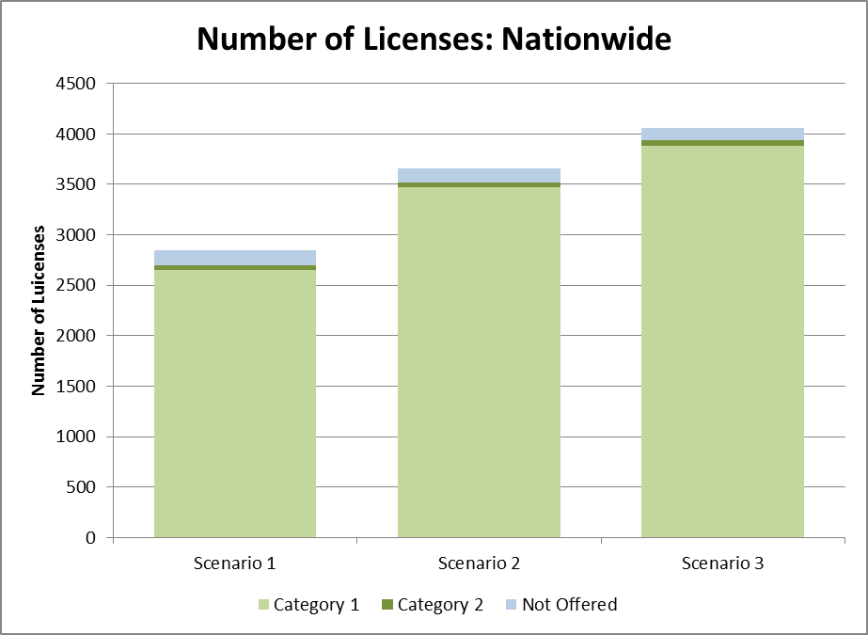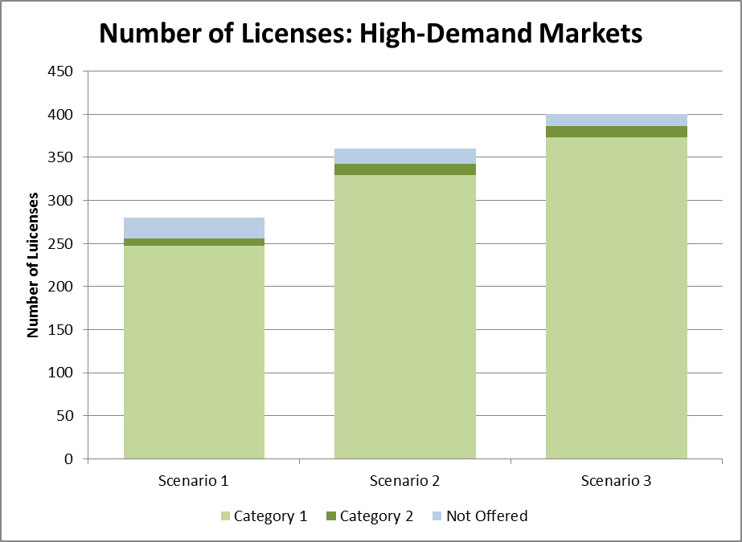

# Weighted MHz Available in the Forward Auction Nationwide and in High-Demand Markets (Not Protecting the Duplex Gap)

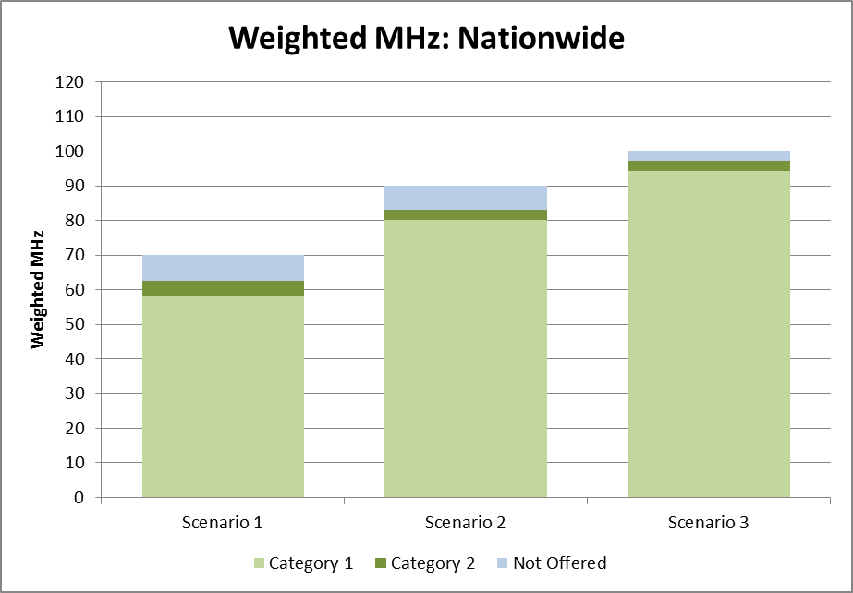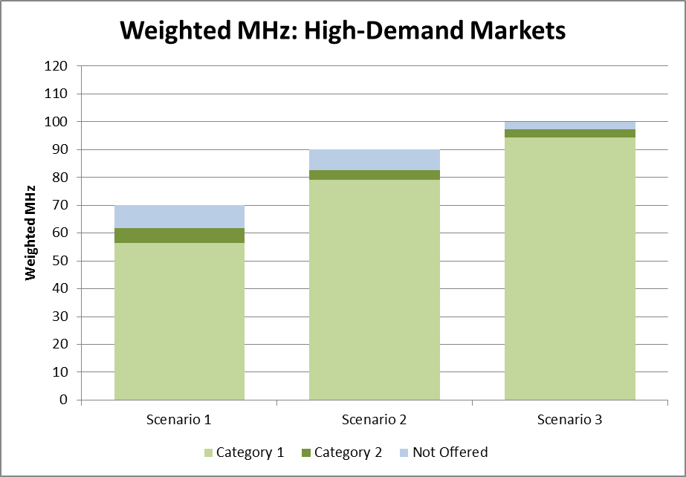

# Weighted MHz-Pops Available in the Forward Auction Nationwide and in High-Demand Markets (Not Protecting the Duplex Gap)

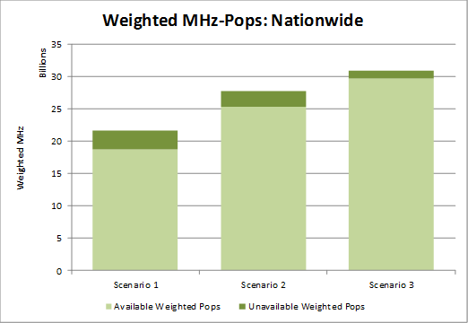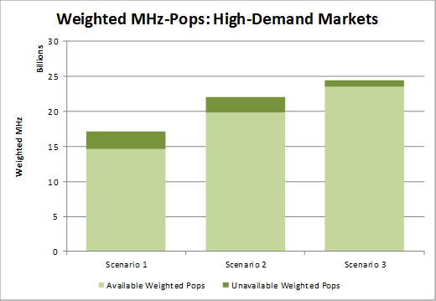

# Impact of Protecting the Duplex Gap: Comparison of Forward Auction Licenses Available in the Top 20 PEAs

