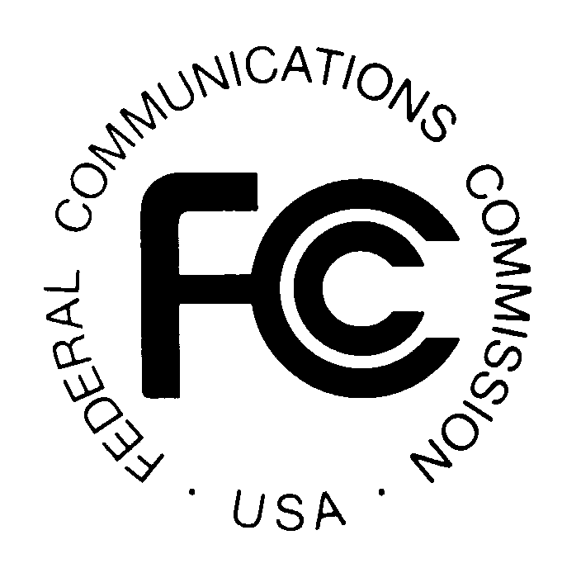 PUBLIC NOTICE

News media information 202 / 418-0500
TTY 202 / 418-2555
Internet: http://www.fcc.gov
Federal Communications Commission
445 12th St., S.W.
Washington, D.C. 20554

DA 15-644

May 29, 2015

PUBLIC SAFETY AND HOMELAND SECURITY BUREAU ANNOUNCES

REGION 45 (WISCONSIN) PUBLIC SAFETY REGIONAL PLANNING COMMITTEES TO HOLD 700 MHZ AND 800 MHZ NPSPAC REGIONAL PLANNING MEETINGS

PR Docket No. 92-273 and WT Docket 02-378

The Region 45 (Wisconsin) Public Safety Regional Planning Committees (RPCs) will hold two consecutive planning meetings on Thursday, June 11, 2015. Beginning at 10:00 a.m., the 700 MHz RPC will convene at the City of Sheboygan Police Department, 1315 North 23rd Street, Sheboygan, Wisconsin. At 11:00 a.m., the Region 45 800 MHz NPSPAC RPC meeting will convene (preceding the East Central Regional Interoperability meeting) at the same location. A conference bridge will be available to participate in both RPC meetings: Dial 866-906-9888, access code 8140705#.

The agenda for the 700 MHz RPC meeting includes:
- Call Meeting to Order
- Current status of FirstNet broadband activity in Wisconsin
- Upcoming FirstNet meeting
- Possible updates to the current Region 45 700 MHz plan
- Current actions
- Opportunity for questions or comments
- Adjourn Meeting

The agenda for the 800 MHz meeting includes:
- Call Meeting to Order
- Current status of 800 MHz rebanding
- NRPC activity
- Updates to the Region 45 800 MHz plan
- Opportunity for questions or comments
- Adjourn Meeting

Both Region 45 Public Safety RPCs’ meetings are open to the public. All eligible public safety providers in Region 45 may utilize these frequencies. It is essential that eligible public safety agencies in all areas of government, including state, municipality, county, and Native American Tribal be represented in order to ensure that each agency’s future spectrum needs are considered in the allocation process. Administrators who are not oriented in the communications field should delegate someone with this knowledge to attend, participate, and represent their agency’s needs.

All interested parties wishing to participate in planning for the use of public safety spectrum in the 700 MHz and 800 MHz bands within Region 45 should plan to attend. For further information, please contact:

Russ Schreiner, Chairman
Region 45 700 MHz and 800 MHz Public Safety RPCs
Communications and Electronics Technician
Sheboygan Police Department
1315 North 23rd Street
Sheboygan, Wisconsin 53081
rschreiner@ci.sheboygan.wi.us
(920) 459-3351

-FCC-

The Region 45 700 MHz and 800 MHz NPSPAC Regional Planning Committees encompass the State of Wisconsin except for the counties of Dane, Dodge, Jefferson, Kenosha, Milwaukee, Ozaukee, Racine, Rock, Walworth, Washington, and Waukesha, which are part of the Region 54 (Great Lakes Area) public safety regional planning area.

