News media information 202 / 418-0500
TTY 202 / 418-2555
Internet: http://www.fcc.gov
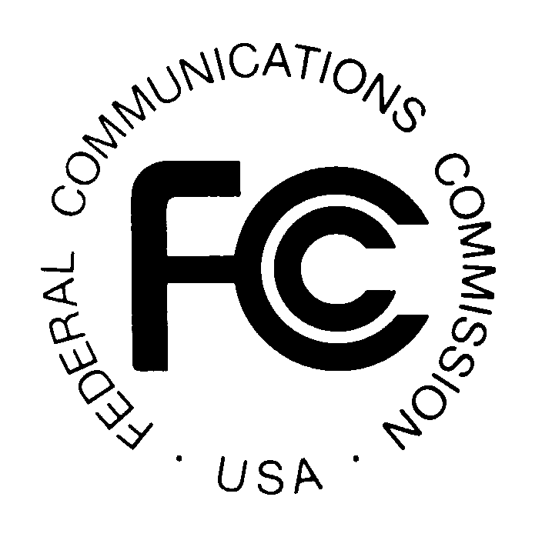
PUBLIC NOTICE

Federal Communications Commission
445 12th St., S.W.
Washington, D.C. 20554

DA 15-682

June 10, 2015

PUBLIC SAFETY AND HOMELAND SECURITY BUREAU ANNOUNCES

REGION 29 (NEW MEXICO) PUBLIC SAFETY REGIONAL PLANNING COMMITTEE TO HOLD 700 MHZ PLANNING MEETING

WT Docket 02-378

The Region 29 (New Mexico) Public Safety Regional Planning Committee (RPC) will hold a 700 MHz Kick-Off planning meeting, via Microsoft Lync, on Wednesday, August 26, 2015 at 8:30 a.m. MDT (10:30 a.m. EDT).

The agenda for the 700 MHz meeting includes:
- Open Meeting - Roll-Call
- Appoint Temporary Secretary
- Review Meeting Agenda
- 700 MHz Planning Review
    - Development of the use of 700 MHz radio spectrum
    - No funding allocations associated with this planning endeavor
    - FCC has allocated spectrum geographically by county; no permanent allocations have been made in this region
- Nominations for Chair, Vice-Chair, Secretary/Treasurer
  - Elections
    - Selections Announced
    - Appointments
- Committee Selections
    - Bylaws
    - Technical/Software/Interoperability
    - Peer Review/Dispute Resolution
- Development of Draft Plan
- Region 29 Website (suggestions)
- Proposed Future Meetings
    - Wednesday, September 23, 2015 Webinar
    - Wednesday, October 21, 2015 Webinar
    - Wednesday, November 18, 2015 Webinar
    - Wednesday, December 16, 2015 Webinar
- Review
- Adjourn – Newly Elected RPC Chair

The Region 29 Public Safety RPC meeting is open to the public. All eligible public safety providers in Region 29 may utilize these frequencies. It is essential that eligible public safety agencies in all areas of government, including state, municipality, county, and Native American Tribal be represented in order to ensure that each agency’s future spectrum needs are considered in the allocation process. Administrators who are not oriented in the communications field should delegate someone with this knowledge to attend, participate, and represent their agency’s needs.

All interested parties wishing to participate in planning for the use of public safety spectrum in the 700 MHz band within Region 29 should plan to attend. The 700 MHz RPC Convener will provide additional information on how to access to the meeting via Microsoft Outlook. For further information, please contact:

Nick Cadena, 700 MHz RPC Convener
Broadband and Radio Service Manager
Department of Information Technology
Office: (505) 476-1796
Nick.Cadena@state.nm.us

- FCC -

