News media information 202 / 418-0500
Fax-On-Demand 202 / 418-2830
TTY 202 / 418-2555
Internet: http://www.fcc.gov
ftp.fcc.gov
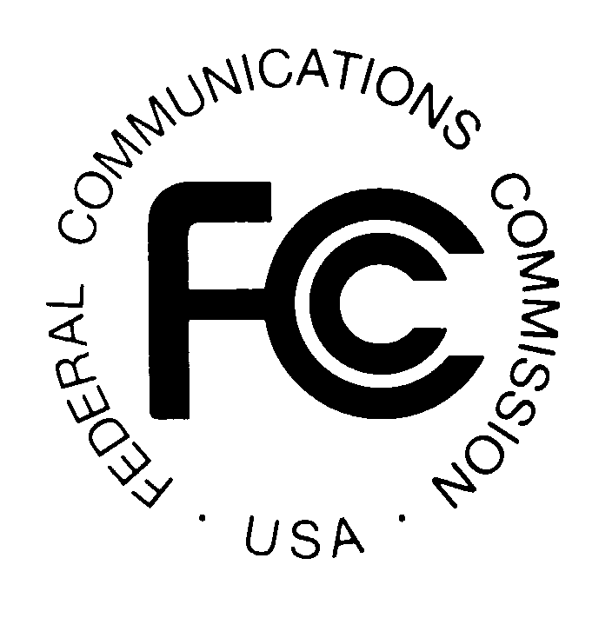
PUBLIC NOTICE

Federal Communications Commission
445 12th St., S.W.
Washington, D.C. 20554

DA 15- 756

June 26, 2015

PUBLIC SAFETY AND HOMELAND SECURITY BUREAU ANNOUNCES

REGION 18 (LOUISIANA) PUBLIC SAFETY REGIONAL PLANNING COMMITTEE TO HOLD 700 MHZ REGIONAL PUBLIC SAFETY PLANNING MEETING

WT Docket 02-378

The Region 18 (Louisiana) 700 MHz Public Safety Regional Planning Committee (Region 18 700 MHz RPC) will hold a planning meeting on Thursday, July 16, 2015. Beginning at 1:30 p.m., the Region 18 700 MHz RPC will convene at the Holiday Inn, 4848 Constitution Avenue, Baton Rouge, Louisiana 70808.

The purpose of this meeting is to review, discuss, and approve FCC required changes to the Region 18 700 MHz plan. The Region 18 700 MHz RPC will also nominate and elect new officers at this meeting.

The Region 18 700 MHz RPC meeting is open to the public. All eligible public safety providers whose sole or principal purpose is to protect the safety of life, health, or property in Region 18 may utilize these frequencies. It is essential that public safety agencies in all areas of government including state, municipality, county, and Native American Tribal, and non-governmental organizations eligible under Section 90.523 of the Commission’s Rules, be represented in order to ensure that each agency’s future spectrum needs are considered in the allocation process. Administrators who are not oriented in the communications field should delegate someone with this knowledge to attend, participate and represent their agency’s needs.

All interested parties wishing to participate in the planning for the use of public safety spectrum in the 700 MHz band within Region 18 should plan to attend. For further information, please contact:

Paul L. Miller, Chairman
Region 18, 700 MHz Public Safety Regional Planning Committee
Louisiana Public Safety Planning Advisory Committee
901 Lakeshore Drive, Suite 200
Lake Charles, Louisiana 70601
(337) 721-3800
plmiller@cppj.net

-FCC-

