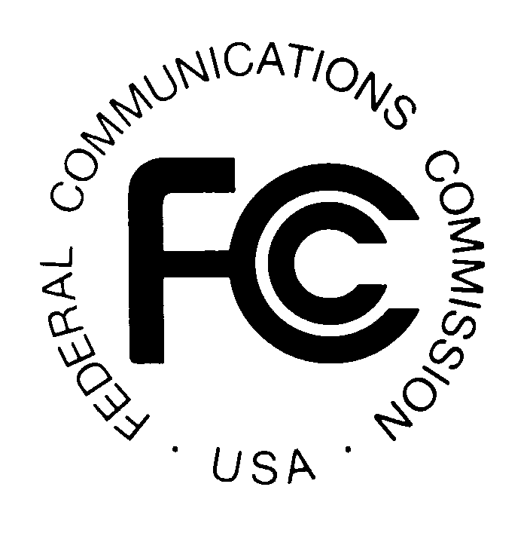 PUBLIC NOTICE
Federal Communications Commission
445 12th St., S.W.
Washington, D.C. 20554

News Media Information: 202.418.0500
TTY: 202.418.2555
Internet: http://www.fcc.gov

DA 15-757

June 26, 2015

PUBLIC SAFETY AND HOMELAND SECURITY BUREAU ANNOUNCES

REGION 13 (ILLINOIS) 700 MHZ REGIONAL PLANNING COMMITTEE MEETING

WT Docket 02-378

The Region 13 (Illinois) 700 MHz Regional Planning Committee (RPC) will hold a special meeting to review and update the 700 MHz Plan. The meeting will be held on Wednesday, July 15, 2015, 10:00 a.m., at Sangamon County 911 Center, 2000 Shale Street, Springfield, IL 62703.

The Region 13 700 MHz RPC meeting is open to the public. It is essential that public safety agencies in all areas of government, including state, municipality, county, and Native American Tribal, and non-governmental organizations eligible under Section 90.523 of the Commission’s rules, 47 C.F.R. § 90.523, be represented in order to ensure that each agency’s future spectrum needs are considered in the allocation process. Administrators who are not oriented in the communications field should delegate someone with this knowledge to attend, participate, and represent their agency’s needs.

For further information, please contact:

William Carter, Chairperson
700 MHz Regional Planning Committee
Illinois Department of Public Health
Radio Communications Coordinator
122 South Michigan
Chicago, Illinois 60603
(312) 814-5208
(312) 497-6802 Mobile
Billy.carter@illinois.gov

-FCC-

The Region 13 (Illinois) 700 MHz regional planning area includes the entire state of Illinois, except for the “Southern Lake Michigan” counties of Boone, Cook, DeKalb, DuPag, Grundy, Kane, Kankakee, Kendallm Lake, McHenry, Will and Winnebago, which are included in the Region 54 (Southern Lake Michigan) tri-state planning area.

