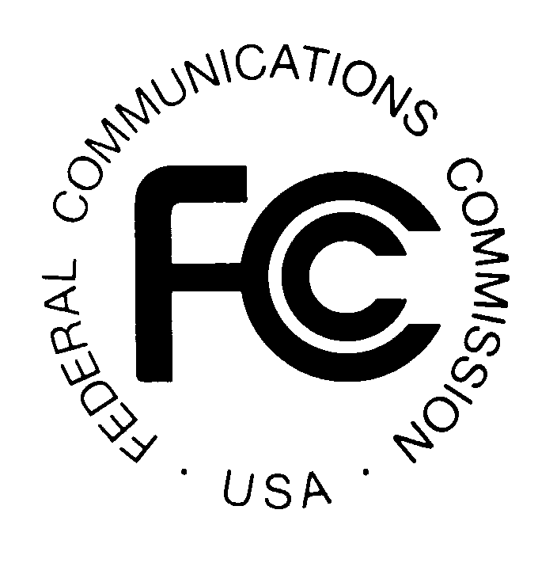 PUBLIC NOTICE
Federal Communications Commission
445 12th St., S.W.
Washington, D.C. 20554
News Media Information: 202.418.0500
TTY: 202.418.2555
Internet: http://www.fcc.gov

DA 15-937

August 20, 2015

PUBLIC SAFETY AND HOMELAND SECURITY BUREAU ANNOUNCES

REGION 8 (NEW YORK CITY METROPOLITAN AREA) 700 MHZ AND 800 MHZ PUBLIC SAFETY REGIONAL PLANNING COMMITTEES UPDATED 2015 MEETING SCHEDULE

General Docket No. 88-476 and WT Docket 02-378

The Region 8 (New York City Metropolitan Area) 700 MHz and 800 MHz NPSPAC Public Safety Regional Planning Committees (RPCs) announces a date change in the schedule of their remaining 2015 quarterly meetings. The 800 MHz NPSPAC meetings will commence immediately following the adjournment of the 700 MHz meetings.

Updated 700 MHz and 800 MHz 2015 meeting schedule:

    - September 17, 2015 at 10:00 am - NEW DATE
Paramus Life Safety Complex
1 Jockish Square
Paramus, New Jersey 07652

    - November 19, 2015 at 10:00 am
Orange County Department of Emergency Services
22 Wells Farm Road
Goshen, New York 10924

The Region 8 700 MHz and 800 MHz NPSPAC Public Safety RPC meetings are open to the public. It is essential that public safety agencies in all areas of government, including state, municipality, county, Native American Tribal, and non-governmental organizations eligible under Section 90.523 of the Commission’s rules, 47 C.F. R. § 90.523, be represented in order to ensure that each agency’s future spectrum needs are considered in the allocation process. Administrators who are not oriented in the communications field should delegate someone with this knowledge to attend, participate, and represent their agency’s needs.

All interested parties wishing to participate in planning for the use of public safety spectrum in the 700 MHz and 800 MHz NPSPAC bands within Region 8 should plan to attend. For further information, please contact:

Allen J. Demcoe
Chair (Region 8 700 MHz and 800 MHz)
Middlesex County Department of Public Safety and Health
1001 Fire Academy Drive
Sayreville, NJ 08872
Office: (732) 316-7183
allen.demcoe@co.middlesex.nj.us

Morton Leifer PE.
Vice Chair (Region 8 700 MHz and 800 MHz)
APCO Co-Primary Frequency Advisor, New York
Clarkstown Police Department
20 Maple Avenue,
New City, NY 10956
Office: (845) 406-0729
mleifer@Clarkstown.org
leiferm@apcointl.org

-FCC-

The Region 8 (New York Metropolitan Area) includes Region 8 (New York – Metropolitan area) consists of Bronx, Kings, Nassau, New York, Orange, Putnam, Queens, Richmond, Rockland, Suffolk, Sullivan, Ulster, Dutchess, and Westchester Counties, New York; and Bergen, Essex, Hudson, Morris, Passaic, Sussex, Union, Warren, Middlesex, Somerset, Hunterdon, Mercer, and Monmouth Counties, New Jersey.

