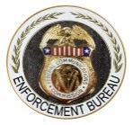
PUBLIC NOTICE 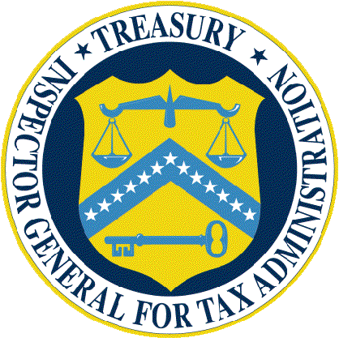
Enforcement Bureau Treasury Inspector General for Tax Administration
Federal Communications Commission Department of the Treasury
445 12th Street, SW 1401 H Street, NW, Suite 469
Washington, D.C. 20554 Washington, D.C. 20005

News Media Information (202) 418-0500 News Media Information (202) 622-6500
Internet: http://www.fcc.gov Internet: https://www.treasury.gov/tigta/oi_office.shtml
TTY: 1-888-835-5322

Media Contact: Media Contact:
Will Wiquist, (202) 418-0509 Karen Kraushaar, (202) 622-6500
Will.Wiquist@fcc.gov Karen.Kraushaar@tigta.treas.gov

DA 16-1392
December 19, 2016
Enforcement Advisory No. 2016-07

FCC AND TIGTA WARN CONSUMERS OF IRS IMPERSONATION PHONE SCAM
Scam Has Cost Victims Tens of Millions of Dollars
Telephone fraudsters posing as Internal Revenue Service (IRS) agents have bilked tens of thousands of American consumers out of millions of dollars. This scam, the largest impersonation scam in the history of the IRS, has cost victims more than $50 million. The Federal Communications Commission (FCC) and the Treasury Inspector General for Tax Administration (TIGTA) are committed to quashing the scam, prosecuting the individuals behind the scam, and protecting consumers from future fraud and harassment.
How the Scam Works
The scam starts with an automated or live call from someone claiming to be an IRS agent or employee of the Treasury Department; the caller may use a common name and a fake IRS badge number. The caller may know the victim’s Social Security number or other personally identifiable information. Often, the telephone number displayed on the victim’s caller ID will show a Washington, D.C. number or even appear as “IRS.” The caller will claim that the victim owes the IRS taxes, which must be paid immediately or else the victim will be arrested or sued. The caller may also threaten the victim with being charged for a criminal violation, a grand jury indictment, immediate arrest, deportation or loss of a business or driver’s license.
The caller usually demands payment in the form of iTunes gift cards, prepaid debit or credit cards (e.g., Green Dot, MoneyPak, Reloadit), wire transfers, Western Union, or MoneyGram. With the victim on the phone, the caller may direct the victim to different stores to purchase multiple cards, in order to circumvent the limitation on how much the consumer may purchase at a single store. If the victim shows hesitance to comply or attempts to talk to anyone else, the caller will use fear and intimidation tactics to obtain the victim’s compliance. For example, the caller will claim that if the victim hangs up the telephone, the IRS will immediately issue an arrest warrant for unpaid taxes. This threat may be accompanied by a simultaneous call that shows up on the victim’s caller ID as “911.” Having succeeded at getting the victim to purchase the gift or prepaid cards, the caller will then ask the victim to read off the account number of the gift card or prepaid card, thereby defrauding the victim of thousands of dollars.

What Consumers Need to Know
Any call purportedly from the IRS demanding payment using gift cards, prepaid cards, or wire transfers is fraudulent. The IRS generally first contacts people by mail—not by phone—about unpaid taxes and never asks for payment in these forms or requests personal or financial information by e-mail, text, or any social media. Consumers should immediately hang up on these callers and file a complaint through TIGTA’s IRS Impersonation Scam Reporting Form. The consumer should also immediately report the incident to the Federal Trade Commission’s Complaint Assistant, and to the FCC’s Consumer Help Center.
Consumers should always be on alert for this scam and others. The following tips can help ward off unwanted calls and scams:
- Do not engage with the callers. Just hang up!
- If you are unclear if a caller is legitimate, just hang up. You can then independently look up the organization’s publicly listed phone number or legitimate website, and contact them through an official number, web form or email address to see if they called you.
- If you answer and the caller (often a recording) asks you to hit a button to stop getting the calls, just hang up. Scammers often use these tricks to identify—and then target—live respondents.
- If you receive a scam call, write down the number and file a complaint with the FCC, TIGTA, and other appropriate authorities so we can help identify and take appropriate action to help consumers targeted by illegal callers.
- Ask your phone service provider if it offers a robocall blocking service that allows subscribers to block unwanted calls. If not, encourage your provider to start offering a blocking service. You can also visit the FCC’s website on “Web Resources for Blocking Robocalls” for information and resources on available robocall blocking tools to help you reduce unwanted calls.
FCC and TIGTA Authority to Penalize Scammers
The FCC and TIGTA are working together to find these scammers, and anyone we find engaged in this scam may be prosecuted and subject to civil penalties.
TIGTA is statutorily mandated to protect the integrity and operations of the IRS and does so, in part, by investigating potential violations of criminal and civil law that adversely impact Federal tax administration. Pursuant to Federal law, anyone who falsely impersonates an IRS employee may be fined, or imprisoned for up to three years, or both. Additionally, anyone committing fraud over the telephone may be fined, or imprisoned for up to 20 years, or both.
The FCC has authority to impose forfeitures under Section 501 and 502 of the Communications Act. Anyone who willfully and knowingly violates the Communications Act and is convicted for such violation may face a penalty of up to $10,000 or imprisonment for up to one year. Any person who willfully and knowingly violates an FCC rule or regulation, may, upon conviction, be subject to a penalty of up to $500 for each and every day during which a violation occurs. Additionally, any violation of the Truth in Caller ID Act, prohibiting the knowing transmission of inaccurate caller identification with the intent to defraud or harm, is subject to a civil forfeiture up to $10,000 for each violation.

Need More Information?
As the agency that implements and enforces the Telephone Consumer Protection Act, the FCC reviews all consumer complaints and will continue, when appropriate, to issue alerts based on those complaints and other public information related to possible scams and frauds.
For further information regarding efforts to combat the IRS impersonation scam, contact: complaints@tigta.treas.gov or 1-800-366-4484 at TIGTA or Kristi Thompson at (202) 418-1318 or kristi.thompson@fcc.gov or Daniel Stepanicich at (202) 418-7451 or daniel.stepanicich@fcc.gov in the FCC’s Enforcement Bureau.

###

