DA: 16-357
Released: April 4, 2016

Consumer AND Governmental Affairs, WIRELINE COMPETITION, AND WIRELESS TELECOMMUNICATIONS BUREAUS APPROVE OPEN INTERNET BROADBAND CONSUMER LABELS
GN Docket No. 14-28

With this Public Notice, the Consumer and Governmental Affairs, Wireline Competition, and Wireless Telecommunications Bureaus (Bureaus) approve, with modifications, the consumer broadband labels proposed by the Commission’s Consumer Advisory Committee (CAC). The CAC proposed the labels pursuant to the 2015 Open Internet Order and, as required by the Commission, the labels will operate as a safe harbor format for broadband providers once the enhanced transparency requirements take effect.

In the 2015 Open Internet Order the Commission enhanced the rule governing broadband providers’ disclosure of commercial terms, network performance, and network management practices. The Commission found that consumers need an easy way to understand provider prices, performance, and network practices and required that providers convey the required information in a simple-to-understand format that would enable consumers to compare services of different broadband providers.

The Commission referred the matter to the CAC to recommend a format that would operate as a safe harbor for the required disclosure format. The Commission found that the CAC, which is composed of industry and consumer interests, with its experience with consumer disclosure issues was “an ideal body to recommend a disclosure format that should be clear and easy to read – similar to a nutrition label – to allow consumers to easily compare the services of different providers.” The deadline for the CAC recommendation was October 31, 2015, and the Commission delegated to the Bureaus authority to issue a Public Notice announcing whether the CAC’s proposal meets its expectations for the safe harbor.

The CAC submitted its proposed labels, one for fixed broadband and one for mobile broadband, and supporting materials on October 26, 2015. The CAC states its Disclosure Task Force met more than 20 times to discuss and develop the proposed labels, and that the CAC voted for the proposed labels unanimously. The Bureaus find that the CAC’s proposed labels substantially fulfill the goals of the 2015 Open Internet Order by providing a simple-to-understand format describing the key factors consumers need to know when considering broadband service, including: price, data allowances, speeds, and management practices, among other things. We find the proposed format displays these terms in plain language that is easy to understand without overwhelming consumers with too much information.

We therefore find that, with the changes incorporated into the attached labels and instructions attached to this Public Notice, the CAC’s proposed labels should operate as the safe harbor for the format and nature of the required disclosure to consumers prescribed in the 2015 Open Internet Order. The changes are consistent with the Order’s directive that the labels be similar to a nutrition label and the CAC’s recommendation that the Commission use design expertise to make the labels consumer-friendly. We reiterate and remind broadband providers that the labels must be provided in accessible formats. While the labels in the attachment may be used as a safe harbor after the enhanced transparency rules have taken effect, broadband providers may of course begin using the labels before that time and we encourage them to do so.

FOR FURTHER INFORMATION CONTACT: Jerusha Burnett, Consumer and Governmental Affairs Bureau, Federal Communications Commission, (202) 418-0526; Jerusha.Burnett@fcc.gov.

-FCC-

Fixed Broadband Consumer Disclosure
Blank Label

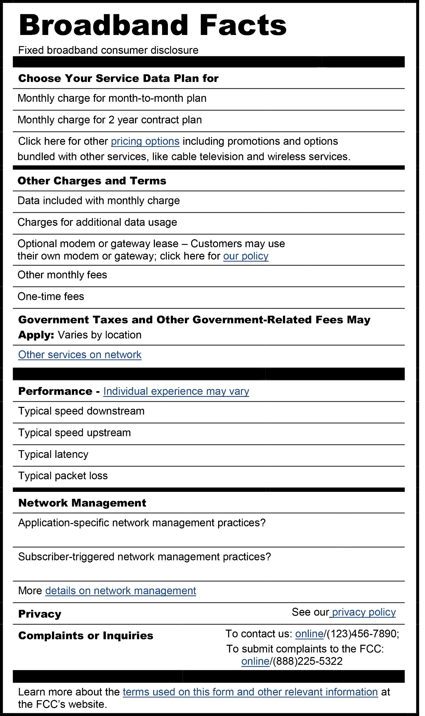

Fixed Broadband Consumer Disclosure
Provider Instructions

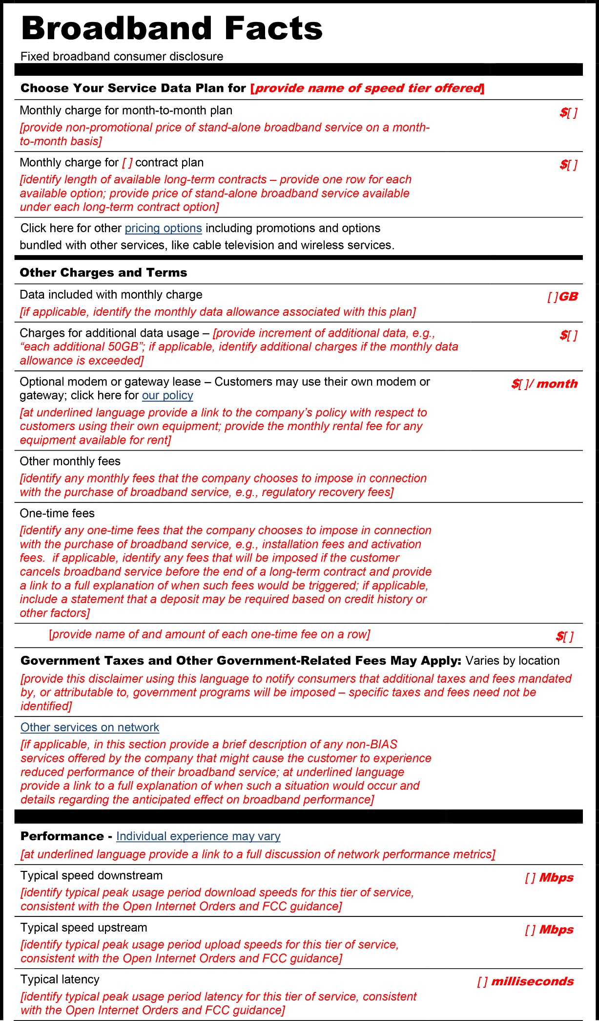
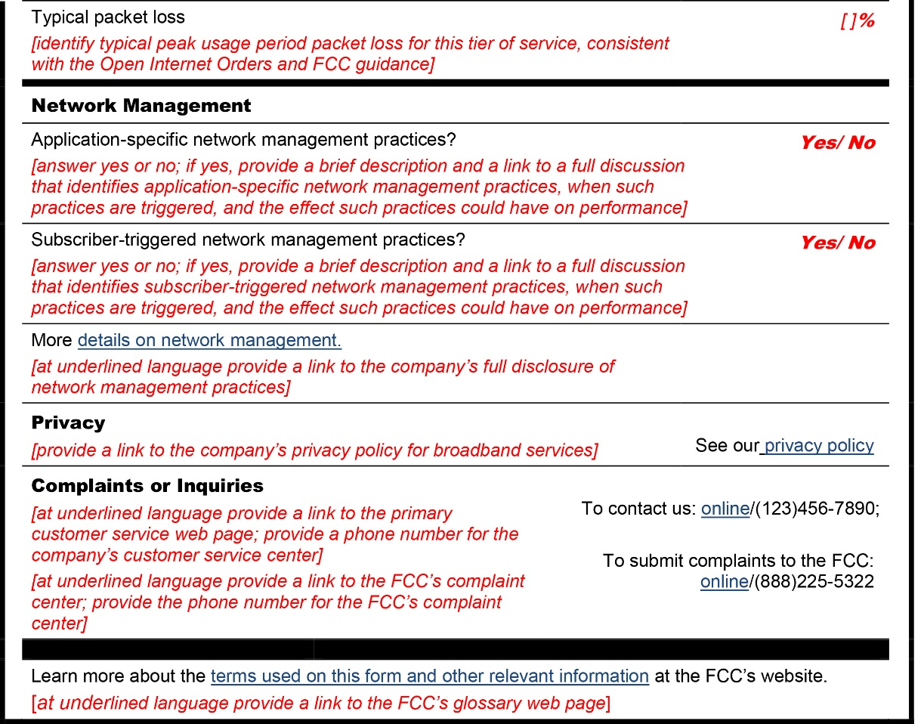

Mobile Broadband Consumer Disclosure
Blank Label

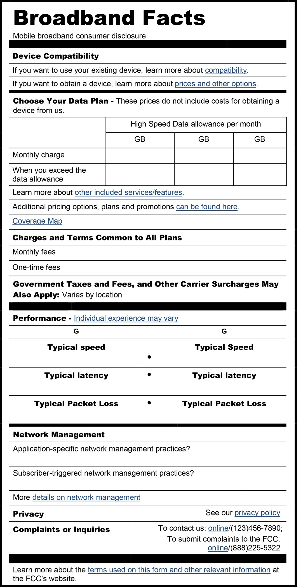

Mobile Broadband Consumer Disclosure
Provider Instructions

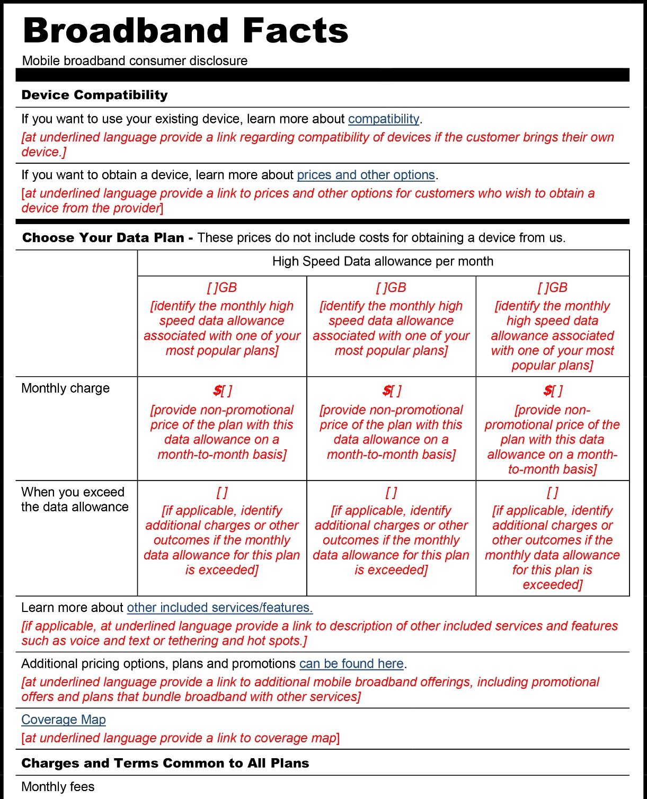

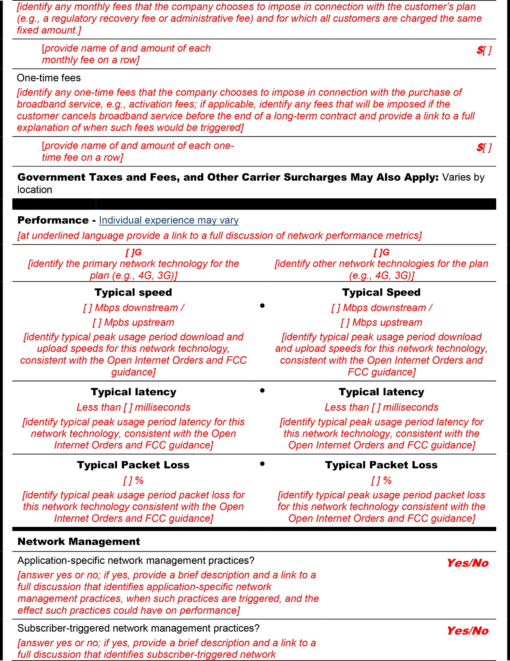

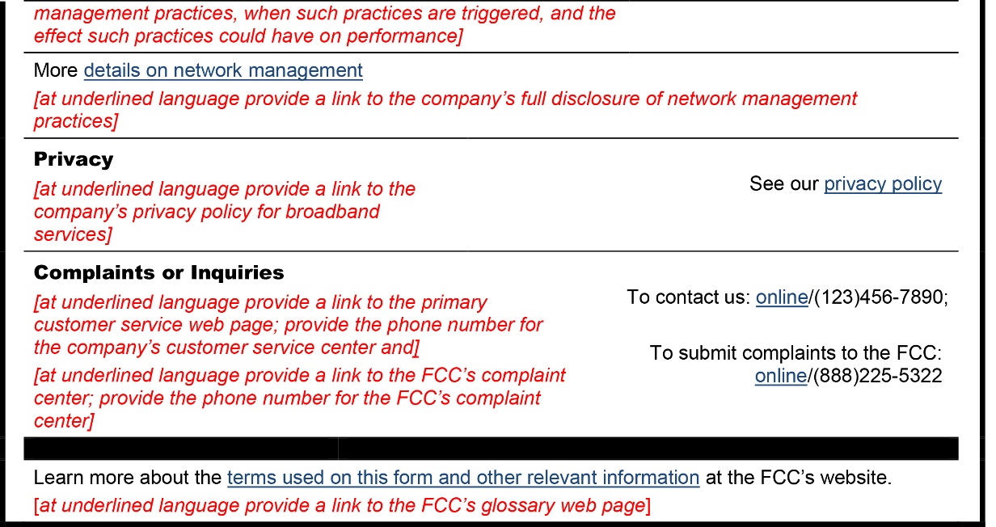

Protecting and Promoting the Open Internet, GN Docket No. 14-28, Report and Order on Remand, Declaratory Ruling, and Order, 30 FCC Rcd 5601, 5881, para. 585 (2015) (2015 Open Internet Order). The Commission has begun the process of obtaining OMB approval for the enhancements and will publish a notice in the Federal Register announcing that approval and the effective date. See id.
Id. at 5669-81, paras. 154-81.
See, e.g., id. at 5672, paras. 162-63.
Id. at 5680-81, paras. 179-80. As explained in the 2015 Open Internet Order, while the use of the broadband labels is a safe harbor with respect to the format of the required disclosure to consumers, a broadband provider meeting the safe harbor could still be found to be in violation of the transparency rules if, for example, the content of a disclosure (e.g., prices) is misleading or inaccurate, or the provider makes misleading or inaccurate statements in another context, such as advertisements or other statements to consumers. Id. at 5681, para. 181. We emphasize that to benefit from the safe harbor providers must use the format and terms as they appear in the Attachment.
Id. at 5680, para. 179.
Id. at 5680-81, para. 180.
See FCC Consumer Advisory Committee Recommendation, Broadband Consumer Disclosures, submitted October 26, 2015, available at https://www.fcc.gov/encyclopedia/consumer-advisory-committee-recommendations-2014-thru-2016.
See id.
See 2015 Open Internet Order, 30 FCC Rcd at 5680, para. 179.
Id. at 5680, para. 179.
See CAC Broadband Label Recommendation at 8, https://apps.fcc.gov/edocs_public/attachmatch/DOC-336136A1.pdf.
See 2015 Open Internet Order at 5680, para. 180. As part of its recommendation, the CAC also suggested approaches for accessibility. See Consumer Advisory Committee Recommendation, Broadband Consumer Disclosures, Section V, Disability Access available at https://apps.fcc.gov/edocs_public/attachmatch/DOC-336136A1.pdf.

