DA 16-945
Released: August 19, 2016
PUBLIC SAFETY AND HOMELAND SECURITY BUREAU REMINDS EAS PARTICIPANTS OF UPCOMING DATES AND DEADLINES RELATED TO THE NATIONWIDE EAS TEST AND RELEASES A REVISED EAS OPERATING HANDBOOK
PS Docket No. 15-94
The Public Safety and Homeland Security Bureau (Bureau) of the Federal Communications Commission (FCC or Commission) reminds all Emergency Alert System (EAS) Participants that, as announced in an earlier Public Notice, they are required to participate in a nationwide test of the EAS that is scheduled for September 28, 2016, at 2:20 pm EDT. The Bureau also reminds all EAS Participants that they must register with the EAS Test Reporting System (ETRS) and file Form One on or before August 26, 2016. EAS Participants shall file ETRS Form Two at or before 11:59 PM EDT on September 28, 2016, and shall file ETRS Form Three on or before November 14, 2016. Instructional materials, including an ETRS instruction manual, frequently asked questions about entering data into the respective forms, and a prerecorded webinar that explains how to file ETRS Form One, can be found at https://www.fcc.gov/general/eas-test-reporting-system.
The nationwide test will assess the reliability and effectiveness of the EAS, with a particular emphasis on testing FEMA’s Integrated Public Alert and Warning System (IPAWS), the gateway through which common alerting protocol-based (CAP-based) EAS alerts are disseminated to EAS Participants. In this regard, one of the main purposes of the test is to measure delays and latencies in the delivery of alerts through the Integrated Public Alert and Warning System (IPAWS). As with our first nationwide EAS test conducted in 2011, this test is diagnostic in nature and is intended to allow the FCC and FEMA to determine how well the nationwide EAS works and what, if any, improvements may be necessary.
The Bureau also announces the release of a revised EAS Operating Handbook (Handbook). A copy of the Handbook must be located at normal duty positions or EAS equipment locations when an operator is required to be on duty and be immediately available to staff responsible for administering EAS tests. The Handbook will supersede all other EAS Handbooks, and must be in place in time for the 2016 nationwide EAS test. The Handbook’s new format was designed by industry and alerting stakeholder members of the Commission’s Communications Security, Reliability, and Interoperability Council (CSRIC). This format allows each EAS Participant to enter data specific to their own configuration, tailoring the operational steps outlined in the manual for local relevance. A copy of the Handbook is attached as Appendix A to this Public Notice, and as noted above, can also be found on the Bureau’s web site at https://www.fcc.gov/general/eas-test-reporting-system.
For further information regarding the nationwide EAS test, contact Austin Randazzo, Attorney Advisor, Policy and Licensing Division, Public Safety and Homeland Security Bureau, at (202) 418-1462 or austin.randazzo@fcc.gov, or Gregory Cooke, Deputy Chief, Policy and Licensing Division, Public Safety and Homeland Security Bureau, at (202) 418-2351 or gregory.cooke@fcc.gov.
-FCC-

Appendix A – EAS Handbook
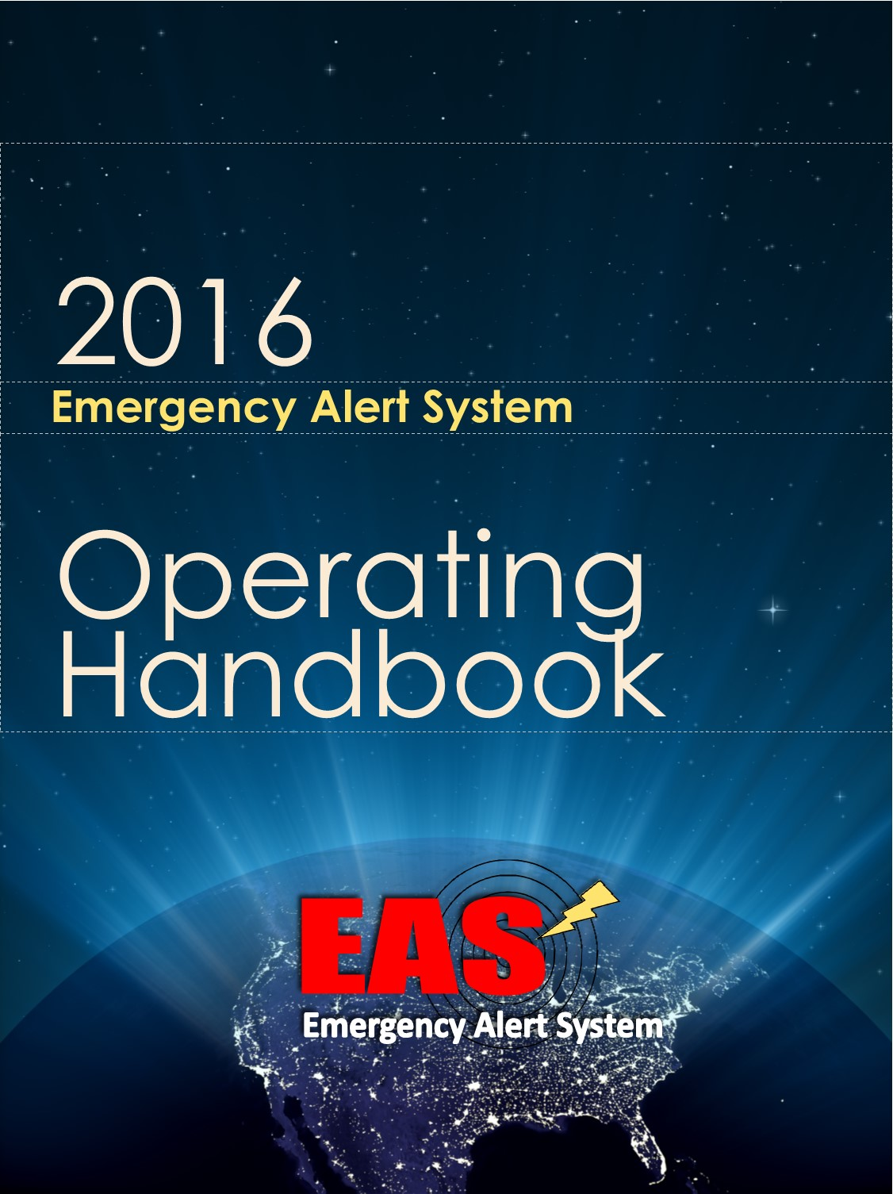

2016 EAS Operating Handbook

IMPORTANT: In order to optimize use of the handbook, blank spaces are provided for EAS Participants that may wish to tailor the handbook to accommodate their own individual procedures prior to posting. Blank spaces are provided for EAS Participants to individualize the handbook. Appropriate State or Local Emergency Communications Committee personnel and the manufacturer of your facility’s EAS device have additional information that will assist you in utilizing this Handbook.

Operators with EAS questions or issues should contact the following individual responsible for EAS operations at this facility:

Name:

Contact Information: ___________________________________________

Post at All EAS Operator Locations

Table of Contents

Introduction 3
EAS Alerts & Tests 5
National-level EAS Alert 5
National EAS Test 7
Monthly EAS Test 8
Weekly EAS Test 10
State and Local EAS Alerts 12
Recovery Procedures………………………………..………………………13

INTRODUCTION

The EAS Operating Handbook aids EAS Participant personnel in handling EAS messages by outlining operational procedures reflective of the requirements found in the part 11 rules. The Handbook states in summary form the actions to be taken by personnel at EAS Participant facilities upon receipt of an EAN, tests, or State and Local Area alerts. It is issued by the FCC and contains instructions for the above situations. A copy of the Handbook must be located at normal duty positions or EAS equipment locations. See 47 CFR § 11.15.

Guidance in this Handbook

This Handbook provides guidance on:

- National-level EAS Alert
  - This alert uses the Emergency Action Notification (EAN) event code.

- National EAS Test
  - This test uses the National Periodic Test (NPT) event code.

- Monthly EAS Test
  - This test uses the Required Monthly Test (RMT) event code.

- Weekly EAS Test
  - This test uses the Required Weekly Test (RWT) event code.

- State and Local EAS Alerts
  - These alerts use all other event codes.

Instructions for Automated Facilities
If your facility operates in Automatic part of the time and Manual at other times, it is suggested that you check the Manual mode box, and in Step 1 of the procedure list the hours your facility is in Automatic mode when no operator intervention is required.
Instructions for Class D non-commercial educational FM, LPFM, and LPTV stations
Class D non-commercial educational FM, LPFM, and LPTV stations are granted the exception in FCC rules of not being required to install an EAS Encoder. However, the rules allow these stations to install an Encoder/Decoder if desired. If your facility does operate an Encoder/Decoder, then you should follow the general instructions in this document. If your facility operates as decoder-only, you should follow the “decoder only” instructions below for Required Monthly Tests (RMT) and Required Weekly Tests (RWT).
NATIONAL-LEVEL EAS ALERT

EAS Event Code: Emergency Action Notification (EAN)

All facilities are required to immediately relay the Emergency Action Notification (EAN).

The EAN is received by our EAS unit from sources outside our facility. It is generated by Federal officials.

What do I need to do if I am the operator on duty? (check one)

- At this facility, EANs are relayed automatically, with no operator intervention.
- OR -
- At this facility, the operator on duty is required to perform the following steps to relay an EAN:

- Step 1:________________________________________________________

- Step 2:________________________________________________________

- Step 3: _______________________________________________________

- Three data bursts and a tone indicate that the End of Message (EOM) code has been received and that the alert will finish by itself, after which regular programming will resume.

What does the EAN sound like?

The EAN begins with three long EAS data bursts, followed by the 8-second attention signal, then the President or other authorized Federal official will speak for as long as necessary. There is no time limit to the EAN alert. The EAN will end with three short EAS data bursts.

There may be silence, or a repeating “please stand by” message during the EAN before the President or other authorized Federal official begins speaking.

What if I am the operator on duty and have a problem?

Note in detail what happened and immediately report the issue to the individual responsible for EAS operations at this facility.

For guidance on resolving problems, see the section on Recovery Procedures at the back of this Handbook.
NATIONAL EAS TEST

EAS Event Code: National Periodic Test (NPT)

All facilities are required to immediately relay the National Periodic Test (NPT).

The National EAS Test is received by our EAS unit from sources outside our facility. It is generated by Federal officials.

What do I need to do if I am the operator on duty? (check one)

- At this facility, NPTs are relayed automatically, with no operator intervention.
- OR -
- At this facility, the operator on duty is required to perform the following steps to relay an NPT:

- Step 1:________________________________________________________

- Step 2:________________________________________________________

- Step 3: _______________________________________________________

- Three data bursts and a tone indicate that the End of Message (EOM) code has been received, and that the test is over.

What does the NPT sound like?

The NPT consists of three long EAS data bursts, the 8 second attention signal, an audio message, and three short EAS data bursts. It has a built-in two minute time limit.
What if I am the operator on duty and have a problem?

If the NPT test does not run, NEVER try to originate one yourself. Instead, note in detail what happened and report the issue to the individual responsible for EAS operations at this facility.

For guidance on resolving problems, see the section on Recovery Procedures at the back of this Handbook.
MONTHLY EAS TEST

EAS Event Code: Required Monthly Test (RMT)

SENDING THE RMT: Not all facilities originate RMTs. (check one)

- This facility sometimes originates RMTs. See instructions at: _______.
- OR -
- At this facility, operators should NEVER originate an RMT.

RECEIVING THE RMT: When the Monthly EAS Test is received by our EAS unit from sources outside our facility, the operator shall follow the guidance below.

What do I need to do if I am the operator on duty? (check one)

- At this facility, received RMT tests are relayed automatically, with no operator intervention.
- OR -
- At this facility, the operator on duty is required to perform the following steps to relay a received RMT:

- Step 1:________________________________________________________

- Step 2:________________________________________________________

- Step 3: _______________________________________________________

- Three data bursts and a tone indicate that the End of Message (EOM) code has been received, and that the test is over.

- At this facility, the Required Monthly Test shall be run with a 90-character or less freeform text Alert Message within ____minutes of being received by the EAS equipment.

What does the RMT sound like?

The RMT includes three long EAS data bursts, an 8- second attention signal, an audio message, and three short EAS data bursts. It has a built-in two minute time limit.
What if I am the operator on duty and have a problem?

If the RMT test does not run, do not try to originate one yourself. Instead, note in detail what happened and report the issue to the individual responsible for EAS operations at this facility.

For guidance on resolving problems, see the section on Recovery Procedures at the back of this Handbook.
Decoder-Only Required Monthly Test Instructions
FCC rule 11.61(a)(1)(i) states that, “Analog and digital class D non-commercial educational FM, analog and digital LPFM stations, and analog and digital LPTV stations are required to transmit only the test script.”
For Required Monthly Tests, Class D NCE FM, LPFM, and LPTV stations may wish to check the box indicating “operator on duty is required to perform the following steps”, and as Step 1 fill in a statement such as, “Read the following script on the air, “This is a Required Monthly Test…”, using the appropriate script for your area as found in the State EAS Plan.
WEEKLY EAS TEST

EAS Event Code: Required Weekly Test (RWT)

- If this box is checked, our facility is exempt from originating the Required Weekly Test and all information below can be disregarded by the operator.

If the box above is not checked, all information below applies to our facility…

The EAS Required Weekly Test is originated by the EAS unit at our facility.

What do I need to do if I am the operator on duty? (check one)

- At this facility, RWT tests are originated automatically, with no operator intervention.
- OR -
- At this facility, the operator on duty is required to perform the following steps to originate an RWT:

- Step 1:________________________________________________________

- Step 2:________________________________________________________

- Step 3: _______________________________________________________

- Three data bursts and a tone indicate that the End of Message (EOM) code has been received, and that the test is over.

What does the RWT sound like?

The RWT includes three long EAS data bursts, a pause, and three short EAS data bursts. There is NO audio message within the RWT.

What if I am the operator on duty and have a problem?

If the RWT test does not run, note in detail what happened and immediately report the issue to the individual responsible for EAS operations at this facility so the test can be rescheduled.

For guidance on resolving problems, see the section on Recovery Procedures at the back of this Handbook.

Decoder-Only Required Weekly Test
FCC rule 11.61(a)(2)(ii) states, “DBS providers, analog and digital class D non-commercial educational FM stations, analog and digital LPFM stations, and analog and digital LPTV stations are not required to transmit this test.”
For RWT, if your facility operates as decoder-only, you may wish to check the box at the top of the RWT page indicating your facility is exempt from originating the RWT.
DBS Provider Exception
The above exception to originating RWTs applies to DBS facilities as well. If you choose to exercise this option, you may wish to check the box at the top of the RWT page indicating your facility is exempt from originating the RWT.

STATE AND LOCAL EAS ALERTS

EAS Event Code: These alerts use all event codes other than those on the preceding pages.

Refer to your facility’s EAS State Plan as well as other State and Local alerting guidance.

Facility Notes:
__________________________________________________________________

__________________________________________________________________

__________________________________________________________________

__________________________________________________________________

__________________________________________________________________

__________________________________________________________________

RECOVERY PROCEDURES

To resolve problems with any EAS event covered in this Handbook, consult the Recovery Procedures below.

At the conclusion of any EAS test or alert, if normal programming does not return or if you hear programming from another source, follow these steps: __________________________________________________________________

__________________________________________________________________

For issues other than the one described above, follow this procedure in the order listed:

- Step 1:________________________________________________________

- Step 2:________________________________________________________

- Step 3: _______________________________________________________

- Step 4:________________________________________________________

- Step 5:________________________________________________________

- Step 6: _______________________________________________________

Note in detail what happened and immediately report the issue to the individual responsible for EAS operations at this facility.

The Commission’s rules define EAS Participants as radio broadcast stations, including AM, FM, and low-power FM stations; digital audio broadcasting stations, including digital AM, FM, and low-power FM stations; Class A television and low-power TV stations; television broadcast stations, including digital Class A and digital low-power TV stations; cable systems; wireline video systems; wireless cable systems; direct broadcast satellite service providers; and digital audio radio service providers. See 47 CFR § 11.11(a).
Public Safety and Homeland Security Bureau Announces Nationwide Test of the Emergency Alert System on September 28, 2016, Public Notice, PS Docket No. 15-94, DA 16-803 (PSHSB July 18, 2016).
A secondary test date has been scheduled for Wednesday, October 5, 2016 at 2:20 p.m. EDT.
Public Safety and Homeland Security Bureau Launches EAS Test Reporting System (ETRS) and Seeks Comment on EAS Operating Handbook Recommendations, Public Notice, PS Docket No. 15-94, DA 16-721 at 2 (PSHSB June 27, 2016). EAS Participants have until September 26, 2016 to update information or correct any errors in their initial Form One filings. Id.
EAS Participants are required to file “day of test” data within 24 hours of any nationwide EAS test or as otherwise required by the Bureau. 47 CFR § 11.61(a)(3)(iv)(B).
EAS Participants are required to file detailed post-test data within 45 days following a nationwide EAS test. 47 CFR § 11.61(a)(3)(iv)(C).
Federal Communications Commission Reminds EAS Participants About November 9, 2011 Nationwide EAS Test, Public Notice, DA 11-1788 (PSHSB October 26, 2011), at 1.
In this regard, the test is intended to help facilitate our understanding of the EAS, including any technical issues concerning the Commission’s requirement that EAS messages be transmitted “immediately.” 47 CFR § 11.52(e)(2).
See 47 CFR § 11.15.

