DA 17-1027
Released: October 18, 2017
Comment Sought on Mobility Fund Phase II Challenge Process Procedures and Technical Implementation
WC Docket No. 10-90
WT Docket No. 10-208
Comment Date: November 8, 2017
Reply Comment Date: November 29, 2017
Table of Contents
Heading Paragraph #
I. Introduction 1
II. Procedures for Generating the Initial Eligible Areas Map 3
III. Procedures for MF-II Challenges 6
A. Specifying Provider Approved Handsets 7
B. Requirements for Speed Test Measurements 9
C. Automated Validation of Challenges 17
D. File Formats 24
IV. Other Important Challenge Process Information 25
A. Access to USAC Challenge Process Portal 25
B. Timing 28
V. Procedural Matters 31
A. Supplemental Initial Regulatory Flexibility Analysis 31
B. Ex Parte Presentations 36
C. Deadlines and Filing Procedures 37
APPENDIX A — Generating Initial Eligible Areas Map
APPENDIX B — Validating Challenge Evidence
APPENDIX C — Applying Subsidy Data
APPENDIX D — File Specifications and File Formats
APPENDIX E — Relational Mapping of Form 477 Filers to Providers

Introduction
- In the MF-II Challenge Process Order, the Commission established the framework for a robust and efficient challenge process to resolve disputes about areas presumptively ineligible for Mobility Fund Phase II (MF-II) support. Pursuant to the Commission’s direction, the Rural Broadband Auctions Task Force (Task Force), with the Wireline Competition Bureau and the Wireless Telecommunications Bureau (the Bureaus), now propose and seek comment on specific parameters and procedures to implement the MF-II challenge process.
- The challenge process will begin with a new, one-time collection of current, standardized coverage data on qualified 4G LTE service, defined by download speeds of 5 Mbps at the cell edge with 80 percent probability and a 30 percent cell loading factor. The coverage data will be used, in conjunction with subsidy data from the Universal Service Administrative Company (USAC), to establish the map of areas presumptively eligible for MF-II support. This Public Notice describes the steps the Commission intends to use to process the coverage and subsidy data and create that map. The Public Notice also proposes specific parameters for the data that challengers and respondents will submit as part of the challenge process, as well as a process for validating challenges. Establishing these parameters and procedures for the challenge process will enable the Commission to take the next step to extend mobile opportunities to rural America as quickly as possible.

Procedures for Generating the Initial Eligible Areas Map
- Appendix A and Appendix C describe in detail the methodology we plan to use to generate the map of areas presumptively eligible for MF-II support. This map will form the baseline for the challenge process. In accordance with the MF-II Challenge Process Order, the methodology revises an earlier methodology for determining presumptively eligible areas, which was detailed in a September 2016 staff report. This revised methodology accounts for the new, one-time 4G LTE data collection as the initial source of coverage data. In this multi-step process, Commission staff will first use the newly-collected 4G LTE coverage data and USAC subsidy data to determine the unsubsidized coverage for each provider. Commission staff would then aggregate these data across all providers to determine the presumptively eligible areas, that is, those areas lacking unsubsidized qualifying coverage by any provider.
- Specifically, in order to generate a map of unsubsidized qualified 4G LTE coverage for each provider, Commission staff would: 1) remove any subsidized areas from the provider’s coverage map; 2) remove any water-only areas; 3) overlay a uniform grid with cells of one square kilometer (1 km by 1 km) on the provider’s coverage map; and 4) remove grid cells with coverage of less than an area approximately equal to the minimum area that could be covered by a single speed test measurement when buffered. While the Commission did not explicitly state that water-only census blocks would be excluded from areas eligible for MF-II support, removing water-only areas is consistent with the staff analysis upon which the Commission relied when calculating the limited MF-II budget. The use of a uniform grid will allow the USAC portal to identify challenged areas automatically based on the grid cell in which a submitted speed test measurement falls, will provide a straightforward way of implementing the de minimis challenge size adopted by the Commission, and will simplify the adjudication process. The uniform grid also will relieve challengers of the burden of creating maps of the areas they wish to challenge, thereby furthering the Commission’s goal of encouraging robust participation in the challenge process to ensure that the determination of eligibility is as accurate as possible.
- Using the maps that result from steps 1-4 of this process, staff would then generate the map of presumptively eligible areas for each state (or state equivalent) with the following steps: 5) merging the maps of unsubsidized coverage for all providers; 6) removing the merged unsubsidized coverage generated in step 5 (the ineligible areas) from the state’s boundary to produce the eligible areas; and 7) removing any water-only areas from the eligible areas. The resulting map of presumptively eligible areas (overlaid with the uniform grid) for each state or state equivalent would then be made available to the public. The maps of unsubsidized coverage for specific providers would only be made available to challengers through USAC’s online challenge portal (the USAC portal) after challengers agree to keep such maps confidential. We seek comment on our proposed procedures for generating the initial map of presumptively eligible areas.

Procedures for MF-II Challenges
- As the Commission explained in the MF-II Challenge Process Order, adopting clear guidance and parameters on speed test data will help to ensure that the evidence submitted by challengers is reliable, accurately reflects consumer experience in the challenged area, and can be analyzed quickly and efficiently. We propose and seek comment on the following requirements for the challenge process.

Specifying Provider Approved Handsets
- In the MF-II Challenge Process Order, the Commission specified that service providers with qualified 4G LTE coverage will be required to identify at least three readily available handset models appropriate for testing those providers’ coverage. Challengers electing to use application-based tests and software-based drive tests must use the applicable handsets specified by each service provider with coverage in the challenged area.
- The Commission also stated that providers will be required to specify at least one handset that is compatible with industry-standard drive test software, and directed the Bureaus to propose and seek comment on the types of devices that may be used for speed tests. Accordingly, in order to ensure that at least one device is drive test compatible, we propose to require providers to identify at least one device that is either: (a) officially supported by the latest versions of drive test software, such as JDSU, ZK-SAM, Rohde & Schwartz, TEMS, or Ookla; or (b) engineering-capable and able to be unlocked and put into diagnostic mode in order to interface with drive test software. We seek comment on this proposal, particularly on whether it is sufficient to allow challengers to conduct drive tests efficiently and effectively.

Requirements for Speed Test Measurements
- In the MF-II Challenge Process Order, the Commission decided to require challengers to submit detailed proof of lack of unsubsidized, qualified 4G LTE coverage in the form of speed test measurements in order to initiate a challenge. While the Commission adopted a number of parameters in the MF-II Challenge Process Order, it also directed the Bureaus to seek comment on and “implement any . . . parameters or requirements as appropriate to ensure that speed tests accurately reflect consumer experience in the challenged area.”
- We will require that speed test data meet the standard parameters adopted by the Commission, in particular that each test be conducted between 6:00 AM and 12:00 AM (midnight) local time, and that the date of the test be after the publication of the initial eligibility map and within six months of the close of the challenge window. We propose to require challengers to submit all speed test measurements collected during these hours and during the relevant timeframe, including those that are above the speed threshold (i.e., showing speeds greater than or equal to 5 Mbps). Consistent with the validation framework adopted by the Commission however, only measurements showing download speeds below the 5 Mbps threshold will be considered as part of a valid challenge.
- The Commission decided in the MF-II Challenge Process Order that challengers must submit actual outdoor speed test measurements with sufficient density to reflect actual consumer experience throughout the entire challenged area. Specifically, the Commission adopted a requirement that challengers take measurements that: 1) are no more than a fixed distance apart from one another in each challenged area, and 2) substantially cover the entire area. The Commission directed the Bureaus to adopt the specific value – no greater than one mile – for the maximum distance between speed tests. Consistent with this direction, we propose to use a maximum distance value of one-half of one kilometer. In order to implement this density requirement, we will buffer each speed test point and calculate the buffered area, as explained by the Commission, then compare the area of the buffered points to the challengeable area within a grid cell. Further, we propose that a challenger have at least one speed test within the challengeable area of a grid cell in order to challenge an area within the grid cell. We anticipate that using a value of one-half of one kilometer as part of the validation process would help to ensure the accuracy of the submitted speed test data while balancing the burden on small carriers. We seek comment on our proposal and how this fixed distance would affect the collection and analysis of challenge data.
- We also propose to require challengers to provide other data parameters associated with a speed test. In addition to the parameters adopted by the Commission, which we will require, we propose to require that a challenger provide: signal strength and latency; the service provider identity and device used (which must be from that provider’s list of pre-approved handsets); the international mobile equipment identity (IMEI) of the tested device; the method of the test (i.e., software-based drive test or non-drive test app-based test); and, if an app was used to conduct the measurement, the identity and version of the app. This information will improve the ability of challenged parties and Commission staff to analyze the validity and probative value of a speed test. We seek comment on these additional proposed data parameter requirements.
- In the MF-II Challenge Process Order, the Commission explained that the evidence submitted by challenged parties must be reliable and credible to be useful during the adjudication process and indicated that submission of speed test data to refute a challenge would be particularly persuasive evidence. The Commission also required that, if a challenged party chooses to submit speed test data, the data must conform to the same standards and requirements it adopted for challengers, except for the recency of submitted data. Accordingly, we would require the same additional parameters as we propose to require of challengers, except for the requirement to identify the service provider, as a challenged party may only provide speed tests of its own network in response to a challenge.
- Recognizing that some providers may reduce the speed of data on their networks for network management purposes (e.g., in the case of large data usage by particular users), we propose to allow a challenged party to submit data that identify a particular device that a challenger used to conduct its speed tests as having been subjected to reduced speeds, along with the precise date and time the speed reductions were in effect on the challenger’s device. We seek comment on this proposal.
- Under the MF-II challenge process framework adopted by the Commission, challenged parties may submit device-specific data collected from transmitter monitoring software. Parties submitting transmitter monitoring software data are required to include “geolocated, device-specific throughput measurements and other device-specific information (rather than generalized key performance indicator statistics for a cell-site).” We propose to allow challenged parties to submit transmitter monitoring software data that is substantially similar in form and content to speed test data in order to facilitate comparison of such data during the adjudication process. In particular, if a challenged party wishes to submit such data, we propose to require: the latitude and longitude to at least five decimals of the measured device; the date and time of the measurement; signal strength, latency, and recorded speeds; and the distance between the measured device and transmitter. We seek comment on this proposal.
- We likewise propose to require that measurements from submitted transmitter monitoring software data conform to the standard parameters and requirements adopted by the Commission for speed test data submitted by a challenged party. Specifically, we propose to require that such measurements reflect device usage between the hours of 6:00 AM and 12:00 AM (midnight) local time and be collected after the publication of the initial eligibility map and within six months of the scheduled close of the response window. We seek comment on these proposed requirements.

Automated Validation of Challenges
- The MF-II Challenge Process Order adopted a general framework for automatic system validation of evidence submitted by challengers, and directed the Bureaus to implement specific parameters for such validations in conjunction with USAC. The framework adopted by the Commission requires the USAC system to:
- determine whether a particular challenged area meets the de minimis threshold of one square kilometer;
- analyze each record to ensure it meets all standard parameters, other than the maximum distance and substantial coverage requirement;
- create a buffer around each counted speed test using a radius equal to half of the maximum distance allowed between tests; and
- determine whether the buffered area of all counted speed tests covers at least 75 percent of the challenged area.
Below we propose details for the automated process by which the USAC system will validate evidence submitted during the challenge process to assure that the evidence meets the required parameters adopted by the Commission as well as any additional parameters that may be required after consideration of the record in response to this Public Notice.
- As discussed above, we plan to analyze geospatial data throughout the challenge process using a uniform grid based on cells of equal area, set at the de minimis challenged area threshold of one square kilometer. The uniform grid will help implement step one of the Commission’s validation framework. For each grid cell containing a speed test measurement submitted by a challenger, the system would consider the challengeable portion of the grid cell (i.e., the ineligible area, or any area that is neither eligible nor water-only) to constitute the challenged area. Our proposal to use a uniform grid of one square kilometer cells would ensure that a challenged area inherently meets the de minimis size threshold for grid cells that are entirely challengeable. In order to allow for challenges in grid cells where the challengeable portion of the cell is less than this threshold, we propose to validate that the sum of all challenged areas in a state is greater than or equal to one square kilometer. Consistent with the Commission’s framework, if a challenge submitted for a state fails this validation, the system would reject the entire challenge.
- To implement step two of the validation framework, we propose to require a challenger to submit speed test measurement data in a standard format on a state-by-state basis. This will permit the system to conduct an initial check for each speed test record to ensure that the data parameters are consistent with all adopted requirements and that the file matches the file specification. Any record that fails this initial check would be rejected, and the system would provide a warning message to the challenger with the reason for failing this step.
- For each speed test measurement passing step two (a counted speed test), the system would calculate the speed test buffer area, thereby determining the density of submitted speed tests and implementing step three of the validation framework. Specifically, we propose that the system determine the set of grid cells in which at least one counted speed test is contained. For each of these grid cells, the system would apply a buffer (i.e., draw a circle of fixed size) with a radius of one-quarter of one kilometer (one-half of the maximum distance allowed between tests) to each counted speed test and determine the total portion of this buffered area that overlaps with the coverage map of the challenged provider for whose network the speed test measurement was recorded (measured areas). Since a challenger has the burden of showing insufficient coverage by each provider of unsubsidized, qualified 4G LTE service, the system would also determine the unmeasured area for each such provider, that is, the portion of each provider’s coverage in the grid cell falling outside of the buffered area.
- Finally, to implement step four of the validation framework, the system would merge the unmeasured area of all providers in a grid cell to determine the aggregated unmeasured area where the challenger has not submitted sufficient speed test evidence for every provider. If the calculated size of the aggregated unmeasured area in the grid cell is greater than 25 percent of the total challengeable portion of the grid cell (the total area of the grid cell minus any water-only areas and any eligible areas), the challenge would be presumptively unsuccessful because it failed the requirement to include speed test measurements of sufficient density for all providers. The system would provide a warning to the challenger for any grid cells that fail this step. In other words, if a challenger has not submitted speed tests that, when buffered and aggregated across providers, dispute at least 75 percent of the coverage in that grid cell, the challenge would presumptively fail.
- We propose to allow challengers to certify their challenges notwithstanding this presumption. This would allow the system to consider all certified challenges in a particular grid cell across all challengers at the close of the challenge window. As a result, even if an individual challenger’s submission is presumptively unsuccessful, the system may determine that, in the aggregate, challenges to an area are presumptively successful if, as a result of multiple certified challenges, the total aggregated unmeasured area across all challengers is less than 25 percent. While the Commission decided not to subject response data submitted by challenged parties to USAC’s automatic system validation, we propose to process any such data jointly at the close of the response window using a similar approach (i.e., applying a buffer with a fixed radius to submitted speed measurements) in order to help evaluate competing data during the adjudication process. Under our proposal, the system would process evidence submitted by both challengers (speed tests) and challenged parties (speed tests, transmitter monitoring software measurements, and/or data speed reduction reports) to facilitate the comparison of such data by staff. We seek comment on this proposed implementation of the Commission’s framework.
- The proposed automated processing of evidence by the USAC system would promote a more streamlined, efficient, and transparent challenge process. Nevertheless, each challenge will be adjudicated using a preponderance of the evidence standard, as adopted by the Commission.

File Formats
- In the MF-II Challenge Process Order, the Commission directed the Bureaus to provide instructions for how to submit data to initiate or respond to a challenge, including file formats, parameters, and other specifications for conducting speed tests. With regard to speed test data, standardizing data-collection parameters will lead to a more efficient and accurate process, deter excessive and unfounded challenges, and minimize the burden on small business challengers as well as other parties participating in the challenge process. As the Commission stated, we will allow challengers to use drive-based or application-based tests to generate the necessary data reports, and the data will be analyzed by an automatic validation system. Consistent with those provisions adopted in the MF-II Challenge Process Order, we propose that challengers and respondents submit speed test data in comma-separated values (CSV) format matching the respective file specifications. Similarly, as discussed above, we propose to require that data from transmitter monitoring software match a substantially similar file specification in CSV form. We likewise propose to require that data submitted about speed reductions for devices match our proposed file specification in CSV form. Additional details about the attributes and the file formats that we propose to require for challengers and respondents may be found in Appendix D. We seek comment on this proposal generally.

Other Important Challenge Process Information

Access to USAC Challenge Process Portal
- The Commission directed the Bureaus to detail the process by which an interested party may request an account in order to access the USAC portal. Unless a party otherwise contacts the Commission as explained below, USAC will create accounts for all service providers, using contact information submitted by a filer in its Form 477 filing data as of June 30, 2017. After creating the account, USAC will issue log-on information to access the portal via email. If a filer wants to use contact information other than the contact it submitted for its Form 477 for purposes of accessing the USAC portal, or if a filer wishes to add other users, we propose that it email the Commission and provide its provider name, the first and last name of the user(s) it wishes to grant access to the portal, and the email address(es) of the user(s), up to a maximum of three users. We propose that government entities eligible to participate in the process (e.g., local, state, or Tribal government entities) submit via email the name of the entity, its legal jurisdiction, the first and last name of the user(s) that should have access to the portal on its behalf, and the email address(es) of the user(s), up to a maximum of three users. Other parties that seek to participate in the MF-II challenge process must first file a waiver petition with the Commission, and we propose requiring them to submit the first and last name of the user(s) that should have access to the portal on its behalf, and the email address(es) of the user(s), up to a maximum of three users, as part of their petition for waiver. We seek comment on these proposals.
- In accordance with the procedures adopted in the MF-II Challenge Process Order, we propose to make available in a downloadable format through the USAC portal the provider-specific data underlying the map of presumptively eligible areas. These baseline data would include geospatial data on a state-by-state basis in shapefile format for: (a) the boundaries of the state (or state equivalent) overlaid with the uniform grid; (b) the confidential coverage maps submitted by providers during the new, one-time data collection; and (c) the map of initial eligible areas. Additionally, the baseline data for each state would include tabular data in CSV format with the list of pre-approved handsets and the clutter information submitted during the new, one-time data collection for each provider.
- After Commission staff have adjudicated all challenges and responses, we propose to make available to challengers and respondents data about their challenges or responses through the USAC portal. Specifically, we would provide to each challenger or respondent for each of the grid cells associated with their certified challenges or certified responses, respectively: (a) the outcome of the adjudication; (b) the confidential evidence submitted and certified by all challengers; and (c) the confidential evidence submitted and certified by all respondents. We propose to make non-confidential information about the adjudication process available to the public on the Commission’s website concurrent with an announcement of the map of final eligible areas via public notice. Specifically, the public data would include: (a) the outcome of the adjudication for each challenged cell; and (b) the map of final eligible areas.

Timing
- We expect to make public a map of areas presumptively eligible for MF-II support no earlier than four weeks after the deadline for submission of the new, one-time 4G LTE provider coverage data. We propose that the challenge process window open on the next business day following the release of the map. Eligible parties would be able to access the USAC portal and download the provider-specific confidential data necessary to begin conducting speed tests on that day. The challenge window will close 150 days later, consistent with the procedures adopted in the MF-II Challenge Process Order. Although challenges will be accepted until the close of the challenge window, we encourage interested parties to file in advance of the closing date to allow ample time for data processing.
- Following the close of the challenge window, the USAC portal system will process the data submitted by challengers. We propose, therefore, to open the response window no earlier than five business days after the close of the challenge window to allow for this data processing. Once opened, the response window will close 30 days later. Although challenged parties will have an opportunity to submit additional data via the USAC portal in response to a certified challenge for the entire duration of the response window, challenged parties are similarly encouraged to file in advance of the deadline. A challenged party will not have a further opportunity to submit any additional data for the Commission’s consideration after the response window closes and should therefore plan accordingly.
- Commission staff will adjudicate certified challenges and responses, consistent with the standard of review and evidentiary standards adopted in the MF-II Challenge Process Order. Following the adjudication process, the Commission will publicly release the final map of areas eligible for MF-II support.

Procedural Matters

Supplemental Initial Regulatory Flexibility Analysis
- As required by the Regulatory Flexibility Act of 1980 (RFA), the Commission prepared Initial Regulatory Flexibility Analyses (IRFAs) in connection with the USF/ICC Transformation FNPRM, the 2014 CAF FNPRM, and the MF-II FNPRM (collectively, MF-II FNPRMs), and Final Regulatory Flexibility Analyses (FRFAs) in connection with the 2014 CAF Order, the MF-II Order, and the MF-II Challenge Process Order (collectively, MF-II Orders). The Commission sought written public comment on the proposals in the MF-II FNPRMs, including comments on the IRFAs. The Commission did not receive any comments in response to those Regulatory Flexibility Analyses.
- The IRFAs for the MF-II NPRMs and the FRFAs for the MF-II Orders set forth the need for and objectives of the Commission’s rules for the MF-II auction and challenge process; the legal basis for those rules; a description and estimate of the number of small entities to which the rules apply; a description of projected reporting, recordkeeping, and other compliance requirements for small entities; steps taken to minimize the significant economic impact on small entities and significant alternatives considered; and a statement that there are no federal rules that may duplicate, overlap, or conflict with the rules. However, because this Public Notice proposes specific procedures for implementing the rules proposed in the MF-II FNPRMs and adopted in the MF-II Orders, we have prepared a supplemental IRFA seeking comment on how the proposals in this Public Notice could affect those Regulatory Flexibility Analyses.
- The proposals in this Public Notice include procedures to allow interested parties the opportunity to contest an initial determination that an area is ineligible for MF-II support and challenged parties the opportunity to respond to challenges. These proposals are necessary in order to give effect to the Commission’s directive to propose and provide an opportunity for comment on detailed instructions, deadlines, and requirements for filing a valid challenge, including file formats, parameters, and other specifications for conducting speed tests. The proposals in this Public Notice are designed to lead to a more efficient and accurate challenge process, deter excessive and unfounded challenges, and minimize the burden on small business challengers, as well as other parties utilizing the challenge process.
- To implement the rules and framework adopted by the Commission in the MF-II Challenge Process Order, this Public Notice details the technical procedures we plan to use when generating the initial eligible areas map and processing challenges or responses submitted by challengers and challenged parties, respectively. The Public Notice also proposes additional requirements and parameters, including file formats and specifications, for data submitted during the challenge process. We have made an effort to anticipate the challenges faced by small entities (e.g., governmental entities or small mobile service providers) in complying with our implementation of the Commission’s rules and our proposals. For example, we plan to perform all geospatial data analysis on a uniform grid, which would remove the need for a challenger to submit a map of the area(s) it wishes to challenge on top of its evidence, reducing burdens on small entities. In addition, we propose to allow a challenged entity to submit evidence identifying devices that were subject to data speed reductions, alongside evidence from transmitter monitoring software and speed tests, which would allow for a small entity to more easily respond to a challenge. We note that smaller providers will have fewer resources available, and we therefore specifically seek comment on the parameters and procedures of the challenge process and ways to make them as efficient as possible for all interested parties, including small entities.
- As noted above, we seek comment on how the proposals in this Public Notice could affect the IRFAs in the MF-II FNPRMs or the FRFAs in the MF-II Orders. Such comments must be filed in accordance with the same filing deadlines for responses to this Public Notice and have a separate and distinct heading designating them as responses to the IRFAs and FRFAs.

Ex Parte Presentations
- This proceeding has been designated as a “permit-but-disclose” proceeding in accordance with the Commission’s ex parte rules. Persons making oral ex parte presentations are reminded that memoranda summarizing the presentations must contain summaries of the substance of the presentations and not merely a listing of the subjects discussed. More than a one- or two-sentence description of the views and arguments presented is generally required. Other provisions pertaining to oral and written ex parte presentations in permit-but-disclose proceedings are set forth in section 1.1206(b) of the Commission’s rules.

Deadlines and Filing Procedures
- Comments are due on or before November 8, 2017, and reply comments are due on or before November 29, 2017. Under the Commission’s current procedures for the submission of filings and other documents, submissions in this matter may be filed electronically through the Commission’s Electronic Comment Filing System (ECFS) or by filing paper copies. We strongly encourage interested parties to file comments electronically.
- Electronic Filers: Comments may be filed electronically using the Internet by accessing the ECFS at http://www.fcc.gov/ecfs. Filers should follow the instructions provided on the website for submitting comments. In completing the transmittal screen, filers should include their full name, U.S. Postal Service mailing address, and the applicable docket numbers, WC Docket No. 10-90 and WT Docket No. 10-208. To get filing instructions, filers should send an e-mail to ecfs@fcc.gov, and include the following words in the body of the message: “get form.” A sample form and directions will be sent in response.
- Paper Filers: Parties who choose to file by paper must file an original and three copies of each filing. Filings can be sent by hand or messenger delivery, by commercial overnight courier, or by first-class or overnight U.S. Postal Service mail. All filings must be addressed to the Commission’s Secretary Attn: WTB/ASAD, Office of the Secretary, Federal Communications Commission.
- The Commission’s contractor will receive hand-delivered or messenger-delivered paper filings for the Commission’s Secretary at the FCC Headquarters building located at 445 12th Street, SW, Room TW-A325, Washington, DC 20554. The filing hours at this location are 8:00 a.m. to 7:00 p.m. Eastern Time (ET). All hand deliveries must be held together with rubber bands or fasteners. Any envelopes must be disposed of before entering the building.
- Commercial overnight mail (other than U.S. Postal Service Express Mail and Priority Mail) must be sent to 9050 Junction Drive, Annapolis Junction, MD 20701.
- U.S. Postal Service first-class, Express, and Priority mail must be addressed to 445 12th Street, SW, Washington DC 20554.
- Copies of comments and reply comments will be available for public inspection between 8:00 a.m. and 4:30 p.m. ET Monday through Thursday, or 8:00 a.m. to 11:30 a.m. ET on Fridays, in the FCC Reference Information Center, Room CY-A257, 445 12th Street, SW, Washington, DC 20554, and will also be accessible through the search function on the ECFS web page at http://www.fcc.gov/ecfs.
- Persons with Disabilities: To request materials in accessible formats (Braille, large print, electronic files, audio format) for people with disabilities, send an e-mail to fcc504@fcc.gov or call the Consumer and Government Affairs Bureau at (202) 418-0530 or (202) 418-0432 (TTY).
- For further information concerning this proceeding, contact Jonathan McCormack, Auctions and Spectrum Access Division, Wireless Telecommunications Bureau, at (202) 418-0660.

-FCC-

- Generating Initial Eligible Areas Map
  - Introduction
In the MF-II Challenge Process Order, the Commission adopted a one-time collection of 4G LTE coverage data, “as defined by download speeds of 5 Mbps at the cell edge with 80 percent probability and a 30 percent cell loading factor.” These data will be used, in conjunction with USAC subsidy data, to establish the map of presumptively eligible areas resulting from the determination of each provider’s unsubsidized service areas. This appendix provides technical details of our planned geospatial-data-processing steps to generate the map of presumptively eligible areas.
  - Removing Water-only Areas and Subsidized Portions of Coverage Maps
After receiving the newly-collected coverage maps, we would initially divide coverage map data by state or state equivalent (if the provider has not already done so), since the challenge process requires the submission of challenges on a state-by-state basis. We would use the 2010 US Census TIGER boundary data for each state or state equivalent.
Once each provider’s coverage maps are separated by state, we would remove from the coverage area any areas where the provider receives subsidies to provide service. This process is comprised of two steps, and uses data sources which are discussed in Appendix C:
- remove from the coverage map any wire centers for which the provider is receiving frozen high-cost support subsidy; and
- remove from the coverage map any census blocks for which the provider received Mobility Fund Phase I (MF-I) support.
Finally, we would identify the census blocks that contain only water and no land areas. Using the 2010 US Census TIGER boundary data for census blocks, we would then remove any “water-only” areas from the provider’s submitted coverage map. Figure 1 provides an example of the original and resulting maps.
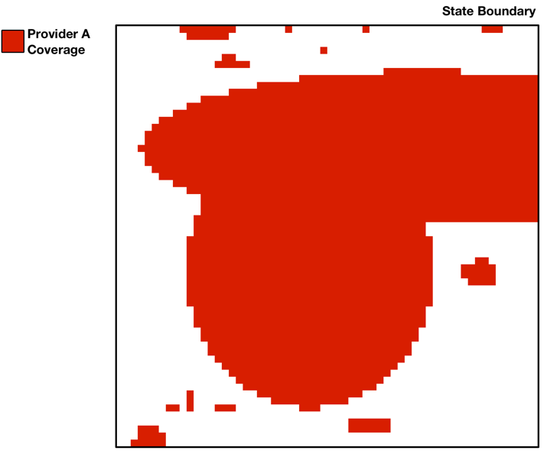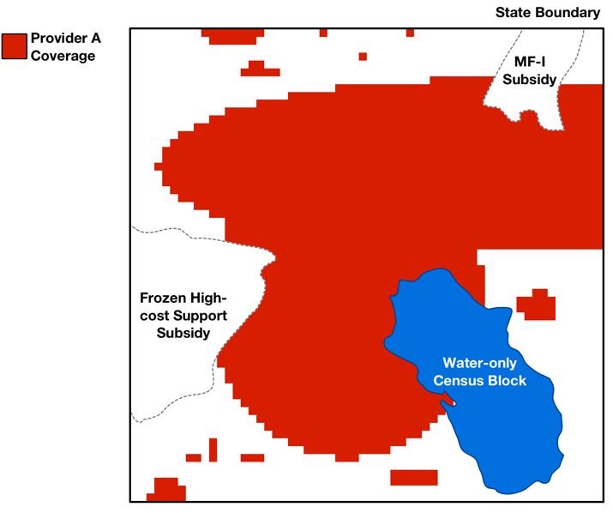
Figure 1: Raw coverage map for a provider separated into a single state (left). Same coverage map with water-only census block, frozen high-cost support and MF-I subsidy areas removed (right).
  - Overlaying the Uniform Grid on Newly Collected Coverage Maps
In order to improve and simplify geospatial data processing, we would define a uniform grid with cells of equal area (1 km by 1 km) across the continental United States, and separate uniform grids with cells of equal area (1 km by 1 km) for overseas territories and Hawaii. These grids would be defined using an “equal area” map projection so that the same number of speed tests would be required to challenge the grid cell regardless of the location of the grid cell. With equal area projections, cells may appear to have a non-uniform shape when viewed using a different map projection, depending on the grid cell’s location on the earth.
After determining the unsubsidized, non-water coverage area for a provider, we would overlay the relevant uniform grid on the provider’s coverage map, dividing it into the predetermined grid cells. Under our proposal, we would ignore coverage in a grid cell if it is less than 50,625 square meters (225 meters by 225 meters), or approximately one quarter of the buffered area of a single speed test, and remove it from the provider’s coverage map. This would both allow challengers and challenged parties to focus only on areas with significant coverage during the challenge process and improve the efficiency of processing. Specifically, when challenging areas within a grid cell, the challenger would need to provide speed tests only for providers with coverage greater than 50,625 square meters within those cells. In addition, eliminating minimal coverage areas will avoid having such areas remain ineligible but be separated from larger coverage areas after the challenge process in cases where the surrounding grid cells were successfully challenged.
An example of the overlaid grid and processed, unsubsidized baseline coverage map for a provider is shown in Figure 2.
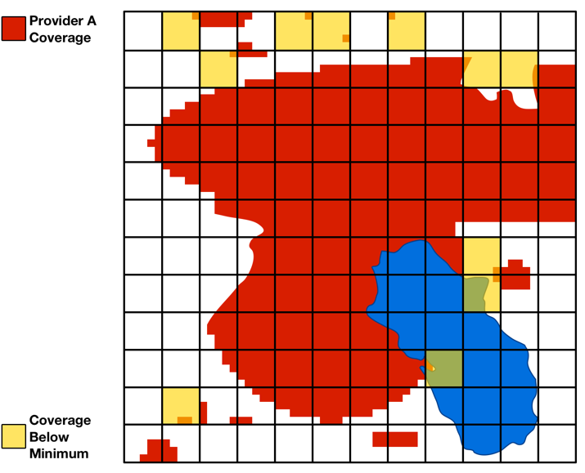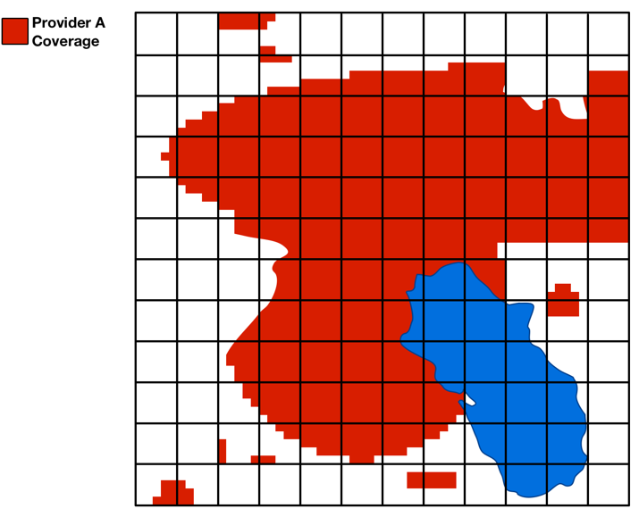
Figure 2: Grid cells applied to coverage map with areas below minimum coverage value highlighted in yellow (left). Coverage in cells below the minimum value is removed, and the area that remains is the final unsubsidized coverage map for the provider (right).
  - Determining Presumptively Eligible Areas
The process described in Sections 2 and 3 above would be repeated for each provider in a state until the unsubsidized coverage maps for all providers have been determined. In order to determine the areas presumptively ineligible for MF-II support, we would merge the unsubsidized coverage maps for all providers. The resulting area where there is unsubsidized 4G LTE coverage from at least one provider is ineligible and would be challengeable during the challenge process. We would then determine the presumptively eligible areas for the state (or state equivalent) from the remaining non-water areas within the state. The set of unsubsidized coverage maps for all providers and resulting map of areas presumptively ineligible for MF-II support are shown in Figure 3.
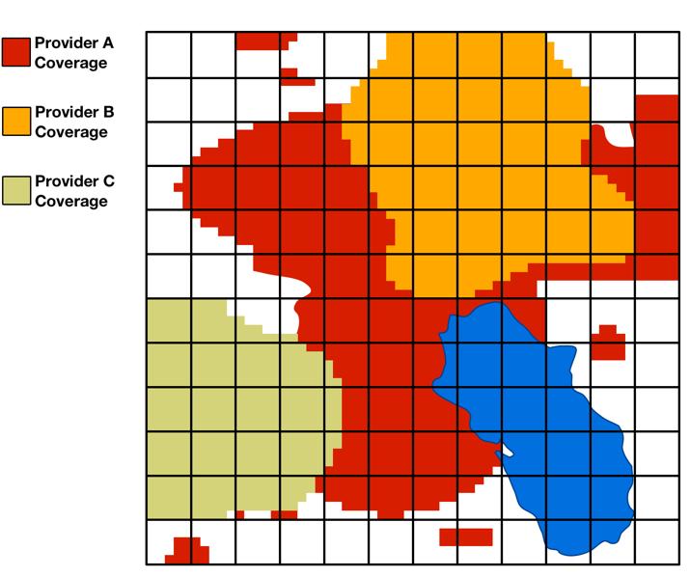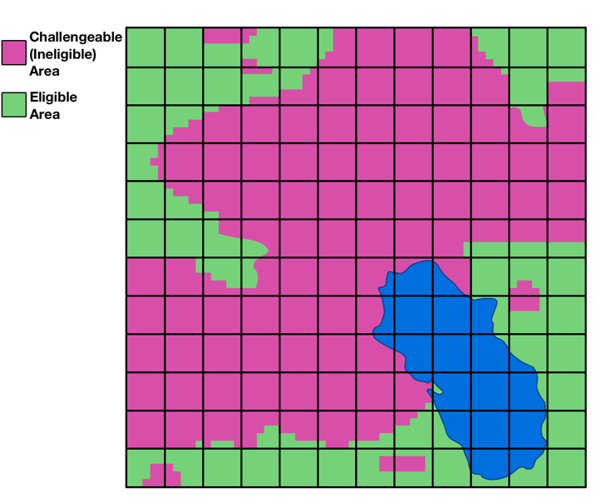
Figure 3: Unsubsidized coverage maps for multiple providers (left). Coverage for multiple providers is combined to determine the challengeable (ineligible) area (right). The area in a state that is neither water-only nor has unsubsidized coverage is eligible.

- Validating Challenge Evidence
  - Introduction
The USAC portal system will validate and process automatically data submitted during the challenge process to determine whether challenges should be deemed presumptively successful. The system will also compare competing evidence during the adjudication process. These processes are described below. As proposed, challenges would be evaluated on a grid cell basis. Only cells with at least one submitted speed test within the cell would be considered as challenged.
  - Determining the Speed Test Measured Areas
When a challenger submits speed test data, each grid cell within which a counted speed test (i.e., meeting the standard parameters as part of step two of the validation framework) is located would be evaluated as to whether a challenge for the entire cell is valid. To determine whether a grid cell has been challenged, each speed test point would be buffered to cover a circular area with a radius of 0.25 km (or half of the 0.5 km maximum distance between speed tests parameter). The speed test buffer area can extend into neighboring grid cells and can be used towards establishing the minimum challenge coverage area in the neighboring cells, as long as there is at least one counted speed test in the neighboring grid cell.
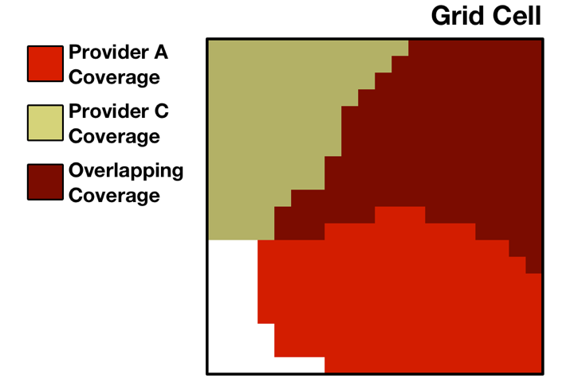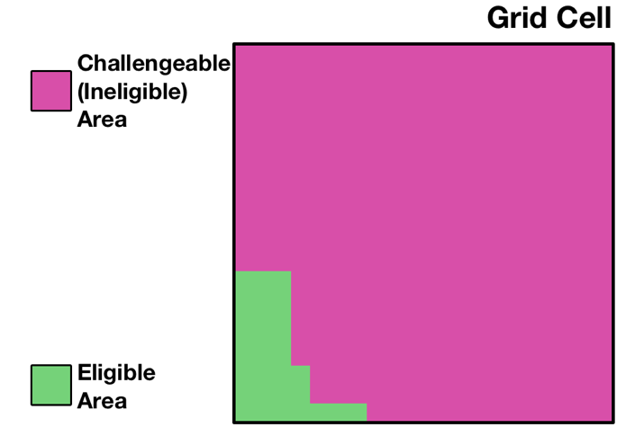
Figure 4: A single grid cell where two providers have unsubsidized service (left). These areas combine to determine the challengeable (ineligible) area and eligible area (right).
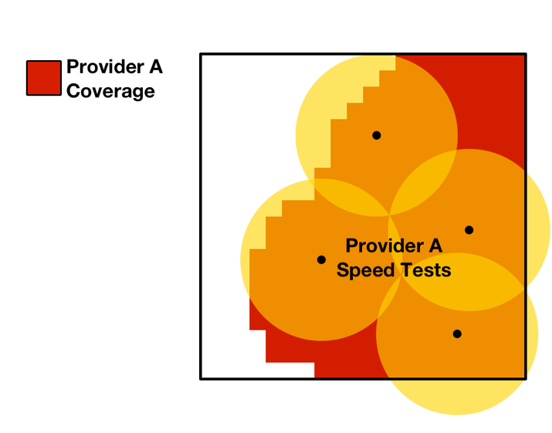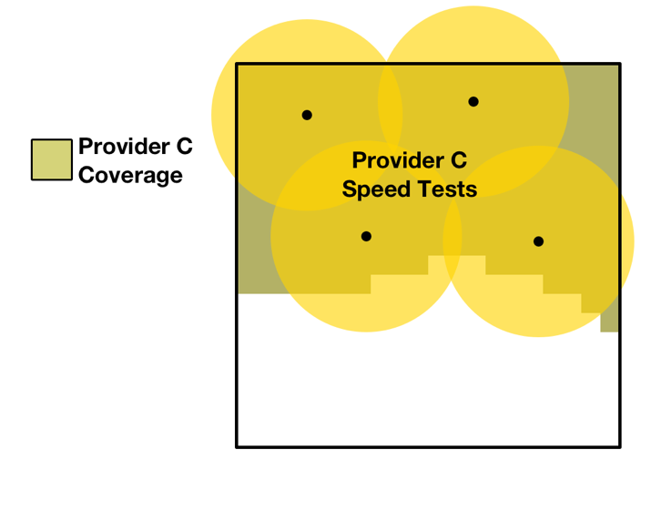
Figure 5: A challenger provides speed tests for each provider within the cell. An area is only considered to have evidence supporting the challenge if the area falls within the speed test buffer for all providers at that point.
  - Calculating the Aggregated Measured Areas
For each grid cell, any coverage by a particular provider that does not overlap the speed test buffer area (based on test(s) of that provider’s network) would be considered to be lacking evidence in support of the challenge (an unmeasured area). The areas without supporting evidence for each provider would be combined to form the total area lacking evidence in support of the challenge (the aggregated unmeasured area).
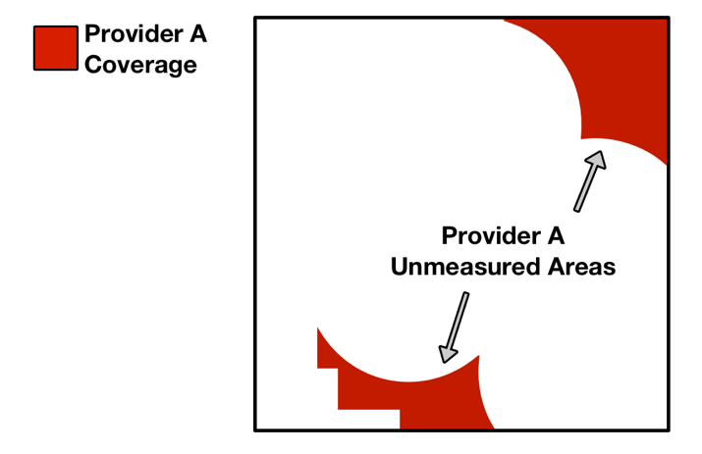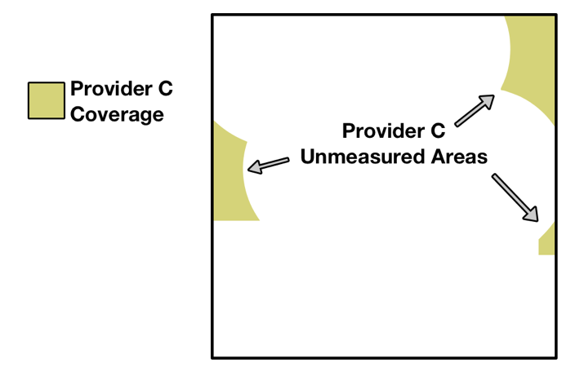
Figure 6: Area served by a provider outside of the speed test buffer areas for the provider are considered to not have evidence in support of the challenge.
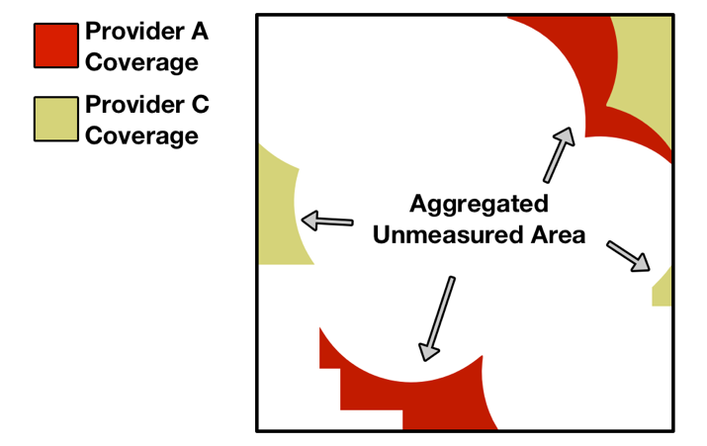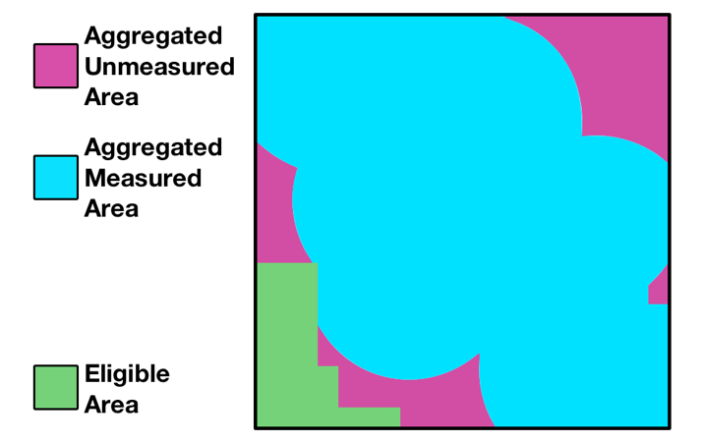
Figure 7: Areas lacking evidence for each provider are combined to determine the total area without evidence in support of the challenge.
If the area with evidence in support of the challenge covers at least 75% of the ineligible area within the cell, then the challenger would have a presumptively successful challenge in the cell (pending any evidence submitted by challenged parties during the response window). All challengeable areas within such a cell would be considered to have a valid challenge.
After all speed tests are submitted, each grid cell containing at least one counted speed test would be evaluated to determine whether the area with evidence in support of the challenge is at least 75% of the challengeable area within the cell. If so, the challenge for that grid cell would be presumptively successful.
After validations are completed, a challenger would be able to certify any of its challenges, regardless of whether or not the challenge is presumptively successful. Only challenges for which a challenger has certified by the close of the challenge window would be considered and presented to challenged parties during the response window.
  - Evaluating Evidence Submitted during the Response Window
A challenged party will be able to view the certified challenges to its coverage areas during the challenge window. Each challenged provider will have the opportunity to submit speed test data, like evidence submitted by challengers, for areas with certified challenges. In addition, a challenged provider will be able to submit similar measurement data from transmitter monitoring software.
Once challenged parties have submitted their response evidence, any cell with speed test or measurement data submitted by a respondent would be evaluated. As with the challenger’s speed tests, each speed test or transmitter monitoring measurement point submitted by a respondent would be buffered to cover a circular area of radius 0.25 km.
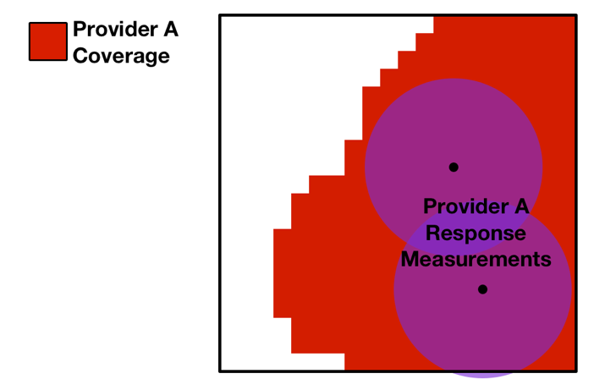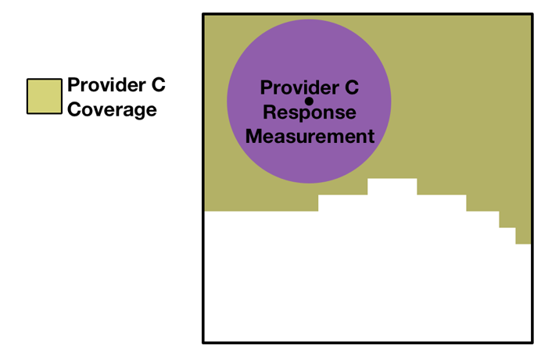
Figure 8: Each provider can provide response speed tests or transmitter monitoring measurements for a grid cell that had a certified challenged.
Any challenged provider coverage areas that overlap the response speed test or measurement buffer area would be considered to have evidence from the challenged provider in response to the challenge.
Similarly, in line with our proposal to accept data indicating a challenger’s device was subject to data speed reductions, any cell with speed tests submitted by a challenger using such a device during the period that the device was subject to speed reductions would also be evaluated. Each affected speed test point submitted by a challenger and its speed test buffer area could be considered to have evidence in response to the challenge from the provider.
Once all areas with evidence in response to the challenge within a grid cell are determined for each challenged provider, the response areas would be combined and considered against the challenger’s aggregated measured area in order to recalculate the presumptive adjudication status of each grid cell.
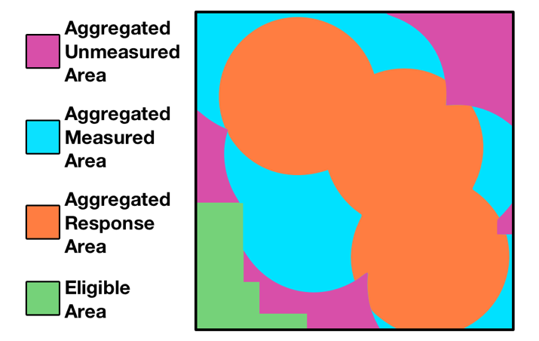
Figure 9: Area that has evidence in response to the challenge is compared against the area with evidence in support of the challenge.
After the processing steps above are complete, a challenged party would be able to certify any of its responses. Only responses that have been certified by the close of the response window would be considered during the adjudication phase.
If the area in the grid cell that has evidence in support of the challenge and for which providers have not certified evidence in response to the challenge is greater than 75% of the total challengeable area for the grid cell, then the challenge in that cell would be considered presumptively successful. If, upon Commission review of the challenge, the challenge is adjudicated in favor of the challenger, the entire challengeable area within the cell would become eligible.
If the area in the grid cell that has evidence in support of the challenge and for which providers have not certified evidence in response to the challenge is less than 75% of the challengeable area for the grid cell, then the challenge in that cell would be considered presumptively unsuccessful. If, upon Commission review of the challenge, the challenge is adjudicated against the challenger, the challengeable area within the grid cell would remain ineligible. In other words, the eligible and ineligible areas in the grid cell would not change from the initial map of presumptively eligible areas.
At the conclusion of the response window, the new eligible and ineligible areas would be determined for each state after Commission staff adjudicate certified challenges and responses. Any challengeable areas in a challenged grid cell that are adjudicated as a successful challenge would become eligible in the final map of areas eligible for the MF-II auction. Figure 10 shows the grid cells that have certified challenges to be considered during the adjudication phase highlighted in yellow, and the final map of eligible areas after challenges have been adjudicated.
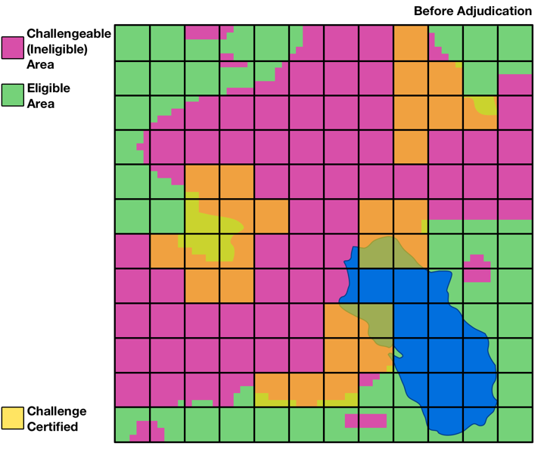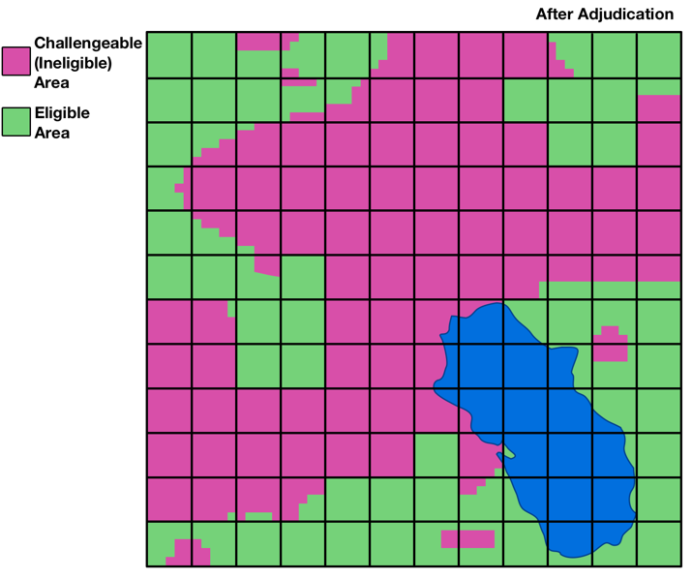
Figure 10: A map of the cells with certified challenges that will be considered during the adjudication phase highlighted in yellow (left). Any challengeable areas in a cell that are adjudicated as a successful challenge would become eligible (right). The eligible areas at the conclusion of this process will be the areas eligible for support in the MF-II auction.

- Applying Subsidy Data
  - Introduction
This appendix describes the methodology by which we will compile and map subsidy data from USAC to determine where a provider’s coverage is deemed to be subsidized for purposes of determining areas presumptively eligible for MF-II support. Using the most up-to-date reports of frozen high-cost support (FHCS) and Mobility Fund Phase I (MF-I) subsidy disbursements provided by USAC, we will associate these data with the respective set of unique providers, consolidating any attributable entities that separately file Form 477 mobile broadband coverage data to a common provider name as appropriate. The list of service providers is detailed in Appendix E.
  - USAC Source Data
As adopted by the Commission, we will use USAC subsidy data as the source for determining whether or not qualified 4G LTE service is provided on a subsidized basis. USAC tracks disbursements from the various universal service funds to a particular Competitive Eligible Telecommunications Carrier (CETC) in a study area, identified by a Study Area Code (SAC) and Study Area Name (SAN); separately, USAC maintains a list of the wire centers (identified by CLLI code) associated with a study area for which each CETC is eligible to receive support. In addition, USAC tracks disbursements of Mobility Fund Phase I (MF-I) support to winning bidders for items won in the MF-I auction, along with any defaults (e.g., due to insufficient performance).
Prior to generating the baseline data as described in Appendix A, USAC will provide:
- the most recent report of FHCS disbursement;
- the most recent report of wire centers for which each CETC is eligible for support; and
- the most recent report of MF-I disbursements to MF-I winning bidders with defaults.
Commission staff will then map the relevant data to providers in order to determine: (a) which wire centers for a particular provider are subsidized with FHCS funding; and (b) which census blocks for a particular provider were subsidized with MF-I support. Any subsidized wire centers and/or subsidized census blocks will be removed from a provider’s coverage map during the baseline data processing step.

- File Specifications and File Formats
  - Introduction
This appendix details the specifications, required data types, and file formats of challenge evidence that would be submitted by challengers or challenged parties during the challenge process.
  - Challenge Evidence Files
    - Challenger Speed Tests
Description: This file would be a CSV that contains entries for each speed test run by the challenger to provide evidence in support of its challenge.
Data Source: This file would be created by the challenger using a template provided by USAC.
Name | Data Type | Sample | Notes
latitude | Decimal | 38.8834816 | Latitude in degrees to at least 5 decimals where test was conducted
longitude | Decimal | -77.0305135 | Longitude in degrees to at least 5 decimals where test was conducted
timestamp | Datetime | 2017-09-07 13:42 -0400 | Date and time of the measurement in ISO 8601 style format:  (YYYY-MM-DD HH:MM ±HH:MM)
signal_strength | Decimal | -102.88 | Measured RSRP signal strength in dBm
download_speed | Decimal | 1.24 | Measured download speed in Mbps
latency | Integer | 204 | Measured latency in milliseconds
provider_id | Integer  {1,3} | 70 | FCC identifier for the provider
provider_name | String  {1,255} | Verizon Wireless | Common name of speed measurement network provider
device_id | Integer  {1,3} | 5 | FCC identifier for the measurement device
device_imei | String  {15,16} | 867686022379640 | Device IMEI number
measurement_method_code | Integer  {1} | 1 | FCC code for method of measurement  (1: non-drive app test, 2: software drive test, 3: hardware drive-test)
measurement_app_name | String  {1,255} | Ookla | Measurement app name  (Value may be null if not applicable)
    - Respondent Speed Tests
Description: This file would be a CSV that contains entries for each speed test run by the respondent to provide evidence in support of its response to a challenge.
Data Source: This file would be created by the respondent using a template provided by USAC.
Name | Data Type | Sample | Notes
latitude | Decimal | 38.8834816 | Latitude in degrees to at least 5 decimals where test was conducted
longitude | Decimal | -77.0305135 | Longitude in degrees to at least 5 decimals where test was conducted
timestamp | Datetime | 2018-03-07 13:42 -0400 | Date and time of the measurement in ISO 8601 style format:  (YYYY-MM-DD HH:MM ±HH:MM)
signal_strength | Decimal | -99.10 | Measured RSRP signal strength in dBm
download_speed | Decimal | 5.89 | Measured download speed in Mbps
latency | Integer | 176 | Measured latency in milliseconds
device_id | Integer  {1,3} | 5 | FCC identifier for the measurement device
device_imei | String  {15,16} | 867686022379640 | Device IMEI number
measurement_method_code | Integer  {1} | 1 | FCC code for method of measurement  (1: non-drive app test, 2: software drive test, 3: hardware drive-test)
measurement_app_name | String  {1,255} | Ookla | Measurement app name  (Value may be null if not applicable)
    - Respondent Transmitter Monitoring Measurements
Description: This file would be a CSV that contains entries for each device measured by transmitter monitoring software by the respondent to provide evidence in support of its response to a challenge.
Data Source: This file would be created by the respondent using a template provided by USAC.
Name | Data Type | Sample | Notes
latitude | Decimal | 38.88348 | Latitude in degrees to at least 5 decimals of measured device
longitude | Decimal | -77.03051 | Longitude in degrees to at least 5 decimals of measured device
timestamp | Datetime | 2018-03-07 13:42 -0400 | Date and time of the measurement in ISO 8601 style format:  (YYYY-MM-DD HH:MM ±HH:MM)
signal_strength | Decimal | -99.10 | Measured RSRP signal strength in dBm
download_speed | Decimal | 5.89 | Measured download speed in Mbps
latency | Integer | 176 | Measured latency in milliseconds
distance | Integer | 2108 | Distance between device and transmitter in meters
    - Respondent Data Speed Reduction Report
Description: This file would be a CSV that contains entries for each device used by a challenger which had its data speeds reduced by the respondent’s network.
Data Source: This file would be created by the respondent using a template provided by USAC.
Name | Data Type | Sample | Notes
device_imei | String  {15,16} | 867686022379640 | Device IMEI number
reduction_start_timestamp | Datetime | 2018-03-03 09:10 -0500 | Date and time that speed reduction started in ISO 8601 style format:  (YYYY-MM-DD HH:MM ±HH:MM)
reduction_end_timestamp | Datetime | 2018-03-14 17:00 -0500 | Date and time that speed reduction ended in ISO 8601 style format:  (YYYY-MM-DD HH:MM ±HH:MM)
device_speed | Decimal | 1.0 | Data speed the device was reduced to in Mbps.

- Relational Mapping of Form 477 Filers to Providers
This page was intentionally inserted as a placeholder for Appendix E, which is available as a separate file.

Connect America Fund; Universal Service Reform – Mobility Fund, Order on Reconsideration and Second Report and Order, 32 FCC Rcd 6282, 6282, 6296-314, paras. 1, 27-64 (2017) (MF-II Challenge Process Order or Order).
See MF-II Challenge Process Order, 32 FCC Rcd at 6298, para. 33.
Id. at 6296, para. 28. On September 22, 2017, the Task Force and Bureaus issued a Public Notice announcing filing instructions, data specifications, and other necessary technical parameters for mobile service providers to file propagation maps and other information with the Commission indicating their current qualified 4G LTE coverage. Instructions for Filing 4G LTE Coverage Data to Determine Areas Presumptively Eligible for Mobility Fund II Support, Public Notice, DA 17-926 (WCB/WTB Sept. 22, 2017) (LTE Data Collection Public Notice); see also Responses to the Mobility Fund Phase II 4G LTE Data Collection Are Due by January 4, 2018, Public Notice, DA 17-975 (WCB/WTB Oct. 6, 2017) (LTE Data Collection Deadline Public Notice).
MF-II Challenge Process Order, 32 FCC Rcd at 6287-88, 6295, paras. 10-11, 25.
See FCC, Wireless Telecommunications Bureau, Working Toward Mobility Fund II: Mobile Broadband Coverage Data and Analysis (2016) (Working Toward Mobility Fund II: Mobile Broadband Coverage Data and Analysis), https://apps.fcc.gov/edocs_public/attachmatch/DOC-341539A1.pdf.
See MF-II Challenge Process Order, 32 FCC Rcd at 6305-06, para. 46 (“[C]hallengers will not be required to match up challenged areas to census blocks or census block groups (CBGs).”).
Id. at 6286, para. 7 (adopting “a new, one-time collection of data to determine the deployment of qualified 4G LTE for the purposes of MF-II”); id. at 6295, para. 25 (explaining that the Commission “would overlay high-cost disbursement data from USAC with coverage data to determine whether qualifying 4G LTE was being provided by a carrier receiving high-cost universal service support”).
Consistent with the Commission’s past practice in releasing Form 477 coverage data, see FCC, Form 477 Mobile Voice and Broadband Coverage, https://www.fcc.gov/form-477-mobile-voice-and-broadband-coverage-areas (last updated Aug. 25, 2017), and as discussed in Appendix C, we plan to consolidate data from any attributable entities that file separately to a common provider name when generating provider-specific maps to be used in the challenge process. See also 47 C.F.R. § 20.22(b) (defining the Commission’s criteria for attribution of partial ownership and other interests in spectrum holdings).
See MF-II Challenge Process Order, 32 FCC Rcd at 6287, para. 10 (“When combined with the high-cost subsidy disbursement data available from USAC, the new data will form the basis of the map of areas presumptively eligible for MF-II support.”).
Appendix C details our methodology for applying subsidy information from USAC.
The size of each cell of the uniform grid will be equal to one square kilometer—the minimum size of a challenged area adopted by the Commission in the MF-II Challenge Process Order. See MF-II Challenge Process Order, 32 FCC Rcd at 6305-06, para. 46.
The area threshold – for determining whether the coverage in a grid cell would be included in the map of unsubsidized coverage (i.e., ineligible areas) for a provider – would equal 225 meters by 225 meters, or 50,625 square meters. This is approximately one quarter of the buffered area of a single speed test, which is the minimum buffered area in a single grid cell that would be covered if a speed test were taken precisely at the corner point of that cell. See Appendix A for further discussion.
See Connect America Fund; Universal Service Reform – Mobility Fund II, Report and Order and Further Notice of Proposed Rulemaking, 32 FCC Rcd 2152, 2169, paras. 42-43 (2017) (MF-II Order or MF-II FNPRM).
Consistent with past Commission practice, we would treat a water-only census block (that is, a census block for which the entire area is categorized by the U.S. Census Bureau as water) as ineligible and not subject to challenge. See Working Toward Mobility Fund II: Mobile Broadband Coverage Data and Analysis at 4, para. 9 (establishing as the basis of analysis the use of 2010 U.S. Census Bureau data excluding all water-only blocks); MF-II Order, 32 FCC Rcd at 2156, 2160, paras. 10, 23 (relying upon the staff analysis to determine the phase-down amount, equal to one year’s amount of subsidy that “is being provided to census blocks fully covered with unsubsidized 4G LTE”); see also Implementation of Section 6002(b) of the Omnibus Budget Reconciliation Act of 1993; Annual Report and Analysis of Competitive Market Conditions With Respect to Mobile Wireless, Including Commercial Mobile Services, Twentieth Report, FCC 17-126, para. 80 (2017) (excluding all water-only census blocks). Moreover, including water-only areas would significantly increase the number of areas that would need to be considered as part of the challenge process, would complicate the ability of challengers or respondents to submit evidence in the form of speed tests for such areas, and would likely reduce the funding available for deployment to land areas where people more often live, work, and travel. We seek comment on excluding all, some, or none of the water-only blocks, and we specifically seek comment on: (1) whether there is a feasible subset of water-only areas that we should not exclude, e.g., coastal waters, inland lakes; (2) specific hydrographic data sources; and (3) specific methodologies to identify water-only areas that should or should not be excluded, as well as any administratively efficient alternatives.
See MF-II Challenge Process Order, 32 FCC Rcd at 6305-06, para. 46 (adopting a requirement that challenged areas must be greater than or equal to a de minimis size of 1 square kilometer to be accepted).
See infra Sections III.B and III.C for discussions of how the grid will be used to validate and process challenges and responses.
See MF-II Challenge Process Order, 32 FCC Rcd at 6296, para. 27.
In accordance with the Commission’s adoption of the Alaska Plan to provide support for mobile service within Alaska and its decision to therefore exclude from MF-II support mobile service within Alaska, Connect America Fund; Universal Service Reform – Mobility Fund; Connect America Fund – Alaska Plan, Report and Order and Further Notice of Proposed Rulemaking, 31 FCC Rcd 10139, 10171, para. 98 (2016), the map of presumptively eligible areas will include all states except Alaska, as well as the District of Columbia and the U.S. Territories of Guam, the Northern Mariana Islands, Puerto Rico, the United States Virgin Islands, and American Samoa (collectively, state equivalents). See 47 U.S.C. § 153(47) (defining “State” to “include[] the District of Columbia and the Territories and possessions”).
State boundaries will be intersected with the grid. Grid cells along the state border may have portions that fall outside of the state boundary, and these portions would be ignored when generating data for the state. Such grid cells would therefore be smaller than one square kilometer in that state.
See MF-II Order, 32 FCC Rcd at 2179, para. 63 (stating that the Wireless Telecommunications Bureau staff “will publish a preliminary list of eligible areas as part of the pre-auction process”). Although the Commission will treat provider-specific coverage maps as confidential information, the map of presumptively eligible areas will be released publicly. In areas where there is known to be only one or two providers, it may be possible to determine some otherwise-confidential information from the publicly-released information in certain circumstances. Using an auction process to provide universal service funding to target coverage gaps without publicly identifying those coverage gaps would not be possible, however. The Commission has found that the auction process “maximize[s] the impact of finite universal service resources and . . . identif[ies] those providers that will make the most effective use of the budgeted finds.” Id. at 2157, para. 17. Accordingly, we find that it is in the public interest to release publicly information about presumptively eligible areas even though some provider-specific coverage information may be implicitly revealed.
See MF-II Challenge Process Order, 32 FCC Rcd at 6297, para. 29 n.82 (explaining that “[a]fter agreeing to treat the data as confidential, challengers will be able to access via the USAC portal (a) the underlying provider-specific coverage maps submitted as part of the new data collection; (b) the list of pre-approved provider-specified handsets with which to conduct speed measurements; and (c) any other propagation model details collected as part of the new data collection”).
Id. at 6307, para. 49.
Id. at 6302, 6308, paras. 39, 50. As discussed in note 8 above and in Appendix C, we plan to consolidate coverage data from affiliated entities that file separately into a single common provider. We propose to similarly consolidate submitted provider handset data for such entities to the extent that the lists of handsets differ.
MF-II Challenge Process Order, 32 FCC Rcd at 6308, para. 50.
See id. at 6308, para. 50 n.148.
Cf. Letter from Rebecca Murphy Thompson, EVP & General Counsel, Competitive Carriers Association, to Marlene H. Dortch, Secretary, FCC at 4 (July 27, 2017) (advocating that carriers identify engineering-capable devices that may be unlocked and put into diagnostic mode).
MF-II Challenge Process Order, 32 FCC Rcd at 6306, para. 47.
See, e.g., id. at 6309, para. 51 (adopting requirements that speed tests must: (a) be conducted between 6:00 AM and 12:00 AM (midnight) local time; (b) be taken no more than a fixed distance apart and substantially cover the challenged area; and (c) be collected after the release of the initial eligibility map but no more than six months prior to the close of the challenge window).
Id. at 6309-10, para. 52; accord id. at 6298, para. 33 (directing the Bureaus to seek comment and adopt “instructions, deadlines, and requirements for filing a valid challenge, including file formats, parameters, and other specifications for conducting speed tests”).
Id. at 6309, para. 51.
See id. at 6309, para. 52 (discussing additional parameters and specifications proposed by commenters, including whether to require reporting of “all results or only those depicting speeds under 5 Mbps”).
Id. at 6310, para. 55 (explaining that “[t]o be counted towards a valid challenge, the speed test must record a download speed less than 5 Mbps . . . and meet all other standard parameters”). All evidence submitted may be considered by Commission staff when adjudicating challenges using the preponderance of the evidence standard. See also id. at 6313-14, paras. 63-64.
Id. at 6306, 6309, paras. 47, 51.
Id. at 6309, para. 51.
Id.
We propose to use kilometers instead of miles in order to be consistent with the de minimis challenge size adopted by the Commission, id. at 6305-06, para. 46, as well as to be consistent with the units used for the “equal area” map projection that we plan to use when processing geospatial data, detailed in Appendix A. As discussed below, consistent with the framework adopted by the Commission, the maximum distance parameter would be validated as part of a multi-step geospatial-data-processing approach. See MF-II Challenge Process Order, 32 FCC Rcd at 6309, para. 55. Specifically, under this automated-validation framework, if a challenger submits speed test measurements less densely than the maximum distance parameter in a challenged area, its evidence may be insufficient to cover at least 75 percent of the challengeable area within a cell, and its challenge would presumptively fail.
MF-II Challenge Process Order, 32 FCC Rcd at 6309, para. 55.
See infra Section III.C for further discussion.
The requirement that measurements be taken no more than one-half of one kilometer apart from one another serves as an upper bound (i.e., maximum distance apart), and a challenger will be free to and, in some circumstances, may be required to submit measurements taken more densely in order to sufficiently prove its challenge. See MF-II Challenge Process Order, 32 FCC Rcd at 6309, para. 51 n.153.
Moreover, using a value representing a fraction of the de minimis challenged area threshold and our proposed grid cell size of one square kilometer would ensure consistency and improve the efficiency of the challenge process.
MF-II Challenge Process Order, 32 FCC Rcd at 6308-09, paras. 50-51 (adopting standard parameters for speed tests showing geographic area, recorded speed, time and date of measurement, and handset).
In order to effectuate the Commission’s decision to not permit challenges to our allocation of subsidy data, MF-II Order, 32 FCC Rcd at 2181, para. 66 n.178, we will not allow a challenger to submit speed test data of its own network. We note that this restriction is consistent with the Commission’s rationale for not permitting challenges to areas deemed presumptively eligible, as “the challenge would consist of nothing more than an update to or correction of the coverage data submitted by the unsubsidized service provider during the new data collection in compliance with our new requirements.” MF-II Challenge Process Order, 32 FCC Rcd at 6305, para. 45.
The complete file specification for challenger speed tests is detailed in Appendix D.
MF-II Challenge Process Order, 32 FCC Rcd at 6312-13, para. 61.
Id. at 6312, para. 60.
Our proposed file specification for respondent speed tests is detailed in Appendix D.
The proposed specifications for submitting these data are detailed in Appendix D.
MF-II Challenge Process Order, 32 FCC Rcd at 6312, para. 60.
Id. at 6312, para. 61 n.173.
See id. at 6312, para. 60.
Id. at 6310, para. 53.
Id. at 6310, paras. 54-55.
See id. at 6305-06, para. 46 & n.130 (requiring “that any challenged area be of a minimum size of at least one square kilometer,” while also allowing challenges to “[i]neligible areas of less than one square kilometer . . . insofar as they are part of a challenge where the total size of areas being challenged exceeds the de minimis size requirement”).
Id. at 6310, para. 54.
See Appendix B.
Unmeasured area is the coverage area outside of the buffer area.
This step would be performed after, and is unrelated to, the check in step one that a challenger has identified grid cells with challengeable areas that in sum meet the de minimis threshold of one square kilometer. In other words, the sufficiency of submitted evidence and whether a challenge is presumptively successful or not would be unrelated to whether a challenger has identified enough ineligible areas with its challenge.
MF-II Challenge Process Order, 32 FCC Rcd at 6312, para. 60.
This approach to processing data submitted by both challengers and challenged parties is detailed in Appendix B.
MF-II Challenge Process Order, 32 FCC Rcd at 6313-14, paras. 63-64.
Id. at 6298, para. 33.
Id. at 6298, para. 32.
Id. at 6307, 6310-11, paras. 49, 53-57.
Id. at 6304, para. 42 n.115.
Any service provider eligible to participate that for some reason did not file Form 477 data in June 2017 would not have an account created unless it contacts the Commission as required for a filer that wishes to use a different contact in order to get access to the USAC portal. Additionally, as discussed in Appendix C, we plan to consolidate any attributable entities that separately file Form 477 mobile broadband coverage data to a common provider. See also supra note 8. As a result, such entities would jointly have access to the USAC portal, and would submit or respond to challenges on behalf of a single provider.
MF-II Challenge Process Order, 32 FCC Rcd at 6296-97, para. 29 & n.82. As described in the Order, a challenger will use the USAC portal to access the confidential provider-specific information that is pertinent to the challenge, as well as submit its challenge, including all supporting evidence and required certifications. Id. at 6297, para. 29 nn.82, 84. A challenger will not have access to confidential provider-specific information unless and until it agrees to treat the data as confidential. See id. at 6297, para. 29 n.82.
See generally LTE Data Collection Public Notice at 3-5.
The public release of the map of final eligible areas may, in some cases, implicitly reveal provider-specific coverage information that is presumptively confidential. Nonetheless, for the reasons expressed earlier, see supra note 21, we find that it is in the public interest to release publicly the map of final eligible areas.
Providers are required to file new, one-time 4G LTE coverage data by January 4, 2018. LTE Data Collection Deadline Public Notice at 1; see also LTE Data Collection Public Notice at 1 (requiring parties to submit data “no later than 90 days after the Commission publishes notice of [the Office of Management and Budget’s] approval of th[e] one-time information collection request in the Federal Register”); MF-II Challenge Process Order, 32 FCC Rcd at 6296, para. 28 (requiring providers to file propagation maps and model details with the Commission indicating their current 4G LTE coverage, as defined by download speeds of 5 Mbps at the cell edge with 80 percent probability and a 30 percent cell loading factor). Contemporaneous with the publication of the map of presumptively eligible areas, we will announce via public notice the availability of this data and subsequent commencement of the challenge window.
MF-II Challenge Process Order, 32 FCC Rcd at 6296-97, para. 29.
Id. at 6311, para. 59.
Id. at 6312, para. 59.
Id. at 6313-14, paras. 63-64.
5 U.S.C. § 603. The RFA, 5 U.S.C. §§ 601-612, has been amended by the Small Business Regulatory Enforcement Fairness Act of 1996 (SBREFA), Public L. No. 104-121, Title II, 110 Stat. 857 (1996).
Connect America Fund et al., Report and Order and Further Notice of Proposed Rulemaking, 26 FCC Rcd 17663, 18364-95, Appx. P, Initial Regulatory Flexibility Analysis (2011) (USF/ICC Transformation Order or USF/ICC Transformation FNPRM); Connect America Fund et al., Report and Order, Declaratory Ruling, Order, Memorandum Opinion and Order, Seventh Order on Reconsideration, and Further Notice of Proposed Rulemaking, 29 FCC Rcd 7051, 7216-44, Appx. D, Initial Regulatory Flexibility Analysis (2014) (2014 CAF Order or 2014 CAF FNPRM); MF-II FNPRM, 32 FCC Rcd at 2269-73, Appx. C, Initial Regulatory Flexibility Analysis.
2014 CAF Order, 29 FCC Rcd at 7190-215, Appx. C, Final Regulatory Flexibility Analysis; MF-II Order, 32 FCC Rcd at 2258-68, Appx. B, Final Regulatory Flexibility Analysis; MF-II Challenge Process Order, 32 FCC Rcd at 6317-25, Appx. A, Final Regulatory Flexibility Analysis.
USF/ICC Transformation FNPRM, 26 FCC Rcd at 18364-69, paras. 2-21; 2014 CAF FNPRM, 29 FCC Rcd at 7190-91, 7216-18, paras. 2-7, 2-11; MF-II Order and FNPRM, 32 FCC Rcd at 2258, 2269, paras. 2-3, 2-3; MF-II Challenge Process Order, 32 FCC Rcd at 6317, paras. 2-3.
See, e.g., MF-II FNPRM, 32 FCC Rcd at 2269, para. 4 (stating that the legal basis for any action is taken pursuant to sections 1, 2, 4(i), 5, 10, 201-206, 214, 218-220, 251, 252, 254, 256, 303(r), 332, 403, and 405 of the Communications Act of 1934, as amended, and section 706 of the Telecommunications Act of 1996, 47 U.S.C. §§ 151, 152, 154(i), 155, 201-206, 214, 218-220, 251, 252, 254, 256, 303(r), 332, 403, 405, 1302, and sections 1.1, 1.3, 1.421, 1.427, and 1.429 of the Commission’s rules, 47 CFR §§ 1.1, 1.3, 1.421, 1.427, and 1.429). See also USF/ICC Transformation FNPRM, 26 FCC Rcd at 18369, para. 22; 2014 CAF FNPRM, 29 FCC Rcd at 7218, para. 12; MF-II FNPRM, 32 FCC Rcd at 2269, para. 4.
The IRFAs prepared with the MF-II FNPRMs and the FRFAs prepared with the MF-II Orders describe in detail the small entities that might be significantly affected by the proposed rules in those proceedings. The Public Notice proposes the procedures for implementing the rules adopted in the MF-II Orders; therefore, we incorporate by reference the descriptions and estimates of the number of small entities that might be significantly affected from the MF-II FNPRMs IRFAs and the MF-II Orders FRFAs into this Supplemental IRFA. USF/ICC Transformation FNPRM, 26 FCC Rcd at 18369-91, paras. 23-78; 2014 CAF FNPRM, 29 FCC Rcd at 7191-7213, 7219-40, paras. 9-64, 13-68; MF-II FNPRM, 32 FCC Rcd at 2270-71, paras. 5-8; MF-II Order, 32 FCC Rcd at 2258-61, paras. 7-10; MF-II Challenge Process Order, 32 FCC Rcd at 6318-20, paras. 8-12. As explained in the MF-II Challenge Process Order, only governmental entities and mobile service providers (as well as entities granted a waiver upon a showing of good-cause) will be eligible to participate in the challenge process. See 32 FCC Rcd at 6303-04, paras. 42-43 (declining to include individuals as eligible to participate, noting that the Commission “do[es] not expect that an individual consumer would have the time, ability, or resources to file a valid challenge”).
USF/ICC Transformation FNPRM, 26 FCC Rcd at 18356-59, 18392-95, paras. 96-104, 79-96; 2014 CAF FNPRM, 29 FCC Rcd at 7213, 7240-42, paras. 65-66, 69-78; MF-II Order and FNPRM, 32 FCC Rcd at 2261-65, 2272, paras. 11-28, 9-11.
USF/ICC Transformation FNPRM, 26 FCC Rcd at 18359-63, 18393-95, paras. 105-21, 90-96; 2014 CAF FNPRM, 29 FCC Rcd at 7213-15, 7242-44, paras. 67-72, 79-90; MF-II Order and FNPRM, 32 FCC Rcd at 2265-68, 2273, paras. 29-39, 12-16; MF-II Challenge Process Order, 32 FCC Rcd at 6323-25, paras. 23-34.
USF/ICC Transformation FNPRM, 26 FCC Rcd at 18395, para. 97; 2014 CAF FNPRM, 29 FCC Rcd at 7244, para. 91; MF-II FNPRM, 32 FCC Rcd at 2273, para. 17.
MF-II Challenge Process Order, 32 FCC Rcd at 6298, para. 33.
MF-II Order, 32 FCC Rcd at 2240, para. 252; see 47 CFR §§ 1.1200(a), 1.1206.
The Commission substantially revised its ex parte rules in 2011. These revised rules require, for example, that an ex parte notice must be filed for each oral ex parte presentation, not just for those presentations that involve new information or arguments not already in the record. Further, a filer typically must submit an ex parte notice electronically in machine-readable format. A filer may not submit a PDF image created by scanning a paper document, except in a situation in which a word processing version of the document is not available. See Amendment of the Commission’s Ex Parte Rules and Other Procedural Rules, Report and Order and Further Notice of Proposed Rulemaking, 26 FCC Rcd 4517 (2011).
FCC Announces Change in Filing Location for Paper Documents, Public Notice, 24 FCC Rcd 14312 (2009).
Change in Filing Location for Commercial Overnight Documents; FCC Warehouse Address Change, Public Notice, DA 17-918 (OMD Sept. 21, 2017).
MF-II Challenge Process Order, 32 FCC Rcd at 6298, para. 34.
See U.S. Census Bureau, 2010 TIGER/Line® Shapefiles Technical Documentation (2012), available at https://www2.census.gov/geo/pdfs/maps-data/data/tiger/tgrshp2010/TGRSHP10SF1.pdf. The U.S. Census Bureau provides boundary data for different geographic areas in Shapefile format on its website. TIGER/Line® - Geography – U.S. Census Bureau, https://www.census.gov/geo/maps-data/data/tiger-line.html (last modified Oct. 2, 2017). Consistent with the data used for prior MF-II analysis, see Working Toward Mobility Fund II: Mobile Broadband Coverage Data and Analysis at 4-5, we plan to use the 2010-vintage “State (and equivalent)” and “Census Block” boundary data files.
All map projections introduce distortions in area, shape, scale, or direction that are inherent when transforming a three-dimensional spherical object to a two-dimensional cartesian representation. An equal area projection is one that minimizes distortion to area across a given geography at the expense of greater distortion in shape, scale, or direction. See John P. Snyder, Map Projections—A Working Manual, U.S. Geological Survey 3-7 (1987), available at https://pubs.usgs.gov/pp/1395/report.pdf.

