DA 17- 1120
November 17, 2017

PUBLIC SAFETY AND HOMELAND SECURITY BUREAU ACCEPTS 800 MHZ TRANSITION ADMINISTRATOR’S RECOMMENDATION WITH CHANGES PROPOSED BY SPRINT FOR ESTABLISHING A DIVIDING LINE FOR ENHANCED SPECIALIZED MOBILE RADIO (ESMR) SYSTEMS IN CANADA BORDER REGIONS 1 THROUGH 6
WT Docket 02-55
By this Public Notice, the Public Safety and Homeland Security Bureau (Bureau) announces the Enhanced Specialized Mobile Radio (ESMR) dividing line in the 800 MHz band for Canada Border Regions (CBR) 1 through 6. The dividing line for each border region is listed in Appendix II.

In 2008, the Bureau released a Report and Order establishing a post reconfiguration band plan in the 800 MHz band for licenses operating in the CBR. The CBRs encompass the geographic area in the U.S. within 140 kilometers (87 miles) of the border with Canada and are divided into eight regions as detailed in Attachment I.

In the 800 MHz 2nd R&O, the Bureau directed the 800 MHz Transition Administrator (TA) to assign post-reconfiguration replacement channels to border area licensees. Specifically, the Bureau instructed the TA to separate ESMR systems from non-ESMR systems in the CBRs by assigning non-ESMR licensees to replacement channels in the lower segment of the 800 MHz band while maintaining the upper portion of the band for licensees operating ESMR systems.

The Bureau noted that because U.S. licensees have limited access to primary spectrum in CBRs 1 through 6, the dividing line between ESMR and non-ESMR segments of the band would vary depending on the number of channels occupied by Business, Industrial, Land-Transportation (B/ILT) and high-site Specialized Mobile Radio (SMR) licensees in each region. Thus, the Bureau advised the TA that it “may wait until replacement frequencies have been assigned and negotiations are complete” before identifying the dividing line for CBRs 1 through 6.

For CBRs 7 and 8, the Bureau established an ESMR dividing line at 817 MHz/ 862 MHz which matches the dividing line for non-border regions throughout the rest of the U.S. since U.S. licensees have primary access in these regions to the entire 800 MHz band.

TA Identifies ESMR Dividing Line for CBR 1 Through 6

On September 1, 2017, the TA informed the Bureau by letter that it had identified the dividing line between the ESMR and the non-ESMR segments of the band for CBRs 1 through 6. The TA stated in its letter that it “determined the highest frequency occupied by a non-ESMR licensee in each CBR” then “identified the dividing line as the frequency 12.5 kHz above the highest frequency licensed by a non-ESMR licensee in each CBR.”

Sprint Requests Adjustment to ESMR Line in CBR 2

On September 11, 2017, Sprint replied to the TA’s letter asking the Bureau to consider establishing an alternative dividing line between the ESMR and non-ESMR segments of the band in CBR 2. Sprint notes that CBR 2 spans west-to-east from the Ohio/Pennsylvania border through Western New York, Upstate New York, Vermont and New Hampshire. It explains that, under the TA’s dividing line definition, the highest non-ESMR licensee in CBR 2 sets the ESMR dividing line for the entire region at 864.825 MHz but notes that the highest non-ESMR licensee in the Buffalo/Rochester market operates at 864.5625 MHz while the highest non-ESMR licensee in Vermont and New Hampshire operates at 863.7375 MHz.

Therefore, Sprint contends that setting the ESMR dividing line in CBR 2 based on the highest non-ESMR licensee in the region prevents it from “deploying an 800 MHz 4G LTE channel in the border areas of Upstate New York, Vermont and New Hampshire.” Sprint states that, under the TA’s definition of the ESMR dividing line for CBR 2, Sprint would be “limited to only a single 3G CDMA channel (1.25 MHz) across all of CBR2.”

Consequently, Sprint requests that the Bureau define the ESMR dividing line in CBR 2 according to National Public Safety Advisory Committee (NPSPAC) Region. It recommends maintaining the TA- recommended dividing line at 864.825 MHz in NPSPAC Region 36 – Western Pennsylvania – but lowering the line to 864.575 MHz in NPSPAC Region 55 – Western New York – and lowering the line to 863.9 MHz in NPSPAC Region 30 – New York Albany – and NPSPAC Region 19 – Vermont/New Hampshire.

On September 25, 2017, the TA responded to Sprint’s request by indicating that it foresees no adverse effect on band reconfiguration in CBR 2 if the Bureau adopts Sprint’s proposal. The TA states it verified “that Sprint has accurately identified the dividing lines for the four NPSPAC regions wholly or partially in Canadian Border Region 2 based on the highest frequency occupied by a non-ESMR licensee within each NPSPAC region for the areas within Canadian Border Region 2.”

Bureau Adopts TA’s Recommended ESMR Dividing Lines with Sprint’s Adjustment

By this Public Notice, we announce our acceptance of the TA-recommended ESMR dividing lines for CBR 1, 3, 4, 5 and 6. As requested by Sprint, we establish a dividing line by NPSPAC region in CBR 2. The final ESMR dividing lines are listed in Appendix II.

We find Sprint’s proposal for CBR 2 to be spectrum efficient and therefore in the public interest because it will allow Sprint to offer LTE service to a significant portion of CBR 2 without negatively affecting licensees operating in the non-ESMR segment of the band.

For further information regarding this proceeding contact Brian Marenco, Electronics Engineer, Policy and Licensing Division, Public Safety and Homeland Security Bureau, (voice) (202) 418-0838 or Brian.Marenco@fcc.gov.

-- FCC --

Appendix I – Canada Border Region Geographic Definitions

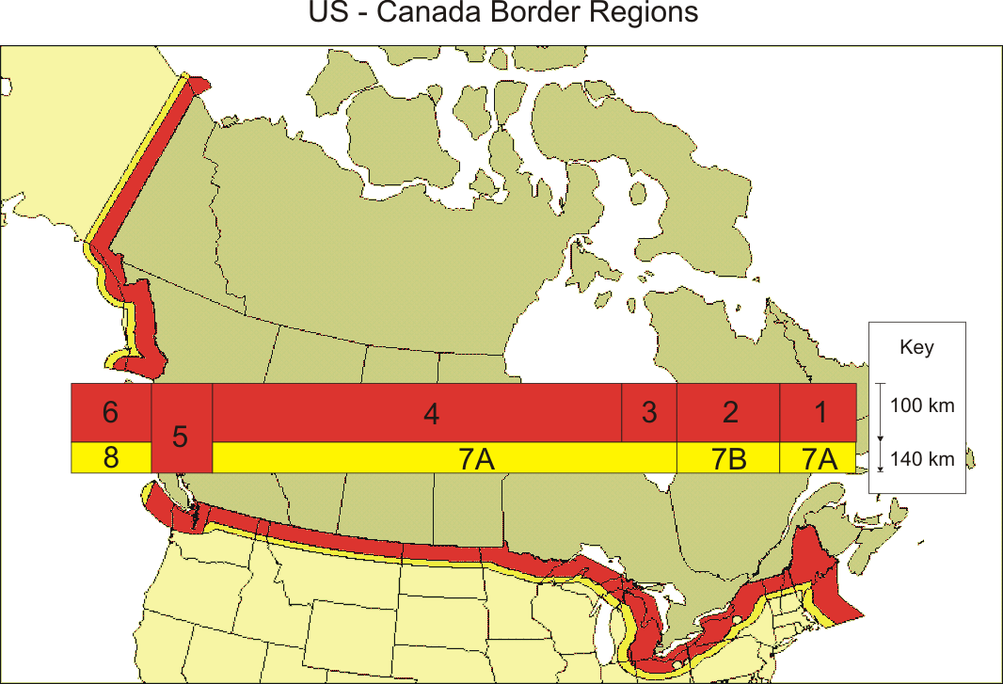

Table 1 – Boundaries of CBRs Based on Longitude and Distance to Border

Region | Location (longitude)
1…… | 66° W – 71° W (0 – 100 km from border)
2…… | 71° W – 80° 30’ W (0 – 100 km from border)
3…… | 80° 30’ W – 85° W (0 – 100 km from border)
4…… | 85° W – 121° 30’ W (0 – 100 km from border)
5…… | 121° 30’ W – 127° W (0 – 140 km from border)
6…... | 127° W – 143° W (0 – 100 km from border)
7A…… | 66° W – 71° W (100 – 140 km from border), 80° 30’ W – 121° 30’ W (100 – 140 km from border)
7B… | 71° W – 80° 30’ W (100 – 140 km from border)
8….. | 127° W – 143° W (100 – 140 km from border)

Appendix II – ESMR Dividing Lines for Canada Border Regions

Table 1 – CBRs Subject to Canada Border Band Plan

Canadian Border Region (CBR) | Distance CBR Extends from Canada Border (KM) | NPSPAC Regions Partially Impacted by CBR | Dividing Line Between ESMR and Non-ESMR Segments of Band in CBR (MHz)*
1 | 0 – 100 | Region 19 – New England | 863.300
2 | 0 – 100 | Region 19 – New England | 863.900
 |  | Region 30 – Upstate New York | 863.900
 |  | Region 55 – Western New York | 864.575
 |  | Region 36 – Western Pennsylvania | 864.825
3 | 0 – 100 | Region 33 – Ohio  Region 21 – Michigan | 862.925
4 | 0 – 100 | Region 22 – Minnesota  Region 32 – North Dakota  Region 25 – Montana  Region 12 – Idaho  Region 43- Washington State | 864.150
5 | 0 – 140 | Region 43 – Washington State | 864.150
6 | 0 – 100 | Region 2 – Alaska | 862.250
* Dividing line reflects the frequency 12.5 kHz above the highest frequency occupied by a non-ESMR licensee except in CBR 6 (Alaska) where the frequency is 12.5 kHz above highest Canada primary frequency.

Table 2 – CBRs Subject to Nationwide Band Plan

Canadian Border Region (CBR) | Distance CBR Extends from Canada Border (KM) | NPSPAC Regions Partially Impacted by CBR | Dividing Line Between ESMR and Non-ESMR Segments of Band in CBR (MHz)**
7A | 100 – 140 | Region 19 – New England  Region 33 – Ohio  Region 21 – Michigan  Region 22 – Minnesota  Region 32 – North Dakota  Region 25 – Montana  Region 12 – Idaho  Region 43- Washington State | 862.000
7B | 100 – 140 | Region 19 – New England  Region 30 – Upstate New York  Region 55 – Western New York  Region 36 – Western Pennsylvania | 862.000
8 | 100 – 140 | Region 2 – Alaska | 862.000
** Dividing line reflects the frequency 12.5 kHz above the highest assignable frequency in the non-ESMR segment of the band according to the nationwide band plan. See 47 CFR § 90.614(a).

See Improving Public Safety Communications in the 800 MHz Band, Second Report and Order, Second Report and Order, 23 FCC Rcd 7605 (PSHSB 2008) (800 MHz 2nd R&O).
Licensees operating in CBRs 1 through 6 are subject to the Canada border specific band plans adopted by the Bureau in the 800 MHz 2nd R&O while licensees operating in CBRs 7 and 8 are subject to the nationwide band plan. See 800 MHz 2nd R&O, 23 FCC Rcd 76218-19 paras. 29-36.
Id. at 7613, para. 17.
Id.
Id.
Id. at n.55.
Id. at 7619, paras. 35-36.
Letter from Brett S. Haan, 800 MHz Transition Administrator, LLC, to David L. Furth, Deputy Chief, Public Safety and Homeland Security Bureau (September 1, 2017) (WT Docket 02-55).
Id. at 1. The TA notes that the dividing line in CBR 6 (Alaska) is set 12.5 kHz above the highest Canada primary channels because all non-ESMR licensees reconfigured into the General Category later cancelled their licenses. Id. at 3.
Letter from James B. Goldstein, Senior Counsel, Legal and Government Affairs, Sprint Corporation, to David Furth, Deputy Chief, Public Safety and Homeland Security Bureau (Sep. 11, 2017) (WT Docket 02-55).
Id. at 3.
Id.
Id.
Id.
Id. at 3-4.
Id.
Letter from Brett S. Haan, 800 MHz Transition Administrator, LLC, to David L. Furth, Deputy Chief, Public Safety and Homeland Security Bureau (Sep. 25, 2017) (WT Docket 02-55).
Id. at 1.

