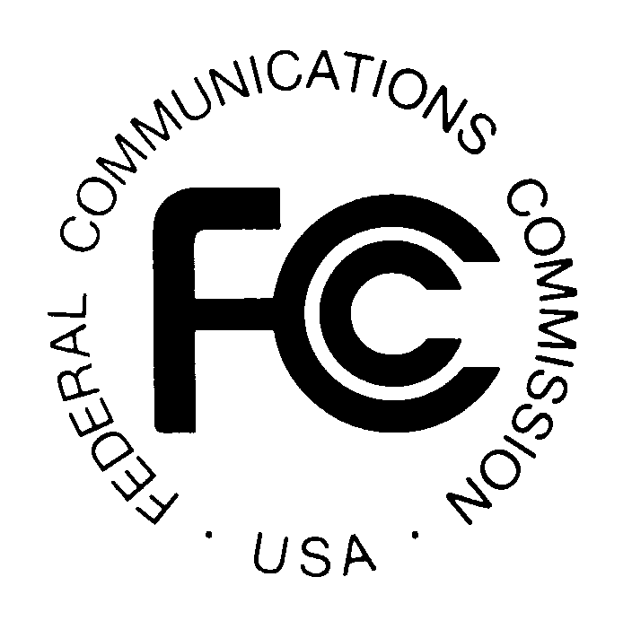PUBLIC NOTICE
FEDERAL COMMUNICATIONS COMMISSION
445 12th Street, S.W.
WASHINGTON, DC 20554 DA 17-267
News media information 202/418-0500 Fax-On Demand 202/418-2830 Internet: http://www.fcc.gov ftp.fcc.gov

Released: March 23, 2017

WIRELESS TELECOMMUNICATIONS BUREAU SEEKS COMMENT ON
THE STATE OF MOBILE WIRELESS COMPETITION

WT Docket No. 17-69

Comments Due: May 8, 2017
Reply Comments Due: June 7, 2017
This Public Notice (Public Notice) solicits input on competition in the mobile wireless industry for the Federal Communications Commission’s (the Commission) Twentieth Annual Report on the State of Competition in Mobile Wireless, including Commercial Mobile Radio Services (Twentieth Report). The Communications Act requires the submission to Congress each year of reports analyzing competitive conditions with respect to commercial mobile services. With this Public Notice, the Wireless Telecommunications Bureau (the Bureau) seeks information and data for the Commission’s analysis of competition in the mobile wireless industry for the Twentieth Report.
This Public Notice requests comment on the criteria or metrics that could be used to evaluate the state of mobile wireless competition. Comment and information also is sought on industry data, competitive dynamics, and trending factors in the mobile wireless industry, including but not limited to, subscribership numbers, financial indicators (such as revenues or profitability), investment, pricing, and network coverage. In addition, the Commission actively endeavors to improve and refine the way it collects, analyzes, and reports on wireless industry information and data. The Bureau requests that commenters provide any other information that may inform the Commission’s analysis of the mobile wireless industry.
It is requested that commenters submit information, data, and statistics for 2016, as well as information on any notable trends and developments that have occurred during early 2017. Industry stakeholders, the public, and other interested parties are encouraged to submit information, comments, and analyses regarding competition in the mobile wireless industry. In order to facilitate analysis of competitive trends, parties that submit data should submit current data, as well as historic data, which are comparable over time. Commenters seeking confidential treatment of their submissions should request that their submission, or a specific part thereof, be withheld from public inspection.

Procedural Matters
Pursuant to Sections 1.415 and 1.419 of the Commission’s rules, 47 CFR §§ 1.415, 1.419, interested parties may file comments on or before May 8, 2017 and reply comments on or before June 7, 2017. All filings should refer to WT Docket No. 17-69. Comments may be filed: (1) using the Commission’s Electronic Comment Filing System (ECFS), or (2) by filing paper copies. Electronic Filing of Documents in Rulemaking Proceedings, 63 FR 24121 (1998).
Comments and reply comments filed in response to this Public Notice will be available for public inspection and copying in the Commission’s Reference Center, Room CY-A257, 445 12th Street, S.W., Washington, D.C. 20554, and via the Commission’s Electronic Comment Filing System (ECFS) by entering the docket number, WT Docket No. 17-69.
Comments may be filed using the ECFS or by filing paper copies. Electronic Filing of Documents in Rulemaking Proceedings, 63 Fed. Reg. 24121 (1998). Comments filed through the ECFS can be sent as an electronic file via the Internet to http://www.fcc.gov/cgb/ecfs/. Generally, only one copy of an electronic submission must be filed. If multiple docket or rulemaking numbers appear in the caption of this proceeding, however, commenters must transmit one electronic copy of the comments to each docket or rulemaking number referenced in the caption. In completing the transmittal screen, commenters should include their full name, U.S. Postal Service mailing address, and the applicable docket or rulemaking number. Parties may also submit an electronic comment by Internet e-mail. To get filing instructions for e-mail comments, commenters should send an e-mail to ecfs@fcc.gov, and should include the following words in the body of the message, get form. A sample form and directions will be sent in reply.
Parties who choose to file by paper must file an original and one copy of each filing. If more than one docket or rulemaking number appears in the caption of this proceeding, commenters must submit two additional copies for each additional docket or rulemaking number.
Filings can be sent by hand or messenger delivery, by commercial overnight courier, or by first-class or overnight U.S. Postal Service mail (although we continue to experience delays in receiving U.S. Postal Service mail). All filings must be addressed to the Commission’s Secretary, Office of the Secretary, Federal Communications Commission, as follows:
-All hand-delivered paper filings for the Commission’s Secretary must be delivered to FCC Headquarters at 445 12th St., S.W., Room TW-A325, Washington, DC 20554. All hand deliveries must be held together with rubber bands or fasteners. Envelopes must be disposed of before entering the building. The filing hours at this location are 8:00 a.m. to 7:00 p.m. PLEASE NOTE: This is the ONLY location where hand-delivered or messenger-delivered paper filings for the Commission’s Secretary will be accepted. The Commission’s former filing location at 236 Massachusetts Ave., N.E., is permanently closed.
-Commercial overnight mail (other than U.S. Postal Service Express Mail and Priority Mail) must be sent to 9300 East Hampton Drive, Capitol Heights, MD 20743.
-U.S. Postal Service first-class mail, Express Mail, and Priority Mail should be addressed to 445 12th Street, S.W., Washington, DC 20554.
-All filings must be addressed to the Commission's Secretary, Office of the Secretary, Federal Communications Commission.
Alternate formats of this Public Notice (computer diskette, large print, audio recording, and Braille) are available to persons with disabilities by contacting the Consumer & Governmental Affairs Bureau at (202) 418-0530 (voice), (202) 418-0432 (TTY), or send an e-mail to fcc504@fcc.gov.
For further information, contact Kate Matraves, Competition & Infrastructure Policy Division, Wireless Telecommunications Bureau, (202) 391-6272, or Leon Jackler, Competition & Infrastructure Policy Division, Wireless Telecommunications Bureau, (202) 418-0946.

47 U.S.C. § 332(c)(1)(C). The relevant portion of the statute requiring the annual report on CMRS competition states: The Commission shall review competitive market conditions with respect to commercial mobile services and shall include in its annual report an analysis of those conditions. Such analysis shall include an identification of the number of competitors in various commercial mobile services, an analysis of whether or not there is effective competition, an analysis of whether any of such competitors have a dominant share of the market for such services, and a statement of whether additional providers or classes of providers in those services would be likely to enhance competition. See, e.g., Implementation of Section 6002(b) of the Omnibus Budget Reconciliation Act of 1993, Annual Report and Analysis of Competitive Market Conditions With Respect to Mobile Wireless, Including Commercial Mobile Services, WT Docket No. 16-137, Nineteenth Report, 31 FCC Rcd 10534 (WTB 2016).
47 C.F.R. § 0.459.

