DA 18-124
Released: February 9, 2018

INCENTIVE AUCTION TASK FORCE AND MEDIA BUREAU ANNOUNCE POST-INCENTIVE AUCTION SPECIAL DISPLACEMENT WINDOW
APRIL 10, 2018, THROUGH MAY 15, 2018, AND
MAKE LOCATION AND CHANNEL DATA AVAILABLE

MB Docket No. 16-306
GN Docket No. 12-268
- The Incentive Auction Task Force and the Media Bureau hereby provide sixty days’ advance notice of the opening of a displacement application filing window for low power television (LPTV), TV translator stations, and analog-to-digital replacement translators (DRT) (referred to collectively as “LPTV/translator stations”) that were displaced by the incentive auction and repacking process (Special Displacement Window). The Special Displacement Window will open on Tuesday, April 10, 2018, and close on Tuesday, May 15, 2018, at 11:59 pm EDT. We also announce that simultaneous with the release of this Public Notice we are releasing a channel study to assist stations in identifying potential new channels in the repacked television bands.
- Detailed guidance regarding eligibility criteria and the procedures and policies applicable to the Special Displacement Window was provided in prior Incentive Auction Task Force and Media Bureau releases. Interested parties are encouraged to review those items prior to filing applications in the Special Displacement Window. We provide herein details regarding the channel study, reiterate some of the eligibility and filing procedures for the window, and lift the displacement application filing freeze for eligible stations. We also remind eligible full power television stations that they may begin filing applications for digital-to-digital replacement translators (DTDRTs) on April 10, 2018.
- Channel Study. As described more fully in the Appendix to this Public Notice, we have compiled and are releasing data that identifies locations and channels where LPTV/translator stations filing applications in the Special Displacement Window likely cannot propose displacement facilities because of the presence of non-displaced LPTV/translator stations and permittees, full power and Class A television stations, or land mobile operations. The release of this data satisfies the Commission’s LPTV DTV Third R&O directive to provide channel availability data to assist eligible LPTV/TV translator stations sixty days prior to the opening of the Special Displacement Window. Identification of the locations and channels where eligible LPTV/translator stations likely cannot operate will provide important information to help facilitate the LPTV/translator displacement application process. Stations are encouraged to use this information to help identify available channels and to use TVStudy to ensure the facilities they plan to propose will satisfy station needs. Stations are reminded that they must also use TVStudy to verify that the displacement facilities they propose will not create harmful interference. Additionally, given the public interest in promoting the efficient use of spectrum, we encourage LPTV/translator stations operating outside of the largest 40 DMAs to select new channels for displaced stations that are adjacent to channels in use by other broadcast television stations to help provide flexibility in the future. Once a station has identified a suitable channel, it should file a construction permit application for it during the Special Displacement Window.
- The data being provided is based on use of the incentive auction repacking and optimization software nationwide, and includes: (1) all other primary users in the repacked television band or in adjacent bands, including land mobile operations; (2) licenses and valid construction permits for LPTV/translator stations; (3) licenses and valid construction permits for full power and Class A stations that were not reassigned to new channels in repacking; (4) the full power and Class A television station technical parameters in the Closing and Channel Reassignment Public Notice; (5) full power and Class A television station modifications proposed in the two alternate channel/expanded facilities filing windows; and (6) full power and Class A television station applications filed during the period from November 28 to December 7, 2017, when the April 2013 freeze on the filing of applications for minor modifications was lifted. The data is provided on the same 2x2 kilometer basis as used in connection with the incentive auction. The data is available online at https://data.fcc.gov/download/incentive-auctions/LPTV-Data. In addition, the Incentive Auction Task Force and the Media Bureau announce today that they will host a webinar on the data on Wednesday, February 28, 2018 at 1 PM, to review the assumptions described in the Appendix and the data we are providing, and to respond to questions from LPTV/translator stations. Additional information on this webinar will be provided in a future Public Notice.
- Reminder of Certain Eligibility and Filing Procedures. To be eligible to file in the Special Displacement Window, an LPTV/translator station must be both “operating” and “displaced.” “Operating” LPTV/translator stations are those that had licensed their authorized construction permit facilities, or had an application for a license to cover on file with the Commission, as of April 13, 2017 – the release date of the Closing and Channel Reassignment Public Notice. In order to be “displaced” for purposes of filing in the Special Displacement Window, an LPTV/translator station must: (1) be subject to displacement by a full power or Class A television station on the repacked television band (channels 2-36) as a result of the incentive auction and repacking process; (2) be licensed on frequencies repurposed for new, flexible use by a 600 MHz Band wireless licensee (channels 38-51); or (3) be licensed on frequencies that will serve as part of the 600 MHz Band guard bands (which includes the duplex gap).
- During the Special Displacement Window, all of the requirements of the current displacement rules will continue to apply (e.g., required interference showing and limits on transmitter moves), except for the requirement that displacement applications be submitted only after the primary full power or Class A station obtains a construction permit or license. Eligible digital stations may propose a change in transmitter site of not more than 48 kilometers from the reference coordinates of the existing station’s community of license. Eligible analog stations may propose a change in antenna location of not more than 16.1 kilometers. In addition, eligible stations may apply only for a channel that continues to be allocated to broadcast television service (i.e., channels 2-36), and not for channels that have been repurposed for the new, flexible 600 MHz Band for wireless services or reserved for the 600 MHz guard band and duplex gap (i.e., former television channels 38-51).
- In order to ensure that as many potential channels as possible are available for operating LPTV/translator stations that are subject to displacement, we will permit stations to file displacement applications proposing pre-auction channels in the repacked television band (channels 2-36) that full power and Class A stations will relinquish as a result of the incentive auction and repacking process. This includes channels that were voluntarily relinquished by License Relinquishment Stations, Channel Sharing Stations, and Band Changing Stations as well as the pre-auction channels of Reassigned Stations. Applicants proposing such channels must include a request to waive the contingent application rule. We expect to view favorably requests to waive the contingent application rule filed by operating LPTV/translator stations that are subject to displacement if the station demonstrates that the requested channel is necessary to allow the station to continue to serve its current viewers. In addition, in order to comply with Section 73.3700(g)(2), the station must agree to a condition that it will not begin transmitting on the requested channel prior to discontinuation of operation by the full power or Class A station that is currently licensed to use that channel. If a conditional grant would require an LPTV/translator station to be silent for a consecutive 12-month period prior to discontinuation of operation by the full power or Class A station, we will consider a request for extension or reinstatement pursuant to Section 312(g) of the Communications Act and a request for waiver of the applicable Commission rule.
- Lifting of Displacement Application Filing Freeze. To facilitate filing in the Special Displacement Window, the current freeze on the filing of displacement applications will be lifted on April 10, 2018, solely for the purposes of accepting applications by eligible stations during the Special Displacement Window. The displacement application filing freeze will be reinstated upon the completion of the Special Displacement Window on May 15, 2018, at 11:59 pm EST.
- We remind displaced LPTV/translator stations that do not qualify for the Special Displacement Window (e.g., permittees that were not operating as of the Closing and Channel Reassignment Public Notice), and stations that are eligible but do not file during the Special Displacement Window, that they must wait until the freeze is lifted to submit a displacement application. In addition, we remind stations that minor change filings and digital companion channel applications also remain frozen. The Media Bureau will announce a lifting of these three freezes in one or more subsequent public notices following the completion of the Special Displacement Window.
- Applications for DTDRTs. Beginning April 10, 2018, eligible full power television stations may file applications for DTDRTs. Applications will continue to be accepted until July 13, 2021 (one year after completion of the post-incentive auction transition period). Additional information about eligibility and filing procedures for DTDRTs is contained in the May 2017 LPTV Procedures Public Notice.
- Additional Information. For additional information or questions, please contact Hossein Hashemzadeh (technical), Hossein.Hashemzadeh@fcc.gov, (202) 418-1658 or Shaun Maher (legal), Shaun.Maher@fcc.gov, (202) 418-2324 of the Video Division, Media Bureau. Press contact: Charles Meisch, Charles.Meisch@fcc.gov, (202) 418-2943.

–FCC–

APPENDIX
Data to Assist LPTV/Translator Stations IN IdentifyING Potential New Channels Prior to the Special Displacement Window

INTRODUCTION
- This appendix describes the maps and data (collectively, “Channel Study”) released in conjunction with this Public Notice. As indicated in the LPTV Procedures Public Notice, the Channel Study provides location and channel availability information to assist eligible low power television (“LPTV”) stations, TV translator stations, and analog-to-digital replacement translators (“DRT”) (referred collectively as “LPTV/translator stations”) in identifying potential new channels in the repacked TV bands, consistent with the Commission’s direction in the LPTV DTV Third R&O. The data is available at https://data.fcc.gov/download/incentive-auctions/LPTV-Data.
- The Channel Study includes detailed information on a 2x2 km cell level about locations and channels that are likely not available for LPTV/translator station displacement facilities because of the presence of full power and Class A television stations, non-displaced LPTV/translator stations and permittees, or land mobile operations. The Channel Study released today also includes maps available in Tableau files to provide LPTV/translator stations a method to visually identify locations and channels that are likely unavailable as displaced channels. Both the maps and the detailed 2x2 km cell-level information should allow LPTV/translator stations to narrow their search options to the most viable locations and channels.
- We emphasize that the Channel Study is based on the assumptions detailed in this appendix. Eligible displaced LPTV/translator stations must also conduct their own interference analysis using TVStudy prior to submitting displacement applications during the Special Displacement Window.

OVERVIEW OF STUDY PROCESS AND ASSUMPTIONS

Overview
- The Channel Study examined potential interference caused by LPTV/translator stations to full power or Class A stations and interference received by LPTV/translator stations from full power and Class A stations. For each full power, Class A and LPTV/translator station, we determined the station’s current interference-free population and then determined how much interference it caused and how much interference it received from each other station using two post auction scenarios—one scenario utilizing the most recent universe of granted applications and the second scenario utilizing the most recent universe of both pending and granted applications.

Compiling the List of Stations
- Compiling a complete list of stations and permittees was a necessary first step in developing the Channel Study. On January 17, 2018 (the “pull date”), we pulled a station list from the Commission’s Licensing and Management System (LMS) that included the following categories of stations:
  - all licensed full-power and Class A stations that existed prior to the auction;
  - all LPTV/translator licensees and permittees (including DRTs, digital companion channels, permittees whose status is currently “CP Off Air,” and the set of LPTVs which have already been displaced as a result of the auction); and
  - all Mexican and Canadian stations.

Calculating Interference
- We entered the compiled list of stations into TVStudy to calculate the interference-free populations for all LPTV/translator stations to create a baseline, using the methodology described in OET Bulletin 69 (OET-69) and at a 2x2 km cell level of granularity consistent with the repacking software used in connection with the incentive auction. We then used TVStudy to run pairwise studies to determine whether two TV stations on either the same channel or on an adjacent channel within the same region would create new pairwise interference greater than 0.5% between the two stations.
- In order for a displaced LPTV/translator station to receive the most complete picture of likely channel availability, two separate sets of data were generated. The first set of data used the parameters from the most recent universe of granted construction permits or licenses. This set will inform LPTV/translator stations of the required protections for full power and Class A stations as of the pull date. The following parameters were used to create this first set of data:
  - the operating parameters from the most recent granted construction permits for any full power, Class A and LPTV/translator station as of the pull date;
  - the post-auction baseline parameters for full power and Class A stations that did not have a granted construction permit since the close of the auction;
  - the licensed operating parameters of LPTV/translator stations that did not have a granted construction permit since the close of the auction; and
  - the protected parameters of Canadian and Mexican stations (including Mexican auction allotments).

- The second set of data used the operating parameters from the most recent universe of both granted and pending applications for any station that has an application still under consideration as of the pull date. This set will inform LPTV/translator stations of the pending operating parameters that may be granted by the Commission. Even if a full power or Class A application is still pending when a displacement application is considered, it must nevertheless be protected from interference, as must any pending LPTV/translator minor modification application filed before December 20, 2017. The following parameters were used in this second set of data:
  - the operating parameters from the most recent pending construction permits for any full power, Class A, and LPTV/translator stations (including LPTV/translator stations that have already been displaced as a result of the incentive auction) as of the pull date;
  - the operating parameters from the most recent granted construction permit for any full power, Class A, and LPTV/translator station that did not have a pending construction permit as of the pull date;
  - the post-auction baseline parameters for full power and Class A stations that did not have a pending or granted construction permit since the close of the auction;
  - the licensed operating parameters of LPTV/translator stations that did not have a pending or granted construction permit since the close of the auction; and
  - the protected parameters of Canadian and Mexican stations (including Mexican auction allotments).
- The results of these pairwise studies indicate, for each 2x2 km cell, whether the LPTV/translator station causes interference to a full power or Class A station or whether the LPTV/translator station receives interference from a full power or Class A station. If the LPTV/translator station was predicted to cause more than 0.5% new interference to the interference-free population of a full power or Class A station, it is considered displaced in the Channel Study due to interference caused. In addition, by aggregating the pairwise studies, the resulting output shows whether a LPTV/translator station receives in aggregate more than 2% new interference to its interference-free population from any combination of repacked full power and Class A stations. Any station that receives more than 2% new interference in aggregate but does not cause more than 0.5% interference will be considered displaced in the Channel Study due to interference received. We used the 2% threshold as a conservative measurement of displacement based on the pairwise protections that LPTV/translator stations owe other LPTV/translator stations.
- LPTV/translator stations that are marked as displaced, either because they cause or receive more than the stated threshold amount of interference, may not in fact be displaced because LPTV/translator stations have the option to modify their facility to eliminate such interference issues and remain on their current channel. Nevertheless, for purposes of the Channel Study, we mark these stations as being potentially displaced so that other LPTV/translator stations will be aware of this fact. Also, LPTV/translator stations that currently broadcast on channels (38-51) are automatically displaced because they are in the new 600 MHz band for mobile broadband service and are not included in the interference studies underlying the Channel Study.
- This data was then aggregated by point (i.e., each 2x2 km cell) for each channel. Any point that exists in an interference-free service area (“service area”) for a given channel is categorized using the first valid condition from the following list:
  - protected due to land mobile or off shore radio;
  - within a full power or Class A station’s service area;
  - within an LPTV/translator station’s service area where that station does not cause more than 0.5% interference to a full power or Class A station or receive more the 2% aggregate interference;
  - within an LPTV/translator station’s service area where that station receives more the 2% aggregate interference; or
  - within an LPTV/translator station’s service area where that station causes more than 0.5% interference to a full power or Class A station.
Points are categorized in this way to show areas likely to be unable to accommodate a displaced LPTV/translator station. Land mobile, full power and Class A stations, and LPTV/translator stations not causing or receiving interference are unlikely to modify their facilities and their current service areas are unlikely to be able to accommodate a displaced LPTV/translator station. LPTV/translator stations that are receiving interference may accept the interference and continue to broadcast or make modifications to mitigate the interference, or, if they cannot tolerate or eliminate the interference, they may file for a new channel in the Special Displacement Window. LPTV/translator stations causing interference must make modifications to mitigate the interference or file for a new channel in the Special Displacement Window.

DESCRIPTION OF MAPS AND CSV data FILES

Maps Overview
- We provide four types of maps as visual tools to assist LPTV/translator stations in identifying available channels in their service area. All visualizations are Tableau workbooks that can be viewed using the free Tableau Reader (available here https://www.tableau.com/products/reader).
- The first and second workbooks show the locations and channels currently in the service area of full power, Class A, non-displaced LPTV/translator, or land mobile operations, and are therefore likely not available to displaced LPTV/translator stations. The third and fourth workbook show which LPTV/translator stations that remain in the TV band are displaced either as a result of causing or receiving interference. The four visualizations are identified in the bullets below and described in more detail in the following subsections.
  - Protected Points by Channel – Granted: These maps provide a visual representation of granted construction permits or licensed stations, as described in detail in Section II.c, paragraph 6, to identify locations and channels that are potentially not available for displaced LPTV/translator stations.
  - Protected Points by Channel – Pending and Granted: These maps provide a visual representation of pending construction permits, granted construction permits, or licensed stations, as described in detail in Section II.c, paragraph 7, to identify locations and channels that are potentially not available for displaced LPTV/translator stations.
  - Potentially Displaced LPTV Stations Map – Granted: These maps provide a visual representation of granted construction permits or licensed stations, as described in detail in Section II.c, paragraph 6 (except those stations in the new 600 MHz band –i.e., channels 38-51 – which are automatically displaced), to identify LPTV/translator stations that are potentially displaced.
  - Potentially Displaced LPTV Stations Map – Pending and Granted: These maps provide a visual representation of pending construction permits, granted construction permits, or licensed stations, as described in detail in Section II.c, paragraph 7 (except those stations in the new 600 MHz band – i.e. channels 38-51 – which are automatically displaced), to identify LPTV/translator stations that are potentially displaced.

Protected Points by Channel Maps
- The two Protected Points by Channel visualizations display color coded maps. The colors identified below signify the existence of certain services in an area. Points that do not fall within any relevant service’s or station’s service area are not colored. Examples of these visualizations are provided in Figure 1 and Figure 2 below, and comprehensive information is available in the CSV files discussed below and posted online.
  - Green denotes an area protected due to land mobile or off shore radio.
  - Blue denotes an area within a full power or Class A station’s service area.
  - Light blue denotes an area within an LPTV/translator station’s service area where that station does not cause more than 0.5% new interference to a full power or Class A station or receive more the 2% new aggregate interference.
  - Orange denotes an area within an LPTV/translator station’s service area where that station receives more than 2% new aggregate interference.
  - Red denotes an area within an LPTV/translator station’s service area where that station causes more than 0.5% interference to a full power or Class A station.
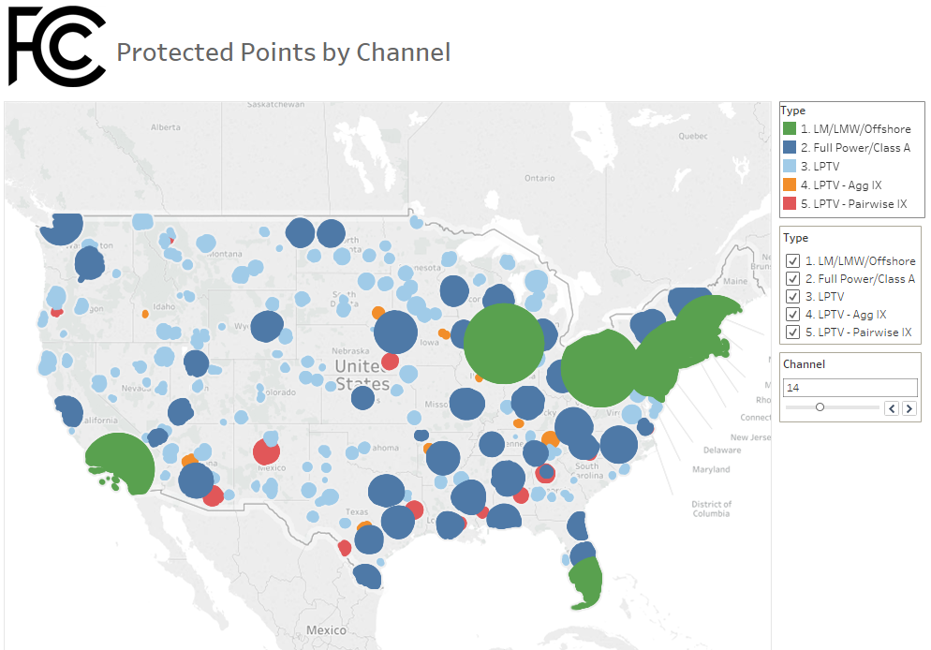Figure 1: From Protected Points by Channel – Granted Workbook: Protected Service Areas for Channel 14
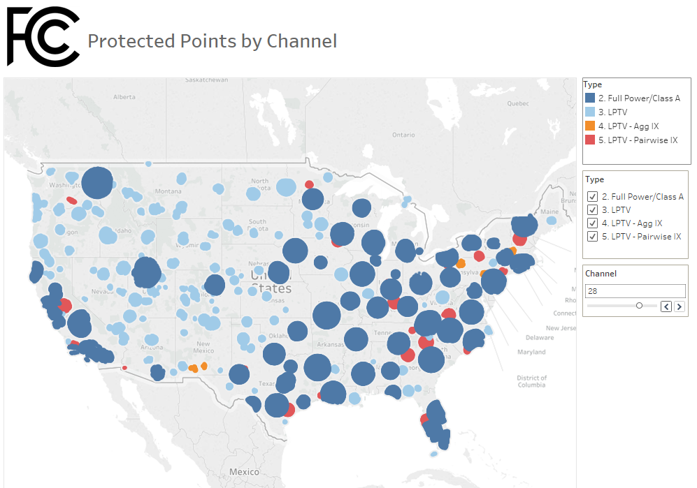
Figure 2: From Protected Points by Channel – Granted Workbook: Protected Service Areas for Channel 28
- As noted above, there are two Tableau workbooks for each visualization. One workbook reflects the data set using the service area parameters from the most recently granted construction permits or licenses of full or Class A TV stations as of the pull date and the second workbook reflects the data set using the service area parameters from pending construction permits as of the pull date.

Potentially Displaced LPTV Stations Maps
- The two Potentially Displaced LPTV Station Map visualizations show LPTV/translator stations that are potentially displaced because they cause new pairwise interference greater than 0.5% to a full power or Class A station or because they receive aggregate new interference greater than 2%. The 2% parameter is a default used in the data but it can be changed using a filter next to the map. Using the lasso tool within Tableau, the user can select a geographic region to generate a table containing the pairwise and aggregate interference data, and also view the interference free service area of individual LPTV stations to see the impact of new interference. Examples of the visualizations available are provided in Figure 3 through Figure 6 below and comprehensive information is available in the data provided online.
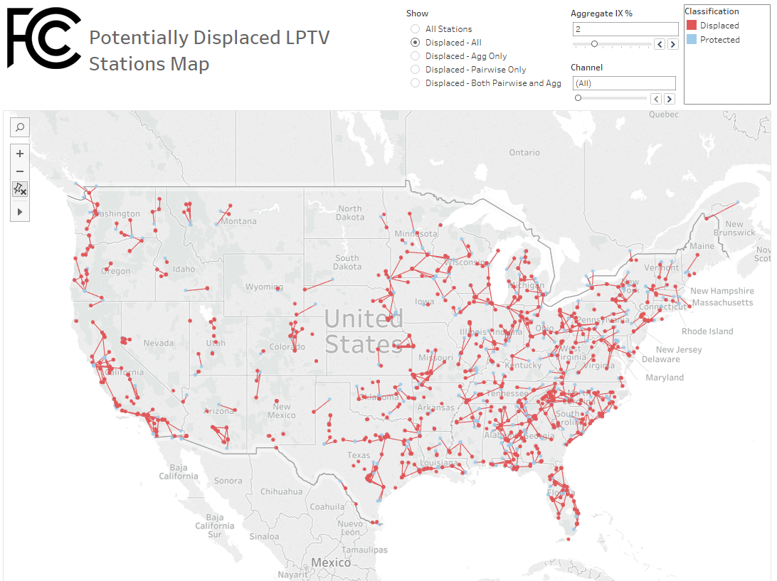
Figure 3: From Potentially Displaced LPTV Stations – Granted Workbook: LPTV stations displaced by causing new pairwise interference or receiving new aggregate interference. For pairwise-displaced stations, a line is drawn between the displaced LPTV station and the full power or Class A station (marked as “Protected” stations in the map shown above) receiving the pairwise interference.
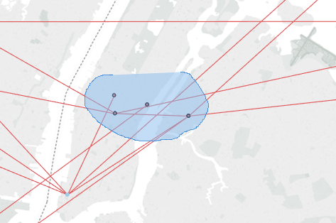
Figure 4: From Potentially Displaced LPTV Stations – Granted Workbook: Data captured by the lasso tool.
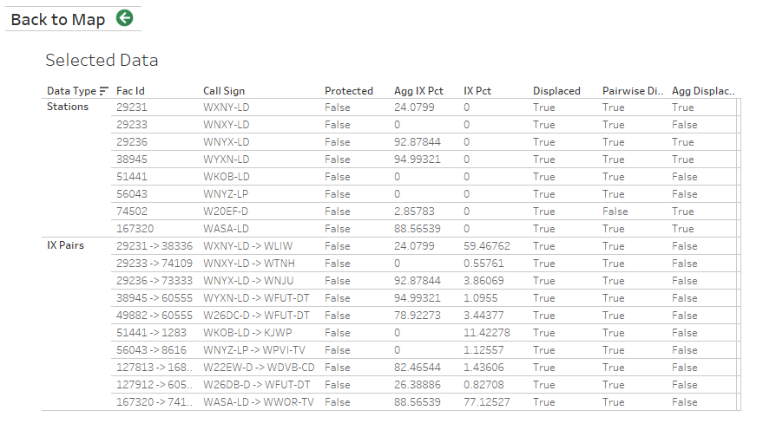
Figure 5: From Potentially Displaced LPTV Stations – Granted Workbook: Table containing data captured by the lasso tool in Figure 4.
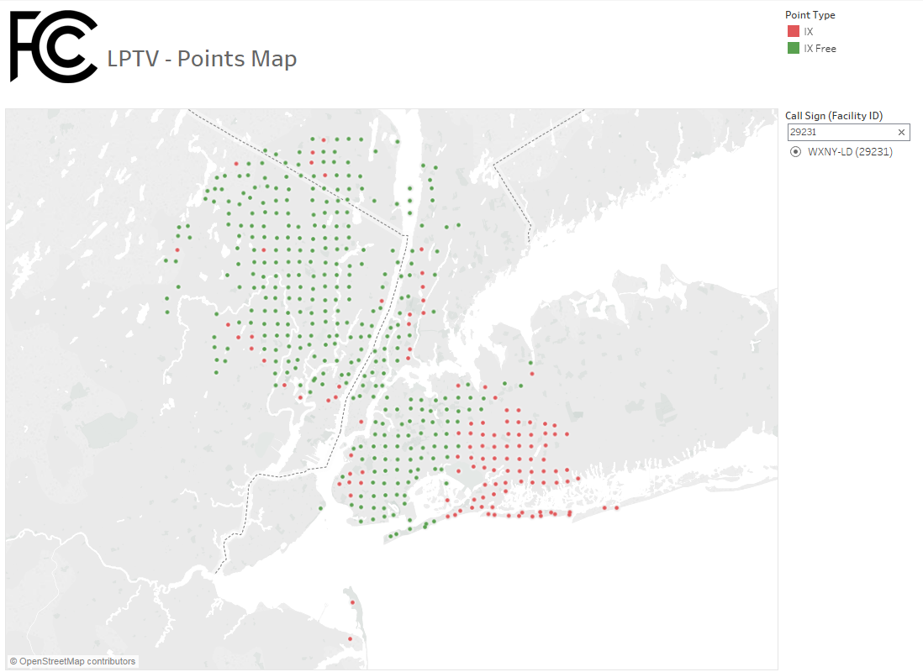
Figure 6: From Potentially Displaced LPTV Stations – Granted Workbook: Example of view of a single LPTV station’s service area.

CSV Data Files
- The online Channel Study includes three zip files. The first zip file contains the three CSV files unique to the granted applications study. The second zip file contains the three CSV files unique to the pending and granted applications study. The third zip file contains the two CSV files common to both studies. The CSV files contained in these three zip files were used to generate the Tableau maps. Each study contains a CSV file, lptv_aggregated.csv, which is the aggregated 2x2 km point data as categorized above, and forms the basis for the Tableau maps. The other two CSV files combined with the common two CSV files contain the underlying point data for each LPTV/translator station used to generate the aggregated data. These are provided in comma separated value format and are available to users to generate their own study scenario or to replicate our analysis.
- The following three files (detailed in Tables 1-3 below) are in the zip file unique to each study. The lptv_aggregated.csv file identifies, for each channel, any point that falls within a service area. The file contains the fields listed in Table 1 below:
Field | Description | Type | Sample
pointkey | the unique identification for a 2 x 2 grid cell determined by TVStudy | Integer | e.g., 62592057
channel | The channel number assigned to the station of the protection category indicated by the “type” field. | Integer | e.g., 29
type | the classification of service for that point according to the priorities listed above | String | Types will be one of the following:  - LM/LMW/Offshore  - FP/CA  - LPTV  - LPTV – Agg IX  - LPTV – Pairwise IX
Table 1: Data Dictionary for lptv_aggregated.csv
- The stations_points.csv file identifies the interference-free points for each station on the station’s assigned channel in the study. These points establish the total interference-free population for a given station and also the possible locations for interference to that station. The file contains the fields listed in Table 2 below:
Field | Description | Type | Sample
facility_id | The unique facility ID assigned to the station | Integer | e.g., 52887
channel_id | The channel number assigned to the station | Integer | e.g., 29
pointkey | The unique ID of each 2x2 km cell | Integer | e.g., 62592057
Table 2: Data Dictionary for stations_points.csv
- The ix_paired.csv file identifies interference between any two stations (LPTV/translator stations and full power/Class A stations) according to TVStudy at a given point. The file contains the following fields listed in Table 3 below:
Field | Description | Type | Sample
facility_id | The unique facility ID assigned to the station receiving interference | Integer | e.g., 52887
channel_id | The channel number assigned to the station receiving interference | Integer | e.g., 29
ix_facility_id | The unique facility ID assigned to the station causing interference | Integer | e.g., 53442
ix_channel_id | The channel number assigned to the station causing interference | Integer | e.g., 35
pointkey | The unique ID of the 2x2 km cell | Integer | e.g., 62592057
Table 3: Data Dictionary for ix_paired.csv
- The following two files (detailed in Tables 4-5 below) are in the other zip file and are common to both runs. The lm_points.csv file identifies points that must be protected on a specific channel due to land mobile, land mobile waivers, and off shore radio (LM/LMW/OSR). The file contains the fields listed in Table 4 below:
Field | Description | Type | Sample
facility_id | The unique facility ID assigned to the LM/LMW/OSR station | Integer | e.g., 52887  Note: facility_id 999999 is used for off shore radio
channel_id | The channel number assigned to the LM/LMW/OSR station | Integer | e.g., 29
pointkey | The unique ID of each 2x2 km cell | Integer | e.g., 62592057
Table 4: Data Dictionary for lm_points.csv
- The pointkeys.csv file identifies the characteristics associated with each point, specifically latitude, longitude, country and population. The file contains the fields listed in Table 5 below:
Field | Description | Type | Sample
pointkey | The unique ID of each 2x2 km cell | Integer | e.g., 62592057
latitude | The latitude coordinate of the 2x2 km point | Decimal | e.g., 28.586667
longitude | The longitude coordinate of the 2x2 km point | Decimal | e.g., -81.082778
country | The country where the 2x2 km point is located | String | One of the following:  - US  - CA  - MX
population | The population of the 2x2 km cell | Integer | e.g., 586
Table 5: Data Dictionary for pointkeys.csv

TVStudy Scenarios
- We are also making available on the website a zip file that contains the three TVStudy XML scenarios used to generate the interference data used in the Channel Study. The first scenario, “180124-Pre.xml”, was used to generate the interference-free service areas of LPTV/translator stations on their current channels. The second scenario, “180124-PostG.xml”, was used to calculate the interference to/from LPTV/translator stations in the granted applications study. The third scenario, “180124-PostP.xml”, was used to calculate interference to/from LPTV/translator stations in the pending and granted applications study. These studies were run using the Interference Check template included with TVStudy 2.2.4. The output of these three TVStudy scenarios was combined into the data tables described in III.d. above.

See In the Matter of Expanding the Economic and Innovation Opportunities of Spectrum Through Incentive Auctions, Report and Order, 29 FCC Rcd 6567 (2014) (Incentive Auction R&O) (subsequent history omitted); Incentive Auction Closing and Channel Reassignment Public Notice: The Broadcast Television Incentive Auction Closes; Reverse Auction and Forward Auction Results Announced; Final Television Band Channel Assignments Announced; Post-Auction Deadlines Announced, Public Notice, 32 FCC Rcd 2786 (2017) (Closing and Channel Reassignment Public Notice).
See The Incentive Auction Task Force and Media Bureau Announce Procedures for Low Power Television, Television Translator and Replacement Translator Stations During the Post-Incentive Auction Transition, Public Notice, 32 FCC Rcd 3860 (IATF and MB 2017) (LPTV Procedures Public Notice).; Incentive Auction Task Force and Media Bureau Set Forth Tools Available to LPTV/Translator Stations Displaced Prior to the Special Displacement Window, Public Notice, 32 FCC Rcd 4943 (IATF and MB 2017).
We note that the Commission in 2015 sought comment on whether to preserve a vacant television channel for use by unlicensed white space devices and wireless microphones in all areas of the country. See In the Matter of Amendment of Parts 15, 73 and 74 of the Commission’s Rules to Provide for the Preservation of One Vacant Channel in the UHF Television Band For Use By White Space Devices and Wireless Microphones, MB Docket No. 15-146, Notice of Proposed Rulemaking, 30 FCC Rcd 6711 (2015). In that proceeding, the Commission proposed that applications filed in the displacement window would have to demonstrate that they do not eliminate the last remaining vacant channel in their proposed service area. Id. at 6719, para. 17. While the Commission has not issued an order in this proceeding to date, we note that the opening of the displacement window and acceptance of displacement applications does not preclude the preservation of a vacant television channel. Because new 600 MHz licensees have already begun to deploy service in the 600 MHz Band and the earliest transitioning full-power and Class A stations will begin testing on their post-auction channels in a few months, we believe time is of the essence in opening the special displacement window and processing displacement applications in order to “preserve the important services provided by LPTV and TV translator stations.” Incentive Auction R&O, 29 FCC Rcd at 6576, para. 21. In addition, we expect that in many areas of the country there will likely be vacant channels available even after displacement applications are processed and granted.
See LPTV Procedures Public Notice, 32 FCC Rcd at 3881, para. 32.
See 47 CFR § 74.709.
Amendment of Parts 73 and 74 of the Commission’s Rules to Establish Rules for Digital Low Power Television and Television Translator Stations, MB Docket No. 03-185, Third Report and Order and Fourth Notice of Proposed Rulemaking, 30 FCC Rcd 14927, 14946-47, paras.40-42 (2015) (LPTV DTV Third R&O); LPTV Procedures Public Notice, 32 FCC Rcd at 3864-5, paras 6-7.
LPTV/translator stations have greater flexibility to propose facilities than full power or Class A stations due to their ability to move transmitter site locations over large distances (up to 30 miles) and the absence of a requirement to replicate coverage areas. In addition, although they may not cause harmful interference to other TV stations, LPTV/translator stations may choose to accept interference from other stations. See 47 CFR §§ 74.793(e)-(h) (defining the levels of protection to the authorized facilities of full power, Class A, LPTV, and TV translator stations). Accordingly, the specific channels available to LPTV/translator stations during the Special Displacement Window, and the predicted interference caused by the proposed facilities, depends on the choices of individual applicants.
See Letter from Paul Margie, Harris, Wiltshire & Grannis LLP Counsel for Microsoft Corporation, to Marlene H. Dortch, Secretary, FCC, MB Docket Nos. 16-306 and 15-146, GN Docket No. 12-268 (filed Feb. 5, 2018).
See LPTV DTV Third R&O, 30 FCC Rcd at 14946, para. 40. The Commission concluded that “use of the repacking and optimization software for this purpose will expedite and ease the post-auction transition and help many low power stations find new channel homes.” Id.
47 CFR § 74.709.
See 47 CFR § 73.3700(g)(2); Incentive Auction R&O, 29 FCC Rcd at 6836 n.1836. If an application filed during either of the alternate channel/expanded facilities filing windows is granted and supersedes the full power or Class A station’s facility as listed in the Closing and Channel Reassignment Public Notice, then an LPTV/translator station filing an application in the Special Displacement Window need only demonstrate that it will not cause interference to the facility authorized in the granted window application.
See Media Bureau Temporarily Lifts the Freeze on the Filing of Minor Modification Applications That Expand the Contour of Full Power and Class A Television Stations From November 28 Through December 7, 2017, Public Notice, 32 FCC Rcd 9328 (MB 2017).
The latest version of the Commission’s TVStudy software is available at https://www.fcc.gov/oet/tvstudy. The version of TVStudy used during the incentive auction, Version 1.3.2 (Patched), remains available on the Commission’s LEARN website at https://data.fcc.gov/download/incentive-auctions/OET-69.
We note that the data shows those locations and channels that are potentially unavailable for displaced LPTV/translator stations. The data also indicates which LPTV/translator stations are potentially displaced as a result of causing interference or receiving interference based on certain assumptions that are described in more detail in the attached Appendix. This information is provided as guidance, and stations must conduct their own interference studies using TVStudy, particularly since technical parameters for stations may change. Technical showings will be required to demonstrate that LPTV/translator station displacement applications are predicted to cause less than the amount of interference prescribed in our rules to other TV stations, including other LPTV/translator stations.
See 47 CFR § 73.3700(g)(1); Incentive Auction R&O, 29 FCC Rcd at 6836, para. 659.
See Media Bureau Announces Date By Which LPTV and TV Translator Stations Must Be “Operating” In Order To Participate In Post-Incentive Auction Special Displacement Window, Public Notice, 31 FCC Rcd 5383 (MB 2016).
With respect to the TV bands, the Commission’s rules define “displacement” as an analog LPTV or TV translator station being “predicted to cause or receive interference to or from an authorized TV broadcast station,” or a “digital low power television or television translator station … causing or receiving interference or [being] predicted to cause or receive interference to or from an authorized TV broadcast station, DTV station or allotment or other protected station or service . . . .” See 47 CFR § 73.3572(a)(4) (analog) and 74.787(a)(4) (digital).
See 47 CFR § 73.3700(g)(1); Incentive Auction R&O, 29 FCC Rcd at 6836, para. 659.
Incentive Auction R&O, 29 FCC Rcd at 6835 n.1833; see 47 CFR §§ 73.3572(a)(4) and 74.787(a)(4). Displacement applications will be treated as a “minor change.” See 47 CFR §§ 73.3572(a)(4), 74.787(a)(4). There is no fee for filing a displacement application.
See 47 CFR §§ 76.53 (reference points list) and 74.787(a)(4) (digital displacement).
See 47 CFR § 73.3572(a)(4)(i) (analog displacement).
For definitions of these terms, see Incentive Auction Task Force and Media Bureau Announce Procedures for the Post-Incentive Auction Broadcast Transition, Public Notice, 32 FCC Rcd 858, 863-4, para. 13 (MB 2017).
See 47 CFR § 73.3517.
See 47 CFR § 73.3700(g)(2) (requiring a displaced LPTV/translator station to demonstrate that its proposed operations on the requested channel “would not cause interference to the predicted service of broadcast television stations on . . . pre-auction channels”). Displaced stations that do not seek to operate on a pre-auction channel relinquished by a full power or Class A station and otherwise comply with our rules can begin operating at any time following the grant of the construction permit for their displacement facilities. See Incentive Auction Task Force and Media Bureau Adopt Post-Incentive Auction Transition Scheduling Plan, Public Notice, 32 FCC Rcd 890, 925-26, para. 72 (MB 2017).
See 47 U.S.C. § 312(g). The Commission’s rules also provide that the “license of . . . [a] TV translator or TV broadcast booster, or low power TV station will expire as a matter of law upon failure to transmit broadcast signals for any consecutive 12-month period notwithstanding any provision, term, or condition of the license to the contrary.” 47 CFR § 74.15(f).
See Freeze on the Filing of Applications for Digital Replacement Translator Stations and Displacement Applications, Public Notice, 29 FCC Rcd 6063 (MB 2014).
See Freeze on the Filing of Applications for Digital Companion Channels, Public Notice, 32 FCC Rcd 566 (MB 2017); Media Bureau Freezes the Filing of Minor Change Applications for LPTV/Translator Stations, Public Notice, DA 17-1227 (rel. Dec. 20, 2017).
See LPTV Procedures Public Notice, 32 FCC Rcd 3860, 3881, para. 32.
Id.
Id. at 3881-3, paras. 31-35. DTDRT applications will be afforded co-equal processing priority with displacement applications filed by full power television stations for their displaced DRTs. LPTV Procedures Public Notice, 32 FCC Rcd at 3882, para. 32. Applications for new DTDRTs and displacement applications for existing DRTs will have processing priority over all other LPTV/translator applications including new, minor change, and displacement applications. Id.
The Incentive Auction Task Force and Media Bureau Announce Procedures for Low Power Television, Television Translator and Replacement Translator Stations During the Post-Incentive Auction Transition, Public Notice, 32 FCC Rcd 3860, 3863, para. 7 (IATF and MB 2017) (LPTV Procedures Public Notice).
Amendment of Parts 73 and 74 of the Commission’s Rules to Establish Rules for Digital Low Power Television and Television Translator Stations, MB Docket No. 03-185, Third Report and Order and Fourth Notice of Proposed Rulemaking, 30 FCC Rcd 14927, 14946-47, paras.40-42 (2015) (LPTV DTV Third R&O).
See 47 CFR § 74.709.
Tableau files can be read with the latest free Tableau Reader software, which is available for download at https://www.tableau.com/products/reader. Using the latest version of Tableau Reader, which as of the release of this Public Notice is version 10.5, is recommended.
The latest version of the Commission’s TVStudy software is available at https://www.fcc.gov/oet/tvstudy. The version of TVStudy used to produce the Data, Version 2.2.4, remains available at this location.
See Public Notice at n.12. See also, LPTV Procedures Public Notice, 32 FCC Rcd at 3863, para. 6.
More specifically, we included all Canadian and Mexican stations in the border regions that were protected during the incentive auction. This approach is consistent with what was done during the incentive auction, however, the data set also includes additional Mexican allotments which need to be protected after the auction.
See 47 CFR §§ 74.703 (specifying the use of the Longley-Rice methodology as specified in OET Bulletin No. 69 for calculating interference); see also, OET-69 (Feb. 6, 2004), available at http://transition.fcc.gov/Bureaus/Engineering_Technology/Documents/bulletins/oet69/oet69.pdf.
See LPTV Procedures Public Notice, 32 FCC Rcd at 3862, para. 5 (instructing the Commission to utilize the software used in the incentive auction to help identify potential channel assignments).
See Expanding the Economic and Innovation Opportunities of Spectrum Through Incentive Auctions, Report and Order, 29 FCC Rcd 6567, 6650, para. 179 (2014) (Incentive Auction R&O) (subsequent history omitted) (adopting the 0.5% standard noting that the 0.5% is no additional interference at integer precision). See also, 47 CFR §§ 74.793 (e) and (g) (specifying that a digital low power TV or TV translator station must not cause a loss of service to 0.5 percent or more of the population predicted to receive service from the authorized DTV facilities, authorized Class A TV facilities or digital Class A TV facilities).
Note that in addition to granted construction permits and licensed operating facilities included in this first set, we also included a small number of pending minor modifications for LPTV/translator stations in this first set. These pending minor modifications are likely either awaiting international coordination or were otherwise filed prior to the December 20, 2017 freeze on LPTV/translator minor modifications and, in either case, will require protection from applications filed in the Special Displacement Window. See Media Bureau Freezes the Filing of Minor Change Applications for LPTV/Translator Stations, Public Notice, DA 17-1227 (rel. Dec. 20, 2017).
We had to make one minor correction to the set of stations included in the pending and granted applications study. WWDT-CD (facility ID: 58261) was accidentally not included in the data used by TVStudy to create this scenario. To provide a more accurate picture for this study, WWDT-CD’s interference-free service area was added manually into the data used to create the Tableau maps. WWDT-CD was, however, correctly included in the study that considered only granted applications.
See also, 47 CFR §§ 74.793 (h) (specifying that a digital low power TV or TV translator station must not cause a loss of service to 2.0 percent or more of the population predicted to receive service from the authorized low power TV, TV translator, digital low power TV or digital TV translator station).
Note that for purposes of generating the Channel Study, we continued to use the same distance-based protections that were used in the incentive auction. See Incentive Auction Task Force Releases Information Related to Incentive Auction Repacking, ET Docket No. 13-26, GN Docket No. 12-268, Public Notice, 28 FCC Rcd 10370, 10407-10 (2013) (Repacking Data PN). This conservative approach was adopted for ease of use, but displaced LPTV/translator stations can still make a technical showing to demonstrate that they can operate on these excluded channels and locations.
When importing these scenarios, a current LMS dataset and the November 2015 CDBS Extract used for the Incentive Auction should be specified in order to ensure that both the US and international stations are properly included in the study.

