DA 18-186
Released: February 27, 2018

Procedures for the Mobility Fund Phase II Challenge process
WC Docket No. 10-90
WT Docket No. 10-208
Table of Contents
Heading Paragraph #
I. Introduction 1
II. Procedures for Generating the Initial Eligible Areas Map 4
III. Procedures for MF-II Challenges 9
A. Overview 9
B. Procedures for Challengers: Filing a Challenge 11
1. Timing for Availability of Initial Coverage Data and Challenge Window 11
2. Using the USAC Challenge Process Portal 14
a. Accessing the Portal 14
b. Access to Provider-Specific Data 16
3. Evidentiary Requirements for Challenge Data 17
a. General Requirements Adopted by the Commission for Speed Test Measurements 17
b. Substantial Coverage of the Challenged Area 19
c. Additional Parameters and Specifications for Speed Test Measurements 27
d. File Formats 32
4. Validation of Challenges 35
5. Certifying a Challenge 39
a. Qualified Engineer/Government Official Certification 39
b. Challenger Certification 40
C. Procedures for Challenged Parties: Responding to a Challenge 43
1. Timing for Availability of Challenge Data and Response Window 43
2. Using the USAC Challenge Process Portal 45
a. Accessing the Portal 45
b. Challenge Information 47
3. Evidentiary Requirements for Response Data 48
a. General Requirements Adopted by the Commission 48
b. Additional Requirements for Speed Test Measurements 49
c. Additional Requirements for Speed Reduction Data 51
d. Requirements for Data from Transmitter Monitoring Software 56
e. File Formats 59
4. Certifying a Response 63
a. Qualified Engineer Certification 63
b. Challenged Party Certification 64
D. Adjudication of Challenges 66
1. Standard of Review 66
2. Announcing Results 67
IV. Procedural Matters 68
A. Congressional Review Act 68
B. Paperwork Reduction Act Analysis 69
C. Supplemental Final Regulatory Flexibility Analysis 70
V. Contact Information 84

APPENDIX A — Generating Initial Eligible Areas Map
APPENDIX B — Validating Challenge Evidence
APPENDIX C — Applying Subsidy Data
APPENDIX D — File Specifications and File Formats
APPENDIX E — Relational Mapping of Form 477 Filers to Providers
APPENDIX F — CHALLENGE DATA CERTIFICATION FORM

Introduction
- In this Public Notice, the Rural Broadband Auctions Task Force (Task Force), with the Wireless Telecommunications Bureau and the Wireline Competition Bureau (the Bureaus), establishes the parameters and procedures to implement the Mobility Fund Phase II (MF-II) challenge process. Release of this Public Notice is another important step toward commencing the MF-II auction.
- Under the challenge process framework established by the Commission in the MF-II Challenge Process Order, mobile providers were required to submit current, standardized coverage data on qualified 4G LTE service by January 4, 2018. These data are used, in conjunction with subsidy data from the Universal Service Administrative Company (USAC), to establish the map of areas presumptively eligible for MF-II support (initial eligible areas map). Interested parties will have an opportunity to challenge an initial determination that an area is ineligible for MF-II support, and challenged providers will then have an opportunity to respond to challenges.
- The Commission directed the Bureaus to provide more details regarding the procedures for generating the initial map of presumptively eligible areas and the procedures for the challenge process. In a Public Notice released on October 18, 2017, the Task Force and Bureaus proposed and sought comment on the procedures for processing the coverage and subsidy data and creating the initial eligible areas map, the specific parameters for the data that challengers and respondents will submit as part of the challenge process, and a process for validating challenges. We now resolve these issues and describe the filing requirements and procedures related to the challenge process.

Procedures for Generating the Initial Eligible Areas Map
- We adopt our proposed methodology for generating the initial map of areas presumptively eligible for MF-II support, i.e., those areas lacking unsubsidized qualifying coverage by any provider. In this multi-step approach, Commission staff first determines the unsubsidized coverage for each provider based on its submitted standardized coverage data of qualified 4G LTE, and then aggregates these data across all providers; this aggregate area of unsubsidized coverage is then removed from the rest of the land area within each state to determine the presumptively eligible areas. This approach is consistent with the Commission’s decision that areas lacking unsubsidized, qualifying 4G LTE service will be eligible for the auction, as well as its decision to create the map of areas presumptively eligible for MF-II support using a combination of the new 4G LTE coverage data and subsidy data from USAC. Specifically, as detailed below and in Appendix A and Appendix C, the methodology we adopt produces a map of unsubsidized qualified 4G LTE coverage for each provider by removing from that provider’s submitted coverage any areas that the USAC subsidy data show are subsidized. The resulting maps of unsubsidized coverage are then merged across all providers to determine the areas ineligible for MF-II support. The initial eligible areas map shows all areas that are not ineligible for MF-II support.
- To generate a map of unsubsidized qualified 4G LTE coverage for each provider, Commission staff: (1) removes any subsidized areas from the provider’s coverage map; (2) removes any water-only areas; (3) overlays a uniform grid with cells of one square kilometer (1 km by 1 km) on the provider’s coverage map; and (4) removes grid cells with coverage of less than the minimum area that could be covered by a single speed test measurement when buffered. Using a uniform grid to analyze the new 4G LTE coverage data will improve and simplify geospatial data processing. Ignoring coverage in a grid cell if it is less than one-quarter of the buffered area of a single speed test will allow challengers and challenged parties to focus only on areas with significant coverage during the challenge process and improve the efficiency of processing.
- Using the maps that result from steps 1-4 of this process, staff then generates the map of presumptively eligible areas for each state (or state equivalent) by: (5) merging the maps of unsubsidized coverage for all providers; (6) removing the merged unsubsidized coverage generated in step 5 (the ineligible areas) from the state’s boundary to produce the eligible areas; and (7) removing any water-only areas from the eligible areas.
- As discussed in the Appendices, we define a uniform grid with cells of equal area (1 km by 1 km) across the continental United States, and separate uniform grids with cells of equal area (1 km by 1 km) for overseas territories and Hawaii. These grids are defined using an “equal area” map projection so that the same number of speed tests will be required to challenge the cell regardless of the location of the grid cell. For the reasons discussed in the MF-II Challenge Process Comment Public Notice, the USAC portal system will use the uniform grid system to validate and process data submitted during the challenge process.
- For the reasons stated in the MF-II Challenge Process Comment Public Notice, Commission staff is making available to the public the resulting map of presumptively eligible areas (overlaid with the uniform grid) for each state or state equivalent. The maps of unsubsidized coverage for specific providers will only be made available to a challenger through USAC’s online challenge portal (the USAC portal) after the challenger agrees to keep such maps confidential.

Procedures for MF-II Challenges

Overview
- Under the framework adopted by the Commission in the MF-II Challenge Process Order, all mobile service providers and government entities (state, local, and Tribal), as well as other interested parties that successfully seek a waiver from the Commission, may challenge areas that are deemed presumptively ineligible for MF-II support in the initial eligible areas map. A challenger will have 150 days (the challenge window) to submit a challenge via the USAC portal. A valid challenge must include evidence in the form of actual outdoor speed test data showing a lack of unsubsidized, qualified 4G LTE coverage. The system will validate that each challenge meets the Commission’s requirements for data characteristics and quantity on a grid cell by grid cell basis. Once validation processing is complete, a challenger will be able to view and certify its challenge(s), and only those challenges that are certified at the close of the challenge window will proceed.
- No sooner than 30 days after the system completes processing all certified challenges, a 30-day response window will open during which a challenged provider may submit additional data in response to a challenge to its coverage area. A challenged party is not required to oppose the challenge and need not submit any information. If a challenged party wishes to oppose the challenge, it must submit and certify response evidence that conforms to the adopted standard parameters, as applicable, before the response window closes. After the response window closes, Commission staff will adjudicate certified challenges and responses using a preponderance of the evidence standard.

Procedures for Challengers: Filing a Challenge

Timing for Availability of Initial Coverage Data and Challenge Window
- We adopt our proposal to make public the map of areas presumptively eligible for MF-II support no earlier than four weeks after the deadline for submission of the new, one-time 4G LTE provider coverage data. Contemporaneously with the publication of the map, we are announcing via public notice the availability of these data and subsequent commencement of the challenge window. The challenge process window will open no sooner than 30 days after the release of the map. Once the challenge window opens, an eligible party will be able to access the USAC portal and download the provider-specific confidential data necessary to begin conducting speed tests. The challenge window will close 150 days later, consistent with the procedures adopted in the MF-II Challenge Process Order. Although challengers will be able to submit speed test data until the close of the challenge window, the Commission determined that only those challenges to areas that are certified by a challenger at the close of the window will proceed. Since a challenger will not be able to certify a challenge until the submitted speed test data has been validated, we strongly encourage challengers to submit data in advance of the closing date to allow ample time for validation processing. Each challenger is responsible for ensuring timely certification of its challenges.
- We are providing 30 days’ notice of the opening of the USAC portal and commencement of the challenge window, as requested by some commenters. We conclude that providing 30 days’ notice of the portal opening will facilitate challengers being able to start collecting and submitting data on the day the window opens.
- While we acknowledge some commenters’ concerns that it may be difficult for rural providers to conduct speed tests in difficult terrain and snow-covered areas during the winter, we find that prospective challengers will have ample time to conduct speed tests and complete the work necessary to initiate a challenge within the 150-day challenge window, even in snow-prone areas. Under our adopted procedures and expected timeline, the challenge window will open in March 2018 and will close in August 2018, giving challengers at least several spring and summer months to conduct speed tests when the weather is less severe and foliage is intact. Delaying the opening of the challenge window would risk opening the response window in the middle of the following winter. In that case, commenters’ concerns about data collection in winter could present difficulties for challenged parties, particularly given the shorter response window. Accordingly, consistent with the Commission’s goal to resolve eligible area disputes expeditiously, we decline to delay the opening of the challenge window.

Using the USAC Challenge Process Portal

Accessing the Portal
- Under the challenge process framework adopted by the Commission, a challenger must use the USAC portal to access the confidential provider-specific information that is pertinent to a challenge, as well as to submit its challenge, including all supporting evidence and required certifications. A challenger must log into the USAC portal using the account created pursuant to the procedures in the MF-II Handset and USAC Portal Access Public Notice.
- We remind parties participating in the challenge process that it is each party’s responsibility to ensure the security of its computer systems, user IDs, and passwords, and to ensure that only authorized persons access, download, or upload data into the challenge process portal on the party’s behalf. The FCC assumes no responsibility or liability for these matters. To the extent a technical or security issue arises with the USAC portal, Commission staff will take all appropriate measures to resolve such issues quickly and equitably. Should an issue arise that is outside the USAC portal or attributable to a challenge process participant—including, but not limited to, a participant’s hardware, software, or Internet access problem—and which prevents the participant from accessing provider-specific data or submitting a challenge prior to the close of the challenge window, the Commission shall have no obligation to resolve or remediate such an issue on behalf of the participant.

Access to Provider-Specific Data
- We adopt our proposal to make available in a downloadable format through the USAC portal the provider-specific data underlying the map of presumptively eligible areas. Among other geographic data, a challenger will be able to access the following data in shapefile format on a state-by-state basis: (a) the boundaries of the state (or state equivalent) overlaid with the uniform grid; (b) the confidential coverage maps submitted by providers for the one-time 4G LTE data collection; and (c) the map of initial eligible areas. In addition, as proposed, challengers will be able to access, for each state, the confidential provider-specific data on the list of pre-approved handsets and the clutter information submitted for the one-time 4G LTE data collection. These data will be available for download in a tabular comma-separated value (CSV) format. A challenger will not have access to confidential provider-specific information unless and until it agrees to treat the data as confidential. Specifically, a challenger must agree to only use confidential provider-specific information for the purpose of submitting an MF-II challenge in the USAC portal before a challenger may download these data.

Evidentiary Requirements for Challenge Data

General Requirements Adopted by the Commission for Speed Test Measurements
- In the MF-II Challenge Process Order, the Commission decided that a challenger must submit detailed proof of lack of unsubsidized, qualified 4G LTE coverage in support of its challenge in the form of actual outdoor speed test data showing measured download throughput. A challenger must submit speed data from hardware- or software-based drive tests or application-based tests that overlap the challenged area. Each speed test must be conducted between the hours of 6:00 AM and 12:00 AM (midnight) local time, and the date of the test must be after the publication of the initial eligibility map but not more than six months before the scheduled close of the challenge window. As discussed in more detail below, speed test data must be certified under penalty of perjury by a qualified engineer or government official.
- When collecting speed data, a challenger must use at least one of the three handsets identified by each provider whose coverage is the subject of the specific challenge. A challenger must purchase an appropriate service plan from each unsubsidized service provider in the challenged area. The Commission explained in the MF-II Challenge Process Order that “[a]n appropriate service plan would allow for speed tests of full network performance, e.g., an unlimited high-speed data plan.” A challenger should be cognizant of the limitations under the service plan(s) it purchases and that respondents have the ability to respond to challenger speed tests with evidence of speed reductions. Depending on the size of the area being challenged and the terms of the plans offered by a challenged provider, a challenger may determine that it should purchase more than one service plan for the handset(s) it uses to test a provider’s coverage in the challenged area.

Substantial Coverage of the Challenged Area
- The Commission decided in the MF-II Challenge Process Order that a challenger must submit actual outdoor speed test measurements with sufficient density to reflect actual consumer experience throughout the entire challenged area. Specifically, the Commission adopted a requirement that a challenger must take measurements that: (1) are no more than a fixed distance apart from one another in each challenged area; and (2) substantially cover the entire area.
- The density of submitted speed points will be validated as part of a multi-step geospatial-data-processing approach. Consistent with the Commission’s decision in the MF-II Challenge Process Order, and as discussed in more detail below, we will determine whether a challenger’s speed test points substantially cover a challenged area (i.e., cover at least 75 percent of the challenged area) by buffering each speed test point that reports a downstream speed less than 5 Mbps, calculating the buffered area, and then comparing the area of the buffered points to the challengeable area within a 1 km by 1 km grid cell. The Commission determined in the MF-II Challenge Process Order that the radius of the buffer will equal “half of the maximum distance parameter.” Under this validation process, if a challenger submits speed test measurements that are further apart than the maximum distance parameter in a challenged area, its evidence may be insufficient to cover at least 75 percent of the challengeable area within a cell, and its challenge would presumptively fail.
- As a preliminary matter, we adopt our proposal to use kilometers instead of miles to be consistent with the de minimis challenge size adopted by the Commission, as well as to be consistent with the units used for the “equal area” map projection that we will use when processing geospatial data. Consistent with the Commission’s direction to adopt a maximum distance value, we adopt our proposal that speed test measurements must be no more than one-half of one kilometer apart from one another. As a result, the buffer radius will equal one-quarter of one kilometer (250 meters). While we are mindful of the burdens on challengers and have sought to reduce the burdens on entities that choose to submit challenges, we must balance the burdens on those entities with the Commission’s need to collect data that reflects consumer experience as accurately as possible. We find that using a maximum distance value of one-half of one kilometer as part of the validation process will help to ensure the accuracy of the submitted speed test challenge data while balancing the burden on small challengers. We also adopt our proposal to require a challenger to submit data for at least one speed test within the challengeable area of a grid cell in order to challenge an area within the grid cell. This requirement facilitates the collection of challenge data that more accurately reflect a consumer’s on-the-ground experience within that grid cell.
- We disagree with commenters that support using a maximum distance greater than one-half of one kilometer, such as one mile, to satisfy the density requirement. These commenters argue that a larger distance would reduce the burden on challengers by lessening the number of speed tests needed to support a valid challenge and also would allow challengers to more easily challenge areas with roads that are one mile apart. Specifically, we reject one commenter’s suggestion to reduce the proposed number of measurements that are required to mount a successful challenge by increasing the speed test buffer radius to one-half mile (implying a maximum distance parameter of one mile) and the grid cell size to 1 square mile. In support of its argument, the commenter explains that adopting a speed test buffer radius of one-quarter of one kilometer as proposed would be unduly burdensome, as it would require a challenger to obtain at least four measurements per square kilometer grid cell. We are not persuaded by the evidence in the record that requiring a challenger to collect four speed test measurements per square kilometer grid cell is “excessive and unnecessary” or would amount to an “insurmountable burden for many potential challengers,” particularly since participation in the challenge process is voluntary. Further, we find that the alleged burden is outweighed by the increased accuracy of collecting speed test data pursuant to our adopted approach.
- Moreover, increasing the buffer radius (i.e., increasing the maximum distance between speed tests) would reduce the number of speed tests needed to support a successful challenge and, in doing so, reduce the accuracy and reliability of a challenger’s speed test data. Larger distances between speed tests would less accurately reflect a consumer’s on-the-ground experience at any given point. Because “signal strength varies from place to place,” as one commenter notes, one can expect the results of a speed test taken at one point to match the results of speed tests taken a short distance around that point. The larger that distance, the less likely the results are to be similar to the results at the original point. A one-mile maximum distance between speed points would, in effect, mean that the Commission was willing to accept that a speed test at one point was representative of the speeds that a consumer could expect one mile away from that point. Download speeds can vary considerably over one mile due to a variety of factors, including signal attenuation, clutter, and terrain.
- Further, the MF-II LTE coverage data has a granularity of at least 100 meters by 100 meters, reflecting the variation that terrain and clutter can cause every 100 meters. It would be inconsistent to require this level of granularity for the coverage data and then allow that same coverage data to be challenged at a granularity of one speed test per mile, which is approximately 1,600 meters and more than 16 times larger. However, we recognize that requiring a challenger to conduct one speed test every 100 meters would be unduly burdensome. We must weigh the burden on challengers against our interest in collecting data that accurately reflects consumers’ experiences. In doing so, we find that adopting a maximum distance between speed tests of 500 meters (one-half of one kilometer) and an associated buffer radius of 250 meters (one-quarter of one kilometer) strikes the appropriate balance.
- We likewise decline to increase the size of the grid cell to one square mile. Since we are not increasing the size of the buffer radius, increasing the size of the grid cell to one square mile will not achieve the result sought by the commenter that made the proposal (i.e., to reduce the number of measurements needed to mount a successful challenge). Further, as discussed above, using metric measurements (e.g., kilometers) as opposed to imperial measurements (e.g., miles) is significantly more efficient for system processing and is consistent with the propagation maps that are generated with a resolution of no more than 100 square meters.
- We also reject commenters’ proposals to allow parties to challenge an area without conducting speed tests throughout the area if portions of the area are non-drivable or otherwise difficult to access. These proposals are inconsistent with the Commission’s requirement that speed tests substantially cover the challenged area and its decision not to provide any special accommodations for areas that challengers claim they cannot access. No petitions for reconsideration were filed regarding this decision of the Commission, and the Bureaus are not free to revisit it here. Under the challenge process framework that the Commission adopted, all ineligible areas may be challenged and challengers have the option to conduct speed tests that cover the areas they wish to challenge. Similarly, responding providers have the option to submit speed tests that demonstrate their coverage. These options will not be diminished or otherwise modified by the relative accessibility of an area.

Additional Parameters and Specifications for Speed Test Measurements
- In addition to the general requirements for speed tests described above, the Commission directed the Bureaus to implement any additional parameters to ensure that speed tests accurately reflect the consumer experience in the challenged area. Consistent with this direction, we adopt our proposal to require a challenger to submit all speed test measurements collected during the relevant time frame, including those that show speeds greater than or equal to 5 Mbps. We note that, while a challenger is able to delete speed tests from the USAC portal, this function should only be used to correct errors in submissions or add information to previous submissions.
- In addition, we adopt our proposal to require a challenger to provide data that is commonly collected by speed test software and speed test apps. Specifically, a challenger must provide: signal strength and latency; the service provider’s identity; the make and model of the device used (which must be from that provider’s list of pre-approved handsets); the international mobile equipment identity (IMEI) of the tested device; the method of the test (i.e., hardware- or software-based drive test or non-drive test app-based test); and, if an app was used to conduct the measurement, the identity and version of the app. In proposing these standard parameters, the Bureaus explained that they would be used by challenged parties and the Commission to analyze the validity and probative value of a speed test.
- Some commenters oppose this proposal, arguing that the Commission should only require challengers to submit the data needed for a valid speed test under the framework adopted in the MF-II Challenge Process Order. The additional parameters we adopt today give necessary context to the submitted speed test data and will ultimately lead to a more efficient challenge process by making it easier to compare data. We are not persuaded that requiring a challenger to submit data for these additional parameters would “exponentially increase[] the cost to raise a challenge and the burdens placed on the challenger.” The data specifications adopted are commonly recorded in testing by speed test software and apps, thus minimizing any the burden on challengers that choose to participate in the challenge process. Signal strength, specifically, is typically tested by speed test software and apps in conjunction with any download or upload test. Latency is also commonly tested, and requiring a challenger to submit latency data is consistent with the Commission’s requirement that MF-II support recipients must submit such data to demonstrate compliance with the Commission’s coverage requirements, which include a latency standard. The service provider’s identity and the make and model of the device used are essential to determining whether the challenger used a device designated by the incumbent provider for speed testing. Further, contrary to one commenter’s contention that these data are extraneous, data such as the device ID, signal strength, and latency, may help challenged parties respond to challenges where the download speed recorded does not accurately reflect the average consumer experience, e.g., where a device was subject to data speed reduction at the time of measurement. While we recognize that there may be some increased burden associated with these additional parameters, we expect these burdens to be relatively small when compared to the total cost of testing and submitting challenges. Moreover, any additional burden is outweighed by the increased accuracy of the submitted data that will assist in correctly adjudicating challenges and targeting MF-II funds to areas that need it most.
- We also adopt a requirement that a challenger report information about the server used for speed and latency testing. Specifically, a challenger is required to submit the identity and location of the server used for speed and latency testing. These additional parameters will allow a challenged party to determine whether submitted speed test data were distorted by the use of a distant server, the use of which could adversely impact measured latency and download speeds without being representative of the standard consumer experience. While one commenter argues that this issue could be addressed in a challenged provider’s response, requiring a challenger to provide server identification and location information is the most efficient way to get this information as a challenger is the party with the information. Moreover, we expect that the burden on a challenger to provide this information will be small, as the server location (i.e., its IP address) is generally collected or can be configured when conducting app-based tests or drive tests.
- The complete list of data required for a challenge may be found in Appendix D.

File Formats
- For the reasons set forth in the MF-II Challenge Process Comment Public Notice, we adopt our proposal that a challenger must submit speed test data in CSV format matching the respective file specifications. A challenger is required to submit a CSV file that contains entries for each speed test run by the challenger to provide evidence in support of its challenge. A challenger can create this file using a template provided in the USAC portal.
- As discussed above, and consistent with a suggestion in the record, we require a challenger to report information about the server used for speed and latency testing. To ensure efficiency in the automated validation of these additional speed test parameters, we have modified the speed test data template proposed in the MF-II Challenge Process Comment Public Notice to include the identity and location of the server used for testing.
- Additional details about the file formats required for challengers may be found in Appendix D.

Validation of Challenges
- We adopt and explain the detailed procedures for implementing system validation of evidence submitted by a challenger, as directed by the Commission in the MF-II Challenge Process Order. Consistent with our decision above to use the uniform grid system to validate and process data submitted by a challenger, the USAC system will use a uniform grid of one square kilometer cells to perform geospatial analysis of a challenger’s speed test data. The first step in the validation process requires the USAC system to determine whether a particular challenged area meets the de minimis threshold of one square kilometer. For each grid cell containing a speed test measurement submitted by a challenger, the challenged area will equal the challengeable portion of the grid cell (i.e., the ineligible area, or any area that is neither eligible nor water-only). The USAC system will superimpose each challenged area onto the initial eligibility map and remove any portions that overlap eligible areas. Since the USAC portal will use a uniform grid of one square kilometer cells to perform geospatial analysis, a challenge for a grid cell that is entirely challengeable will inherently meet the de minimis size threshold. Consistent with the reasons set forth in the MF-II Challenge Process Comment Public Notice, in areas where the challengeable portion of the grid cell is less than this threshold, we adopt our proposal to have the system validate that the sum of all areas challenged by a challenger in a state is greater than or equal to one square kilometer. If a challenge does not meet the de minimis area threshold, the challenge would fail step one of the validation process. If a challenge meets the de minimis area threshold, the USAC system will proceed to the second step of the validation process.
- In the second step of the system validation process, the USAC system will analyze each speed test record to ensure it meets all standard parameters, other than the maximum distance and substantial coverage requirement. Consistent with our proposal, a challenger must submit speed test data in a standard format on a state-by-state basis. If the challenge speed test data meet all standard parameters, the USAC system, as proposed, will determine the set of grid cells in which at least one counted speed test is contained (the challenged grid cells) and will proceed to the third step of the validation process.
- In step three, the USAC system creates a buffer (i.e., draws a circle of fixed size) around each counted speed test (i.e., each speed test point that passes steps one and two) using a radius of one quarter of one kilometer, which is equal to half of the maximum distance allowed between tests. For each challenged grid cell, the system will then determine how much of the total buffered area overlaps with the coverage map of the challenged provider for whose network the speed test measurement was recorded; this overlapping portion is the measured area. Since a challenger has the burden of showing insufficient coverage by each provider of unsubsidized, qualified 4G LTE service, the system will also determine the unmeasured area for each such provider, that is, the portion of each provider’s coverage in the grid cell falling outside of the buffered area.
- In the last step of the validation process, the USAC system determines whether the buffered area of all counted speed tests covers at least 75 percent of the challengeable area in a grid cell. The system will merge the unmeasured area of all providers in a grid cell to determine the aggregated unmeasured area where the challenger has not submitted sufficient speed test evidence for every provider. If the calculated size of the aggregated unmeasured area in the grid cell is greater than 25 percent of the total challengeable area of the grid cell (i.e., the total area of the grid cell minus any water-only areas and any eligible areas), the challenge will be presumptively unsuccessful because it failed the requirement to include speed test measurements of sufficient density for all providers. The system will provide a warning to the challenger for any grid cells that fail this step. The system will consider all certified challenges in a particular grid cell across all challengers at the close of the challenge window.

Certifying a Challenge

Qualified Engineer/Government Official Certification
- The Commission decided in the MF-II Challenge Process Order that all submitted speed tests must be substantiated by the certification of a qualified engineer or government official to be considered during the adjudication phase of the challenge process. As requested by commenters, we clarify that a qualified engineer may be an employee of the challenger or a third-party vendor, so long as the individual: (1) possesses a sufficient degree of technical knowledge and experience to validate the accuracy of submitted speed test data; and (2) has actual knowledge of the accuracy of the submitted data. Using the Challenge Data Certification form in Attachment F, the qualified engineer or government official shall certify under penalty of perjury that: (a) he/she has examined the information prepared for submission; and (b) all data and statements contained therein were generated in accordance with the parameters specified by the Commission and are true, accurate, and complete to the best of his/her knowledge, information, and belief. The challenger must possess an executed Challenge Data Certification form in order to have all of the information it needs to certify a challenge. Persons making willful false statements in any part of a speed data submission may be subject to punishment by fine or imprisonment.

Challenger Certification
- A challenger must certify its challenge(s) before the challenge window closes in order for the challenge to proceed. Through the USAC portal, a challenger will be able to electronically certify its counted speed test measurements on a grid cell by grid cell basis, since the system will consider each challenged grid cell as a separate challenge, or to certify some or all of its challenged grid cells on an aggregated basis. To certify a challenged grid cell, an authorized representative of the challenger must: (1) provide the name and title of the certifying engineer or government official who substantiated the speed test data; and (2) certify under penalty of perjury that: (a) the qualified engineer or government official has examined the information submitted; and (b) the qualified engineer or government official has certified that all data and statements contained in the submission were generated in accordance with the parameters specified by the Commission and are true, accurate, and complete to the best of his or her knowledge, information, and belief.
- We adopt our proposal to allow a challenger to certify a presumptively unsuccessful challenge in a grid cell that fails validation solely because the challenger did not include speed test measurements of sufficient density for all providers. This will allow the system to consider all certified challenges in a particular grid cell across all challengers at the close of the challenge window, even if the individual challenges would fail the density requirement on their own.
- During the challenge window, each challenger will be able to review its certified challenges on a grid cell by grid cell basis and may modify data submitted in support of a challenge after certifying (e.g., to correct or submit additional data). A challenger will be required to re-certify any challenges for which it submits additional or modified data; however, any new or modified data must also be substantiated by the certification of a qualified engineer or government official. At the close of the challenge window, only those challenges that are certified will proceed to adjudication; however, all data entered into the USAC portal may be considered in determining the weight of the evidence.

Procedures for Challenged Parties: Responding to a Challenge

Timing for Availability of Challenge Data and Response Window
- Following the close of the challenge window, the USAC portal system will process the data submitted by challengers. We proposed to open the response window no earlier than five business days after the close of the challenge window to allow sufficient time for processing. Recognizing some commenters’ concerns that the 30-day response window adopted by the Commission provides little time for mobile providers to evaluate challenges and conduct their own tests, we will provide challenged parties 30 days to review challenges and supporting data in the USAC portal prior to opening the response window. Therefore, the response window will open no sooner than 30 days after the USAC system finishes processing the data submitted by challengers.
- Once opened, the response window will close 30 days later. Although a challenged party will have an opportunity to submit additional data via the USAC portal in response to a certified challenge for the entire duration of the response window, challenged parties are encouraged to file in advance of the deadline. A challenged party will not have an opportunity to submit additional data for the Commission’s consideration after the response window closes.

Using the USAC Challenge Process Portal

Accessing the Portal
- A challenged provider must use the USAC portal if it chooses to: (1) access and review the data submitted by the challenger with respect to a challenge within the provider’s service area; and/or (2) submit additional data/information to oppose the challenge (i.e., demonstrate that the challenger’s speed test data are invalid or do not accurately reflect network performance). A challenged provider must log into the USAC portal using the account created pursuant to the procedures in the MF-II Handset and USAC Portal Public Notice.
- We again remind parties participating in the challenge process that it is each party’s responsibility to ensure the security of its computer systems, user IDs, and passwords, and to ensure that only authorized persons access, download, or upload data into the challenge process portal on the party’s behalf. The FCC assumes no responsibility or liability for these matters. To the extent a technical or security issue arises with the USAC portal, Commission staff will take all appropriate measures to resolve such issues quickly and equitably. Should an issue arise that is outside the USAC portal or attributable to a challenge process participant—including, but not limited to, a participant’s hardware, software, or Internet access problem—and which prevents the participant from accessing challenge information or submitting response data prior to the close of the response window, the Commission shall have no obligation to resolve or remediate such an issue on behalf of the participant.

Challenge Information
- Each challenged provider will be able to access and download through the USAC portal all speed test data associated with certified challenges on that provider’s network. Specifically, after the USAC system finishes processing challenger data, a challenged party will be able to view and download the counted speed test data associated with a certified challenge that disputes the challenged party’s coverage, i.e., counted speed tests conducted by a challenger on the challenged party’s network. In addition, each challenged provider will be able to view and download speed test measurements that failed validation solely because a measurement was greater than or equal to 5 Mbps.

Evidentiary Requirements for Response Data

General Requirements Adopted by the Commission
- A challenged party is not required to respond to a challenge within its service area. If a challenged provider chooses to respond to a challenge, the Commission will accept as response data certain technical information that is probative regarding the validity of a challenger’s speed tests, including speed test data, information regarding speed reductions that affected specific challenger speed tests, and other device-specific data collected from transmitter monitoring software. If a challenged party submits its own speed test data, the data must conform to the same standards and requirements adopted for the challengers, except for the recency of the submitted data. Parties submitting technical data other than speed tests, including data from transmitter monitoring software, are required to include “geolocated, device-specific throughput measurements and other device-specific information (rather than generalized key performance indicator statistics for a cell-site).” Only data collected after the publication of the initial eligibility map and within six months of the scheduled close of the response window will be accepted from challenged parties. Response data must be reliable and credible to be useful during the adjudication process. As discussed in more detail below, any evidence submitted by a challenged party in response to a challenge must be substantiated by the certification of a qualified engineer or official under penalty of perjury.

Additional Requirements for Speed Test Measurements
- Consistent with the Commission’s decision in the MF-II Challenge Process Order, if a challenged party chooses to submit its own speed test data, the data must conform to the same additional parameters adopted above for challengers, except for the requirement to identify the service provider. Specifically, in addition to the parameters adopted by the Commission in the MF-II Challenge Process Order, a challenged party’s speed data must include: signal strength and latency; the device used (which must be from that provider’s list of pre-approved handsets); the IMEI of the tested device; the method of the test (i.e., hardware or software-based drive test or non-drive test app-based test); if an app was used to conduct the measurement, the identity and version of the app; and the identity and location of the server used for testing. As with challenger data, a challenged party’s speed test measurements may be no further than one-half kilometer apart from one another. Additionally, a challenged party must submit all speed test measurements collected during the relevant time frame, including those that show speeds less than or equal to 5 Mbps. The complete file specification for respondent speed tests is detailed in Appendix D.
- While data submitted by a challenged party will not be subject to the identical system validation process used for challenger speed test data, the system will process any submitted speed data using a similar approach. Specifically, the USAC system will analyze each speed test record to ensure it meets all standard parameters and apply a buffer with a fixed radius to each counted speed measurement. By processing certified speed data evidence submitted by both challengers and challenged parties in an equivalent manner, the adjudication process will be able to evaluate competing data objectively.

Additional Requirements for Speed Reduction Data
- For the reasons set forth in the MF-II Challenge Process Comment Public Notice, we adopt our proposal to allow a challenged party to submit data identifying a particular device that a challenger used to conduct its speed tests as having been subjected to reduced speeds, along with the precise date and time the speed reductions were in effect on the challenger’s device (speed reduction data). This type of user-specific data will assist the Bureaus with reconciling conflicting speed test measurements and is consistent with the Commission’s decision to allow challenged parties to submit “certain technical information that is probative regarding the validity of a challenger’s speed tests.”
- We disagree with commenters claiming that allowing this type of response evidence would undercut the purpose of the challenge process. One of the goals of MF-II is to “target universal service funding to coverage gaps, not to areas already built out by private capital.” Allowing challenged parties to submit speed reduction data will help Commission staff determine whether submitted speed tests truly reflect network performance and whether an area truly lacks qualifying 4G LTE coverage. Disallowing the submission of speed reduction data would mean that eligibility could turn on whether user-specific speed reductions were in effect at the time of testing. We acknowledge, however, that a provider may reduce data speed for various reasons, as one commenter points out, and expect that evidence of user-specific speed reductions will be more probative and given more weight during adjudication than evidence of common network practices affecting all subscribers independent of the service plan used. Accordingly, we agree with and provide CCA’s request for clarification that evidence of “common network processes that affect all subscribers independent of the rate plan used” should not affect the validity of challenger speed tests. Speed reduction data will be most probative of the validity of challenger speed tests when those data show that specific test results were caused by the challenger’s chosen rate plan or the challenger’s data usage in the relevant billing period.
- We reject one commenter’s alternative proposal to require a challenger and challenged party to coordinate before speed test data are recorded. Since we will accept speed reduction data from challenged parties, we find that the potential administrative burden of requiring interested parties to coordinate with one another outweighs the resulting benefit, especially if a carrier needs to reduce network speeds for an unexpected reason (e.g., emergency network management). However, we will not prohibit interested parties from coordinating with one another regarding speed tests if they choose to do so.
- We also disagree with commenters who argue that allowing response evidence about speed reductions will be burdensome to respondents. A challenged party is not required to respond to any challenges within its service area. Thus, we are not requiring a challenged party to “review all tests to determine whether they were subject to reduced speeds.” We are merely giving a challenged party the opportunity to submit such evidence if it so chooses.
- Several commenters object to the fact that the proposed challenge process procedures do not allow a challenger to refute a challenged party’s speed reduction data. Allowing a challenger to submit additional information to refute a challenged party’s response data, however, would be inconsistent with the challenge process framework adopted by the Commission in the MF-II Challenge Process Order. Under this framework, challengers do not have the opportunity to respond to the data submitted by responding providers. No petitioners sought reconsideration of this decision by the Commission and the Bureaus are not free to revisit it here.

Requirements for Data from Transmitter Monitoring Software
- Under the MF-II challenge process framework adopted by the Commission, a challenged party may submit device-specific data collected from transmitter monitoring software in responding to a challenge. As stated in the MF-II Challenge Process Order, these data “should include geolocated, device-specific throughput measurements or other device-specific information (rather than generalized key performance indicator statistics for a cell-site) in order to help refute a challenge.” We adopt our proposal to allow challenged parties to submit transmitter monitoring software data that is substantially similar in form and content to speed test data in order to facilitate comparison of such data during the adjudication process. In particular, challenged parties wishing to submit such data must include: the latitude and longitude to at least five decimals of the measured device; the date and time of the measurement; and signal strength, latency, and recorded speeds.
- We likewise adopt our proposal to require that measurements from submitted transmitter monitoring software data conform to the standard parameters and requirements adopted by the Commission for speed test data submitted by a challenged party. Specifically, we will require that such measurements reflect device usage between the hours of 6:00 AM and 12:00 AM (midnight) local time and be collected after the publication of the initial eligibility map and within six months of the scheduled close of the response window. The complete file specifications for respondent transmitter monitoring software data is detailed in Appendix D.
- One commenter argues that data from transmitter monitoring software may not be able to accurately locate measured devices. While we acknowledge this concern, the Commission previously decided that a challenged party may submit device-specific data collected from transmitter monitoring software in responding to a challenge. As no party filed a petition for reconsideration of this decision, we will not revisit it here. We caution, however, that triangulated data with large inaccuracies may not be precise enough to constitute device-specific geolocated measurements because an engineer would not be able to certify to the accuracy of a particular speed test occurring at a particular location.

File Formats
- For the reasons stated in the MF-II Challenge Process Public Notice, we adopt our proposal that challenged parties submit speed test data in CSV format matching the respective file specifications. Challenged parties are required to submit a CSV file that contains entries for each speed test run by the challenged party to provide evidence in support of its response. A challenged party can create this file using a template provided in the USAC portal. We will also require that data from transmitter monitoring software be submitted using this same template. Having both types of data filed in a combined template will allow for efficient analysis and adjudication.
- We also adopt our proposal to require challenged parties that file speed reduction data to file the data in CSV format matching the respective file specifications. This file can be created using a template provided in the USAC portal. In light of one commenter’s concern that the proposed speed reduction data template may not be suitable for all service plans, we will permit challenged parties to leave the device download speed data field blank if that provider’s plan does not reduce speeds to a fixed value. However, we decline to modify the data fields for the reduced speed start and end dates and times to capture more generally the dates and times between which the device was subject to speed reduction, regardless of whether the device’s speed was actually reduced. In order to be useful when evaluating challenges, we conclude that the data captured in the speed reduction data template must reflect when a particular device was known to have actually experienced reduced speeds.
- Our decision to require that response speed test data, transmitter monitoring software data, and speed reduction data be submitted in a certain format is consistent with the Commission’s direction that the Bureaus implement “any additional requirements that may be necessary or appropriate for data submitted by a challenged party in response to a challenge.” To the extent response data requires further explanation that does not fit into the templates, a challenged party may additionally provide a descriptive narrative in a text box accessible via the USAC portal; however, speed test data, transmitter monitoring data, or speed reduction data submitted by challenged parties must otherwise conform to the required templates in order to be considered. We disagree that requiring challenged parties to submit certain types of response data in a particular format contradicts the Commission’s decision in the MF-II Challenge Process Order to accept “certain technical data that are probative regarding the validity of a challenger’s speed tests.” The Commission’s decision concerned the types of data (e.g., speed test data and transmitter monitoring data) it is willing to accept from a challenged party, not the format of that data.
- Additional details about the attributes and the file formats that we will require for respondents may be found in Appendix D.

Certifying a Response

Qualified Engineer Certification
- The Commission decided in the MF-II Challenge Process Order that all response evidence must be certified by a qualified engineer to be considered during the adjudication phase of the challenge process. We again clarify that a qualified engineer may be an employee of the challenged party or a third-party vendor so long as the individual: (1) possesses a sufficient degree of technical knowledge and experience to validate the accuracy of submitted data; and (2) has actual knowledge of the accuracy of the submitted data. Using the Challenge Data Certification form in Attachment F, the qualified engineer shall certify under penalty of perjury that: (a) he/she has examined the information prepared for submission; and (b) all data and statements contained therein were generated in accordance with the parameters specified by the Commission and are true, accurate, and complete to the best of his/her knowledge, information, and belief. The challenged party must possess an executed Challenge Data Certification form in order to have all of the information it needs to certify a response. Persons making willful false statements in any part of a speed data submission may be subject to punishment by fine or imprisonment.

Challenged Party Certification
- Only those responses that have been certified by the close of the response window will be considered during the adjudication phase. A challenged party will be able to electronically certify its submitted response data for each challenged grid cell via the USAC portal. To certify a response, an authorized representative of the challenged party must: (1) provide the name and title of the certifying engineer that substantiated the data; and (2) certify under penalty of perjury that: (a) the qualified engineer has examined the information submitted; and (b) the qualified engineer has certified that all data and statements contained in the submission were generated in accordance with the parameters specified by the Commission and are true, accurate, and complete to the best of his or her knowledge, information, and belief.
- During the response window, a challenged party will also be able to review, modify, and delete any certified response data it no longer wishes to submit, and will be required to re-certify any responses for which it submits additional or modified data or deletes data; however, any new or modified data must also be certified by a qualified engineer. A challenged party will not have an opportunity to amend submitted data, submit additional data, or certify any response after the response window has closed.

Adjudication of Challenges

Standard of Review
- As the Commission determined in the MF-II Challenge Process Order, the Bureaus will adjudicate the merits of certified challenges based upon a preponderance of the evidence standard of review, and the challenger will bear the burden of persuasion. One commenter asked the Commission to ensure that challengers include all of the key information that is necessary for Commission staff to adjudicate challenges. We agree, and find that the parameters and processes adopted today accomplish this objective.

Announcing Results
- We adopt our proposal to make available to challengers and respondents data about their challenges and responses through the USAC portal after Commission staff have adjudicated all challenges and responses. In particular, we will provide to each challenger or respondent for each of the grid cells associated with their certified challenges or certified responses, respectively: (a) the outcome of the adjudication; (b) the evidence submitted and certified by all challengers; and (c) the evidence submitted and certified by all respondents. Additionally, we will make public on the Commission’s website, concurrent with the publication of the final eligibility map, the outcome of the adjudication for each challenged cell and the non-confidential components of the data submitted by challengers and respondents.

Procedural Matters

Congressional Review Act
- The Commission will send a copy of this Public Notice to Congress and the Government Accountability Office, pursuant to the Congressional Review Act.

Paperwork Reduction Act Analysis
- This Public Notice implements the information collection requirements adopted in the MF-II Challenge Process Order and does not contain any additional information collection requirements subject to the Paperwork Reduction Act of 1995 (PRA), Public Law 104-13. On February 7, 2018, the Commission received PRA approval from the Office of Management and Budget (OMB) for the information collection requirements related to the challenge process, as adopted in the MF-II Challenge Process Order. Because this Public Notice does not adopt any additional information collection requirements beyond those adopted in the MF-II Challenge Process Order and approved by OMB, this Public Notice does not implicate the procedural requirements of the PRA or the Small Business Paperwork Relief Act of 2002, Public Law 107-198.

Supplemental Final Regulatory Flexibility Analysis
- As required by the Regulatory Flexibility Act of 1980, as amended (RFA), the Commission prepared Initial Regulatory Flexibility Analyses (IRFAs) in connection with the USF/ ICC Transformation FNPRM, the 2014 CAF FNPRM, and the MF-II FNPRM (collectively, MF-II FNPRMs). A Supplemental Initial Regulatory Flexibility Analysis (Supplemental IRFA) was also filed in the MF-II Challenge Process Comment Public Notice in this proceeding. The Commission sought written public comment on the proposals in the MF-II FNPRMs and in the MF-II Challenge Process Comment Public Notice, including comments on the IRFAs and Supplemental IRFA. The Commission received three comments in response to the MF-II FNPRM IRFA. No comments were filed addressing the other IRFAs or the Supplemental IRFA. The Commission included Final Regulatory Flexibility Analyses (FRFAs) in connection with the 2014 CAF Order, the MF-II Order, and the MF-II Challenge Process Order (collectively, the MF-II Orders). This Supplemental Final Regulatory Flexibility Analysis (Supplemental FRFA) supplements the FRFAs in the MF-II Orders to reflect the actions taken in this Public Notice and conforms to the RFA.

Need for, and Objectives of, this Public Notice
- This Public Notice establishes the parameters and procedures to implement the MF-II challenge process. Following the release of the MF-II Orders, the Commission released the MF-II Challenge Process Comment Public Notice. The MF-II Challenge Process Comment Public Notice proposed and sought comment on specific parameters and procedures to implement the MF-II challenge process.
- More specifically, this Public Notice establishes the technical procedures for generating the initial eligible areas map and processing challenges or responses submitted by challengers and challenged parties, respectively. This Public Notice also establishes additional requirements and parameters, including file formats and specifications, for data submitted during the challenge process.
- Finally, the challenge procedures established in this Public Notice are designed to anticipate the challenges faced by small entities (e.g., governmental entities or small mobile service providers) in complying with our implementation of the Commission’s rules and our proposals. For example, the Commission will perform all geospatial data analysis on a uniform grid, which will remove the need for a challenger to submit a map of the area(s) it wishes to challenge on top of its evidence, reducing burdens on small entities. Additionally, this Public Notice adopts procedures to allow a challenged entity to submit evidence identifying devices that were subject to data speed regulations, alongside evidence from transmitter monitoring software and speed tests, which would allow for a small entity to more easily respond to a challenge. Challenged parties will also be given 30 days to review challenges and supporting data before the response window opens, further reducing the burden on small entities of responding to a challenge.

Summary of Significant Issues Raised by Public Comments in Response to the IRFA
- There were no comments filed that specifically addressed the proposed procedures and policies presented in the Supplemental IRFA.

Response to Comments by the Chief Counsel for Advocacy of the Small Business Administration
- Pursuant to the Small Business Jobs Act of 2010, which amended the RFA, the Commission is required to respond to any comments filed by the Chief Counsel for Advocacy of the Small Business Administration (SBA), and to provide a detailed statement of any change made to the proposed rule(s) as a result of those comments.
- The Chief Counsel did not file any comments in response to the proposed procedures in this proceeding.

Description and Estimate of the Number of Small Business Entities to Which Procedures Will Apply
- The RFA directs agencies to provide a description of and, where feasible, an estimate of the number of small entities that may be affected by the proposed rules adopted herein. The RFA generally defines the term “small entity” as having the same meaning as the terms “small business,” “small organization,” and “small governmental jurisdiction.” In addition, the term “small business” has the same meaning as the term “small business concern” under the Small Business Act. A “small business concern” is one which: (1) is independently owned and operated; (2) is not dominant in its field of operation; and (3) satisfies any additional criteria established by the SBA.
- As noted above, FRFAs were incorporated into the MF-II Orders. In those analyses, we described in detail the small entities that might be significantly affected. In this Public Notice, we hereby incorporate by reference the descriptions and estimates of the number of small entities from the previous FRFAs in the MF-II Orders.

Description of Projected Reporting, Recordkeeping, and Other Compliance Requirements for Small Entities
- The data, information, and document collection required by the MF-II Orders, as described in the previous FRFAs and the SIRFA in the MF-II Challenge Process Comment Public Notice in this proceeding, are hereby incorporated by reference. This Public Notice describes certain additional parameters for the data submitted by challengers and challenged parties during the challenge process. Specifically, we require a challenger to submit all speed test measurements collected during the relevant time frame, including those that show speeds greater than or equal to 5 Mbps. Each submitted speed test measurement must include: signal strength and latency; the service provider’s identity; the make and model of the device used (which must be from that provider’s list of pre-approved handsets); the international mobile equipment identity (IMEI) of the tested device; the method of the test (i.e., hardware- or software-based drive test or non-drive test app-based test); if an app was used to conduct the measurement, the identity and version of the app; and the identity and location of the server used for speed and latency testing.
- If a challenged party chooses to submit its own speed test data in response to a challenge, the data must conform to the additional parameters described above, except for the requirement to identify the service provider. A challenged party may also submit data identifying a particular device that a challenger used to conduct its speed tests as having been subjected to reduced speeds, along with the precise date and time the speed reductions were in effect on the challenger’s device. If a challenged party chooses to submit data collected from transmitter monitoring software, the data should include geolocated, device-specific throughput measurements or other device-specific information (rather than generalized key performance indicator statistics for a cell-site). Measurements from submitted transmitter monitoring software data must conform to the standard parameters and requirements for speed test data submitted by a challenged party, and must include: the latitude and longitude to at least five decimals of the measured device; the date and time of the measurement; and signal strength, latency, and recorded speeds.

Steps Taken to Minimize the Significant Economic Impact on Small Entities, and Significant Alternatives Considered
- The RFA requires an agency to describe any significant alternatives that it has considered in reaching its proposed approach, which may include the following four alternatives (among others): “(1) the establishment of differing compliance or reporting requirements or timetables that take into account the resources available to small entities; (2) the clarification, consolidation, or simplification of compliance or reporting requirements under the rule for small entities; (3) the use of performance, rather than design, standards; and (4) and exemption from coverage of the rule, or any part thereof, for small entities.”
- As discussed above, the challenge procedures established in this Public Notice are intended to remove the need for a challenger to submit a map of the area(s) it wishes to challenge on top of its evidence by having the Commission perform all geospatial data analysis on a uniform grid, which will benefit small entities. The challenge procedures also allow a challenged entity to submit evidence identifying devices that were subject to data speed reductions, alongside evidence from transmitter monitoring software and speed tests, thereby minimizing the significant economic impact on small entities. Challenged parties will also be given 30 days to review challenges and supporting data before the response window opens. In addition, we note that the challenge processes and procedures adopted in this Public Notice will only apply to small entities who participate in the challenge process. We also note that to the extent a challenged party is a small entity, since a challenged party is not required to respond to challenges within their service area(s), the processes and procedures associated with responding to challenges adopted in this Public Notice are only applicable should a small entity choose to submit responsive evidence.

Report to Congress
- The Commission will send a copy of this Public Notice, including this Supplemental FRFA, in a report to Congress pursuant to the Congressional Review Act. In addition, the Commission will send a copy of this Public Notice, including this Supplemental FRFA, to the Chief Counsel for Advocacy of the SBA. A copy of this Public Notice and Supplemental FRFA (or summaries thereof) will also be published in the Federal Register.

Contact Information
- For general questions about the challenge process and the USAC portal, email mf2challengeprocess@fcc.gov or contact Jonathan McCormack, Jonathan.McCormack@fcc.gov, (202) 418-0660. For questions about the one-time, 4G LTE data collection, contact Ken Lynch, Kenneth.Lynch@fcc.gov, (202) 418-7356, or Ben Freeman, Ben.Freeman@fcc.gov, (202) 418-0628.
- Additional challenge process information is available at the Mobility Fund Phase II website (https://www.fcc.gov/mobility-fund-phase-2).

-FCC-

- Generating Initial Eligible Areas Map
  - Introduction
In the MF-II Challenge Process Order, the Commission adopted a one-time collection of 4G LTE coverage data, “as defined by download speeds of 5 Mbps at the cell edge with 80 percent probability and a 30 percent cell loading factor.” These data are used, in conjunction with USAC subsidy data, to establish the map of presumptively eligible areas resulting from the determination of each provider’s unsubsidized service areas. This appendix provides technical details of our adopted geospatial data processing steps to generate the map of presumptively eligible areas.
  - Removing Water-only Areas and Subsidized Portions of Coverage Maps
After receiving the newly-collected coverage maps, we initially divide coverage map data by state or state equivalent (if the provider has not already done so), since the challenge process requires the submission of challenges on a state-by-state basis. We use the 2010 US Census TIGER boundary data for each state or state equivalent.
Once each provider’s coverage maps are separated by state, we remove from the coverage area any areas where the provider receives subsidies to provide service. This process is comprised of two steps and uses data sources which are discussed in Appendix C:
- remove from the coverage map any wire centers for which the provider is receiving frozen high-cost support subsidy; and
- remove from the coverage map any census blocks for which the provider received Mobility Fund Phase I (MF-I) support.
Finally, we identify the census blocks that contain only water and no land areas. Using the 2010 US Census TIGER boundary data for census blocks, we then remove any “water-only” areas from the provider’s submitted coverage map. Figure 1 provides an example of the original and resulting maps.
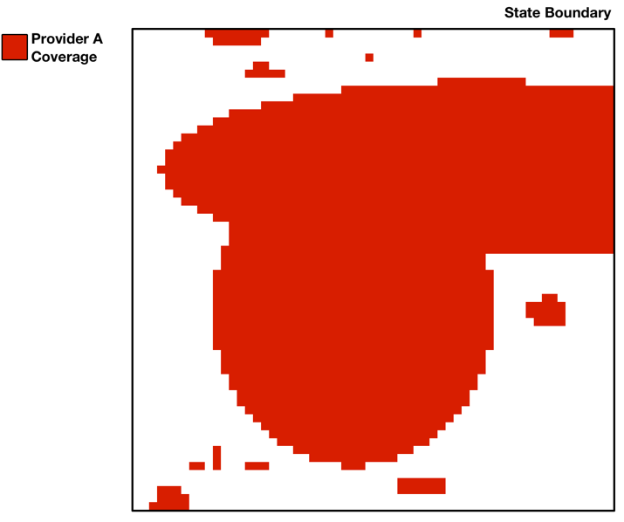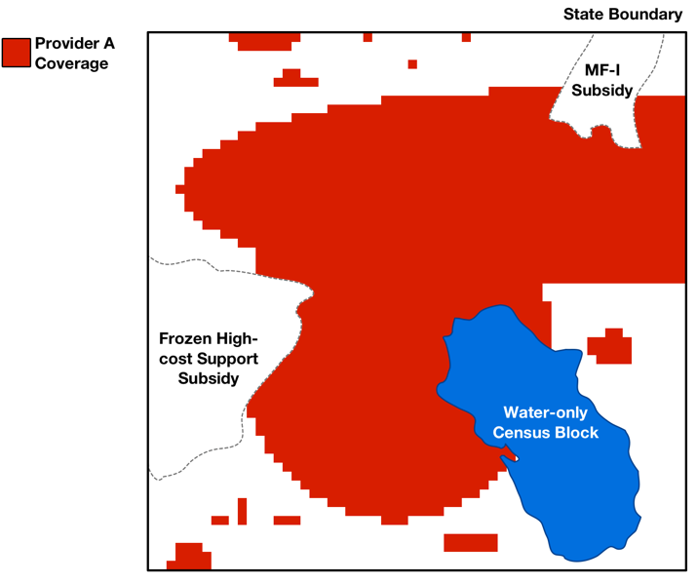
Figure 1: Raw coverage map for a provider separated into a single state (left). Same coverage map with water-only census block, frozen high-cost support and MF-I subsidy areas removed (right).
  - Overlaying the Uniform Grid on Newly Collected Coverage Maps
In order to improve and simplify geospatial data processing, we define a uniform grid with cells of equal area (1 km by 1 km) across the continental United States, and separate uniform grids with cells of equal area (1 km by 1 km) for overseas territories and Hawaii. These grids are defined using an “equal area” map projection so that the same number of speed tests will be required to challenge the grid cell regardless of the location of the grid cell. With equal area projections, cells may appear to have a non-uniform shape when viewed using a different map projection, depending on the grid cell’s location on the earth.
After determining the unsubsidized, non-water coverage area for a provider, we overlay the relevant uniform grid on the provider’s coverage map, dividing it into the predetermined grid cells. As adopted, we ignore coverage in a grid cell if it is less than 50,625 square meters (225 meters by 225 meters), or approximately one quarter of the buffered area of a single speed test, and remove it from the provider’s coverage map. This both allows challengers and challenged parties to focus only on areas with significant coverage during the challenge process and improves the efficiency of processing. Specifically, when challenging areas within a grid cell, the challenger will need to provide speed tests only for providers with coverage greater than 50,625 square meters within those cells. In addition, eliminating minimal coverage areas will avoid having such areas remain ineligible but be separated from larger coverage areas after the challenge process in cases where the surrounding grid cells were successfully challenged.
An example of the overlaid grid and processed, unsubsidized baseline coverage map for a provider is shown in Figure 2.
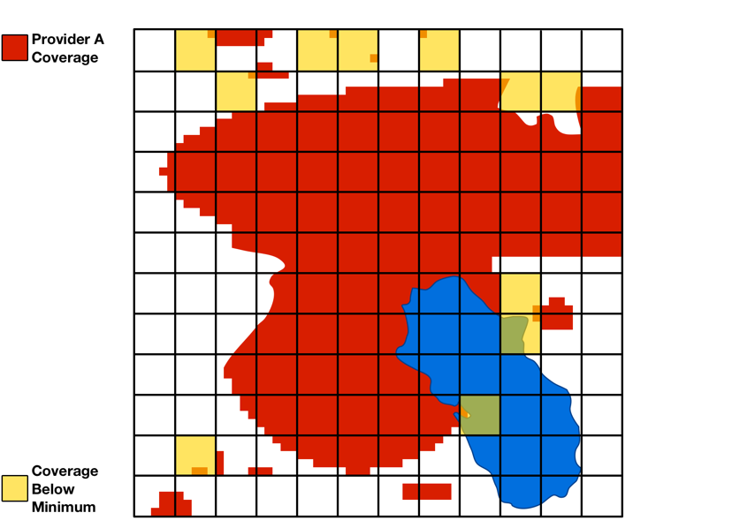
Figure 2: Grid cells applied to coverage map with areas below minimum coverage value highlighted in yellow (left). Coverage in cells below the minimum value is removed, and the area that remains is the final unsubsidized coverage map for the provider (right).
  - Determining Presumptively Eligible Areas
The process described in Sections 2 and 3 above is repeated for each provider in a state until the unsubsidized coverage maps for all providers have been determined. In order to determine the areas presumptively ineligible for MF-II support, we merge the unsubsidized coverage maps for all providers. The resulting area where there is unsubsidized 4G LTE coverage from at least one provider is ineligible and is challengeable during the challenge process. We then determine the presumptively eligible areas for the state (or state equivalent) from the remaining non-water areas within the state. An example set of unsubsidized coverage maps for all providers and resulting map of areas presumptively ineligible for MF-II support is shown in Figure 3.
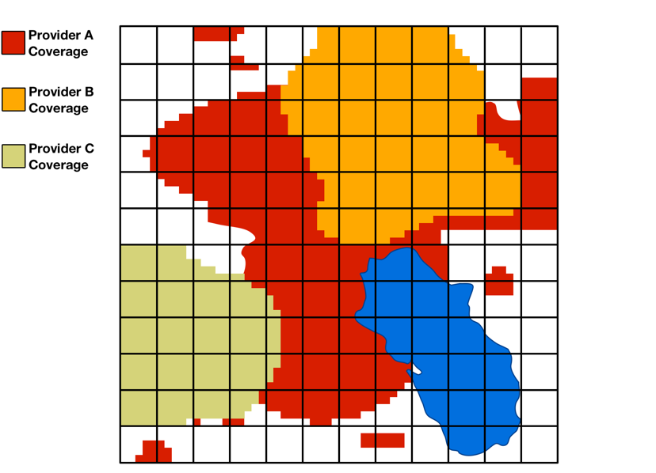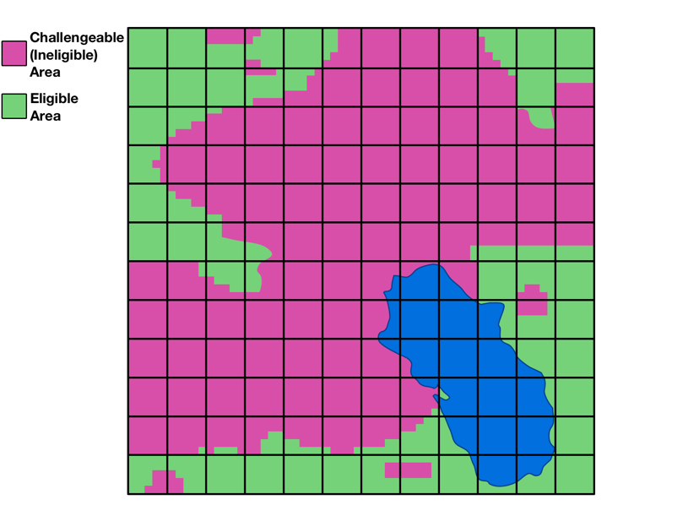
Figure 3: Unsubsidized coverage maps for multiple providers (left). Coverage for multiple providers is combined to determine the challengeable (ineligible) area (right). The area in a state that is neither water-only nor has unsubsidized coverage is eligible.

- Validating Challenge Evidence
  - Introduction
The USAC portal system will validate and process automatically certain data submitted during the challenge process to determine whether challenges should be deemed presumptively successful. The system will also compare competing evidence during the adjudication process. These processes are described below. As adopted, challenges will be evaluated on a grid cell by grid cell basis. Only cells with at least one submitted speed test within the cell will be considered as challenged.
  - Determining the Speed Test Measured Areas
When a challenger submits speed test data, each grid cell within which a counted speed test (i.e., a speed test meeting the standard parameters as part of step two of the validation framework) is located will be evaluated as to whether a challenge for the entire cell is valid. To determine whether a grid cell has been challenged, each speed test point will be buffered to cover a circular area with a radius of 0.25 km (or half of the 0.5 km maximum distance between speed tests parameter). The speed test buffer area can extend into neighboring grid cells and can be used towards establishing the minimum challenge coverage area in the neighboring cells, as long as there is at least one counted speed test in the neighboring grid cell.
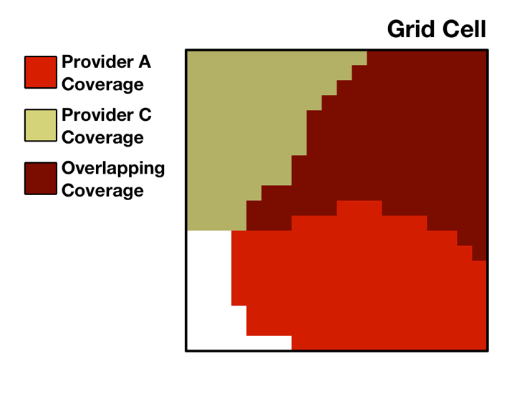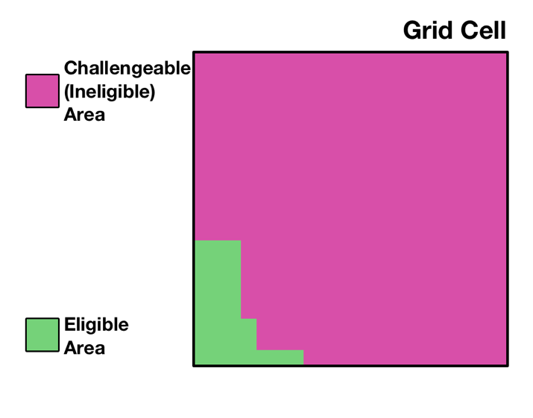
Figure 4: A single grid cell where two providers have unsubsidized service (left). These areas combine to determine the challengeable (ineligible) area and eligible area (right).
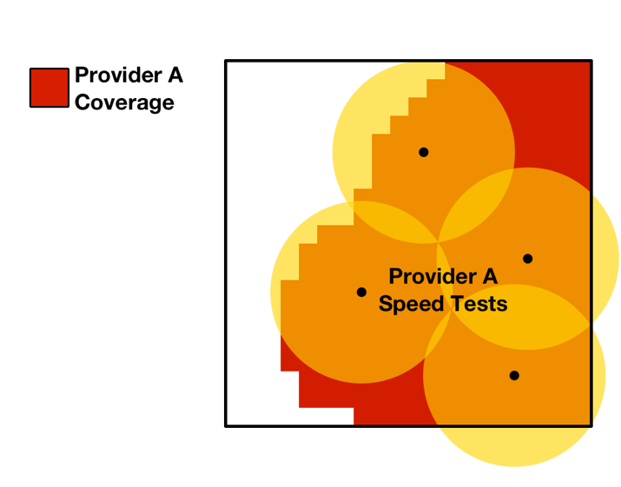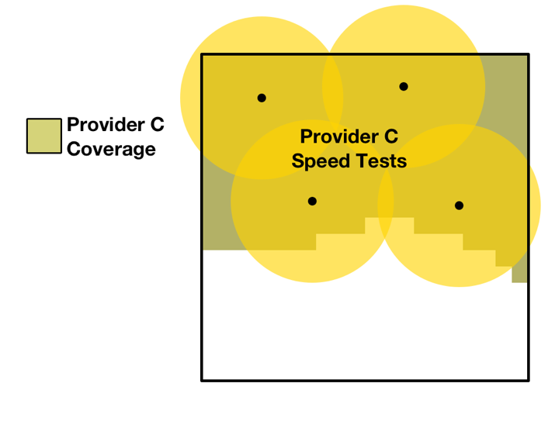
Figure 5: A challenger provides speed tests for each provider within the cell. An area is only considered to have evidence supporting the challenge if the area falls within the speed test buffer for all providers at that point.
  - Calculating the Aggregated Measured Areas
For each grid cell, any coverage by a particular provider that does not overlap the speed test buffer area (based on test(s) of that provider’s network) will be considered to be lacking evidence in support of the challenge (an unmeasured area). The areas without supporting evidence for each provider will be combined to form the total area lacking evidence in support of the challenge (the aggregated unmeasured area).
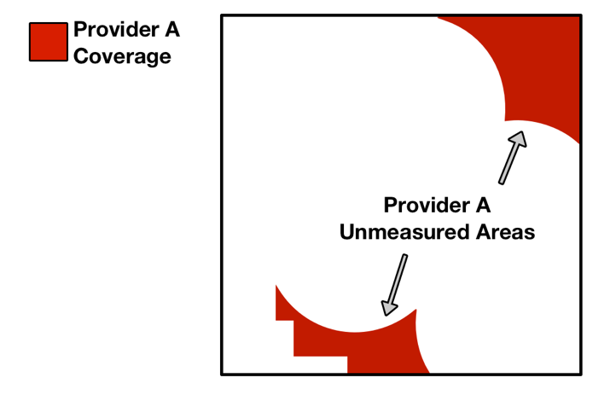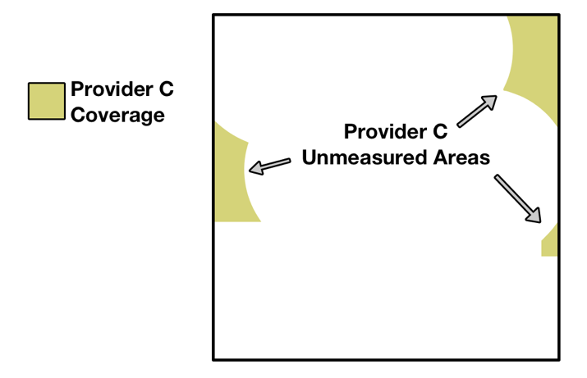
Figure 6: Area served by a provider outside of the speed test buffer areas for the provider are considered to not have evidence in support of the challenge.
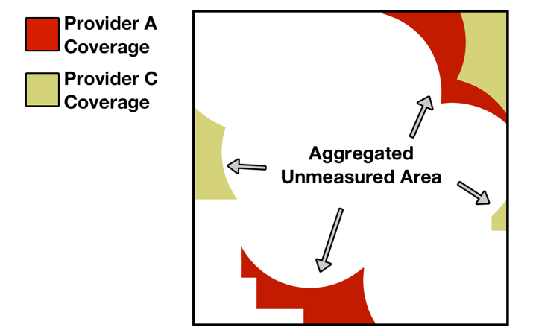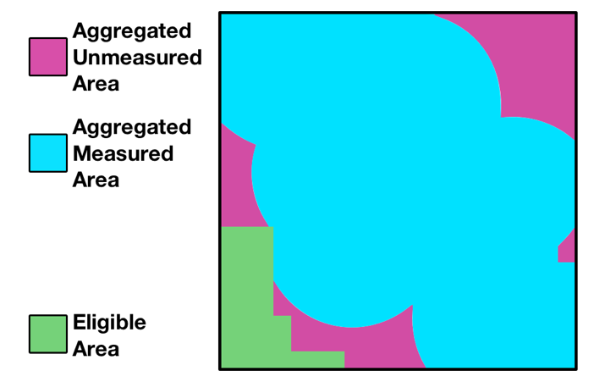
Figure 7: Areas lacking evidence for each provider are combined to determine the total area without evidence in support of the challenge.
If the area with evidence in support of the challenge covers at least 75% of the ineligible area within the cell, then the challenger will have a presumptively successful challenge in the cell (pending any evidence submitted by challenged parties during the response window). All challengeable areas within such a cell will be considered to have a valid challenge.
After all speed tests are submitted, each grid cell containing at least one counted speed test will be evaluated to determine whether the area with evidence in support of the challenge is at least 75% of the challengeable area within the cell. If so, the challenge for that grid cell will be presumptively successful.
After validations are completed, a challenger will be able to certify any of its challenges, regardless of whether or not the challenge is presumptively successful (i.e., has met the 75% coverage requirement). Only challenges for which a challenger has certified by the close of the challenge window will be considered and presented to challenged parties during the response window.
  - Evaluating Evidence Submitted during the Response Window
A challenged party will be able to view the certified challenges to its coverage areas after the system has completed processing challenger data and during the response window. Each challenged provider will have the opportunity to submit speed test data, like evidence submitted by challengers, for areas with certified challenges. In addition, a challenged provider will be able to submit similar measurement data from transmitter monitoring software.
Once challenged parties have submitted their response evidence, any cell with speed test or measurement data submitted by a respondent will be evaluated. As with a challenger’s speed tests, each speed test or transmitter monitoring measurement point submitted by a respondent will be buffered to cover a circular area of radius 0.25 km (the “response area”).
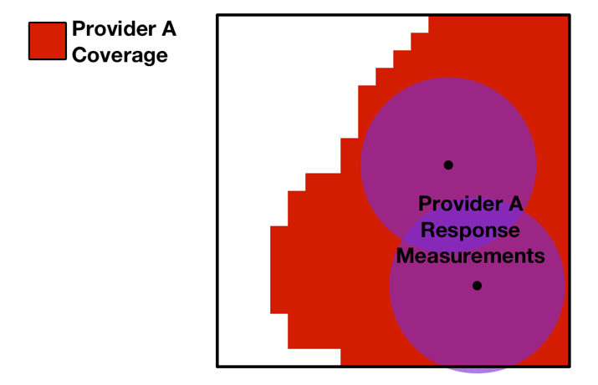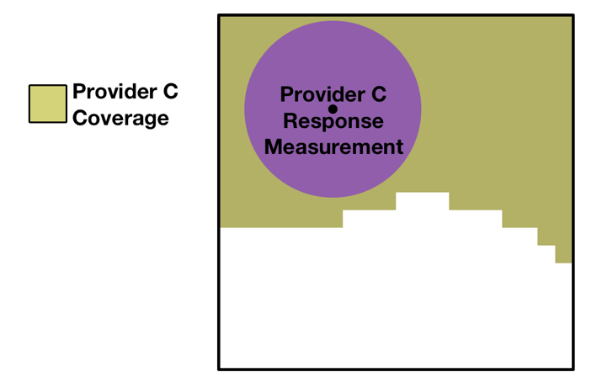
Figure 8: Each provider can provide response speed tests or transmitter monitoring measurements for a grid cell that has a certified challenged.
Any challenged provider coverage areas that overlap the response speed test or measurement buffer area will be considered to have evidence from the challenged provider in response to the challenge.
Similarly, in line with our decision to accept data indicating a challenger’s device was subject to data speed reductions, any cell with speed tests submitted by a challenger using such a device during the period that the device was subject to speed reductions will also be evaluated. Each affected speed test point submitted by a challenger and its speed test buffer area could be considered to have evidence in response to the challenge from the provider.
Once all areas with evidence in response to the challenge within a grid cell are determined for each challenged provider, these response areas will be combined and considered against the challenger’s aggregated measured area in order to recalculate the presumptive adjudication status of each grid cell.
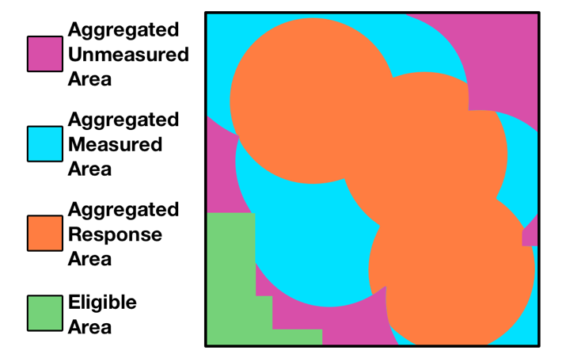
Figure 9: Area that has evidence in response to a challenge is compared against the area with evidence in support of the challenge.
After the processing steps above are complete, a challenged party will be able to certify any of its responses. Only responses that have been certified by the close of the response window will be considered during the adjudication phase.
If the area in the grid cell that has evidence in support of a challenge and for which providers have not certified evidence in response to the challenge is greater than 75% of the total challengeable area for the grid cell, then the challenge in that cell will be considered presumptively successful. If, upon review of the challenge, the challenge is adjudicated in favor of the challenger, the entire challengeable area within the cell will become eligible.
If the area in the grid cell that has evidence in support of a challenge and for which providers have not certified evidence in response to the challenge is less than 75% of the challengeable area for the grid cell, then the challenge in that cell will be considered presumptively unsuccessful. If, upon review of the challenge, the challenge is adjudicated against the challenger, the challengeable area within the grid cell will remain ineligible. In other words, the eligible and ineligible areas in the grid cell will not change from the initial map of presumptively eligible areas.
At the conclusion of the response window, the new eligible and ineligible areas will be determined for each state after the adjudication of certified challenges and responses. Any challengeable areas in a challenged grid cell that are adjudicated as a successful challenge will become eligible in the final map of areas eligible for the MF-II auction. Figure 10 shows an example of the grid cells that have certified challenges to be considered during the adjudication phase highlighted in yellow, and the final map of eligible areas after challenges have been adjudicated.
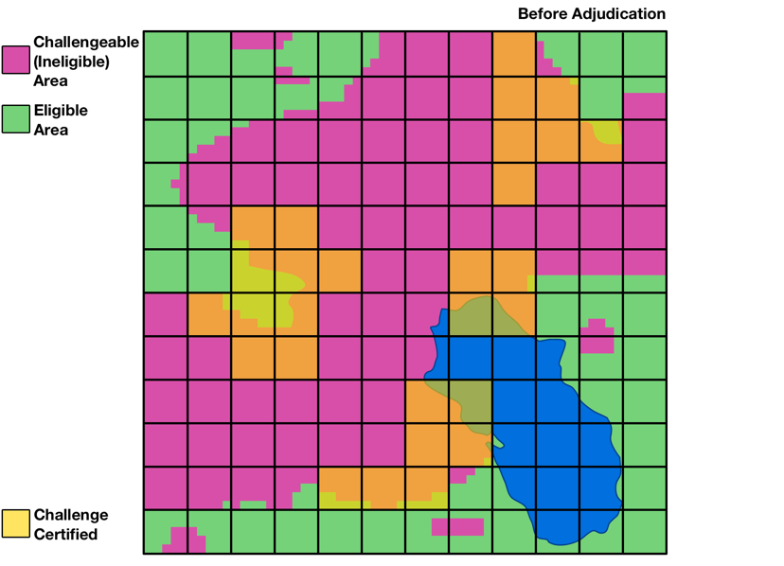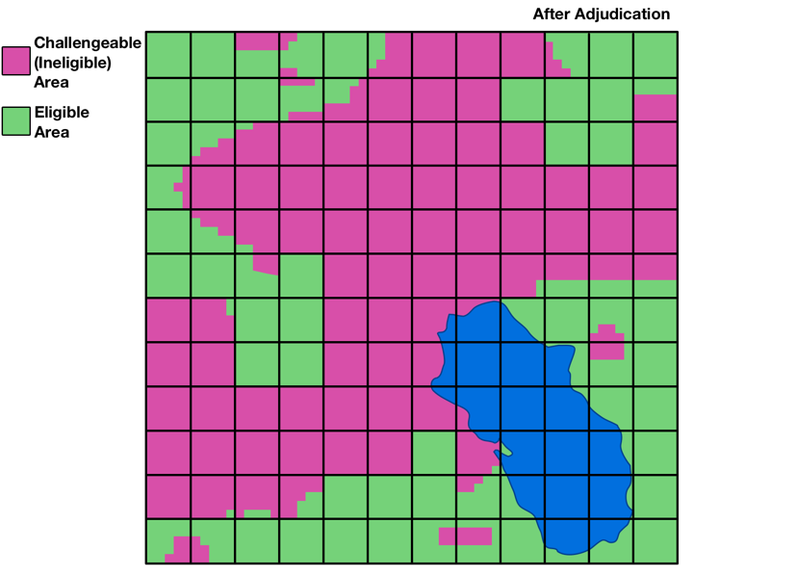
Figure 10: A map of the cells with certified challenges that will be considered during the adjudication phase highlighted in yellow (left). Any challengeable areas in a cell that are adjudicated as a successful challenge will become eligible (right). The eligible areas at the conclusion of this process will be the areas eligible for support in the MF-II auction.

- Applying Subsidy Data
  - Introduction
This appendix describes the methodology by which we compile and map subsidy data from USAC to determine where a provider’s coverage is deemed to be subsidized for purposes of determining areas presumptively eligible for MF-II support. Using up-to-date reports of frozen high-cost support (FHCS) and Mobility Fund Phase I (MF-I) subsidy disbursements provided by USAC, we associate these data with the respective set of unique providers, consolidating any attributable entities that separately file Form 477 mobile broadband coverage data to a common provider name as appropriate. The list of service providers is detailed in Appendix E.
  - USAC Source Data
As adopted by the Commission, we use USAC subsidy data as the source for determining whether or not qualified 4G LTE service is provided on a subsidized basis. USAC tracks disbursements from the various universal service funds to a particular Competitive Eligible Telecommunications Carrier (CETC) in a study area, identified by a Study Area Code (SAC) and Study Area Name (SAN); separately, USAC maintains a list of the wire centers (identified by CLLI code) associated with a study area for which each CETC is eligible to receive support. In addition, USAC tracks disbursements of Mobility Fund Phase I (MF-I) support to winning bidders for items won in the MF-I auction, along with any defaults (e.g., due to insufficient performance).
In order to generate the baseline data as described in Appendix A, USAC has provided:
- a report of FHCS disbursement (reflecting payments in September 2017);
- a report of wire centers for which each CETC is eligible for support (reflecting updates through July 2017); and
- a report of MF-I disbursements to MF-I winning bidders with defaults (reflecting updates through November 2017).
Commission staff maps the relevant data to providers in order to determine: (a) which wire centers for a particular provider are subsidized with FHCS funding; and (b) which census blocks for a particular provider were subsidized with MF-I support. Consistent with the process described in Appendix A, any subsidized wire centers and/or subsidized census blocks are removed from a provider’s coverage map during the baseline data processing step.

- File Specifications and File Formats
  - Introduction
This appendix details the specifications, required data types, and file formats of a) the baseline eligible areas and confidential coverage maps; and b) challenge evidence that will be submitted by challengers or challenged parties during the challenge process.
  - Baseline Data
Description: These files are a set of Zip archives including all constituent baseline Shapefile and Provider Handsets data on a per-state basis. Each baseline data archive includes: (1) Baseline State Boundary data for the state; (2) Baseline Coverage Map data for each provider in the state; (3) Baseline Propagation Map data for each provider disaggregated by spectrum band and bandwidth in the state; (4) Baseline Water-only Area data for the state; (5) Baseline Eligible Area data for the state; (6) Provider Handsets data for the state; and (7) Provider Clutter Factors data for each provider in the state. All Shapefiles except for the Propagation Map data are intersected by the challenge area grid.
File Naming: baseline_<2-digit Zero-padded State FIPS Code>.zip
    - Baseline State Boundaries
Description: These files are a set of Shapefiles that contain the geographic shape data for state boundaries taken from the 2010 US Census TIGER Line shapefiles on a per-state basis. This boundary serves as the complete area that may be included as part of any challenge for a particular state.
File Naming: state_boundary_<2-digit Zero-padded State FIPS Code>.<extension: shp / shx / prj / dbf>
Field | Data Type | Sample | Notes
STATE_FIPS | Integer  {1,2} | 6 | 2010 Census State FIPS code in integer format
GRID_COL | Integer  {1,4} | 5423 | Challenge Area Grid column ID
GRID_ROW | Integer  {1,4} | 179 | Challenge Area Grid row ID
AREA | Decimal  (10,3) | 1000000.000 | Calculated total area of grid cell in square meters to at most 3 decimals
WATER_AREA | Decimal  (10,3) | 14573.580 | Calculated total water-only area of the grid cell in square meters to at most 3 decimals
NONWO_AREA | Decimal  (10,3) | 985426.420 | Calculated total non-water-only area of the grid cell in square meters to at most 3 decimals
ELIG_AREA | Decimal  (10,3) | 268974.313 | Calculated total eligible area of the grid cell in square meters to at most 3 decimals  (equal to elig_area in Baseline Eligible Areas)
CH_AREA | Decimal  (10,3) | 716452.107 | Calculated area of grid cell subject to challenge in square meters to at most 3 decimals  (equal to total area minus water-only area minus eligible area)
    - Baseline Coverage Maps
Description: These files are a set of Shapefiles that contain the geographic shape data for provider coverage maps on a per-state and per-provider basis (merging all propagation maps submitted by providers as part of the new data collection across all spectrum bands).
File Naming: coverage_map_<2-digit Zero-padded State FIPS Code>_<Provider ID>_<Provider Short Name>.<extension: shp / shx / prj / dbf>
Field | Data Type | Sample | Notes
STATE_FIPS | Integer  {1,2} | 6 | 2010 Census State FIPS code in integer format
GRID_COL | Integer  {1,4} | 5423 | Challenge Area Grid column ID
GRID_ROW | Integer  {1,4} | 179 | Challenge Area Grid row ID
AREA | Decimal  (10,3) | 572840.211 | Calculated area of coverage in cell in square meters to at most 3 decimals
PID | Integer  {1,3} | 99 | FCC identifier for the provider
PNAME | String  {1,255} | Acme Wireless | Common name of the provider
    - Baseline Propagation Maps
Description: These files are a set of Shapefiles that contain the geographic shape data for propagation maps submitted through the new data collection on a per-state and per-provider basis.
File Naming: propagation_map_<Provider ID>_<Provider Short Name>_<Spectrum Band or “Agg”>_<Bandwidth (if not combined into one file)>.<extension: shp / shx / prj / dbf>
Field | Data Type | Sample | Notes
STATE_FIPS | Integer  {1,2} | 6 | 2010 Census State FIPS code in integer format
PID | Integer  {1,3} | 99 | FCC identifier for the provider
PNAME | String  {1,255} | Acme Wireless | Common name of the provider
SOFTWARE | String  {1,255} | PlanetDB | Name of software used to generate propagation maps
DATE | Date | 08042017 | As of date when propagation map was generated
SPECTRUM | String  {2,255} | 90,93 | FCC spectrum category or categories (separated by comma when using spectrum aggregation)
BANDWIDTH | Integer  {2} | 10 | Channel bandwidth in MHz
RSRP | Integer  {2,3} | -110 | Minimum predicted RSRP signal strength in dBm
    - Baseline Water-only Areas
Description: These files are a set of Shapefiles that contain the geographic shape data for water-only areas taken from the 2010 US Census TIGER Line shapefiles for Census Blocks on a per-state basis.
File Naming: water_area_<2-digit Zero-padded State FIPS Code>.<extension: shp / shx / prj / dbf>
Field | Data Type | Sample | Notes
STATE_FIPS | Integer  {1,2} | 6 | 2010 Census State FIPS code in integer format
GRID_COL | Integer  {1,4} | 5423 | Challenge Area Grid column ID
GRID_ROW | Integer  {1,4} | 179 | Challenge Area Grid row ID
WATER_AREA | Decimal  (10,3) | 14573.580 | Calculated area of water-only area in cell in square meters to at most 3 decimals
    - Baseline Eligible Areas
Description: These files are a set of Shapefiles that contain the geographic shape data for the FCC’s initial eligible areas determination on a per-state basis.
File Naming: eligible_area_<2-digit Zero-padded State FIPS Code>.<extension: shp / shx / prj / dbf>
Field | Data Type | Sample | Notes
STATE_FIPS | Integer  {1,2} | 6 | 2010 Census State FIPS code in integer format
GRID_COL | Integer  {1,4} | 5423 | Challenge Area Grid column ID
GRID_ROW | Integer  {1,4} | 179 | Challenge Area Grid row ID
ELIG_AREA | Decimal  (10,3) | 268974.313 | Calculated area of coverage in cell in square meters to at most 3 decimals
    - Provider Handsets
Description: This file contains at least 3 records for each wireless provider with its approved handsets.
File Naming: Provider_Handsets.csv
Name | Data Type | Sample | Notes
provider_id | Integer  {1,3} | 99 | FCC internal identifier for the provider
device_id | Integer  {1,3} | 4 | FCC internal identified for the unique device
device_manufacturer | String  {1,255} | Samsung  Apple | Provider approved device manufacturer
device_model | String  {1,255} | G950U  A1865 | Provider approved device model identifier
drive_test_compatibility_flag | Integer  [0-1] | 1 | Boolean flag for whether device is identified as compatible with industry-standard drive test software
    - Provider Clutter Data
Description: This file contains details on the Provider’s clutter data used to generate the Provider Coverage Map data submitted for the new data collection prior to the challenge process.
File Naming: clutter_data_<Provider ID>_<Provider Short Name>.csv
Name | Data Type | Sample | Notes
provider_id | Integer  {1,3} | 99 | FCC identifier for the provider
clutter_data_source | String | Forsk | Source of clutter data
clutter_category_id | Integer | 3 | Unique identifier for each category of clutter
clutter_category_name | String | Evergreen Forest | Unique name for each category of clutter
variable_clutter_loss_min | Decimal | 0.02 | Variable clutter loss as a function of distance in dB per meter (minimum)
variable_clutter_loss_max | Decimal | 0.04 | Variable clutter loss as a function of distance in dB per meter (maximum)
constant_clutter_loss_min | Decimal | 6.0 | Constant clutter loss in dB (minimum)
constant_clutter_loss_max | Decimal | 14.0 | Constant clutter loss in dB (maximum)
  - Challenge Evidence Files
    - Challenger Speed Tests
Description: This file is a CSV that contains entries for each speed test run by the challenger to provide evidence in support of its challenge.
Data Source: This file will be created by the challenger using a template provided by USAC.
Name | Data Type | Sample | Notes
latitude | Decimal | 38.8834816 | Latitude in degrees to at least 5 decimals where test was conducted
longitude | Decimal | -77.0305135 | Longitude in degrees to at least 5 decimals where test was conducted
timestamp | Datetime | 2018-05-07 13:42 -0400 | Date and time of the measurement in ISO 8601 style format:  (YYYY-MM-DD HH:MM ±HH:MM)
signal_strength | Decimal | -102.88 | Measured RSRP signal strength in dBm  (Value may be 0 if coverage is insufficient to conduct test)
download_speed | Decimal | 1.24 | Measured download speed in Mbps  (Value may be 0 if coverage is insufficient to conduct test)
latency | Integer | 204 | Measured latency in milliseconds  (Value may be 0 if coverage is insufficient to conduct test)
provider_id | Integer  {1,3} | 99 | FCC identifier for the provider
provider_name | String  {1,255} | Acme Wireless | Common name of speed measurement network provider
device_id | Integer  {1,3} | 5 | FCC identifier for the measurement device
device_imei | String  {15,16} | 867686022379640 | Device IMEI number
measurement_method_  code | Integer  {1} | 1 | FCC code for method of measurement  (1: non-drive app test, 2: software drive test, 3: hardware drive test)
measurement_app_  name | String  {1,255} | Ookla | Measurement app name  (Value may be null if measurement_method_code is 2 or 3)
measurement_server_  location | String  {2,255} | Virginia - 12.185.7.144 | Measurement server location and/or IP address
    - Respondent Speed Tests and Transmitter Monitoring Software Measurements
Description: This file is a CSV that contains entries for each speed test run by the respondent or for measurements collected from transmitter monitoring software to provide evidence in support of its response to a challenge.
Data Source: This file will be created by the respondent using a template provided by USAC.
Name | Data Type | Sample | Notes
latitude | Decimal | 38.8834816 | Latitude in degrees to at least 5 decimals where test was conducted
longitude | Decimal | -77.0305135 | Longitude in degrees to at least 5 decimals where test was conducted
timestamp | Datetime | 2018-09-03 18:20 -0400 | Date and time of the measurement in ISO 8601 style format:  (YYYY-MM-DD HH:MM ±HH:MM)
signal_strength | Decimal | -99.10 | Measured RSRP signal strength in dBm  (Value may be 0 if coverage is insufficient to conduct test)
download_speed | Decimal | 5.89 | Measured download speed in Mbps  (Value may be 0 if coverage is insufficient to conduct test)
latency | Integer | 176 | Measured latency in milliseconds  (Value may be 0 if coverage is insufficient to conduct test)
device_id | Integer  {1,3} | 5 | FCC identifier for the measurement device  (Value may be null if measurement_method_code is 4)
device_imei | String  {15,16} | 867686022379640 | Device IMEI number  (Value may be null if measurement_method_code is 4)
measurement_method_code | Integer  {1} | 1 | FCC code for method of measurement  (1: non-drive app test, 2: software drive test, 3: hardware drive test, 4: transmitter monitoring report)
measurement_app_  name | String  {1,255} | Ookla | Measurement app name  (Value may be null if measurement_method_code is 2, 3, or 4)
measurement_server_  location | String  {2,255} | Virginia - 12.185.7.144 | Measurement server location and/or IP address  (Value may be null if measurement_method_code is 4)
    - Respondent Data Speed Reduction Report
Description: This file is a CSV that contains entries for each device used by a challenger which had its data speeds reduced by the respondent’s network.
Data Source: This file will be created by the respondent using a template provided by USAC.
Name | Data Type | Sample | Notes
device_imei | String  {15,16} | 867686022379640 | Device IMEI number
reduction_start_timestamp | Datetime | 2018-04-03 09:10 -0500 | Date and time that speed reduction started in ISO 8601 style format:  (YYYY-MM-DD HH:MM ±HH:MM)
reduction_end_timestamp | Datetime | 2018-04-03 09:21 -0500 | Date and time that speed reduction ended in ISO 8601 style format:  (YYYY-MM-DD HH:MM ±HH:MM)
device_speed | Decimal | 1.0 | Download data speed the device was reduced to in Mbps.  (Value may be null if variable or speed is not reduced to a fixed value)

- Relational Mapping of Form 477 Filers to Providers
This page was intentionally inserted as a placeholder for Appendix E, which is available as a separate file.

- Challenge Data Certification Form
This page was intentionally inserted as a placeholder for Appendix F, which is available as a separate file.

Connect America Fund; Universal Service Reform – Mobility Fund, Order on Reconsideration and Second Report and Order, 32 FCC Rcd 6282, 6282, 6296-314, paras. 1, 27-64 (2017) (MF-II Challenge Process Order).
For the purposes of MF-II, the Commission defined “qualified 4G LTE service” as mobile wireless service provided using 4G LTE technology with download speeds of at least 5 Mbps at the cell edge with 80 percent probability and a 30 percent cell loading factor. See Connect America Fund; Universal Service Reform – Mobility Fund, Report and Order and Further Notice of Proposed Rulemaking, 32 FCC Rcd 2152, 2173, para. 51 (2017) (MF-II Order or MF-II FNPRM); MF-II Challenge Process Order, 32 FCC Rcd at 6296, 6298, paras. 28, 34.
See MF-II Challenge Process Order, 32 FCC Rcd at 6296, 6303, paras. 28, 41 n.112; Instructions for Filing 4G LTE Coverage Data to Determine Areas Presumptively Eligible for Mobility Fund II Support, Public Notice, 32 FCC Rcd 7023, 7023-28 (WCB/WTB 2017) (4G LTE Data Collection Public Notice); Responses to the Mobility Fund Phase II 4G LTE Data Collection Are Due by January 4, 2018, Public Notice, 32 FCC Rcd 7431, 7431 (WCB/WTB 2017) (4G LTE Data Collection Deadline Public Notice). Due to the destruction caused by Hurricanes Irma and Maria, the Bureaus waived the deadline for mobile wireless providers in Puerto Rico and the U.S. Virgin Islands to submit information regarding 4G LTE coverage. Connect America Fund; Universal Service Reform – Mobility Fund, Order, 32 FCC Rcd 10167, 10169, para. 5 (WCB/WTB 2017) (MF-II PR-USVI Waiver Order).
MF-II Challenge Process Order, 32 FCC Rcd at 6287-88, 6295-96, paras. 10-11, 25.
Id. at 6282-83, 6296-98, 6303-14, paras. 1, 29-31, 42-64.
Id. at 6297-98, 6302-04, 6308-10, 6313, paras. 29 n.84, 33, 39 n.109, 41 n.112, 42 n.115, 50 n.148, 51, 52 n.161, 53, 62.
Comment Sought on Mobility Fund Phase II Challenge Process Procedures and Technical Implementation, Public Notice, 32 FCC Rcd 7596, 7597-99, paras. 3-5 (WCB/WTB 2017) (MF-II Challenge Process Comment Public Notice).
Id. at 7599-607, paras. 6-30.
We encourage prospective challenge process participants to review carefully the Commission’s orders and public notices relating to the MF-II auction and challenge process. Copies of MF-II- and challenge process-related Commission documents, including public notices, can be retrieved from the Commission’s MF-II website at https://www.fcc.gov/mobility-fund-phase-2. Additionally, documents are available for public inspection and copying between 8:00 AM and 4:30 PM Eastern Time (ET) Monday through Thursday or 8:00 AM to 11:30 AM ET Fridays at the FCC Reference Information Center, 445 12th Street, S.W., Room CY-A257, Washington, DC 20554. These documents include, but are not limited to: Connect America Fund et al., Report and Order and Further Notice of Proposed Rulemaking, 26 FCC Rcd 17663 (2011) (USF/ICC Transformation Order or USF/ICC Transformation FNPRM); Connect America Fund et al., Report and Order, Declaratory Ruling, Order, Memorandum Opinion and Order, Seventh Order on Reconsideration, and Further Notice of Proposed Rulemaking, 29 FCC Rcd 7051 (2014) (2014 CAF Order or 2014 CAF FNPRM); MF-II Order, 32 FCC Rcd 2152; MF-II Challenge Process Order, 32 FCC Rcd 6282; MF-II Challenge Process Comment Public Notice, 32 FCC Rcd 7596.
MF-II Challenge Process Comment Public Notice, 32 FCC Rcd at 7598-99, paras. 4-5.
Id. at 7597-98, para. 3.
See MF-II Order, 32 FCC Rcd at 2168, para. 39 (“[W]e find that all areas lacking unsubsidized, qualifying 4G LTE service will be eligible for the auction.”).
See MF-II Challenge Process Order, 32 FCC Rcd at 6287-88, para. 10 (“When combined with the high-cost subsidy disbursement data available from USAC, the new data will form the basis of the map of areas presumptively eligible for MF-II support.”).
The term “water-only area” is defined as a water-only census block (that is, a census block for which the entire area is categorized by the U.S. Census Bureau as water). Removal of these areas is consistent with past Commission practice. See, e.g., FCC, Wireless Telecommunications Bureau, Working Toward Mobility Fund II: Mobile Broadband Coverage Data and Analysis at 4, para. 9 (2016), https://apps.fcc.gov/edocs_public/attachmatch/DOC-341539A1.pdf (establishing as the basis of analysis the use of 2010 U.S. Census Bureau data excluding all water-only blocks); MF-II Order, 32 FCC Rcd at 2156, 2160, paras. 10, 23 (relying upon the staff analysis to determine the phase-down amount, equal to one year’s amount of subsidy that “is being provided to census blocks fully covered with unsubsidized 4G LTE”); see also Implementation of Section 6002(b) of the Omnibus Budget Reconciliation Act of 1993; Annual Report and Analysis of Competitive Market Conditions With Respect to Mobile Wireless, Including Commercial Mobile Services, Twentieth Report, 32 FCC Rcd 8968, 9025, para. 80 (2017) (excluding all water-only census blocks).
MF-II Challenge Process Comment Public Notice, 32 FCC Rcd at 7598-99, para. 4. The area threshold—for determining whether the coverage in a grid cell is included in the map of unsubsidized coverage (i.e., ineligible areas) for a provider—would equal 225 meters by 225 meters, or 50,625 square meters. This is approximately one quarter of the buffered area of a single speed test, which is the minimum buffered area in a single grid cell that would be covered if a speed test were taken precisely at the corner point of that cell.
Id. at 7612, Appx A., Section 3.
Id. This approach also “will avoid having such areas remain ineligible but be separated from larger coverage areas after the challenge process in cases where the surrounding grid cells were successfully challenged.” Id.
Since the Bureaus waived the deadline for mobile wireless providers in Puerto Rico and the U.S. Virgin Islands to submit information regarding 4G LTE coverage, the map of presumptively eligible areas does not include Puerto Rico and the U.S. Virgin Islands. See MF-II PR-USVI Waiver Order, 32 FCC Rcd at 10169, para. 5.
To ensure that the generated eligible areas exclude water-only areas, such areas are removed both in step 2 and in step 7 of the data processing. Specifically, when the system determines the eligible areas in step 5 by inverting the ineligible areas, water-only areas are included as part of the state boundary and are removed again in step 7 to exclude these areas.
See generally MF-II Challenge Process Comment Public Notice, Appendices A and B.
See discussion infra Appx. A, Section 3.
MF-II Challenge Process Comment Public Notice, 32 FCC Rcd at 7598-99, para. 4 (“The use of a uniform grid will allow the USAC portal to identify challenged areas automatically based on the grid cell in which a submitted speed test measurement falls, will provide a straightforward way of implementing the de minimis challenge size adopted by the Commission, and will simplify the adjudication process. The uniform grid also will relieve challengers of the burden of creating maps of the areas they wish to challenge, thereby furthering the Commission’s goal of encouraging robust participation in the challenge process to ensure that the determination of eligibility is as accurate as possible.” (footnotes omitted)). While we received comments concerning the use of the grid for the purpose of validating challenger speed data, commenters did not directly address the use of the grid with respect to analyzing the 4G LTE coverage data to generate the initial areas map. As a result, comments pertaining to the grid are addressed below. See Sections III.B.3.b (Substantial Coverage of the Challenged Area), III.B.4 (Validation of Challenges).
MF-II Challenge Process Comment Public Notice, 32 FCC Rcd at 7599, para. 5 n.20 (finding that it is in the public interest to release publicly information about presumptively eligible areas even though some provider-specific information may be implicitly revealed); see also MF-II Order, 32 FCC Rcd at 2179, para. 63 (stating that “[t]he Wireless Telecommunications Bureau staff . . . will publish a preliminary list of eligible areas as part of the pre-auction process”).
See MF-II Challenge Process Order, 32 FCC Rcd at 6297, para. 29 n.82 (explaining that “[a]fter agreeing to treat the data as confidential, challengers will be able to access via the USAC portal (a) the underlying provider-specific coverage maps submitted as part of the new data collection; (b) the list of pre-approved provider-specified handsets with which to conduct speed measurements; and (c) any other propagation model details collected as part of the new data collection.”).
If a consumer, organization, or business believes that its interests cannot be met through its state, local, or Tribal government entity and wishes to participate in the process as a challenger, the individual or entity may file a petition with the Commission requesting a waiver for good cause shown. Id. at 6304, para. 43 n.119 (citing 47 CFR § 1.3); see also Mobility Fund Phase II Challenge Process Handsets and Access Procedures for the Challenge Process Portal, Public Notice, 32 FCC Rcd 10372, 10376, para. 10 & n.33 (WCB/WTB 2017) (MF-II Handset and USAC Portal Access Public Notice).
MF-II Challenge Process Order, 32 FCC Rcd at 6303-05, paras. 42-43, 43 n.119, 45. Areas determined to be presumptively eligible for MF-II support will not be challengeable in this process. Id. at 6305, para. 45.
Id. at 6296-97, para. 29. As discussed below, we are providing 30 days’ notice of the opening of the challenge window. See discussion infra Section III.B.1 (Timing for Availability of Initial Coverage Data and Challenge Window); see also Mobility Fund Phase II Initial Eligible Areas Map Available; Challenge Window Will Open March 28, 2018, Public Notice, DA 18-187, at 1 (WCB/WTB Feb. 27, 2018) (MF-II Initial Eligible Areas Map Public Notice).
MF-II Challenge Process Order, 32 FCC Rcd at 6296-97, para. 29.
See MF-II Challenge Process Comment Public Notice, 32 FCC Rcd at 7598, 7603-04, 7614, paras. 4, 18-22, Appx. B. As explained below, for each grid cell containing a speed test measurement submitted by a challenger, the system would consider the challengeable portion of the grid cell (i.e., the ineligible area, or any area that is neither eligible nor water-only) to constitute the challenged area. See discussion infra Section III.B.4 (Validation of Challenges).
MF-II Challenge Process Order, 32 FCC Rcd at 6297, para. 30; see also MF-II Challenge Process Comment Public Notice, 32 FCC Rcd at 7615, Appx. B.
MF-II Challenge Process Order, 32 FCC Rcd at 6311, para. 59. We will provide challenged parties 30 days to review challenges and supporting data in the USAC portal prior to opening the response window. See discussion infra Section III.C.1 (Timing for Availability of Challenge Data and Response Window).
MF-II Challenge Process Order, 32 FCC Rcd at 6311, para. 59.
Id. at 6297, para. 30; see also id. at 6312-13, paras. 60-61 (discussing the types of evidence that a challenged party may submit in response to a challenge).
Id. at 6313-14, paras. 63-64. Pursuant to the challenge process framework adopted by the Commission, a challenger will not have an opportunity to submit additional data in response to a challenged party’s submission. Id. at 6297, para. 30 (“Once the challenge window closes, however, the challenger will have no further opportunity to correct existing, or provide additional, data in support of its challenge.”).
MF-II Challenge Process Comment Public Notice, 32 FCC Rcd at 7606, para. 28; see also MF-II Initial Eligible Areas Map Public Notice at 1. Providers were required to file new, one-time 4G LTE coverage data by January 4, 2018. 4G LTE Data Collection Deadline Public Notice, 32 FCC Rcd at 7431.
See MF-II Challenge Process Comment Public Notice, 32 FCC Rcd at 7606, para. 28 n.69; MF-II Initial Eligible Areas Map Public Notice at 1.
See MF-II Challenge Process Comment Public Notice, 32 FCC Rcd at 7606, para. 28; MF-II Initial Eligible Areas Map Public Notice at 1.
See MF-II Challenge Process Comment Public Notice, 32 FCC Rcd at 7606, para. 28; MF-II Initial Eligible Areas Map Public Notice at 1 & n.4.
MF-II Challenge Process Order, 32 FCC Rcd at 6296-97, para. 29; MF-II Challenge Process Comment Public Notice, 32 FCC Rcd at 7606, para. 28; see also MF-II Initial Eligible Areas Map Public Notice at 1.
MF-II Challenge Process Order, 32 FCC Rcd at 6297, para. 30; see also id. at 6296-97, para. 29; MF-II Challenge Process Comment Public Notice, 32 FCC Rcd at 7615, Appx. B. This means that only challenges certified by 12:00 AM (midnight) on the day the window closes will proceed. See MF-II Initial Eligible Areas Map Public Notice at 1.
See MF-II Challenge Process Order, 32 FCC Rcd at 6311, para. 57 (“Challenged areas that meet the validations . . . will proceed once certified by the challenger.”); MF-II Challenge Process Comment Public Notice, 32 FCC Rcd at 7615, Appx. B (“After validations are completed, a challenger would be able to certify any of its challenges . . . .”); see also discussion infra Sections III.B.4 (Validation of Challenges), III.B.5 (Certifying a Challenge).
MF-II Challenge Process Comment Public Notice, 32 FCC Rcd at 7606, para. 28. CCA and RWA argue that it may not be possible for smaller carriers to file in advance of the deadline and suggest that the Bureaus postpone opening the response window if extra time is needed for data processing. See CCA Comments at 3; RWA Reply at 4. We conclude that the Commission’s adoption of a 150-day challenge window—which is 30 days longer than the 120-day window proposed by both commenters—provides ample time for a smaller carrier to submit and certify a challenge in advance of the deadline. See MF-II Challenge Process Order, 32 FCC Rcd at 6296-97, para. 29 n.81. In addition, postponing the opening of the response window would not resolve commenters’ alleged need for additional data processing time because the automated data validation processing will occur before a challenger certifies and submits a challenge, i.e., before the close of the challenge window. See infra note 149. To the extent that CCA and RWA effectively seek reconsideration of the 150-day challenge window, the deadline for filing a petition for reconsideration of the MF-II Challenge Process Order passed on October 10, 2017. See 47 CFR § 1.429(d) (requiring that petitions for reconsideration “be filed within 30 days from the date of public notice of such action”); 82 Fed. Reg. 42473 (Sept. 8, 2017). No party filed a petition for reconsideration of the MF-II Challenge Process Order. Moreover, no party filed a comment or reply comment in response to the MF-II Challenge Process Comment Public Notice before that deadline. See WC Docket 10-90; WT Docket 10-208. Therefore, we will not entertain any proposals that amount to untimely requests for reconsideration by commenters.
MF-II Initial Eligible Areas Map Public Notice at 1.
See U.S. Cellular Reply at 14 (requesting 30 days’ advance notice of the USAC portal opening to “enable prospective challengers to better utilize the 150-window [sic] to undertake and complete the work necessary to prepare and submit challenges”); RWA Comments at 2-3 (arguing that if the USAC portal is not available immediately after the release of the initial eligibility map, the Bureaus should provide at least 30 days’ notice ahead of the USAC portal opening).
See NTCA Comments at 4-6; RWA Comments at 3 n.7 (cautioning the Bureaus that inclement winter weather in areas of difficult terrain and high elevation could negatively impact some members’ ability to complete drive tests and meet the challenge submission deadline); RWA Reply at 3 (explaining that many wilderness areas frequently visited during the summer are difficult and dangerous, if not impossible, to reach during the winter); U.S. Cellular Reply at 15; Letter from David LaFuria, Counsel for U.S. Cellular, to Marlene H. Dortch, Secretary, FCC, WT Docket No. 10-208 et al., at 1 (filed Jan. 8, 2018) (“Some of the lower level secondary roads eligible for support are unpaved, and in many states seasonal road closures significantly limit travel and reduce testing efficiency.”) (U.S. Cellular Jan. 8 Ex Parte).
See MF-II Challenge Process Order, 32 FCC Rcd at 6296-97, para. 29 n.81 (“Out of an abundance of caution, we find that a 150-day challenge window is appropriate to allow challengers to complete all the tasks necessary to submit challenges, such as reviewing the map of presumptively eligible areas, identifying areas to challenge, conducting speed tests, analyzing test data, and preparing the submission.”).
MF-II Initial Eligible Areas Map Public Notice at 1.
See Verizon Reply at 5-6 (noting that “[e]ven if the challenge window opens on the earliest possible date, at the beginning of February, the challenge window will include the entire spring and extend into July, allowing more than enough time for testing even in northern areas”).
See NTCA Comments at 5 (arguing that speed data should accurately represent service availability “when the foliage is intact”); RWA Reply at 3 (arguing that lack of foliage in winter could lead to overstatement of service availability in many rural areas). We believe that our timeline for the challenge process, in which the entire challenge window will fall during spring and summer months, adequately addresses commenters’ concerns about lack of foliage. See MF-II Initial Eligible Areas Map Public Notice at 1.
But see NTCA Comments at 5 (urging the Commission to ensure that the challenge window is open during the entirety of the summer months); accord RWA Reply at 3; U.S. Cellular Reply at 15; U.S. Cellular Jan. 8 Ex Parte at 1 (requesting that the challenge window open no sooner than May 1, 2018); Letter from Caressa D. Bennet, General Counsel, RWA et al., to Marlene H. Dortch, Secretary, FCC, WT Docket No. 10-208 et al., at 3 (filed Dec. 8, 2017) (RWA Ex Parte). NTCA’s proposal would cause an unwarranted delay in the challenge process. See Verizon Reply at 6 (“The Bureaus should reject NTCA’s proposal because further delay would be inconsistent with the Commission’s ‘policy goal of proceeding expeditiously to an MF-II auction.’” (citation omitted)).
MF-II Challenge Process Order, 32 FCC Rcd at 6296-97, para. 29 n.84. The Commission explained that the use of an automated process, by way of the USAC portal, “is the most efficient way to evaluate the data submitted by a challenger because it ensures that the objective validation criteria are applied consistently across every challenge.” Id. at 6310, para. 53.
See MF-II Handset and USAC Portal Access Public Notice, 32 FCC Rcd at 10375-76, paras. 7-10; see also Rural Broadband Auctions Task Force Announces Availability of Mobility Fund Phase II Challenge Process Portal Access Request Form, Public Notice, DA 18-142 at 1 (WCB/WTB Feb. 14, 2018) (MF-II Challenge Portal Access Request Form Public Notice). More instructions regarding accessing the USAC portal can be found in a forthcoming USAC challenge process portal user guide.
MF-II Challenge Process Comment Public Notice, 32 FCC Rcd at 7606, para. 26; see also MF-II Challenge Process Order, 32 FCC Rcd at 7606, para. 29 n.84.
MF-II Challenge Process Comment Public Notice, 32 FCC Rcd at 7606, para. 26. The full list of geographic data that will be accessible to a challenger is set forth in Appendix D.
MF-II Challenge Process Comment Public Notice, 32 FCC Rcd at 7606, para. 26.
MF-II Challenge Process Order, 32 FCC Rcd at 6297, para. 29 n.82; MF-II Challenge Process Comment Public Notice, 32 FCC Rcd at 7606, para. 26; MF-II Handset and USAC Portal Access Public Notice, 32 FCC Rcd at 10372-75, paras. 2-6.
MF-II Challenge Process Order, 32 FCC Rcd at 6297, para. 29 n.82; MF-II Challenge Process Comment Public Notice, 32 FCC Rcd at 7606, para. 26 n.66. Specifically, a challenger will need to agree electronically in the USAC portal to treat the provider-specific data as confidential in order to download the data.
MF-II Challenge Process Order, 32 FCC Rcd at 6306, 6308, paras. 47, 50. For purposes of the MF-II challenge process, “outdoor” means not inside of a building.
Id. at 6307, para. 49. Since the system will consider the challengeable portion of a 1 km by 1 km grid cell to constitute the challenged area, speed test data must substantially cover the grid cell. Id. at 6309, para. 51.
Id. at 6309, para. 51.
See discussion infra Section III.B.5 (Certifying a Challenge).
MF-II Challenge Process Order, 32 FCC Rcd at 6308, para. 49 & n.146 (“For challengers that are governmental entities and do not have a qualified engineer available to certify, we will allow certification by a governmental official authorized to act on behalf of the organization and with actual knowledge of the accuracy of the underlying data.”).
Id. at 6306, 6308, paras. 47, 49-50.
Id. at 6308-09, para. 50. If there are multiple unsubsidized service providers in the challenged area, the challenger must purchase service plans that are appropriate for each provider. Id.
See id. at 6308, para. 50 n.150. Some commenters request that we require a challenger to conduct tests using handsets that are not subject to reduced speeds. See, e.g., Letter from Rebecca Murphy Thompson, EVP & General Counsel, CCA, to Marlene H. Dortch, Secretary, FCC, WC Docket No. 10-90 et al., at 3 (filed Feb. 7, 2018) (“The Commission should therefore consider whether devices purchased for the challenge process should be exempt from rate-based throttling practices.”) (CCA Ex Parte); NTCA Comments at 3 (urging the Commission to “require that handsets identified as appropriate for testing not be subject to any network management practices that could or would undermine the value of the data they are used to collect”); Verizon Comments at 5 (arguing that “the Commission should require challengers either to (1) conduct all testing using service plans that do not include specific speed reduction terms; or (2) conduct all testing with devices that are not subject to the plan’s specific speed reduction terms”); U.S. Cellular Reply at 8-9 (agreeing with NTCA’s proposal); RWA Comments at 7 (suggesting that the Commission “require the challenged carrier to remove the data cap on the phone(s) in question to avoid throttling during the challenge period”). We interpret these proposals as requests that handsets used for testing must not be subject to reduced speeds under the terms of the applicable service plan(s) purchased to conduct speed tests, as opposed to requests that the handsets be technically incapable of being subject to reduced speeds. We agree with CTIA that these proposals are inconsistent with the Commission’s goal that speed tests accurately reflect the consumer experience. Letter from Matthew Gerst, Assistant Vice President – Regulatory Affairs, CTIA et al., to Marlene H. Dortch, Secretary, FCC, WC Docket No. 10-90 et al., at 5 (filed Jan. 12, 2018) (“CTIA is not aware that any wireless carrier currently offers a service plan that allows subscribers to disable routine data management policies. To achieve its express purpose that challengers’ tests ‘reflect consumer experience in the challenged area,’ the Commission cannot grant RWA’s request and force carriers to create new service plans, exclusively for the purpose of administering the MF II challenge process.”) (CTIA Ex Parte). As the Commission has already determined that a challenger must use an appropriate service plan that allows for speed tests of full network performance, MF-II Challenge Process Order, 32 FCC Rcd at 6308-09, para. 50 n.150, we decline to impose any additional requirements or restrictions on the types of plans that a challenger must purchase and use to conduct speed tests. Moreover, since no petitions for reconsideration were filed regarding the Commission’s decision concerning service plans, the Bureaus are not free to revisit this determination here.
See RWA Comments at 7 (arguing that the Commission’s proposal to accept speed reduction data from challenged parties will require a challenger to “constantly monitor the data usage to ensure that they do not go over the data plan limits”). The record in this proceeding lacks convincing evidence that it will be unduly burdensome for a challenger to monitor its data usage under its data plan(s).
See discussion infra Section III.C.3.c (Additional Requirements for Speed Reduction Data); see also Verizon Comments at 5 (arguing that requiring a challenger to submit speed tests conducted only before the usage threshold is met “would improve the reliability of the submitted speed tests and thus reduce the number of cases in which speed reduction reports are needed”).
CCA provides data plan cost estimates based upon hypothetically testing two very large areas. CCA Ex Parte at 3 (testing 35,000 square miles covering an entire regional providers’ s footprint; testing half of all of the roads in a large Midwest state). We have considered these estimates and find that we have appropriately balanced the burdens associated with challengers choosing and using appropriate service plans for testing against the Commission’s interest in administering a challenge process that will most efficiently allocate $4.5B in MF-II support. The challenge process is optional and is based upon the most standardized and granular LTE coverage collection the Commission has ever conducted. We believe that the collection of new LTE coverage data should reduce the need and scope of potential challenges.
See RWA Comments at 7 n.19 (“Testing four points per kilometer, a challenger will be able to perform tests on 520 square kilometers with a 20-gigabit plan from a service provider.”); Verizon Reply at 5; CTIA Ex Parte at 3 (stating that “there is nothing in the record suggesting that challengers frequently will need substantial amounts of data during the challenge period”). We are not requiring a challenger to purchase multiple service plans from a challenged carrier; it is a challenger’s decision what type of service plan and how many plans to purchase in order to collect speed test data that support a challenge. See CTIA Ex Parte at 3 (“Given wireless providers’ existing disclosures about data management practices, prospective challengers should have sufficient information to choose . . . the type of plans selected for testing.”).
MF-II Challenge Process Order, 32 FCC Rcd at 6306, 6309, paras. 47, 51; see also MF-II Challenge Process Comment Public Notice, 32 FCC Rcd at 7601, para. 11.
MF-II Challenge Process Order, 32 FCC Rcd at 6309, para. 51.
See MF-II Challenge Process Comment Public Notice, 32 FCC Rcd at 7601, para. 11 n.36 (citing MF-II Challenge Process Order, 32 FCC Rcd at 6309, para. 55).
See discussion infra Section III.B.4 (Validation of Challenges).
MF-II Challenge Process Order, 32 FCC Rcd at 6310, para. 55 n.162. Since we are adopting a maximum distance between speed test points of one-half of one kilometer, the buffer radius will be one-quarter of one kilometer.
See discussion infra Section III.B.4 (Validation of Challenges); MF-II Challenge Process Comment Public Notice, 32 FCC Rcd at 7601, para. 11 n.36.
MF-II Challenge Process Comment Public Notice, 32 FCC Rcd at 7601, para. 11 n.36 (citing MF-II Challenge Process Order, 32 FCC Rcd at 6305-06, para. 46); see also Appx. A; 47 CFR § 1.19 (“Use of metric units required”).
MF-II Challenge Process Order, 32 FCC Rcd at 6309, para. 51. The Commission directed that the maximum distance between speed points would be no greater than one mile. Id.
MF-II Challenge Process Comment Public Notice, 32 FCC Rcd at 7601, para. 11.
Id.
Id. The requirement that measurements be taken no more than one-half of one kilometer apart from one another serves as an upper bound (i.e., maximum distance apart), and a challenger will be free to and, in some circumstances, may be required to submit measurements taken more densely in order to sufficiently prove its challenge. See MF-II Challenge Process Order, 32 FCC Rcd at 6309, para. 51 n.153.
See ATN Comments at 2, 4; accord RWA Reply at 7; RWA Ex Parte at 2; U.S. Cellular Reply at 11; NTCA Reply at 5-6.
See, e.g., ATN Comments at 3-4; RWA Reply at 7 (arguing that “this approach would reduce the testing burden to a more manageable level – particularly for smaller carriers”).
See ATN Comments at 2, 4; accord RWA Reply at 7; RWA Ex Parte at 2; U.S. Cellular Reply at 11.
See ATN Comments at 3-4; accord RWA Reply at 7. ATN argues that “[o]btaining four measurements per kilometer would not have been particularly difficult if the Commission had adopted road miles as the coverage unit in MF-II, but the Commission instead adopted as its coverage unit square miles of land area – irrespective of whether those square miles are served by roads or accessible to the public. As a result, under the Public Notice’s proposal, challenge process participants are likely to have to take measurements using much more costly and time-consuming procedures such as sending personnel on foot into areas that are nowhere near a public road.” ATN Comments at 3.
ATN Comments at 4; RWA Reply at 7.
See ATN Comments at 3; accord RWA Reply at 7. As discussed below, the Commission decided in the MF-II Challenge Process Order not to provide any special accommodations for areas that challengers claim they cannot access. MF-II Challenge Process Order, 32 FCC Rcd at 6310-11, para. 56.
See Verizon Reply at 3 (“Given that signal strength varies from place to place, a single test point is not sufficient to provide reliable evidence of coverage for an entire one square mile grid cell.”).
Verizon Reply at 3.
See ATN Comments at 4 (proposing that the Commission increase the size of the buffer radius and the grid cell).
ATN Comments at 3-4; RWA Comments at 4; U.S. Cellular Reply at 12-13. ATN proposes to allow a challenger to take speed test measurements solely from the boundaries of the census block or census tract containing the challenged area and to “grant” a challenge if a certain percentage of those measurements show a lack of qualifying 4G LTE coverage. ATN Comments at 3-4 (explaining that “this would facilitate parties’ ability to take measurements without creating undue burdens from having to gain access to large areas that are not vehicle-accessible”). RWA proposes that a non-drivable or otherwise less accessible grid cell in a rural area where road grids are one square mile or larger should be considered eligible for MF-II support if it abuts against or in is a group of grid cells that do not meet the Commission’s requisite speed threshold. See RWA Comments at 4; see also U.S. Cellular Reply at 12-13. But see Verizon Reply at 2 (arguing that “the Bureaus should reject proposals that would allow parties to challenge an area without conducting speed test throughout the area”).
MF-II Challenge Process Order, 32 FCC Rcd at 6309-11, paras. 51, 56; id. at 6311, para. 56 (“We decline to provide any special accommodations for a challenger to indicate that it was unable to access any part of the challenged area.”); see also Verizon Reply at 2-3. As a reminder, a potential challenger can collect speed test data from non-drivable areas using application-based tests and accessing the area without the use of a road. MF-II Challenge Process Order, 32 FCC Rcd at 6307-08, para. 49.
MF-II Challenge Process Order, 32 FCC Rcd at 6309-10, para. 52.
As noted above, each speed test must be conducted between the hours of 6:00 AM and 12:00 AM (midnight) local time, and the date of the test must be after the publication of the initial eligibility map but not more than six months before the close of the challenge window. MF-II Challenge Process Order, 32 FCC Rcd at 6309, para. 51; see also discussion supra Section III.B.3.a (General Requirements Adopted by the Commission for Speed Test Measurements).
MF-II Challenge Process Comment Public Notice, 32 FCC Rcd at 7600-01, para. 10. Only Verizon, who voiced its support, commented on this proposal. Verizon Comments at 2.
We note that the Commission will have the ability to review all submitted data, including deleted submissions and speed test data points that show speeds equal to or greater than 5 Mbps. See MF-II Challenge Process Comment Public Notice, 32 FCC Rcd at 7601, para. 10 n.32 (“All evidence submitted may be considered by Commission staff when adjudicating challenges using the preponderance of the evidence standard.”).
In order to effectuate the Commission’s decision to not permit challenges to our allocation of subsidy data, MF-II Order, 32 FCC Rcd at 2181, para. 66 n.178, we will not allow a challenger to submit speed test data of its own network. We note that this restriction is consistent with the Commission’s rationale for not permitting challenges to areas deemed presumptively eligible, as “the challenge would consist of nothing more than an update to or correction of the coverage data submitted by the unsubsidized service provider during the new data collection in compliance with our new requirements.” MF-II Challenge Process Order, 32 FCC Rcd at 6305, para. 45.
MF-II Challenge Process Comment Public Notice, 32 FCC Rcd at 7601-02, para. 12.
Id.
See, e.g., RWA Comments at 5-6; U.S. Cellular Reply at 7.
See RWA Comments at 6 (arguing that collecting latency and signal level data would “exponentially increase[] the cost to raise a challenge and the burdens placed on the challenger”); see also RWA Ex Parte at 2 (arguing that additional parameters will exponentially increase challenger costs because of the “common practice to test each parameter with a separate device to ensure accuracy.”).
For example, the FCC Speed Test App includes the following in a speed test report: Location; Date and Time; Active Metrics (download speed; upload speed; latency; loss); Passive Metrics (network type; carrier name; carrier country code; carrier network code; carrier ISO country code; target test server identifier; cell tower identifier; signal strength; phone; operating system). See, e.g., FCC Speed Test, Apple App Store, https://itunes.apple.com/us/app/fcc-speed-test/id794322383?mt=8 (last visited Nov. 15, 2017).
JDSU, Drive Testing LTE at 3-4 (2012), available at https://www.viavisolutions.com/en-us/literature/drive-testing-lte-white-paper-en.pdf; see also Ascom, TEMS Investigation 14.1 Technical Product Description at 49-50 (2012), available at http://www.livingston-products.com/products/pdf/139777_1_en.pdf.
See Connect America Fund; Universal Service Reform – Mobility Fund, Second Order on Reconsideration, FCC 18-19, at 14, para. 21 (Feb. 27, 2018) (requiring that MF-II support recipients “provide reports of speed and latency demonstrating that at least 90 percent of the required measurements have a data latency of 100 milliseconds (ms) or less round trip”). In the MF-II Order, the Commission indicated that it would require parties awarded MF-II support to demonstrate compliance with the Commission’s coverage requirements by submitting data consistent with the evidence determined to be necessary in the challenge process. MF-II Order, 32 FCC Rcd at 2195, para. 100; see also MF-II Challenge Process Order, 32 FCC Rcd at 6310, para. 52 n.161. Pursuant to the Commission’s direction, the Bureaus will define these requirements in the pre-auction process, and will determine more precisely the content and format of the information, including substantiation that MF-II recipients are required to include in their Milestone Reports. MF-II Order, 32 FCC Rcd at 2226-27, para. 198.
See RWA Comments at 6.
We similarly believe that other data values, such as the measurement method (i.e., hardware- or software-based drive test, or app-based test) and, if applicable, the identity of the measurement application, likewise will be of assistance to staff when adjudicating competing speed test measurements, and we are unconvinced that the small burden on challengers to disclose this information outweighs its benefits to a fair, accurate, and efficient adjudication process.
See RWA Ex Parte at 2 (“[I]t is common practice to test each parameter with a separate device to ensure accuracy. As such each additional required data set will exponentially increase challenger costs.”).
See MF-II Handset and USAC Portal Public Notice, 32 FCC Rcd at 10374, para. 6.
Verizon Comments at 2-3 (explaining that the “location of the server and other attributes of the server will affect the measured latency and may affect the measured speed as well”).
We reject Verizon’s proposal to require challengers to use servers located close to the tested network “to ensure that the challenger’s test results are not distorted by the use of an inappropriate server.” Verizon Comments at 3. Server location data provide transparency into the submitted speed test data and will allow a challenged party and the Commission to identify potential distortion. We find that server location data are sufficient to protect against possible distortion and the benefits of requiring a server to be located near the tested network do not outweigh the burden on challengers.
See RWA Reply Comments at 15 (opposing Verizon’s proposal to collect server information and arguing that “‘ensur[ing] the challenger’s test results are not distorted by the use of an inappropriate server’ can be addressed by challenged carriers during the response period”).
See FCC, Measuring Broadband America Mobile Data Dictionary, https://github.com/FCC/mobile-mba-androidapp/wiki/Data-Representation#CLOSESTTARGET (last visited Feb. 6, 2018); see also Accuver, XCAL – Mobile 4G (For Android OS) User Guide at 120-21 (2014).
MF-II Challenge Process Comment Public Notice, 32 FCC Rcd at 7605, para. 24.
Verizon Comments at 3.
MF-II Challenge Process Order, 32 FCC Rcd at 6310, para. 53 (“[W]e direct the Bureaus to work with USAC to implement specific parameters for the validation process.”); see also MF-II Challenge Process Comment Public Notice, 32 FCC Rcd at 7603, para. 17.
See discussion supra Section III.B.3.b (Substantial Coverage of the Challenged Area).
MF-II Challenge Process Comment Public Notice, 32 FCC Rcd at 7601, para. 11 n.36 (citing MF-II Challenge Process Order, 32 FCC Rcd at 6309, para. 55). For the reasons discussed above, see discussion supra Section III.B.3.b (Substantial Coverage of the Challenged Area), we reject one commenter’s proposals to increase the grid cell size to one square mile and to validate data on a census block or census tract basis. See ATN Comments at 3-4 (proposing that the Commission: (1) allow challengers to take speed test measurements from the boundaries of the census block or census tract being challenged and to “grant” a challenge if a certain percentage of those measurements show a lack of qualifying 4G LTE coverage or, in the alternative, (2) increase the size of the buffer radius and grid cell).
MF-II Challenge Process Order, 32 FCC Rcd at 6310, para. 54; MF-II Challenge Process Comment Public Notice, 32 FCC Rcd at 7603, paras. 17-18.
MF-II Challenge Process Comment Public Notice, 32 FCC Rcd at 7603, para. 18.
MF-II Challenge Process Order, 32 FCC Rcd at 6310, para. 54.
MF-II Challenge Process Comment Public Notice, 32 FCC Rcd at 7603, para. 18.
Id.
If a challenge fails step one of the validation process, the system will inform the challenger that its challenge for the state is below the de minimis threshold and will stop further processing. See MF-II Challenge Process Order, 32 FCC Rcd at 6310, para. 54.
Id.
Id. at 6310, para. 55; see also MF-II Challenge Process Comment Public Notice, 32 FCC Rcd at 7603, paras. 17, 19. As with step one of the validation process, records that fail this validation step will not count as evidence in support of a challenge, and such records will be excluded from further processing. In addition, for records failing this step, the system will generate an error message indicating why the record was excluded.
MF-II Challenge Process Comment Public Notice, 32 FCC Rcd at 7603-04, para. 19.
Id. at 7604, para. 20.
Id.
MF-II Challenge Process Order, 32 FCC Rcd at 6310, para. 55; see also MF-II Challenge Process Comment Public Notice, 32 FCC Rcd at 7603, para. 17.
MF-II Challenge Process Comment Public Notice, 32 FCC Rcd at 7604, para. 20. For the reasons discussed above, we reject ATN’s proposal to increase the size of the buffer radius to one-half mile. See discussion supra Section III.B.3.b (Substantial Coverage of the Challenged Area); see also ATN Comments at 4.
MF-II Challenge Process Comment Public Notice, 32 FCC Rcd at 7604, para. 20.
MF-II Challenge Process Order, 32 FCC Rcd at 6310, para. 55; see also MF-II Challenge Process Comment Public Notice, 32 FCC Rcd at 7603, para. 17.
MF-II Challenge Process Comment Public Notice, 32 FCC Rcd at 7604, para. 21.
Id. For the reasons discussed above, supra Section III.B.3.b (Substantial Coverage of the Challenged Area), we reject RWA’s proposal that a non-drivable or otherwise less accessible grid cell in a rural area where road grids are one square mile or larger should be considered eligible for MF-II support if it abuts against or in is a group of grid cells that do not meet the Commission’s requisite speed threshold. See RWA Comments at 4.
MF-II Challenge Process Comment Public Notice, 32 FCC Rcd at 7604, para. 21. Under the approach we adopt below, in contrast to data failing steps one or two of the validation process, the system will not exclude data that fail to meet the density requirement validated through steps three and four. See discussion infra Section III.B.5 (Certifying a Challenge). As a result, a challenger may submit and certify its challenge for a particular grid cell even if the calculated coverage is less than 75 percent. See MF-II Challenge Process Comment Public Notice, 32 FCC Rcd at 7604, para. 22.
MF-II Challenge Process Comment Public Notice, 32 FCC Rcd at 7604, para. 22.
MF-II Challenge Process Order, 32 FCC Rcd at 6307-08, para. 49; see id. at 6296-97, para. 29. For challengers that are governmental entities and do not have a qualified engineer available to certify, we will allow certification by a government official authorized to act on behalf of the organization and with actual knowledge of the accuracy of the underlying data. Id. at 6308, para. 49 & n.146.
For purposes of certification, a qualified engineer need not meet state professional licensing requirements, such as may be required for a licensed Professional Engineer, so long as the individual possesses the requisite technical knowledge, engineering training, and relevant experience to validate the accuracy of the submitted data.
This clarification should provide challengers with sufficient flexibility to comply with our certification requirement, while ensuring the accuracy of submitted data. See Mosaik Comments at 5-6 (urging the Commission to “provide clarity . . . by affirming . . . that participating entities may provide certifications from outside, third-party vendors so long as the certifying organization or individual has actual knowledge of the accuracy of the underlying data”); RWA Comments at 10 (urging the Bureaus to “clarify that a ‘qualified engineer’ may work directly for an operator or a third party on behalf of an eligible challenger”); U.S. Cellular Reply at 9.
See MF-II Challenge Process Order, 32 FCC Rcd at 6302, para. 39; 4G LTE Data Collection Public Notice, 32 FCC Rcd at 7027.
See 47 U.S.C. §§ 416(c), 503(b)(1)(B); 18 U.S.C. § 1001; 4G LTE Data Collection Public Notice, 32 FCC Rcd at 7027.
MF-II Challenge Process Order, 32 FCC Rcd at 6297, para. 30; see also MF-II Challenge Process Comment Public Notice, 32 FCC Rcd at 7615, Appx. B (“Only challenges for which a challenger has certified by the close of the challenge window would be considered and presented to challenged parties during the response window.”).
See MF-II Challenge Process Comment Public Notice, 32 FCC Rcd at 7603, para. 18. For example, the challengeable portion of one grid cell will be considered one challenge and the challengeable portion of a different grid cell would be considered a separate challenge, even if those grid cells and the challengeable areas within them are adjacent to one another.
See MF-II Challenge Process Order, 32 FCC Rcd at 6302, 6307, paras. 29, 49. We will not require a challenger to submit an executed Challenge Data Certification form when it certifies a challenge, though we reserve the right to request a copy of the executed form. We caution challengers that they will not be legally capable of making the required challenge certification in the USAC portal unless a qualified engineer or government official has substantiated the challenge speed test data by executing the Challenge Data Certification form.
See MF-II Challenge Process Comment Public Notice, 32 FCC Rcd at 7604, para. 22. A challenger will not be permitted to certify data that were rejected or excluded for failure to meet the de minimis threshold or conform to the standard parameters. See discussion supra Section III.B.4 (Validation of Challenges).
MF-II Challenge Process Comment Public Notice, 32 FCC Rcd at 7604, para. 22 (“As a result, even if an individual challenger’s submission is presumptively unsuccessful, the system may determine that, in the aggregate, challenges to an area are presumptively successful if, as a result of multiple certified challenges, the total aggregated unmeasured area across all challengers is less than 25 percent.”).
See MF-II Challenge Process Order, 32 FCC Rcd at 6297, para. 30; MF-II Challenge Process Comment Public Notice, 32 FCC Rcd at 7604, 7615, paras. 21-22, Appx. B.
MF-II Challenge Process Order, 32 FCC Rcd at 6297, para. 30.
See MF-II Challenge Process Comment Public Notice, 32 FCC Rcd at 7601, para. 10 n.32; discussion infra Section III.D.1 (Standard of Review).
MF-II Challenge Process Comment Public Notice, 32 FCC Rcd at 7607, para. 29. The type of processing that occurs after the challenge window closes is different from the automatic validation processing that takes place before the window closes. Specifically, once the challenge window closes, the system will aggregate all certified challenges and recalculate density for each challenged grid cell to determine whether the combined challenges cover at least 75 percent of the challenged area. Only those challenges that are certified at the close of the challenge window will undergo this post-window processing; any challenges that have not completed automatic validation processing and/or have not been certified by the close of the challenge window will not proceed. MF-II Challenge Process Order, 32 FCC Rcd at 6297, para. 30; see also discussion infra Appx. B.
See MF-II Challenge Process Comment Public Notice, 32 FCC Rcd at 7607, para. 29.
See Verizon Comments at 2; U.S. Cellular Reply at 16-17; U.S. Cellular Jan. 8 Ex Parte at 2.
A responding provider can submit speed test data collected after the publication of the initial eligible areas map but not more than six months before the close of the response window. MF-II Challenge Process Order, 32 FCC Rcd at 6312, para. 60. Thus, during this 30-day review period a challenged provider can conduct its own tests in response to a challenge.
MF-II Challenge Process Order, 32 FCC Rcd at 6311, para. 59. U.S. Cellular requests that we extend the response window by 30 days. U.S. Cellular Reply at 16-17; U.S. Cellular Jan. 8 Ex Parte at 2; see also Verizon Comments at 2. U.S. Cellular’s request is effectively an untimely petition for reconsideration of the Commission’s decision to adopt a 30-day response window. See 47 CFR § 1.429(d); see also discussion supra note 42. Accordingly, we reject U.S. Cellular’s request. Because we have delayed opening the response window until no sooner than 30 days after the USAC system finishes processing challenger-submitted data, however, we are providing challenged parties with the additional time requested to evaluate challenges and conduct their own tests.
MF-II Challenge Process Order, 32 FCC Rcd at 6311, para. 59.
MF-II Challenge Process Comment Public Notice, 32 FCC Rcd at 7607, para. 29.
MF-II Challenge Process Order, 32 FCC Rcd at 6312, para. 59.
Id. at 6311, para. 59.
See MF-II Handset and USAC Portal Access Public Notice, 32 FCC Rcd at 10375-76, paras. 7-10; see also MF-II Challenge Portal Access Request Form Public Notice at 1. More instructions regarding accessing the USAC portal can be found in a forthcoming USAC challenge process portal user guide.
See MF-II Challenge Process Order, 32 FCC Rcd at 6311, para. 59.
A provider will not be able to view speed test data associated with certified challenges on other providers’ networks, even if those providers serve the same challenged area.
See Verizon Comments at 2. USAC will not make available to a challenged party any speed tests that receive error codes other than for being above the 5 Mbps download speed threshold (e.g., tests that failed because they were not conducted during the required time period). We note that, since the USAC system will not fully process the failed speed test data, these data will only be available in a downloadable format. Also, we remind parties that challenger speed test data for speed tests above 5 Mbps are not certified to, as they did not make it all the way through the challenger validation process.
MF-II Challenge Process Order, 32 FCC Rcd at 6311-12, para. 59.
Id. at 6312, para. 60.
Id. The complete file specification for challenger speed tests is detailed in Appendix D.
MF-II Challenge Process Order, 32 FCC Rcd at 6312, para. 61 n.173.
Id. at 6312, para. 60.
Id. at 6312-13, para. 61. The Commission noted that “‘on the ground’ data collected using standardized parameters are a reliable form of evidence because they simulate what consumers actually experience.” Id. (“[W]e expect that speed test data would be particularly persuasive evidence for challenged parties to submit to refute a challenge, especially since it will be easier for the Bureaus to compare equivalent data.”).
See discussion infra Section III.C.4 (Certifying a Response).
MF-II Challenge Process Order, 32 FCC Rcd at 6312, para. 60.
See discussion supra Sections III.B.3.b (Substantial Coverage of the Challenged Area), c (Additional Parameters and Specifications for Speed Test Measurements); MF-II Challenge Process Comment Public Notice, 32 FCC Rcd at 7602, para. 13.
A challenged party may only provide speed tests of its own network in response to a challenge. MF-II Challenge Process Comment Public Notice, 32 FCC Rcd at 7602, para. 13.
MF-II Challenge Process Order, 32 FCC Rcd at 6312, para. 60.
MF-II Challenge Process Comment Public Notice, 32 FCC Rcd at 7602, para. 13; see discussion supra Section III.B.3.c (Additional Parameters and Specifications for Speed Test Measurements).
See discussion supra Section III.B.3.b (Substantial Coverage of the Challenged Area). While the system will not validate a challenged party’s response data, response speed tests must record a download speed of at least 5 Mbps and meet all other standard parameters. MF-II Challenge Process Order, 32 FCC Rcd at 6313, para. 61 n.175.
See discussion supra Section III.B.3.c (Additional Parameters and Specifications for Speed Test Measurements).
MF-II Challenge Process Order, 32 FCC Rcd at 6312, para. 60.
MF-II Challenge Process Comment Public Notice, 32 FCC Rcd at 7604, para. 22 n.59. See supra Section III.B.4 (Validation of Challenges) and infra Appendix B for a more detailed description of our data processing method.
MF-II Challenge Process Comment Public Notice, 32 FCC Rcd at 7604, para. 22.
Id. at 7602, para. 14 (recognizing that “some providers may reduce the speed of data on their networks for network management purposes (e.g., in the case of large data usage by particular users)”).
Id.; see also CTIA Ex Parte at 3-5 (urging the Commission to adopt its “data management proposal” because (1) “the Commission’s proposal reasonably balances the burdens to challengers with the need for an efficient process to distribute federal universal service support to deploy mobile wireless broadband services in unserved rural areas”; (2) “commenters proposing alternative approaches to the Commission’s Challenge Process PN do not explain why their proposals are necessary to ensure the integrity of the challenge process”; and (3) “even if the alternative proposals had merit, which they do not, the Bureaus lack the authority to adopt them.”). The file specifications for speed reduction data are detailed in Appendix D. See discussion infra Section III.C.3.e (File Formats).
See CTIA Ex Parte at 4 (“Allowing responding carriers to include evidence of routine data management practices will reduce the burden on the Bureaus in evaluating the challenge. Absent such information, it could be more difficult to reconcile conflicting speed information from two different tests, based on the same parameters.”). As the Commission explained in the MF-II Challenge Process Order, we expect that speed test data will be particularly persuasive evidence to rebut a challenge. MF-II Challenge Process Order, 32 FCC Rcd at 6312-13, para. 61. Accordingly, speed test data will be given more weight during the adjudication process than speed reduction data.
MF-II Challenge Process Order, 32 FCC Rcd at 6312, para. 60; see also CTIA Ex Parte at 4 (“[E]ven if responding carriers were prohibited from furnishing evidence that speed tests were subject to throttling, the responding carriers would still be able to submit other ‘additional data/information.’”); Verizon Comments at 5 (supporting the proposal to allow respondents to submit speed reduction reports); RWA Comments at 6 (stating that challenged carriers “are welcome to seek any additional data they deem relevant to the provision of their own claimed unsubsidized service when responding to a challenge”). We do not expect a challenged provider to submit challenger speed tests as part of its rebuttal because the challenged provider would need actual knowledge of the conditions under which the challenger speed tests were conducted to be able to certify to the accuracy of the challenger’s speed tests.
See, e.g., NTCA Comments at 2-3; CCA Reply at 3-4; U.S. Cellular Reply at 8; see also RWA Comments at 7. But see CTIA Ex Parte at 4 (arguing that (1) “[c]ommenters have not explained how wireless providers would have any ability to selectively throttle challengers’ service during the challenge window”; (2) the proposal is “not susceptible to abuse” since a “responding carrier would have to submit reliable, credible evidence, under penalty of perjury”; and (3) “evidence of routine data management will be additive to, and consistent with, the available 4G-LTE coverage data.”).
MF-II Order, 32 FCC Rcd at 2156-57, para. 14 (also noting that “we seek to assure that 4G LTE service is preserved and advanced to those areas of the country where there is no unsubsidized service”).
See CTIA Ex Parte at 2 (arguing that the “Bureaus’ data management proposal is consistent with the Commission’s goals of improving the accuracy of eligibility determinations to ensure that only unserved areas receive funding while also minimizing the costs of the challenge process for participating parties and the Bureaus.”).
See CTIA Ex Parte at 2 (alleging that “a challenger could influence the Commission’s challenge process by submitting speed test data generated on a service plan where the challenger had intentionally exceeded a data cap in order to convert a presumptively ineligible area into an eligible area, despite the fact that 5 Mbps service is actually available”).
CCA Ex Parte at 2-3 (explaining that a provider may reduce speeds due to common network management processes in an area, as well as a result of a subscriber expending the data limits of a certain plan).
CCA Ex Parte at 3 (“It is imperative that the Commission recognize the difference in these practices when considering which data is permitted in the challenge process.”).
CCA Ex Parte at 2.
See RWA Comments at 7.
See Verizon Comments at 5; CCA Reply at 3-4.
See Verizon Comments at 5.
See, e.g., CCA Comments at 4; NTCA Comments at 3; NTCA Reply at 4; RWA Reply at 8; U.S. Cellular Reply at 8.
See CTIA Ex Parte at 3 (“[T]he fact that a challenger will not be able to further respond to a responding carrier’s evidence of throttling is consistent with the Commission’s determination not to permit challenger replies as a matter of administrative efficiency.”).
Requests to allow a challenger an opportunity to refute response data would be essentially an untimely petition for reconsideration of the Commission’s challenge process framework. 47 CFR § 1.429(d) (requiring that petitions for reconsideration “be filed within 30 days from the date of public notice of such action”); see also discussion supra note 42.
MF-II Challenge Process Order, 32 FCC Rcd at 6312, para. 60.
Id. at 6312, para. 61 n.173.
See MF-II Challenge Process Comment Public Notice, 32 FCC Rcd at 7602, para. 15.
See id. Unlike our proposal, we will not require challenged parties submitting data from transmitter monitoring software to provide the measured distance between the device and transmitter. See id. We adopt this modification to facilitate the submission of speed test data and transmitter monitoring data using a combined template, as provided in Appendix D.
See id. at 7602-03, para. 16.
See id. We will not require challenged parties to submit all transmitter monitoring software data collected over the relevant time period due to the potential massive volume of data that could be collected over six months.
RWA Comments at 9 (arguing that transmitter monitoring software may not be substantially similar in form and content to speed test data because of questions regarding accuracy in geo-locations, with distance errors of more than one-half of a mile, making transmitter monitoring software triangulations not appropriate to rebut a challenge).
MF-II Challenge Process Order, 32 FCC Rcd at 6312, para. 60.
See supra note 42.
See RWA Comments at 9 (“If a TMS system pulled GPS locations from the end device, the method would be more reliable and could be used.”).
MF-II Challenge Process Comment Public Notice, 32 FCC Rcd at 7605, para. 24 (“[S]tandardizing data-collection parameters will lead to a more efficient and accurate process, deter excessive and unfounded challenges, and minimize the burden on small business challengers as well as other parties participating in the challenge process.”); see also Appx. D.
MF-II Challenge Process Comment Public Notice, 32 FCC Rcd at 7605, para. 24.
Id. As set forth in Appendix D, a challenged party may leave the device IMEI and device ID fields blank when submitting data from transmitter monitoring software. See Appx. D, Section 3.2; see also RWA Comments at 9-10 (“[T]he Commission’s Customer Proprietary Network Information (‘CPNI’) rules may be an issue concerning the release of the IMEI for each test being shared if the challenged carrier is using customer data.”).
MF-II Challenge Process Comment Public Notice, 32 FCC Rcd at 7605, para. 24.
See Verizon Comments at 5-6.
To be useful to our adjudication, we expect that speed reduction data would need to show that a specific speed test result was affected by a speed reduction—not merely that the challenger was eligible for (i.e., potentially subject to) reduced speeds sometimes under the terms of its service plan (because of the amount of recent data usage or not). Accordingly, we expect that, for speed data submitted by challengers that chose appropriate rate plans (those that allowed for testing of full network performance), a challenged party’s data showing that a specific speed reduction occurred over a very limited time period, such as a few minutes, would be more probative of the validity of challenger speed tests taken during that time than data alleging that a speed reduction occurred over several hours or several days. If, however, the challenger chose an inappropriate rate plan or the challenger’s data usage triggered a constant and extended speed reduction, for example by the challenger going over a high-speed data allotment in a billing period, we expect that a challenged party’s speed reduction data would be useful if it showed the entire period that challenger speed tests were taken under such conditions.
See MF-II Challenge Process Order, 32 FCC Rcd at 6313, para. 62 (“Such order or notice will contain any further detailed instructions, guidance, and specifications for responding to a challenge.”).
Additional details concerning how a challenged party can enter descriptive data into the USAC challenge portal will be provided in the forthcoming USAC challenge portal user guide.
Contra Verizon Comments at 3 (“The Commission should clarify that respondents may submit technical data that does not conform to the templates provided in the Public Notice.”).
Verizon Comments at 3-4. Verizon mischaracterized the Commission’s decision concerning response data. Contrary to Verizon’s assertion, the Commission did not agree to accept “any” technical data. See MF-II Challenge Process Order, 32 FCC Rcd at 6312, paras. 60=61 (“[W]e are willing to accept certain technical data . . . .”).
MF-II Challenge Process Order, 32 FCC Rcd at 6312, para. 60.
For purposes of certification, a qualified engineer need not meet state professional licensing requirements, such as may be required for a licensed Professional Engineer, so long as the individual possesses the requisite technical knowledge, engineering training, and relevant experience to validate the accuracy of the submitted data.
See discussion supra Section III.B.5 (Certifying a Challenge).
See MF-II Challenge Process Order, 32 FCC Rcd at 6312, para. 60; 4G LTE Data Collection Public Notice, 32 FCC Rcd at 7027.
See 47 U.S.C. §§ 416(c), 503(b)(1)(B); 18 U.S.C. § 1001; 4G LTE Data Collection Public Notice, 32 FCC Rcd at 7027.
MF-II Challenge Process Comment Public Notice, 32 FCC Rcd at 7616, Appx. B.
See MF-II Challenge Process Order, 32 FCC Rcd at 6312, paras. 60. We will not require a challenged party to submit an executed Challenge Data Certification form when it certifies a response, though we reserve the right to request a copy of the form. We caution challenged parties that they will not be legally capable of making the required response certification unless a qualified engineer has substantiated the response data by executing the Challenge Data Certification form.
MF-II Challenge Process Order, 32 FCC Rcd at 6313-14, paras. 63-64. In the MF-II Challenge Process Order, the Commission adopted a framework for adjudicating challenges consistent with the standard of review adopted in the Connect America Fund Report & Order and the CAF II Challenge Process Order. Id.; see also Connect America Fund, Report & Order, 28 FCC Rcd 7766, 7779, para. 33 (2013) (explaining that the Bureau would consider evidence using a “more likely than not” evidentiary standard to determine whether to change a census block’s status as served or unserved) (Connect America Fund Report & Order); Connect America Fund, Report and Order, 28 FCC Rcd 7211, 7220, para. 21 n.48 (WCB 2013) (CAF II Challenge Process Order) (concluding that a preponderance of the evidence test is suitable to this type of fact finding inquiry). In accordance with the Commissions’ determinations in the MF-II Challenge Process Order, we retain discretion to weigh challenge process evidence in light of the goals of MF-II when adjudicating challenges. MF-II Challenge Process Comment Public Notice, 32 FCC Rcd at 6313, para. 63 & n.180.
Verizon Comments at 2 (advocating that “the Commission should adopt its proposal to require challengers to submit all of their speed tests results, including tests showing a speed greater than or equal to 5 Mbps”). As adopted above, challengers and challenged parties that choose to submit response speed test data must submit all speed test measurements collected during the applicable time period. See discussion supra Sections III.B.3.c (Additional Parameters and Specifications for Speed Test Measurements), III.C.3.b (Additional Requirements for Speed Test Measurements).
See MF-II Challenge Process Comment Public Notice, 32 FCC Rcd at 7601, para. 10 n.32 (explaining that “[a]ll evidence submitted may be considered by Commission staff when adjudicating challenges using the preponderance of the evidence standard”); see also MF-II Challenge Process Order, 32 FCC Rcd at 6313-14, paras. 63-64 (explaining that the standard of review adopted by the Commission balances the need to ensure “that the Commission has the data necessary to evaluate the merits of any challenges, while not unduly burdening smaller providers”).
MF-II Challenge Process Comment Public Notice, 32 FCC Rcd at 7606, para. 27.
We decline to require a challenged party to compensate a challenger if the challenger “successfully demonstrates that the challenged party’s underlying data was wrong,” as suggested by CCA. CCA Comments at 3. Requiring such compensation would be inconsistent with the challenge process framework adopted by the Commission in the MF-II Challenge Process Order. See Verizon Reply at 4 (arguing that the Bureaus only have the authority to implement the challenge process rules adopted by the Commission and the rules do not provide for reimbursement of challengers). Since no petitioners sought reconsideration of this decision by the Commission, the Bureaus are not free to revisit it here.
MF-II Challenge Process Comment Public Notice, 32 FCC Rcd at 7606, para. 27.
Id. at 7606-07, paras. 27, 30.
See 5 U.S.C. § 801(a)(1)(A).
See 83 Fed. Reg. 6562 (Feb. 14, 2018).
44 U.S.C. § 3506(c)(4).
5 U.S.C. § 603. The RFA, id. §§ 601-612, has been amended by the Small Business Regulatory Enforcement Fairness Act of 1996 (SBREFA), Pub. L. No. 104-121, Title II, 110 Stat. 857 (1996).
Connect America Fund et al., Report and Order and Further Notice of Proposed Rulemaking, 26 FCC Rcd 17663, 18364-95, Appx. P, Initial Regulatory Flexibility Analysis (2011) (USF/ICC Transformation FNPRM); Connect America Fund et al., Report and Order, Declaratory Ruling, Order, Memorandum Opinion and Order, Seventh Order on Reconsideration, and Further Notice of Proposed Rulemaking, 29 FCC Rcd 7051, 7216-44, Appx. D, Initial Regulatory Flexibility Analysis (2014) (2014 CAF Order or 2014 CAF FNPRM); MF-II FNPRM, 32 FCC Rcd at 2269-73, Appx. C, Initial Regulatory Flexibility Analysis.
MF-II Challenge Process Comment Public Notice, 32 FCC Rcd at 7607-09, paras. 31-35.
Those comments were addressed in the MF-II Challenge Process Order FRFA. MF-II Challenge Process Order, 32 FCC Rcd at 6317-18, Appx. A, paras. 4-5.
2014 CAF Order, 29 FCC Rcd at 7190-215, Appx. C, Final Regulatory Flexibility Analysis; MF-II Order, 32 FCC Rcd at 2258-68, Appx. B, Final Regulatory Flexibility Analysis; MF-II Challenge Process Order, 32 FCC Rcd at 6317-25, Appx. A, Final Regulatory Flexibility Analysis.
See 5 U.S.C. § 604.
MF-II Challenge Process Comment Public Notice, 32 FCC Rcd at 7596-610, paras. 1-42.
Id. at 7596-97, para. 1.
5 U.S.C. § 604(a)(3).
Id. § 604(a)(3).
Id. § 601(6).
Id. § 601(3) (incorporating by reference the definition of “small-business concern” in the Small Business Act, 15 U.S.C. § 632). Pursuant to 5 U.S.C. § 601(3), the statutory definition of a small business applies “unless an agency, after consultation with the Office of Advocacy of the Small Business Administration and after opportunity for public comment, establishes one or more definitions of such term which are appropriate to the activities of the agency and publishes such definition(s) in the Federal Register.”
15 U.S.C. § 632.
2014 CAF Order, 29 FCC Rcd at 7191-213, Appx. C, paras. 9-64; MF-II Order, 32 FCC Rcd at 2259-61, Appx. B, paras. 7-10; MF-II Challenge Process Order, 32 FCC Rcd at 6318-20, Appx. A, paras. 8-12.
2014 CAF Order, 29 FCC Rcd at 7213, Appx. C, paras. 65-66; MF-II Order, 32 FCC Rcd at 2261-65, Appx. B, paras. 11-28; MF-II Challenge Process Order, 32 FCC Rcd at 6320-23, Appx. A, paras. 13-22; MF-II Challenge Process Comment Public Notice, 32 FCC Rcd at 7607-09, paras. 32-34.
See supra Section III.B.3.c (Additional Parameters and Specifications for Speed Test Measurements).
See id.
See supra Section III.C.3.b (Additional Requirements for Speed Test Measurements).
See supra Section III.C.3.c (Additional Requirements for Speed Reduction Data).
See supra Section III.C.3.d (Requirements for Data from Transmitter Monitoring Software).
See id.
5 U.S.C. § 603(c)(1)-(4).
See id. § 801(a)(1)(A).
See id. § 604(b).
MF-II Challenge Process Order, 32 FCC Rcd at 6298, para. 34.
In order to speed up processing, we subdivide particularly large and complex polygons (those with greater than 7500 vertices) into component shapes.
See U.S. Census Bureau, 2010 TIGER/Line® Shapefiles Technical Documentation (2012), available at https://www2.census.gov/geo/pdfs/maps-data/data/tiger/tgrshp2010/TGRSHP10SF1.pdf. The U.S. Census Bureau provides boundary data for different geographic areas in Shapefile format on its website. TIGER/Line® - Geography – U.S. Census Bureau, https://www.census.gov/geo/maps-data/data/tiger-line.html (last modified Oct. 2, 2017). Consistent with the data used for prior MF-II analysis, see Working Toward Mobility Fund II: Mobile Broadband Coverage Data and Analysis at 4-5, we use the 2010-vintage “State (and equivalent)” and “Census Block” boundary data files.
We use shape data from the TomTom Telecommunications Suite to determine the boundary of a wire center identified in the USAC subsidy data. As wire center boundaries can change over time, we consider the boundary of the wire center for which a provider is receiving frozen high-cost support subsidy to be the boundary as it existed when the provider was first designated as eligible for support (as reported by USAC). If the appropriate vintage of the TomTom wire center boundary data that was current on the date the provider was designated as eligible for support does not include the boundary for a particular wire center, we ignore that wire center when removing subsidized areas.
Each grid has been created by overlaying a 1 km x 1 km “fishnet” across the extent of the respective state boundary or, for the continental United States, state boundaries, with an origin starting in the bottom-left corner of each overlay. We have generated each separate grid using an appropriate Albers equal area conic projection. Each projection is available as an ESRI-standard .PRJ file alongside the resulting WGS-84 projected shapefiles for each state boundary intersected by uniform grid, available at https://www.fcc.gov/mobility-fund-phase-2.
All map projections introduce distortions in area, shape, scale, or direction that are inherent when transforming a three-dimensional spherical object to a two-dimensional cartesian representation. An equal area projection is one that minimizes distortion to area across a given geography at the expense of greater distortion in shape, scale, or direction. See John P. Snyder, Map Projections—A Working Manual, U.S. Geological Survey 3-7 (1987), available at https://pubs.usgs.gov/pp/1395/report.pdf.
As adopted, Commission staff will adjudicate each challenge on a case-by-case basis, and may choose to accept or ignore data asserting that a device was subject to speed reduction as convincing evidence based upon a variety of factors, including, but not limited to, the other standard parameters associated with that device’s speed tests (i.e., signal strength, latency, etc.). If such data are accepted, Commission staff may treat affected speed tests as invalid when applying a preponderance of the evidence standard in adjudicating a particular challenge.

