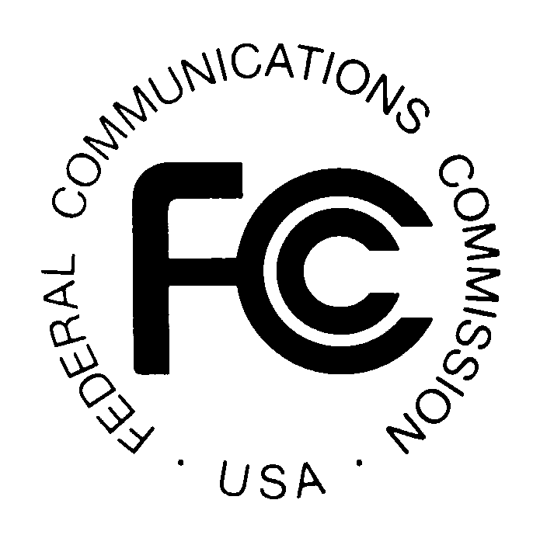
News media information 202 / 418-0500
Fax-On-Demand 202 / 418-2830
TTY 202 / 418-2555
Internet: http://www.fcc.gov
ftp.fcc.gov
PUBLIC NOTICE

Federal Communications Commission
445 12th St., S.W.
Washington, D.C. 20554

DA 18-865

August 21, 2018

PUBLIC SAFETY AND HOMELAND SECURITY BUREAU APPROVES

REGION 35 (OREGON) 800 MHZ NPSPAC REGIONAL PLAN AMENDMENT
PR Docket No. 92-269

Introduction. By this Public Notice, the Public Safety and Homeland Security Bureau (Bureau) approves the Region 35 (Oregon) Regional Planning Committee’s (RPC) proposed modifications to its 800 MHz National Public Safety Planning Advisory Committee (NPSPAC) Plan.
Background. The Commission’s policies require the RPCs to prepare and submit regional plans for public safety use of the NPSPAC band in their respective Regions. The RPCs may update their regional plans as needed to reflect changes in the disposition of NPSPAC channels within the region, technical requirements, or procedures for assigning channels.
Review of the Region 35 Plan Amendment. On December 1, 2017, the RPC submitted the Plan Amendment to modify its 800 MHz NPSPAC Plan. The Plan Amendment proposes to modify the following sections and appendices to address digital emissions, time division multiple access technologies, and use of the latest version TSB-88 methodology for interference analysis:

7.1.2. Calculations of Service Area;
7.1.4 Proposed Service Area Exhibit;
7.4.2 Adjacent Channel Design;
7.7.1. Traffic Loading Study;
7.8.2. Average Elevation Exhibit;
Appendix 1: Carey Propagation Curves;
Appendix 2: Procedures for Determining Service Area Contour; and
Appendix 3: Co-Channel Interference Procedure.

All four regions adjacent to Region 35 - Region 6 (Northern California); Region 12 (Idaho); Region 27 (Nevada); and Region 43 (Washington) - have reviewed and provided letters of concurrence in support of the Plan Amendment.
On January 16, 2018, the Bureau released a Public Notice seeking comment on the amended Region 35 Plan. We received no comments. We have reviewed the Region 35 NPSPAC Plan Amendment, and conclude, based on the information before us that it complies with FCC rules and policies.
Accordingly, pursuant to Section 4(i) of the Communications Act of 1934, as amended, 47 U.S.C. § 154(i), and Section 1.102(b) of the Commission’s rules, 47 CFR § 1.102(b), the Region 35 (Oregon) 800 MHz NPSPAC Plan Amendment is APPROVED.
This action is taken under delegated authority pursuant to Sections 0.191 and 0.392 of the Commission’s rules, 47 CFR §§ 0.191, 0.392.
Action by the Chief, Policy and Licensing Division, Public Safety and Homeland Security Bureau

– FCC –

The Region 35 (Oregon) 800 MHz regional planning area encompasses the entire state of Oregon.
See Letter from Joe Kuran, Chair, Region 35 (Oregon) 800 MHz NPSPAC Regional Planning Committee, to Marlene H. Dortch, Secretary, Federal Communications Commission, General Docket 92-269 (filed Dec. 1, 2017) (on file in Gen. Docket No. 92-269) (Plan Amendment).
See 47 CFR § 90.16 (no assignments will be made in spectrum designated for the Public Safety National Plan until a regional plan for the area has been accepted by the Commission); see also Development and Implementation of a Public Safety National Plan and Amendment of Part 90 to Establish Service Rules and Technical Standards for Use of the 821-824/866-869 MHz Bands by the Public Safety Services, Gen. Docket No. 87-112, Report and Order, 3 FCC Rcd 905 (1987) (National Plan Report and Order).
See National Plan Report and Order, 3 FCC Rcd at 911 para. 57.
See Plan Amendment.
Region 43 (Washington) conditioned its concurrence on Region 35 including the following language under Section 7.4.2: “If an interference contour extends into an adjacent region, the contour analysis shall follow that adjacent region’s plan.” See Letter from Debra Davis, Chair, NPSPAC Region 43 (Washington), to Joe Kuran, Chair, Region 35 (Oregon) (dated Nov. 30, 2017). Region 35 amended the plan as suggested by Region 43. See also Letter from John Lemmon, Chair, Region 6 (No. California) 800 MHz NPSPAC Regional Planning Committee, to Federal Communications Commission (dated Nov. 27, 2017). See Letter from Karl Rudorf, Chair, Region 12 (Idaho) 800 MHz NPSPAC Regional Planning Committee (dated Dec. 1, 2017), to Joe Kuran Chair, Region 35 (Oregon). See Letter from David L. Goss, Chair, Region 27 (Nevada) 800 MHz NPSPAC Regional Planning Committee (dated Nov. 9, 2017), to Joe Kuran Chair, Region 35 (Oregon).
See Public Safety and Homeland Security Bureau Seeks Comments on Region 35 (Oregon) 800 MHz NPSPAC Regional Plan Amendment, PR Docket No. 92-269, Public Notice, 33 FCC Rcd 159 (PSHSB 2018).

