DA 19-1263
Released: December 12, 2019

BIENNIAL REVIEW FOR THE ALASKA PLAN WIRELINE CARRIERS

WC Docket Nos. 10-90 and 16-271

In this Public Notice, the Wireline Competition Bureau announces the conclusion of the Biennial Review required by the Federal Communications Commission pursuant to the Alaska Plan Order adopted by the Commission on August 23, 2016. In the Alaska Plan Order, the Commission provided a one-time opportunity for Alaskan rate-of-return carriers to elect to receive support frozen at adjusted 2011 levels for a 10-year term in exchange for meeting individualized performance obligations—offering voice and broadband services meeting specific service obligations at specified minimum speeds by five-year and 10-year service milestones to a specified number of locations.
On December 16, 2016, the Wireline Competition Bureau (Bureau) authorized the individualized performance obligations and support amounts for 13 rate-of-return companies in Alaska. Carriers with approved plans to maintain existing levels service, which include Arctic Slope Telephone Cooperative, Inc. (ASTAC), Adak Eagle Enterprise, LLC, Bush-Tell, Inc., Circle Telephone & Electric, LLC, and Mukluk Telephone Company, Inc., are subject to biennial review.
In conducting this Biennial Review, the Bureau held discussions with the carriers and/or assessed of the carriers’ annual location and middle-mile map filings. Based on our review, we conclude that Circle and Bush-Tell will remain authorized to continue to maintain service at existing levels per the Alaska Plan Wireline Authorization Public Notice. Since the inception of the Alaska Plan, these carriers have not obtained access to new or upgraded middle-mile facilities in any of the areas of Alaska they serve. For the same reasons, Adak will also remain authorized to continue to maintain service per the Alaska Plan Wireline Authorization Public Notice, but we note that Adak has a petition for reconsideration pending related to its Alaska Plan authorization.
For ASTAC and Mukluk, we approve revised performance obligations provided in the Appendix to this Public Notice. On November 1, 2018, ASTAC submitted proposed revised wireline performance obligations. After discussions with Bureau staff, ASTAC clarified those proposed obligations on November 27, 2018 and then further supplemented them on December 26, 2018 and again on November 19, 2019. On March 1, 2019, Mukluk submitted proposed revised wireline performance obligations. After discussions with Bureau staff, Mukluk clarified and revised those performance obligations on March 8, 2019 and again on May 17, 2019; and Mukluk subsequently addressed why it does not offer a level of service consistent with that of GCI’s TERRA Network in certain communities. As shown in their submissions, each of these carriers has obtained access to new middle-mile facilities allowing them offer improved service in parts of their study areas. The performance obligations we approve today replace the performance obligations the Bureau approved for ASTAC and Mukluk on December 16, 2016.
For additional information on this proceeding, contact Jesse Jachman, jesse.jachman@fcc.gov of the Wireline Competition Bureau, (202) 418-2668.
- FCC -

Appendix
Revised Performance Obligations

1. Arctic Slope Telephone Cooperative, Inc.

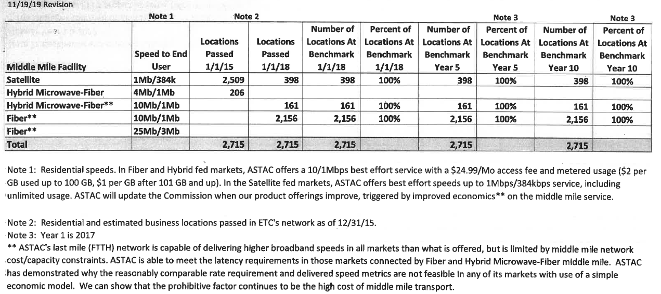
2. Mukluk Telephone Company, Inc.

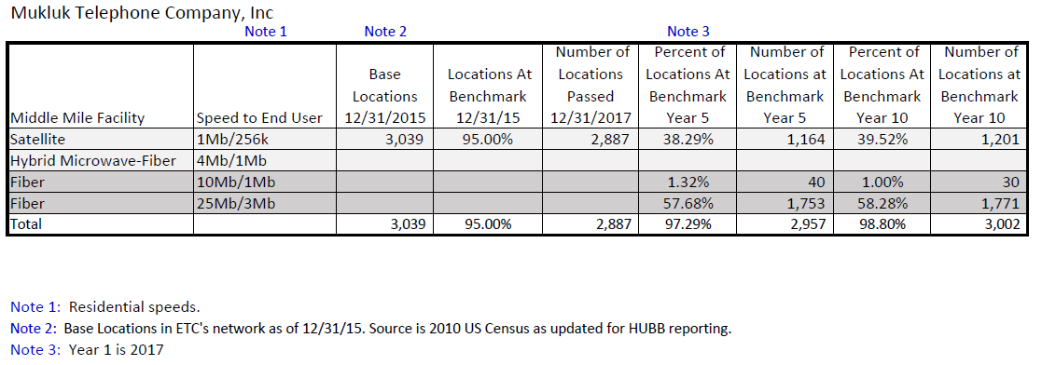

Connect America Fund, et al., WC Docket No. 10-90 et al., Report and Order and Further Notice of Proposed Rulemaking, 31 FCC Rcd 10139 (2016) (Alaska Plan Order).
Wireline Competition Bureau Authorizes Alaska Plan Support for 13 Alaskan Rate-of-Return Companies, WC Docket Nos. 10-90, 16-271, Public Notice, 31 FCC Rcd 13347 (WCB 2016) (Alaska Plan Wireline Authorization Public Notice).
See Alaska Plan Order, 31 FCC Rcd at 10158, para. 62.
See Letter from David Masephol, President, Circle Telephone & Electric, LLC, to Marlene H. Dortch, Secretary, FCC, WC Docket No. 16-271 (Apr. 4, 2019); Letter from William Douglas DeVore, President, Bush-Tell, Inc., to Marlene H. Dortch, Secretary, FCC, WC Docket No. 16-271 (May 10, 2019) (letter filed on May 22, 2019 and dated May 10, 2019).
See Petition for Reconsideration of Adak Each Enterprises, LLC, WC Docket No. 10-90 (Jan. 19, 2017).
Letter from Jeffry H. Smith President and CEO, GVNW Consulting, to Marlene H. Dortch, Secretary, FCC, WC Docket Nos. 10-90, 16-271, at Attachment (Nov. 1, 2018).
Letter from Jeffry H. Smith President and CEO, GVNW Consulting, to Marlene H. Dortch, Secretary, FCC, WC Docket Nos. 10-90, 16-271, at Attachment (Nov. 27, 2018); Letter from Jeffry H. Smith President and CEO, GVNW Consulting, to Marlene H. Dortch, Secretary, FCC, WC Docket Nos. 10-90, 16-271, at Attachment (Dec. 26, 2018); Letter from Jeffry H. Smith President and CEO, GVNW Consulting, to Marlene H. Dortch, Secretary, FCC, WC Docket Nos. 10-90, 16-271, at 4 (Nov. 19, 2019).
See Letter from David J. Goggins, President and General Manager, TelAlaska, Inc., to Marlene H. Dortch, Secretary, FCC, WC Docket No. 16-271 (Mar. 1, 2019), Letter from David J. Goggins, President and General Manager, TelAlaska, Inc., to Marlene H. Dortch, Secretary, FCC, WC Docket No. 16-271 (Mar. 8, 2019). Letter from David J. Goggins, President and General Manager, TelAlaska, Inc., to Marlene H. Dortch, Secretary, FCC, WC Docket No. 16-271 (May 17, 2019).
See Letter from David J. Goggins, President and General Manager, TelAlaska, Inc., to Marlene H. Dortch, Secretary, FCC, WC Docket No. 16-271 (Jun. 7, 2019).
See Alaska Plan Wireline Authorization Public Notice, 31 FCC Rcd at 13354, Appx. B. Alaska Plan carriers are subject to the Alaska-specific reasonable comparability benchmark, see Alaska Plan Order, 31 FCC Rcd at 10149, para. 28, which the Bureau announces annually. See, e.g., Wireline Competition Bureau Announces Results of 2019 Urban Rate Survey for Fixed Voice and Broadband Services, Posting of Survey Data and Explanatory Notes, and Required Minimum Usage Allowance for Eligible Telecommunications Carriers, WC Docket No. 10-90, Public Notice, 33 FCC Rcd 12316 (WCB 2018). See also 47 CFR § 54.313(a)(3) (broadband benchmark certification), and Connect America Fund et al., WC Docket No. 10-90 et al., Report and Order, 29 FCC Rcd 15644, 15700-01, para. 155-57 (2014) (directing the Universal Service Administrative Company “to gather additional information when ETCs fail to make the reasonably comparable certification about their voice or broadband rates in their section 54.313 annual report and transmit that information to the Commission.”).

