DA 19-1264
Released: December 12, 2019

wireless telecommunications bureau approves ASTAC’s AND GCI’S revised performance planS pursuant to the alaska plan ORDER
WC Docket No. 16-271

By this Public Notice, the Wireless Telecommunications Bureau approves Arctic Slope Telephone Association Cooperative’s (ASTAC) and GCI Communication Corp.’s revised performance plans, filed pursuant to the terms provided by the Alaska Plan Order. The approved performance plans are included in the attached Appendix.
The Commission’s Alaska Plan Order requires eligible wireless service providers participating in the Alaska Plan (Plan) to submit for Bureau approval individual performance plans with service commitments. Pursuant to the Alaska Plan Order, the Bureau approved wireless service providers’ initial plans in 2016.
Participants, including ASTAC and GCI, who, in their initial plan exclusively relied upon performance-limiting satellite backhaul to serve all or a portion of the population in their service area, are required to certify if terrestrial backhaul or new-generation satellite backhaul became commercially available in the previous calendar year in the affected area. If a carrier so certifies and has not previously committed to providing 10/1 Mbps LTE in the affected area, the carrier must revise its performance plan to take into account the availability of the new backhaul option.
In its 2018 FCC Form 481, ASTAC timely certified that terrestrial backhaul became commercially available. On July 11, 2018, ASTAC filed a letter revising its performance plan with updated commitments, replacing its approved plan. On November 1, 2018, ASTAC refiled these commitments in the attached format. We approve ASTAC’s revised performance plan.
On July 1, 2019, GCI updated its commitments to reflect the Quintillion undersea fiber cable becoming commercially available to GCI in Utqiagvik (formerly known as Barrow), Wainwright, and Point Hope, Alaska. GCI is updating its last-mile commitments for 5,443 Alaskans previously reliant on satellite middle mile to fiber-based 10/1 Mbps LTE. We approve GCI’s revised performance plan.
Additional Information. For additional information on this proceeding, contact Matthew Warner of the Wireless Telecommunications Bureau, Competition and Infrastructure Policy Division, Matthew.Warner@fcc.gov, (202) 418-2419.
- FCC -
Appendix

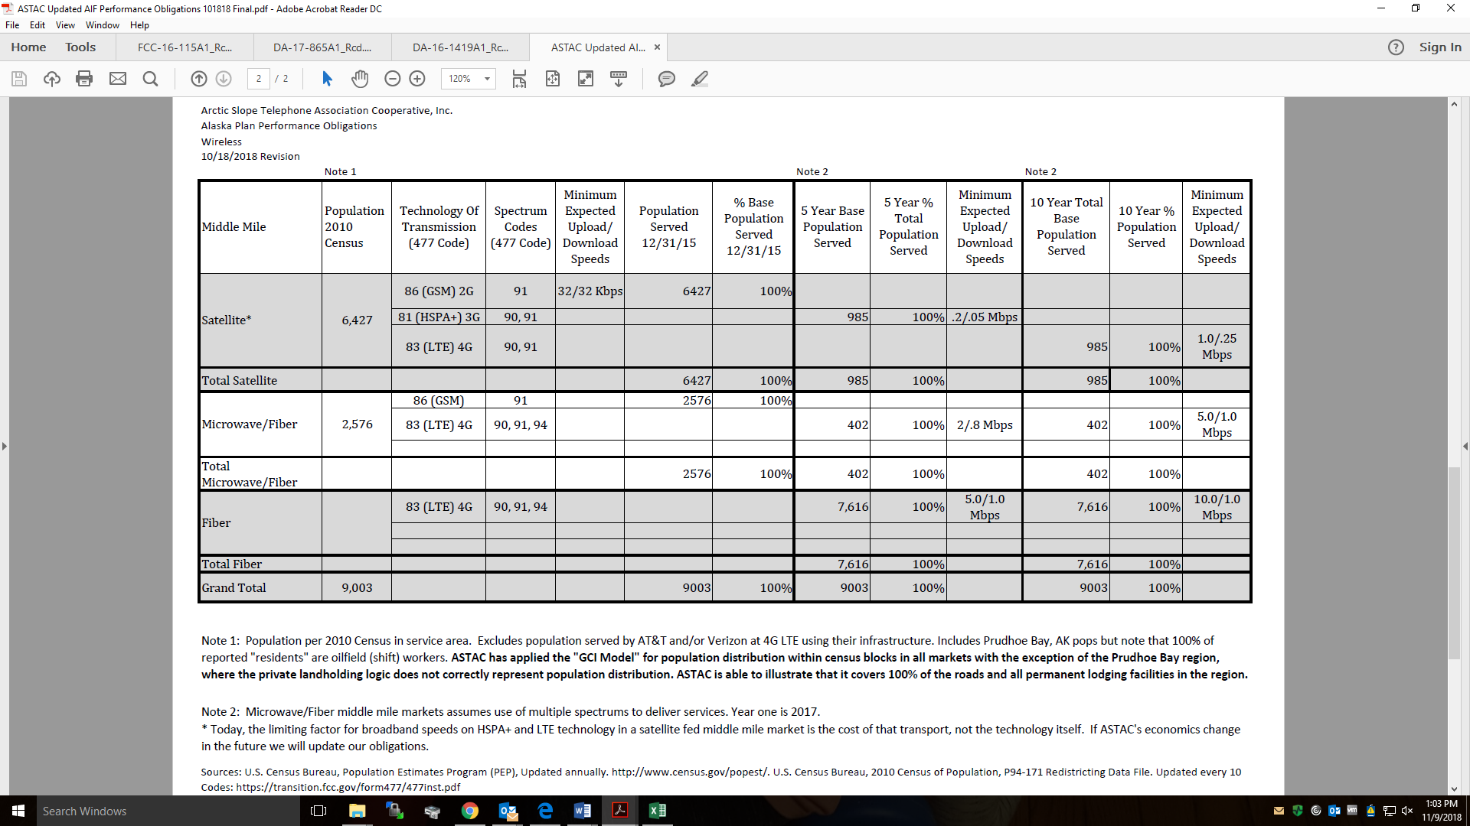

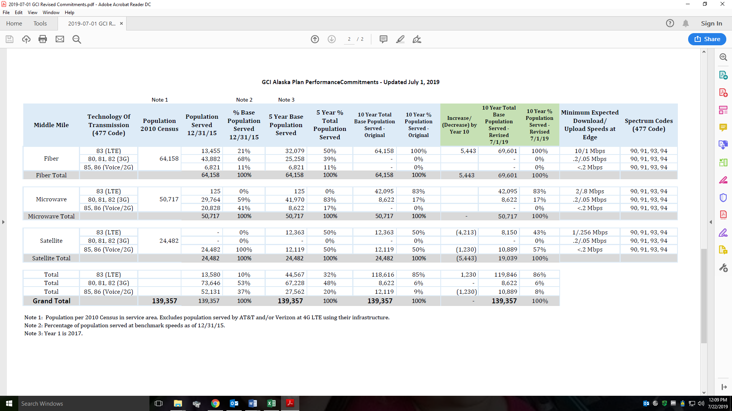

Connect America Fund et al., Report and Order and Further Notice of Proposed Rulemaking, 31 FCC Rcd 10139 (2016) (Alaska Plan Order); Letter from Jeffry H. Smith, on behalf of ASTAC, to Marlene H. Dortch, Secretary, FCC, WC Docket No. 16-271, Attach. 2 at 2 (filed Nov. 1, 2018) (ASTAC 2018 Commitments); Letter from Julie A. Veach, Counsel to GCI, to Marlene H. Dortch, Secretary, WC Docket No. 16-271, Attach. (July 1, 2019) (GCI 2019 Commitments).
See Alaska Plan Order, 31 FCC Rcd at 10166-67, para. 85.
See id., at 10171, para. 97.
Wireless Telecommunications Bureau Approves Performance Plans of the Eight Wireless Providers That Elected to Participate in the Alaska Plan, Public Notice, 31 FCC Rcd 13317, Appx. (WTB 2016) (approving ASTAC’s, GCI’s, and six other providers’ plans).
See Alaska Plan Order, 31 FCC Rcd at 10172, para. 102.
Id.
Form 481 Program Year 2019 Data (Non-Confidential), https://www.usac.org/_res/documents/hc/xls/templates/Form-481-Program-Year-2019-Data-Non-Confidential.xlsx (showing a filing under tab 5013(a-c)).
See Letter from Douglas A. Neal, CEO, to Marlene H. Dortch, Secretary, FCC, WC Docket No. 16-271 (filed Oct. 8, 2018). We note that OTZ Telephone Cooperative Inc. (OTZ) resubmitted its original commitments, which accounted for terrestrial middle mile becoming commercially available to Kotzebue, Alaska. Therefore, OTZ is in compliance.
See ASTAC 2018 Commitments.
See 47 CFR § 54.317(f); Alaska Plan Order, 31 FCC Rcd at 10160, 10172, paras. 67, 102.
Letter from Julie A. Veach, Counsel to GCI, to Marlene H. Dortch, Secretary, WC Docket No. 16-271 (July 1, 2019).
See GCI 2019 Commitments.

