Before the
Federal Communications Commission
Washington, D.C. 20554

In the Matter of  Modernizing the E-Rate Program for Schools and Libraries | )  )  )  )  ) | WC Docket No. 13-184

report

Adopted: February 11, 2019 Released: February 11, 2019

By the Chief, Wireline Competition Bureau:
Table of Contents
Heading #
I. Introduction 1
II. Background 3
III. Discussion 13
A. Total Internal Connections Funding and Percentage of Funded Requests 13
B. Yearly Participation 16
C. Cumulative Participation 19
D. School District Participation 22
E. Usage Rates for Schools and Libraries 26
F. Distribution of Funding Commitments by Applicant Type 28
G. Applicant Usage of Budgets by Funding Year 33
H. Participation by Schools Serving Students with Special Educational Services 38
IV. Conclusion 41
V. Ordering Clauses 47
APPENDIX A – Data Sources
APPENDIX B – Category Two Commitments/Pending Requests by State, FY2015-FY2018

Introduction
- Since 1998, the E-Rate program (more formally known as the schools and libraries universal support mechanism) has provided support for connectivity to and within schools and libraries. As a result, the program has been instrumental in bringing essential communications services to students and library patrons. In 2014, the Commission took steps to further tailor the E-Rate program to the needs of schools and libraries, making changes aimed at closing the high-speed connectivity gap between rural schools and libraries and their urban and suburban counterparts, as well as ensuring that all schools and libraries have sufficient and certain funding for their high-speed connectivity needs. As part of these changes, the Commission established a new budget approach for internal connections, primarily used for Wi-Fi, a transformative educational tool that has allowed schools and libraries to transition from computer labs to one-to-one digital learning, and thereby help close the digital divide. Specifically, the Commission adopted rules establishing five-year budgets for schools and libraries that provide a set amount of funding to support internal connections. The Commission also directed the Wireline Competition Bureau (Bureau) to monitor this new five-year budget approach and report on its sufficiency and effectiveness.
- In this Report, the Bureau analyzes available data on the five-year budgets for internal connections, also referred to as “category two budgets.” Based on our review of the data, we identify numerous ways in which the category two budget approach has resulted in a broader distribution of funding that is more equitable and more predictable for schools and libraries. Accordingly, as discussed below, we recommend that the Commission retain the category two budget approach and avoid a return to the prior so-called “two-in-five rules” approach. This recommendation is based on the data showing clear improvements in the way in which funding for internal connections has been administered since Funding Year (FY) 2015 and is supported by the Public Notice comments. In addition, we recommend that the Commission consider modifications to the existing category two budget approach to enhance the ability of the E-Rate program to provide funding to schools and libraries to support high-speed connectivity. For example, the Bureau recommends raising the funding floor if the Commission finds that insufficient funding is deterring participation by schools and libraries at the funding floor.

Background
- The E-Rate program funding cap for FY2018 was approximately $4 billion, broadly divided between category one services, including data transmission and Internet access, and category two services, including internal connections (e.g., Wi-Fi), managed internal broadband services (e.g., managed Wi-Fi), and basic maintenance of internal connections. Funding for category one services is committed first, and remaining funding is committed to category two services. In the event demand for category two support exceeds available funding, category two support is first committed to applicants eligible for a 90% discount, then to applicants eligible for an 89% discount, and continues descending by a single digit discount percentage until the cap is reached. In an effort to distribute funding for internal connections more widely, the Commission adopted the two-in-five rules, first effective in FY2005, which limited category two funding, on an individual school or library basis, to two out of every five years.
- The two-in-five rules approach, however, proved to be ineffective for ensuring broad, equitable, and predictable access to funding for internal connections. In most years, the E-Rate program could still only provide support for internal connections to applicants with the highest discount rates, which were disproportionately urban schools. From FY2010 to FY2014, applicants below the 89% discount rate received funding only once, in FY2010. In FY2013 and FY2014, no funding was available for category two services. Further, applicants had little certainty that funding for internal connections would be available. As a result, schools and libraries were discouraged from planning for support for internal connections, particularly those below the top discount bands for which funding was unlikely to be available. Moreover, because per-site funding was uncapped, entities at the top discount levels had an incentive to overbuy or use less cost-effective network designs, as there was no limit on the total amount of funding available to an applicant to encourage maximizing spending efficiency.
- To better ensure equitable and reliable support for Wi-Fi networks and other internal connections, in 2014, the Commission adopted rules establishing five-year budgets for schools and libraries requesting category two services. Beginning in FY2015, the rules provide a pre-discount budget of $150 per student over five years for schools, and a pre-discount budget of $2.30 or $5.00 per square foot for libraries depending on their location. The rules also provide a pre-discount funding floor of $9,200 per site over a five-year period. These pre-discount budget amounts are adjusted for inflation. Applicants may request funding in one or multiple years, and may use their category two budget over a five-year funding cycle, beginning in the first year that funding is committed.
- When the rules were adopted, the Commission established a five-year test period (FY2015 to FY2019) to consider whether the category two budget approach is effective in ensuring greater access to E-Rate discounts for internal connections. During this test period, the Commission directed the Bureau to “monitor these applicant budgets and provide a report on their sufficiency to the Commission before the opening of the filing window for funding year 2019.” The Commission further directed the Bureau to “analyze data from applicants for trends across different types of applicants or regions of the nation, particularly those schools that serve students with special education services,” and to “analyze the applicant requests from funding years 2015 to 2018 for libraries serving different population sizes, so that we have information needed to assess whether the category two library budget is reasonable.”
- In September 2017, in preparation for this Report, the Bureau sought comment on the sufficiency of the category two budget approach, and received hundreds of comments from trade associations, public interest organizations, school districts, and libraries. Commenters expressed near-unanimous support for the category two budget approach. No commenter supported a return to the two-in-five rules. Commenters also discussed the adequacy of the current budgets, as well as the funding floor. Many commenters supported modifications to the current system, including a change from calculating budgets on a per-entity basis (i.e., school or library) to a per-applicant basis (i.e., per-school district or library system). Commenters also identified several administrative challenges with the category two budget approach.
- This Report reviews funding for category two services through the close of the FY2018 filing window. In response to the Commission’s directive, the Bureau has observed four ways in which the category two budget approach appears to be more effective than the two-in-five rules approach. First, since the category two budgets went into effect in FY2015, the E-Rate program has committed more category two funding than it did from FY2010 to FY2014, despite overall lower demand, and without previously observed large year-over-year variations. In addition, no funding requests for category two services have been denied due to lack of available funding, as funding has been available every year since FY2015.
- Second, under the category two budget approach, funding for category two services is more widely dispersed and used than under the two-in-five rules approach. More schools and libraries per year have received category two funding commitments, and a higher percentage of schools and libraries request category two discounts than previously. More than six times as many schools and ten times as many libraries per-year receive funding commitments than under the two-in-five rules approach; and, cumulatively more than twice as many schools and four times as many libraries participate in the program. As of May 2, 2018, most schools had used at least 70% of their available category two budgets.
- Third, the distribution of category two funding requests under the category two budget approach more closely approximates the composition of participating schools and libraries in the E-Rate program overall than under the two-in-five rules approach. Prior to FY2015, the program committed a disproportionate amount of funding to schools with higher discount percentages, primarily in urban areas. Since FY2015, urban and rural applicants at all discount rates have requested and received funding commitments for internal connections at roughly the same rate.
- Fourth, the category two budget approach appears to provide more flexibility to applicants to plan for the deployment and maintenance of their networks in a way that best suits their needs, particularly for school districts. Flexibility is measured in terms of school districts and library systems having the choice to request money in one year or across multiple years. School districts and library systems have taken advantage of these options, requesting funding for individual entities in one or multiple years, and using funding in either the first year or over the five-year budget cycle.
- Based on these four metrics (i.e., overall funding, participation and usage rates, distribution of funding, and degree of flexibility) and our review of the data through the close of the FY2018 filing window, we conclude that the category two budget approach is an effective means to ensure greater access to E-Rate discounts for internal connections. Specifically, the existing budget amounts are likely sufficient for school districts, which (1) participate at a high rate, (2) are likely to request funding for most or all schools within their respective districts, and (3) use the majority of their funding over multiple years. The budgets may not, however, be sufficient for rural libraries and entities at the funding floor, which are the least likely to participate and overall use only a small portion of their budgets. Several possible factors might explain the lower participation and usage rates for libraries and funding floor entities, including administrative burdens, lack of funds for non-discounted share, and, for libraries, Children’s Internet Protection Act compliance.

Discussion

Total Internal Connections Funding and Percentage of Funded Requests
- With the category two budget approach, the Commission sought to ensure sufficient funding for category two services and provide greater certainty regarding the availability of funding. To evaluate whether the category two budget approach met these objectives, we measured the total committed funding under the two-in-five rules approach and compared it to the total committed (and currently pending) funding under the category two budget approach. In the first four years under the category two budget approach, more funding has been committed than in the last five years under the two-in-five rules approach. A higher percentage of funding requests have been committed, and there has been an increased regularity of funding commitments under the category two budget approach.
- The Commission estimated that total category two pre-discount demand from FY2015 through FY2019 would be $8.8 billion, and that post-discount demand would be $5 billion. The Bureau measured progress towards these targets by analyzing funding commitments for FY2015 through FY2018, and pending funding requests for FY2017 and FY2018, to account for requests under review by USAC. Through FY2018, approximately $5.09 billion pre-discount, and $3.69 billion post-discount, was committed or pending. Category two demand has been lower than estimated; on a post-discount basis, there is approximately $310 million in “unused” funding through FY2018.
Funding Year | Pre-Discount Commitment/ Pending Request | Post-Discount Commitment/ Pending Request
2015 | $1.63b | $1.25b
2016 | $1.26b | $0.89b
2017 | $1.12b | $0.79b
2018 | $1.08b | $0.76b
TOTALS | $5.09b | $3.69b

- Further, a higher percentage of requests have resulted in funding commitments. From FY2010 to FY2012, requests and commitment percentages varied greatly. Of the $5.79 billion that applicants requested for internal connections from FY2010 to FY2012, only $2.16 billion, or approximately 37%, was committed. By contrast, from FY2015 to FY2018, $4.5 billion was requested, and $2.8 billion has been committed, with an additional $900 million pending funding requests. Over 70% of requests were committed in FY2015 and FY2016, and over 60% in FY2017. Although requests are still pending for FY2017 and FY2018, we expect the final commitment ratios for these funding years will increase, continuing an upward trend.
Two-in-Five |  | Category Two Budgets
Funding Year | Commitment Ratio | Funding Year | Commitment Ratio
2010 | 52% | 2015 | 74%
2011 | 35% | 2016 | 77%
2012 | 32% | 2017* | 64%
2013 | 0% | 2018* | 15%
2014 | 0% | * Includes pending requests; final ratio to increase

Yearly Participation
- The five-year budget approach sets reasonable limits on category two requests and allows support for internal connections to be spread more broadly. To measure the effectiveness of this approach, we analyzed the number of individual schools and libraries receiving support for internal connections under the two-in-five rules approach, and compared those totals to the number of schools and libraries that have received support under the category two budget approach. Each year, under the category two budget approach, more schools and libraries have received funding commitments than under the two-in-five rules approach.
- Schools. From FY2008 to FY2012, an average of 106,000 schools per year participated in the E-Rate program by receiving category one funding commitments. Of those schools, an average of 7,200 per year also received category two funding commitments. On average, between 5 and 12% of schools participating in E-Rate received category two commitments. Since FY2015, the average number of schools receiving category two commitments (or with pending requests) has increased to approximately 45,000 per year, a 525% increase. Likewise, the average participation rate per year has increased to 43%, as much as an eight-fold increase over participation rates from FY2008 to FY2012.
- 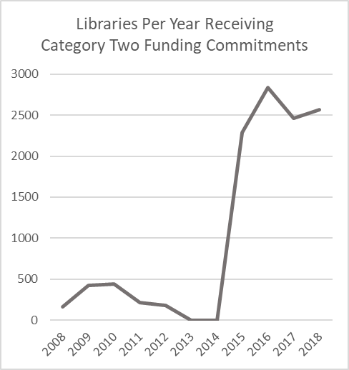Libraries. From FY2008 to FY2012, an average of 16,520 libraries participated in the E-Rate program. Of these libraries, an average of 280 per year also received category two funding commitments. On average, just 2% of libraries participating in the E-Rate program received category two commitments. Since FY2015, the average number of libraries receiving category two commitments (or with pending requests) has increased to approximately 2,700 per year, an 865% increase. The average participation rate per year has increased to approximately 23%, as much as a ten-fold increase from FY2008 to FY2012.
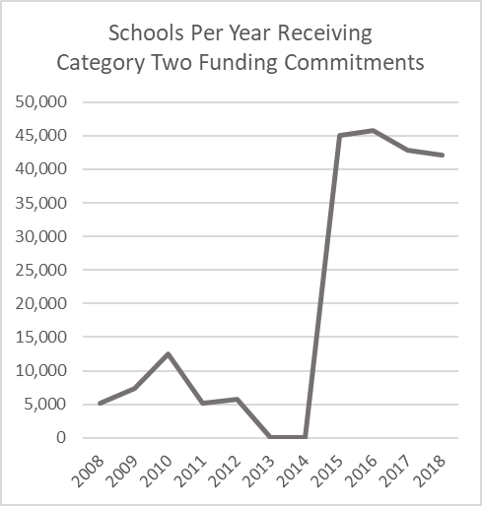

Cumulative Participation
- The number of unique schools and libraries that receive support for internal connections in at least one funding year is another way in which the Bureau evaluated the sufficiency of the category two budget approach. Comparing cumulative participation rates, the category two budget approach has allowed for broader participation by schools and libraries over time than experienced under the two-in-five rules approach. Notably, the cumulative participation rate is higher under category two budget approach than under the two-in-five rules approach.
- Schools. Since FY2015, of the 104,500 schools that participate in the E-Rate program by receiving a category one funding commitment, approximately 90,000, or 86%, receive a category two funding commitment (or currently have a pending request) in at least one year. By contrast, between FY2008 and FY2012, the cumulative participation rate was no higher than 34%, substantially lower than the cumulative rate under the category two budget approach.
- Libraries. Since FY2015, of the 11,490 libraries per year that participate in the E-Rate program, approximately 4,900, or 44%, have received a category two funding commitment (or currently have a pending request) in at least one year. By contrast, between FY2008 and FY2012, the cumulative participation rate was no higher than 8%, far below the 44% cumulative participation rate under the category two budget approach.
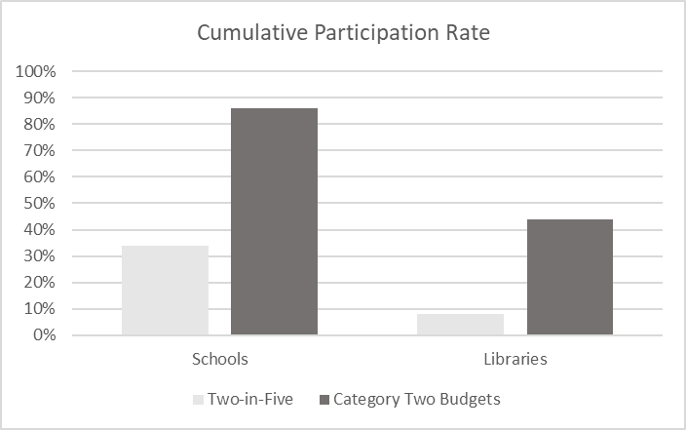

School District Participation
- The Bureau analyzed available data regarding school districts that received category two funding from FY2015 to FY2018. Overall, the category two budget approach appears to provide a framework that most school districts nationwide have used to fund internal connections. Most school districts receive category two discounts for at least some schools, and districts that participate are likely to receive category two funding for all, or nearly all, of their schools. By contrast, smaller school districts with lower student enrollment appear less likely to receive or request category two support.
- Of 14,179 total school districts, 68% have received a category two funding commitment (or have a pending request) for every school in the district. An additional 16% have received a funding commitment (or have a pending request) for some schools in the district, meaning 84% of districts have received a funding commitment (or have a pending request) for some or all schools in the district. Only 16% have not received or requested a funding commitment for any schools in the district.
- Excluding non-participating districts, 91% of the 91,800 schools in participating districts have received a category two funding commitment (or have a pending request). Just 7,800 have yet to receive or request category two funding support. More than half of non-participating schools are in districts in which no schools receive or request category two funding.
- The data further shows that districts that have not requested or received any category two funding tend to be the smallest, have the lowest average district-wide full-time student enrollment, and the highest percentage of sites at the funding floor. Districts where all schools receive category two funding are slightly larger, have a larger average district-wide full-time enrollment, and the lowest percentage of sites at the funding floor.
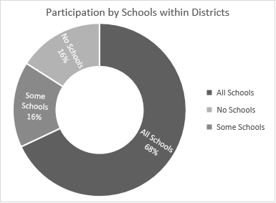

Usage Rates for Schools and Libraries
- Schools. Overall, schools use their budgets at a high rate. Approximately 42,000 schools have used more than 75% of their category two budgets, and 30,000 have used more than 90%. An additional 16,000 schools have used between 50 and 75% of their budgets. Approximately 25,000 schools have not received or requested a category two funding commitment through FY2018, and thus have 100% of their budgets remaining.
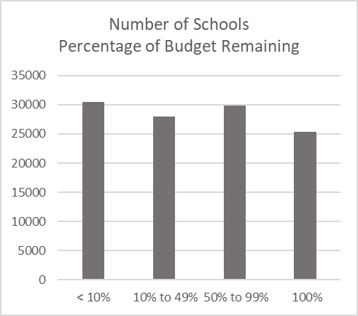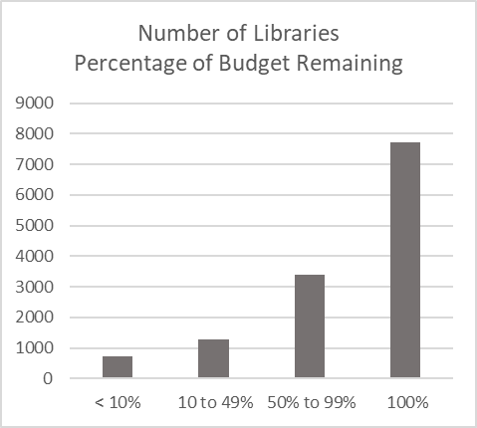
- Libraries. Libraries do not appear to use their category two budgets to the same degree as schools. Just over 1,000 libraries have used more than 75% of their budgets. An additional 900 libraries have used between 50 and 75%. By contrast, over 7,000 libraries have not received or requested a category two funding commitment, and thus have 100% of their budgets remaining.

Distribution of Funding Commitments by Applicant Type
- The 2014 First E-Rate Order observed two major shortcomings with the two-in-five rules approach: E-Rate funding for category two services was distributed only to schools and libraries with the highest discount levels, and a disproportionate amount of available funding went to urban schools. The creation of five-year budgets, with a cap on available funding, was designed to make the distribution of category two funding more equitable. To evaluate whether the category two budget approach has achieved this goal, the Bureau examined the distribution of funding commitments across different types of applicants.
- Since FY2015, category two funding commitments have been broadly available to entities across all discount bands. The funding committed to urban schools closely approximates the overall ratio of urban to rural schools, and urban and rural schools participate at roughly the same rate. Urban libraries, however, tend to receive more funding than rural libraries, and participate at a higher rate.
- Discount Band. Prior to FY2015, more than 80% of category two funding was committed to schools in the top one or two discount bands – i.e., those schools with 90 or 89% discount rates; and, only 13% of funding went to applicants below 88%. By contrast, only 17% of category one funding went to applicants with 90 or 89% discount rates, and 80% of category one funding went to applicants below 88%. Since FY2015, however, applicants at all discount rates have requested and received funding commitments for category two services at roughly rates equal to category one funding commitments.
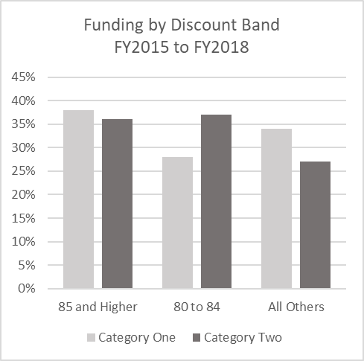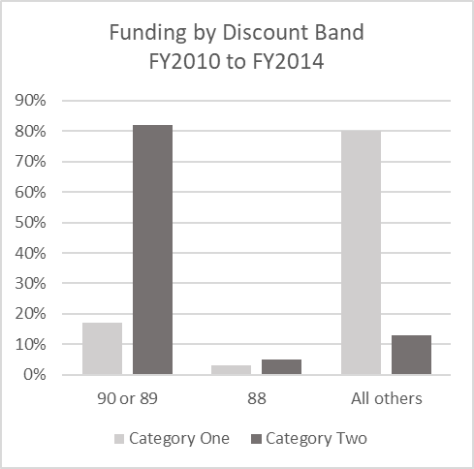

- Urban and Rural. Under the two-in-five rules approach, urban schools received a disproportionate amount of category two funding. Under the category two budget approach, urban and rural schools receive category two commitments at approximately the same ratio as the overall ratio of urban and rural schools participating in the E-Rate program. Urban and rural schools also participate at roughly the same rate (82% for urban schools, 81% for rural schools), suggesting that urban or rural status does not dictate whether a school requests category two funding. Libraries, by contrast, do not participate in the same manner as schools based on urban or rural status. Urban libraries receive category two commitments at a higher ratio than the overall ratio of urban and rural libraries participating in the program. Moreover, urban libraries are more likely to participate than rural libraries (54% for urban libraries, 38% for rural libraries).
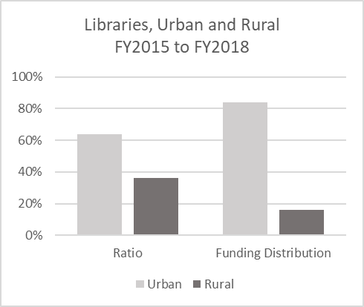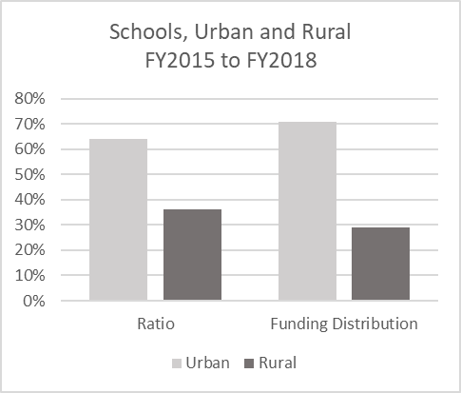

- The higher participation rate, and percentage of overall library category two funding that goes to urban libraries, is likely explained by libraries in highly concentrated urban areas (i.e., those with IMLS codes 11, 12, and 21, and with $5.00 per-square-foot budgets). These libraries participate at a significantly higher rate than any other type of library; further, they have access to more than twice as much funding. By contrast, most rural libraries are at the funding floor, and only a small number of rural libraries with budgets above the funding floor participate. These two factors, and the absence of rural libraries with $5.00 per-square foot budgets, potentially explain why only 15% of category two funding for libraries goes to rural libraries.
Libraries by Budget Type: FY2015 to FY2018
 | Total | Participants | Participation Rate
Funding Floor Urban | 1,632 | 649 | 40%
Standard Urban | 1,784 | 1,027 | 58%
Highly Concentrated Urban | 917 | 774 | 84%
Funding Floor Rural | 2,569 | 950 | 37%
Standard Rural | 1,271 | 649 | 40%

Applicant Usage of Budgets by Funding Year
- Under the two-in-five rules approach, applicants had little flexibility to determine how to plan for network upgrades over time. Applicants were incentivized to apply for maximum funding each year and hope that funding would be available for at least some sites. Even for those entities that received funding, at most, funding could be used in two years. Year-over-year unpredictability created uncertainty whether funding would be available at all. Indeed, in FY2013 and FY2014, category one demand was greater than the funding cap, and thus no funding was available for category two services.
- The 2014 First E-Rate Order created the category two budget approach to give applicants flexibility, over a five-year period, to deploy and maintain Wi-Fi networks both in terms of how they seek funding (i.e., whether they seek funding for all locations in one year or over multiple years) and how an individual location might use its budget (i.e., whether it might use the entirety of its budget in one year or over two or more years). Further, this approach allows applicants to purchase managed Wi-Fi or allocate shared network elements to multiple locations over multiple years.
Years Active | Percentage
0 | 22
1 | 34
2 | 24
3 | 13
4 | 7

- As shown in the chart above, through FY2018, 78% of all entities have received a category two funding commitment (or have a pending request) in at least one year, 44% in at least two years, and 20% in three or more years. Once FY2019 commitments are taken into account, these percentages will likely rise, as entities spend their remaining budgets, and new entities receive funding commitments for the first time.
- According to Funds for Learning, approximately 93% of the 21,125 applicants (i.e., school districts and library systems) that applied for category one funding in FY2018 have also begun five-year category two cycles, and over 10,000 of these five-year cycles began in FY2015. The Bureau likewise analyzed applicant usage of budgets by looking at the first year that schools received funding commitments. Through FY2018, 88,284 schools have received funding, with most schools first receiving commitments in FY2015 and FY2016.
- Schools that commenced participation earlier in the five-year funding cycles (i.e., schools first receiving commitments in FY2015 and FY2016) tend to have larger average student enrollment and a higher discount rate than later starting schools (i.e., schools first receiving funding commitments in FY2017 and FY2018). Earlier starting schools have also received more pre- and post-discount support and have used a higher percentage of their budgets, than later starting schools.
First Year | Number of Schools | Average Enrollment | Pre-Discount Funding | Post-Discount Funding | Average  Discount Rate | Budget Utilization
FY2015 | 43,729 | 550 | $2,624,918,382 | $1,956,140,983 | 75% | 80%
FY2016 | 25,930 | 551 | $1,348,290,500 | $948,593,978 | 70% | 73%
FY2017 | 11,067 | 488 | $481,726,466 | $327,811,919 | 68% | 68%
FY2018 | 7,558 | 466 | $315,779,926 | $221,645,197 | 70% | 72%

Participation by Schools Serving Students with Special Educational Services
- The 2014 Second E-Rate Order instructed the Bureau to analyze data regarding schools that serve students with special education services as part of its Report on the sufficiency of the category two budget approach. The FCC Form 471 does not currently ask applicants to identify entities that specialize in special education. To estimate category two funding for and participation by special education schools, the Bureau relied upon the National Center for Education Statistics (NCES) Common Core of Data School Directory Dataset for the 2015/2016 school year (https://nces.ed.gov/ccd/pubschuniv.asp), which identifies special education public schools.
- Most public schools participating in the E-Rate program do not supply NCES identification numbers; as a result, the Bureau used a combination of school name, address, and phone number data to match E-Rate entities with entities in the NCES dataset. Through this method, the Bureau matched 75% of the approximately 100,000 public schools participating in the E-Rate program to the NCES dataset. The NCES dataset identifies 2,029 schools as “Special Education Schools.” Using the matching methodology above, the Bureau identified 656 E-Rate entities that the dataset identified as “Special Education Schools.”
- Of the 656 special education schools identified, 487, or 74%, received a category two funding commitment (or currently have a pending request) between FY2015 and FY2018. The average pre-discount budget for these special education schools is approximately $31,000. Fewer than 3% of these schools are at the funding floor. The 487 participating schools received $1.9 million in post-discount category two support (commitments and pending requests) between FY2015 and FY2018, an average of approximately $3,915 per school. The usage distribution for the special education schools identified mirrors the overall usage distribution by schools generally. Specifically, 217 special education schools have used more than 90% of their category two budgets, while 169 have not used any. The remaining 270 are distributed roughly evenly in between, as seen in the figure below:

Conclusion
- The Bureau concludes, based on participation rates, budget utilization, and other data in this Report, that the category two budget approach is generally sufficient. Overall, we observe that schools and libraries participate at a high rate, and funding is available to entities in urban and rural areas, and across all discount bands. Applicants have flexibility to determine how best to use funding, demonstrated by the varied usage rates and number of years applicants receive funding.
- We conclude that the category two budget approach is a clear improvement over the two-in-five rules approach. Under the category two budget approach, greater funding is available for internal connections, distributed to more applicants, in a more equitable and predictable manner, giving applicants more flexibility to determine how best to upgrade their systems. Specifically, under the category two budget approach, applicants have had access to category two funding every year, and no requests have been denied due to insufficient funding. By contrast, under the two-in-five rules approach, a small number of applicants exhausted available funding, with most applicants receiving no funding. In addition, 43% of schools and 23% of libraries each year now receive category two funding as compared to 10% of applicants under the two-in-five rules. Indeed, 86% of schools have participated in at least one year as have over 80% of highly concentrated urban libraries. Moreover, the category two budget approach has generally resulted in a more equitable distribution of funding that better approximates the makeup of E-Rate applicants, in comparison to the distribution under the two-in-five rules approach where funding disproportionately went to urban schools.
- We also find that the category two budget approach appears to be sufficient for most schools and libraries. Almost half of schools (48.6%) and most libraries (84.6%) have used less than half of their allocated five-year budget, and a supermajority of schools (73.2%) and libraries (94.4%) will use less than 90% of their budgets.
- The category two budget approach may not be sufficient, however, for schools and libraries at the funding floor, as well as libraries outside of highly-concentrated urban areas. Only 48% of the 10,000 schools at the funding floor requested category two funding since FY2015, compared to 85% of schools with budgets above the funding floor. Similarly, less than half of libraries outside of highly-concentrated urban areas, including rural libraries and libraries at the funding floor, have requested category two funding. Low total budgets may be deterring participation by these entities because the administrative costs of participating outweigh the benefits of doing so.
- Recommendations. We recommend that the Commission retain the category two budget approach. Given the improvements that the category two budget approach has shown over the two-in-five rules, the Bureau does not recommend a return to the two-in-five rules approach. The Commission established five-year category two budgets to make funding for internal connections more equitable, predictable, and more broadly available. It did so in recognition of the importance of internal connections, particularly robust Wi-Fi networks, the role they play in enhancing educational opportunities for students and library patrons, and the potential for these networks to close the digital divide. The Bureau’s review of the data from the first five-year category two budget cycle shows that the Commission’s goals in creating these budgets have largely been met.
- Further, we recommend that the Commission consider some targeted changes to the budgets moving forward such as an increase in the funding floor, to the extent that it finds that insufficient funding is deterring entities at the funding floor and rural libraries from participating. These recommendations are supported by the data the Bureau reviewed and are also consistent with the Public Notice comments.

Ordering Clauses
- Accordingly, IT IS ORDERED that, pursuant to the authority delegated pursuant to Section 0.91 of the Commission’s rules, 47 CFR § 0.91, and pursuant to the delegation in paragraph 93 of the 2014 Second E-Rate Order, this Report in WC Docket No. 13-184 IS ADOPTED.

FEDERAL COMMUNICATIONS COMMISSION

Kris Anne Monteith
Chief
Wireline Competition Bureau

Appendix A

Data Sources
Unless otherwise stated, all data is as of May 2, 2018.

Funding Requests and Commitments:

- FY2010 through FY2015: USAC Data Retrieval Tool: http://www.slforms.universalservice.org/DRT/Default.aspx.
- FY2016 through FY2018: FRN Status dataset on the USAC Open Data Platform, as of May 02, 2018. https://opendata.usac.org/E-rate/E-rate-Request-for-Discount-on-Services-FRN-Status/qdmp-ygft
Requested funding figures represent the original funding request as listed by applicants, and commitment figures are the total amount of funding committed by USAC at the time of commitment.

Number of Schools and Libraries Receiving Category Two Support, Percentage of Total Schools and Libraries

- FY2008 though FY2013: Modernizing E-Rate: Providing 21st Century Wi-Fi Networks for Schools and Libraries across America, released on July 1, 2014. https://docs.fcc.gov/public/attachments/DOC-327993A1.pdf
- FY2014: As no category two commitments were made, and the total number of schools and libraries is unavailable, to estimate the total, the Bureau averaged the total schools and libraries between FY2013 and FY2015.
- FY2015: The USAC Form 471 download tool for 2015: https://slweb.universalservice.org/form471publicdatatool/app/#/.
  - The Data Retrieval Tool was used to identify funded applications for FY2015.
  - The Supplemental Entity Information on the Open Data Platform was used to identify entity types (https://opendata.usac.org/E-rate/E-rate-Supplemental-Entity-Information/7i5i-83qf).
  - “Participating” entities are entities that received E-Rate support.
- FY2016 through FY2018: The USAC Open Data Platform Recipients of Service dataset (https://opendata.usac.org/E-rate/E-rate-Request-for-Discount-on-Services-Recipients/tuem-agyq).
  - The FRN Status set listed above was used to identify funded applications, and the Supplemental Entity Information was used to identify entity types.
  - FY2016, “Participating” entities are entities that received E-Rate commitments.
  - FY2017 and FY2018, “Participating” entities are entities that have either received E-Rate commitments, or have pending E-rate applications.
Support by Discount Band, FY2010 though FY2018

- FY2010 through FY2015: USAC Data Retrieval Tool, and includes all funding commitments.
- FY2016 through FY2018: FRN Status dataset of the USAC Open Data Platform.
  - FY2016: Includes all funding commitments, and excludes pending and denied requests.
  - FY2017 and FY2018: Includes funding commitments and pending requests.

Appendix B

Category Two Commitments/Pending Requests by State, FY2015-FY2018
State/Territory | Post-Discount C2 Commitments/  Pending Requests  FY2015-FY2018 | State/Territory | Post-Discount C2 Commitments/  Pending Requests  FY2015-FY2018
Alabama | $66,495,600 | Montana | $10,882,503
Alaska | $10,885,621 | Nebraska | $18,005,076
American Samoa | $1,712,416 | Nevada | $15,530,223
Arizona | $88,438,875 | New Hampshire | $6,772,753
Arkansas | $34,781,906 | New Jersey | $105,284,224
California | $433,909,229 | New Mexico | $20,610,764
Colorado | $47,501,549 | New York | $137,742,238
Connecticut | $31,813,721 | North Carolina | $147,523,189
Delaware | $8,884,338 | North Dakota | $8,437,521
District of Columbia | $4,564,390 | N. Mariana Islands | $823,689
Florida | $208,053,752 | Ohio | $103,288,798
Georgia | $150,515,064 | Oklahoma | $60,782,946
Guam | $2,160,148 | Oregon | $37,821,870
Hawaii | $11,324,743 | Pennsylvania | $121,830,462
Idaho | $19,004,077 | Puerto Rico | $16,826,699
Illinois | $163,100,493 | Rhode Island | $8,135,106
Indiana | $85,990,871 | South Carolina | $59,255,720
Iowa | $33,193,283 | South Dakota | $9,161,579
Kansas | $25,301,207 | Tennessee | $63,659,342
Kentucky | $65,732,018 | Texas | $394,644,013
Louisiana | $80,855,573 | US Virgin Islands | $1,353,060
Maine | $8,303,391 | Utah | $26,299,218
Maryland | $46,800,809 | Vermont | $5,264,389
Massachusetts | $64,362,671 | Virginia | $91,913,710
Michigan | $100,685,778 | Washington | $66,587,318
Minnesota | $50,147,077 | West Virginia | $17,674,113
Mississippi | $45,084,028 | Wisconsin | $73,338,258
Missouri | $63,375,894 | Wyoming | $4,771,076

Modernizing the E-Rate Program for Schools and Libraries, Report and Order and Further Notice of Proposed Rulemaking, 29 FCC Rcd 8870 (2014) (2014 First E-Rate Order); Modernizing the E-Rate Program for Schools and Libraries, Second Report and Order and Order on Reconsideration, 29 FCC Rcd 15538 (2014) (2014 Second E-Rate Order).
2014 First E-Rate Order, 29 FCC Rcd at 8894-95, para. 64; 2014 Second E-Rate Order, 29 FCC Rcd at 15539, paras. 1-2; see also Remarks of Commissioner Ajit Pai, Connecting the American Classroom: A Student-Centered E-Rate Program (July 16, 2013), (https://www.fcc.gov/document/commissioner-pai-speech-student-centered-e-rate-program) (proposing a budget approach for the E-Rate Program).
In the 2014 Second E-Rate Order, the Commission directed the Bureau to provide the Report before the opening of the filing window for funding year 2019. 2014 Second E-Rate Order, 29 FCC Rcd at 15575-76, para. 93. The filing window for funding year 2019 opened on January 16, 2019. Due to the recent lapse in appropriations that resulted in the suspension of most Commission operations from January 3, 2019 through January 25, 2019, the Bureau is now releasing this Report.
Wireline Competition Bureau Seeks Comment on Category Two Budgets, Public Notice, 32 FCC Rcd 7012 (WCB 2017) (Public Notice).
See Wireline Competition Bureau Announces E-Rate Inflation-Based Cap for Funding Year 2018, Public Notice, 33 FCC Rcd 1923 (WCB 2018); 47 CFR § 54.507(a)(3).
Prior to FY2015, these two categories were referred to as “priority one” and “priority two” services, respectively. This Report uses the terms “category one” and “category two” throughout for consistency and ease of comparison.
Schools and Libraries Universal Service Support Mechanism, Third Report and Order and Second Further Notice of Proposed Rulemaking, 18 FCC Rcd 26912, 26917-18, paras. 11-12 (2003); 47 CFR 54.502(a)(4)(iii) (2011).
2014 First E-Rate Order, 29 FCC Rcd at 8913, para. 111.
Id. at 8894-95, para. 64.
2014 First E-Rate Order, 29 FCC Rcd at 8912-13, para. 109; 2014 Second E-Rate Order, 29 FCC Rcd at 15572, para. 85.
See 2014 First E-Rate Order, 29 FCC Rcd at 8914, para. 113 (explaining that uncapped funding incentivized entities to purchase more expensive solutions); 2014 Second E-Rate Order, 29 FCC Rcd at 15572, para. 85 (explaining how capped funding eliminates prior incentives for wasteful spending).
2014 First E-Rate Order, 29 FCC Rcd 8870; 2014 Second E-Rate Order, 29 FCC Rcd 15538.
Libraries located in cities and urbanized areas with a population of 250,000 or more, as identified by the Institute of Museum and Library Services (IMLS) locale codes of 11, 12, and 21, have a $5.00 per-square foot budget. All other libraries have a $2.30 per-square foot budget. See 2014 Second E-Rate Order, 29 FCC Rcd at 15573, para. 88.
See 2014 First E-Rate Order, 29 FCC Rcd at 8909-10, para. 103; 2014 Second E-Rate Order, 29 FCC Rcd at 15572-73, paras. 86, 88.
For FY2018, the per-student budget is $156.23; the library pre-discount budgets are $2.40 and $5.21, respectively; and the pre-discount funding floor is $9,582.23. See USAC, Category Two Budget, https://www.usac.org/sl/applicants/step03/category-two-budget.aspx (last visited Jan. 31, 2019).
2014 First E-Rate Order, 29 FCC Rcd at 8911-12, para. 107.
See id. at 8911, para. 106; 2014 Second E-Rate Order, 29 FCC Rcd at 15571, para. 82.
2014 Second E-Rate Order, 29 FCC Rcd at 15575-76, para. 93.
Id. at 15576, para. 94.
Public Notice, 32 FCC Rcd 7012.
Nebraska Department of Education (DOE) Public Notice Comments at 2 (calling the category two budgets a “welcome change” from the two-in-five rules); Urban Libraries Council Public Notice Comments at 2 (stating that the budgets provide “a relatively predictable and equitable framework”); American Library Association Public Notice Comments at 2 (stating that the budgets allow entities to “self-determine how to prioritize planning”); CoSN Public Notice Comments at 5 (calling the category two budgets an “unquestioned success”).
Florida E-Rate Team Public Notice Comments at 2 (noting that the Commission “should not revert back to the 2/5 rule”); Pennsylvania DOE Public Notice Comments at 9 (observing that the “2/5 Rule was inconsistent with the needs of schools and libraries”); Utah Education and Telehealth Network Public Notice Comments at 2 (imploring the Commission to “avoid a return to the pre-modernization 2/5 rule”).
American Library Association Public Notice Comments at 4-5 (proposing to retain the current per-square-foot budget); E-Rate Central Public Notice Comments at 3 (proposing to retain the current budget levels); US Telecom Public Notice Comments at 2 (same); CoSN Public Notice Comments at 15 (stating that per-student costs are higher than $150); Infinity Communications and Consulting Public Notice Comments at 2 (same); AdvanEdge Solutions Public Notice Comments at 4 (stating that the funding floor should be $25,000).
Council of the Great City Schools Public Notice Comments at 5 (stating that district-wide budgeting would allow districts to better spend allocated funds); Florida E-Rate Team Public Notice Comments at 2 (stating that the current per-entity budgeting causes Florida schools to leave money on the table); SECA Public Notice Comments at 7.
CoSN Public Notice Comments at 9-10 (per-entity budgeting creates a tremendous administrative burden); CSM Consulting Public Notice Comments at 11 (tracking and de-obligating funding requests per-entity is time consuming and detailed); SECA Public Notice Comments at 8-15 (district-wide budgeting will ease administrative burdens).
All data relied upon in this Report is current as of May 2, 2018. For FY2015 and FY2016, the data relied upon is based on committed funding, and does not include the few requests still pending or those that have been denied by USAC. For FY2017 and FY2018, because many funding requests are still pending, the data relied upon is based on funding commitments and pending requests, excluding only those requests that have been denied.
Entities at the funding floor include those schools that, calculating a per-student budget, would be less than $9,200 (approximately 60 students), and those libraries that, calculating a per-square-foot budget, would be less than $9,200 (approximately 4,000 square feet, and approximately 1,840 square feet for libraries in urbanized areas).
The Children’s Internet Protection Act (CIPA) requires schools and libraries to take certain steps to adopt an Internet safety policy. Pursuant to the Commission’s rules, eligible schools and libraries may only receive E-Rate support for Internet access and related services (including category two discounts) upon certifying compliance with CIPA. See Children’s Internet Protection Act (CIPA), https://www.fcc.gov/consumers/guides/childrens-internet-protection-act (last visited Jan. 31, 2019); see also 47 U.S.C. § 254(h)(5)-(6); 47 CFR § 54.520.
2014 First E-Rate Order, 29 FCC Rcd at 8899-8900, 8916, paras. 78, 118.
Id. at 8912-13, paras. 108, 111.
This rate is likely to rise once requests and commitments from FY2019 are considered. Through the first four funding years of the five-year test period for the category two budget approach, at least 6,000 new entities have received funding each year. If that trend holds for FY2019, the cumulative participation rate could approach 90%.
Cumulative participation for the FY2008 to FY2012 period is difficult to calculate due to the age and availability of the data. If each of the 7,200 schools per year that received category two funding commitments were unique, and thus received category two funding only in one year, participation would be no higher than 34%. The actual rate is likely lower, as many entities likely received funding in two of the five years per the two-in-five rules approach.
If each of the 280 libraries per year that received category two funding commitments were unique, the cumulative participation rate would be 8%. This rate is likely lower, though, given that some libraries likely received category two funding commitments in two of the five years per the two-in-five rules approach.
This analysis excludes approximately 13,000 schools that are not identified with a school district.
According to Funds for Learning, through FY2018, 93% of applicants (school districts and library systems) have received a category two funding commitment (or have a pending request). Of individual sites, 76% have received a category two funding commitment or have a pending request. See Letter from John Harrington, Chief Executive Officer, Funds for Learning, to Marlene H. Dortch, Secretary, FCC, WC Docket No. 13-184 et al., at 2 (filed June 17, 2018) (Funds for Learning Ex Parte).
These percentages may rise, as all schools have at least one additional funding year to use their budgets, and approximately 45,000 schools have two or more years remaining.
This number is likely to decrease in FY2019, as 7,800 of these schools are in districts that have requested category two funding for other schools.
2014 First E-Rate Order, 29 FCC Rcd at 8913, para. 111.
The available data counts some entities as both urban and rural, and approximately 10,000 entities are missing an urban/rural designation.
See 2014 First E-Rate Order, 29 FCC Rcd at 8911-14, paras. 107-112.
See Funds for Learning ex parte at 8.
2014 Second E-Rate Order, 29 FCC Rcd at 15576, para. 94.
It is unclear if the remaining 1,375 special education schools in the dataset do not participate in the E-Rate program, or if they belong to the 25% of E-Rate public schools that we were unable to match to the NCES Common Core of Data School Directory Dataset.
2014 Second E-Rate Order, 29 FCC Rcd at 15575-76, para. 93.

