DA 19-77
OMB Control No. 3060-1161
Released: February 12, 2019

wireless telecommunications bureau announces process for relicensing 700 MHz Spectrum in unserved areas

WT Docket No. 06-150

INTRODUCTION
- For certain spectrum blocks in the 700 MHz band, licensees that fail to meet the Commission’s construction benchmarks keep the areas of the license that they serve, and the remaining unserved areas are returned to the Commission’s inventory for relicensing. This approach provides other parties with opportunities to acquire spectrum that is not adequately built out and to serve communities that might otherwise not receive service.
- This Public Notice describes the process for relicensing unserved areas, beginning with the “keep-what-you-serve” (KWYS) rules applicable to failing licensees, and ending with the specific rules and requirements for licensees that acquire unserved areas through the relicensing process, including through auction where necessary. We note that this Public Notice is not inclusive of all relevant requirements and restrictions applicable to operations in this band, and it is the responsibility of applicants and licensees to remain current with all Commission rules and with all public notices pertaining to the 700 MHz band, the KWYS rules, and the relicensing process. We also offer maps or examples in certain instances for illustrative purposes only; these are not meant to exhaustively cover all rule requirements or describe the only permissible scenarios.

background
- The Commission’s construction obligations serve the important purpose of ensuring that scarce spectrum resources are put to use and deployed in a manner that serves all communities. Indeed, construction obligations promote the Commission’s goal of making spectrum available, so far as possible, to all the people of the United States regardless of where they live.
- In 2007, the Commission, in the 700 MHz Second Report and Order, set forth rules governing certain wireless licenses in the 700 MHz band that, among other things, established interim and end-of-term construction benchmarks and status reporting requirements. In 2013, the Commission released the Interoperability Report and Order, which extended the interim construction deadline for Lower 700 MHz A and B Block licensees and removed the interim construction deadline for certain A Block licensees adjacent to Channel 51 operations. For E Block licensees, the Commission also extended the interim and end-of-term deadlines and permitted a showing of population coverage, rather than geographic coverage.
- For licensees that fail to meet the applicable interim benchmark, the rules specify that the license term will be accelerated by two years for Lower A and B Block and Upper C Block licenses, and by one year for Lower E Block licenses. Most licensees in these blocks were auctioned in Auction 73 and have the respective construction requirements and deadlines listed below.
- Lower A and B Block. To satisfy the interim construction requirement, Lower 700 MHz A and B Block licensees must provide signal coverage and offer service to 35% of the geographic area of their licenses; to satisfy the end-of-term construction requirement, licensees must provide signal coverage and offer service to 70% of the geographic area. If a licensee does not satisfy the interim construction benchmark, its license term is reduced by two years, thereby requiring it to meet the end-of-term construction benchmark two years sooner. If a licensee does not meet its end-of-term construction benchmark, it is subject to the KWYS rules.
Interim Deadline: December 16, 2016
End-of-Term Deadline: June 13, 2019
Accelerated End-of-Term Deadline: June 13, 2017
- Lower E Block. Lower 700 MHz E Block licensees have the option of meeting their interim construction benchmark by providing signal coverage and offering service to 35% of the geographic area of the license, or to at least 40% of the total population of all the licensee’s E block licenses. Lower 700 MHz band E Block licensees may meet their end-of-term construction benchmark by providing signal coverage and offering service to 70% of the geographic area, or to at least 70% of the population in the license area. If a licensee fails to satisfy the interim construction benchmark, its license term is reduced by one year, thereby requiring it to meet the end-of-term construction benchmark one year sooner. If a licensee does not meet its end-of-term construction benchmark, it is subject to the KWYS rules.
Interim Deadline: March 7, 2017
End-of-Term Deadline: March 7, 2021
Accelerated End-of-Term Deadline: March 7, 2020

- Upper C Block. To satisfy the interim construction requirement, Upper 700 MHz C Block licensees must provide signal coverage and offer service to 40% of the population in each Economic Area (EA) comprising the Regional Economic Area Grouping (REAG) license area; to satisfy the end-of-term construction requirement, licensees must provide signal coverage and offer service to 75% of the population in each EA comprising the REAG license area. If a licensee does not satisfy the interim construction benchmark, its license term is reduced by two years, thereby requiring it to meet the end-of-term construction benchmark two years sooner. If a licensee does not meet its end-of-term construction benchmark, it is subject to the KWYS rules.
Interim Deadline: June 13, 2013
End-of-Term Deadline: June 13, 2019
Accelerated End-of-Term Deadline: June 13, 2017
- The Commission’s rules require that licensees subject to the end-of-term deadline must file construction notifications, including coverage maps and supporting documentation, demonstrating that the licensee has met the end-of-term coverage requirement. Under the KWYS rules applicable to these blocks, if a licensee fails to meet its end-of-term construction deadline, its authorization to operate will terminate automatically without Commission action for those geographic areas of its license authorization in which the licensee is not providing service on the date of the end-of-term deadline, and those areas will become available for reassignment by the Commission. The Commission delegated authority to the Wireless Telecommunications Bureau (Bureau) to establish by public notice the process by which licenses will become available for relicensing under these rules.
- On August 28, 2017, the Bureau released the 700 MHz Relicensing Comment Public Notice (700 MHz Relicensing Comment PN, or Comment PN), which described the foregoing rules and policies set forth in the 700 MHz Second Report and Order and other relevant Commission rules and sought comment on the Bureau’s proposed approach to the remaining elements of the KWYS and relicensing process. The Bureau sought comment on several aspects of its proposed approach: (a) the process of identifying a failing licensee’s service area and the resulting unserved areas to be returned to the Commission’s inventory for relicensing; (b) rules and procedures for the administration of the two-phased relicensing process; and (c) the appropriate requirements and restrictions to be applied to relicensed areas. Interested parties submitted three comments and five reply comments in response to the Comment PN.

KWYS RULES AND PROCESS

Construction Notifications
- Licensees must file a construction notification with the Commission no later than 15 days after the relevant end-of-term construction deadline, regardless of whether they have met the construction requirements. Licensees that have satisfied the construction requirement must continue to comply with the specific construction notification filing requirements the Bureau has previously provided by this public notice. Licensees that fail to satisfy the construction requirement must file their construction notification according to the specifications for KWYS, which we discuss below.
- In the 700 MHz Second Report and Order, the Commission delegated responsibility to the Bureau for establishing the specifications for filing maps and other documents (e.g., file format and appropriate data) needed to determine a licensee’s service area. The Bureau previously outlined the specific construction notifications required by the Commission’s rules in a series of public notices. The Bureau places construction notifications on public notice and reviews each notification and any related comments before making a determination regarding the notification. Interested parties are permitted to file comments, which must be filed no later than 30 days after the public notice release date.
- After examining the construction notifications and public comments, the Bureau will determine whether each licensee has made a sufficient showing to satisfy the end-of-term construction benchmark and retain its entire license. The Bureau may return the filing and ask the licensee to amend the notification with additional or different information as it deems necessary, e.g., description of service, description of technology, or link budgets. Alternatively, if a licensee files a notification admitting failure, but does not conform to the specifications required for the KWYS process, the Bureau will return the filing and ask the licensee to amend it with the requirements described herein. If a licensee files a request for an extension of time or a waiver of the construction deadline and the Bureau denies the request, the Bureau will instruct the licensee to file a construction notification, either demonstrating compliance with the construction benchmark as of the end-of-term construction deadline or admitting failure. Licensees that fail to meet the end-of-term construction benchmark—whether they admit failure or are deemed by the Bureau to have failed following review of the construction notification—are subject to the KWYS rules and must file their construction notification according to the specifications for KWYS described below.

Automatic Termination
- We implement the Commission’s long-standing auto-termination process here, in combination with the additional filing procedures established below to address the failure of a licensee to make required filings. If a licensee does not file either a request for extension of time before the construction deadline or the required construction notification within 15 days after the construction deadline (as required by Section 1.946 of the Commission’s rules), we presume that the license has not been constructed or the coverage requirement has not been met. As a result, the Bureau places such licenses in “Termination Pending” status and lists the license on the Weekly Termination Pending Public Notice. The Bureau also notifies the licensee by letter that, if it has met its construction requirement, it has 30 days from the date of that public notice to file a petition for reconsideration showing that it timely met the construction deadline. If the licensee does not file a petition for reconsideration within the 30-day reconsideration period showing timely construction, the Bureau updates its licensing records in the Commission’s Universal Licensing System (ULS) to show the license as “Terminated,” effective as of the construction deadline. The license is also listed on a weekly public notice reflecting its status as changed to Terminated. This process will be applied to 700 MHz KWYS licenses. As applied to such licenses, failure to file either the required construction notification or a timely petition for reconsideration will result in automatic termination of the entire license, regardless of whether a licensee provides service in its license area such that it might otherwise retain that portion of the license under the KWYS rules. We anticipate that this approach will ensure time to confirm that areas are only classified as unserved where the licensee is actually failing to provide service required by the Commission’s rules, while avoiding unnecessary delays to the relicensing process.
- In contrast, T-Mobile asked the Bureau to find that if licensees fail to file the required construction notifications, the entire license will terminate and become available for relicensing. T-Mobile also asks the Bureau to require licensees that seek to challenge the Bureau’s evaluation of their performance demonstration to submit a map identifying the unserved areas pursuant to the Bureau’s evaluation, and it suggests that a licensee’s failure to do so should result in termination of the license. T-Mobile argues that, without these requirements, licensees could thwart the relicensing process, “which is dependent on a clear understanding of the geographic boundaries for served areas.” We decline to implement T-Mobile’s specific request to automatically terminate a license if the licensee fails to file the required construction notification so that the license is available for relicensing because we find that the Commission’s long-standing auto-termination process, in combination with the additional filing procedures established in this public notice, will adequately address the failure of a licensee to make required filings. We agree that the prompt commencement of the relicensing process depends on having licensees that fail to satisfy their construction requirements make the required KWYS filings, as it is these filings that will enable the Bureau to identify the unserved areas available for relicensing.

Required KWYS Filing
- In the 700 MHz Relicensing Comment PN, we noted that licensees that fail to meet the construction requirement—whether they admit failure or are found by the Bureau to have failed following review of the construction notification—are subject to the KWYS rules. Accordingly, they will be required to file an electronic coverage map that demarcates the geographic portion of the licensed area that the licensee will retain and the geographic area that will be returned to the Commission for reassignment. Licensees admitting failure must file their construction notification at the end-of-term construction deadline according to the specifications for KWYS described below. If a licensee claims to have met the construction benchmark, but the Bureau deems the licensee to have failed after review of the construction notification, the licensee will be asked to amend its initial construction notification filing to comply with the KWYS specifications.

Service Area
- In the 700 MHz Relicensing Comment PN, we proposed a process whereby licensees would demonstrate the “served” areas of their license by submitting a shapefile showing a smooth enclosed 40 dBµV/m field strength contour of existing facilities by the end-of-term deadline. The portion of the license market covered by the smooth contour would be deemed “served” for purposes of the KWYS rule and become the reduced licensed area that the licensee “keeps.” Noting the requirement that licensees not exceed 40 dBµV/m field strength at the license boundary, as well as our observations of existing services in the 700 MHz band, we anticipated the 40 dBµV/m field strength smooth contour would be the most suitable means of determining licensees’ service areas. However, because some licensees might provide service at lower field strength such that the 40 dBµV/m smooth contour would result in a reduced licensed area that might be substantially smaller than the licensee’s actual service area, we proposed an alternative option for licensees. Under the alternative option, if the 40 dBµV/m smooth contour would result in a reduced licensed area that is at least 25% smaller than the licensee’s actual service area, the licensee could demonstrate the service area using a lower dBµV/m field strength smooth contour.
- In response to our proposal, CTIA argues that the 40 dBµV/m field strength smooth contour will not accurately represent coverage provided by 700 MHz licensees, will penalize licensees providing service at lower field strengths, and will create unnecessarily duplicative coverage filings. Instead, CTIA suggests that we allow licensees to “provide a coverage showing that is based on real-world service to the public and not be bound to a particular metric or technology in doing so.” Three commenters expressed general support of CTIA’s position.
- Because allowing licensees to tailor their demonstrations to the services they provide more accurately represents their service areas, we agree with CTIA and other commenters’ suggested modification of our proposal. Accordingly, licensees will be required to identify their service area based on the methodology the licensee deems to best represent the areas of coverage in which it provides service. Licensees must file service area demonstrations that reflect the signal level that the licensee has previously represented as service to its customers (e.g., in advertised coverage materials) and the Bureau (e.g., in construction notifications), and licensees should be prepared to defend the methodology used. We also remind licensees that the service area demonstration will ultimately establish the licensees’ revised license boundary; at the boundary, licensees will be required to comply with the 40 dBµV/m field strength limit for 700 MHz licensees set forth in the Commission’s rules. Geographic areas to be made available for relicensing must include a contiguous area of at least 50 square miles, and areas smaller than that will be retained by the licensee. Licensees should include and identify such areas in the maps representing their service area. As with all other 700 MHz construction notifications, licensees are required to submit shapefiles, PDF maps, and technical narratives supporting their coverage demonstrations. As demonstrated in Figure 1 below, a licensee’s shapefile map reflecting their service area must clearly reflect the market boundary and the areas served, and identify (using a different color) the unserved areas less than 50 square miles that the licensee is retaining.

Figure 1: Service Area Demonstration
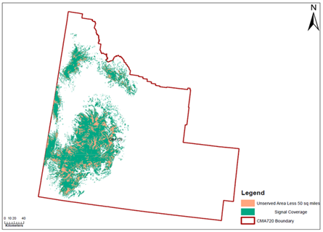

- T-Mobile asks the Bureau to consider a “county-based approach,” under which licensees that serve over 50% of the geography of a county would retain the entire county; licensees that cover 50% or less of a county, in contrast, would have their license area reduced so as to no longer include that county. T-Mobile argues that this approach would make spectrum available for relicensing in a more efficient manner and that, since most license authorizations are based on county boundaries, county-based areas would conform more easily to the boundaries of licensees’ other spectrum assets. It further argues that allowing licensees to define license areas would be burdensome and could lead to inaccurate results. Three commenters opposing T-Mobile’s county-based approach argue that it runs counter to the purpose of the KWYS rules, as it would require licensees serving up to 50% of a county to cease providing service in those areas, while allowing other licensees to retain an entire county even where there were unserved areas in the county, thus leaving potentially large portions of unserved areas unavailable for relicensing.
- We reject T-Mobile’s county-based approach. Implementing this approach would require a rule change, which is beyond the scope of the authority delegated to the Bureau in the 700 MHz Second Report and Order. It also would be contrary to the underlying purpose of the KWYS rules. In other words, rather than fulfilling the purpose of the rules to allow failing licensees to keep the areas that they serve and make any unserved areas available for relicensing, a county-based determination of coverage would terminate the authorizations of certain licensees in areas where they actually are providing service, while allowing other licensees to retain up to half a county of unserved area.

Bureau Review
- As noted above, we will allow licensees to demonstrate coverage based on their actual service in each geographic license area. A licensee must submit a coverage showing that reflects its actual service to the public, based on the methodology it deems to best represent the areas in which the public receives its actual service.
- As we also stated above, demonstrations of service area should reflect the signal level that the licensee has previously represented as service to its customers (e.g., in advertised coverage materials) and the Bureau (e.g., in construction notifications), and licensees should be prepared to defend the methodology used. We caution licensees that the Bureau will look critically at demonstrations that deviate from the metrics used in the licensee’s interim construction notification or represented to its customers, especially showings that materially reduce the signal level at the boundary such that the demonstration might artificially inflate the licensee’s service area.
- While we recognize that license boundaries will not be uniform (see Figure 1), we warn licensees against including areas where no real service is provided that are merely figments of topography (e.g., areas of high elevation distanced from and not part of areas where actual service is provided). Even though the reduced license boundaries will be non-uniform, applicants participating in the relicensing process can apply for adjacent unserved areas and take advantage of the flexibility in our power and secondary markets rules to coordinate and cooperate with neighboring licensees.
- We again remind licensees that have not met their construction and service requirements that the service area demonstration, if approved, ultimately will establish the licensees’ new license boundary. At the boundary, licensees will be required to comply with the 40 dBµV/m field strength limit for 700 MHz licensees set forth in the Commission’s rules. Licensees must file demonstrations of service area using map and file formats similar to those required for construction notifications.
- For these licensees, following the 30-day public notice period and after review of each KWYS filing and any related comments, if the Bureau agrees with the licensee’s depiction of areas to be retained, it will accept the licensee’s construction notification. The Bureau will also update ULS using the licensee’s service area demonstration to reflect the reduced license area. The remaining portion of the original license market will be deemed unserved area and will return to the Commission’s inventory for relicensing.
- We note that the Bureau will have the opportunity to assess the success of this approach when it is implemented for the first group of licenses subject to KWYS. We will monitor the results of the finalized process described above and will consider adjusting our methodology for future iterations of KWYS should the current approach prove to be cumbersome, inefficient, or ineffective.

Identifying Unserved Areas
- Information about the available unserved areas will be publicly available. The Bureau will use the shapefiles submitted by failing licensees to determine the unserved areas of each market. The Bureau will then compile those unserved portions together as areas that will be available for relicensing and will provide instructions on how to access that information by public notice. The Bureau will provide applicants with access to a publicly available map displaying the areas available for relicensing, which they can view, download, and use to determine the areas for which they may wish to seek a license. The public notice announcing the unserved areas available for relicensing will also provide further instructions and specific dates for the commencement of the relicensing process. In setting these dates, the Bureau will provide at least 60 days before the commencement of relicensing to enable potential applicants to conduct all manner of due diligence, including evaluating sites and technical requirements, e.g., site acquisition or lease, existing infrastructure, neighboring operations, and network and backhaul needs. These inquiries are particularly important, given the requirements of licensees described in Section V.

PHASED RELICENSING PROCESS
- Pursuant to the Commission’s rules, relicensing of unserved areas will occur through a two-phase application process, beginning with a 30-day Phase 1 filing window, followed by a Phase 2 rolling window for applications. Applications for available unserved areas must be filed via ULS, and applicants must submit a shapefile describing the areas for which they seek a license.

Applications
- In the interest of administrative clarity and functionality, in the Comment PN we proposed to limit the shapefiles attached to applications for unserved areas to include a single shape covering one contiguous area; if an applicant sought non-contiguous areas to be authorized under the same license, we proposed requiring that the shapes be within a single market boundary. We also proposed that, if an applicant files for non-contiguous shapes in a single application, grant of the application would result in a single license and a single buildout requirement that would be applied to all shapes as a whole. Consequently, failure to meet the buildout requirement with respect to one non-contiguous shape would result in the imposition of the penalty for buildout failure on all shapes covered by the license.
- Only one commenter—CTIA—addressed our proposals concerning the processing of applications. It requests that applicants be permitted to list all the unserved areas for which they seek a license within a single application to avoid the need to file multiple applications for each unserved area. Second, “rather than relying only on a map to indicate areas available for relicensing, CTIA suggests that the Bureau also provide a ‘drop-down list’ of unserved areas that an interested party may select from when submitting its application.” RWA supported both suggested changes in its reply.
- Consistent with our initial proposal, licenses issued through the relicensing process may cover unserved area that crosses market boundaries, as long as the license area is a single contiguous shape; if an applicant seeks a single license for multiple non-contiguous areas, those non-contiguous areas must fall within a single FCC-defined market boundary for the appropriate channel block. We will modify the ULS system, however, so that applicants may file requests for multiple licenses within a single application form. Under this process, the number of shapefiles uploaded within a single application form will dictate the number of licenses that will be issued, if the application is granted. For example, if an applicant wishes to apply for multiple areas to be authorized under separate licenses, it may do so within a single application form by uploading separate shapefiles, each covering the area(s) for which it seeks an individual license. Grant of the application will result in separate licenses being issued for the area(s) covered by each shapefile and separate buildout requirements for each license. If an applicant seeks to apply for multiple non-contiguous areas within a single market boundary to be authorized under a single license, it may do so by uploading to its application a single shapefile that includes each of those areas. Grant of the application will result in a single license and a single buildout requirement, which will apply to all the non-contiguous areas as a whole. A request for such a license could be combined in the same application form with requests for other licenses—whether covering another set of non-contiguous areas within a single market boundary, or covering one contiguous area—in which case each additional shapefile uploaded to the application form would result in an additional license.
- While we are taking several steps to make the relicensing process efficient and easy to use, we reject CTIA’s suggested “drop-down list” of available unserved areas. In the 700 MHz relicensing context, available unserved areas will be determined based on the non-uniform, potentially scattered service areas of failing licensees, which will be constantly changing as unserved areas are returned to the Commission’s inventory. Moreover, applicants are free to apply to serve as much or as little available unserved area as they choose. Instead, we provide greater flexibility for applicants to choose whatever portions of available unserved areas they wish to serve at that time rather than limiting applicant’s choices to a pre-defined “drop-down list.” Therefore, we will allow applicants to select from the available unserved areas by uploading a shapefile covering the area(s) for which they seek a license.
- Parties must file applications for available unserved areas via ULS by submitting a shapefile describing the area for which they seek a license. Applicants can download the publicly available map displaying the available unserved areas and use the file to create the shapefiles to be included in their application. Acceptable shapefiles include all GIS Map File types, including XML, KML, KMZ, and Shape(zip). Subject to the restrictions of Phase 1 and other relicensing rules described below, applicants may apply for any sized area or number of available areas they choose. For instance, while only unserved areas that are at least 50 square miles will be returned to the Commission for relicensing, there is no minimum size requirement for applications to license available unserved areas. Given the stringent construction benchmarks for relicensed areas and the penalty for failure, described in Section V, it is particularly important that potential participants in the relicensing process perform due diligence to determine the areas to which they will be able to provide service, including inquiries about site acquisition or lease, existing infrastructure, neighboring operations, and network and backhaul needs. Applicants should only apply for portions of available unserved areas that accurately reflect their predicted service area based on precise engineering and projected signal propagation specific to the area.
- As with other processes for the licensing of spectrum, at the application stage applicants will not be required to, and should not, file any technical specifications of the services they intend to provide. If an applicant submits any technical specifications or other information not required in the application, the Bureau will not review such information, and the Bureau’s acceptance of an application that includes such information is not an acceptance of those technical specifications. Such filings with technical specifications of the service provided will be reviewed when the licensee files its notification of construction, as discussed in Section V.
- All applications for available unserved areas found acceptable for filing (including the shapefile) will be placed on public notice, and the applications will be available for public review and comment. Because the shapefile contains the primary substantive information for which public notice is provided, i.e., details about the scope of the requested license area sufficient to determine whether the license application is mutually exclusive with another application, we do not anticipate a likely scenario in which confidential treatment of a shapefile would be warranted.
- Form of Application. Applicants will file an application for either one or more new licenses or to modify an existing license. To file an application for a new license for available unserved area, applicants will select the ULS purpose code NE (New). Alternatively, modifications may be used where an applicant is an existing 700 MHz licensee of area adjacent to available unserved areas and wishes to expand the existing license area to contiguously cover a portion of that adjacent unserved area in the same frequency band. Licensees wishing to modify an existing license in such a manner will select the ULS purpose code MD (Modification). While unserved areas acquired as a new license will have a ten-year license term, the effect of requesting a modification of an existing license would be to include the same expiration date as the original license being modified. However, please note that the same construction requirements will apply, regardless of whether the area is acquired as a new license or a license modification.
- Permissible Area(s) under Single License. A license issued through the relicensing process may cover unserved area that crosses market boundaries, as long as the license area is a single contiguous shape. If an applicant seeks a single license for multiple non-contiguous areas, those non-contiguous areas must fall within a single market boundary (see Figure 2). With the exception of applicants filing license modifications during the first round of relicensing, if a licensee wishes to modify an existing license to add available unserved area(s), it may do so as long as the area(s) are adjacent to the area of the existing license (see Figure 2).

Figure 2: Permissible Applications
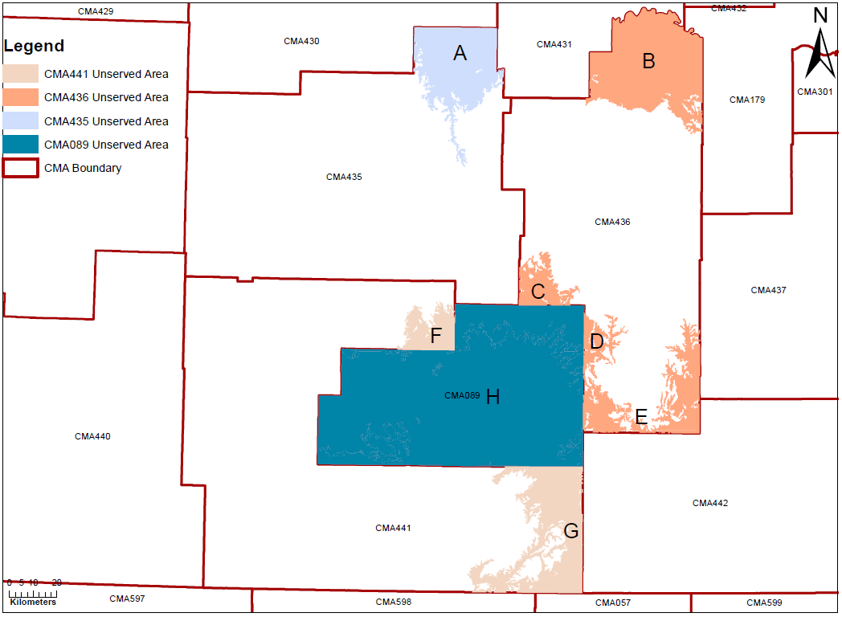
- In Figure 2 above, the areas labeled as A through H represent unserved areas in various adjacent Cellular Market Areas (CMAs). An applicant could file for F, H, and D to be authorized under a single license, even though those areas cross multiple CMA boundaries, because they are all contiguous with each other. An applicant could also file for B, C, D, and E to be authorized under a single license, even though the areas are non-contiguous, because the non-contiguous areas fall within the same CMA. An applicant could not, however, apply for A and B to be authorized under a single license, because the areas are non-contiguous and are in different CMAs. Multiple licenses would be required to offer service in these areas.
- Now suppose that in Figure 2 above, the area marked H represents an existing license for the entire market area of CMA089, which is adjacent to market areas containing the available unserved areas labeled A through G. If the licensee in CMA089 wanted to modify its license to add available unserved areas, it could do so with areas C, D, E, F, and G, because they are all contiguous to the existing license. However, the licensee in CMA089 could not modify its license to add areas A or B, because they are not contiguous to the existing license and are not within the same market area as the existing license. Provision of service in areas A or B would require a new license.
- Applying for Multiple Licenses on a Single Application Form. Applicants seeking new licenses will have the flexibility to file requests for multiple licenses on a single application form. Under this process, the number of shapefiles uploaded within a single application form will dictate the number of licenses that will be issued if the application is granted. For example, if an applicant wishes to apply for multiple contiguous or non-contiguous areas to be authorized under separate licenses, it may do so within a single application form by uploading separate shapefiles, each covering the areas for which it seeks an individual license; grant of the application would result in separate licenses for the areas covered by each shapefile and an individual buildout requirement for each license. If an applicant seeks to apply for multiple non-contiguous areas to be authorized under a single license, it may do so (as long as the areas are within a single market boundary) by uploading to its application a single shapefile that includes all of those areas. Grant of the application would result in a single license and a single buildout requirement would apply to all shapes as a whole. A request for such a license could be combined on the same application form with requests for other licenses—whether covering another set of non-contiguous areas within a single market boundary or covering one contiguous area—in which case each additional shapefile uploaded to the application form would result in an additional license. This functionality will not apply to license modifications, however, because applications to expand into unserved areas adjacent to an existing license require processing through an individual license modification application.
- Error Codes. When an applicant uploads a shapefile in an application for unserved area that does not conform to the requirements for shapefile filing format, the system will display an error code. The table in Figure 3 below provides an explanation of each error code and how it can be resolved.
Figure 3: Error Codes
Error Code | Description of Error/Solution
Invalid Spectrum | The radio frequency data attribute does not match the selected radio service code or is not in the proper form. For example, the frequencies listed for the Lower B Block should appear as:  000704.00000000-000710.00000000, 000734.00000000-000740.00000000
Invalid Market | (For Modifications Only) The Market Area Code listed in the shapefile data attributes does not match the Market Area Code for the license being modified.
Invalid Channel Block | (For Modifications Only) The channel block reflected in the shapefile data attributes does not match the channel block of the license being modified.
Missing Shapefile Attribute | The shapefile does not include all the required data attributes.
Please Upload at least one 700 MHz Relicensed Area Shapefile | No shapefile has been uploaded.
Invalid Radio Service Code | The radio service code reflected in the shapefile data attributes does not match the Radio Service Code selected by the applicant at the beginning of the application.
Invalid Channel Block for Radio Service | The channel block reflected in the shapefile data attributes does not match the Radio Service Code selected by the applicant at the beginning of the application.

- Ownership Certification. Section 27.14 bars the original licensee of available unserved areas, whose authorization to serve that area terminated due to failure to meet the end-of-term construction benchmark, from applying to relicense that area during Phase 1. The section also permanently bars licensees of areas acquired through the relicensing process from applying to serve that area at any future date if they fail to satisfy the one-year 100% construction requirement.
- In order to implement Section 27.14(j)’s requirements, we proposed in the Comment PN to apply the prohibition to any applicant that has any interest or ownership in, or any control of, the original licensee and to any applicant in which the original licensee has any interest, ownership, or control. We sought comment on requiring applicants to make certain certifications regarding the applicant’s relationship to any barred parties in each application for unserved area (Ownership Certification). Alternatively, we sought comment on using a standard similar to the one the Commission uses in evaluating pro forma transfers of control, which considers both de jure and de facto control of the licensee, and we asked whether such a standard might be more appropriate than the proposed bright-line test for ownership.
- All commenters addressing this issue favored our alternate proposal, which would apply the bar based on de jure or de facto control. CTIA argues that barring parties with any interest in a barred party, as proposed, might go too far, and that such a bright-line rule “could inadvertently exclude parties that were not in control of the initial 700 MHz licensee that failed to provide service.” Instead, CTIA argues that determining ownership based on de jure and de facto control will allow the Bureau more effectively and precisely to bar the correct parties. T-Mobile asks the Bureau to “take an expansive view of this bar,” and apply the bar to any parties that “have had a management agreement, lease arrangement, or similar interests in the licensee.”
- We conclude, based on the record, that our alternative proposal of using de jure and de facto standards of control will best serve our goals of encouraging licensees to satisfy their construction requirements while providing others with the opportunity to serve areas that remain unconstructed, and ensuring that the appropriate entities are barred from filing pursuant to Commission rule Section 27.14. Our initial proposal was designed to provide an easily administered bright-line test to prevent potential gaming of the relicensing process. After review of the record, we recognize that such a broad standard may inadvertently exclude entities that do not have a significant connection, in terms of ownership or control, with the barred licensee to be indicative of the applicant’s future actions. It is our predictive judgement that using a de jure and de facto standard of control approach strikes a balance that will help to promote a larger and more diverse pool of applicants – particularly given the Commission’s goal of promoting prompt provision of service through adoption of a one-year construction period for relicensed areas. In light of this balance, we do not agree with T-Mobile that the existence of management agreements or lease arrangements with a barred entity should be sufficient to bar an applicant in all cases. However, we find that the fact-specific, case-by-case nature of the de jure and de facto control standard will provide the Commission the flexibility to consider that nature of various business relationships between parties, as T-Mobile suggests, to determine whether a party is barred from filing under Section 27.14. We therefore make modifications to our proposed Ownership Certification as described below to implement the rule Section 27.14 bar applicable to: (1) temporarily during Phase 1 to licensees that failed to satisfy their initial term construction requirements (Original Licensee), and (2) permanently to licensees of relicensed area that fail to satisfy the construction requirements (Relicensed Area Licensee).
- We define “Original Licensee” or “Relicensed Area Licensee” to include any entities or individuals that have either de jure or de facto of the party that failed to satisfy the construction requirement, and any entities in which the party that failed to satisfy the construction requirement has either de jure or de facto control. A would-be applicant will be barred from applying to serve available unserved areas if any entity or individual that had or has de jure or de facto control of the Original Licensee or Relicensed Area Licensee also has de jure or de facto control of the applicant, the applicant has either de jure or de facto control of the Original Licensee or Relicensed Area Licensee, or if the Original Licensee or Relicensed Area Licensee has de jure or de facto control of the applicant.
- All applications for available unserved areas filed during both phases of relicensing must include as an attachment the Ownership Certification provided below. While applicants will not be required to file any supporting documentation with respect to the Ownership Certification, the Bureau may request such information at its discretion.
Ownership Certification: “By filing this certification and the accompanying application for 700 MHz unserved area, the applicant hereby certifies that, pursuant to Section 27.14(j)(1) and (3) of the Commission’s rules: (1) the applicant is not the Original Licensee or Relicensed Area Licensee that is barred from applying to serve the area during the current phase of relicensing; (2) the applicant does not at the time of filing, and did not at the time of the relevant construction deadline, have de jure or de facto control over the Original Licensee or Relicensed Area Licensee (including any entity or individual that had or has de jure or de facto control of such entity) of the unserved area; and (3) the Original Licensee or Relicensed Area Licensee of the unserved area does not at the time of filing, and did not at the time of the relevant construction deadline, have de jure or de facto control of the applicant.”

Tribal Priority
- The Navajo Nation Telecommunications Regulatory Commission (NNTRC), in its reply comments, asked the Bureau to create a “Tribal Priority” for the relicensing process. Under its proposal, qualifying Tribal entities would notify the Bureau of “proposed Tribal Lands they wish to serve and, after notice and comment, such lands would be removed from the areas available for relicensing.” The NNTRC asks for several amendments to the Commission’s Part 27 rules to implement its proposal. It also asks us to delay the commencement of the relicensing process, as well as to modify and extend our construction obligations for qualifying Tribal entities.
- The Commission did not adopt any type of priority for Tribal entities when it established the KWYS rules and relicensing process in the 700 MHz Second Report and Order. Moreover, the Bureau did not make any proposals relating to a Tribal Priority in the 700 MHz Relicensing PN. Accordingly, we find that NNTRC's requests are beyond the scope of the authority delegated to the Bureau in this context and that its comments are outside the scope of our Public Notice seeking comment on specific aspects for implementing that process. We therefore take no substantive action in response to those requests, and they will not be considered further in connection with the Bureau’s implementation of this relicensing process.

Phase 1 of Relicensing
- Filing Window. Relicensing will begin with a 30-day Phase 1 filing window. At least 60 days before the commencement of the relicensing process, the Bureau will issue a public notice announcing the available unserved areas and the relevant dates on which the Phase 1 filing window will start and end. During this Phase 1 filing window, the original licensee of available unserved areas, whose authorization to serve that area terminated due to failure to meet the end-of-term construction benchmark, is barred from applying to relicense that area. This Phase 1 bar is specific to each unserved area, and therefore an applicant that is barred from applying for one unserved area during Phase 1 is not barred from applying for other available areas for which it was not the original licensee. All applications received during the Phase 1 filing window for a particular unserved area are treated as contemporaneous for the purposes of mutual exclusivity. At the end of the 30-day Phase 1 filing window, the Bureau will issue a public notice listing applications found acceptable for filing during Phase 1, and identifying which acceptable applications, if any, are mutually exclusive. No further applications that are mutually exclusive of a pending Phase 1 application may be filed after the 30-day Phase 1 filing window has ended, but licensees and third parties may file petitions to deny any pending applications within 30 days of the release of the public notice listing Phase 1 applications found acceptable for filing.
- Mutual Exclusivity. Applications will be deemed mutually exclusive if they propose areas overlapping with other applications. As proposed in the Comment PN, this definition of mutually exclusive applications includes “daisy chains” of mutual exclusivity, see Figure 7, which occur when two or more applications contain proposed areas that do not directly overlap, but are linked together into a chain by the overlapping proposals of others. Mutually exclusive applications are subject to auction and the Bureau will provide a limited settlement period for the applicants to resolve the mutual exclusivity prior to auction. Subject to the Greenmail Rule, applicants may resolve mutual exclusivity by withdrawing or filing a minor amendment to one or both mutually exclusive applications.
- Settlement. Pursuant to the Communications Act and the Commission’s rules, mutually exclusive applications are subject to auction. The Commission delegated authority to the Bureau to designate a limited settlement period for the applicants to resolve the mutual exclusivity prior to auction. In the 700 MHz Relicensing Comment PN, we proposed that Phase 1 applicants would be permitted to resolve their mutually exclusive applications during a 30-day period that follows the close of the Phase 1 filing window.
- In its comments, CTIA asks the Bureau to “provide additional time for settlement discussions following the Phase 1 filing window,” as the 30-day Phase 1 public notice period may be insufficient for the parties to negotiate and settle their mutually exclusive applications. No parties filed comments in response to CTIA’s request.
- Given the complexity of resolving mutually exclusive applications in either Phase 1 or Phase 2, we provide applicants consistency by giving Phase 1 applicants the same settlement period that we proposed for Phase 2 applicants. Therefore, upon release of the public notice listing the applications found acceptable for filing during Phase 1, applicants will have 60 days to attempt to reach a settlement concerning the mutually exclusive applications. Any mutual exclusivity that is not resolved by the end of the 60-day period will subject the mutually exclusive applications to auction.
- Amendments. Amendments to an application are considered either major amendments or minor amendments, depending on the circumstance. If one or both of the applicants agrees to reduce or “pull back” the area covered by the application to avoid mutual exclusivity, the change is deemed a minor amendment. Minor amendments do not materially alter the original applications and do not require a new public notice period. Such treatment, however, is not available when a modification to an application constitutes a major amendment. If the applicants’ agreement would require that either application be modified to “move” the area applied for, such that it would include area that was not part of the area specified in the application as originally filed, such a change would be deemed a major amendment. Because major amendments constitute new applications for unserved area, major amendments to Phase 1 applications after the 30-day Phase 1 filing window has ended are not permitted, and the underlying application may be dismissed unless the applicant withdraws the major amendment or adjusts the filing to represent only a minor amendment. At that point, the dismissed applicant could file a new application for a license covering the modified area, but such application, because it would be filed during Phase 2, would be subject to potential Phase 2 competing filings.

Figure 4: Mutual Exclusivity
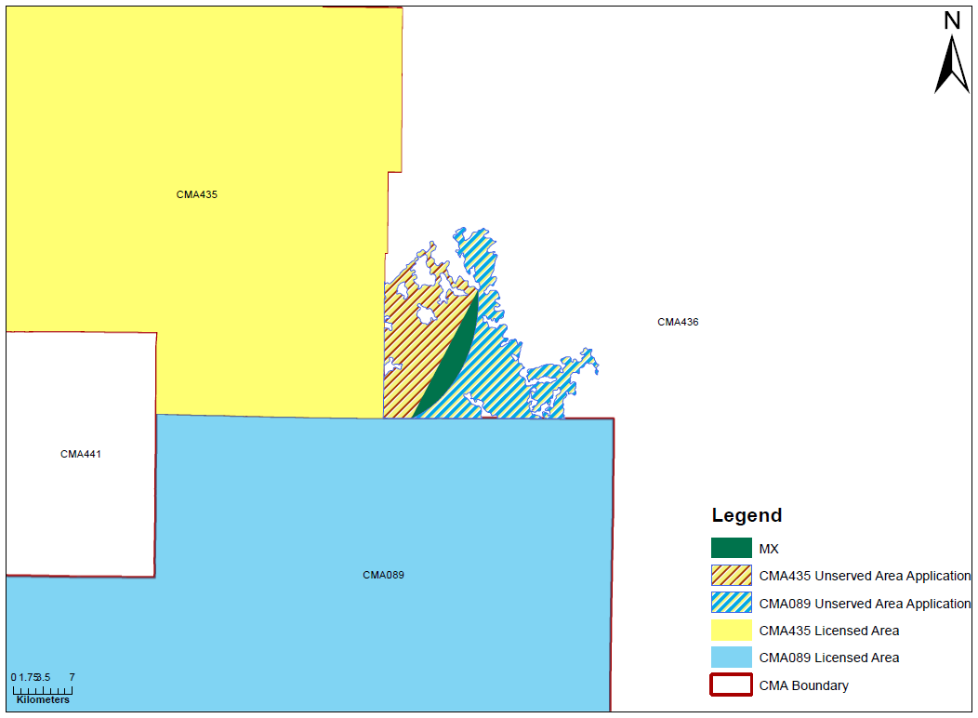
Figure 5: Minor Amendment
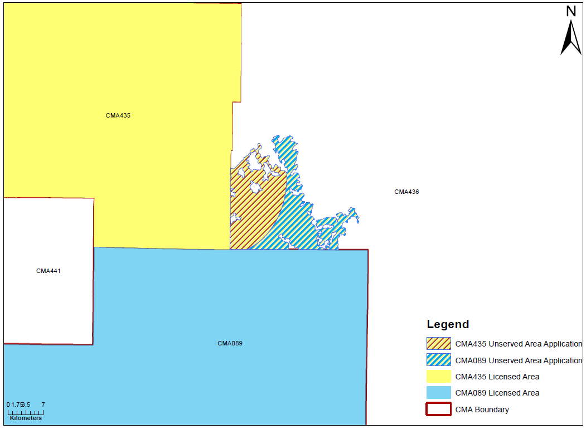

Figure 6: Major Amendment
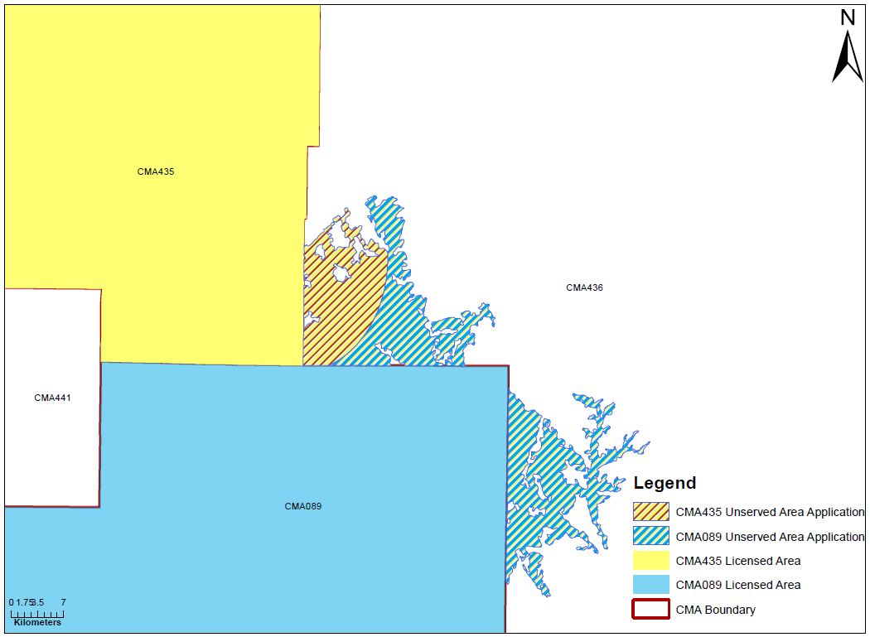
- Figure 4 above represents two existing licensees—one in CMA435 and one in CMA089—that have applied for available unserved areas adjacent to both existing licenses, in CMA436. Because the areas covered by the applications overlap, the applications are mutually exclusive. In Figure 5, the licensee in CMA089 has pulled back its application for unserved area to eliminate the overlapping area, thereby avoiding mutual exclusivity. Figure 5 reduces the area of the application and therefore represents a minor amendment. In contrast, in Figure 6, in addition to pulling back its application to eliminate the overlapping area, the licensee in CMA089 has also expanded its application to include additional available unserved area in CMA436. While the amendment in Figure 6 avoids mutual exclusivity, it adds unserved area that was not included in the application as originally filed, and therefore represents a major amendment. Such major amendments, if filed after the 30-day Phase 1 filing window has ended, are not permitted; therefore, the underlying application may be dismissed unless the applicant withdraws the major amendment or adjusts the filing to represent only a minor amendment.

Phase 2 of Relicensing
- Following Phase 1, the Bureau will issue a public notice that will (1) list applications found acceptable for filing during Phase 1, (2) direct interested parties to the publicly available information about the available unserved areas, and (3) announce the date on which the Bureau will begin accepting Phase 2 applications. The Bureau will update the publicly available relicensing map to reflect pending applications, licenses that were issued, and areas that remain available for relicensing.
- During Phase 2, interested applicants, including those that were barred during Phase 1, may file applications on a rolling basis for available unserved areas that were not licensed during Phase 1 or for which there are no pending applications. However, licensees that have failed to satisfy the construction requirements for relicensed area are permanently barred from applying to serve that area at any future date, including during Phase 2. The Bureau will place each first-filed Phase 2 application deemed acceptable for filing on public notice for 30 days, during which interested applicants may file mutually exclusive applications subject to the guidelines in this document.
- Mutual Exclusivity. As with Phase 1, Phase 2 applications will be deemed mutually exclusive if they propose areas overlapping with other applications. This definition of mutually exclusive applications includes “daisy chains” of mutual exclusivity, which occur when two or more applications contain proposed areas that do not directly overlap but are linked together in a chain by the overlapping proposal(s) of other(s), see Figure 7. The date of the public notice of the first-filed application in a given unserved area will establish the 30-day filing period for all subsequent applications that are mutually exclusive—whether directly or through a “daisy chain” relationship—with the first-filed application. The Bureau may dismiss any further mutually exclusive applications filed after this 30-day filing period, unless the applicant amends the application to avoid mutual exclusivity. Mutually exclusive applications are subject to auction and the Bureau may designate a limited settlement period, see paragraph 36, for the applicants to resolve the mutual exclusivity prior to auction. Subject to the Greenmail Rule, applicants may resolve mutual exclusivity by withdrawing or filing a minor amendment to one or both mutually exclusive applications.
Figure 7: Daisy Chain of Mutual Exclusivity
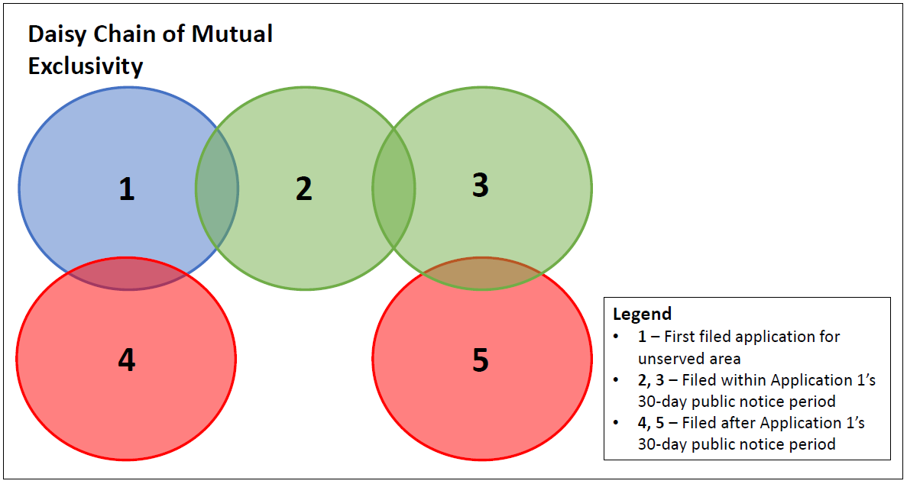
- Figure 7 illustrates how applications that do not directly overlap with other applications may nevertheless be considered mutually exclusive through a daisy chain. In Figure 7, an applicant files Application 1 for available unserved area during Phase 2, which starts a 30-day public notice period during which third parties may file petitions to deny and applications that are mutually exclusive of Application 1. On day 10 of Application 1’s public notice period, a party files Application 2, which is mutually exclusive of Application 1. On day 20 of Application 1’s public notice period, another party files Application 3, which is mutually exclusive of Application 2, but not mutually exclusive of Application 1. Applications 1, 2, and 3 represent a daisy chain of mutual exclusivity and all three applicants would be required to reach a settlement to avoid an auction to resolve the conflicting applications. Applications 4 and 5 are filed on day 40, after the close of Application 1’s public notice period. Unless Application 4 is amended to avoid mutual exclusivity, Application 4 may be dismissed because it is mutually exclusive of Application 1 and was filed after the close of Application 1’s public notice period. Application 5 is mutually exclusive of Application 3 and may be dismissed unless amended to avoid mutual exclusivity, because it is part of the daisy chain of mutual exclusivity with Application 1 and was filed outside of the first-filed application’s public notice period.
- Settlement. As proposed in the 700 MHz Relicensing Comment PN, following a Phase 2 application’s 30-day public notice period, if the Bureau determines there are existing applications that are mutually exclusive of the initial application, it will issue a public notice identifying the conflicting applications and providing the parties with 60 days to resolve the mutual exclusivity. Any mutually exclusive applications that are not resolved by the end of the 60-day period are subject to auction.
- Amendments. As with Phase 1, Phase 2 applicants may withdraw or amend their applications to avoid mutual exclusivity. In contrast to Phase 1, both major and minor amendments to Phase 2 applications are permitted, see Figures 4-6, and such amendments may be filed during the first-filed application’s public notice period or the period for settlement of mutually exclusive applications described below. A major amendment to a pending application, however, will require a new public notice period during which the applicant would be subject to further mutually exclusive applications.

RELICENSED AREA

Construction Requirement
- Licensees of 700 MHz licenses acquired through the relicensing process will have one year from the date the new license is issued to complete construction, provide signal coverage, and offer service over 100% of the geographic area of the relicensed area. If the licensee fails to meet this construction requirement, its license will automatically terminate without Commission action and it will be ineligible to apply to provide service to that area at any future date. Unlike the KWYS rules, which provide that unserved area less than 50 square miles will be deemed “served” for purposes of determining a failing licensee’s service area, the rules setting forth the construction requirements for relicensed area do not contain any provision for treating such smaller unserved portions of a licensee’s service area as “served.” Rather, Section 27.14(j)(3) states, without exception, that the failure of a licensee of relicensed area to complete its construction and provide signal coverage and offer service over 100% of the geographic area of the new license area will result in the automatic termination of the license. Therefore, any portion of the relicensed area that remains unserved at the one-year construction deadline—even if less than 50 square miles—will result in failure to satisfy this requirement and application of the penalty for failure.

Modifications
- In the 700 MHz Relicensing Comment PN, we proposed that licensees would not be permitted to modify the license to reduce the licensed area before meeting the one-year construction benchmark, as this would effectively avoid the 100% geographic coverage requirement by reducing the area they must cover.
- In its comments, RWA asks the Bureau to apply a de minimis standard to reductions in license area before the one-year construction benchmark and to permit license modifications as long as the modification does not result in a reduction of greater than 10% in the size of the licensed area. RWA asserts that the “vagaries of RF radiation” make it difficult for a licensee to precisely duplicate its predicted coverage. RWA argues that permitting 10% license reductions “will balance the occasional need of a licensee to reduce the size of its coverage area by a de minimis amount to account for real world technical impediments against the Bureau’s desire to deter manipulation of its relicensing process.” None of the commenting parties filed in response to RWA’s request.
- We reject RWA’s proposal, as it would permit a licensee to construct only 90% of the area originally authorized through relicensing without losing the license. Such a proposal is inconsistent with the 100% construction requirement that the Commission adopted and outside the scope of the Bureau’s delegated authority. The Commission provided applicants with the flexibility to select whatever size of available unserved areas they choose, and applicants can take into account the variations in real world signal propagation when determining the area they seek to license.
- Therefore, as proposed, we will deem any modification to reduce the license area of a license acquired through the relicensing process as a failure to satisfy the 100% construction requirement. Such a failure will result in automatic termination of the license and a permanent bar on the licensee, including any entities that would be barred as a result of their relationship to the former licensee, from applying to serve that area at any future date.

Assignments
- In the 700 MHz Relicensing Comment PN, we proposed that licensees would be permitted to file applications to assign licenses acquired through relicensing (including requests to partition and disaggregate) only after they have demonstrated that they have met the construction benchmark. We observed that, while the Bureau believes this procedure for assignment would best promote administrative efficiency, we would consider waivers for larger assignment transactions on a case-by-case basis.
- In its comments, T-Mobile objects to the Bureau’s proposal to only allow assignment applications after a licensee has satisfied its construction requirement. It argues that the Bureau should permit such assignments “so long as the successor entities are bound by the same 100% coverage requirement at the end of the one-year construction deadline.” None of the commenting parties filed in response to T-Mobile’s request.
- We agree that T-Mobile’s proposal would increase the flexibility of our proposed approach without creating unnecessary mutually exclusive applications filed against those of applicants that actually intend to serve those areas. In the WRS Renewal Second Report and Order, the Commission adopted a requirement that parties to a partition or disaggregation agreement either: (1) each certify that they will independently meet the construction requirements; or (2) agree to share the responsibility for satisfying the construction requirements. Under the Commission’s construction rules, however, in the case of a full assignment, only the assignee, not the assignor, is responsible for satisfying the one-year construction benchmark.
- To provide the flexibility sought, while at the same time preventing potential gaming of the relicensing process, we will permit assignment of relicensed area (including through partition or disaggregation) before satisfying the one-year construction benchmark subject to two restrictions.
- First, the license may not be assigned to any parties that would have been barred, given their relationship to the assignor, from applying to serve the relicensed area during the phase of relicensing in which the assignor acquired it. For example, a party that would have been barred from applying during Phase 1 for a particular area could not acquire that area through assignment if the current licensee acquired it during Phase 1, but that same party could acquire it through assignment from a licensee who acquired it during Phase 2 (when the party would no longer have been barred from applying to serve the area). A party who is permanently barred from applying to serve an area due to failure to satisfy the construction requirements for relicensed area would be barred from acquiring that area through assignment in any case, irrespective of whether the current licensee acquired it during Phase 1 or 2.
- Second, if the one-year construction benchmark is not satisfied with respect to the entire relicensed area, the penalty for failure, i.e., automatic termination of the license and a permanent bar from serving that area at any future date, will apply to all parties to the transaction, including any entities that would be barred as a result of their relationship to either party to the transaction, regardless of whether the assignment is a full assignment, partition, or disaggregation.
Example 1: A, a licensee of relicensed area, assigns the entire license to B. B fails to satisfy the one-year 100% construction benchmark. The entire relicensed area, including any portion that B is serving, automatically terminates. Both A and B, including any entities that would be barred because of their relationship to A or B, are permanently barred from applying to serve that area at any future date.
Example 2: A, a licensee of relicensed area, partitions half of the license to B. B builds 100% of its half of the license by the one-year construction deadline, but A does not. The entire license area as originally licensed through the relicensing process, including any portion that A or B is serving, terminates automatically. Both A and B, including any entities that would be barred because of their relationship to A or B, are permanently barred from applying to serve the entire area as originally acquired through relicensing at any future date.
Example 3: A, a licensee of relicensed area, disaggregates half of its licensed spectrum to B. A and B must either individually or collectively offer services that provide combined coverage to 100% of the geographic area. Regardless of whether the licensees choose to meet the construction benchmark individually or collectively, if they fail to provide coverage to 100% of the geographic area as of the one-year deadline, both licenses will automatically terminate and both A and B, including any entities that would be barred as a result of their relationship to A or B, will be permanently barred from applying to serve that area at any future date.
- By eliminating any potential secondary market for assignments to barred parties and holding the assignor, as well as the assignee, accountable for failure to satisfy the construction requirement, we find this approach will adequately discourage gaming and speculation during the relicensing process. We will require assignment applications filed before the one-year construction benchmark to include the same Ownership Certification regarding non-barred status that applicants are required to file when applying for available unserved areas in the relicensing process.

Cancellation
- In the Comment PN, we proposed to treat any cancellation of a license before meeting the 100% coverage requirement as a failure to satisfy the performance obligations. No party objected to this proposal. We adopt this proposal, based upon the rationale described in the Comment PN—namely, that it provides an incentive for rapid deployment of service on relicensed spectrum. Therefore, we will deem the cancellation of a license before meeting the one-year construction benchmark as failure to satisfy the required performance obligations. Consequently, the cancelling licensee, including any entities that would be barred because of their relationship to the cancelling licensee, will be ineligible to apply to serve any portion of the cancelled license area at any future date.

Construction Showing
- Licensees must demonstrate compliance with the one-year construction benchmark by filing a construction notification with the Commission no later than 15 days after the relevant deadline demonstrating that they have met the construction requirements. To implement this requirement, in the Comment PN we proposed that, at the one-year construction deadline, licensees would be required to demonstrate that they provide signal coverage and offer service to 100% of the geographic area by filing either a 40 dBµV/m smooth contour or an alternative smooth contour. No commenters responded directly to this proposal. Nonetheless, we adjust our final approach in light of the changes we made above to the required KWYS filing service area demonstration.
- Accordingly, licensees must demonstrate compliance with the 100% geographic coverage requirement by filing a service area demonstration that reflects their actual service in the license area, based on the methodology the licensee deems to best represent the areas in which it provides an actual service. We expect that licensees will have used due diligence and made necessary inquiries to ensure their ability to meet our 100% geographic coverage requirement before filing their application for unserved areas. Demonstrations of service area should reflect the signal strength that the licensee represents to its customers as service, and licensees should be prepared to defend the methodology used. We caution licensees that the Bureau will look critically at showings that materially reduce the signal level at the boundary such that the demonstration might artificially inflate the licensee’s coverage area. While licensees are permitted to file construction demonstrations that reflect the signal levels they deem to represent the services they provide, those signal levels may not result in a field strength that exceeds 40 dBµV/m at the license boundary, as licensees of relicensed area will be bound by the same license boundary field strength limit applicable to all 700 MHz licensees. As with the KWYS showing, we will require that construction demonstrations be filed using the map and filing formats described herein.
- The Bureau places construction notifications on public notice and reviews each notification and any related comments before making a determination regarding the notification. Interested parties are permitted to file comments, which must be filed no later than 30 days after the public notice release date. After examining the construction notifications and public comments, the Bureau determines whether each licensee has made a sufficient showing to satisfy the one-year construction benchmark and retain its license.
- If a licensee does not file either a request for extension of time before the construction deadline, or the required construction notification within 15 days after the construction deadline, as required by Section 1.946 of the Commission’s rules, we presume that the license has not been constructed, or the coverage requirement has not been met. As a result, the Bureau places such licenses in “Termination Pending” status and lists the license on the Weekly Termination Pending Public Notice. The Bureau also notifies the licensee by letter that, if it has met its construction requirement, it has 30 days from the date of that public notice to file a petition for reconsideration showing that it timely met the construction deadline. If the licensee does not file a petition for reconsideration within the 30-day reconsideration period showing timely construction, the Bureau updates its licensing records in ULS to show the license as “Terminated,” effective as of the construction deadline. The license is also listed on a weekly public notice reflecting its status as changed to Terminated. The former licensee of the terminated license, including any entities that would be barred because of their relationship to the former licensee, will also be permanently barred from applying to serve the terminated license area at any future date.

Unserved Relicensed Area
- If a licensee of relicensed area fails to satisfy the one-year 100% construction requirement, the entire relicensed area returns to the Commission’s inventory for relicensing. Such area would enter relicensing via Phase 2 status, as there would be no applicable Phase 1 bar such that the 30-day Phase 1 filing window is necessary. Except for the barred parties and related entities, interested parties are permitted to begin filing applications to serve the area on the 30th day after the release of the public notice listing the license as terminated.

Procedural Matters
- Regulatory Flexibility Analysis. As required by the Regulatory Flexibility Act of 1980 (RFA), the Commission prepared an Initial Regulatory Flexibility Analysis (IRFA) in connection with the 700 MHz Further Notice and a Final Regulatory Flexibility Analysis (FRFA) in connection with the 700 MHz Second Report and Order. While no commenter directly responded to the IRFA, the FRFA addressed concerns about the impact on small business of the KWYS rules. The IRFA and FRFA set forth the need for and objectives of the Commission’s rules for the KWYS rules; the legal basis for those rules, a description and estimate of the number of small entities to which the rules apply; a description of projected reporting, recordkeeping, and other compliance requirements for small entities; steps taken to minimize the significant economic impact on small entities and significant alternatives considered; and a statement that there are no federal rules that may duplicate, overlap, or conflict with the rules. While the proposals in the 700 MHz Relicensing Comment PN did not change any of those descriptions, we sought comment on whether the implementation of our proposals might affect either the IRFA or the FRFA. No comments were filed in response to the 700 MHz Relicensing Comment PN with respect to potential impacts on the IRFA or the FRFA, and we have concluded that the implementation of our proposals herein has had no further impact beyond that identified in the IRFA and FRFA.
- Paperwork Reduction Act. This document does not contain proposed information collection(s) subject to the Paperwork Reduction Act of 1995 (PRA), Public Law 104-13. In addition, it does not contain any new or modified information collection burden for small business concerns with fewer than 25 employees, pursuant to the Small Business Paperwork Relief Act of 2002, Public Law 107-198, see 44 U.S.C. 3506(c)(4).
- Congressional Review Act. The Commission will send a copy of this Public Notice to Congress and the Government Accountability office, pursuant to the Congressional Review Act.
- This Public Notice shall become effective thirty (30) days after the date of publication in the Federal Register.
- Further Information. Questions regarding this public notice may be directed to Melissa Conway, Attorney Advisor, Wireless Telecommunications Bureau, Mobility Division, at (202) 418-2887 or Melissa.conway@fcc.gov.

authority
- Action taken under delegated authority pursuant to Sections 0.131 and 0.331 of the Commission’s rules, 47 CFR §§ 0.131, 0.331, and Service Rules for 698-746, 747-762, and 777-792 MHz Bands et al., Second Report and Order, 22 FCC Rcd 15289 (2007).
By the Chief, Mobility Division, Wireless Telecommunications Bureau.

See generally Service Rules for 698-746, 747-762, and 777-792 MHz Bands et al., Second Report and Order, 22 FCC Rcd 15289 (2007) (700 MHz Second Report and Order).
See Promoting Interoperability in the 700 MHz Commercial Spectrum, Report and Order and Order of Proposed Modification, 28 FCC Rcd 15122, 15151-52, para. 65 (2013) (Interoperability Report and Order).
Interoperability Report and Order, 28 FCC Rcd at 15147-49, paras. 56-59.
47 CFR § 27.14(g)(1), (h)(1); Interoperability Report and Order, 28 FCC Rcd at 15148, para. 58.
As discussed above, the coverage requirements vary by spectrum block.
47 CFR § 27.14(g)(2), (h)(2), (i)(2). Licensees also may be subject to enforcement action, including forfeitures. Id.
700 MHz Second Report and Order, 22 FCC Rcd at 15353, para. 171; 47 CFR § 27.14(j)(1).
See generally Wireless Telecommunications Bureau Seeks Comment on Process for Relicensing 700 MHz Spectrum Unserved Areas, DA 17-810, Public Notice, 2017 WL 3725816 (WTB, rel. Aug. 28, 2017) (700 MHz Relicensing Comment PN); see also generally 700 MHz Second Report and Order.
See CTIA Comments; Rural Wireless Association, Inc. Comments (RWA Comments); T-Mobile USA, Inc. Comments (T-Mobile Comments); AT&T Reply; RWA Reply, Competitive Carrier Association Reply (CCA Reply); Navajo Nation Telecommunications Regulatory Commission Reply (NNTRC Reply); DISH Network Corporation Reply (DISH Reply).
700 MHz Second Report and Order, 22 FCC Rcd at 15352, para. 166.
See Wireless Telecommunications Bureau Establishes Electronic Map Format for Covered 700 MHz Band Licensee Construction Notifications, Public Notice, 30 FCC Rcd 11407 (WTB 2015); 700 MHz Construction and Reporting Requirements and Related Deadlines, Public Notice, 31 FCC Rcd 5297 (WTB 2016) (clarifying and updating certain filing requirements).
Biennial Regulatory Review – Amendment of Parts 0, 1, 13, 22, 24, 26, 27, 80, 87, 90, 95, 97, and 101 of the Commission’s Rules to Facilitate the Development and Use of the Universal Licensing System in the Wireless Telecommunications Services, et al., Report and Order, 13 FCC Rcd 21027, 21074-77, paras. 102-08 (1999). See also Wireless Telecommunications Bureau Announces Deployment of “Auto-Term,” the Automated Feature in its Universal Licensing System that Identifies Unconstructed Stations Resulting in Automatic Termination of Licenses, Public Notice, 21 FCC Rcd 163 (WTB 2006) (Auto-Term PN).
Auto-Term PN, 21 FCC Rcd at 164; see 47 CFR §§ 1.106, 1.115.
Id.
T-Mobile Comments at 6; see also RWA Reply at 3.
Id.; see infra para. 16.
T-Mobile Comments at 6.
See RWA Reply at 3 (suggesting that an immediate loss of license for failing to submit a construction notification not be automatic).
700 MHz Relicensing Comment PN at 3, paras. 5-6. See also 700 MHz Second Report and Order, 22 FCC Rcd at 15352, para. 166; 47 CFR § 27.14(g)(2), (h)(2), (i)(2).
A smooth contour is a closed, non-overlapping polygon. Here, the smooth contour would be a closed, non-overlapping polygon reflecting the signal area at 40 dBµV/m field strength.
700 MHz Relicensing Comment PN at 4, para. 7.
Id.
Id.
Id.
CTIA Comments at 2-5.
Id. at 6.
See AT&T Reply at 1-2; DISH Reply at 3; CCA Reply at 4. None of the commenting parties opposed CTIA’s position.
Smooth contour methodology is permissible but not required. We would observe, however, that if a licensee’s coverage demonstration contains a large number of non-contiguous, small areas (e.g., the scattering of green dots in Figure 1), the revised license will have a large number of license boundaries—one around each non-contiguous area. At each of these boundaries, the licensee must observe the 40 dBµV/m field strength limit. Given that compliance with the field strength limit along a large number of these non-contiguous boundaries may be difficult to achieve, such licensees may want to opt for a smooth contour methodology, or other methodology that minimizes non-contiguous boundaries yet accurately depicts areas of coverage in which they provide service.
47 CFR § 27.14(g)(3), (h)(3), (i)(3).
In Figure 1, the red line depicts the original license boundary; the green is an example of the areas where a licensee may argue it provides service; and the orange is an example of areas that a licensee claims to be less than 50 square miles (yet enclosed within area of coverage).
T-Mobile Comments at 3-4. T-Mobile also suggests that other defined geographic areas, such as census tracts, could be used in lieu of counties. Id. at 5.
Id. at 4.
AT&T Reply at 2; DISH Reply at 4; RWA Reply at 2-3.
RWA Reply at 1-2.
The maps and service area demonstrations presented in the Figures of this Public Notice are for illustrative purposes only. Any such maps or demonstrations contained in a given application must accurately reflect the unique characteristics of each applicant’s specific demonstration or request.
47 CFR § 27.55(a)(2).
700 MHz Relicensing Comment PN at 4-5, para. 9.
Id. There are no concerns raised in the record involving the proposals contained in paragraph 9 of the 700 MHz Relicensing Comment PN.
47 CFR § 27.14(j)(1) and (2).
700 MHz Relicensing Comment PN at 6, para. 12. For example, a non-contiguous shapefile for A-Block areas must be contained within one Economic Area (EA); a non-contiguous shapefile for B-Block areas must be contained within one Cellular Market Area (CMA).
Id. None of the commenting parties responded to this proposal.
CTIA Comments at 8-9.
Id. at 9.
RWA Reply at 3-4.
ULS purpose code NE (New). This functionality will not apply to license modifications – ULS purpose code MD (Modification) – as applications to expand into unserved areas adjacent to an existing license require separate processing through an individual license modification application.
47 CFR § 27.13.
See 700 MHz Relicensing Comment PN at 6-7, para. 12; 700 MHz Second Report and Order, 22 FCC Rcd at 15353, para. 171; 47 CFR § 27.14(j)(1).
Due to pending changes to ULS necessary for the processing of such applications, applicants during the first round of relicensing (i.e., relicensing of unserved areas returned to the Commission’s inventory as a result of failure to satisfy the June 13, 2017 construction deadline) will not have the ability to modify an existing license to add available unserved areas in an adjacent market. However, we anticipate that the necessary system changes will be completed in time to process such applications during the next round of relicensing unserved areas resulting from any failures in 2019 or thereafter.
47 CFR § 27.14(j)(1).
47 CFR § 27.14(j)(3).
700 MHz Relicensing Comment PN at 6, para. 14.
Id. While we did not use the defined term “Ownership Certification” in the Comment PN, we do so here to clarify that the Ownership Certification includes all the statements that we will require applicants to certify to in order to determine which applicants are barred, as described in this section.
See, e.g., 47 CFR §§ 1.929(k)(1) (applications for pro forma assignment or transfer of control deemed a minor application), 1.933(d)(2) (no public notice required prior to grant of pro forma assignments and transfers), 1.948(c)(1) (prior Commission approval not required for pro forma assignment of authorization or transfer of control).
The Commission reiterated long-standing principles of affiliation and controlling interests, including de jure and de facto control, when it established a new standard for evaluating designated entity status. See Updating Part 1 Competitive Bidding Rules et al., Report and Order, 30 FCC Rcd 7493, 7507-11, paras. 29-39 (2015) (Updating Part 1 Order) (“De jure control is typically evidenced by the holding of greater than 50% of the voting stock of a corporation, or in the case of a partnership, general partnership interests. De facto control is assessed on a case-by-case basis to determine whether the licensee has actual control over its business. Pursuant to section 1.2110, control and affiliation may also arise through, among other things, ownership interests, voting interests, management and other operating agreements, or the terms of any other types of agreements—including spectrum lease agreements—that independently or together create a controlling, or potentially controlling, interest in the DE's business as a whole.”); 47 CFR § 1.2110 (addressing material relationships attributable to applicants seeking designated entity status; defining controlling interests at 1.2110(c)(2)). See also Federal Communications Bar Association’s Petition for Forbearance from Section 310(D) of the Communications Act Regarding Non-Substantial Assignments of Wireless Licenses and Transfers of Control Involving Telecommunications Carriers et al., FCC 98-18, Memorandum Opinion and Order, 13 FCC Rcd 6293, paras. 7-9 (1998).
700 MHz Relicensing Comment PN at 6-7, para 14.
See CTIA Comments at 9-10; T-Mobile Comments at 6-7; RWA Reply at 4.
CTIA Comments at 9.
T-Mobile Comments at 6-7, citing 47 CFR § 1.2110(c)(2). While T-Mobile asserts that this “expansive view” is supported by the factors listed in the Commission’s designated entity rule, those rules only include present management agreements, not past management agreements or past or present lease arrangements. Id.
While lease arrangements and management agreements are relevant considerations, they are not per se evidence of de facto control. Rather, the existence of such an agreement is one of many factors that may together or independently, depending on the factual circumstances, create a controlling interest. See Updating Part 1 Order, 30 FCC Rcd at 7507, para. 30.
In assessing the existence of either de jure or de facto control, the relevant time periods are the time of failure to satisfy the construction requirement and the time of filing an application for unserved area. De jure and de facto control may exist either directly, or indirectly through one or more intervening corporations linked together through a vertical ownership chain. See 47 CFR § 1.2105(a)(4); Updating Part 1 Order, 30 FCC Rcd at 7580-81, para. 207, n.656. We will continue to apply the Commission’s Intermountain Microwave factors when making determinations regarding de facto control of a licensee’s facilities. See Intermountain Microwave, Public Notice, 12 FCC 2d 559, 560, Report No. 1142 (1963). See also Application of Ellis Thompson Corp., Memorandum Opinion and Order and Hearing Designation Order, 9 FCC Rcd 7138 (1994).
We note that, while we will require applicants to attach the Ownership Certification during both phases of relicensing, applicants are only certifying that they are not barred during the phase in which they are filing. For example, an applicant that would have been barred only during Phase 1 for a particular unserved area (i.e., the original licensee of the unserved area or a related entity as defined by the certification) is not barred during Phase 2 and could make the necessary Ownership Certification stating that it is not a barred party.
See generally NNTRC Reply.
Id. at 5.
Id. at 4-5. The requested amendments include: (1) adding a definition for “Qualified Tribal Applicants” that could make use of the Tribal Priority to Part 27; (2) amending Section 27.14(j)(1) so that an application for unserved areas in a Tribal Land that is mutually exclusive of an application filed by a qualifying Tribal applicant would not result in an auction; and (3) amending Section 27.14(j)(3) to apply the full-term interim and final construction requirements contained in Section 27.14(g) to licenses acquired using the Tribal Priority.
Id. at 5.
We also note that none of the interested parties commenting in that proceeding, including NNTRC, asked the Commission to consider the rule changes necessary to create a Tribal Priority for the relicensing process, nor did they file a petition for reconsideration of the 700 MHz Second Report and Order.
700 MHz Second Report and Order, 22 FCC Rcd at 15481, para. 557. See also 700 MHz Second R&O Order on Reconsideration, 28 FCC Rcd at 2677-78, para. 15 (stating that in the 700 MHz Second Report and Order, the Commission delegated to the Bureau “the authority to establish further specifications for filings and to determine coverage areas” to implement the relicensing process). See also 47 CFR § 0.331 (defining the authority delegated to the Wireless Telecommunications Bureau).
That said, our declining to take action here is without prejudice to any future request NNTRC may choose to file with the full Commission to initiate further rulemaking action in these regards.
47 CFR § 27.14(j)(1).
700 MHz Relicensing Comment PN at 8-9, para 19. None of the commenting parties responded to this proposal.
See, e.g., Auction No. 81 Final Settlement Window Announced, Public Notice, 18 FCC Rcd 25141, 25142 (MB 2003); Supplemental Closed Broadcast Auction; Auction No. 28, Notice and Filing Requirements for Auction of AM, FM, TV, LPTV, and FM and TV Translator Construction Permits Scheduled for March 21, 2000; Minimum Opening Bids and Other Procedural Issues, DA 99-2958, Public Notice (MB/WTB, Dec. 23, 1999).
47 CFR § 1.935 (Settlement agreements require Commission approval and applicants may not “receive any money or other consideration in excess of the legitimate and prudent expenses incurred in preparing and prosecuting the application, petition to deny, informal objection, or other pleading in exchange for withdrawal or dismissal of the application, petition to deny, informal objection or other pleading, or threat to file a pleading . . . .”). See also id. § 27.14(j)(1). For examples of how this rule has been applied to applications for unserved area in the Cellular Radiotelephone Service band, see, e.g., Wireless Telecommunications Bureau Approves Settlement Agreement Between Keystone Wireless, Inc. and Verizon Wireless (VAW) LLC, Public Notice, 23 FCC Rcd 7931 (WTB 2008); Wireless Telecommunications Bureau Approves Settlement Agreement Between WWC License L.L.C. and WWC Holding Co., Inc., and N.E. Colorado Cellular Inc., Public Notice, 17 FCC Rcd 26148 (WTB 2002); Settlement Agreement Between ACS Wireless Sub, Inc. and Copper Valley Wireless, Inc. Approved, Public Notice, 17 FCC Rcd 10571 (WTB 2002).
47 USC §309(j); 47 CFR §§ 27.14(j)(1), 90.165(c)(4)(ii).
47 CFR § 27.14(j)(1).
700 MHz Relicensing Comment PN at 8, para. 17.
CTIA Comments at 10.
Id.
In both Phase 1 and Phase 2, applicants must consider the likelihood of success at auction when compared to agreeing to reduce coverage in some way. Considerations of reducing coverage include meeting consumer demand in particular areas, whether other spectrum bands could be used to address these demands, whether sites can be economically re-engineered to reduce coverage as needed, etc.
See 47 CFR § 1.929; see also 700 MHz Relicensing Comment PN at 7-8, para. 16.
Such a modification could reflect an expansion of the originally requested area, or it could be the result of a substitution that maintains or reduces the net square mileage covered by the original request, but which describes an area that includes at least some geographic portion that was not requested in the application as originally filed.
47 CFR § 1.929(a)(1).
See 47 CFR § 90.165(b)(3).
See supra note 72.
700 MHz Relicensing Comment PN at 9, para. 19. None of the commenting parties responded to this proposal.
47 USC §309(j); 47 CFR §§ 27.14(j)(1), 90.165(c)(4)(ii).
47 CFR § 27.14(j)(3).
Id.
700 MHz Relicensing Comment PN at 10, para 22.
RWA Comments at 2.
Id.
Id. at 2-3.
700 MHz Relicensing Comment PN at 10, para. 22.
Id. at 10, n.65.
T-Mobile Comments at 7.
WRS Renewal Second Report and Order, 2017 WL 3381028 at *23-28, paras. 74-89. The WRS Renewal Second Report and Order adopted a unified framework for construction, renewal, and service continuity rules for flexible-use geographic licenses in the Wireless Radio Services. We note that while the rule the Commission adopted to address construction obligations resulting from partition and disaggregation – 47 CFR § 1.950 – is pending approval from the Office of Management and Budget, we anticipate this rule will take effect before commencement of the 700 MHz relicensing process.
See supra paras. 43-48.
700 MHz Relicensing Comment PN at 10, para. 22.
47 CFR § 1.946(d).
700 MHz Relicensing Comment PN at 10, para. 24.
47 CFR § 27.55(a)(2).
Auto-Term PN, 21 FCC Rcd at 164; see 47 CFR §§ 1.106, 1.115.
See 5 U.S.C. § 603. The RFA was amended by the Small Business Regulatory Enforcement Fairness Act of 1996, Pub. L. No. 104-121, Title II, 110 Stat. 857 (1996).
Service Rules for 698-746, 747-762, and 777-792 MHz Bands et al., Report and Order and Further Notice of Proposed Rulemaking, 22 FCC Rcd 8064, 8212 (2007) (700 MHz Further Notice).
700 MHz Second Report and Order, 22 FCC Rcd at 15542.
Id. at 15550-51, paras. 33-36.
See 5 U.S.C. § 801(a)(1)(A).

