PATH TO MEDIA OWNERSHIP AND SUSTAINABILITY
Access to Capital Working Group of the
Advisory Committee on Diversity and Digital Empowerment and
FCC Media Bureau
Virtual Symposium, November, 6, 2020
ACDDE Member and Speaker Bios

WELCOME
Michelle Carey
Chief, Media Bureau, Federal Communications Commission

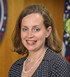
Michelle Carey is Chief of the Media Bureau at the Federal Communications Commission. She previously served as a Media Bureau Deputy Chief, assisting in shaping the Bureau’s policies designed to facilitate competition in the multichannel video programming marketplace. Prior to this appointment, she was a Senior Advisor to the Assistant Secretary at the National Telecommunications and Information Administration in the Department of Commerce. Ms. Carey has also served as Senior Legal Advisor to Chairman Kevin J. Martin, Deputy Chief of the Wireline Competition Bureau, and Chief of the Competition Policy Division of the Wireline Competition Bureau. Before joining the Commission, she clerked for the Honorable Hart T. Mankin of the U.S. Court of Veterans Appeals. Ms. Carey received her J.D. from the Georgetown University Law Center and received her B.A., magna cum laude, from Georgetown University.

Commissioner Geoffrey Starks
Federal Communications Commission

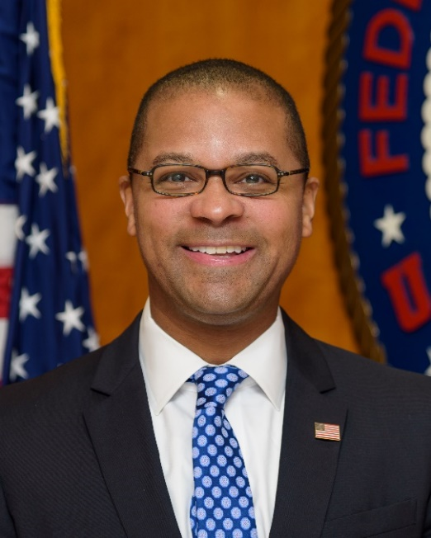
Commissioner Geoffrey Starks believes that communications technology has the potential to be one of the most powerful forces on Earth for promoting equality and opportunity. To unlock that potential, however, all Americans must have access. From combatting internet inequality to advocating for diversity in employment, entrepreneurship, and media ownership, Commissioner Starks fights for policies designed to ensure that modern communications technology empowers every American.

Because high-quality broadband is essential to participating in our economy and society, Commissioner Starks has been a champion for the millions of Americans who lack access to or cannot afford a home internet connection. As a native Kansan, he understands the communications needs of rural America. He has consistently advocated for broadband deployment that helps rural communities tap into economic and educational opportunities that may not be close to home, which both encourages young people to stay and attracts new residents and employers.

Bringing a wealth of enforcement experience to the Commission, Commissioner Starks advocates for consumer protection and accountability, particularly in managing the Universal Service Fund. Before he was appointed Commissioner, Starks helped lead the FCC’s Enforcement Bureau, handling a wide variety of complex investigations. At the Department of Justice, he served as a senior advisor to the Deputy Attorney General on a variety of domestic and international law enforcement matters and received the Attorney General’s Award for Exceptional Service—the highest honor award a DOJ employee can receive.

Commissioner Starks is also a leader on national security policy, working to eliminate untrustworthy equipment from America’s communications networks. His Find It, Fix It, Fund It initiative brought national attention to the urgent need to support small and rural companies as they work to make their networks more secure. With regard to personal data security, while Commissioner Starks fully supports the promise of advanced wireless service and other cutting-edge technologies—and works to ensure that all communities share in the benefits of these advancements—he also fully appreciates the potentially intrusive powers of some communications technologies and is vigilant to ensure against any uses of those powers that would promote illegal discrimination or compromise personal privacy. Before he entered federal public service, Commissioner Starks practiced law at Williams & Connolly, clerked on the U.S. Court of Appeals for the 8th Circuit, served as a legislative staffer in the Illinois State Senate, and worked as a financial analyst. Commissioner Starks graduated from Harvard College with high honors and Yale Law School. He lives in Washington, D.C. with his wife, Lauren, and their two children.

Anna Gomez
Representing Hispanic National Bar Association
Chair, Advisory Committee on Diversity and Digital Empowerment

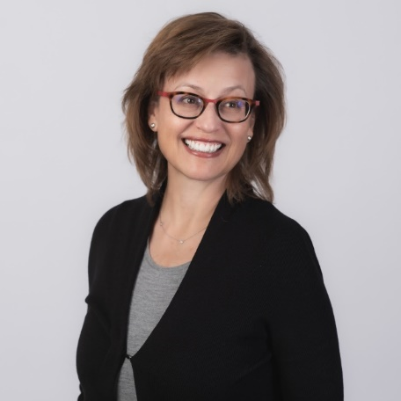
The former National Telecommunications and Information Administration (NTIA) Deputy Administrator, Anna specializes in a wide range of spectrum licensing issues and regulatory, policy, and transactional matters related to domestic and international telecommunications and unmanned aircraft systems. Anna also served for 12 years in various positions at the FCC, including Senior Legal Advisor to then-Chairman William E. Kennard and Deputy Chief of the International Bureau, where she developed and implemented Commission policy on international telecommunications and satellite spectrum. Anna is co-chair of Wiley’s Unmanned Aircraft Systems Practice Group.

Heather Gate
Director of Digital Inclusion, Connected Nation
Vice Chair, ACDDE
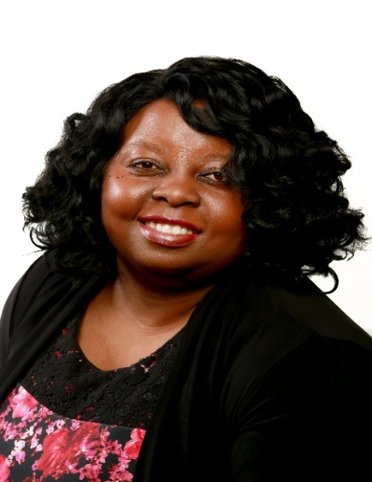
As the Director of Digital Inclusion for Connected Nation (CN), Heather Gate is responsible for strategy development and implementation of programs that impact digital inclusion for all people in all places. Ms. Gate has more than 12 years’ experience working in digital inclusion with the mission of improving the lives of vulnerable populations across the country. She has extensive experience engaging with minorities, rural communities, families, and others on the frontlines of the digital divide and working behind the scenes as an advocate and tactician with local, state, and federal leaders. Heather also serves on the Federal Communications Commission’s Advisory Committee on Diversity and Digital Empowerment (ACDDE).

Caroline Beasley
CEO, Beasley Broadcast Group
Chair, Access to Capital Working Group

Caroline Beasley was appointed Chief Executive Officer of Beasley Broadcast Group, Inc. on January 1, 2017, previously serving as interim Chief Executive Officer from March 18, 2016 until December 31st, 2016 and as Executive Vice President, Chief Financial Officer, Treasurer and Secretary beginning in 1994. She has served as a Director of Beasley Broadcast Group, Inc. since she joined the Company in 1983.
Ms. Beasley currently serves as the Joint Board Chair of the National Association of Broadcasters (NAB) Board of Directors and is a past Chairman of the NAB Radio Board. In addition, she is a member of the BMI Board of Directors and the Broadcasters Foundation of America Board of Directors.
In 2017, Ms. Beasley was honored by Radio Ink magazine as “Radio Executive of the Year”. Ms. Beasley was named one of the “40 Most Powerful People in Radio” in 2011, 2012, 2016 2017 and 2018. In addition, she has been recognized in the magazine’s “Most Influential Women in Radio” listing on an annual basis since 2003.

Ms. Beasley received the 2016 “Distinguished Service Award” from the North Carolina Association of Broadcasters and was the 2012 recipient of the “Frances Preston Trailblazer Award” from the Mentoring and Inspiring Women in Radio Group (MIW), a national organization dedicated to promoting the advancement of women to senior positions in the radio industry.

She is a member of the Board of Visitors at her alma mater, the University of North Carolina, where Ms. Beasley earned a B.S. degree.

PANEL: OBTAINING FINANCING IN TODAY’S CHANGING ENVIRONMENT

Moderator: DuJuan A. McCoy
Owner President & CEO, Circle City Broadcasting, LLC
Lender/Finance Subgroup Lead, Access to Capital Working Group, ACDDE

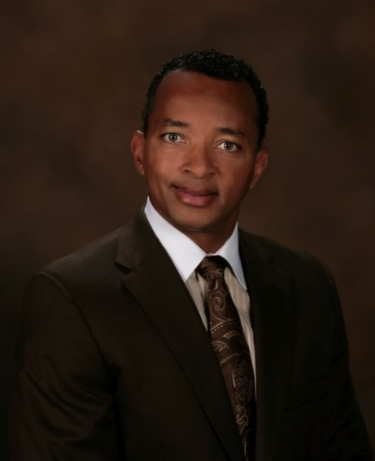
Circle City Broadcasting, LLC is an Indianapolis based company and is majority owned and operated by long time television veteran, DuJuan A. McCoy. He began his television career in 1989 as an Account Executive for WTTV in Indianapolis, IN.

McCoy currently has over 30 years of diverse local broadcasting television experience which includes stints in small, medium, and large television markets as well as working for small, medium and large TV group owners.

To help fulfill his lifelong dream of owning television stations and to hone his television ownership skills further, McCoy enrolled in the exclusive National Association of Broadcasters Broadcast Leadership Training Program (BLT), in September 2007 and graduated in June 2008. He continues to be involved with BLT where he has served as Dean, Faculty, and on the Advisory and Selection Committees for the program.

While still a participant in BLT in 2007, McCoy agreed to purchase, own and operate seven broadcast TV stations owned by Sage Broadcasting in Abilene and San Angelo, TX. With that purchase, McCoy became the only African American to own and operate a Fox and other Big 4 affiliate in the United States. In 2012, in order to move into larger market ownership, McCoy divested the Abilene and San Angelo stations to London Broadcasting. In 2015, he purchased the Fox and CBS affiliates in Evansville, Indiana with $27 million in capital that he personally raised capital. In 2017, he purchased the NBC, Fox and My Net affiliates in Lafayette, IN for $40M. In July 2019, he divested Evansville and Lafayette to Byron Allen Media for $165M. Finally, in April 2019, he agreed to purchase the CW and MY Net Affiliates in his hometown of Indianapolis, IN for $42.5M.

McCoy is a strong advocate for broadcast diversity via his active participation on all major national broadcasting Boards of Directors, FCC Diversity Working Groups and as a frequent visitor to Members of Congress on Capitol Hill.

Ty M. Shea
Chief Financial Officer, Circle City Broadcasting, LLC
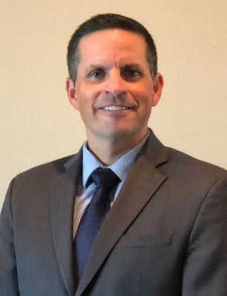
Now CFO of Circle City Broadcasting in Indianapolis, IN, Ty began his career as a public accountant with Grant Thornton, LLP in Madison, WI. This experience provided valuable insight into numerous industries, including manufacturing, public colleges and television broadcasting. He was also a commercial loan officer for two years in Madison where he found helping and working with small businesses to be immensely rewarding.

Ty moved on to become the Corporate Controller for Morgan Murphy Media, and worked with the company’s stations in Wisconsin and Washington for eight years. He gained valuable experience working with a closely-held organization and learning the nuances of the television broadcasting industry.

In 2015, he joined Bayou City Broadcasting as its CFO when the company purchased WEVV-CBS and WEEV-LD in Evansville, IN. The company purchased KADN-FOX, KLAF-NBC and MyNet in Lafayette, LA in 2017. Bayou City Broadcasting divested its stations to Allen Media Group in July 2019. In September 2019, Circle City Broadcasting purchased WISH-CW and WNDY-MyNet in Indianapolis, IN.

Ty graduated from the prestigious National Association of Broadcasters Broadcast Leadership Training Program (NAB-BLT) in 2014. NAB-BLT is an exclusive, 10 month, executive-style MBA program for broadcast executives who aspire to career advancement or station ownership. Ty currently serves as a NAB-BLT faculty member. Ty also graduated from the University of Wisconsin with a BA in Accounting and lives near Sarasota, FL.

Garret Komjathy
Senior Vice President, Media & Communications Division-U.S. Bank
Working Group Member, Lending/Finance Subgroup, Access to Capital Working Group, ACDDE

Garret has 30 years of corporate banking experience including more than 20 years in Media & Communications new deal origination, structuring, and relationship management.
Prior to joining U.S. Bank, he was responsible for managing the New Jersey Department of Banking as part of Governor Chris Christie’s Administration. Prior to joining the Christie Administration, Garret served as Managing Director & Originator in GE Capital’s Media, Entertainment & Communications Group in New York City. Garret has been a frequent panelist/speaker on SNL Kagan Broadcast Finance, Dickstein Shapiro/Pillsbury Radio Show Finance panels and Radio Ink’s Forecast 2019, among others. Garret has been a regular speaker and panelist at the NAB-BLT Program and Minority Lending Seminar at the FCC.
Prior to joining GE Capital, he was an originator in Bank of America’s (formerly FleetBoston Financial) Media, Communications & Entertainment Group in New York City. Prior to joining Bank of America, he was a relationship manager in a number of different industry specialty groups within Corporate Banking for HSBC in Hong Kong and New York City.
He received his B.A. in Economics with a concentration in Finance from Rutgers College. In 2015, Garret was the recipient of U.S. Bank’s Summit Award as recognition for being among the bank’s Top Corporate Bankers. While at GE Capital, Garret received the External Focus Growth Trait Award for Best Overall Performance in 2005.

Dan Damon, Managing Director
Loan Capital Markets, U.S. Bank
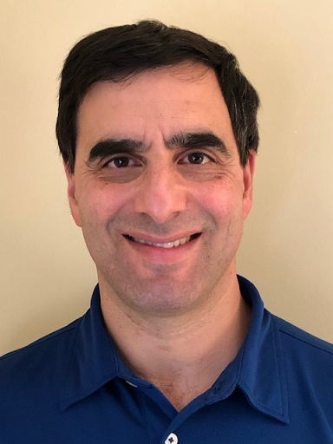
Daniel Damon is a Managing Director in the Loan Capital Markets Group of U.S. Bank. Mr. Damon has almost 30 years of experience financing acquisitions, recapitalizations and leveraged buyouts. At U.S. Bank, he leads loan structuring for the Bank’s Media and Telecommunications and Sports Groups and is responsible for originating, structuring and syndicating lead agent transactions to corporate clients and private equity sponsors in these industries. Mr. Damon has extensive experience financing broadcasting companies and has been a guest speaker at the National Association of Broadcasters Broadcast Leadership Training Program.
Prior to joining U.S. Bank, Mr. Damon was in the Sponsor Finance Capital Markets Group of GE Capital and in the Capital Markets Group at The Bank of New York where he was Head of the Structuring Group.

Mr. Damon has an MBA in Finance and Accounting from The University of Chicago Booth School of Business and a BS in Management and Finance from Binghamton University.

SPEAKERS: TAX CERTIFICATE POLICIES TO INCREASE OWNERSHIP DIVERSITY: PAST, PRESENT, FUTURE
Introduction and Update on Tax Certificate Reinstatement Legislation
Aama Nahuja
Legal Counsel, A Wonder Media Company, LLC
Political Subgroup Lead/Working Group Member, Access to Capital Working Group, ACDDE
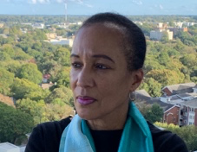
Aama Nahuja (or Nahuja, as she prefers to be called) is the in-house Legal Counsel for A Wonder Media Company LLC and its subsidiaries: American Urban Radio Networks LLC and Superadio Networks LLC. Her responsibilities include contract development and negotiations and other legal matters with which the companies are engaged. She also serves as the Political Subgroup Lead of the Access to Capital Working Group, under the FCC Advisory Committee on Diversity & Digital Empowerment (ACDDE).
Previously, Attorney Nahuja served as Associate Counsel for the Center for Law & Social Justice in Brooklyn, New York and as Confidential Law Clerk for The Honorable John T. Curtin in the U.S.
District Court for the Western District of New York. She has served on the faculties of the Vanderbilt University School of Law and the City University of New York School of Law.
Attorney Nahuja holds an earned LL.M. degree from Louisiana State University, a J.D. degree
from SUNY-Buffalo, an M.L.S. degree from Case Western Reserve University and a B.A. degree
from Oberlin College with a major in government. She is married to Kofi Lomotey and is the
mother of three and the grandmother of five.

History of Tax Certificate Policy and Minority Media Ownership
David Honig
Principal and CEO, JulGlo Productions
President Emeritus and Senior Advisor, MMTC
Member, Access to Capital Working Group, ACDDE

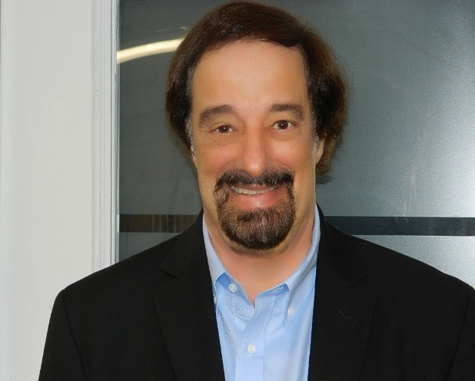
David Honig is Special Counsel for Civil Rights for the Florida State Conference of Branches of the NAACP. In that capacity, he has served since 2009 as the Florida NAACP’s Chief Counsel and legal strategist. Mr. Honig also services as President Emeritus and Senior Advisor for the Multicultural Media, Telecom and Internet Council (MMTC). MMTC has represented over 80 minority and civil rights national organizations in proceedings before the FCC. It operates the nation’s only full service, minority-owned media and telecom brokerage.
Since 1983, Mr. Honig has also been engaged in the private practice of communications and civil rights law, representing national organizations, broadcasters and broadcast applicants. He has litigated twenty federal appeals in four courts and participated in over 90 FCC rulemaking proceedings and hundreds of adjudicatory cases.
From 1975 to 1985, Mr. Honig taught communications policy, research and law at the School of Communications, Howard University. Mr. Honig served as an adjunct lecturer at Catholic University’s Columbus School of Law in 1988, teaching the advanced seminar in International Regulation of Communications. He taught Civil Rights Litigation at the University of Miami School of Law in 1996. Mr. Honig has published numerous journal articles, monographs and empirical research studies on international and domestic communications issues. He is the author of law review articles on group defamation, minority broadcast station ownership, and municipal services discrimination. The National Law Journal has named Mr. Honig one of the thirty most influential communications lawyers.

Mr. Honig served as a U.S. Delegate to the 1979 World Administrative Radio Conference in Geneva, where he helped write the ITU’s rules governing AM radio. He has chaired working groups of the FCC’s Advisory Committee on Radio Broadcasting and Advisory Committee on Broadcast Satellite Service Planning. In 2003, he was named by then-FCC Chairman Michael Powell to serve on the FCC Advisory Committee on Diversity for Communications in the Digital Age, on which he served as Chair of the Constitutional Issues Subcommittee. Subsequently reappointed by then-FCC Chairman Martin and then-Chairman Genachowski, Mr. Honig served as Chair of the Constitutional Issues Subcommittee and the Equal Employment Opportunity Subcommittee. In 2017, Chairman Pai named Mr. Honig to the Advisory Committee on Diversity and Digital Empowerment.
Mr. Honig received a B.A. degree in mathematics from Oberlin College in 1971 and an M.S. Degree in Systems Analysis from the University of Rochester in 1974. He earned his J.D. cum laude in 1983 from Georgetown University Law Center. Attendant to the 2008 and 2017 elections, he served as one of the two co-chairs and as the organizer of Telecom Lawyers for Obama-Biden. In the 2016, 2018, and 2020 elections, he managed the voter protection program of the Florida NAACP. Mr. Honig resides in Vero Beach, Florida.

Update on Media Ownership Diversity Legislation
Kate O’Connor
Chief Counsel
Subcommittee on Communications and Technology, Committee on Energy and Commerce,
U.S. House of Representatives

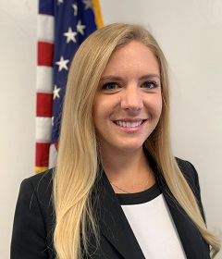
Kate O’Connor is the Chief Counsel for the Subcommittee on Communications and Technology with the U.S. House of Representatives Committee on Energy and Commerce. O’Connor previously served as the Chief of Staff for the National Telecommunications and Information Administration, where she worked on legislative and communications policy focused on spectrum and broadband issues. She also worked in NTIA’s Office of Congressional Affairs and engaged with Congress, state government officials, and other federal agencies to advance the Administration’s legislative initiatives on broadband and 5G.
Prior to joining NTIA, O’Connor worked in the United States Senate. She began her Senate career working in the office of Senator Mark Kirk (R-IL) and then served as a Legislative Assistant for Senator Dan Sullivan (R-Alaska), where she handled issues before the Committee on Commerce, Science, and Transportation, including telecommunications policy. Ms. O’Connor attended the University of Chicago, and is originally from Chicago, Illinois.
PANEL: POTENTIAL IMPACT OF A TAX CERTIFICATE ON THE MARKETPLACE
Moderators:
Henry Rivera
Partner, Wiley Rein LLP, Representing Emma Bowen Foundation
Member, Access to Capital Working Group, ACDDE

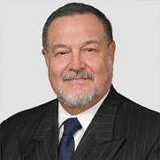
Henry Rivera has more than 42 years of experience representing clients in all types of telecommunications transactions and is an internationally recognized communications expert, author, speaker, and conference leader. A former Federal Communications Commission (FCC) Commissioner, this highly experienced practitioner has been named one of the District of Columbia’s “Super Lawyers,” among The Best Lawyers in America in Communications Law and named by Lawdragon as one of “500 Leading Lawyers in America.” He has also been singled out as a “Leading Lawyer” by Chambers USA and named among the top twelve telecom experts in the United States by Legal Media Group’s Best of the Best. He has also served as a senior advisor to several U.S. international telecommunications delegations and to the U.S. Department of State. Mr. Rivera is a graduate of the University of New Mexico School of Law where he edited the Natural Resources Law Journal. In addition, he received his B.S.B.A. from the University of Albuquerque and a B.A. from the University of New Mexico.

Maurita Coley Flippin
President and CEO, Multicultural Media, Telecom and Internet Council (MMTC)
Member, Diversity in the Tech Sector Working Group, ACDDE
Maurita Coley Flippin, Esq., serves as President and CEO of the Multicultural Media, Telecom and Internet Council (MMTC), a national nonprofit, nonpartisan social impact organization dedicated to promoting and preserving equal opportunity in the tech, media, and telecom industries. She is currently serving her second term as a member of the Federal Communications Commission’s Advisory Committee on Diversity and Digital Empowerment, on the Tech Diversity Working Group. Immediately, prior to MMTC she served as the chief executive officer of Capital Area Asset Builders, a leading nonprofit in community economic development and asset building in the Washington, DC metropolitan area. Previously, she served on the executive management team of BET Holdings, Inc. (now Viacom, Inc.), owner and operator of the BET Cable Networks with authority over legal affairs and later over television production operations. Coley is a former partner with the Davis Wright Tremaine and the Cole, Raywid & Braverman law firms, where she represented cable television programmers and distributors and other media and entertainment businesses. She holds a B.A. in Mass Communications from Michigan State University, and a law degree from Georgetown Law where she has been the recipient of the Law Center’s highest honors. Passionate about media and diversity, Coley has been an investor in several award-winning independent films produced by filmmakers of color.
Panelists:
Russell M. Perry
CEO, Perry Broadcasting

Russell Perry is the President of Perry Publishing and Broadcasting Company with radio stations in Oklahoma City and Tulsa, Oklahoma, Augusta, Georgia, South Carolina, and Fayetteville/Bentonville, Arkansas. He is also President of Perry Broadcasting of Arkansas, Inc. In addition, Russell Perry is the Publisher and Editor of The Black Chronicle Newspaper, Oklahoma City and Tulsa. He was appointed a member. He has also been appointed Commissioner of the Oklahoma City Urban Renewal Authority and Oklahoma City Economic Development Authority, and a Board Member of InvesTrust Wealth Management. Between 1990-2003, then-Governor Frank Keating appointed him Secretary of Commerce and Secretary of Economic Development and Special Affairs for the State of Oklahoma. From 1967 to 1979 he was Co-Publisher of the Black Dispatch. He graduated from Maryland State College, Princess Anne, Maryland in 1957, received an Honorary Doctor of Humane Letters from Mid-American Christian University in 2011, and an Honorary Doctor of Science, Langston University in 2012.

Russell Perry has served on the Board of Directors of several civic organizations such as the Oklahoma Blood Institute and State Fair and the Oklahoma City University and Philharmonic Orchestra, as well as a member of civic organizations including the Oklahoma Development Finance Authority, Oklahoma City Chamber of Commerce, Oklahoma Crime Commission, and Commission on State Government Reform. He is a member of numerous professional organizations, and has received numerous honors including: Leadership Oklahoma, Oklahoma Business of The Year; Teachers of The Year Foundation, Lifetime Achievement Award; Treasures for Tomorrow; Oklahoma Health Center Foundation; and Oklahoma Hall of Fame.

Tomas Martinez
CEO/Owner, Solmart Media LLC

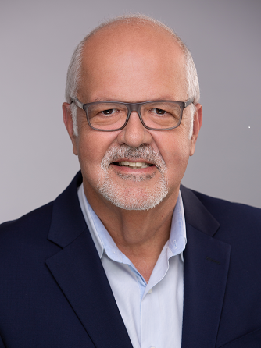
As CEO and owner of Solmart Media, LLC since 2013, Tomás is responsible for all management aspects of the three Southwest Florida stations (WZSP-FM, WTMY-AM and WTMY-FM) which the company owns.

Martinez has been involved in the radio industry for more than three decades. He spent 3 years as GM and COO of Actualidad Media Group in Miami, managing four stations, WURN-AM/FM, WLVJ-AM and WMYM-AM, during his time there the ESPN brand was secure, WURN-AM increased power to 50,000 and billing was substantially increased.

Previously he was associated for 10 years of his career at Prisa Radio as General Manager of Radio Caracol Miami, there, he executed the power upgrade from 5,000 to 50,000 watts, improving the station’s reach to Northern Broward, Palm Beach and Monroe counties. In addition, he secured the rights to the city’s leading sports franchise: The Miami Dolphins and, the most popular international sports event available to advertising: The Soccer World Cup. In the same short period, he has more than tripled the station’s revenues and significantly improved benefits for all employees.

Mr. Martinez also ran the Miami and New York properties for the Radio Unica network. Creating a stellar sales team, along with a winning content combination that proved pivotal to supporting the whole network. Before that, he succeeded in the general market as General Sales Manager for the state of Florida on behalf of Shadow Broadcast Services/Westwood One.

Upon arriving in Miami, Mr. Martinez managed WQBA AM and WAQI AM, and directed the national marketing and merchandising divisions for the Heftel Broadcasting Corporation. Martinez launched his media career in 1983 at WOJO-FM, Chicago.

Throughout his prolific professional life, Mr. Martinez has maintained a long-standing commitment to civic organizations and provided community leadership to highly distinguished social service agencies. Currently, Mr. Martinez is board member of the NAB’s small and medium size market committee, and a member of the Florida Association of Broadcasters. He is also an active member of the Gulf Coast Latin Chamber of Commerce, the Hardee Chamber of commerce and the Manatee Chamber of Commerce. Furthermore, Mr. Martinez has long been associated with the Dean’s Council, at Harvard University’s John F. Kennedy School of Government as well as the NAB’s Broadcast Leadership Training Program.

A native of Cuba, Mr. Martinez arrived in Chicago in 1970 where he graduated from Loyola University in 1984. He resides in Sarasota with his wife and busines partner Mercedes. Their two children, Victoria age 24 lives and works in New York while Thomas age 20 attends Florida State University.

Jeffrey Smulyan
Chairman and CEO, Emmis Communications

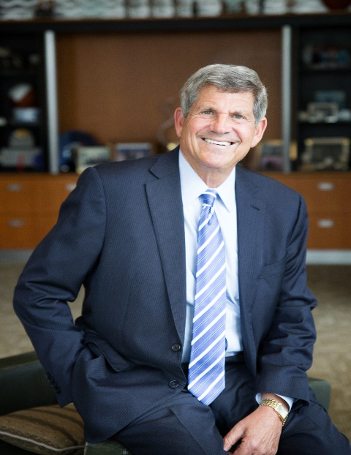
Jeffrey Smulyan serves as founder, chief executive officer and chairman of the board of Emmis Communications Corporation, an Indianapolis-based, publicly traded diversified media company. Jeff is currently leading Emmis through a transition from slower growth traditional media assets to new businesses with better growth profiles. To that end, Emmis recently announced the acquisition of Lencore Acoustics, the world leader in high quality sound masking solutions for offices and other commercial applications. Emmis currently owns 4 FM and 2 AM radio stations in New York and Indianapolis; a controlling interest in Digonex, which provides dynamic pricing solutions across multiple industries; and Indianapolis Monthly magazine.

Jeff is a former director of the National Association of Broadcasters, former chair of the Radio Advertising Bureau, past chair of the Central Indiana Corporate Partnership, and a member of numerous civic boards and committees. As principal shareholder, he led a group that purchased the Seattle Mariners baseball team in 1989. He also served on the Major League Baseball ownership and television committees.
Jeff has been recognized as a Giant of Broadcasting by the Library of American Broadcasting, received the National Association of Broadcasters National Radio Award, and was inducted in the Broadcasting & Cable Hall of Fame and the Indiana Business Hall of Fame. He was named a Living Legend of Indiana by the Indiana Historical Society. The Broadcasters Foundation honored him with its Golden Mike Award. In 2017, he received the Lowry Mays Excellence in Broadcasting Award from the Broadcasters Foundation of America. Emmis was named one of Fortune magazine’s 100 Best Companies to Work For due to its vibrant, collaborative culture.
In 1994, Jeff was named by the White House to head the U.S. Delegation to the Plenipotentiary Conference of the International Telecommunications Union. As a U.S. ambassador, he helped negotiate a landmark agreement between Israel and the Palestine Liberation Organization.
A cum laude graduate of USC with a B.A. in history and telecommunications, Jeff earned a J.D. from the USC Gould School of Law, where he served as note and comment editor of the Southern California Law Review. He has served on the USC Board of Trustees since 2001.
Smulyan resides in suburban Indianapolis with his wife Heather, and he has three children: Samantha, Cari, and Bradley and two grandchildren.

Sara Lomax-Reese
President and CEO, WURD Radio
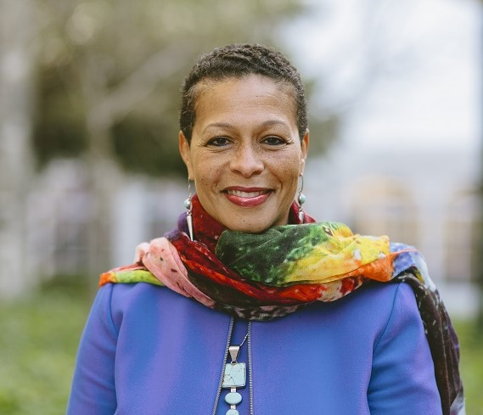
Sara Lomax-Reese is the President and CEO of WURD Radio, LLC, Pennsylvania’s only African-American owned talk radio station. She is credited with transforming WURD Radio from a legacy talk radio station to a multimedia communications company providing cutting edge, original programming on air, online and through community events. In 2017, Sara led the expansion of 900AM-WURD to the FM dial, now simulcasting on both 900AM and 96.1FM. In 2018, Sara spearheaded the launch of an environmental justice journalism platform called ecoWURD.com. And this year she is launching a new initiative called Lively-HOOD focused on jobs, career readiness and entrepreneurship to address the persistent wealth gap in the Black community. In 1992, prior to her work with WURD Radio, Sara co-founded HealthQuest: Total Wellness for Body, Mind & Spirit, a trailblazing African-American consumer health magazine that grew from a quarterly publication to a bi-monthly with a national circulation of over 500,000.

A graduate of the University of Pennsylvania and Columbia University Graduate School of Journalism, Sara has written for The Miami Herald, The Philadelphia Inquirer, The Atlanta Journal-Constitution, Essence Magazine, and Modern Maturity. In 2016, Sara contributed to a book of essays, “Our Black Sons Matter,” written by Black mothers of sons. And in 2018 Sara presented before the Knight Commission on Trust, Media and Democracy, writing an article about the topic. Last June, Sara was sought out and featured on multiple BBC news programs, offering commentary about the protests throughout the country and the world. She was also recently named Program Lead for the new BIPOC Sustainability Accelerator funded by Facebook designed to empower Black and Brown-owned media organizations.

Sara has served as an adjunct professor of communications at Oglethorpe University in Atlanta, GA. She has taught a collaborative course at the University of Pennsylvania with Dr. John Jackson titled “Urban Ethnography” which taught students how to create audio documentaries that aired on WURD Radio. In 2018, Sara completed the Harvard Business School’s Executive Leadership program: The Business of Entertainment, Media and Sports. In 2019 Sara completed the Media Transformation Challenge (formerly the Sulzberger Program) at Harvard Kennedy School.

Sara has received numerous awards, including the Beacon of Light Award from the Congressional Black Caucus for HealthQuest Magazine’s outstanding health coverage. She received the Woman of Substance Award from the National Medical Association; was recognized as one of the "100 People to Watch" by Business Philadelphia Magazine, and selected for the “Women of Distinction” award given by the Philadelphia Business Journal. Additionally, Sara has received the PECO “Power to the Community” award given by the National Coalition of 100 Black Women of Pennsylvania, the Moving Mountains Award from the Leon Sullivan Charitable Trust, the RAD Award for Activist of the Year, and the 2017 Trailblazer Award from the Philadelphia Association of Black Journalists. In 2018, Sara was also named one of the “100 Most Influential Philadelphians” by Philadelphia Magazine.
Sara sits on Arcadia University’s Board of Trustees and Drexel University’s College of Medicine Advisory Council. Additionally, Sara participated on the Federal Communications Commission’s Broadcast Diversity and Development Working Group of the Advisory Committee on Diversity and Digital Empowerment.
An avid yoga and meditation practitioner, Sara is also co-founder of Philadelphia’s People of Color meditation group. She is the proud mother of three sons, Langston, Elijah and Julian.
PANEL: NIELSEN MEDIA RATINGS MEASUREMENTS FOR DIVERSE MEDIA OWNERS
Introduction
Skip Dillard
Operations Manager and Program Director, WBLS/WLIB, Emmis Communications
Broadcast Subgroup Lead, Access to Capital Working Group, ACDDE

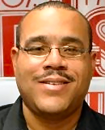
Graham "Skip" Dillard has served as the Operations Manager and Program Director for Urban WBLS-FM and Gospel WLIB, Emmis Communications, for over 10 years, joining then-Inner City in 2008. Previously, he spent almost a year as Program Director of then-CBS Radio's Urban WPGC-FM/Washington, DC. Before that, he was Operations Manager for Radio One's 3-station group in Detroit, Program Director of KBTB-FM (The Beat)/San Francisco and Program Director of WBLK-FM/Buffalo from 1996-2003. Dillard has also served as the Top 40 Editor of Billboard Airplay Monitor.
Dillard's career began at Hampton University's WHOV-FM while a student. He also volunteered at North Carolina A&T State University's WNAA-FM, during the summers.
Dillard has received numerous honors in his career including the Proclamation of Service to New York State and New York City Hall, 2017. Dillard was also voted onto the Executive Board of the Greater Harlem Chamber of Commerce in October 2017.
Moderators:
James Winston
President, National Association of Black Owned Broadcasters
Member, Access to Capital Working Group, ACDDE

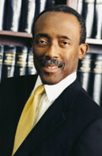
James Winston represents clients on a wide variety of communications matters, specializing in broadcast and wireless issues. Beginning in 1982, Mr. Winston has served, first as executive director and general counsel, and now president, of the National Association of Black Owned Broadcasters. In that capacity, he represents NABOB before the U.S. Congress and the Federal Communications Commission, as well as before executive branch agencies and the White House. He also handles government relations for NABOB, including filing comments in rulemakings before the FCC. In addition to NABOB, Mr. Winston represents a wide range of clients in the broadcast, cable television, radio, and wireless telephone industries. He handles general corporate matters as well as the purchase of radio and television stations and regulatory filings and applications before the FCC.

Prior to establishing his law firm with Eric Rubin in 1981, Mr. Winston was an associate at Wolf, Block, Schorr and Solis-Cohen, LLP (1980-1981), and he also served as legal advisor to FCC Commissioner Robert E. Lee from 1978 to 1980. Earlier in his career, he was an associate with LeBoeuf, Lamb, Leiby & MacRae in New York and Washington, D.C. (1973-1976) and associate counsel of Western Union Telegraph Company (1976-1978).
Nimisha Shukla, M.D.
CEO, New Jersey Broadcasting, LLC/South Asian Broadcasting, LLC
Member, Access to Capital Working Group, ACDDE

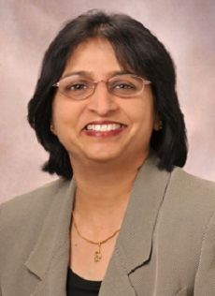
Medical Doctor and Business Entrepreneur are titles that rarely apply to the same person. The rigors of completing medical studies and professional preparation, joining or building a practice, and caring for patients is more than a full-time job for most medical practitioners. Yet, Dr. Nimisha Shukla has summoned the personal resources to complete all of those things, as well as found and develop a major player in the pre-paid international calling card industry, become the first South Asian woman to be a Broadcaster in the USA, and launch and manage various philanthropic endeavors.

Dr. Shukla developed her passion for the practice of medicine by caring for her severely depressed mother from a young age. may be found. An outstanding student from her early years, Nimisha graduated first in her class from Wilson College, making her entry into medical school a near certainty. Subsequently, she earned degrees and diplomas including Bachelor of Medicine, Bachelor of Surgery (M.B.B.S.) from Seth Gordhandas Sunderdas (G.S.) Medical College and King Edward Memorial (K.E.M.) Hospital, Diploma in Child Health (D.C.H.) from the College of Physicians and Surgeons, and Medical Doctor (M.D.) in Pediatrics from G.S. Medical College and K.E.M. Hospital.

Her professional development carried her across three continents where she witnessed differing forms of care and therapeutic interventions for children with a wide range of illnesses. Completing her residency and ascending to teaching positions in India, Dr. Shukla emigrated to the United States and continued her professional development as a Clinical Assistant Instructor and ultimately Chief Resident at SUNY Downstate Medical Center College of Medicine in Brooklyn, New York – a singular distinction for a foreign medical graduate. During her Chief Residency Dr. Shukla completed a Fellowship in Pediatric Infectious Diseases at the world-renowned Hospital for Sick Children at Great Ormond Street in London. Returning to the United States, she accepted a position as an Attending Physician at Mid-Michigan Regional Medical Center and subsequently and concurrently as an Assistant Clinical Professor at Michigan State University.

During this period in Michigan Dr. Shukla and her husband founded pre-paid calling card company Reliable Communication, having seen a need in the Indian-American community to affordably call friends and relatives in their native land. Beginning sales efforts by phone, Dr. Shukla realized that this type of pre-paid service was the perfect digital product for ecommerce and created reliablecom.com – a secure, high-volume online retail environment. Continuing her medical career in New Jersey, Dr. Shukla and her husband sold their enterprise in 2003to a large, publicly-traded company, when it employed 40 in its New Jersey offices and 6 in its information technology (IT) branch office in India.

With a small part of the proceeds of the sale, Dr. Shukla purchased another medical practice to add to her own. In 2011, she founded “7 days Pediatrics” with three locations and about 7 Pediatricians serving the daily needs of children in Middlesex County, NJ. Her location houses Saint Peter’s Children’s Hospital and Rutgers medical School- Robert Wood Johnson Hospital Pediatric Sub-specialty practices.

Realizing that Indian-American culture can inure to the benefit of society as whole, she has Co-founded Art Speaks for Autism, a charitable foundation affiliated with the Saint Peter’s Foundation dedicated to elevating public awareness about autism and raising funds for research and support to families with autistic children. In 2014, she received a prestigious Mahatma Gandhi Pravasi Sanman Award at House of Lords, London for keeping the flag of India high as a Non-resident Indian.

In 2016, she became the First South Asian Female Broadcaster as a result of the acquisition of WWRL, 1600 AM, a 25,000 Watts mega station. Creation of South Asian Radio has fulfilled her long-term desire to give voice to the South Asian community in New York Metropolitan area. In January 2019, Dr. Shukla partnered with Radio Mirchi, owner of a vast network of FM radio stations in India, to bring to the Metropolitan New York area the latest Hindi and Bollywood songs and programming hosted by popular Radio Mirchi RJs. She also lends her broadcasting and managerial expertise to Radio Mirchi USA as an appointed advisor. Dr. Shukla has contributed significantly in creating a path for giving Voice to Indian American Community thru media including Radio Broadcasting, formation of Indian classical dance institute, Indian American Women Entrepreneur’s Association (IAWEA) and serving as President of IAWEA.
Civic minded, she has founded Nrityanjali USA, a dance institute dedicated to teaching a classical Indian dance form Kathak to a new generation of Indian Americans. She was nominated as President of South Asian Community Outreach Organization for 2015 -2017, helping South Asians bridge their relationship. She has been serving on the Health Advisory Board of Edison Township, NJ since January of 2018 and on Lincoln Technical School curriculum board since 2015. Most recently, she has delved into the political arena where, in 2019, she was elected a Democratic Committeeperson in the community of her residence, Edison, NJ.
Panelists:
Stacie de Armas
Senior Vice President for Community Alliances, Nielsen Global Media

Stacie M. de Armas is Senior Vice President Inclusive Insights & Initiatives and a Leader within Nielsen’s Diversity, Equity & Inclusion practice. She is a researcher, consumer behaviorist, thought leader and subject matter expert on the diverse communities. Stacie is responsible for producing inclusive thought leadership and new research initiatives on diverse consumers and audiences.
She joined Nielsen in 1998 and has served in many roles related to multicultural marketing. She sits on the Cultural Marketing Council Board of Directors as well as Google’s 21st Century Multicultural Marketing Council and has been the recipient of industry honors for her work in diversity marketing.
Stacie is an adjunct professor of qualitative research at California State University Los Angeles and California State University Northridge. She received her master’s degree in Business Administration with a focus on marketing from Texas A & M. Stacie is first generation Cubana and lives in Los Angeles with her two children.
Jon Miller
Vice President, Audience Insights, Nielsen Global Media
Jon Miller oversees the entirety of Nielsen’s interactions, insights and tools designed for radio programmers and content creators. He’s been with Nielsen for nearly twenty years working with both radio and local TV clients, and previously worked for both iHeartMedia & Westwood One both on and off the air.
PANEL: INCREASING ACCESS TO ADVERTISING FOR DIVERSE MEDIA OWNERS

Moderators:
Sherman Kizart
Managing Director and Founder, Kizart Media Partners
Member, Access to Capital Working Group, ACDDE

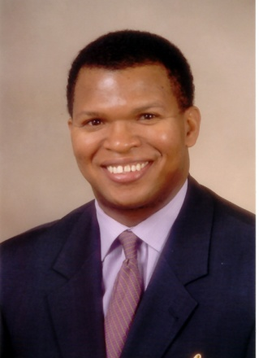
Sherman K. Kizart is founder and managing director of Kizart Media Partners, Inc. (KMP, Inc.). The company he launched in 2008 is a national media sales and marketing consulting firm headquartered in Chicago, Illinois that partners with clients to generate greater sales that focus on revenue opportunities for urban targeted media platforms.

Kizart has acquired his expert knowledge from over 20 years of experience as a marketing specialist. He is one of the leading advocates and authorities in the U.S. on urban radio and multicultural media strategies and tactics. Prior to founding KMP, Inc., Kizart worked for Interep, Inc. as senior vice president and director of urban radio. He is recognized for his experience in the media and telecom industry.

Kizart Media Partners owns the intellectual property, Power of Urban Radio Forum (PURF). PURF works in partnership with the National Association of Black Owned Broadcasters in Washington, D.C. Executives responsible for planning and placing more than $50 billion in measured media attended PURF, including advertising agency media directors, global media agency planners, and chief marketing officers of major corporations. Kizart was named Multicultural Entrepreneur of the Week by the Minority Media and Telecommunications Council.

Kizart serves as an urban sales and marketing expert to the industry's leading advocacy organizations, including the Radio Advertising Bureau, National Association of Broadcasters, and National Association of Black Owned Broadcasters. He is the Chairman of RADIO INK Magazine's Urban Advisory Council and is seated on the Board of Visitors at the Howard University John H. Johnson School of Communications. He was awarded the radio industry's highest recognition, the Radio Wayne Award. He is an active member of Kappa Alpha Psi Fraternity , Inc. and was recently appointed Chairman of the Corporate Outreach and Strategic Media Partnerships Committee.

Prior to his 15-year stint at Interep, he had a leadership role in the urban sales efforts for some of the country's leading broadcasters including Clear Channel Communications, Hawes-Saunders Broadcasting, Gilliam Communications, and D. Rivers Broadcasting in markets such as New Orleans, Memphis, and Dayton, respectively.

A graduate of the University of Mississippi, he is an avid tennis player and enjoys travel. Contact him at shermankizart@att.net.

Raul Alarcón
President, CEO and Chairman, Spanish Broadcast System, Inc.
Member, Access to Capital Working Group, ACDDE

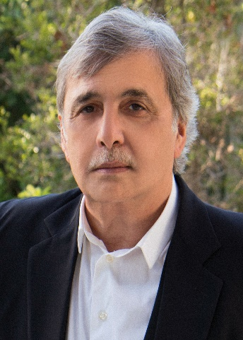
Mr. Alarcón joined the Spanish Broadcast System (SBS) in 1983 as an Account Executive and has served as President since 1985 and Chief Executive Officer since 1994. He was elected Chairman of the Board in 1999. Currently, Mr. Alarcón is responsible for the formation and execution of SBS' overall corporate strategy. Under his leadership, the company has grown into a leading Spanish-language multi-media entity complete with top-ranked radio stations in the largest U.S. markets, including the most-listened-to Hispanic station in the world, WSKQ-FM in New York City, as well as LaMusica, the nation's Number One ranked Hispanic digital streaming site and top Hispanic radio mobile app, and a leading live events and experiential platform, SBS Entertainment.

Panelists:
Bob Wingo
Chairman and CEO, Sanders Wingo Advertising
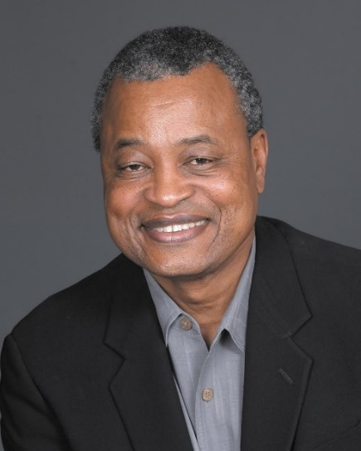
Bob Wingo joined Sanders\Wingo in 1984. In the decades since, Bob’s commitment to authenticity and excellence has fueled the Sanders\Wingo team to expand the agency’s presence from El Paso across Texas to Austin, and into regional offices in New York, San Francisco and Los Angeles.
The years he spent devoted to client-side marketing have made him a trusted authority for many current and former clients. He intuitively understands how to match talent and capabilities to client needs. His leadership has been prized by clients like AT&T, Burger King, Chevrolet, KFC, State Farm Insurance, the United States Postal Service and Shell Oil.
Generosity with his knowledge and experience has led to a wealth of civic involvement and public service over the course of his career. In the 1990s, Texas Governor George W. Bush made Bob a member of the Finance Commission of Texas. In January of 2004, Texas Governor Rick Perry appointed Bob to the Texas Economic Development Corporation Board, where he served as Chairman. Governor Perry also appointed Bob to a position on the Texas Higher Education Coordinating Board. On a national scale, Bob sat on the board of the Martin Luther King, Jr. Memorial Foundation. Currently, Bob sits on the Board of Las Palmas Del Sol Medical Center, Burrell College Osteopathic Medicine, ROICOM USA Board of Directors, UTEP College of Business and El Paso Community Foundation.

Many organizations have honored Bob for his contributions to the community and to the fields of marketing and advertising. One of the most notable testaments to Bob’s leadership has been the recognition of Sanders/Wingo as Black Enterprise 2009 Advertising Agency of the Year. In 2013, The University of Texas at El Paso and its Alumni Association honored Bob Wingo as one of their Distinguished Alumni.
A. Curtis Farrow
CEO and Founder, Irving Street Rep, Inc.
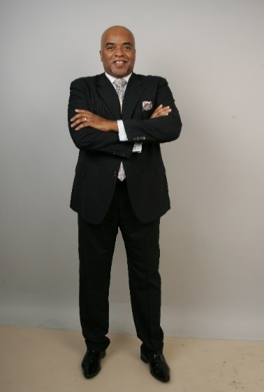
A. Curtis Farrow has just returned from Johannesburg, South Africa where he was awarded the Global Marketplace Award, “Acknowledging his Outstanding Leadership and Global Impact.” Locally, Mr. Farrow has received many honors for his business experience, including a commendation from former Newark Mayor Cory Booker in 2011 and former Mayor Sharpe James in 2005, who proclaimed June 17, 2005, as A. Curtis Farrow Day. In 2009, he was named Man of the Year by the Christian Times and has received a commendation from the Manhattan Borough President and the Public Advocate Award for New York City.

He is internationally known as the producer of the McDonald’s Gospelfest, which he has directed and produced for 20 years. Under his direction McDonald’s Gospelfest has become the preeminent gospel event in the nation and has garnered him two Emmy awards and ten nominations. Mr. Farrow was responsible for the organization, planning and execution of the homegoing services for the late Whitney Houston and most recently he produced the homegoing services for the late Aretha Franklin, which were viewed around the world.

Mr. Farrow serves as CEO of Irving Street Rep., Inc, A Marketing and Public Relations agency whose clients have included McDonald’s, Dupont, Family Federation, and Essex County College.
Doug Ray
CEO Media, dentsu Americas
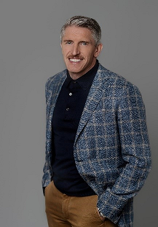
Doug Ray is CEO, Dentsu Media with responsibility for its media agencies and platforms across the Americas, including Carat, iProspect and dentsu X.
Doug was named CEO in 2019 after serving as dentsu’s first President of Product and Innovation. In that role, he led the development and implementation of dentsu’s product suite, including the integration of Merkle's M1 platform, which now underpins dentsu’s entire media organization.
Previously, Doug served as Carat US CEO, where he led the agency’s transformational growth, doubling revenue by partnering with some of the world’s most iconic brands. Doug served as Carat's first Global President from 2012 to 2015, during which time Carat was named Campaign Global Network of the Year, Adweek Agency of the Year, MediaPost Agency of the Year and Advertising Age Agency A-List, and was consistently ranked Number 1 within RECMA’s Qualitative Agency Assessment.
Doug has been recognized as an Adweek Media Executive of the Year, Advertising Age Media Maven, and Internationalist Agency Innovator and Legend & Leader.
Steve Williams
Global COO, Essence Communications

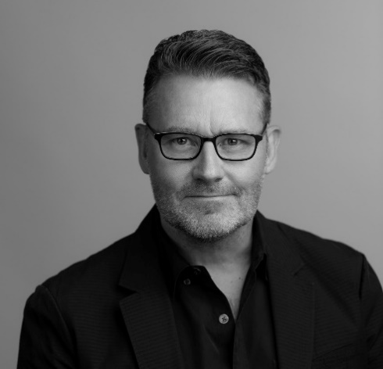
Steve works within the WPP/GroupM business, leading its data and measurement-driven media agency, Essence, as Global COO. He has global responsibility for the strategy and creative experience communities, marketing and reputation management, and business development.

Steve was privileged to have learned his trade (in the UK} in a full-service ad agency environment. Given this experience, he is a firm believer in, and propagator of, creativity. He is as interested in the quality of a message or a creative idea, as how communications planning, data and technology can create a breakthrough execution.
He is zealous about nurturing conditions whereby people can seed and grow ideas together. Leading great people, building strong teams, and driving impactful creativity, get him up early. Steve has always subscribed to a people-first philosophy, believing that a creative and respectful culture begets results in business.
He is committed to help raise industry standards. While in the UK, he served as Chair of the IPA’s Media Futures Group, and was awarded Fellow of the IPA. Now in the USA, Steve is chair of the 4A’s Media Leadership Council and an active 4A's board member. He is a proud recipient of the NABOB 2018 National Service Award.
He loves spending time with the work and is a frequent judge for awards events both locally and globally, including IPA Effectiveness, Cannes Lions [Global], Festival of Media [Global and North America], and the North American Effie Awards.
He is married to Suzanne, his much smarter half, and has four [two of his own making] incredible kids. And a dog, Fitzgerald.

