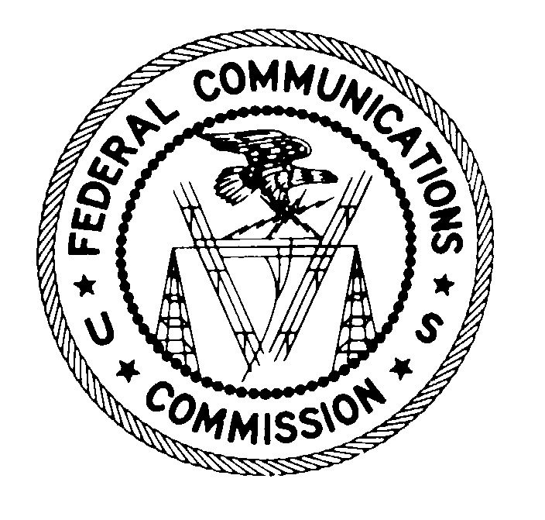
Federal Communications Commission Washington, D.C. 20554

November 23, 2020

DA 20-1393

Small Entity Compliance Guide
Rules for Interstate Inmate Calling Services Report and Order on Remand and Fourth Further Notice of Proposed Rulemaking

FCC 20-111
WC Docket No. 12-375
Released: August 7, 2020

This Guide is prepared in accordance with the requirements of Section 212 of the Small Business Regulatory Enforcement Fairness Act of 1996. It is intended to help small entities—small businesses, small organizations (non-profits), and small governmental jurisdictions—comply with the revised rules adopted in the above-referenced Federal Communications Commission (FCC or Commission) rulemaking dockets. This Guide is not intended to replace or supersede these rules, but to facilitate compliance with the rules. Although we have attempted to cover all parts of the rules that might be especially important to small entities, the coverage may not be exhaustive. This Guide cannot anticipate all situations in which the rules apply. Furthermore, the Commission retains the discretion to adopt case-by-case approaches, where appropriate, that may differ from this Guide. Any decision regarding a particular small entity will be based on the statute and any relevant rules.

In any civil or administrative action against a small entity for a violation of rules, the content of the Small Entity Compliance Guide may be considered as evidence of the reasonableness or appropriateness of proposed fines, penalties or damages. Interested parties are free to file comments regarding this Guide and the appropriateness of its application to a particular situation. The FCC will then consider whether the recommendations or interpretations in the Guide are appropriate in that situation. The FCC may decide to revise this Guide without public notice to reflect changes in the FCC’s approach to implementing a rule, or it may clarify or update the text of the Guide. Direct your comments and recommendations, or calls for further assistance, to the FCC’s Consumer Center:

1-888-CALL-FCC (1-888-225-5322)
TTY: 1-888-TELL-FCC (1-888-835-5322)
Videophone: 1-844-4-FCC-ASL (1-844-432-2275)
Fax: 1-866-418-0232

TABLE OF CONTENTS

I. OBJECTIVES OF THE PROCEEDING 3
II. COMPLIANCE REQUIREMENTS 3
III. RECORDKEEPING AND REPORTING REQUIREMENTS 4
IV. IMPLEMENTATION DATE 4
V. INTERNET LINKS 4

OBJECTIVES OF THE PROCEEDING

In the Rules for Interstate Inmate Calling Services, Report and Order on Remand and Fourth Further Notice of Proposed Rulemaking, WC Docket No. 12-375, FCC 20-111 (rel. Aug. 7, 2020) (Remand Order), the Federal Communications Commission revised its ancillary service charge rules for inmate calling services in response to a remand from the United States Court of Appeals for the District of Columbia Circuit (D.C. Circuit). The Commission also reinstated its rule prohibiting providers from marking up mandatory taxes or fees and, in response to the D.C. Circuit, adopted rule changes that clarify that the Commission’s inmate calling service rate and fee cap rules apply only to interstate and international inmate calling services. These actions were part of the Commission’s continuing efforts to comprehensively reform inmate calling services rates and charges to ensure just and reasonable rates for interstate and international inmate calling services.

COMPLIANCE REQUIREMENTS
Ancillary service charges are separate fees that are not included in the per-minute rates assessed for an individual inmate calling services call. The Commission previously had established five types of permissible ancillary service charges that inmate calling services providers can impose on consumers and placed a fee cap on each category. In response to a directive from the D.C. Circuit, the Commission determined that, except in limited circumstances, it is impractical to separate out the interstate and intrastate components of ancillary service charges imposed in connection with inmate calling services.
The five types of permissible ancillary service charges are: single-call service fees, automated payment fees, third-party financial transaction fees, live agent fees, and paper bill/statement fees. Inmate calling services providers are prohibited from charging other types of ancillary fees in connection with interstate or international calls, or a mixture of interstate/intrastate or international/intrastate calls. In those circumstances, inmate calling services providers may charge no more than the applicable cap for the five types of permissible ancillary service charges.
Ancillary Service Charges
Under the ancillary service charge rules, providers may:
- Pass through to consumers the exact fee, with no markup, charged by a third party for individual interstate collect calls.
- Charge a maximum of $3.00 for automated payments made by inmate calling services customers to fund prepaid or debit accounts related to interstate calls. The cap applies to all payments made before calls are completed where it is impossible to determine at the time the payments are made that no portion of the funds will be used to place interstate or international calls or to pay for jurisdictionally mixed ancillary services.
- Pass through third-party financial transaction fees, with no markup, to the inmate calling services customer.
- Charge inmate calling services customers a maximum of $5.95 per interaction with a live operator for interstate or jurisdictionally mixed live operator assisted services.
- Charge a maximum of $2.00 per paper bill or statement obtained by an inmate calling services customer for interstate or jurisdictionally mixed billing.
In the Remand Order, the Commission warned inmate calling services providers against taking new actions to segregate interstate and intrastate activity (for example, providing separate paper bills for intrastate and interstate inmate calling services, and placing separate fees on each type of bill). The Commission specified that it will presumptively consider those actions as unjust and unreasonable practices that are prohibited under federal law. A provider that takes such actions should be prepared to demonstrate to the Commission that its affected interstate ancillary service charges are just and reasonable, including that the affected charges do not recover jurisdictionally common costs that are already, or should properly be, recovered through the provider’s corresponding intrastate ancillary service charges.
The Commission also reminded providers that they are prohibited from imposing ancillary service charges in connection with interstate or international inmate calling services that do not fall into one of the five types of permissible charges and that they are bound to provide accurate data in their annual reports to the Commission. Failure to comply with the Commission’s rules may result in enforcement action.
Other Revisions
- The Commission reinstated its rule prohibiting markup of mandatory taxes and fees. Inmate calling services providers are prohibited from marking up mandatory taxes and fees in connection with interstate and international inmate calling services calls.
- The Commission revised certain of its rules regarding inmate calling services in response to a D.C. Circuit order. Specifically, the Commission eliminated sections of its rules relating to rate caps and relating to reporting requirements for video visitation services. The Commission also revised its rules to reflect the D.C. Circuit’s decision that the Commission’s ratemaking jurisdiction only extends to interstate and international inmate calling services.

RECORDKEEPING AND REPORTING REQUIREMENTS
The Remand Order requires inmate calling services providers to properly identify whether ancillary service charges are related to interstate/international or intrastate inmate calling services. To the extent a provider cannot definitively establish that a call is intrastate, the provider should apply the Commission’s interstate ancillary service charge rules in connection with that call.

IMPLEMENTATION DATE
The Remand Order and its requirements for inmate calling services providers will become effective on November 23, 2020.

INTERNET LINKS
A copy of the Remand Order is available at: https://docs.fcc.gov/public/attachments/FCC-20-111A1.pdf.
A copy of the Federal Register Summary of the Remand Order, 85 Fed. Reg. 67450 (October 23, 2020) is available at: https://www.govinfo.gov/content/pkg/FR-2020-10-23/pdf/2020-19951.pdf.

47 CFR § 64.6000(a).

